Sensitivity to Trophic Discrimination Factors

Ashlee Mikkelsen

2022-03-21

Since I concluded from my previous analysis not to group sources (pending comments from collaborators), I went forward with looking at the sensitivity of my diet estimates to different tropic discrimination factors, hereafter abbreviated as TDF.

Here I will generate several models with different discrimination factors to estimate how these effect my diet estimates

I will compare 6 models, all with uninformative priors. The first model will have the specific TDFs that I calculated from the linear equations of Hilderbrand et al 1996 and Felicetti et al 2003.I will also run a model with TDFs calculated using each equation in those papers. I will also run models with TDFs that are both lower and higher than mine by 1 per mil. Finally I also include a model with no TDF corrections, as done in Ro et al. 2021.

For each group of TDFs, I include the same variance around the TDFs of standard deviations of 1 per mil.

### Model list:

Model 1: My derived TDF

Model 2: TDF calculated from Hilderbrand et al 1996

Model 3: TDF calculated from Felicetti et al. 2003

Model 4: My TDFs -1 per mil

Model 5: My TDFs +1 per mil

Model 6: No TDF as in Ro et al. 2021

##### Take raw SI data and convert moose hair to moose meat and correct for Suess

First, I use the TDFs that I derived from 3 published bear feeding experiments. Below are the two linear regression models that I derived following recommendations by Philips et al. 2014 using the feeding experiment Hilderbrand et al. 1996, Felicetti et al. 2003, and Rode et al. 2016.

Mikkelsen13C <- function(x,y){  
 y=-10.6+(0.42*x)  
}  
  
Mikkelsen15N <- function(x,y){  
 y=5.02+(0.90*x)  
}  
  
# I use these linear equations to predict the isotopic signature of a brown bear eating 100% of a diet source (y) given the mean isotopic signature of that source (x)  
  
  
d13C.Mikkelsen <- Mikkelsen13C(bears_species_means$mean13C)  
print(d13C.Mikkelsen)

## [1] -21.61969 -23.08303 -21.94546 -22.03492 -21.81413

# The actual TDF is the difference between our predicted isotopic signature for a bear eating 100% of that source and the mean isotopic signature for that source  
C13TDF.Mikkelsen <-abs(d13C.Mikkelsen-bears_species_means$mean13C)  
  
# Here are the TDFs for Carbon for ants, bilberries, crowberries, lingonberries, and moose  
print(C13TDF.Mikkelsen)

## [1] 4.617668 6.638470 5.067540 5.191080 4.886174

# Now we repeat the process for Nitrogen  
  
d15N.Mikkelsen <- Mikkelsen15N(bears_species_means$mean15N)  
print(d15N.Mikkelsen)

## [1] 6.342151 2.680450 -0.289550 1.131100 6.432603

N15TDF.Mikkelsen <-d15N.Mikkelsen-bears_species_means$mean15N  
  
# And here we have the TDFs for Nitrogen for ants, bilberries, crowberry, lingonberry, and moose  
print(N15TDF.Mikkelsen)

## [1] 4.873094 5.279950 5.609950 5.452100 4.863044

Prior to running our model, I performed a check that my consumers fall within the mixing space

## C13TDF.Mikkelsen N15TDF.Mikkelsen  
## [1,] 4.617668 4.873094  
## [2,] 6.638470 5.279950  
## [3,] 5.067540 5.609950  
## [4,] 5.191080 5.452100  
## [5,] 4.886174 4.863044

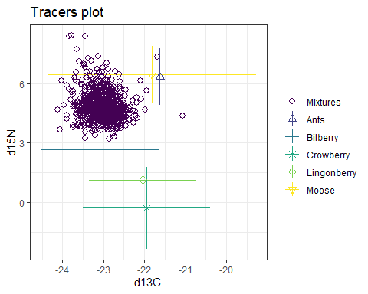

Next we run the model and examine output

##   
## Summary for 1   
## Gelman diagnostics - these values should all be close to 1.  
## If not, try a longer run of simmr_mcmc.  
## deviance Ants Bilberry Crowberry Lingonberry Moose   
## 1 1 1 1 1 1   
## sd[d13C] sd[d15N]   
## 1 1

##   
## Summary for 1   
## mean sd  
## deviance 3619.477 3.581  
## Ants 0.064 0.005  
## Bilberry 0.507 0.013  
## Crowberry 0.115 0.019  
## Lingonberry 0.271 0.022  
## Moose 0.043 0.003  
## sd[d13C] 0.034 0.026  
## sd[d15N] 0.039 0.029

##   
## Summary for 1   
## 2.5% 25% 50% 75% 97.5%  
## deviance 3614.579 3616.836 3618.802 3621.447 3628.278  
## Ants 0.054 0.061 0.064 0.067 0.074  
## Bilberry 0.481 0.498 0.507 0.516 0.533  
## Crowberry 0.079 0.102 0.115 0.128 0.154  
## Lingonberry 0.229 0.256 0.271 0.285 0.314  
## Moose 0.037 0.041 0.043 0.046 0.050  
## sd[d13C] 0.001 0.013 0.028 0.048 0.096  
## sd[d15N] 0.002 0.016 0.033 0.057 0.107

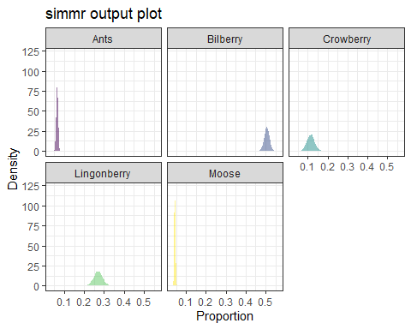

The output from this model is the same as the output from determining whether to group diet sources, because so far the model specifications are identical

We see from the Gelman diagnostics that the model has converged and we can look at the dieatary proportion estimates and the uncertainty around those estimates. And then see the estimates and uncertainty graphically.

##### Now I use the same methods and work flow as above to calculate TDFs derived from the linear equation in Hilerbrand et al. 1996 and estimate dietary estimates for the same source and mixture data.

Hilderbrand13C<- function(x,y) {  
 y=-10.34+(0.42*x)  
}  
  
Hilderbrand15N<- function(x,y) {  
 y=4.76+(0.91*x)  
}  
  
d13C.Hilderbrand <- Hilderbrand13C(bears_species_means$mean13C)  
print(d13C.Hilderbrand)

## [1] -21.35969 -22.82303 -21.68546 -21.77492 -21.55413

C13TDF.Hilderbrand <-abs(d13C.Hilderbrand-bears_species_means$mean13C)  
#Here are our Carbon TDFs for ants, bilberries, crowberries, lingonberries, and moose  
print(C13TDF.Hilderbrand)

## [1] 4.877668 6.898470 5.327540 5.451080 5.146174

d15N.Hilderbrand <- Hilderbrand15N(bears_species_means$mean15N)  
print(d15N.Hilderbrand)

## [1] 6.096842 2.394455 -0.608545 0.827890 6.188299

N15TDF.Hilderbrand <-d15N.Hilderbrand-bears_species_means$mean15N  
  
#Here are the calculated Nitrogen TDFs for ants, bilberry crowberry, lingonberry, and moose  
print(N15TDF.Hilderbrand)

## [1] 4.627785 4.993955 5.290955 5.148890 4.618740

bear_speciesTDF_means.Hilderbrand <- cbind(C13TDF.Hilderbrand,N15TDF.Hilderbrand)  
print(bear_speciesTDF_means.Hilderbrand)

## C13TDF.Hilderbrand N15TDF.Hilderbrand  
## [1,] 4.877668 4.627785  
## [2,] 6.898470 4.993955  
## [3,] 5.327540 5.290955  
## [4,] 5.451080 5.148890  
## [5,] 5.146174 4.618740

bearsimmr_TDF_Hilderbrand = simmr_load(  
 mixtures=bearmix,  
 source_names=bears_species_names,  
 source_means=bears_species_means,  
 source_sds=bears_species_sds,  
 correction_means=bear_speciesTDF_means.Hilderbrand,  
 correction_sds=bear_speciesc_sds,  
 concentration_means = bear_species_conc  
 )  
  
plot(bearsimmr_TDF_Hilderbrand)

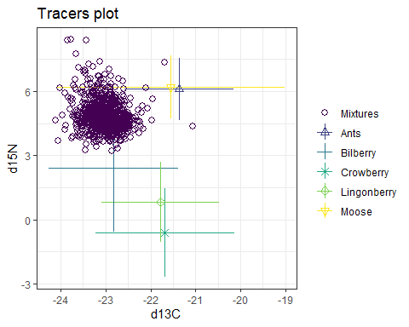

Here we can see that the different TDFs cacluted from Hilderbrand’s linear equation have created a different mixing space, but our mixtures (consumers) still fall within the mixing polygon.

##   
## Summary for 1   
## Gelman diagnostics - these values should all be close to 1.  
## If not, try a longer run of simmr_mcmc.  
## deviance Ants Bilberry Crowberry Lingonberry Moose   
## 1 1 1 1 1 1   
## sd[d13C] sd[d15N]   
## 1 1

##   
## Summary for 1   
## mean sd  
## deviance 3920.852 3.469  
## Ants 0.078 0.006  
## Bilberry 0.622 0.013  
## Crowberry 0.045 0.018  
## Lingonberry 0.199 0.023  
## Moose 0.056 0.004  
## sd[d13C] 0.042 0.031  
## sd[d15N] 0.038 0.029

##   
## Summary for 1   
## 2.5% 25% 50% 75% 97.5%  
## deviance 3916.181 3918.270 3920.205 3922.632 3929.099  
## Ants 0.067 0.074 0.078 0.082 0.090  
## Bilberry 0.596 0.613 0.622 0.631 0.649  
## Crowberry 0.014 0.031 0.043 0.057 0.084  
## Lingonberry 0.153 0.184 0.200 0.216 0.242  
## Moose 0.048 0.053 0.056 0.058 0.063  
## sd[d13C] 0.001 0.017 0.035 0.060 0.117  
## sd[d15N] 0.001 0.015 0.032 0.055 0.107

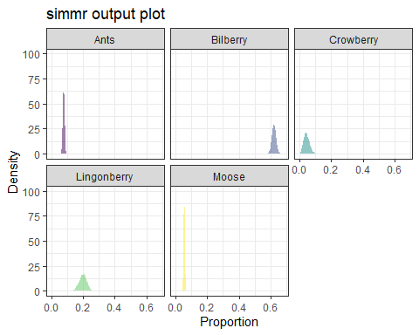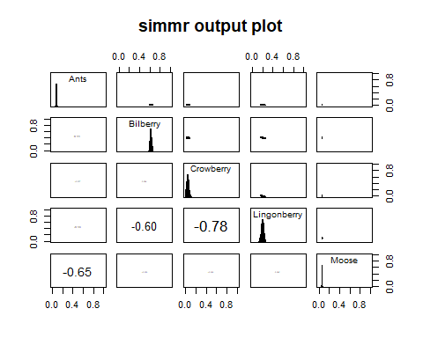

This model also converges and we con compare estimates and uncertainty given these TDFs. While the actual proportion estimates are similar between the two models, the estimates using Hilerbrand TDFs have more variance around than the estimates using the Mikkelsen TDFs. In addition, the negative variances have increased, both between the Nitrogen sources, as well as between the berry species.

##### We now move on to calculating TDFs using the linear equation from Felicetti et al. 2003 and using those TDFs to estimate diet of our brown bears.

Felicetti13C<- function(x,y) {  
 y=-10.86+(0.42*x)  
}  
  
Felicetti15N<- function(x,y) {  
 y=5.28+(0.88*x)  
}  
  
d13C.Felicetti <- Felicetti13C(bears_species_means$mean13C)  
C13TDF.Felicetti <-abs(d13C.Felicetti-bears_species_means$mean13C)  
# Here are the Carbon TDFs from Felicetti's equation for ants, bilberry, crowberry, lingonberry, and moose  
print(C13TDF.Felicetti)

## [1] 4.357668 6.378470 4.807540 4.931080 4.626174

d15N.Felicetti <- Felicetti15N(bears_species_means$mean15N)  
N15TDF.Felicetti <-d15N.Felicetti-bears_species_means$mean15N  
  
# And the TDFs for Nitrogen for ants, bilberry, crowberry, lingonberry, and moose  
N15TDF.Felicetti

## [1] 5.103713 5.591940 5.987940 5.798520 5.091653

Again, the different TDFs have rendered a different mixing space, but out mixtures (consumers) are still within that space

Convergence looks good and we have the model estimate means for each diet source, variance around those estimates and the residual model variance

##   
## Summary for 1   
## Gelman diagnostics - these values should all be close to 1.  
## If not, try a longer run of simmr_mcmc.  
## deviance Ants Bilberry Crowberry Lingonberry Moose   
## 1 1 1 1 1 1   
## sd[d13C] sd[d15N]   
## 1 1

##   
## Summary for 1   
## mean sd  
## deviance 3342.646 3.593  
## Ants 0.054 0.004  
## Bilberry 0.399 0.013  
## Crowberry 0.184 0.017  
## Lingonberry 0.329 0.018  
## Moose 0.034 0.003  
## sd[d13C] 0.028 0.021  
## sd[d15N] 0.039 0.030

##   
## Summary for 1   
## 2.5% 25% 50% 75% 97.5%  
## deviance 3337.671 3340.078 3341.973 3344.505 3351.478  
## Ants 0.046 0.051 0.054 0.057 0.062  
## Bilberry 0.374 0.391 0.399 0.408 0.424  
## Crowberry 0.151 0.173 0.184 0.195 0.217  
## Lingonberry 0.293 0.317 0.329 0.341 0.366  
## Moose 0.029 0.032 0.034 0.036 0.039  
## sd[d13C] 0.001 0.011 0.024 0.040 0.080  
## sd[d15N] 0.001 0.015 0.032 0.055 0.111

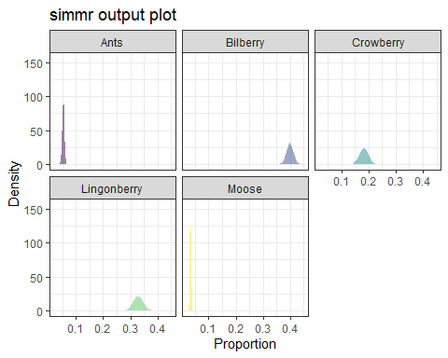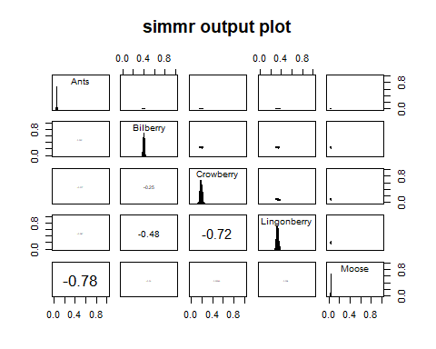

In this case we see some fairly large differences in the estimates of our dietary proportions. While ants and moose are still estimated to make up a small proportion of the diet, bilberry, crowberry, and lingonberry are estimated to make up almost equal proportions of the diet and there is a lot of uncertainty around the estimates. Even so, the negative correlations between moose and ants has greatly inflated, while the correlations between the berry species has decreased relative to the estimates using the Mikkelsen TDFs.

##### The next model uses no TDF corrections as was done in Ro et al. 2021

bear_speciesTDF_means.Ro <- matrix(  
 rep(  
 0,10  
 ),  
 ncol=2,  
 nrow=5  
)  
  
print(bear_speciesTDF_means.Ro)

## [,1] [,2]  
## [1,] 0 0  
## [2,] 0 0  
## [3,] 0 0  
## [4,] 0 0  
## [5,] 0 0

bearsimmr_TDF_Ro = simmr_load(  
 mixtures=bearmix,  
 source_names=bears_species_names,  
 source_means=bears_species_means,  
 source_sds=bears_species_sds,  
 correction_means=bear_speciesTDF_means.Ro,  
 correction_sds=bear_speciesc_sds,  
 concentration_means = bear_species_conc  
 )  
  
plot(bearsimmr_TDF_Ro)

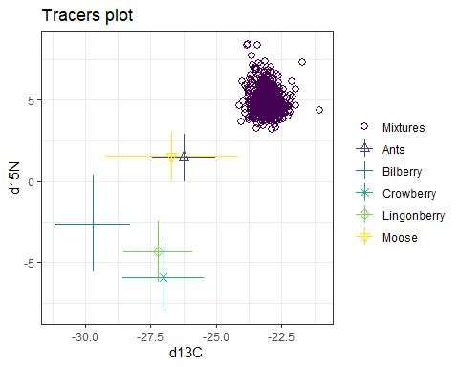

With not corrections for the tropic discrimination, our consumers fall well outside our mixing space. This is a huge red flag that should be addressed prior to running a mixture model, because the model will still run and generate proportion estimates, they will just be really terrible. BUT since this is an exercise in sensitivity to different methods, I am going to run this model anyway. It is important to point out that in Ro et al. 2021, they provide a graph of their consumers and sources, and approximately half of their consumers fall within their mixing space.

The model still converges, but the residual variance is much higher than the other models and the deviance is quite high as well. The estimates of the dietary proportions in this model are very different from the previous three, almost exclusively made of ants.

##   
## Summary for 1   
## Gelman diagnostics - these values should all be close to 1.  
## If not, try a longer run of simmr_mcmc.  
## deviance Ants Bilberry Crowberry Lingonberry Moose   
## 1 1 1 1 1 1   
## sd[d13C] sd[d15N]   
## 1 1

##   
## Summary for 1   
## mean sd  
## deviance 8834.739 4.476  
## Ants 0.982 0.009  
## Bilberry 0.002 0.001  
## Crowberry 0.004 0.003  
## Lingonberry 0.004 0.003  
## Moose 0.008 0.007  
## sd[d13C] 3.023 0.087  
## sd[d15N] 3.138 0.093

##   
## Summary for 1   
## 2.5% 25% 50% 75% 97.5%  
## deviance 8827.587 8831.572 8834.099 8837.384 8845.342  
## Ants 0.959 0.978 0.984 0.989 0.995  
## Bilberry 0.000 0.001 0.002 0.003 0.005  
## Crowberry 0.001 0.002 0.003 0.005 0.012  
## Lingonberry 0.001 0.002 0.003 0.005 0.011  
## Moose 0.001 0.003 0.006 0.010 0.026  
## sd[d13C] 2.860 2.962 3.022 3.080 3.201  
## sd[d15N] 2.958 3.074 3.136 3.199 3.325

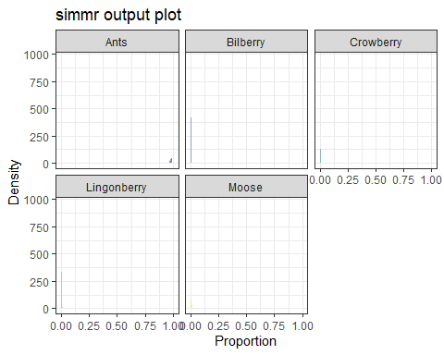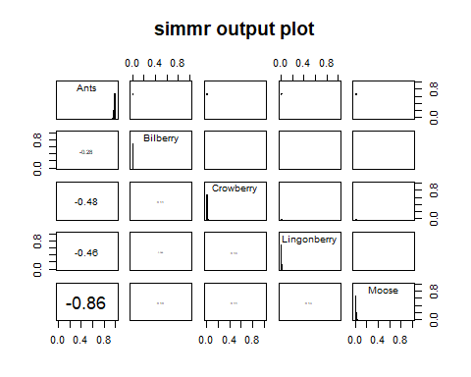

##### The next step is looking at the effects of varying the Mikkelsen TDFs. I begin by reducing the Mikkelsen TDFs by 1 per mil across the board.

## C13TDF.Mikkelsen N15TDF.Mikkelsen  
## [1,] 3.617668 3.873094  
## [2,] 5.638470 4.279950  
## [3,] 4.067540 4.609950  
## [4,] 4.191080 4.452100  
## [5,] 3.886174 3.863044

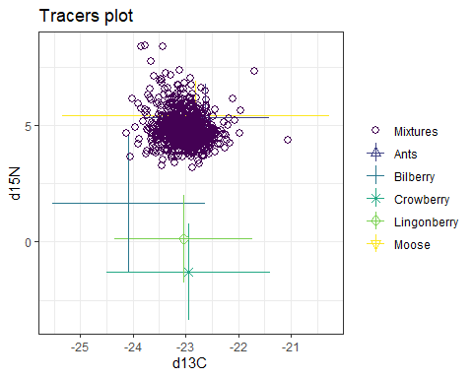

All of our sources have been shifted down and to the left, so I expect that we will have much higher estimates of ants, moose, and bilberry in our estimates

The model converges, and we have dietary proportion estimates that are different from the Mikkelsen DTFs. As predicted, the estimated proportion of ants has increased, as has the estimated proportion of moose, though less drastically. Except for moose, there is a lot of uncerntainty around the dietary source estimates. We also have much smaller negative correlations between the sources, however comparing the deviance and residual variance is also important to consider.

##   
## Summary for 1   
## Gelman diagnostics - these values should all be close to 1.  
## If not, try a longer run of simmr_mcmc.  
## deviance Ants Bilberry Crowberry Lingonberry Moose   
## 1 1 1 1 1 1   
## sd[d13C] sd[d15N]   
## 1 1

##   
## Summary for 1   
## mean sd  
## deviance 2986.586 3.542  
## Ants 0.217 0.011  
## Bilberry 0.192 0.012  
## Crowberry 0.193 0.015  
## Lingonberry 0.301 0.017  
## Moose 0.096 0.006  
## sd[d13C] 0.022 0.016  
## sd[d15N] 0.038 0.029

##   
## Summary for 1   
## 2.5% 25% 50% 75% 97.5%  
## deviance 2981.776 2983.937 2985.933 2988.498 2995.265  
## Ants 0.196 0.210 0.217 0.224 0.240  
## Bilberry 0.167 0.184 0.192 0.201 0.216  
## Crowberry 0.164 0.183 0.193 0.203 0.222  
## Lingonberry 0.268 0.290 0.301 0.312 0.333  
## Moose 0.085 0.092 0.096 0.101 0.108  
## sd[d13C] 0.001 0.009 0.018 0.031 0.061  
## sd[d15N] 0.002 0.015 0.031 0.054 0.108

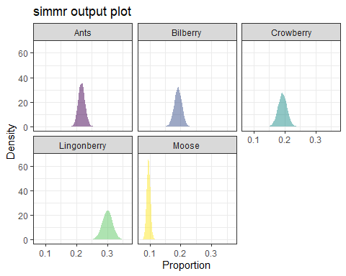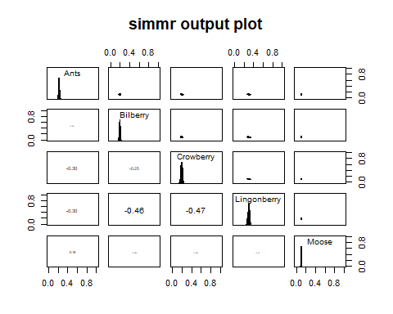

##### After decreasing the Mikkelsen TDFS by 1 per mil, I increase them by 1 per mil.

## C13TDF.Mikkelsen N15TDF.Mikkelsen  
## [1,] 5.617668 5.873094  
## [2,] 7.638470 6.279950  
## [3,] 6.067540 6.609950  
## [4,] 6.191080 6.452100  
## [5,] 5.886174 5.863044

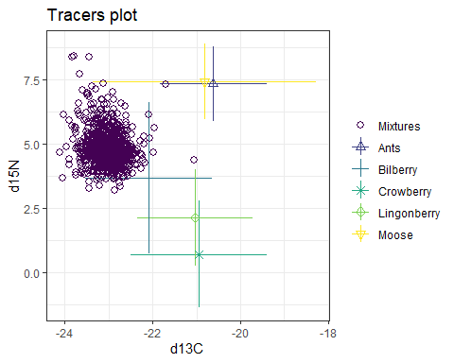

Most of our consumers are onside the mixing space, but several are now outside of the mixing polygon.

All of our sources have been shifted up and to the right, so I expect that we will have much higher estimates of berries, particularly bilberry in or final estimates.

##   
## Summary for 1   
## Gelman diagnostics - these values should all be close to 1.  
## If not, try a longer run of simmr_mcmc.  
## deviance Ants Bilberry Crowberry Lingonberry Moose   
## 1.00 1.00 1.04 1.03 1.04 1.03   
## sd[d13C] sd[d15N]   
## 1.03 1.00

##   
## Summary for 1   
## mean sd  
## deviance 5192.241 3.805  
## Ants 0.029 0.004  
## Bilberry 0.689 0.177  
## Crowberry 0.026 0.031  
## Lingonberry 0.231 0.160  
## Moose 0.025 0.004  
## sd[d13C] 0.604 0.559  
## sd[d15N] 0.047 0.036

##   
## Summary for 1   
## 2.5% 25% 50% 75% 97.5%  
## deviance 5186.485 5189.473 5191.690 5194.430 5201.163  
## Ants 0.021 0.027 0.029 0.032 0.038  
## Bilberry 0.413 0.492 0.816 0.839 0.864  
## Crowberry 0.003 0.008 0.014 0.031 0.119  
## Lingonberry 0.065 0.095 0.119 0.411 0.473  
## Moose 0.018 0.022 0.024 0.028 0.032  
## sd[d13C] 0.008 0.096 0.267 1.234 1.407  
## sd[d15N] 0.002 0.018 0.040 0.066 0.133

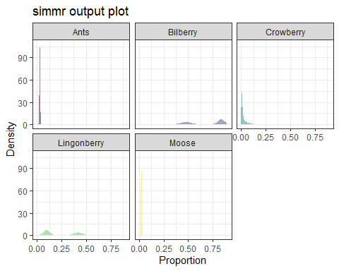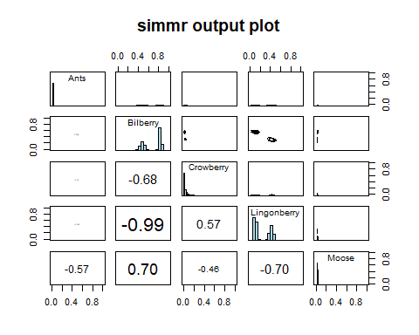

# Summary

SummaryData <- read_excel("DietEstimates.xlsx")  
  
  
ggplot(data = SummaryData, aes(Dsource,DietProp))+  
 geom_line(aes(group=Model,lty=Model, color=Model),lwd=1)+  
 geom_point(size=7,alpha=0.8, aes(color=Model))+  
 scale_color_viridis(discrete = TRUE, end=0.95)+  
 theme(axis.text = element_text(size=20),  
 axis.title = element_text(size=20,face = "bold"),  
 panel.background = element_rect(fill = "grey97"),  
 legend.text = element_text(size=20),  
 legend.title = element_text(size=20,face="bold"))+  
 scale_x_continuous(labels = c("Ants","Bilberries","Crowberries","Lingonberries","Moose"))+  
 xlab("Diet source")+  
 ylab("Estimated dietary proportion")

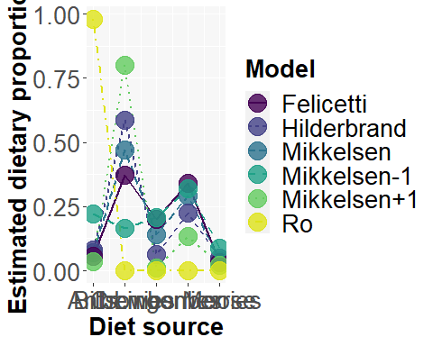

ggplot(data = SummaryData, aes(Model,DietProp))+  
 geom_col(aes(group=Source, fill=Source))+  
 scale_fill_viridis(discrete = TRUE)+  
 theme(axis.text = element_text(size=20),  
 axis.title = element_text(size=20,face = "bold"),  
 panel.background = element_rect(fill = "grey97"),  
 legend.text = element_text(size=20),  
 legend.title = element_text(size=20,face="bold"))+  
 ylab("Estimated diet proportion")

