Sensitivity to Trophic Discrimination Factors

Ashlee Mikkelsen

2022-03-23

Since I concluded from my previous analysis not to group sources (pending comments from collaborators), I went forward with looking at the sensitivity of my diet estimates to different tropic discrimination factors, hereafter abbreviated as TDF. Here I generated several models with different discrimination factors to estimate how this effects my diet estimates. I will compare 6 models, all with uninformative priors. The first model will have the specific TDFs that I derived from the linear equations of Hilderbrand et al. (1996), Felicetti et al. (2003) and Rode et al. (2016). I also included a model with TDFs calculated using the linear equations from Hilderbrande et al. (1996) and Felicetti et al. (2003). I also ran models with TDFs that are both lower and higher than mine by 1 per mil. Finally, I also include a model with no TDF corrections, as done in Ro et al. 2021. For each group of TDFs, I include the same variance around the TDFs of standard deviations of 1 per mil.

### Model list:

Model 1: My derived TDF (hereafter referred to as Mikkelsen)

Model 2: TDF calculated from Hilderbrand et al 1996

Model 3: TDF calculated from Felicetti et al. 2003

Model 4: My TDFs -1 per mil

Model 5: My TDFs +1 per mil

Model 6: No TDF as in Ro et al. 2021

# Summary

Brown bear diet estimates are sensitive to changes in the trophic discrimination factor. Changing the TDF by only 1‰ changed the estimated proportion of a given source by 11–216% depending on the source and the direction of the change (increasing or decreasing the TDF; Table 1). The greatest changes were seen in proteins sources when the TDFs were decreased by one, which resulted in an increased proportion of ants from 0.07 to 0.22 and moose from 0.04 to 0.09. Disregarding the Ro Model with no TDFs, bilberries had the most variation across the models and moose had the least variability (Figure 1).

Small changes in the linear regression used to predict the stable isotope signatures resulted in changes in the TDFs, which resulted in large differences in the estimated proportions of bear diets. For example, the linear equations to estimate δ13C from Hilderbrand et al. (1996) and Felicetti et al. (2003) are miraculously similar— their intercepts differ by 0.52 while both beta estimates are 0.42 (Table 1). This difference resulted in TDFs from Hilerbrand et al. (1996) being 0.52‰ higher than those derived from Felicetti et al. (2003) and the resulting proportional dietary estimates that varied by 0.02–0.22, depending on the food source. Ants and moose changed very little, but bilberries accounted for either 0.59 (Hilderbrand) of brown bear diets or 0.47 (Felicetti) of brown bear diets. Both model estimates had high precision (0.35 – 0.40 and 0.56 – 0.61, respectively).

Figure 1. Estimated Dietary proportions of each diet source with different colors and lines representing each model. Error bars are not included because estimated variance is smaller than the circles used.

Table 1. Model output summary used to calculate trophic discrimination factors and dietary estimates of brown bears in Sweden



### Unless you are interested in double-checking my R code and output or you want to see the mixing space plots and correlation plots, stop reading here.

### TDF calculation and model procedures

First, I use the TDFs that I derived from 3 published bear feeding experiments. Below are the two linear regression models that I derived following recommendations by Philips et al. 2014 using the feeding experiment Hilderbrand et al. 1996, Felicetti et al. 2003, and Rode et al. 2016.

Mikkelsen13C <- function(x,y){  
 y=-10.6+(0.42*x)  
}  
  
Mikkelsen15N <- function(x,y){  
 y=5.02+(0.90*x)  
}  
  
# I use these linear equations to predict the isotopic signature of a brown bear eating 100% of a diet source (y) given the mean isotopic signature of that source (x)  
  
d13C.Mikkelsen <- Mikkelsen13C(bears_species_means$mean13C)  
print(d13C.Mikkelsen)

## [1] -21.61969 -23.08303 -21.94546 -22.03492 -21.92740

# The actual TDF is the difference between our predicted isotopic signature for a bear eating 100% of that source and the mean isotopic signature for that source  
C13TDF.Mikkelsen <-abs(d13C.Mikkelsen-bears_species_means$mean13C)  
  
# Here are the TDFs for Carbon for ants, bilberries, crowberries, lingonberries, and moose  
print(C13TDF.Mikkelsen)

## [1] 4.617668 6.638470 5.067540 5.191080 5.042600

# Now we repeat the process for Nitrogen  
  
d15N.Mikkelsen <- Mikkelsen15N(bears_species_means$mean15N)  
print(d15N.Mikkelsen)

## [1] 6.3421509 2.6810783 -0.2897428 1.1312665 6.6436818

N15TDF.Mikkelsen <-d15N.Mikkelsen-bears_species_means$mean15N  
  
# And here we have the TDFs for Nitrogen for ants, bilberries, crowberry, lingonberry, and moose  
print(N15TDF.Mikkelsen)

## [1] 4.873094 5.279880 5.609971 5.452081 4.839591

Prior to running our model, I performed a check that my consumers fall within the mixing space

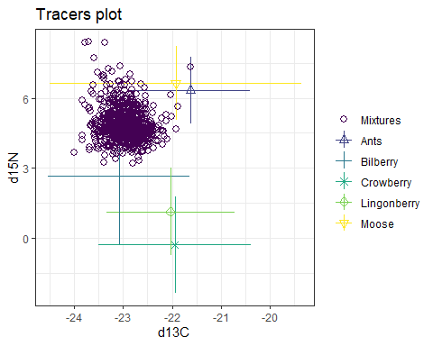

Next we run the model and examine output

##   
## Summary for 1   
## Gelman diagnostics - these values should all be close to 1.  
## deviance Ants Bilberry Crowberry Lingonberry Moose   
## 1 1 1 1 1 1   
## sd[d13C] sd[d15N]   
## 1 1  
## Summary   
## mean sd  
## deviance 3409.785 3.498  
## Ants 0.066 0.005  
## Bilberry 0.473 0.013  
## Crowberry 0.136 0.018  
## Lingonberry 0.287 0.021  
## Moose 0.038 0.003  
## sd[d13C] 0.032 0.024  
## sd[d15N] 0.039 0.030

## Summary  
## 2.5% 25% 50% 75% 97.5%  
## deviance 3405.018 3407.218 3409.089 3411.580 3418.393  
## Ants 0.057 0.063 0.066 0.069 0.076  
## Bilberry 0.448 0.465 0.473 0.482 0.499  
## Crowberry 0.099 0.123 0.136 0.148 0.172  
## Lingonberry 0.247 0.274 0.287 0.301 0.328  
## Moose 0.032 0.036 0.038 0.040 0.043  
## sd[d13C] 0.001 0.013 0.027 0.046 0.090  
## sd[d15N] 0.001 0.015 0.033 0.056 0.110

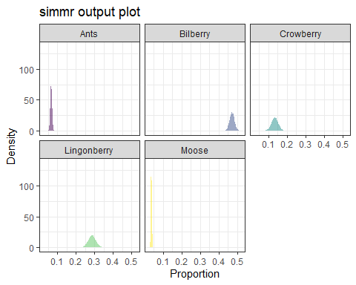

The output from this model is the same as the output from determining whether to group diet sources, because so far the model specifications are identical

We see from the Gelman diagnostics that the model has converged and we can look at the dieatary proportion estimates and the uncertainty around those estimates. And then see the estimates and uncertainty graphically.

##### Now I use the same methods and workflow as above to calculate TDFs derived from the linear equation in Hilerbrand et al. 1996 and estimate dietary estimates for the same source and mixture data.

Hilderbrand13C<- function(x,y) {  
 y=-10.34+(0.42*x)  
}  
  
Hilderbrand15N<- function(x,y) {  
 y=4.76+(0.91*x)  
}  
  
d13C.Hilderbrand <- Hilderbrand13C(bears_species_means$mean13C)  
print(d13C.Hilderbrand)

## [1] -21.35969 -22.82303 -21.68546 -21.77492 -21.66740

C13TDF.Hilderbrand <-abs(d13C.Hilderbrand-bears_species_means$mean13C)

#Here are our Carbon TDFs for ants, bilberries, crowberries, lingonberries, and moose  
## [1] 4.877668 6.898470 5.327540 5.451080 5.302600

d15N.Hilderbrand <- Hilderbrand15N(bears_species_means$mean15N)  
N15TDF.Hilderbrand <-d15N.Hilderbrand-bears_species_means$mean15N  
  
#Here are the calculated Nitrogen TDFs for ants, bilberry crowberry, lingonberry, and moose  
## [1] 4.627785 4.993892 5.290974 5.148873 4.597632

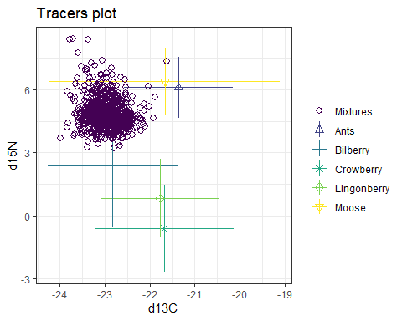

Our mixtures (consumers) still fall within the mixing polygon.

##   
## Summary for 1   
## Gelman diagnostics - these values should all be close to 1.  
## deviance Ants Bilberry Crowberry Lingonberry Moose   
## 1 1 1 1 1 1

Summary   
## mean sd  
## deviance 3703.140 3.423  
## Ants 0.080 0.006  
## Bilberry 0.587 0.013  
## Crowberry 0.063 0.020  
## Lingonberry 0.223 0.024  
## Moose 0.048 0.003  
## sd[d13C] 0.039 0.029  
## sd[d15N] 0.039 0.030

##   
## Summary for 1   
## 2.5% 25% 50% 75% 97.5%  
## deviance 3698.433 3700.641 3702.500 3704.967 3711.377  
## Ants 0.069 0.076 0.080 0.083 0.091  
## Bilberry 0.561 0.578 0.587 0.596 0.614  
## Crowberry 0.025 0.048 0.062 0.077 0.104  
## Lingonberry 0.175 0.207 0.223 0.239 0.270  
## Moose 0.042 0.046 0.048 0.050 0.055

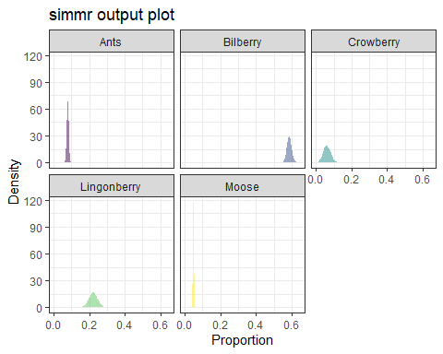

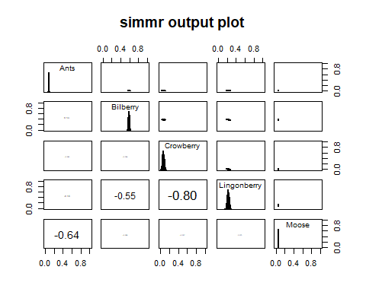

This model also converges and we con compare estimates and uncertainty given these TDFs. While the actual proportion estimates are similar between the two models, the estimates using Hilerbrand TDFs have more variance around than the estimates using the Mikkelsen TDFs. In addition, the negative variances have increased, both between the Nitrogen sources, as well as between the berry species.

##### We now move on to calculating TDFs using the linear equation from Felicetti et al. 2003 and using those TDFs to estimate diet of our brown bears.

Felicetti13C<- function(x,y) {  
 y=-10.86+(0.42*x)  
}  
  
Felicetti15N<- function(x,y) {  
 y=5.28+(0.88*x)  
}  
  
# Here are the Carbon TDFs from Felicetti's equation for ants, bilberry, crowberry, lingonberry, and moose

## [1] 4.357668 6.378470 4.807540 4.931080 4.782600

# And the TDFs for Nitrogen for ants, bilberry, crowberry, lingonberry, and moose  
N15TDF.Felicetti

## [1] 5.103713 5.591856 5.987966 5.798498 5.063509

Again, the different TDFs have rendered a different mixing space, but out mixtures (consumers) are still within that space

Convergence looks good and we have the model estimate means for each diet source, variance around those estimates and the residual model variance

## Summary for 1   
## mean sd  
## deviance 3159.352 3.520  
## Ants 0.057 0.004  
## Bilberry 0.372 0.013  
## Crowberry 0.200 0.016  
## Lingonberry 0.342 0.017  
## Moose 0.030 0.002  
## sd[d13C] 0.027 0.020  
## sd[d15N] 0.038 0.029

##   
## Summary for 1   
## 2.5% 25% 50% 75% 97.5%  
## deviance 3154.569 3156.797 3158.672 3161.161 3167.721  
## Ants 0.049 0.054 0.057 0.059 0.065  
## Bilberry 0.347 0.363 0.372 0.381 0.398  
## Crowberry 0.169 0.189 0.200 0.210 0.232  
## Lingonberry 0.308 0.330 0.342 0.354 0.377  
## Moose 0.025 0.028 0.029 0.031 0.034  
## sd[d13C] 0.001 0.011 0.023 0.039 0.075  
## sd[d15N] 0.001 0.015 0.033 0.056 0.109

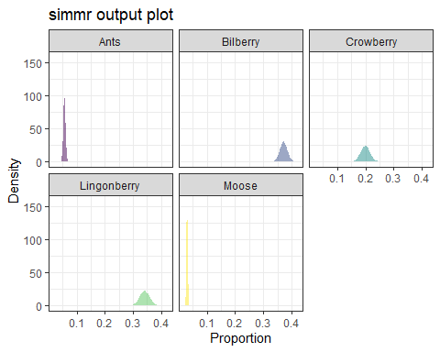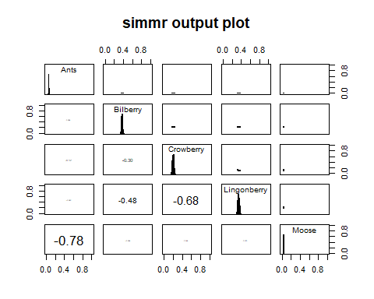

##### The next model uses no TDF corrections as was done in Ro et al. 2021

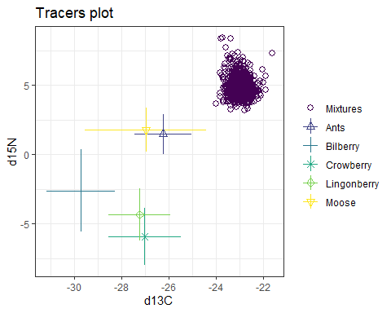

With not corrections for the tropic discrimination, our consumers fall well outside our mixing space. This is a huge red flag that should be addressed prior to running a mixture model, because the model will still run and generate proportion estimates, they will just be really terrible. BUT since this is an exercise in sensitivity to different methods, I am going to run this model anyway. It is important to point out that in Ro et al. 2021, they provide a graph of their consumers and sources, and approximately half of their consumers fall within their mixing space.

The model still converges, but the residual variance is much higher than the other models and the deviance is quite high as well. The estimates of the dietary proportions in this model are very different from the previous three, almost exclusively made of ants.

##   
## Summary for 1   
## Gelman diagnostics - these values should all be close to 1.  
## deviance Ants Bilberry Crowberry Lingonberry Moose   
## 1 1 1 1 1 1   
## sd[d13C] sd[d15N]   
## 1 1

##   
## Summary for 1   
## mean sd  
## deviance 8558.511 4.602  
## Ants 0.980 0.011  
## Bilberry 0.002 0.001  
## Crowberry 0.004 0.003  
## Lingonberry 0.004 0.003  
## Moose 0.009 0.009  
## sd[d13C] 3.103 0.092  
## sd[d15N] 3.141 0.093

##   
## Summary for 1   
## 2.5% 25% 50% 75% 97.5%  
## deviance 8551.523 8555.168 8557.854 8561.240 8569.202  
## Ants 0.952 0.975 0.983 0.988 0.994  
## Bilberry 0.000 0.001 0.002 0.003 0.006  
## Crowberry 0.001 0.002 0.004 0.006 0.013  
## Lingonberry 0.001 0.002 0.003 0.005 0.012  
## Moose 0.001 0.004 0.007 0.012 0.033  
## sd[d13C] 2.929 3.040 3.100 3.164 3.290  
## sd[d15N] 2.962 3.076 3.142 3.204 3.326

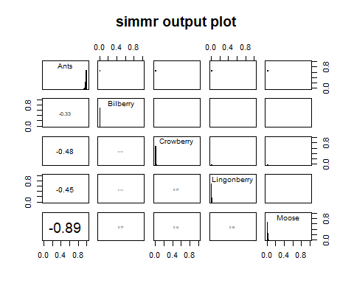

This model is obviously flawed.

##### The next step is looking at the effects of varying the Mikkelsen TDFs. I begin by reducing the Mikkelsen TDFs by 1 per mil across the board.

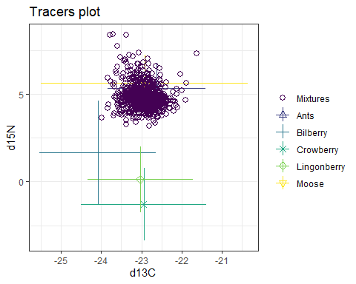

All of our sources have been shifted down and to the left, so I expect that we will have much higher estimates of ants, moose, and bilberry in our estimates

The model converges, and we have dietary proportion estimates that are different from the Mikkelsen DTFs. As predicted, the estimated proportion of ants has increased, as has the estimated proportion of moose, though less drastically. Except for moose, there is a lot of uncerntainty around the dietary source estimates. We also have much smaller negative correlations between the sources, however comparing the deviance and residual variance is also important to consider.

## Summary   
## mean sd  
## deviance 2919.451 3.557  
## Ants 0.221 0.012  
## Bilberry 0.166 0.013  
## Crowberry 0.206 0.015  
## Lingonberry 0.321 0.017  
## Moose 0.086 0.006  
## sd[d13C] 0.022 0.017  
## sd[d15N] 0.040 0.030

##   
## Summary   
## 2.5% 25% 50% 75% 97.5%  
## deviance 2914.536 2916.803 2918.765 2921.378 2928.289  
## Ants 0.198 0.213 0.221 0.229 0.245  
## Bilberry 0.141 0.158 0.167 0.175 0.191  
## Crowberry 0.176 0.196 0.206 0.216 0.236  
## Lingonberry 0.288 0.309 0.321 0.332 0.354  
## Moose 0.075 0.082 0.086 0.090 0.097  
## sd[d13C] 0.001 0.008 0.018 0.032 0.061  
## sd[d15N] 0.002 0.016 0.034 0.056 0.111

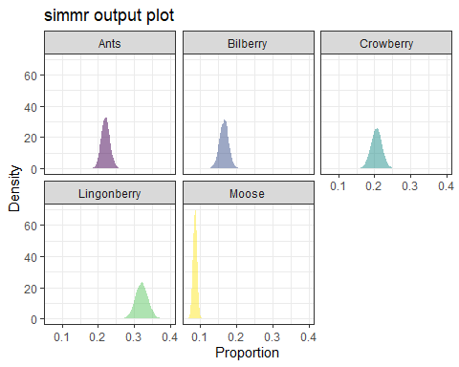

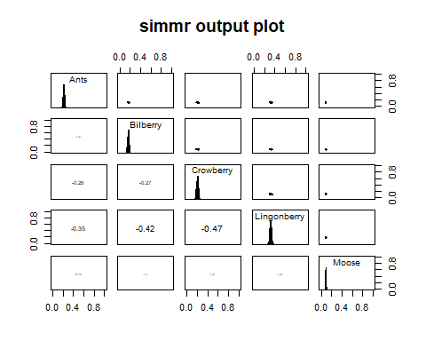

##### After decreasing the Mikkelsen TDFS by 1 per mil, I increase them by 1 per mil.

## C13TDF.Mikkelsen N15TDF.Mikkelsen  
## [1,] 5.617668 5.873094  
## [2,] 7.638470 6.279880  
## [3,] 6.067540 6.609971  
## [4,] 6.191080 6.452081  
## [5,] 6.042600 5.839591

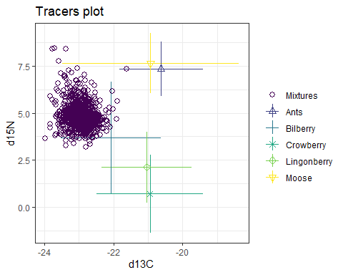

Most of our consumers are onside the mixing space, but several are now outside of the mixing polygon.

All of our sources have been shifted up and to the right, so I expect that we will have much higher estimates of berries, particularly bilberry in or final estimates.

## Summary  
## mean sd  
## deviance 4926.098 3.967  
## Ants 0.034 0.005  
## Bilberry 0.801 0.020  
## Crowberry 0.011 0.007  
## Lingonberry 0.132 0.022  
## Moose 0.021 0.003  
## sd[d13C] 0.131 0.107  
## sd[d15N] 0.050 0.038

##   
## Summary for 1   
## 2.5% 25% 50% 75% 97.5%  
## deviance 4920.197 4923.275 4925.481 4928.232 4935.592  
## Ants 0.025 0.031 0.034 0.037 0.043  
## Bilberry 0.764 0.791 0.802 0.814 0.835  
## Crowberry 0.002 0.006 0.010 0.014 0.028  
## Lingonberry 0.093 0.119 0.131 0.145 0.174  
## Moose 0.016 0.019 0.021 0.023 0.027  
## sd[d13C] 0.006 0.052 0.107 0.185 0.391  
## sd[d15N] 0.002 0.020 0.043 0.071 0.140

