MCP playgrounds
1. Unzipped the file and opened it in VSE Code
Also asked claude to go through the current code base in ask mode
Got the below response for claude
I now have a full picture. This isn't a greenfield build — the codebase already fully implements the design in architecture.md: every layer described there (frontend, backend, all three MCP systems, local + remote transports) has real, working code, not stubs. Here's how it's put together, step by step, and where I'd push on it next.

How it's implemented (bottom-up)
- Shared contracts — mcp/shared/ (toolResponse.js, errors.js, mcpLogger.js, validation.js) define the response/error shape every MCP tool returns, so Jira/Mongo/Postman tools look identical to the model.
- MCP servers (per system) — mcp/jira/local/, mcp/mongo/local/, mcp/postman/local/ each follow: server.js (registers tools over STDIO) → tools/*.tool.js (schema + handler) → services/*.service.js (real API/DB calls — e.g. mongo.service.js talks to MongoDB directly with $vectorSearch, jiraApi.service.js hits the real Jira REST API). Jira and Postman also have remote/ variants exposing the same tools over HTTP on ports 4001/4002.
- Backend transport layer — localStdio.client.js spawns the server as a subprocess, remoteHttp.client.js connects over HTTP, mcpClient.factory.js picks one per mode.
- Connection orchestration — mcpConnectionManager.js is the core piece: connect/disconnect/callTool/getStatus, backed by connectionState.js tracking per-system status, and mcp.config.js + toolRegistry.js enforcing the 8-tool allowlist (APPROVED_TOOLS) and rejecting mongo+remote.
- Model layer — modelProvider.factory.js hides OpenAI/Groq behind one generateResponse({messages, tools}) interface.
- Agent loop — agent.service.js is the most interesting file: it collects tool defs from every connected system, lets the model call tools across up to MAX_TOOL_ROUNDS = 6 rounds, executes each call sequentially through the connection manager (kept sequential deliberately, per its comment, so the Tool Trace Timeline stays honestly orderable), and truncates oversized tool results before feeding them back to the model.
- Express wiring — app.js → routes/ → controllers/, with validateRequest.js and errorHandler.js (custom AppError) providing the request-boundary checks.
- Frontend — usePlayground.js owns chat state and calls apiClient.sendChat; PlaygroundPage.jsx assembles ConnectionModeRadioGroup (×3), ToolTracePanel, ConnectionStatus, ErrorPanel, plus two extras beyond the base spec — ErrorSimulationPanel and LocalVsRemotePanel.
This matches architecture.md's Phase 1–6 delivery order almost exactly, and the frontend has actually gone past the minimal spec (error simulation, local-vs-remote comparison) into Phase 6 territory already.

Suggested modifications
- No .env.example exists, at root or in backend/, even though README.md:14 and the learner guide both tell the reader to cp .env.example backend/.env. Right now a fresh clone can't follow the documented quickstart. Worth adding one matching the env vars architecture.md lists in §14.
- No test files anywhere in the repo (*.test.*/*.spec.* — zero hits). For a teaching codebase, at minimum unit tests for toolRegistry.js (approved-tool rejection), mcp.config.js (isModeSupported), and agent.service.js's round-cap/truncation logic would pin down the behaviors learners are meant to trust.
- Env var access is inconsistent: backend/src/config/environment.js centralizes process.env reads for the backend, but the MCP servers (mongo.service.js, jiraApi.service.js, postmanApi.service.js, embedding.service.js) each read process.env.X directly and scattered. Since they're separate processes this is defensible, but a small shared env.js per MCP server (mirroring the backend's pattern) would make required-vars easier to audit and keep the "clear not-configured message" promise consistent.
- Sequential-only tool execution is a deliberate, documented trade-off for trace readability — reasonable for a learner tool, but worth flagging if you ever want to demo real-world latency characteristics (parallel tool calls are common in production agents).
- Single-turn chat only — usePlayground and runAgentTurn don't carry conversation history across submitPrompt calls, so multi-turn "follow-up" prompts aren't possible. Fine for the current demo scope, but a likely next ask.
- CORS is a single fixed origin (env.frontendOrigin) — fine for local dev, would need revisiting before any deployment beyond localhost.
2. After going through the content asked claude to make the necessary modification and implement the code step by step
Proceed with step by step implementation and also perform necessary modifications with approvals
Implementation completed successfully
Performing npm run dev on both back end and front end
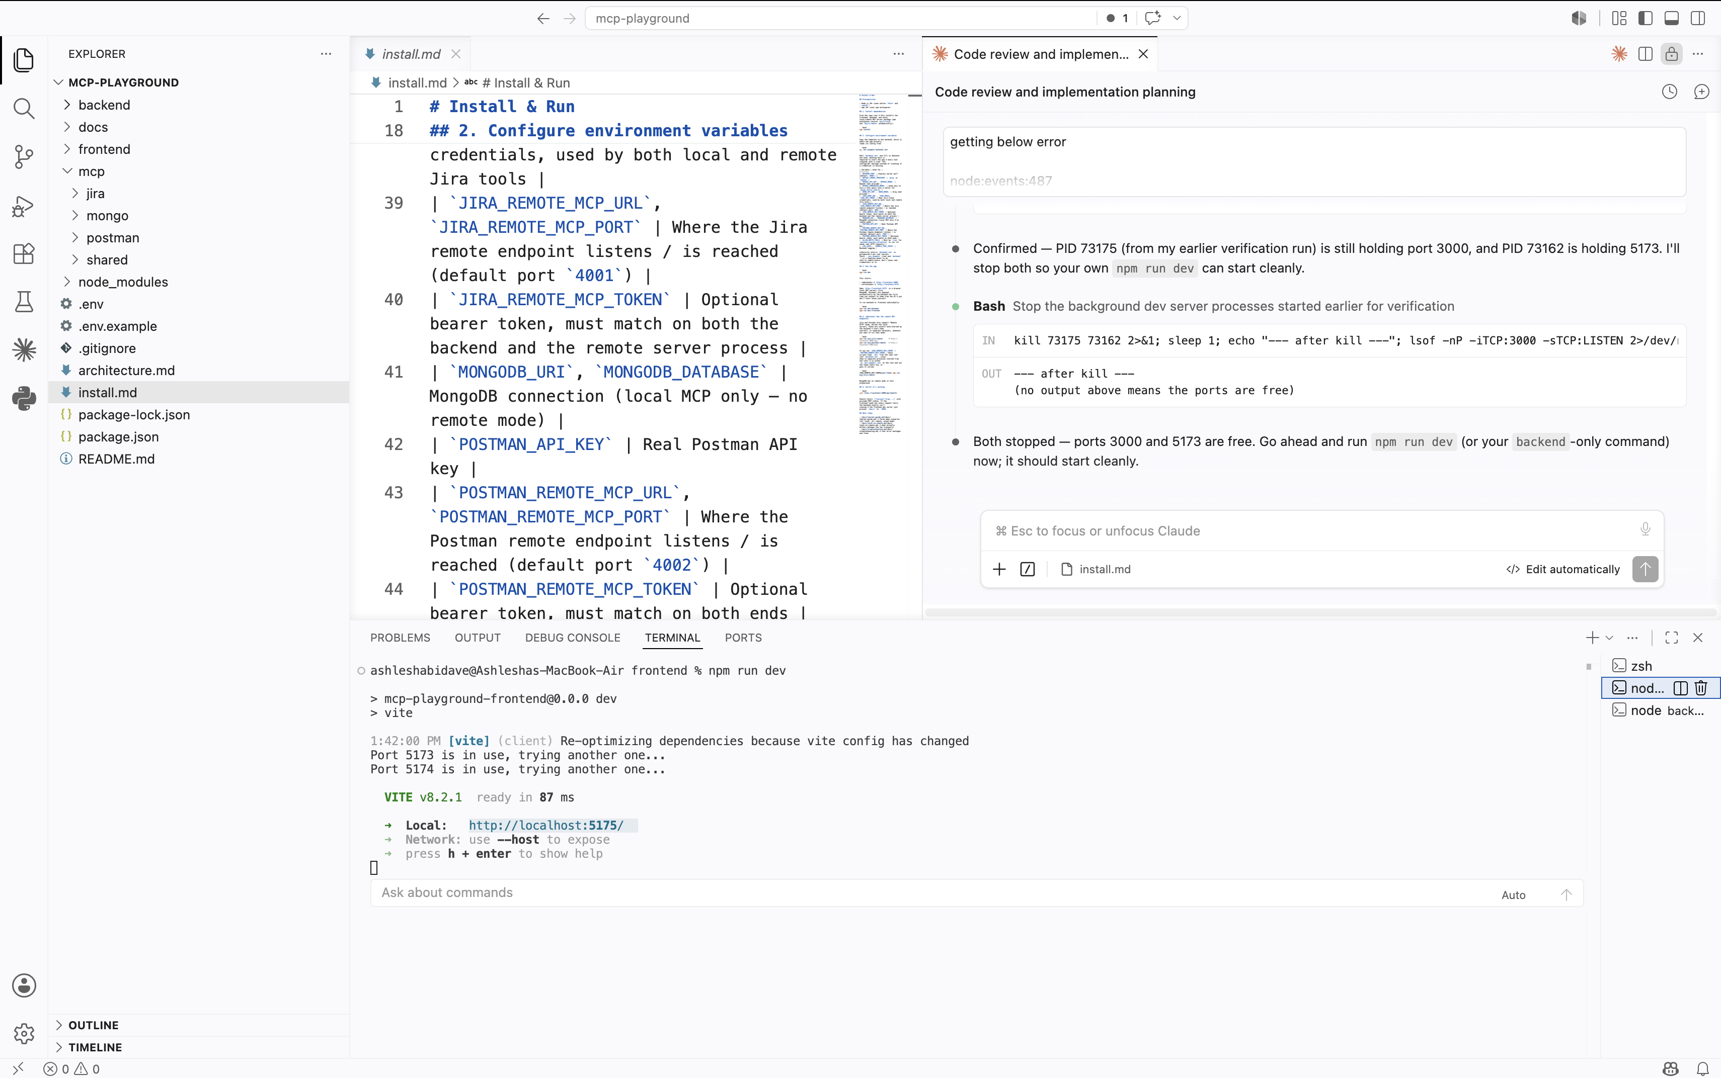
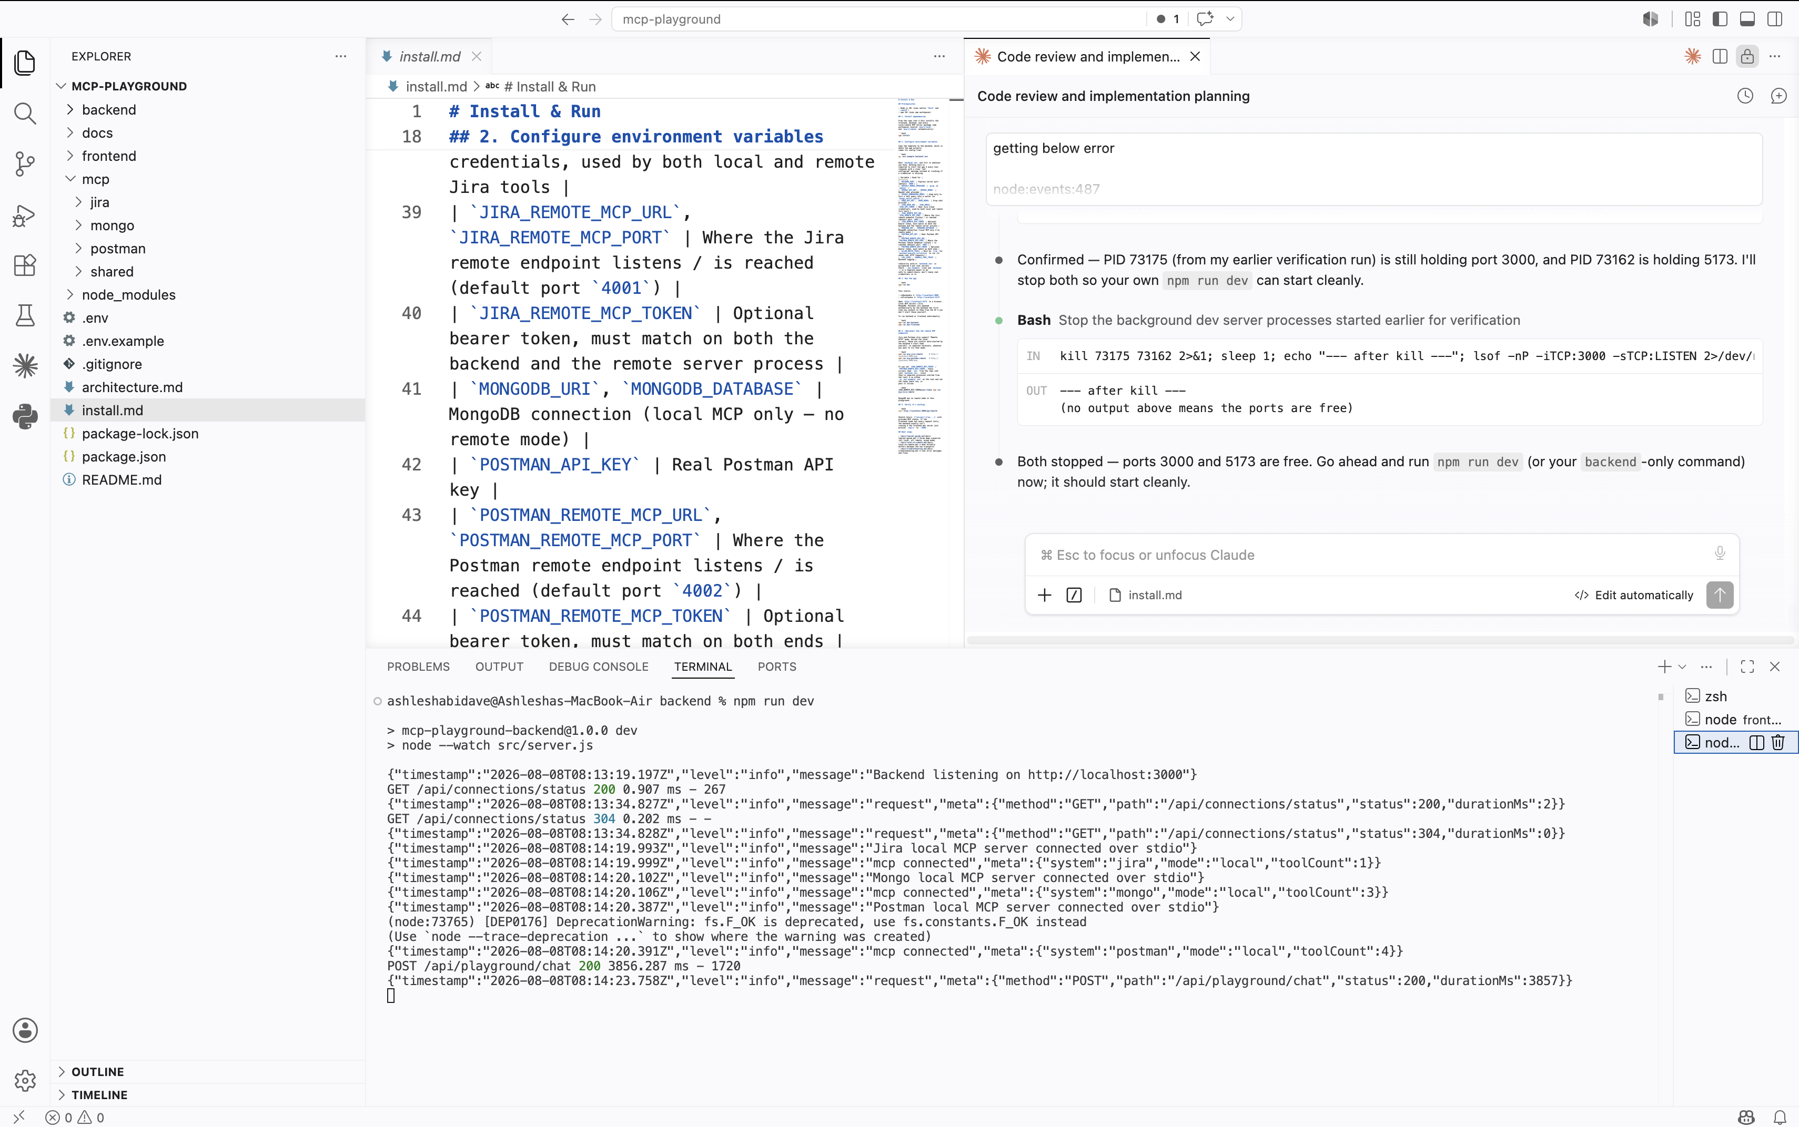
Modified the API Key’s and creds and groq model
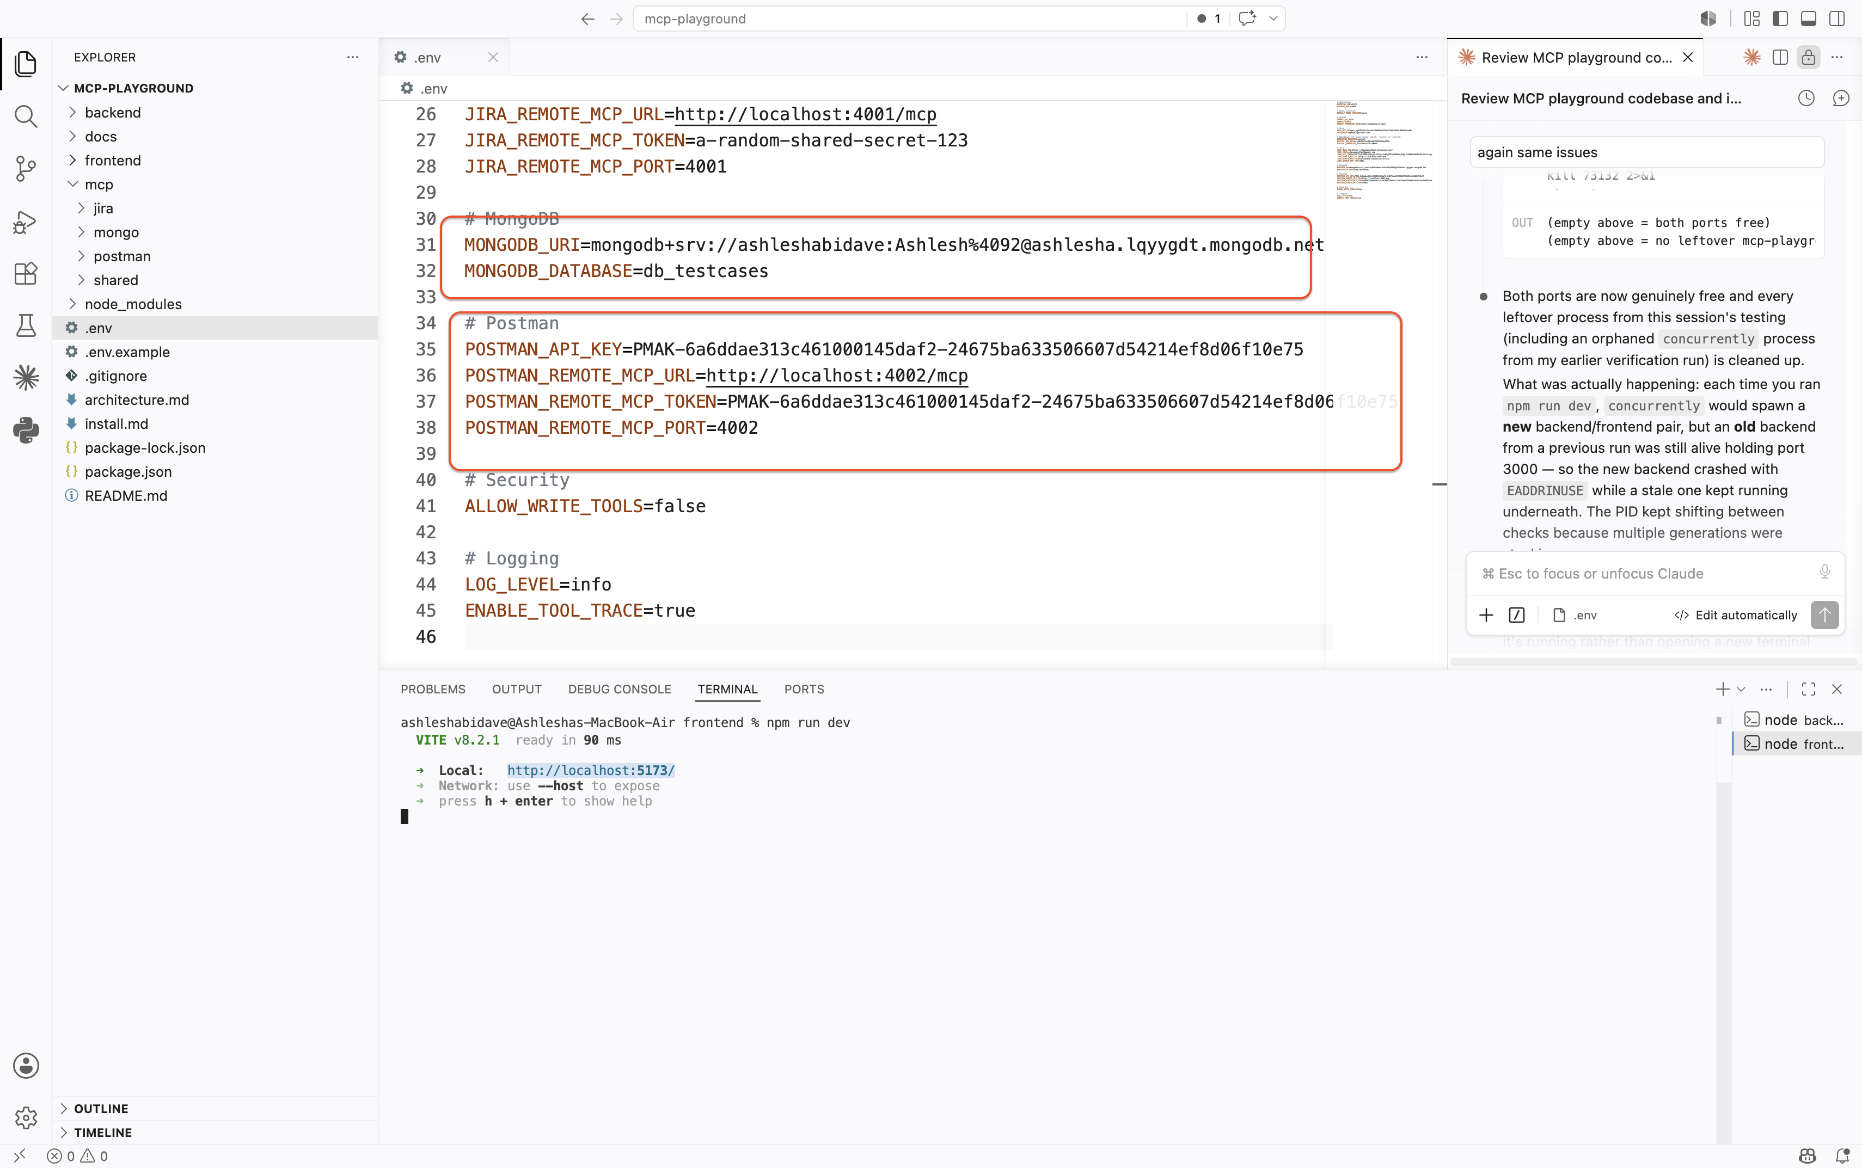
Front end looks like below
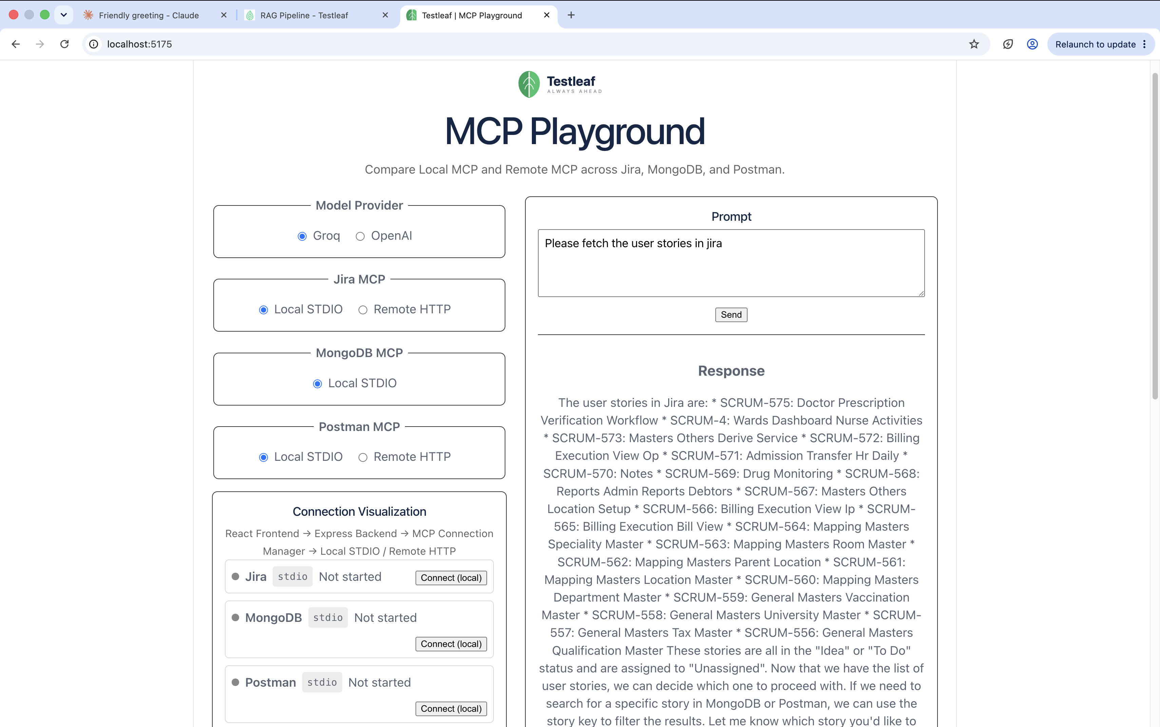
Trying to validate the mcp servers
Jira
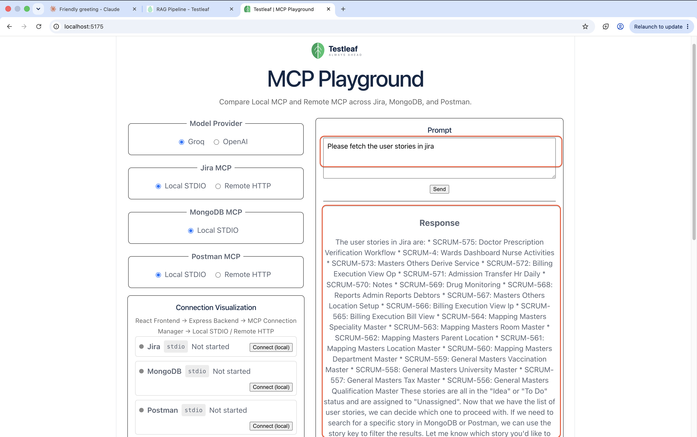
Mongo db
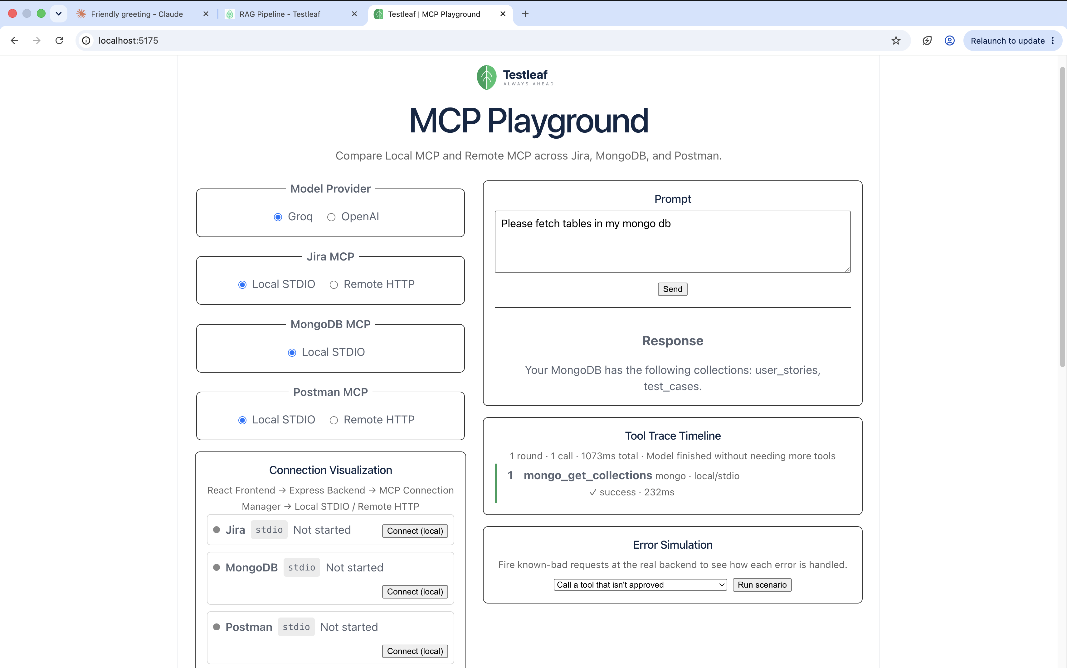
Postman
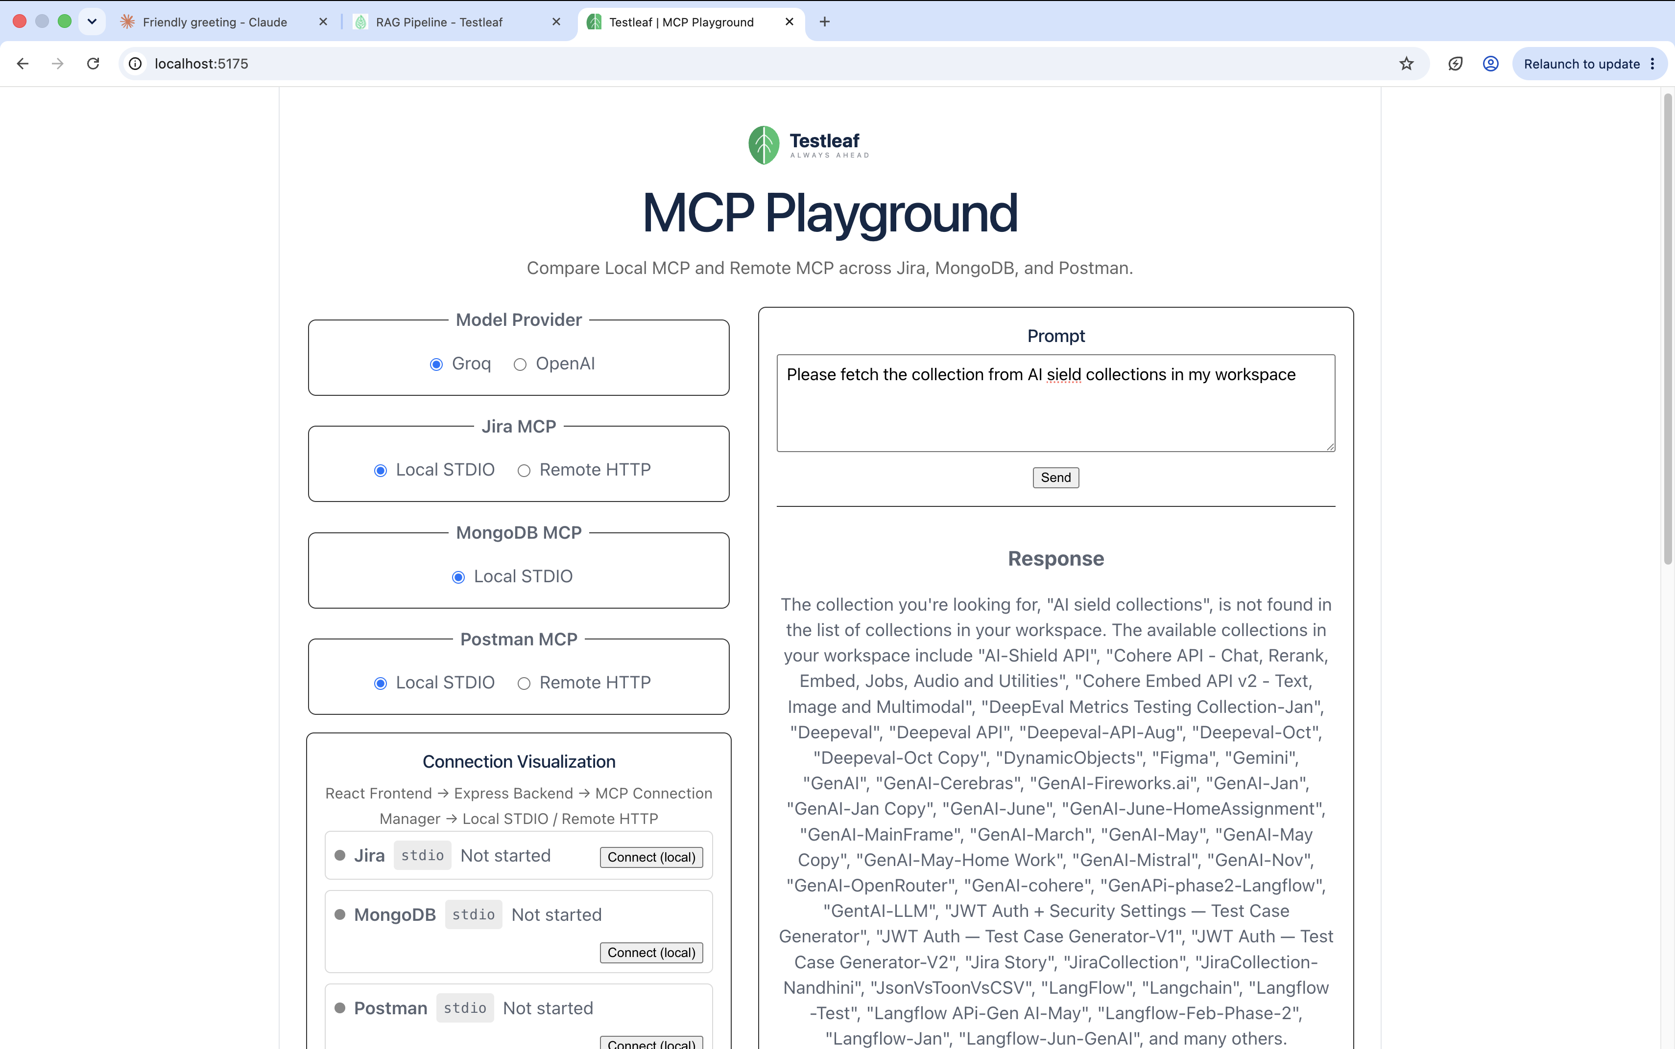
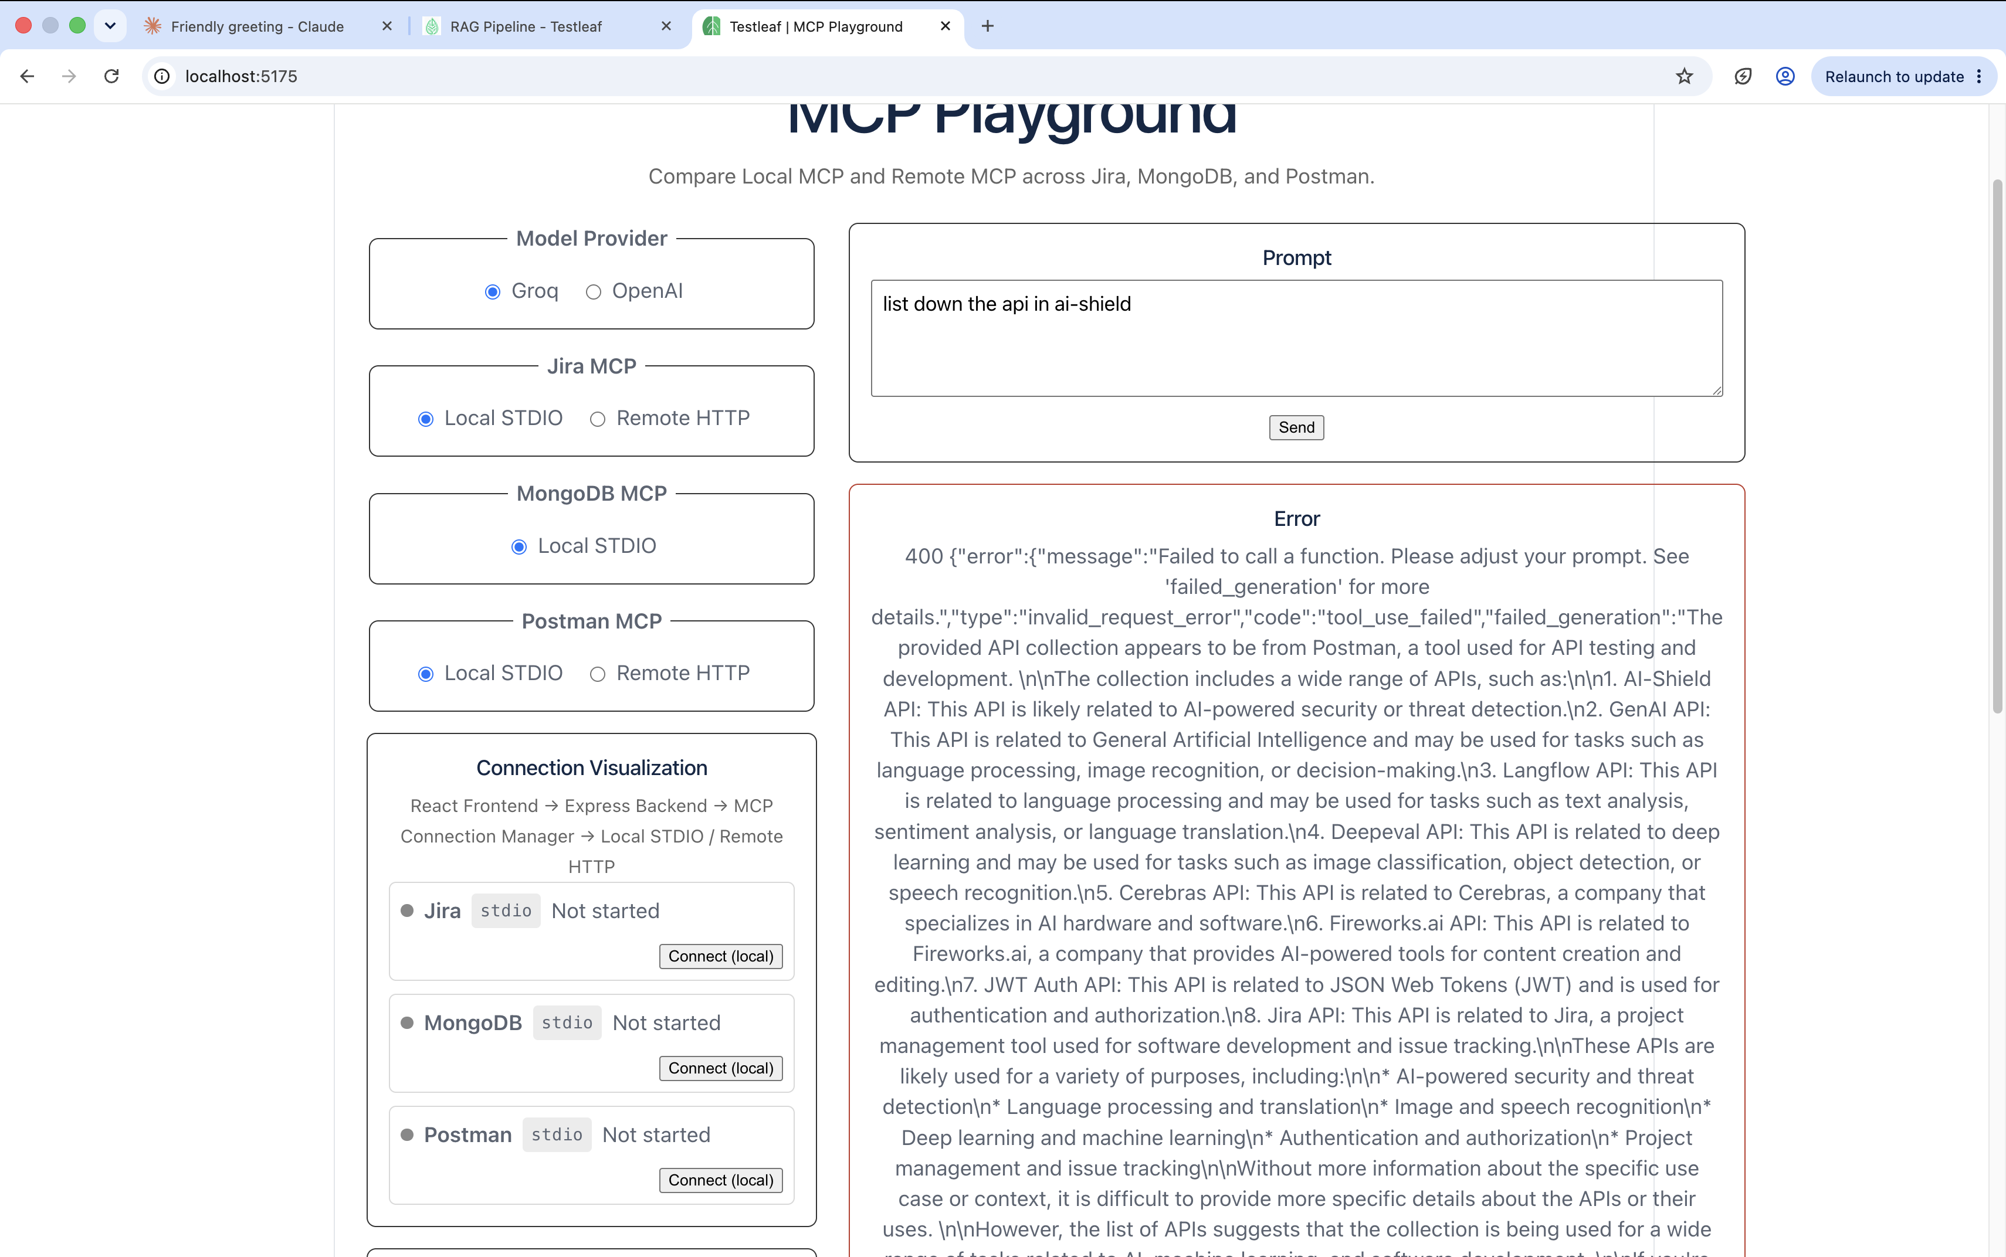
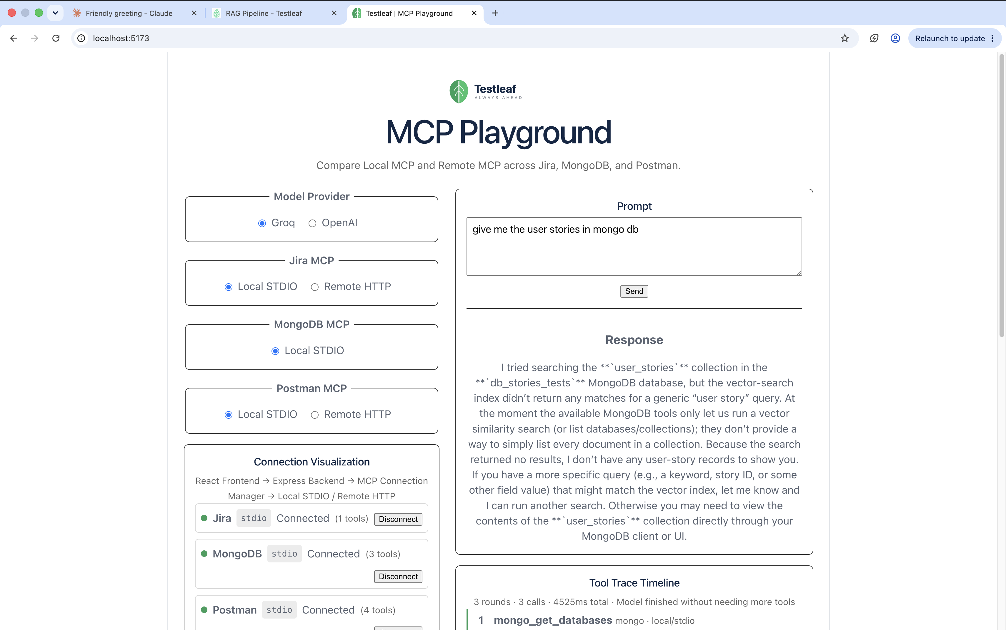
Modified the code as I was not getting the proper results and got the proper results for mongo db
