Week_10_Day_02
1. I have created my architecture.md file
2. I have created a folder and moved the .md file into it
3. Using the prompt given I have asked claude to implement the architecture in vse code
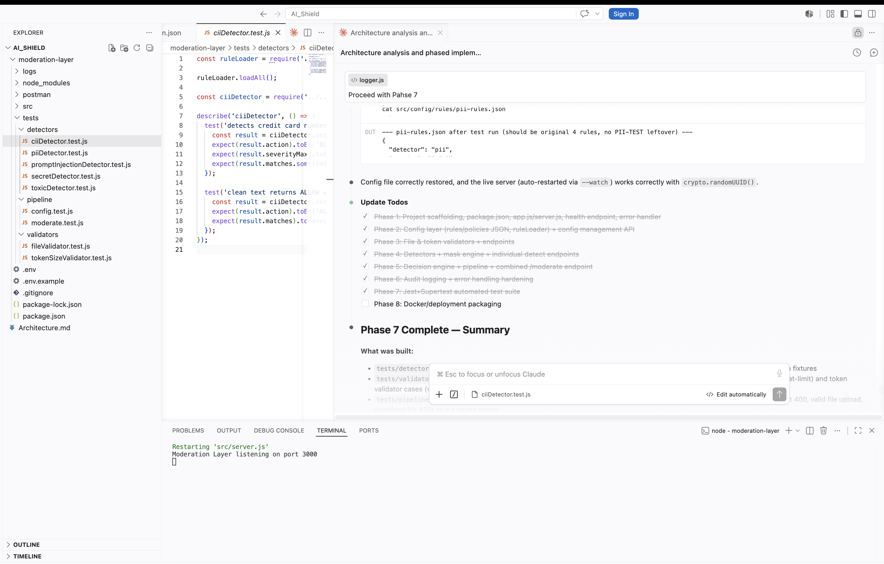
4. All the 7 phases were implemented
5. Now let’s check the postman collections
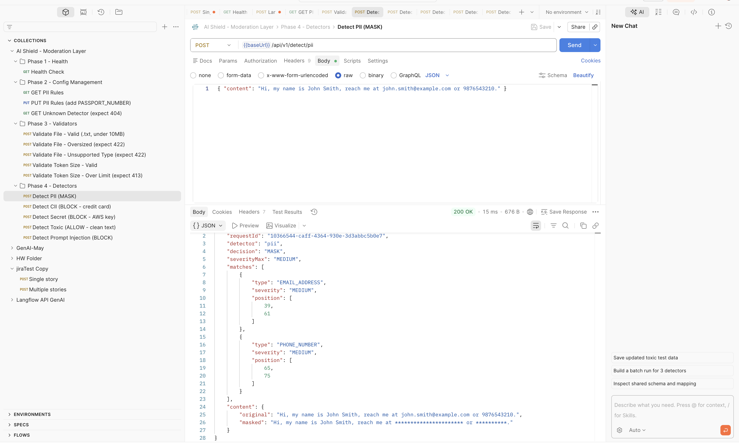
6. Automation test cases are also generated
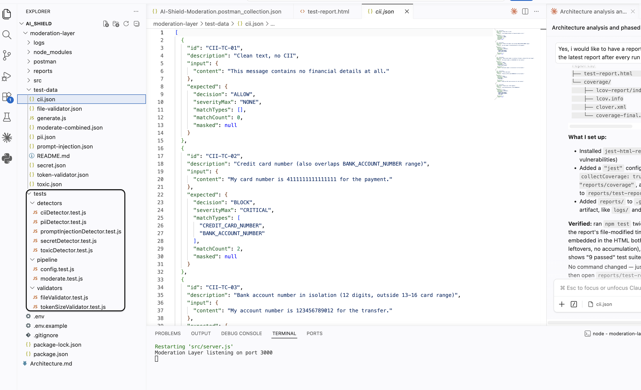
7. Test data is also generated per api’s and json is also generated for same

8. Also I have executed the test scripts and created a report for the same.
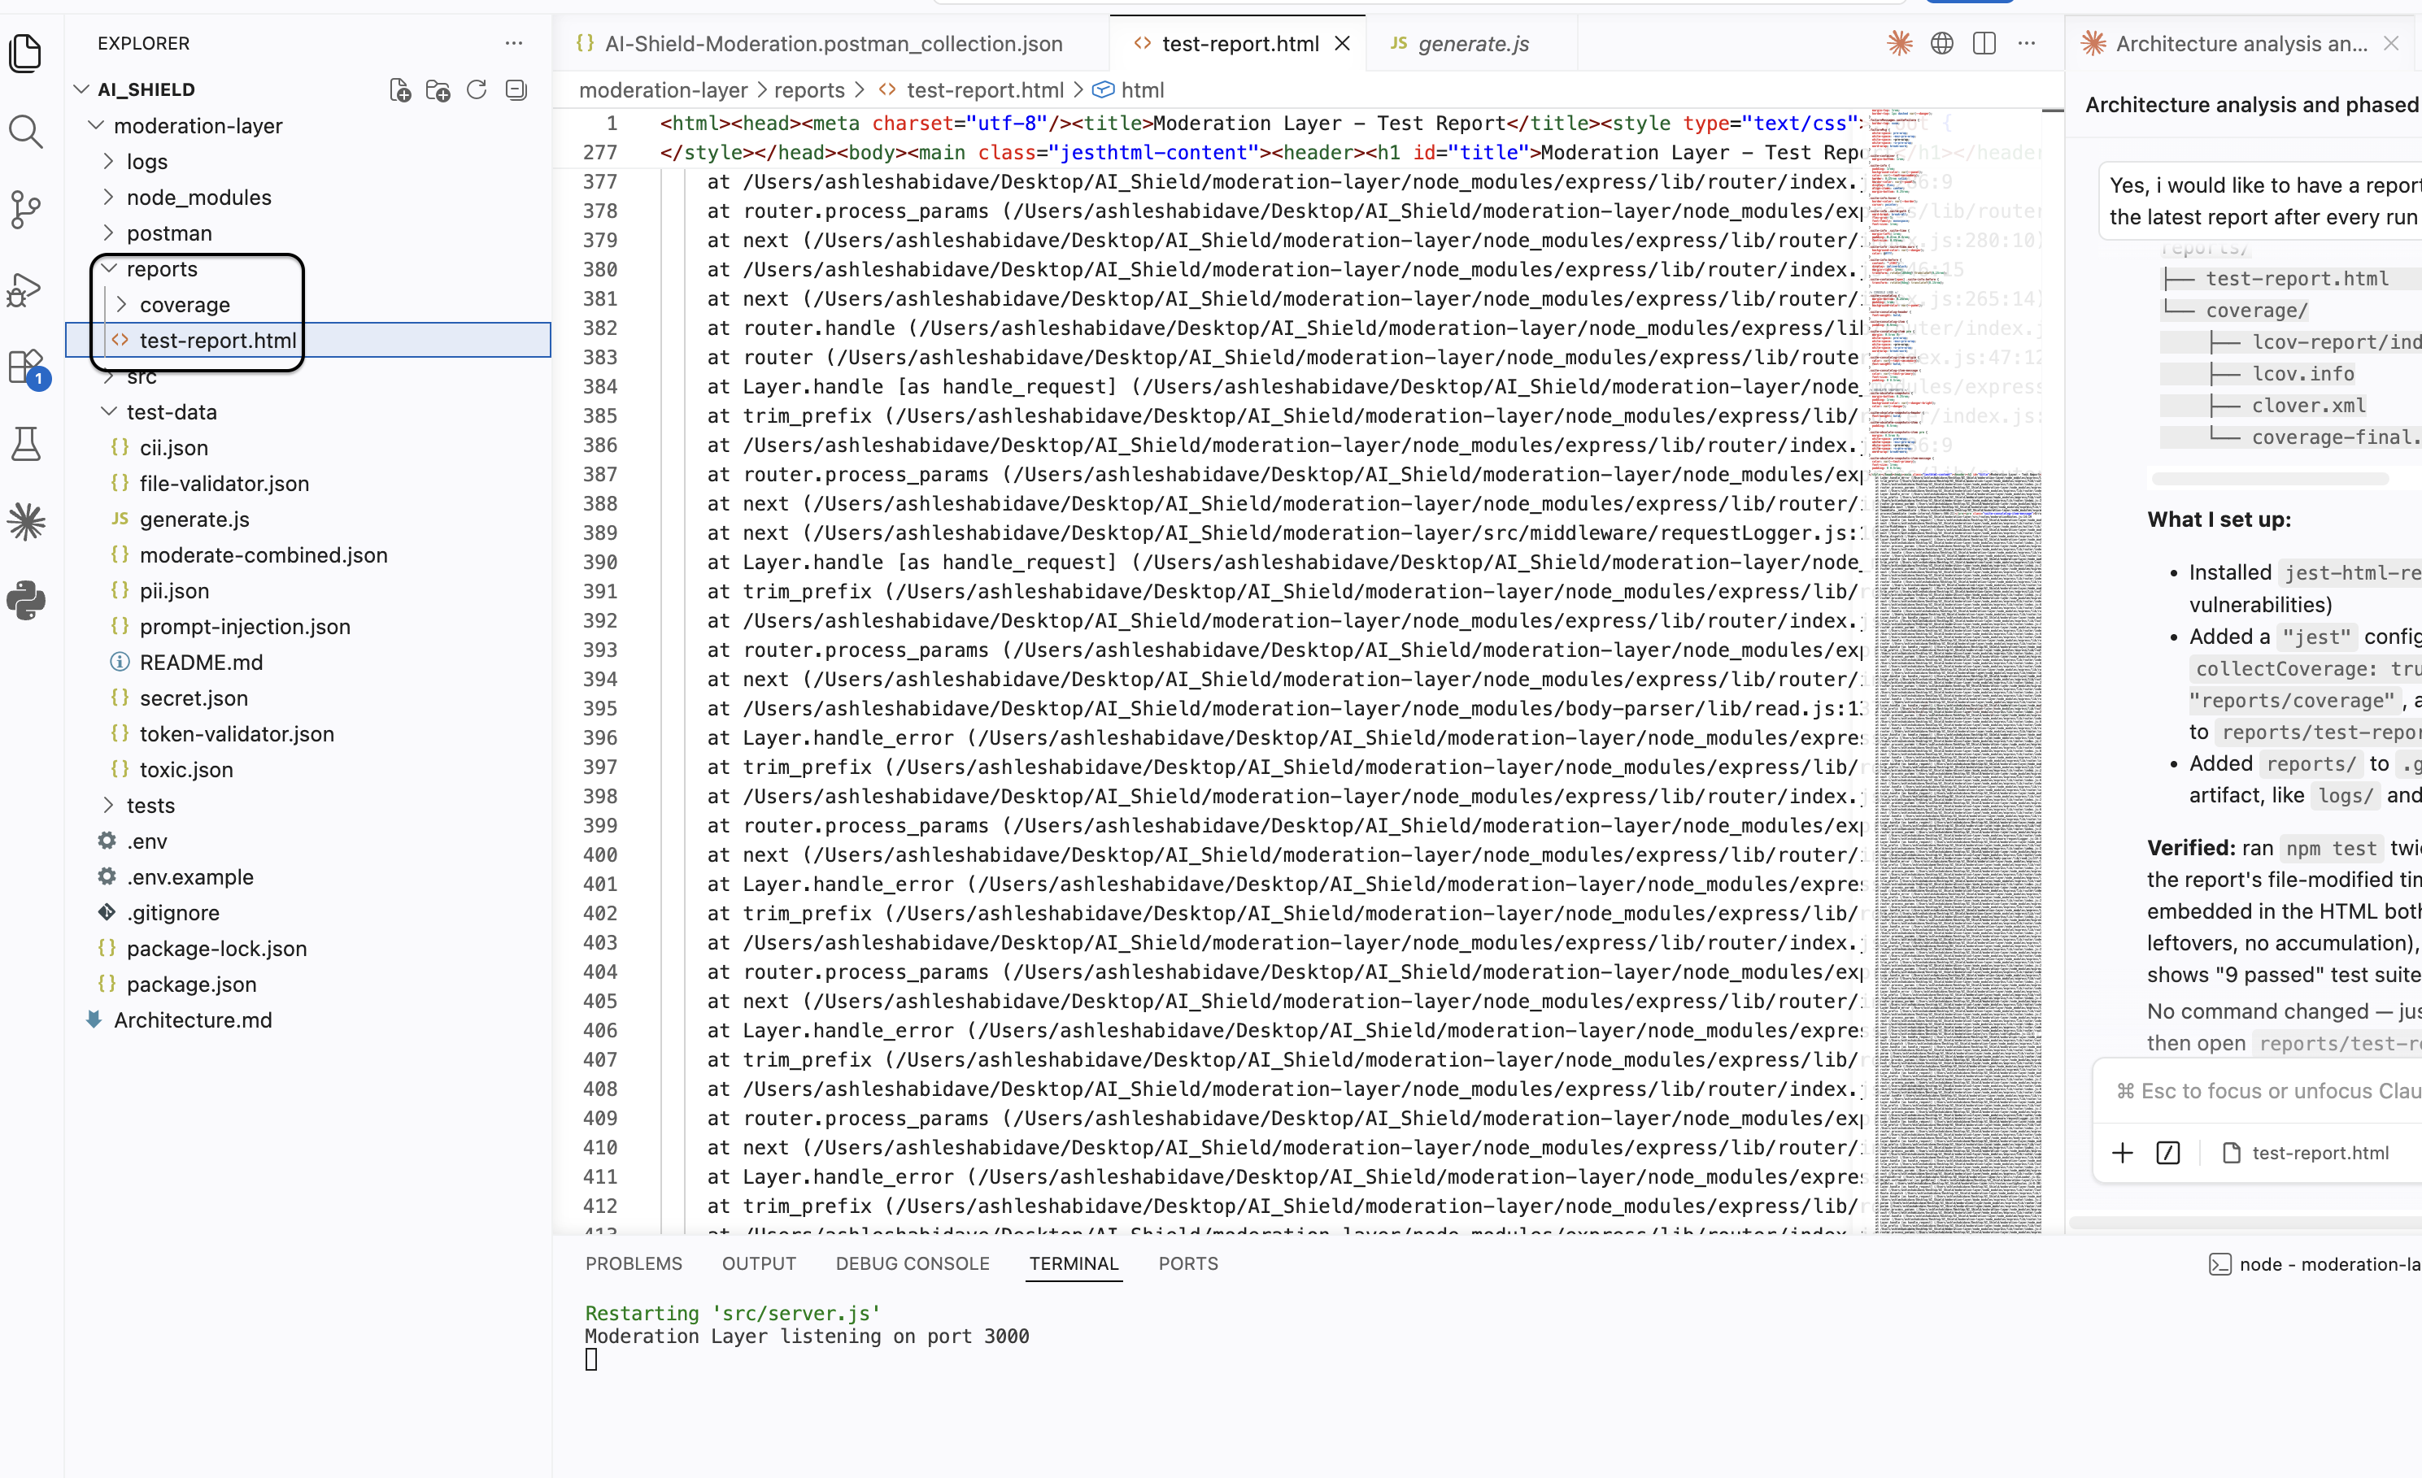
Also we can see the reports in html
