Install Playwright set up is completed and agents are displayed
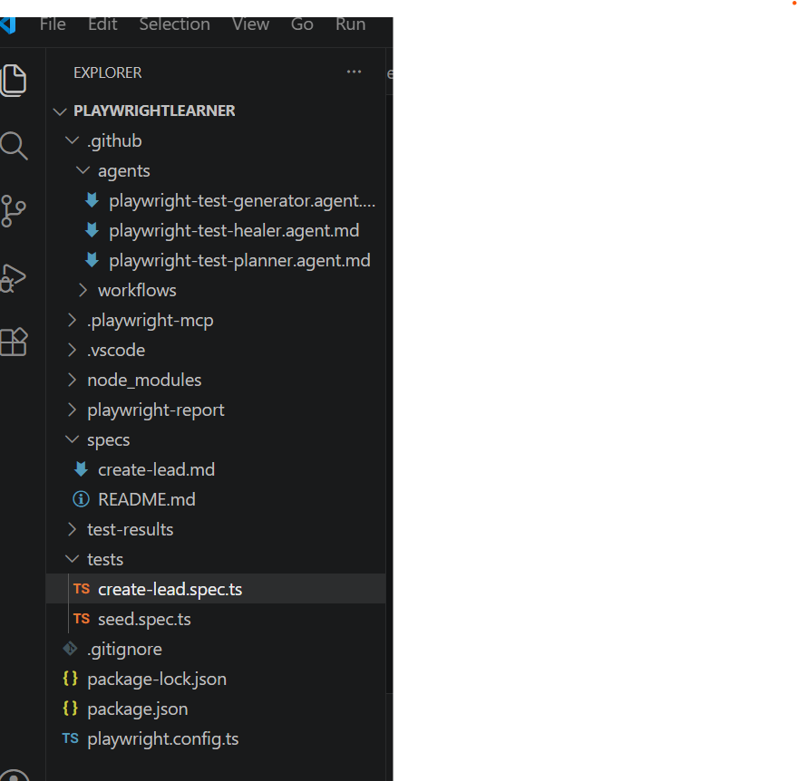

Verify planner agent is creating plan for create lead
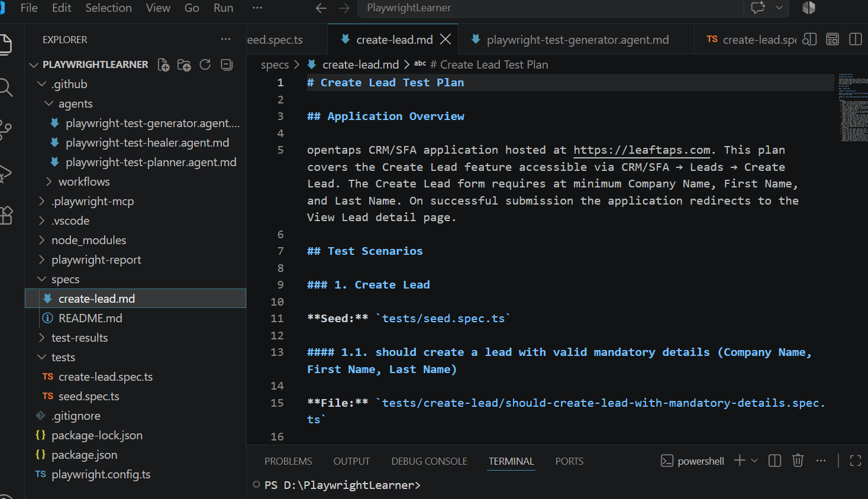

Verify Test case Generator is generating automated test case
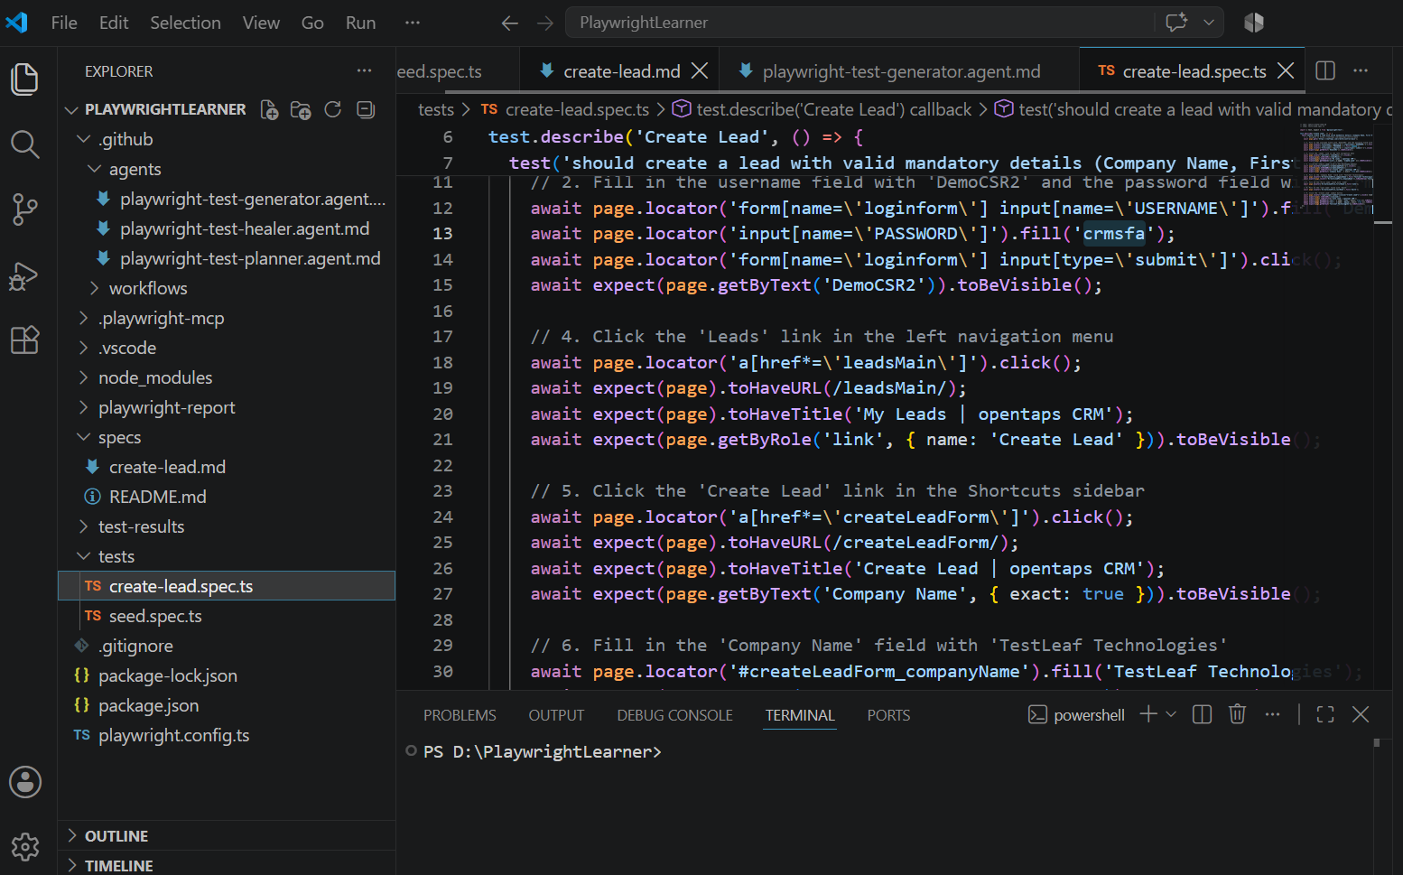

Verify with help of healer, failed test case can be curated
Wantedly made password spell wrong to curate it by healer
