Download the project and open it in VS code
Update UI to accept baseURL or endpoint and generate json file for APIs
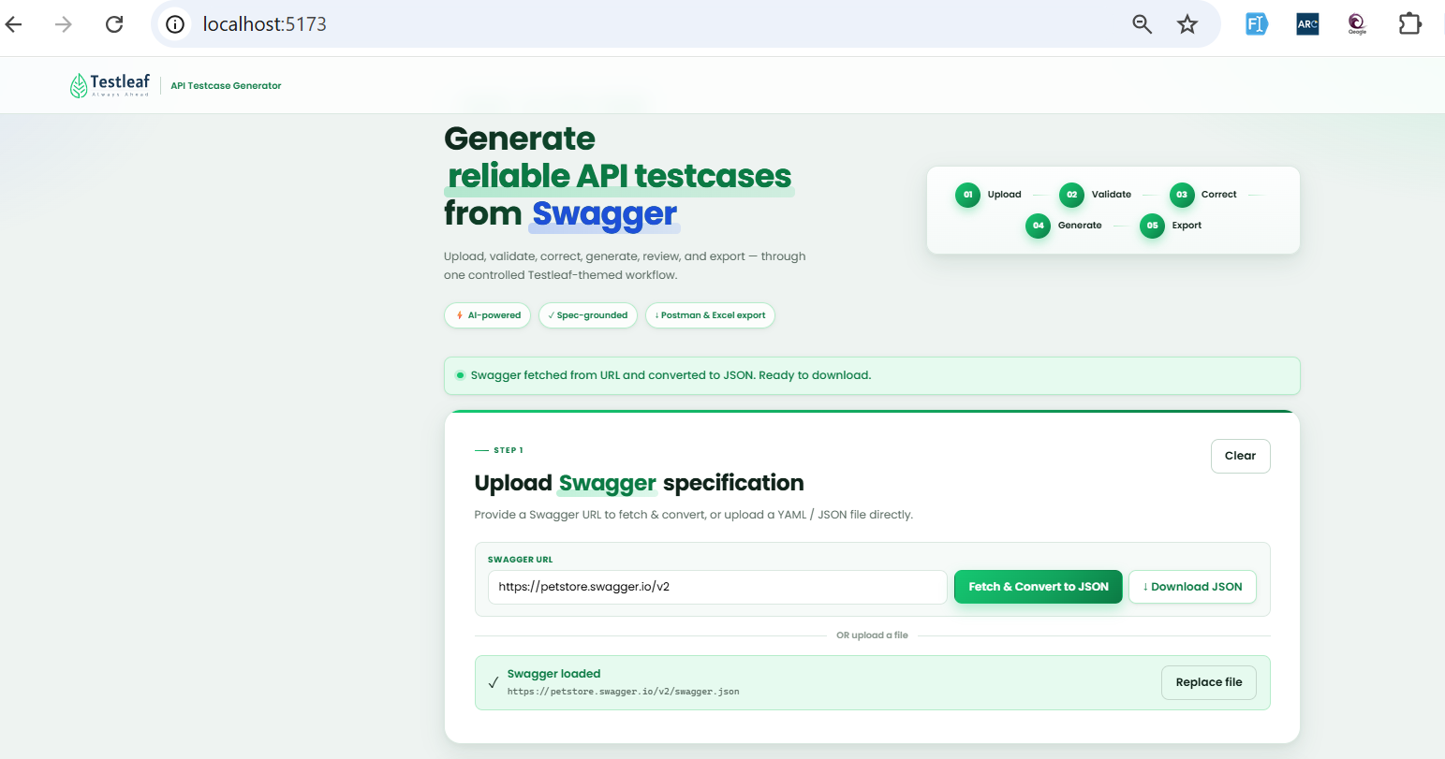
Verify json file can be downloaded and uploaded to procced further
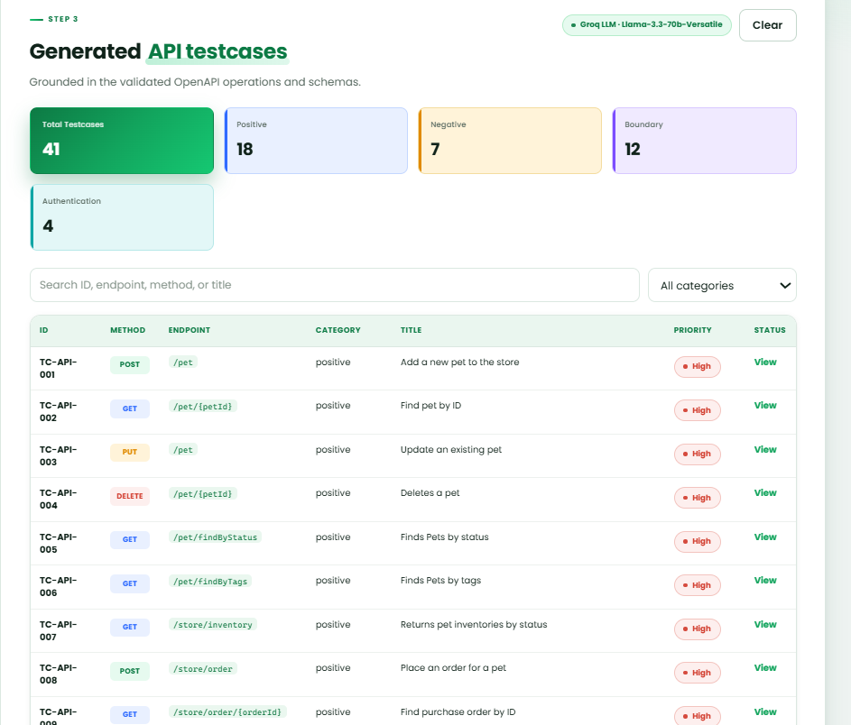

Verify Resassured code can be generated from json file

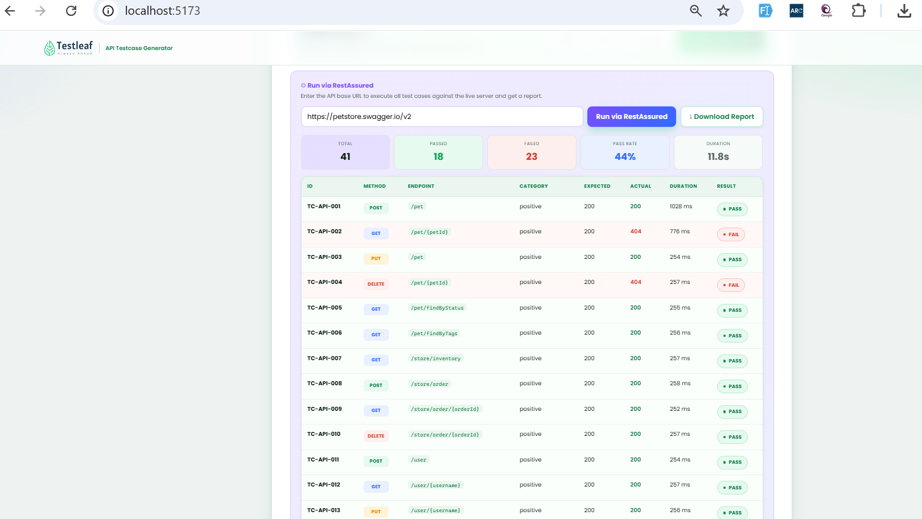

Verify RESTAssured code is generated
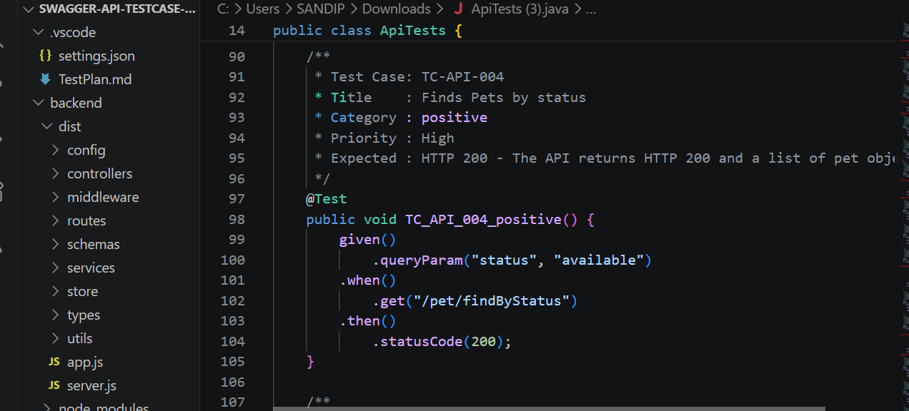

Verify n8n flow for test case generation
Node 1 --Chat Trigger (serach for chat)
Node 2 ---AI Agent (Search for AI)
Click on the AI Agent node
Add Option
System message
----Add the Prompt for Testcase Generation
In AI AGent node --click on chat model
Search for Groq
Add the crednetials (Groq API Key)
---Click on Setup credentials
--paste and Save groq key
