POSTMAN Remote MCP Installation
Using GitHub copilot
Installing MCP Extension for postman and opening the configuration json is as follows-
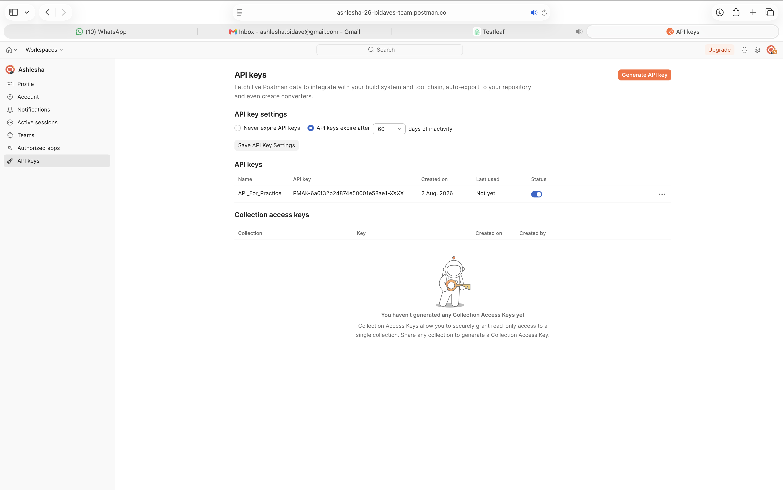
Installing the postman extension in VSE Code
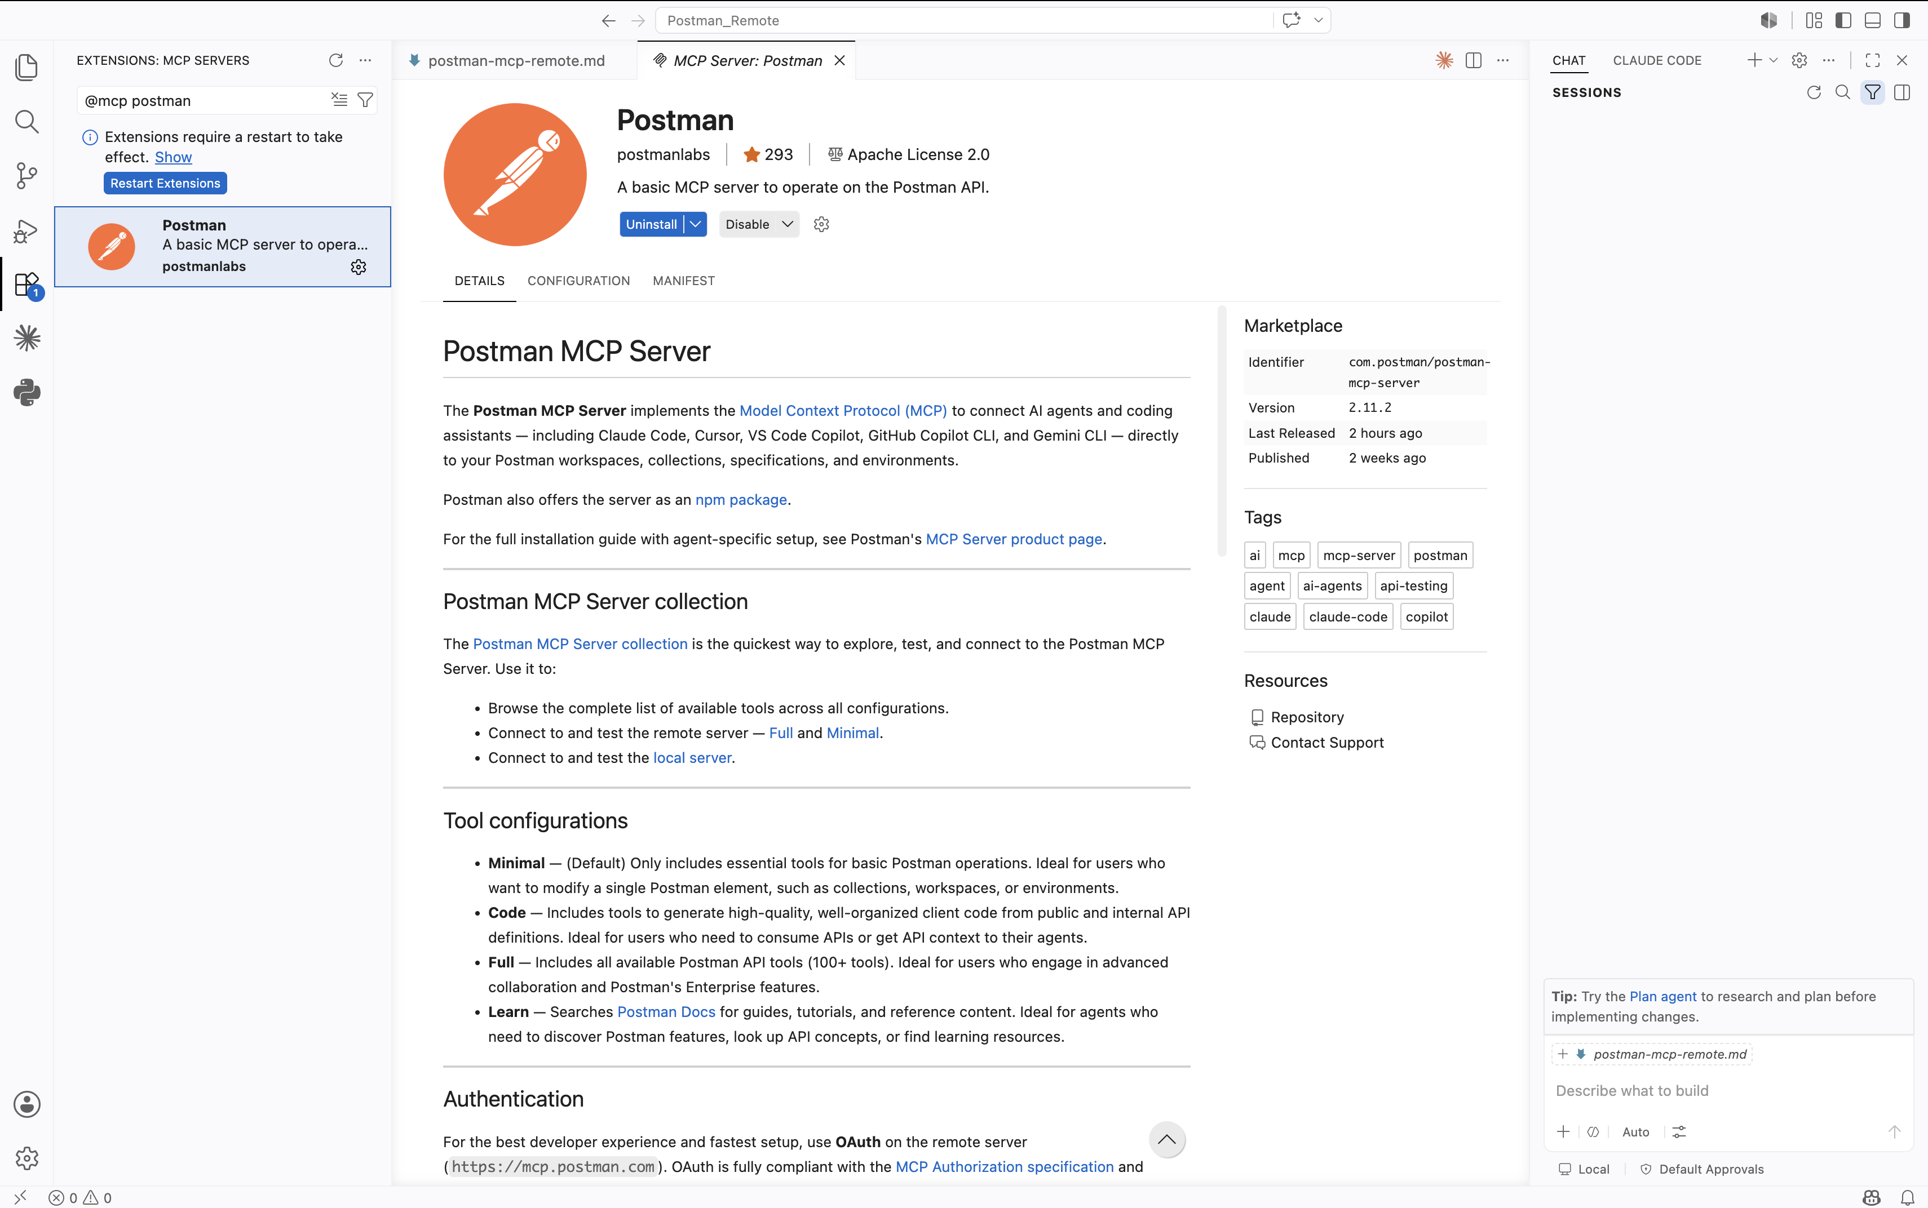
Watch the configuration json from the extension
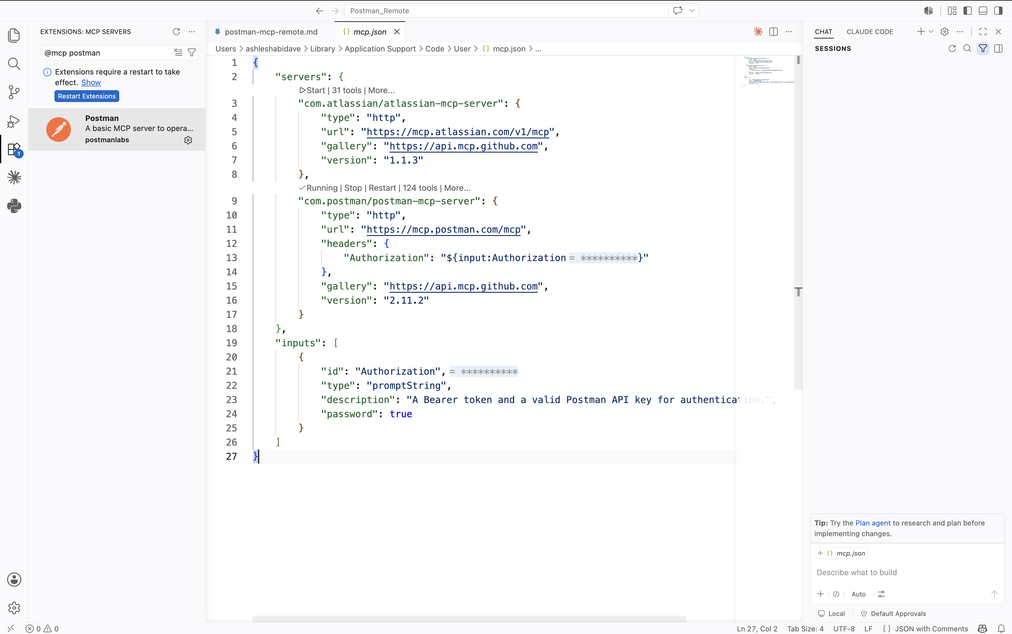
Enter the bearer token for remote postman
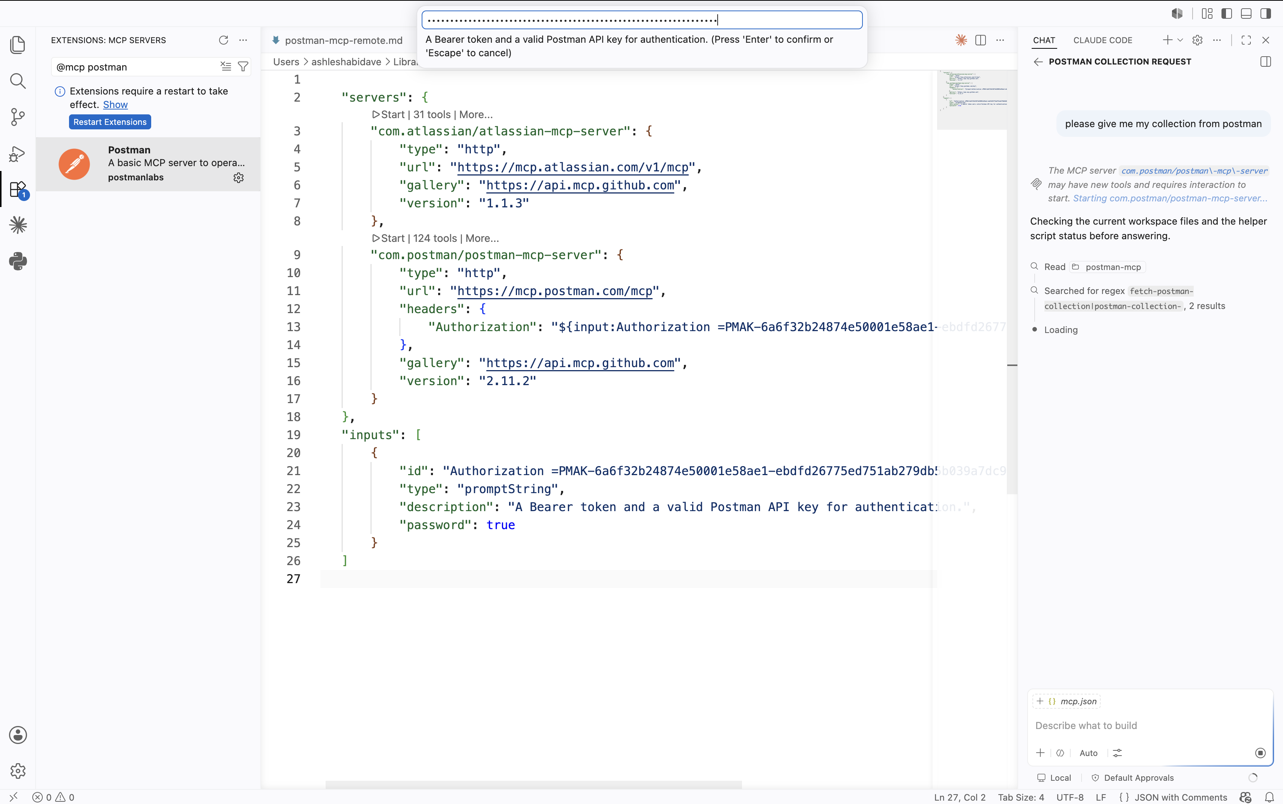
Collection returned
