RAG-Ingestion-Pipeline
Before Ingestion Mongo DB
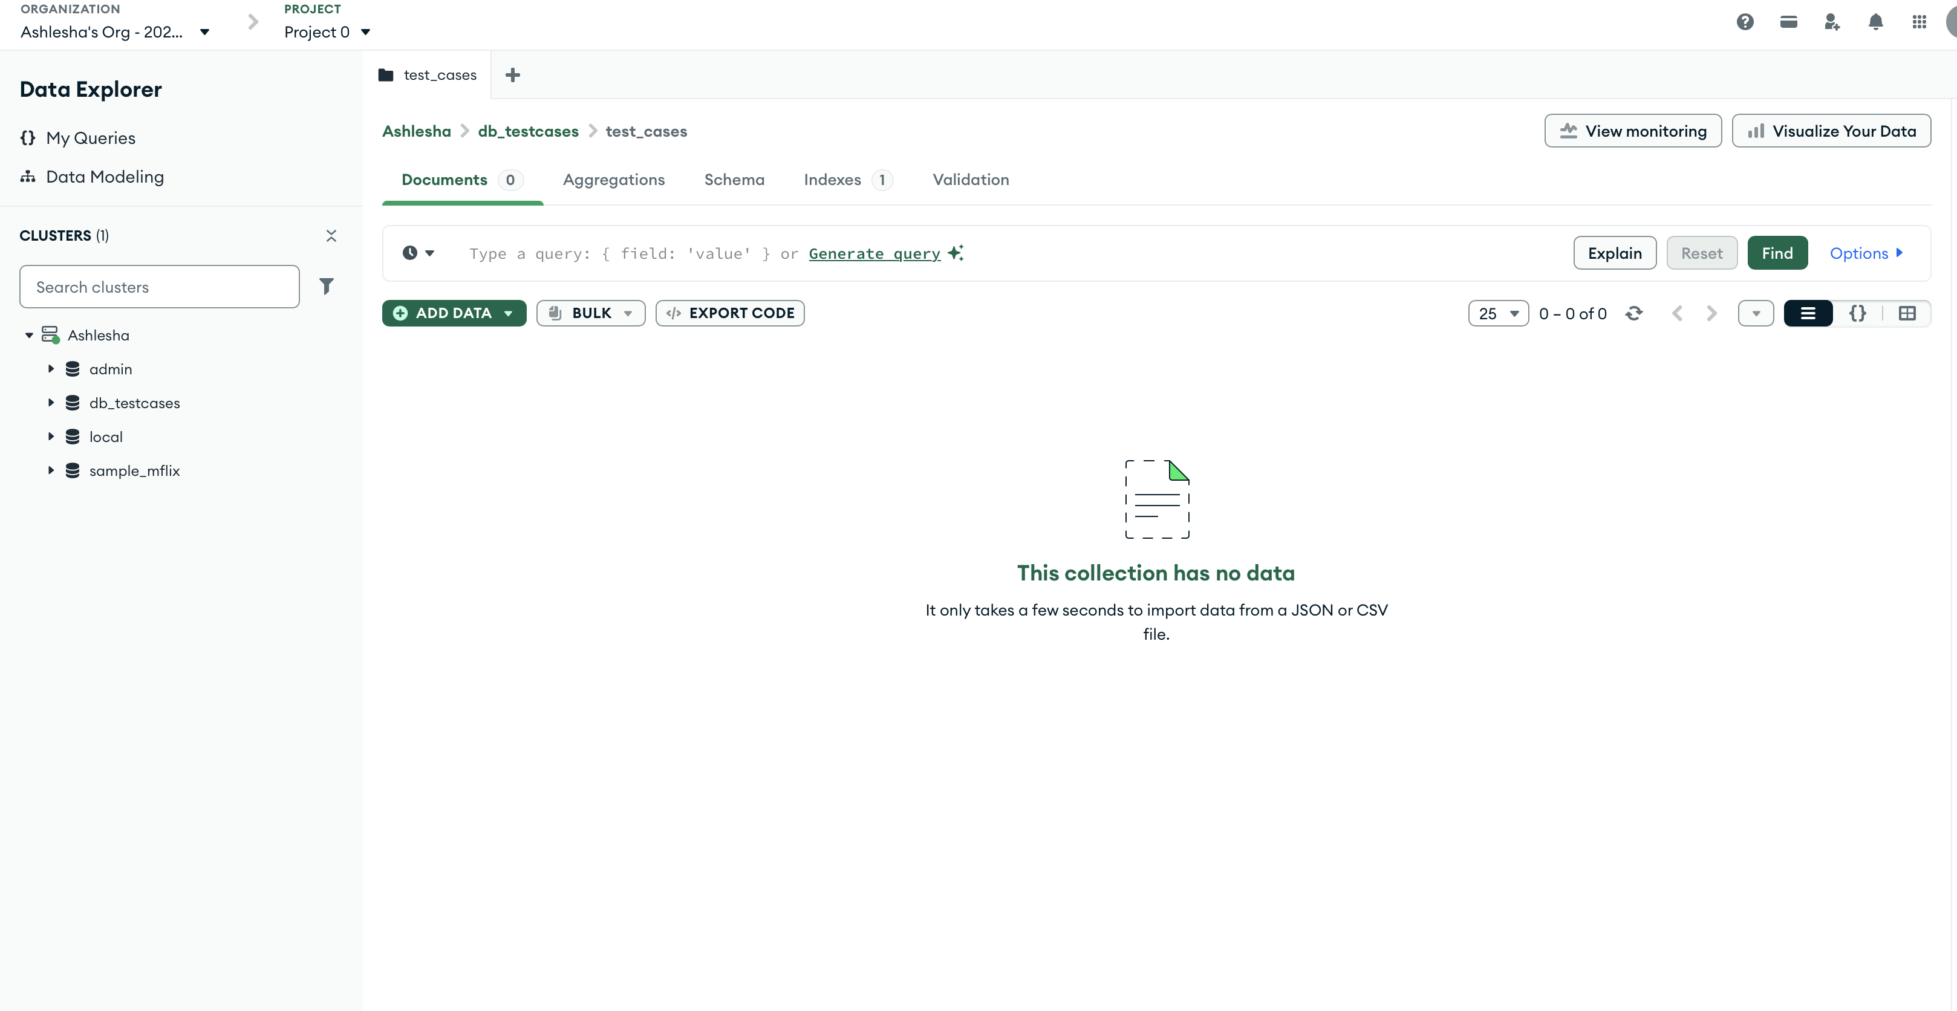
Langflow Configuration
1. Added a read file module – Where in uploaded the test cases csv given by SHAN
2. Added Mistral Embedding Module- Enter the MISTRAL API Key
3. Added Mongo DB module
Entered- mongo d burl, db name, collection name, vector search name.
Modified the Dimensions
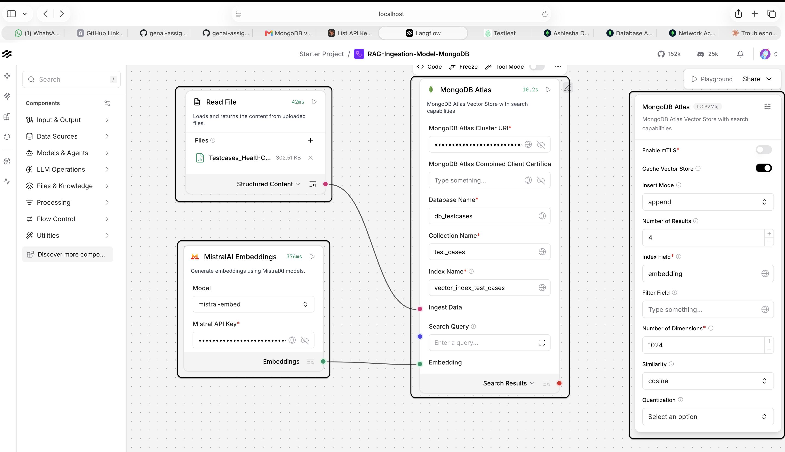
After Ingestion—changes in Mondo DB
