RAG- Retrieval- Pipeline
1. Added Mistral Embedding Module- Enter the MISTRAL API Key
2. Added Mongo DB module
Entered- mongo d burl, db name, collection name, vector search name.
Query - Generate Test cases for validating ATM Card
Modified the number of results count
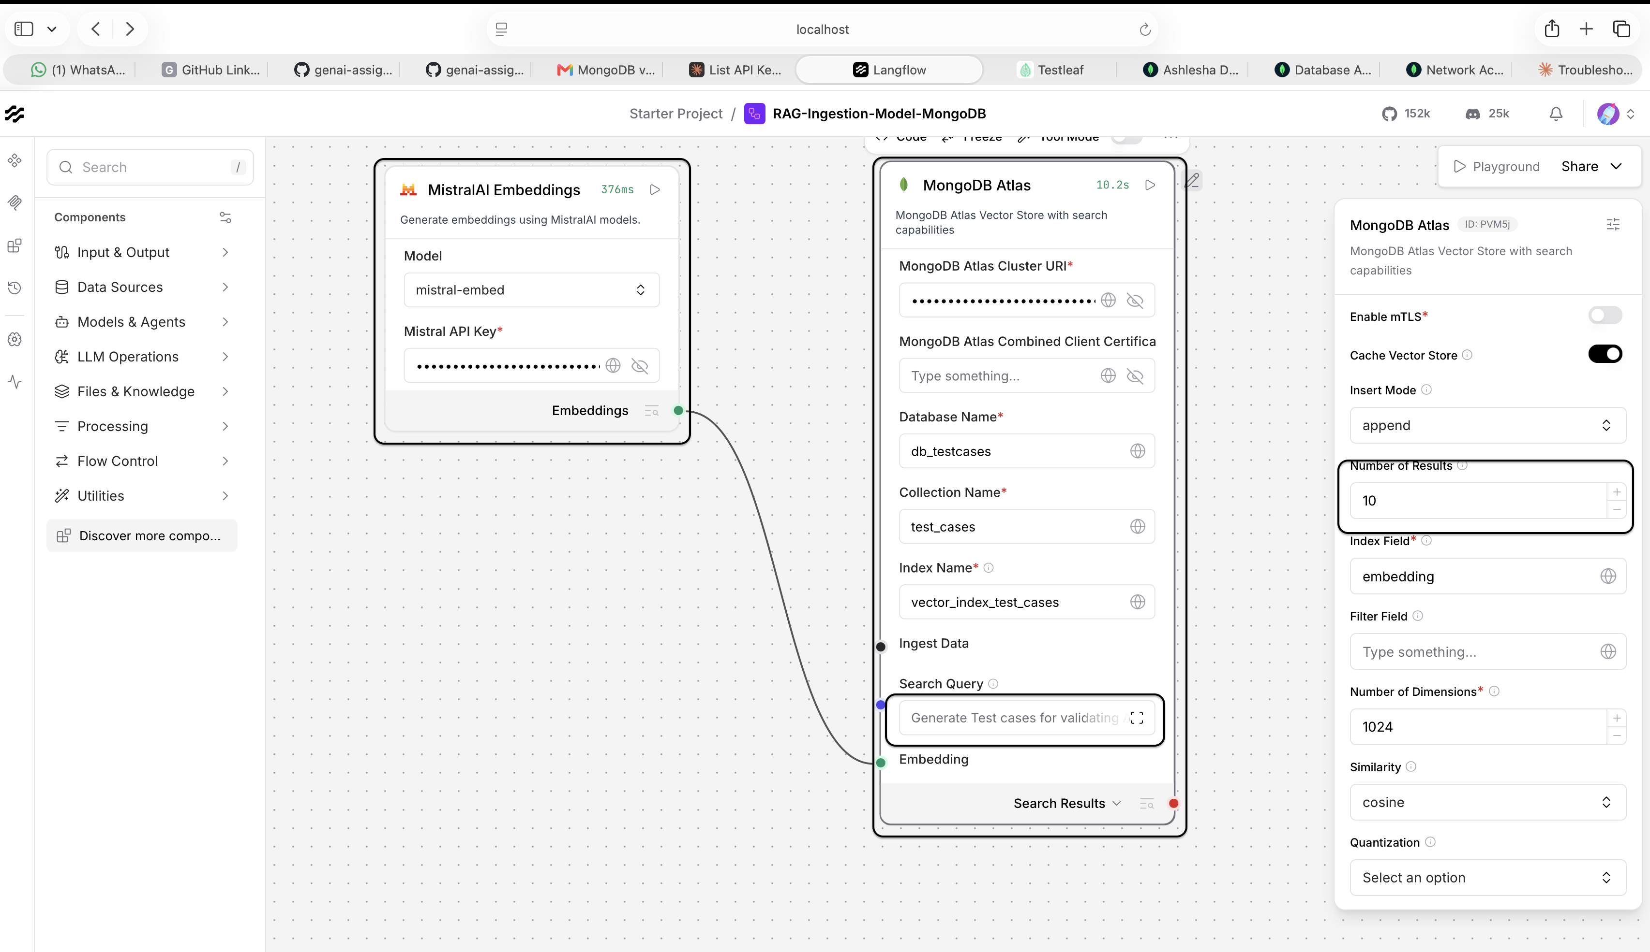
Generated Output- 10 test cases as per query given
