Metrics Evaluation for new test cases generator using deepeval and RAG Pipeline
1. Made the rag pipeline up
Made the deepeval server up and running
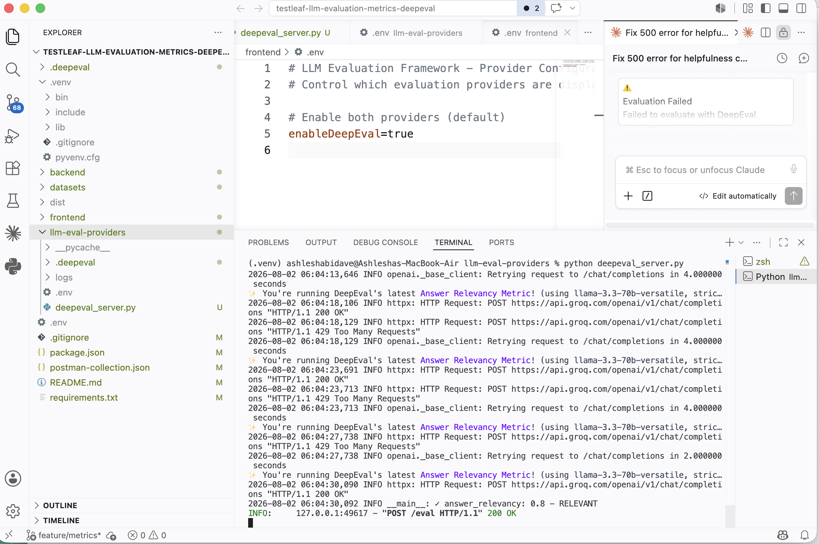
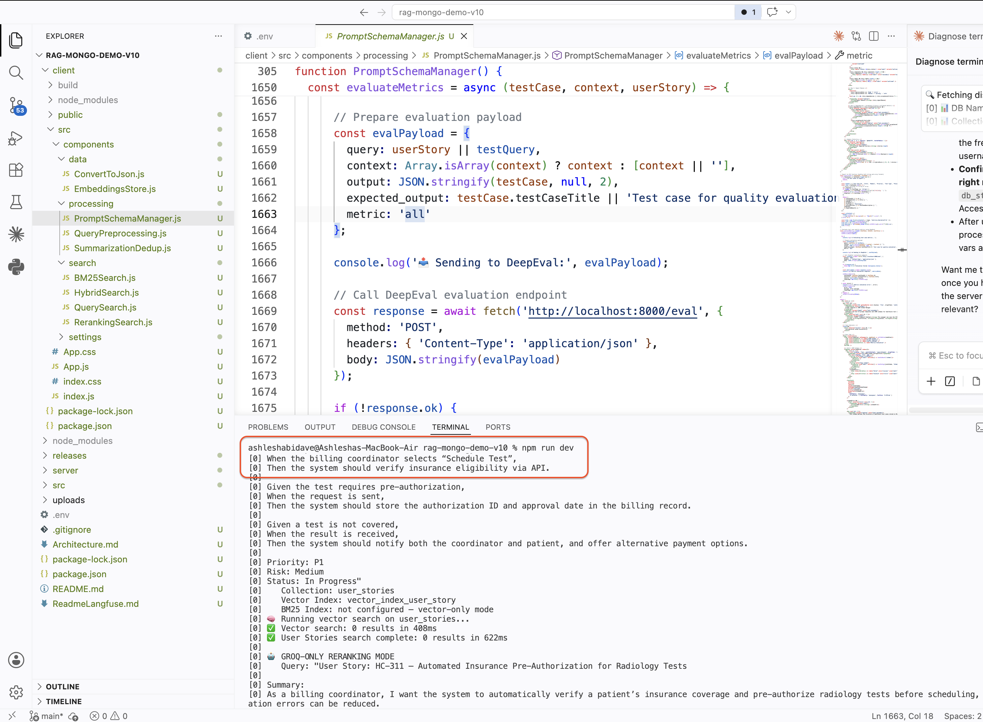

2. Now take the any user story and navigate to PROMPT & SCHEMA in RAG Pipeline
Navigate to test preview >paste the user story in Test Query field
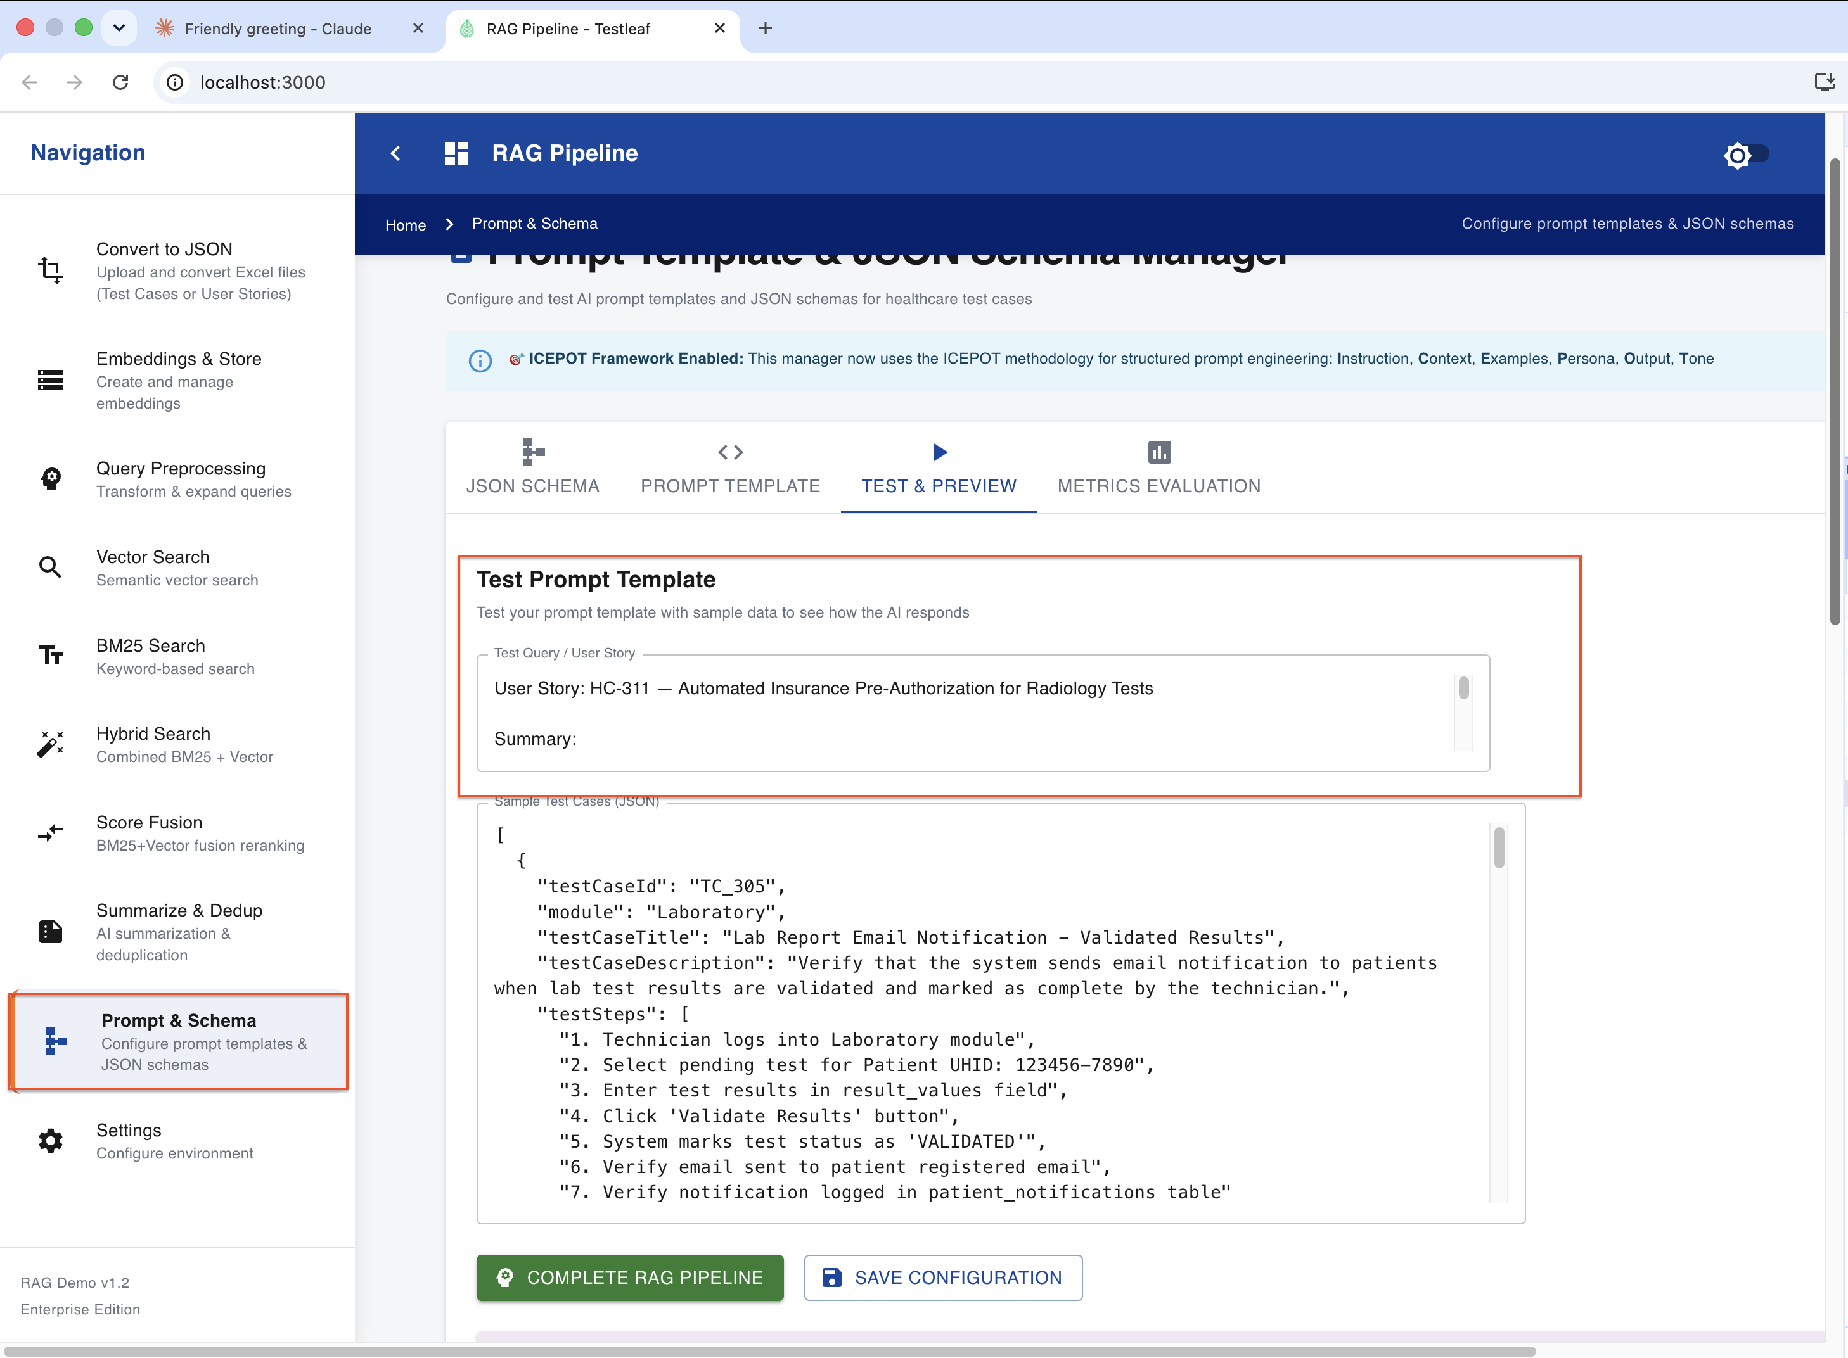
Complete the RAG Pipeline and validate the test cases
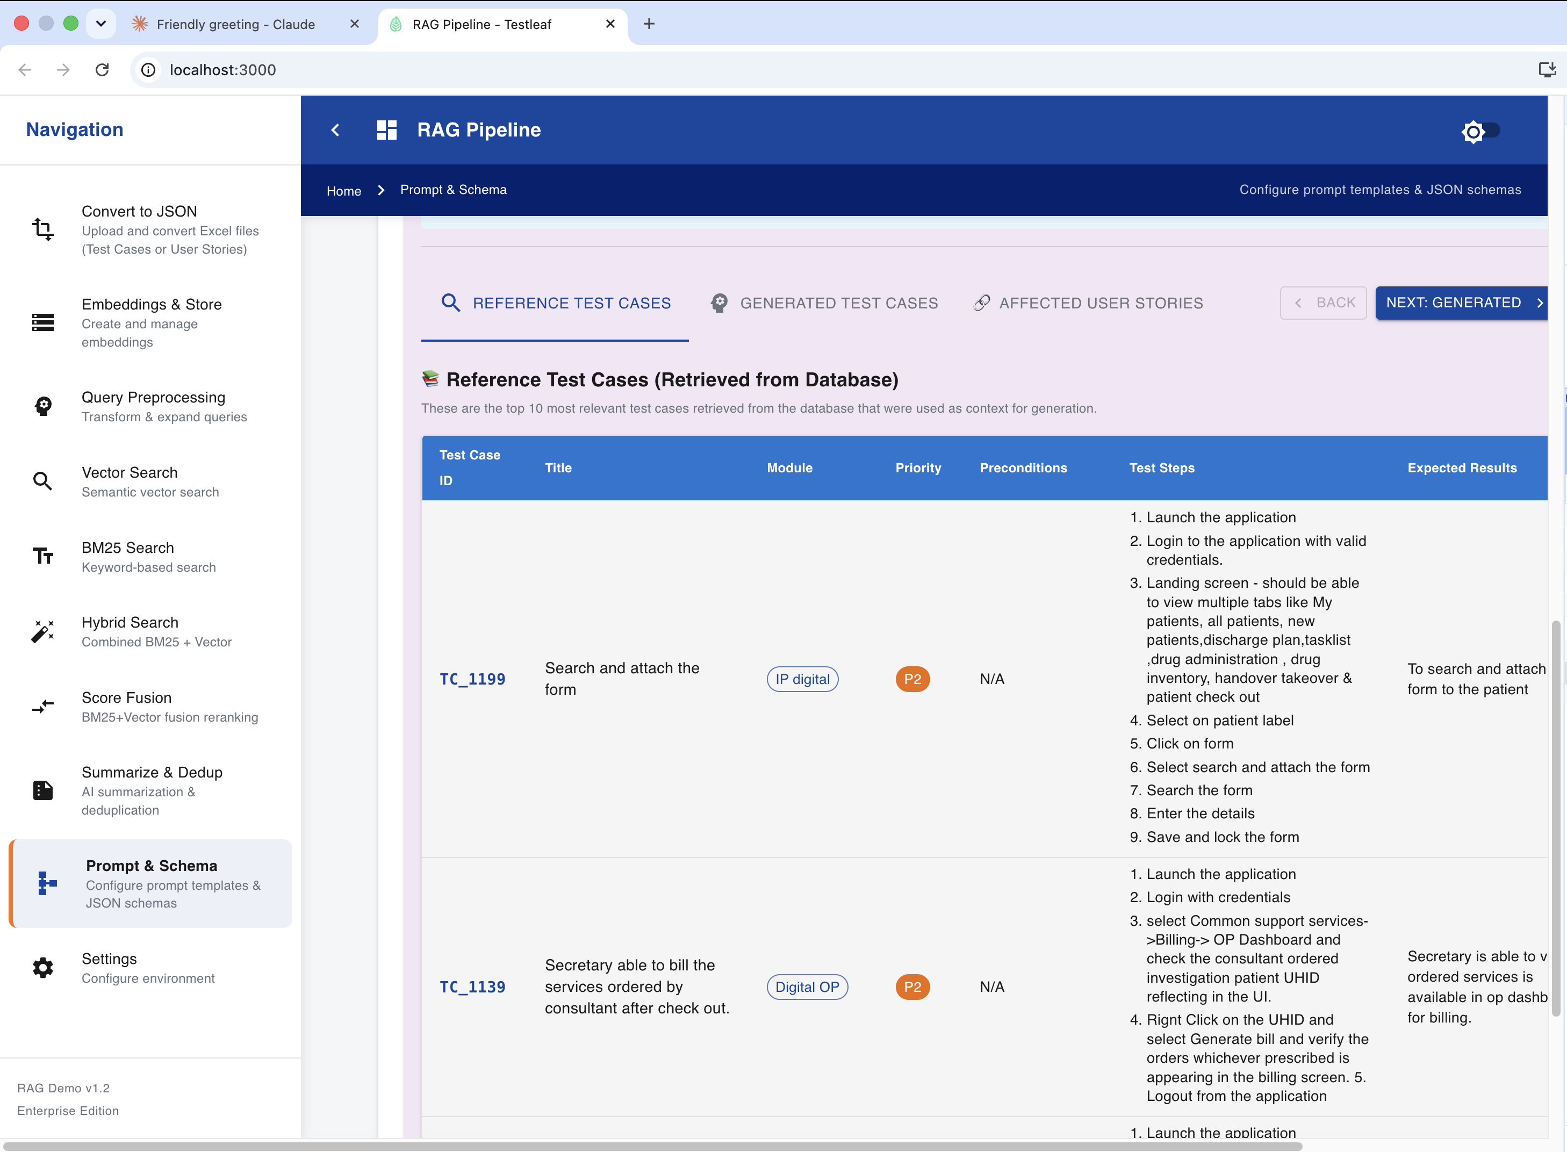
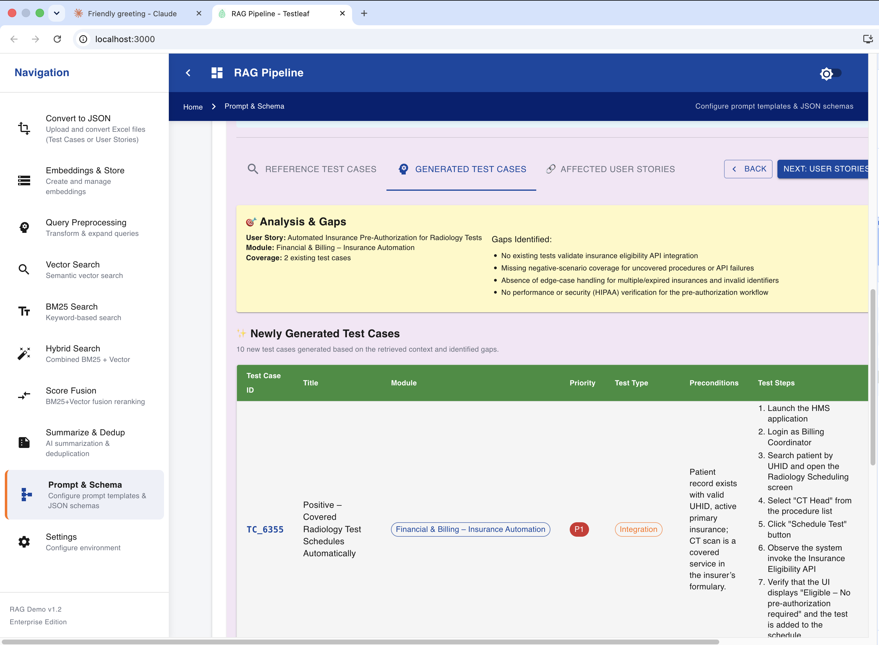
3. Evaluate the test cases generation in metrics evaluation
select any test case from the drop down ( below one is from reference test case section)
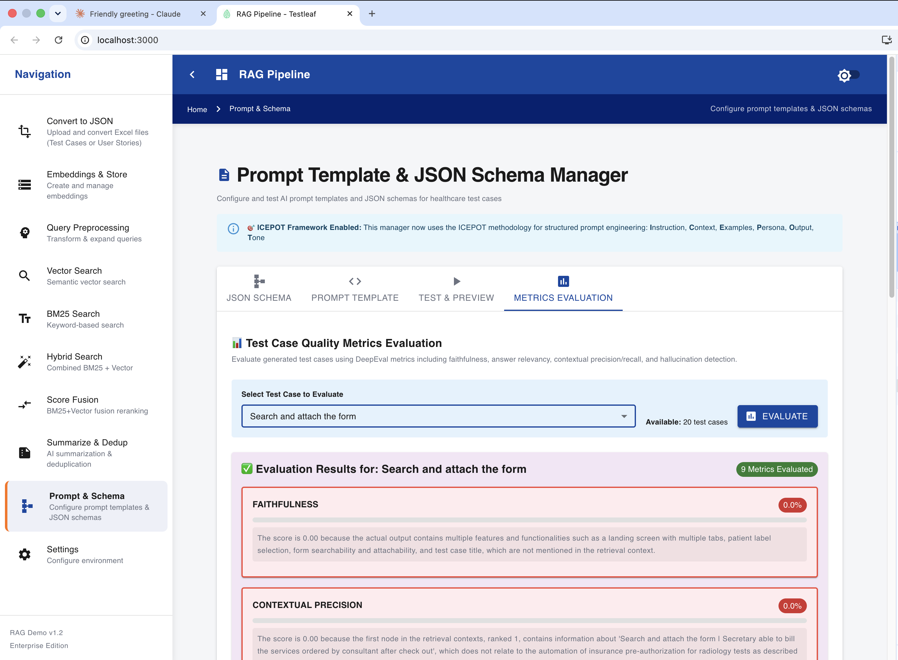
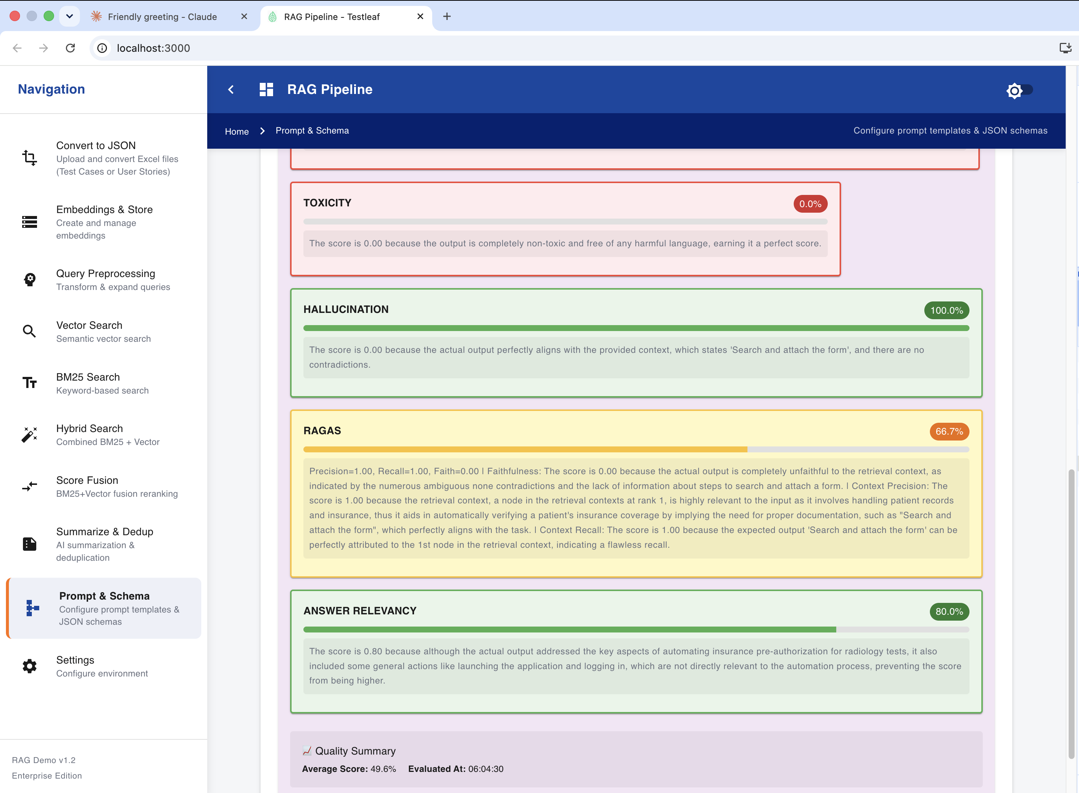
Back end calls for the whole process is as follows -
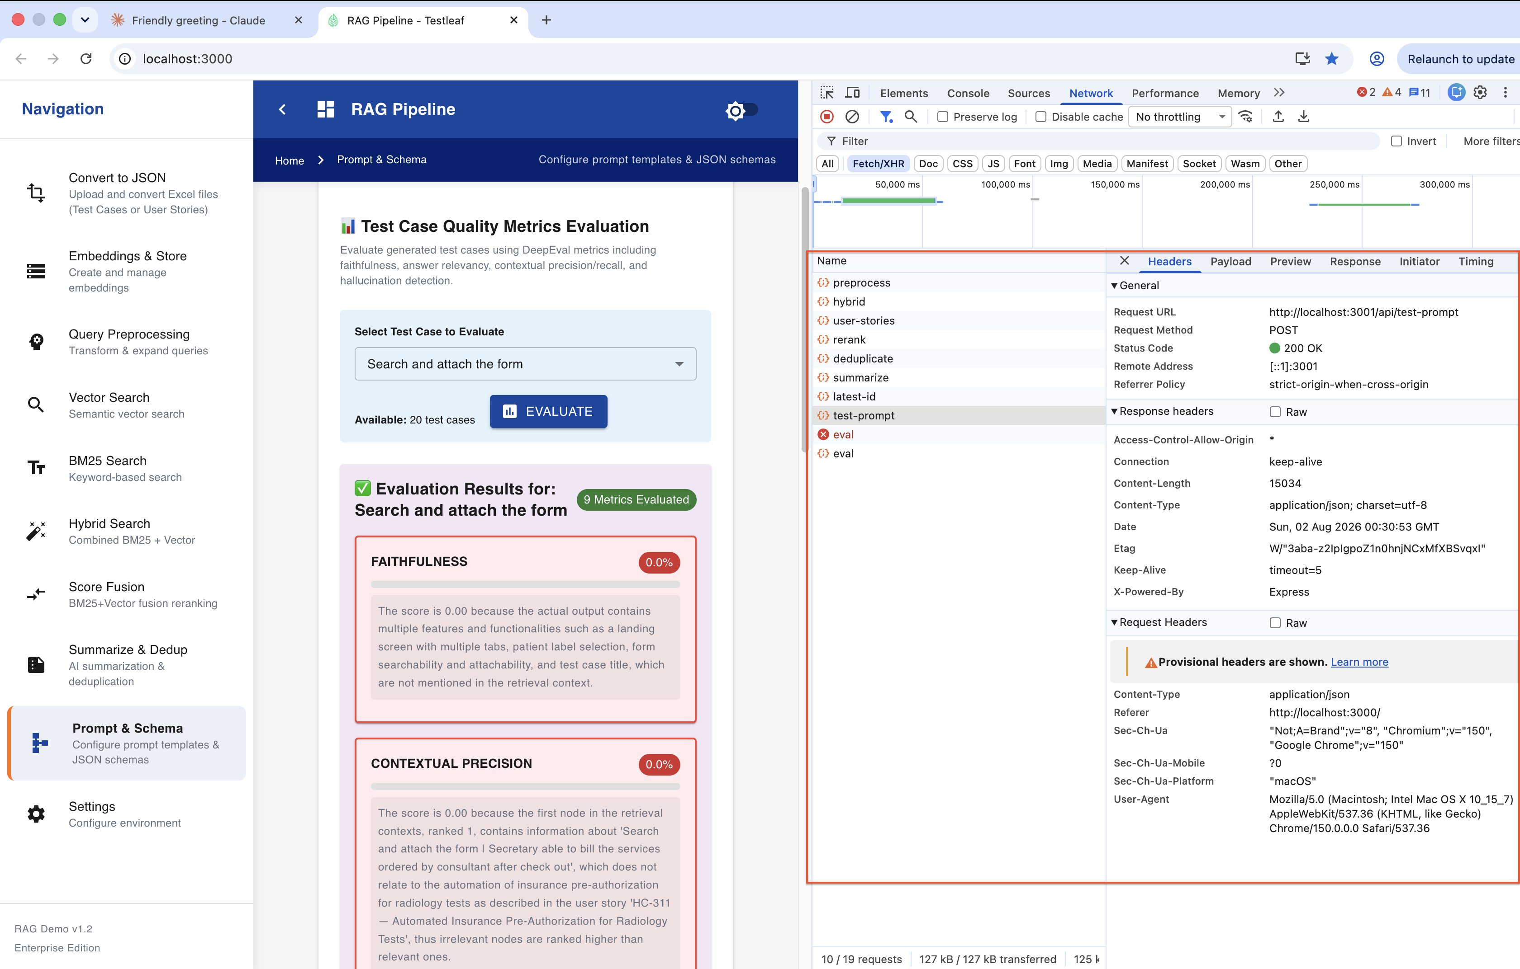
4. Second Round of evaluation
Evaluate the test cases generation in metrics evaluation
select any test case from the drop down ( below one is from generated test case section)
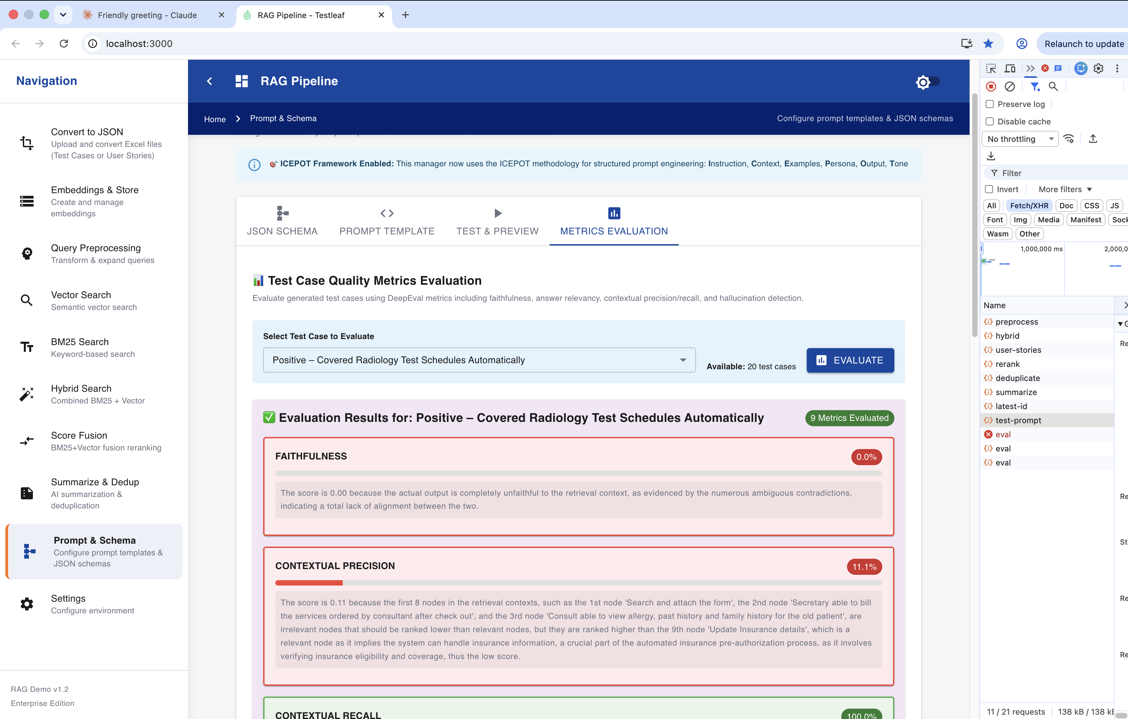
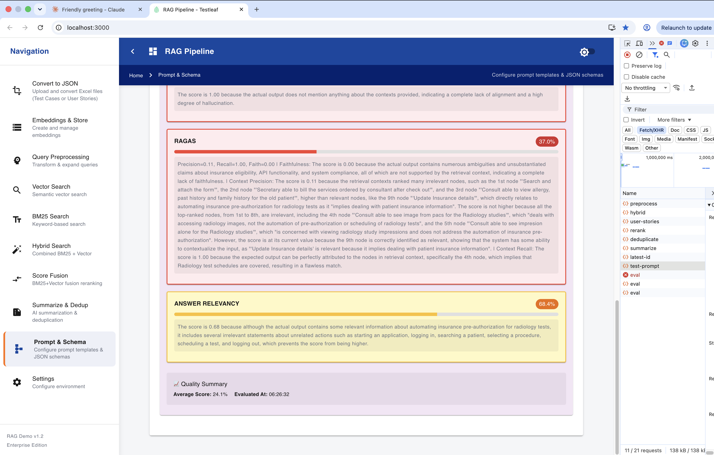
5. Now will customize the metrics to be evaluated in the code..
will go for answer relevancy, faithfulness
Modify the code in RAG Pipeline
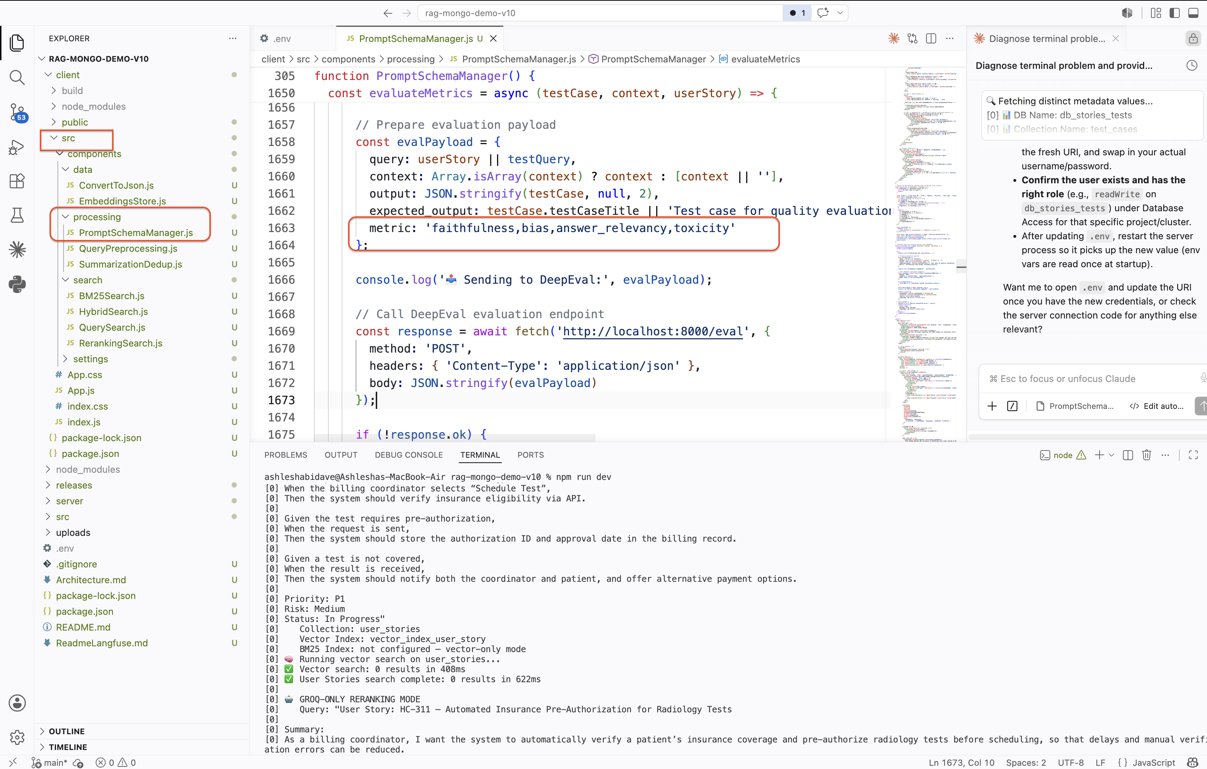
Now again perform npm run dev and verify the above process again
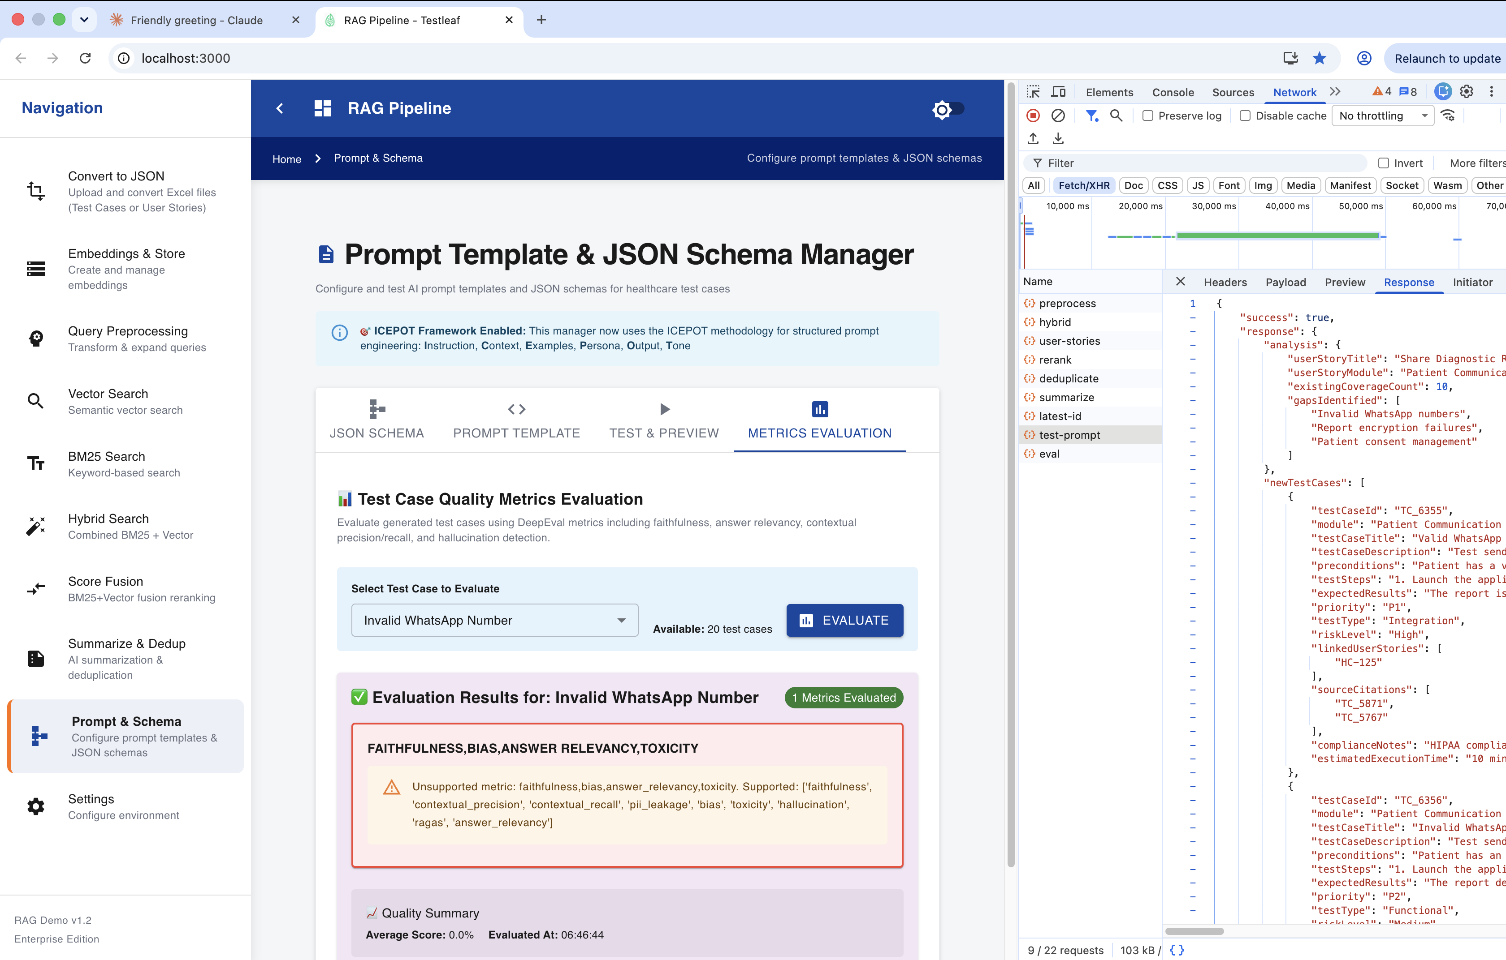
Changed metrics into the array
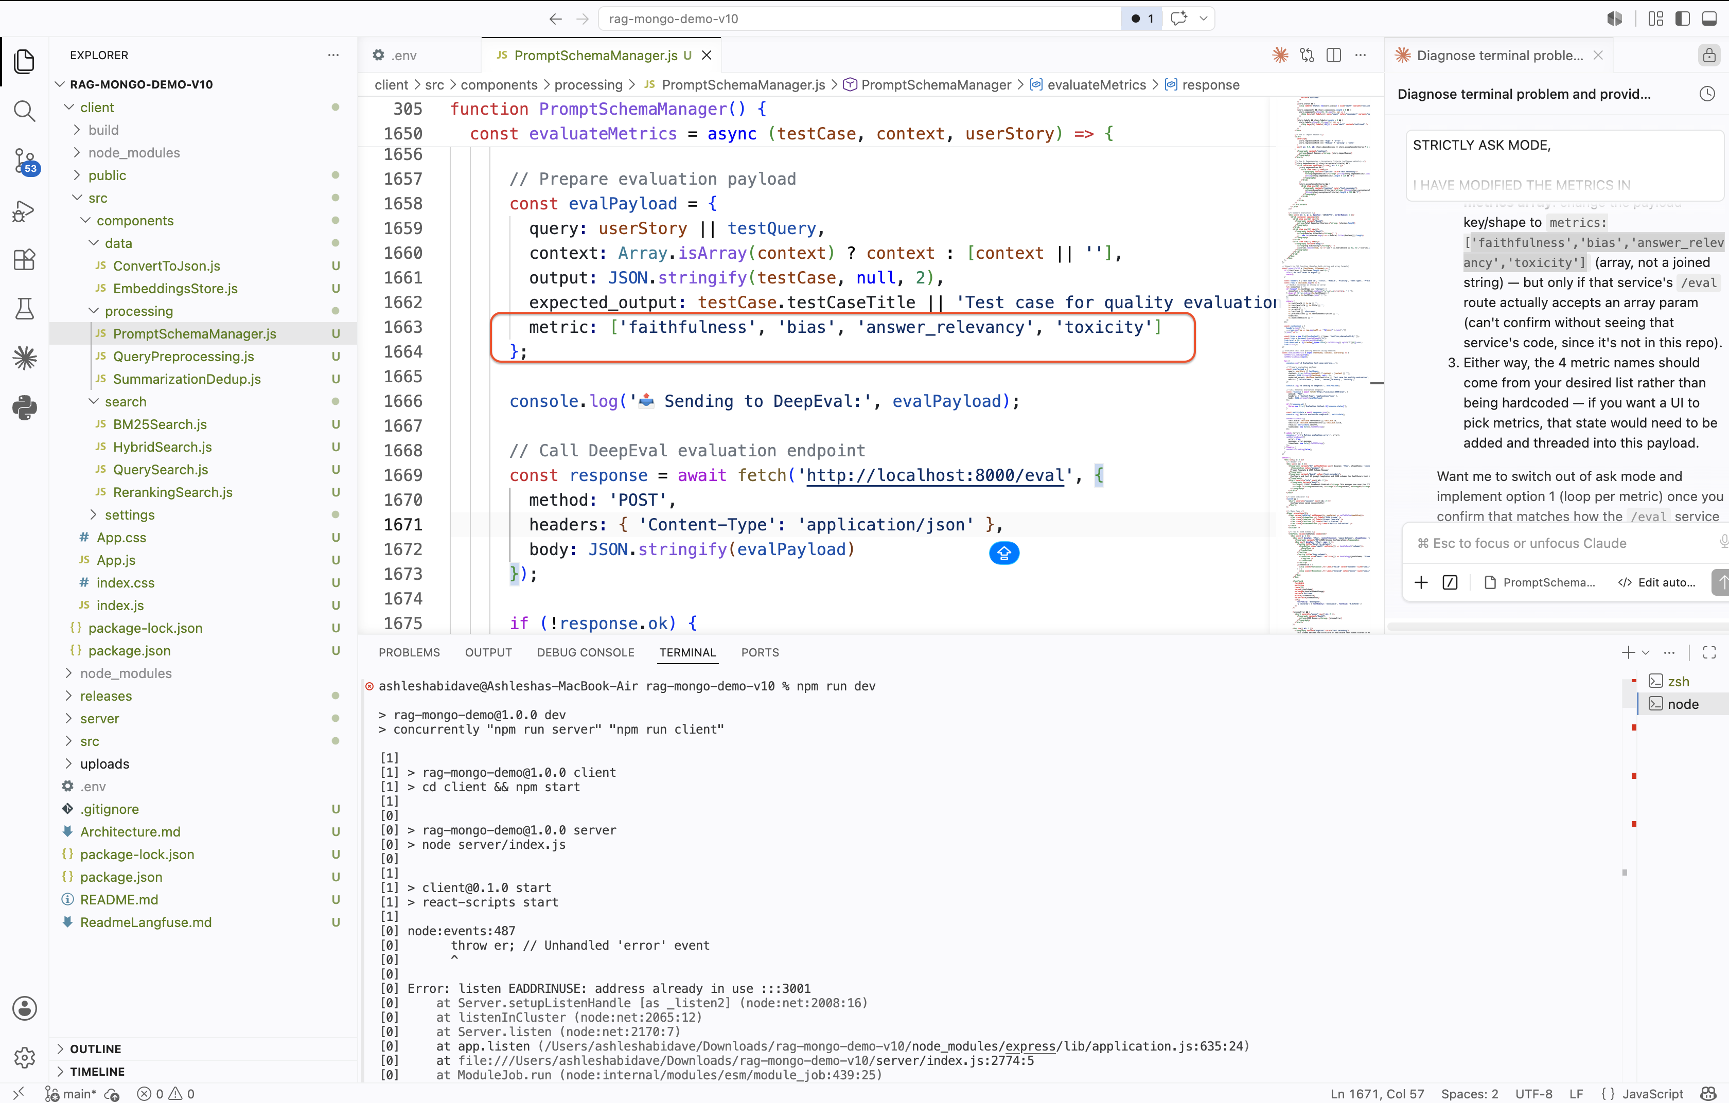
Again checking of the configured metrics
