Hybrid and BM25 Search Implementation using Vibe Coding
1. RAG Pipeline Application is up
Entered the prompt for vibe coding -
STRICTLY STEP BY STEP IMPLEMENTATION Go through my current codebase Do not hamper any existing code. On the other hand Please follow steps for the vector search implementation for langfuse tracing. Implement the same for Hybrid search and BM25 Search
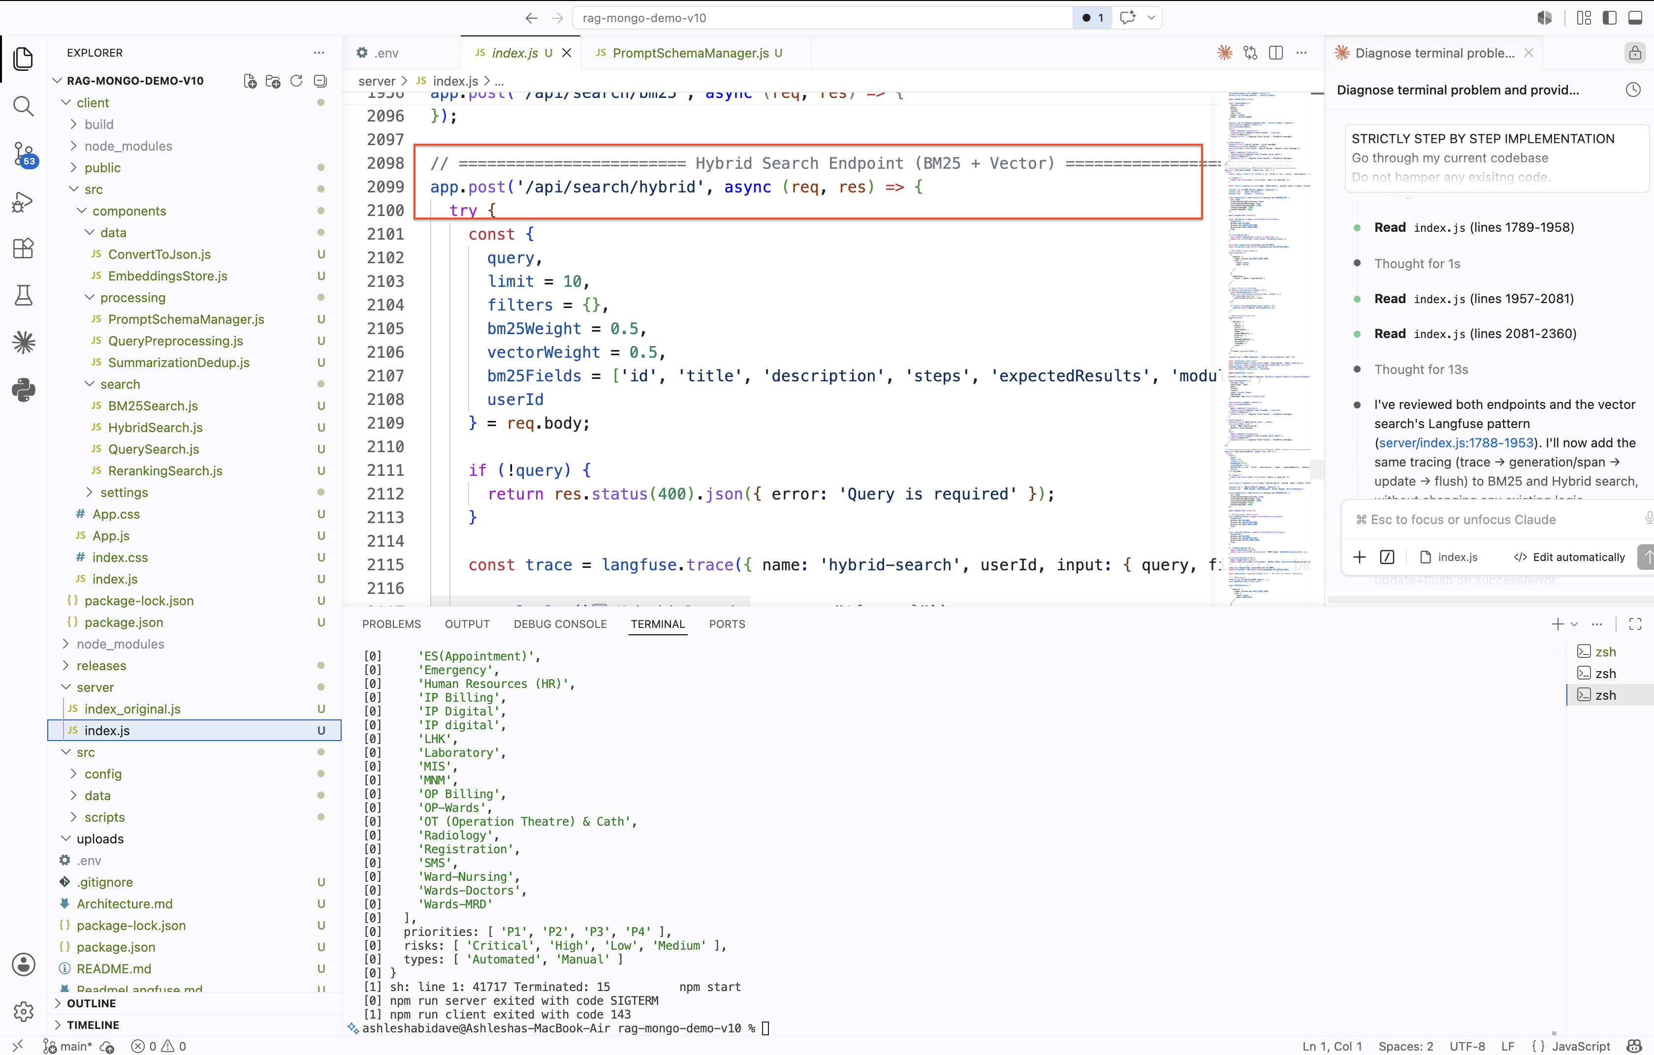
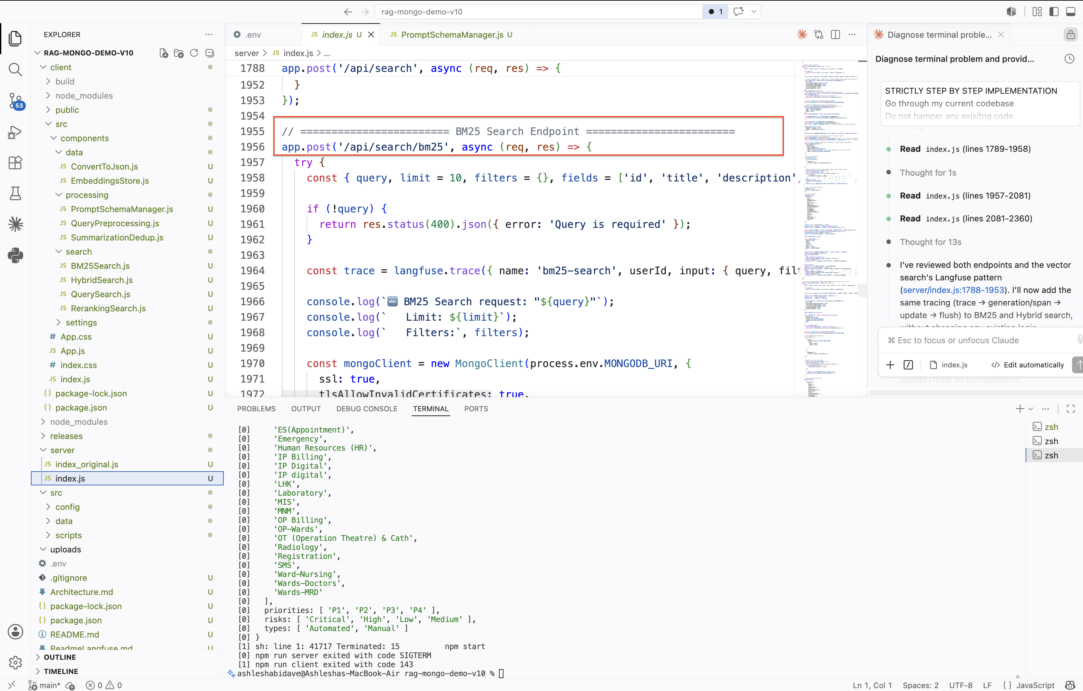
Making the app up and running
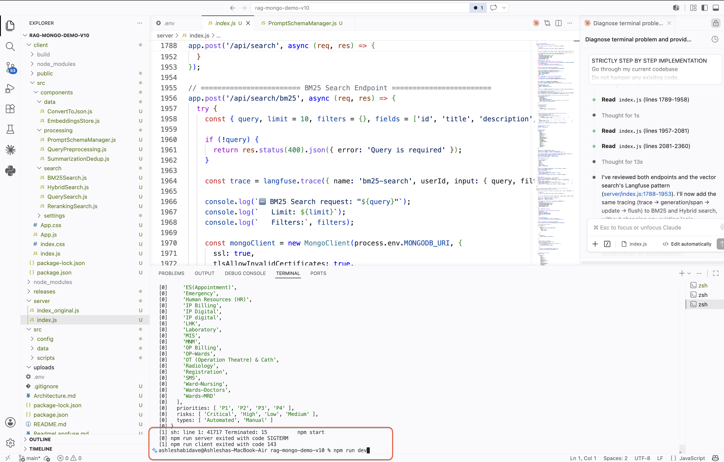
The application is up and running
Performing BM25 Search
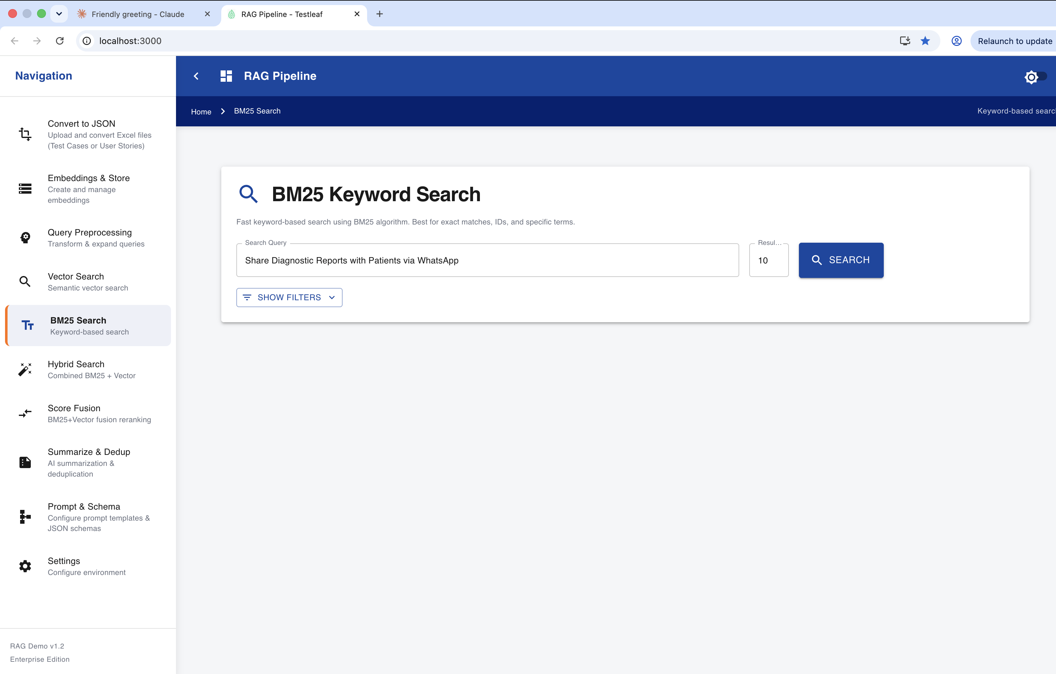

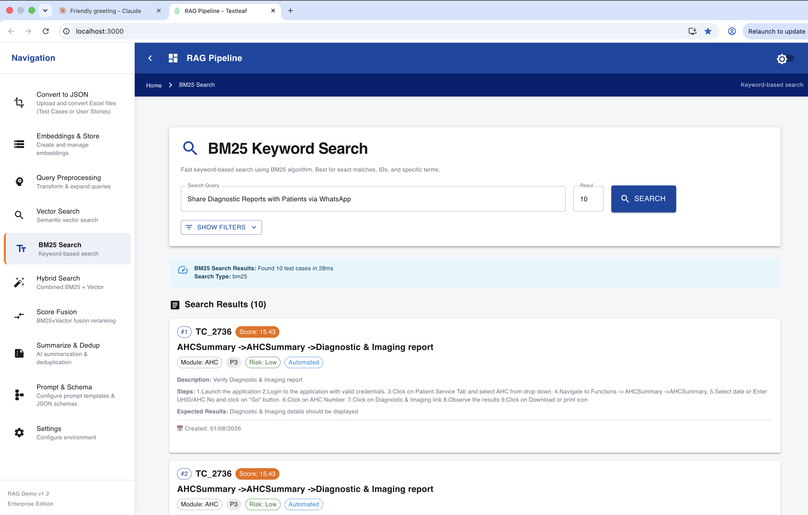
Performing Hybrid Search
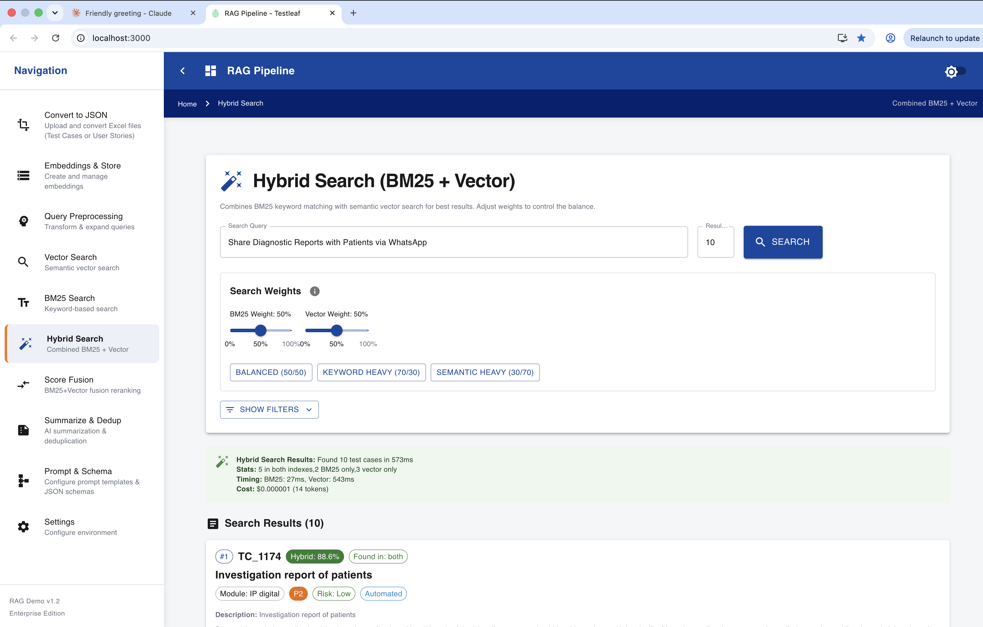
Verifying the traces in Langfuse
Hybrid Search
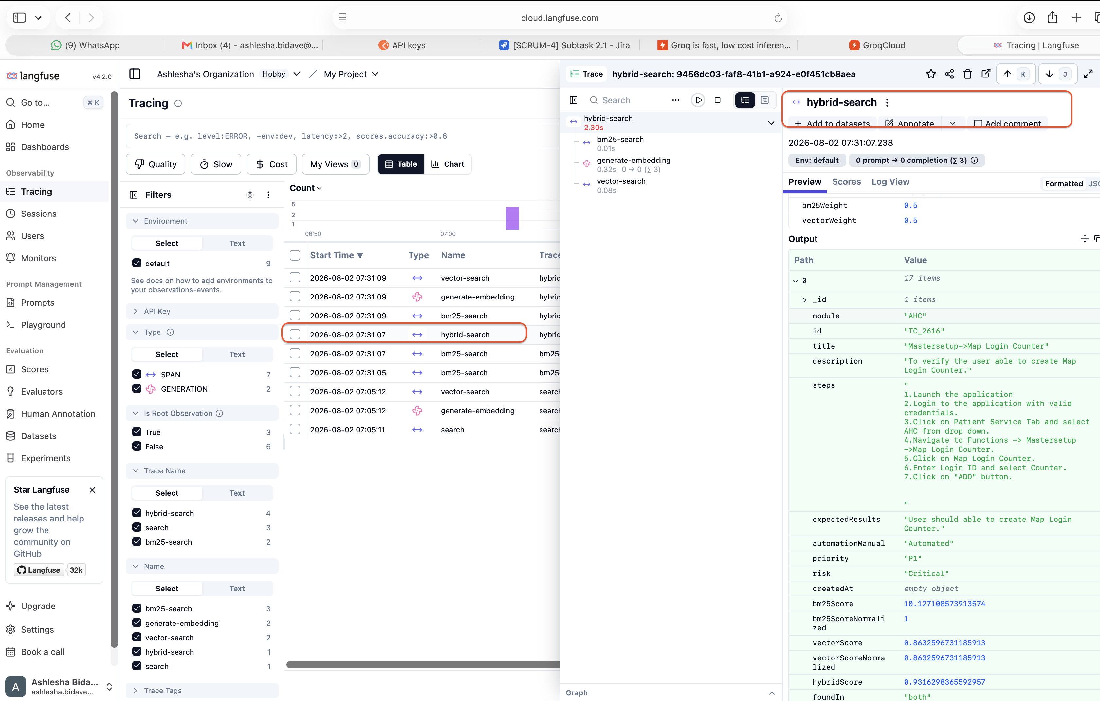
BM25 Search
