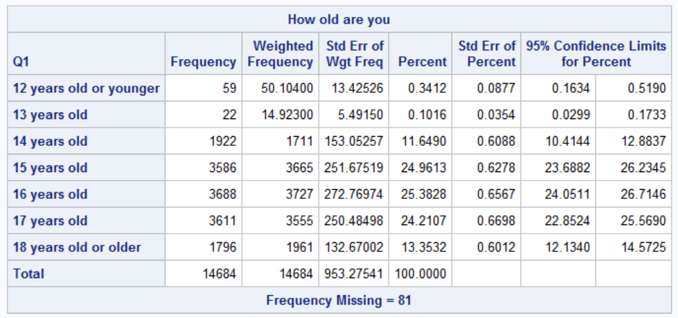

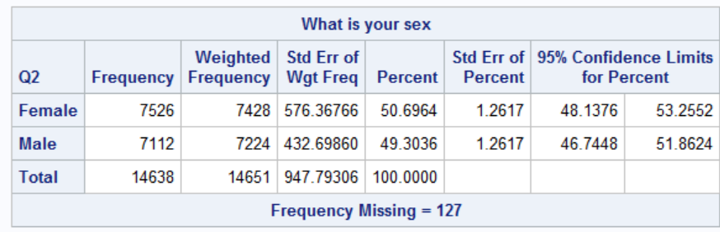

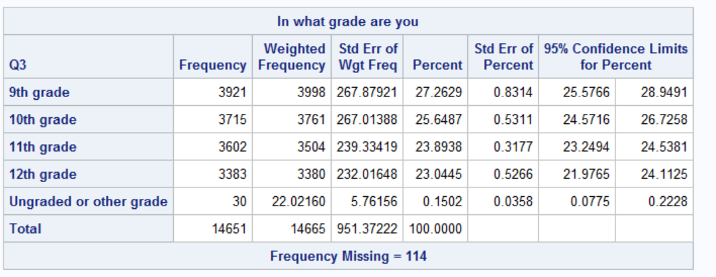

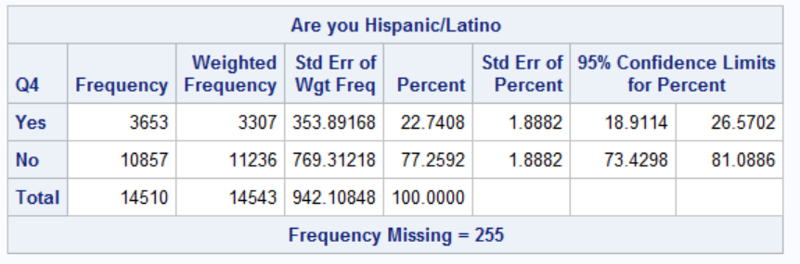

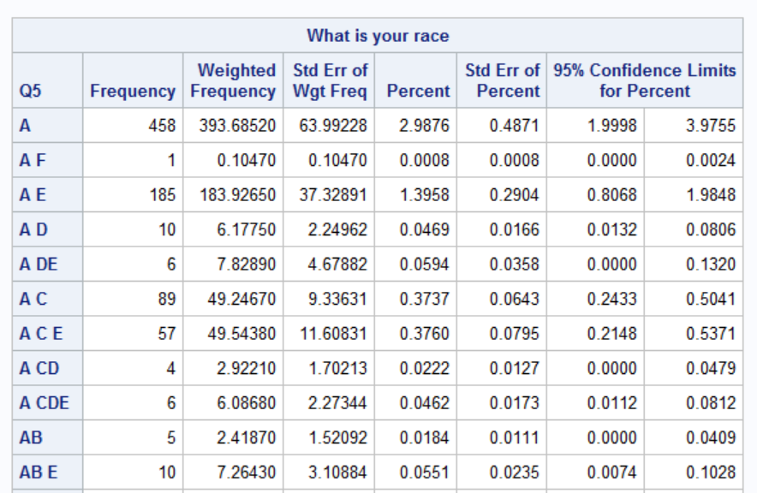

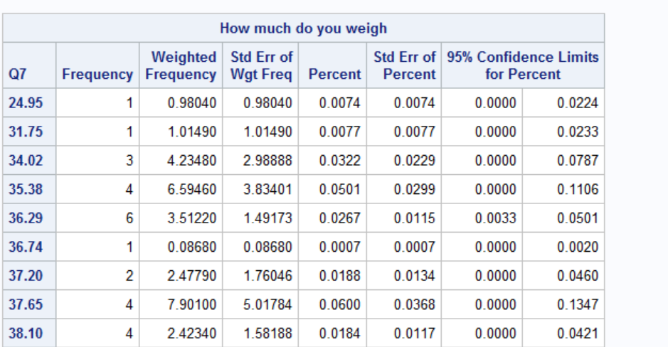

Seat belt use- correlation

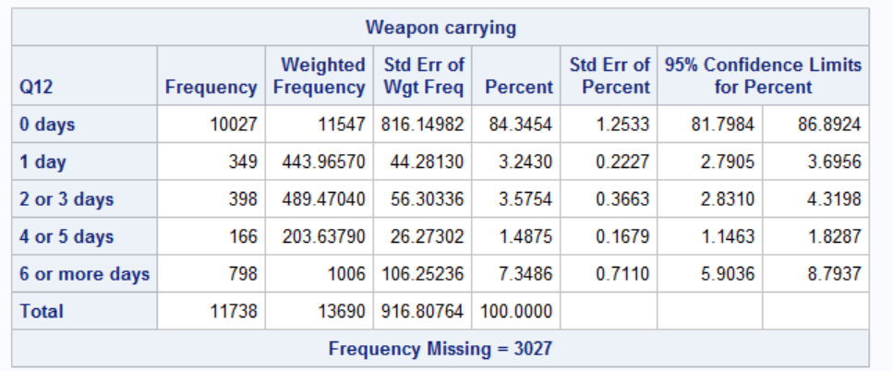

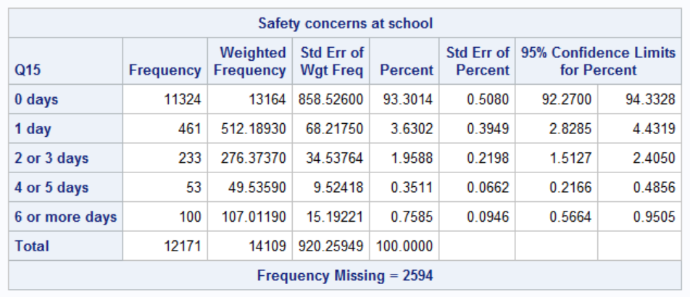

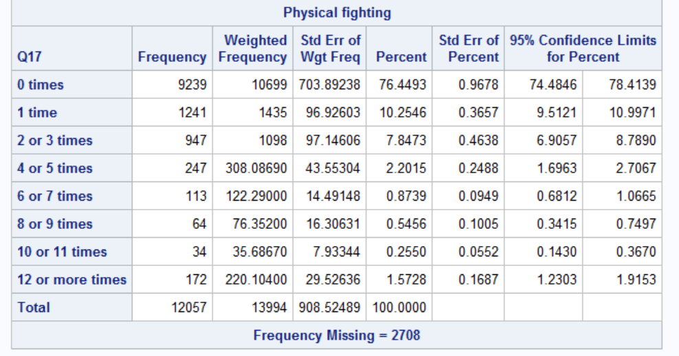

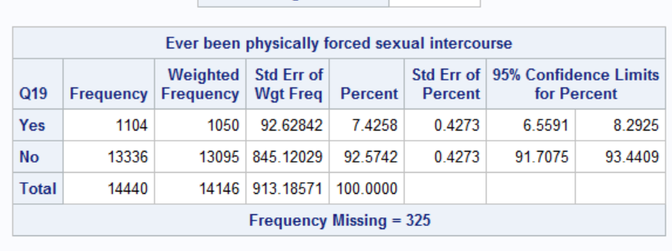

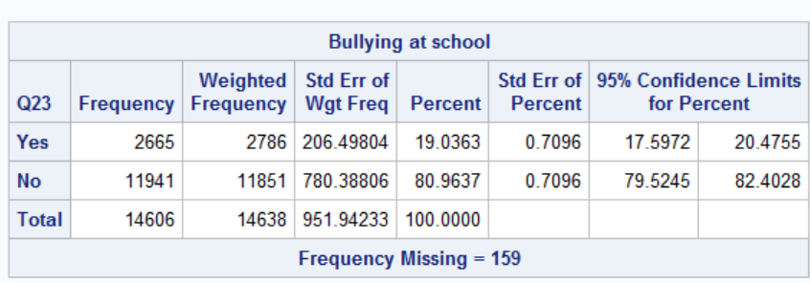

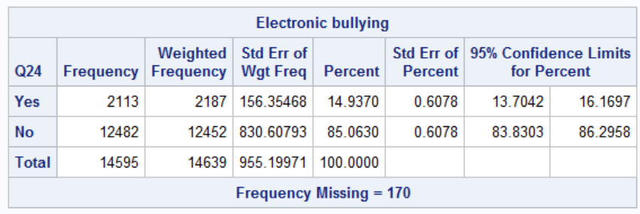

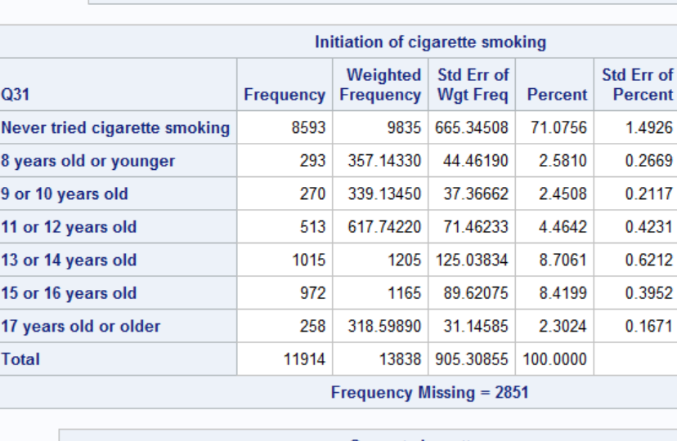

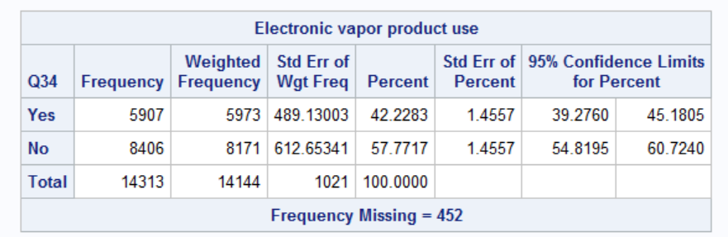

Alcohol → Q42(Current alcohol use), Q45(Largest number of drinks)

Drugs → Q48(Marijuana use), Q58(illegal drugs at school)

Sexual behavior → Q59(sexual intercourse ever), Q62(current sexual behavior), Q67(sexual identity)

Weight management → Q68(perception of weight), Q69(weight loss)

Fruits → Q70(drink fruit juice), Q71(eat fruits), Q72(Green salad eating),

Soda&milk → Q76(soda drinking), Q77(milk drinking), Q78(breakfast eating),

activities → Q79(physical activity), Q80(Television watching), Q81(Video games), Q83(Sports), Q88(hours of sleep), Q89(grades), Q98(Mental issues),Q99(English speaking)

Rejected:

Tall

Weight

Riding with drinking driver

Driking and driving

Texting and driving