### EXPT.NO. 6

### CLASS : B.E. E &TC SUBJECT : IoT

**ROLL No. : DATE :**

**TITLE : IoT based Web Controlled Home Automation using**

**Raspberry Pi.**

**PROBLEM STATEMENT:**

To develop RFID based automatic door opening and closing system.

OBJECTIVE **:**

1. To understand the installation and configuration of Django.
2. To develop program to upload the data to cloud and analyze it.
3. Interfacing of EM-18 RFID Reader and Stepper Motor with RPi.

**S/W PACKAGES AND H/W USED:**

Raspberry Pi, Stepper Motor, EM-18 Module, RFID Tag, Adapter and connecting wires.

**THEORY:**

## Home Automation

Home automation is the process of controlling home appliances automatically using various control system techniques. The electrical and electronic appliances in the home such as fan, lights, outdoor lights, fire alarm, kitchen timer, etc., can be controlled using various control techniques.

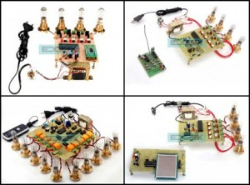

Fig. Various Applications of Home Automation

The [**concept of Home Automation**](https://smartify.in/knowledgebase/what-is-home-automation/) aims to bring the control of operating your every day home electrical appliances to the tip of your finger, thus giving user affordable lighting solutions, better energy conservation with optimum use of energy. Apart from just lighting solutions, the concept also further extends to have a overall control over your home security as well as build a centralized home entertainment system and much more. The **Internet of Things** (or commonly referred to as IoT) based Home Automation system, as the name suggests aims to control all the devices of your smart home through internet protocols or cloud based computing.

The IoT based Home Automation system offer a lot of flexibility over the wired systems s it comes with various advantages like ease-of-use, ease-of-installation, avoid complexity of running through wires or loose electrical connections, easy fault detection and triggering and above and all it even offers easy mobility.

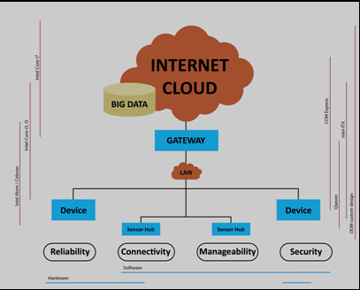

Thus IoT based Home Automation system consist of a servers and sensors. These servers are remote servers located on Internet which help you to manage and process the data without the need of personalised computers. The internet based servers can be configured to control and monitor multiple sensors installed at the desired location.

**BLOCK DIAGRAM:**

**CONCLUSION:**

### _______________________________________________________________________________________________________________________________________________________________________________________________________________________________________________________________________________________________________________________________________________

**ATTACHMENTS**

RPi interfacing diagram with following peripherals (with programs and output):

a. Door control using RFID and stepper motor

**REFERENCES:**

a. *https://www.raspberrypi.org*