|  |  |  |  |  |  |  |  |  |
| --- | --- | --- | --- | --- | --- | --- | --- | --- |
| **Employability Skills& Mini Project** | | | | | | | | |
| **Class & Batch** | | **:** | **TE-5; K5** | | **Group No.** | | **:** | **3** |
| **Synopsis**  **on** | | | | | | | | |
| **“MULTIPLE LANGUAGE DISPLAY UNIT”** | | | | | | | | |
|  | | | | | | | | |
| **Submitted By** | | | | | | | | |
|  | | | | | | | | |
| **Roll No.** | **Name of the Student** | | | **e-mail id** | | **Mobile No.** | | |
| **3503** | **Aditi Dorle** | | | **dorle.aditi@gmail.com** | | **7743876151** | | |
| **3506** | **Akhil Rane** | | | **ar.federer@gmail.com** | | **9604780239** | | |
| **3508** | **Ashlesh Khajbage** | | | **ashleshuk@gmail.com** | | **9168003015** | | |
|  | | | | | | | | |
| **Project Guide:**  **Dr. R. Sreemati** | | | | | | | | |
|  | | | | | | | | |
|  | | | | | | | | |
|  | | | | | | | | |
|  | | | | | | | | |
| **DEPARTMENT OF ELECTRONICS AND TELECOMMUNICATIONS**  **PUNE INSTITUTE OF COMPUTER TECHNOLOGY**  **Academic Year : 2018 - 2019** | | | | | | | | |
|  | | | | | | | | |

1. **Project Title: MULTIPLE LANGUAGE DISPLAY UNIT.**

**2. Introduction/ Motivation :**

**Why is the name board in railway stations written in three languages? As Railways falls under the Ministry of Railways of the Central Government, it follows the above two articles of the Constitution of India. Hence for the spread of Hindi as the Official Language (Raajbhasha), All stations display name boards in three languages i.e. English, Hindi and the official language of the state. The Same is with the case of bus stations, airports, locals trains, and buses etc. the displays used to announce the arrival and departure of a particular train, bus. There are many such displays used at a time on these stations. These displays are also used to display various other important messages like if someone’s missing if anyone has lost their belongings, which part of the stations the entire schedule can be seen, etc. Hence, such displays are usually called PLATFORM DISPLAYS.**

**These displays are mainly made up of an LED- matrix. The LED-matrix consists of many LEDs grouped together to form a matrix and is controlled through a control unit and a controller. This matrix mainly displays the messages pre-stored or short messages which can be instantly displayed from an interface for a certain amount of time. The led-matrix can be of 24x8 LEDs. It will be a sliding display, which will display words or messages (characters and numbers) in Hindi or English language.**

**3. Literature Survey / Prior work :**

**In earlier times when bus and railway stations were not developed and people had to find out time and wait hours for their buses and trains to arrive. There used to be pre-scheduled printed boards of arrival and departure of trains and buses. Then there used to be simple announcements through microphones and loudspeakers explaining the time of arrival and departure or the delay of the trains. Also, the driver has to yell about the next stop. But as the technology grew, platform displays came into existence. People could now read as to when their train will arrive. Since there are people from different linguistic backgrounds in India, there is a need for multiple language displays. The first platform displays were set in Britain and later on adapted worldwide. This project is just an extension of platform displays with additional benefits.**

**4. Problem Definition and Objectives :**

**The project will consist of an LED-MATRIX (24X8) which will be used to display the short and concise messages. The LED-MATRIX will be controlled using a control circuit/module and a controller. The major objective of this project is that in a place like India, where different people speak and understand different languages we need to account to their needs. The messages are after all displayed for the people’s benefit. So, everyone should be able to understand displayed messages easily, hence this concept of different language display.**

**5. Objectives :**

**1. Multiple languages to be displayed: Hindi, English.**

**2. Self-made LED MATRIX.**

**3. 24x8 LED MATRIX**

**1.Block Diagram :**

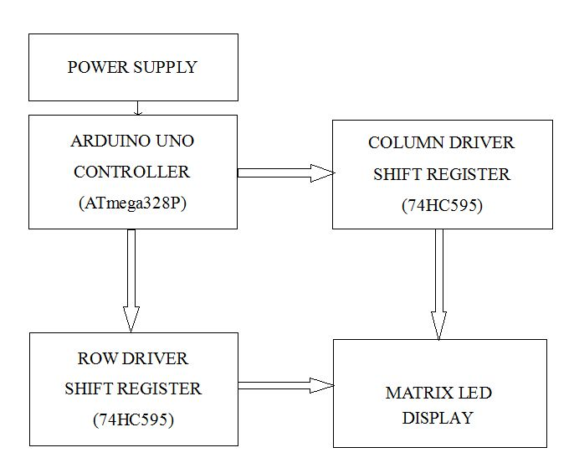

1. **Power Supply** - Through the Power Supply, we'll provide 5V and 3.3V for the microcontroller board and communication module that may be wifi module or a Bluetooth module.

2. **PIC microcontroller-** The PIC stands for Peripheral Interface Controller. The microcontroller generates the output logic pulses so that the LED light is switched ON and OFF at certain intervals. The Crystal interfaced to the input pins of the microcontroller provides accurate clock signals at the crystal frequency.

3.**Control Unit**-The circuit is able to drive a 24×8 LED matrix using an external Microcontroller. Control signals can be easily generated by a microcontroller.

1. **LED Matrix**- In a dot matrix display, multiple LEDs are wired together in rows and columns. This is done to minimize the number of pins required to drive them. For example, an 8×8 matrix of LEDs (shown below) would need 64 I/O pins, one for each LED pixel. By wiring all the anodes together in rows (R1 through R8), and cathodes in columns (C1 through C8), the required number of I/O pins is reduced to 16. Each LED is addressed by its row and column number.

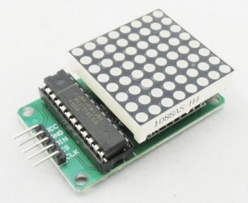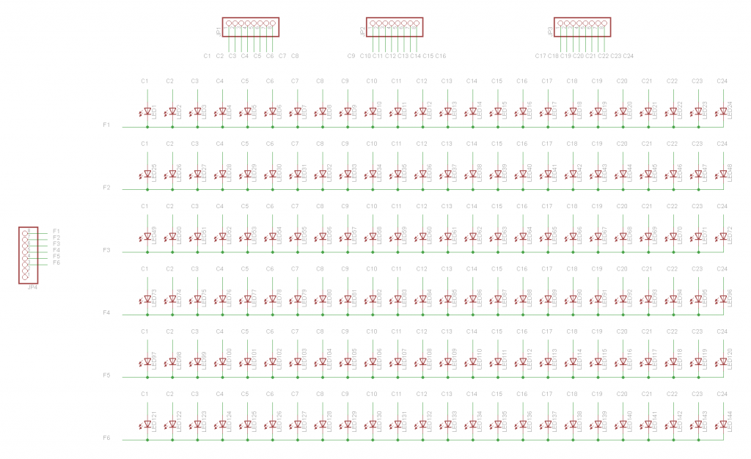

1. **Hardware Requirements:**
2. LEDS
3. SHIFT REGISTERS
4. RESISTORS
5. DECADE COUNTERS
6. WIFI / BLUETOOTH MODULE
7. DC POWER SUPPLY
8. MICROCONTROLLER
9. USB-to-SERIAL CONVERTER
10. **Software Requirements:**
11. MPLAB/ARDUINO/PUTTY
12. PROTEUS
13. EAGLE
14. **References**
15. Electronics LAB, Santi Rodríguez: 24x6 led matrix control unit[online]. Available from: <http://www.electronics-lab.com/project/24x6-led-matrix-control-circuit/>
16. Intructables, [karthimech09](https://www.instructables.com/member/karthimech09/) : 48x8 Scrolling matrix Display using arduino [online]. Available from:  <https://www.instructables.com/id/Make-a-24X6-LED-matrix/>