OPTIMISATIONS

MOD **************************************

f64
mod (vector a)
{
vector r;
f64 modulo;
r.x = a.x * a.x;
r.y = a.y * a.y;
modulo = sqrt(r.x + r.y);
return modulo;
}

EN

f64
mod (vector a)
{
f64 modulo = (a.x*a.x) + (a.y*a.y);
return sqrt(modulo);
}

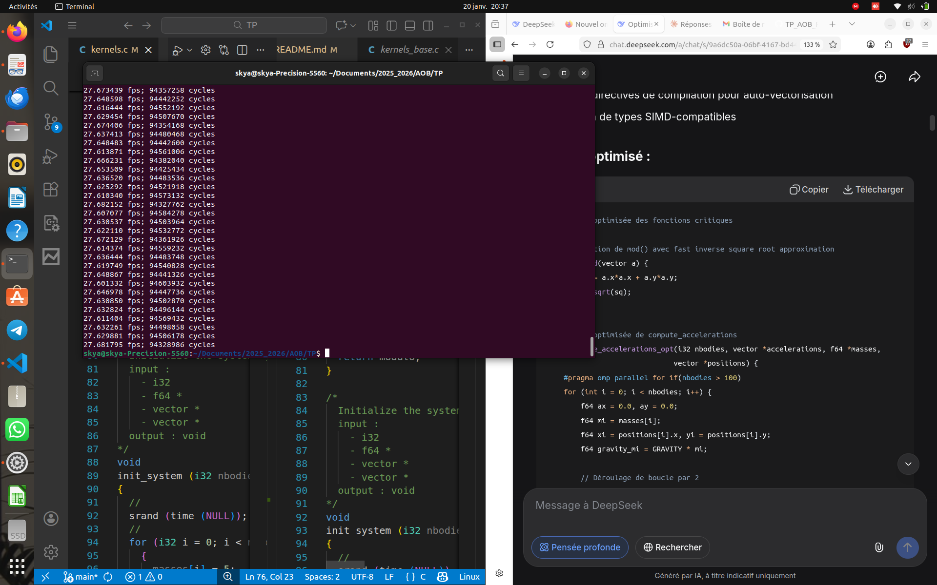
COMPUTE ACCELERETION ******************************************************

void
compute_accelerations (i32 nbodies, vector *accelerations, f64 *masses,
vector *positions)
{
for (int i = 0; i < nbodies; i++) {
accelerations[i].x = 0;
accelerations[i].y = 0;
for ( int j = 0; j< nbodies; j++) {
if (i==j) continue;
vector diff = sub_vectors(positions[j], positions[i]);
vector diff2 = sub_vectors(positions[i], positions[j]);
f64 d = pow(mod(diff2), 3) + 1e7;
f64 f = GRAVITY * masses[i] / d;
vector a_ij = scale_vector(f, diff);
accelerations[i] = add_vectors(accelerations[i], a_ij);
}
}
}

en

void
compute_accelerations (i32 nbodies, vector *accelerations, f64 *masses,
vector *positions)
{
for (int i = 0; i < nbodies; i++) {
accelerations[i].x = 0;
accelerations[i].y = 0;
for ( int j = 0; j< nbodies; j++) {
if (i==j) continue;
vector diff = sub_vectors(positions[j], positions[i]);
vector diff2 = sub_vectors(positions[i], positions[j]);
f64 d = pow(mod(diff2), 3) + 1e7;
f64 f = GRAVITY * masses[i] *(1/d); //////////////////////////// { on a remplacer x/y par (1/y)*x }
vector a_ij = scale_vector(f, diff);
accelerations[i] = add_vectors(accelerations[i], a_ij);
}
}
}

