**Instructions for GUI software for the detection, feature extraction, and classification of episodes of spontaneous activity**

Developed by: Ashley Dalrymple, early stages by Nathan Osachoff

Program last updated: Aug. 13, 2018 (Mac: Aug. 30, 2018)

Instructions last updated: Aug. 30, 2018

The program was written using Matlab R2017b.

**When using this GUI software for academic purposes, please cite the following manuscript:**

Dalrymple AN, Sharples SA, Osachoff N, and Whelan PJ. A Supervised Machine Learning Approach to Characterize Spinal Network Function. 2018.

***** The citation will be updated once acceptance has been confirmed*****

Standalone:

You will need to download the compiler for Matlab R2017b (version 9.3):

Windows: <https://www.mathworks.com/products/compiler/matlab-runtime.html>

Mac: <http://www.mathworks.com/products/compiler/mcr/index.html>

For .exe (Windows) or .app (Mac): double click to open. This will open the terminal briefly before a prompt will pop-up asking you to open a data file.

M-file:

Open Matlab

Launch SpontaneousClassification function (type in command window). A prompt will appear asking you to open a data file.

Opening a data file

This program can open .abf files (The .abf files in this work were obtained using Clampex software (Molecular Devices, Sunnyvale, CA)) or .mat files that were previously saved using the GUI.

**Note**: For the m-file: the data and program should be in the same folder.

For the standalone: check which default folder opens when you run the program. This is the folder that your data should be moved to.

Otherwise, an error will occur and the program will close.

When prompted, select a .mat file OR to **select an .abf file**, select All Files from the file-type drop-down menu to reveal .abf files

If you are a Mac user, click Options on the dialog box and enable All Files

Select the file you wish to analyze. Some text containing file information will appear in the command window, followed by the GUI opening displaying your data.

You will get a display such as the following: the borders around the menu are for instructional purposes

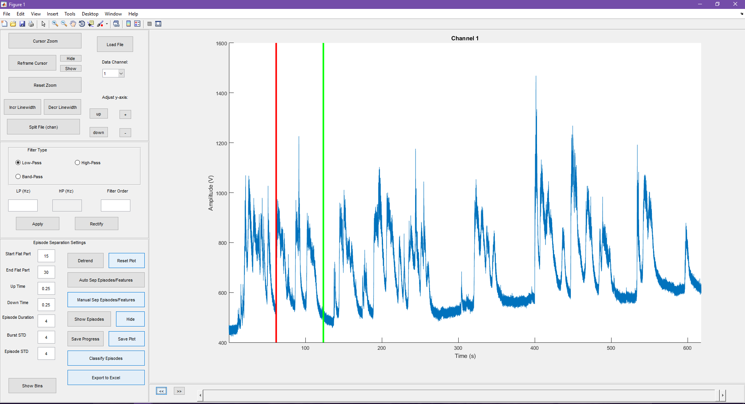

The red border indicates the visualization module. Functions for each button:

* Cursor zoom: zooms in on area between red and green lines. The lines can be moved to a region of interest
* Reframe cursor: brings cursors back into view
* Hide/Show: hides and shows red and green lines
* Reset zoom: un-zooms data to show original view
* Incr linewidth /decr. linewidth: adjusts line thickness of data
* Split file: if data file is too long, cross-hairs will allow you to select regions for splitting the file. The first and last data point are automatically selected, so you only need to select regions in between. The new data files will save as .mat files: OriginalFile_Chan#_x.mat where x refers to the number of the split region

Example: if you click 2 different regions it will split the file into 3 new files, each saved separately. ‘x’ will equal 1, 2, and 3 for each file, respectively. You will need to then load the new file to work on it.

* Load file: load a new file. Can load .mat or .abf as in launch of program
* Data Channel: drop-down menu. Select which channel from file you would like to view and work on. Channel manipulations are saved in isolation so you can extract features for all channels and export data for all.
* Adjust y-axis:
  + Up: shifts axis up so data is higher in view
  + Down: shifts axis down so data is lower in view
  + + : zooms in on y-axis to smaller partitions
  + - : zooms out of y-axis to larger partitions

Additional visualization tool: underneath the data plot there are arrows. If you zoom in a bar is revealed. You can use these to move along the data in the time axis, or zoom in and out along the x-axis.

The filter module is surrounded by the blue box:

Select filter type, type in frequency value and filter order, then hit apply. To rectify data, select rectify. These settings are saved for each channel.

The green box surrounds the feature extraction and classification module:

* Detrend: brings up crosshairs to select regions of different slopes to bring all the data to a common baseline. The first and last data point are automatically selected so you just need to select regions in between. This may need to be done multiple times to get the episodes on a flat line.
* Reset plot: this undoes any detrending, filtering, or any other modifications to the plot
* The numbers in the boxes on the left correspond to settings for thresholds to detect episodes of activity. The only ones that you should modify are the first 2: start flat part, end flat part. Use ‘show bins’ to guide these values.
* Show bins: Sorts all data points from a channel into bins of ascending amplitude. The resultant amplitude plot of the data displays all data points of extreme high amplitude on the right representing bursting activity, with a flat region of data points on the left that represents non-bursting activity. You want to use the numbers from the flat region and type them into the aforementioned boxes. These may need to be adjusted to get the episode detection to your liking.
* Auto Sep Episodes/Features: Using the settings on the left, finds episodes of activity and extracts the features from each of them. This saves a .mat file with the name of the OriginalFile_detect.mat. If you click this button after changing the settings, the file is over-written. A message box will appear to inform you when the features are done being extracted.
  + Features extracted for each episode: start data point, end data point, start time, end time, duration, peak frequency, bandwidth, peak power at freq, maximum amplitude, average amplitude, maximum amplitude (%), average amplitude (%).
* Manual Sep Episodes/Features: Brings up cross-hairs to manually select episode start and end points, then extracts the features from each of them. This saves a .mat file with the name of the OriginalFile_manualdetect.mat. If you click this button after selecting new episodes, the file is over-written. Same features are extracted from each episode.
* Show episodes/hide: Once episodes are selected from either method, shades in regions of episodes. This can guide the settings for auto-detection. Hide removes the shading from the plot.
* Save progress: If you wish to come back and continue to work on a file later, can save progress at any time. This saves a .mat file with the name of the OriginalFile_progress.mat. If you work on it more and click save progress again, it will over-write the file. A message box will appear to inform you when your progress has been saved.
* Save plot: saves the plot of the current channel into a Matlab figure and as a .png file. Name = OriginalFile_Channel-#trace.fig (or .png).
* Classify Episodes: Classifies episodes using multilayer perceptrons into one of 5 classes. This function will classify all episodes from all traces within a file with one click. It will create a .mat file with the name OriginalFile_classify.mat. A message box will appear to inform you when the episodes have been classified.
* Export to excel: Once episodes have been classified, this button generates a table that is saved as both a .mat file (name = OriginalFile_table.mat) and to an excel file (name = OriginalFile_features.xlsx). Any channel that has been classified will be present in table.
  + The table first lists the features and classes for each episode channel-by-channel. The episodes are numbered on the left, followed by the feature values, and finally the classification. Average and standard deviation for each feature and the mode for the class are below for each channel.
  + The table also lists the feature information according to class. Specifically, the number of instances of the class, the proportion of the total number of episodes, and the feature values for the episodes of each class are listed. This also includes average and standard deviation calculations for each class.
  + A sample of the excel output is shown in the figure on the following page.

The class labels in the excel spreadsheet are numbered 1 – 5. These numbers correspond to the following classes:

1: Small amplitude

2: Large amplitude, not rhythmic

3: Large amplitude, rhythmic

4: Multi-burst, rhythmic

5: Multi-burst, not rhythmic

A Matlab figure and .png file are also generated containing histograms for the following features: duration, pk frequency, bandwidth, pk power, max amp (%), and avg amp (%) for each channel. Name = OriginalFile_Channel-#histograms.fig (or .png).

Users are encouraged to gain intimate knowledge of their data prior to using this tool. Thoroughly understanding the features extracted will guide understanding and interpretation of the classification results. If the classification results appear erroneous, consider the following checklist:

* Is the data appropriate for this tool? How was your data acquired? This tool is designed for DC-coupled recordings.
* Is your version of Matlab or the compiler 2017 or later?
* Did you detrend properly?
* Are the episodes separated correctly?
* Is your file too big? Sometimes long recordings can be difficult to generalize on all in one go. Try splitting up the file and treating smaller sections separately. This can be useful for files that have changes in activity, are noisy, or if you’re having difficulty separating the episodes properly.
* Double check the feature values for each episode in the spread sheet. Do they make sense to you?
* Are you reading the output correctly?

