DriverPass System Design Document
CS-255 Project Two
This design addresses the system described in the DriverPass client interview. It includes five UML diagrams and the technical requirements needed to support registration, training, scheduling, and secure recordkeeping.

UML Use Case Diagram
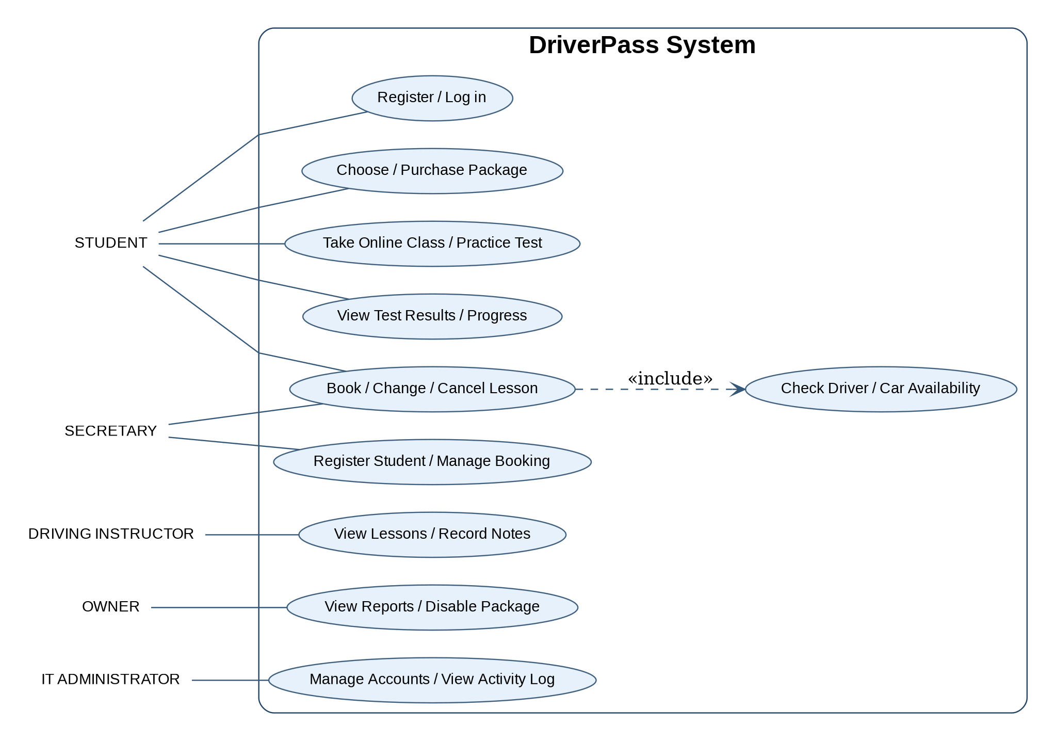
This diagram shows how students, the secretary, instructors, the owner, and the IT administrator use the system.

UML Activity Diagram 1 — Schedule a Driving Lesson
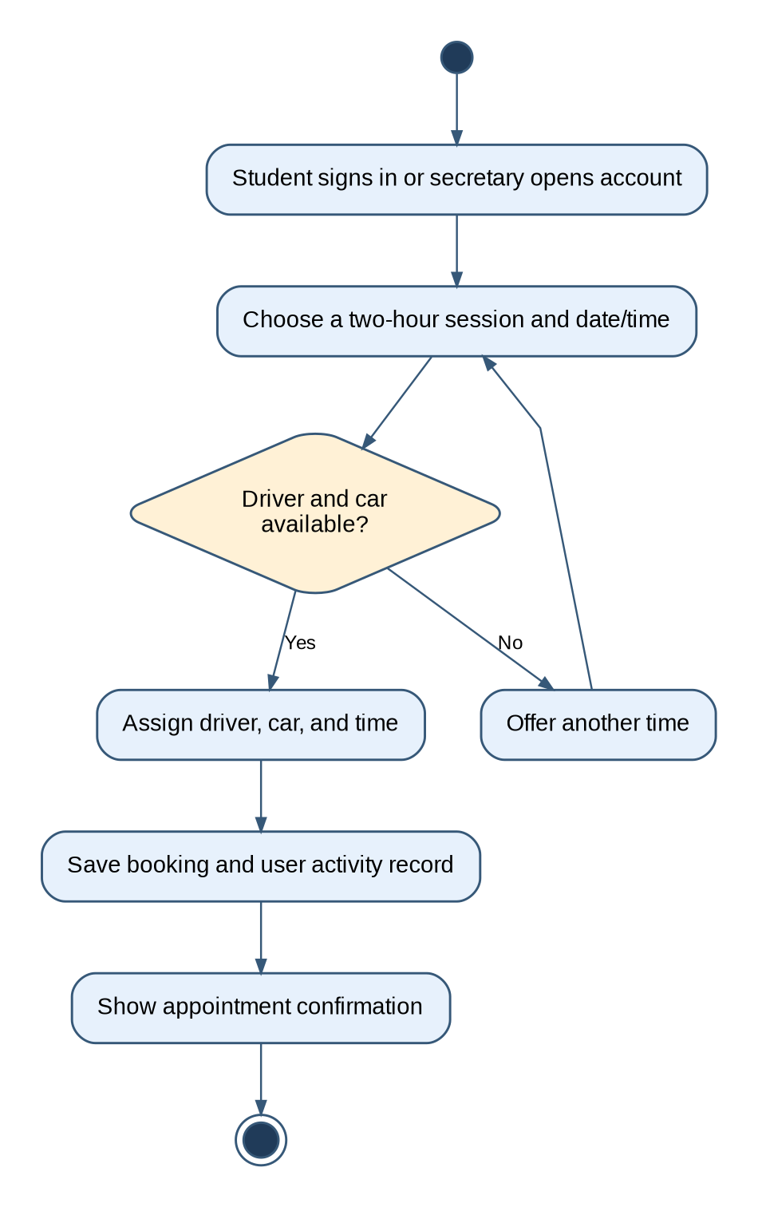
A booking must reserve an available instructor, vehicle, and two-hour time slot. If none is available, the student chooses another time.

UML Activity Diagram 2 — Take a Practice Test
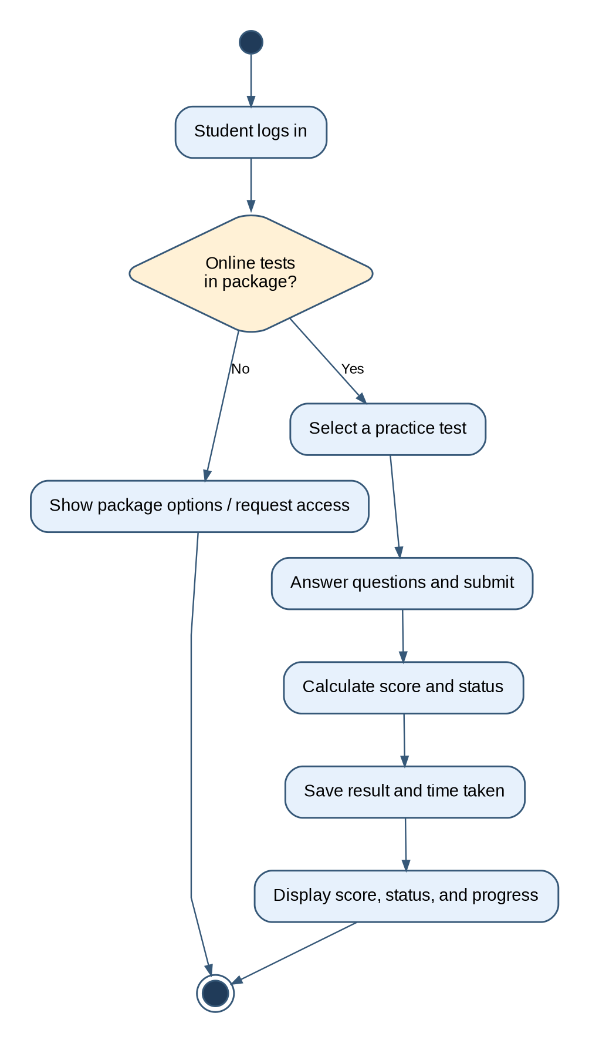
Practice tests are available to students whose selected package includes online training. Scores and completion status are saved.

UML Sequence Diagram — Schedule a Driving Lesson
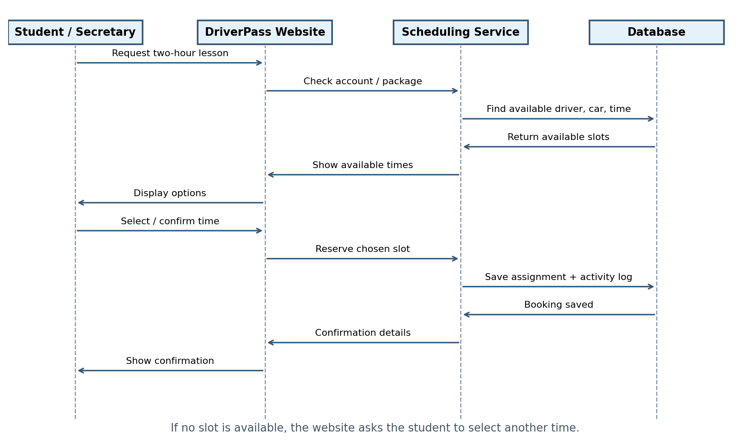
The website checks the student account, obtains available times, saves the selected reservation, and confirms the booking.

UML Class Diagram
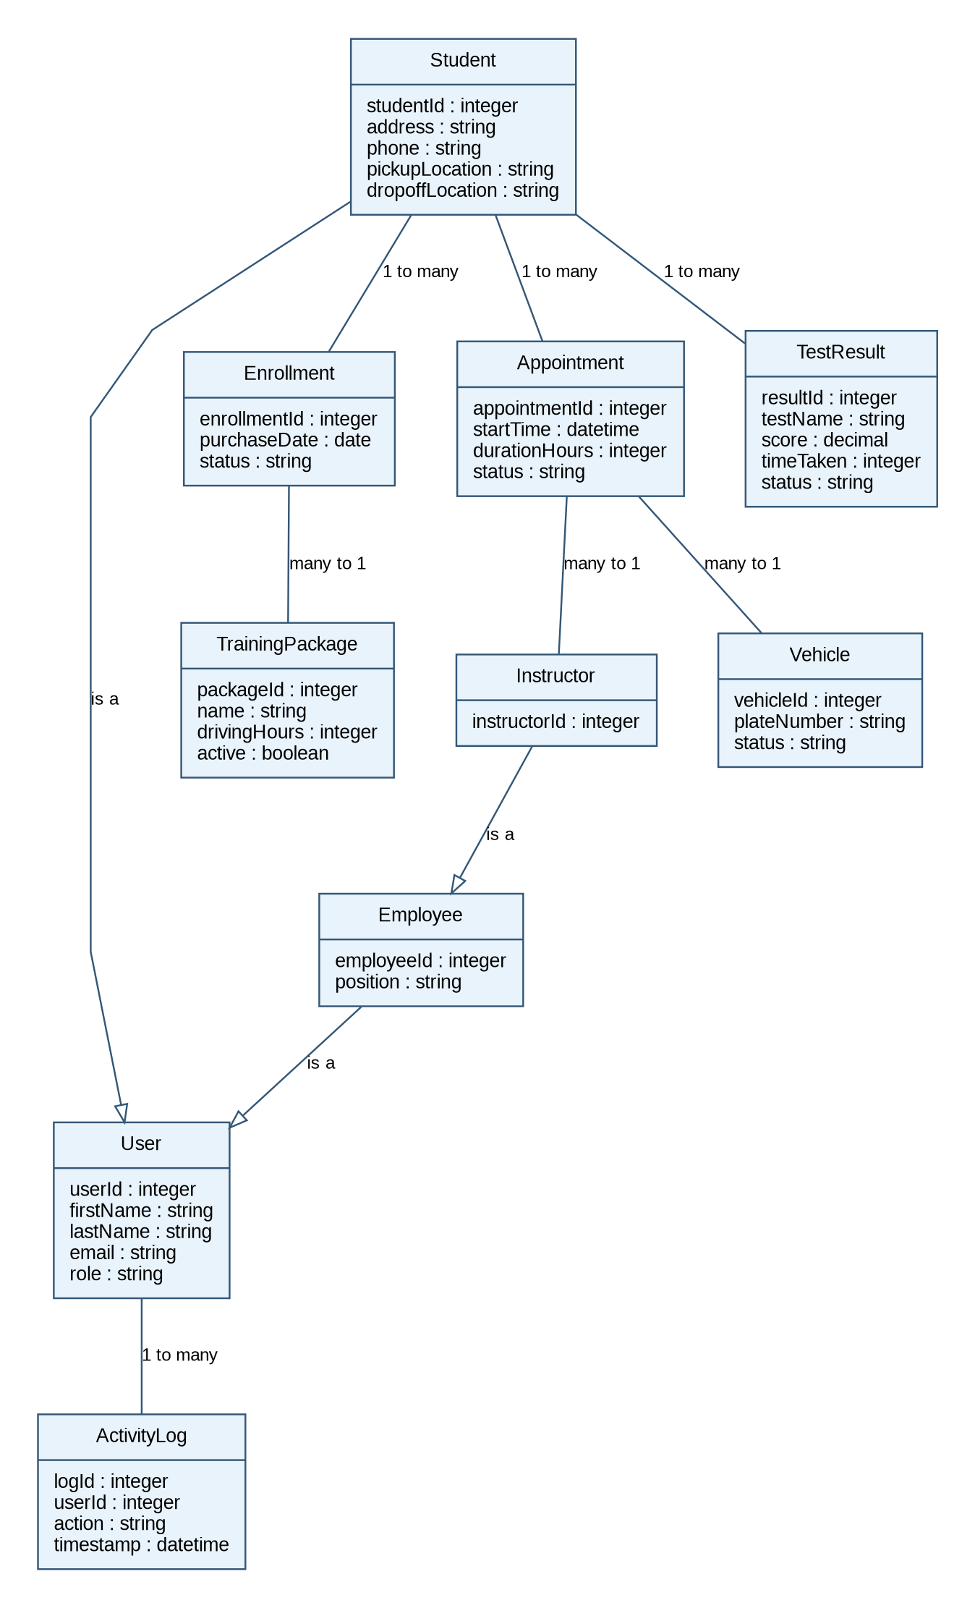
The main records cover students, staff, training packages, enrollments, appointments, vehicles, instructors, practice-test results, and activity logs.

Technical Requirements
Hardware: Students and employees need an internet-connected computer, tablet, or phone. The office needs workstations and a printer for reports; instructors need a supported mobile device or office access.
Software and platforms: A responsive browser-based site supported on current Windows, macOS, Android, and iOS browsers, plus a cloud-hosted application and relational database.
Cloud infrastructure: Managed hosting, HTTPS, automated backups, system monitoring, and recovery procedures. Downloaded reports may be opened offline in spreadsheet software, but live records require an internet connection to update.
User permissions: Distinct student, secretary, instructor, owner, and IT administrator accounts. IT can add, modify, disable, and reset accounts without source-code changes.
Lesson scheduling: All on-road lessons last two hours. Check package hours and prevent double-booking any instructor or vehicle. DriverPass has ten cars.
Training packages: Package One: six driving hours. Package Two: eight driving hours and an in-person DMV rules lesson. Package Three: twelve driving hours, an in-person DMV lesson, online classes, and practice tests. The owner can disable packages; new modules require later development.
Student and training records: Store student contact and pickup/drop-off details, enrollments, lesson history, instructor notes, test names, scores, time taken, and status (not taken, in progress, failed, or passed).
Security and payments: Use encrypted connections, protected storage, account access controls, and a compliant payment provider. Do not retain payment card security codes.
Accountability and DMV changes: Log who created, modified, or canceled a reservation and when. Notify designated staff when DMV rules or questions are updated, subject to available DMV information.
Proposed performance and maintenance targets: For client approval: 95% of normal page requests within three seconds; 99.5% monthly availability; daily backups with recovery testing; timely IT alerts for critical errors. These targets are recommendations, not stated client requirements.
Validation and updates: Validate required fields, use case-insensitive name searches, prevent duplicate reservations, apply routine security patches, and test browser/platform compatibility after updates.

