**Sustainable Development Goal 1 (SDG 1 or Global Goal 1)**, one of the 17 [Sustainable Development Goals](https://en.m.wikipedia.org/wiki/Sustainable_Development_Goals) established by the [United Nations](https://en.m.wikipedia.org/wiki/United_Nations) in 2015, calls for the end of [poverty](https://en.m.wikipedia.org/wiki/Poverty) in all forms. The official wording is: "No Poverty". Member countries have pledged to "Leave No One Behind": [underlying](https://en.m.wikipedia.org/wiki/Underlying) the goal is a "powerful commitment to leave no one behind and to reach those farthest behind first". Sustainable

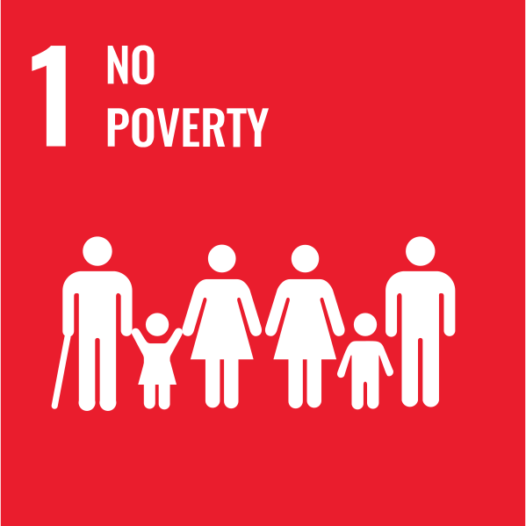

[**Mission statement**](https://en.m.wikipedia.org/wiki/Mission_statement)

"End poverty in all its forms everywhere"

**Type of project**

[Non-Profit](https://en.m.wikipedia.org/wiki/Nonprofit_organization)

**Location**

Global

**Founder**

[United Nations](https://en.m.wikipedia.org/wiki/United_Nations)

**Established**

2015

SDG 1 aims to eradicate every form of [extreme poverty](https://en.m.wikipedia.org/wiki/Extreme_poverty) including the lack of food, clean drinking water, and [sanitation](https://en.m.wikipedia.org/wiki/Sanitation). Achieving this goal includes finding solutions to new threats caused by [climate change](https://en.m.wikipedia.org/wiki/Climate_change) and [conflict](https://en.m.wikipedia.org/wiki/Conflict_(process)). SDG 1 focuses not just on people living in poverty, but also on the services people rely on and social policy that either promotes or prevents poverty.

The goal has seven targets and 13 indicators to measure [progress](https://en.m.wikipedia.org/wiki/Progress). The five outcome targets are: eradication of extreme poverty; reduction of all poverty by half; implementation of social protection systems; ensuring equal rights to ownership, basic services, technology and economic resources; and the building of resilience to environmental, economic and social [disasters](https://en.m.wikipedia.org/wiki/Disaster). The two targets related to means of implementation SDG 1 are [mobilization](https://en.m.wikipedia.org/wiki/Mobilization) of resources to end poverty; and the establishment of [poverty](https://en.m.wikipedia.org/wiki/Poverty) eradication policy frameworks at all levels.

Despite the ongoing progress, 10 percent of the [world's population](https://en.m.wikipedia.org/wiki/World_population) live in poverty and struggle to meet basic needs such as [health](https://en.m.wikipedia.org/wiki/Health), [education](https://en.m.wikipedia.org/wiki/Education), and access to [water and sanitation](https://en.m.wikipedia.org/wiki/WASH). Extreme poverty remains [prevalent](https://en.m.wikipedia.org/wiki/Prevalence) in [low-income](https://en.m.wikipedia.org/wiki/Poverty) countries, particularly those affected by [conflict](https://en.m.wikipedia.org/wiki/Conflict_(process))and [political upheaval](https://en.m.wikipedia.org/wiki/Political_upheaval). In 2015, more than half of the world's 736 million people living in extreme poverty lived in Sub-Saharan Africa. The [rural poverty](https://en.m.wikipedia.org/wiki/Rural_poverty) rate stands at 17.2 percent and 5.3 percent in urban areas (in 2016).

One of the key indicators that measure poverty is the proportion of population living below the international and national poverty line. Measuring the proportion of the population covered by [social protection systems](https://en.m.wikipedia.org/wiki/Social_protection) and living in households with access to [basic services](https://en.m.wikipedia.org/wiki/Universal_basic_services) is also an indication of the level of poverty.

**Background**

[Poverty](https://en.m.wikipedia.org/wiki/Poverty)

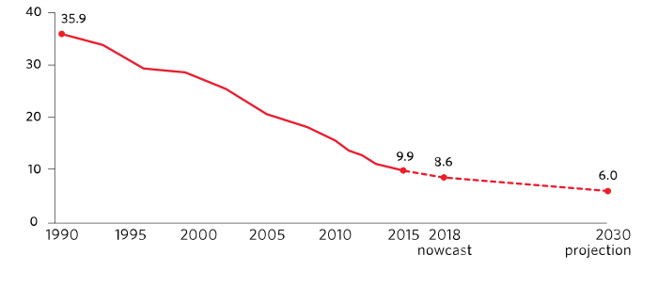

Proportion of people living below $1 90 a day, 1990–2015, 2018 nowcast and 2030 projection (percentage)

In 2013, an estimated 385 million children lived on less than US$1.90 per day. These figures are unreliable due to huge gaps in data on the status of children worldwide.

Since 1990, countries around the world have taken various measures to reduce poverty and achieved remarkable results. The number of people living in [extreme poverty](https://en.m.wikipedia.org/wiki/Extreme_poverty) decreased from 1.8 billion to 776 million in 2013. Still, people continue to live in poverty with the [World Bank](https://en.m.wikipedia.org/wiki/World_Bank)estimating that 40 million to 60 million people will fall into extreme poverty in 2020.

Changes relative to higher poverty lines, not just extreme poverty, are also tracked.

The World Bank's 2024 analysis shows that 22 low-income countries, representing 7% of the global population, have experienced only a 0.26% annual GDP growth since the late 1980s.

**Targets, indicators and progress**

[Poverty eradication](https://en.m.wikipedia.org/wiki/Poverty_reduction) is important for the reduction of inequalities that currently exist among people and for the [socio-economic](https://en.m.wikipedia.org/wiki/Socioeconomics) and political stability of countries left behind. The [UN](https://en.m.wikipedia.org/wiki/United_Nations) defined 7 Targets and 14 Indicators for SDG 1. The main data source for SDG 1 indicators (including maps) come from Our World in Data's SDG Tracker.[5] The targets cover a wide range of issues including the eradication of extreme poverty (target 1.1), reduction of poverty by half (1.2), implementation of [social protection](https://en.m.wikipedia.org/wiki/Social_protection) systems (1.3), ensuring equal rights to ownership, basic services, technology and economic resources (1.4), building of [resilience](https://en.m.wikipedia.org/wiki/Resilience_(engineering_and_construction)) towards environmental, economic and social disasters (1.5), and mobilization of resources to end poverty (1.6).

Targets specify the goals while indicators represent the metrics by which the world aims to track whether these targets are achieved. SDG 1 has two specific poverty reduction targets: eradicating extreme poverty (target 1.1) and reduce poverty by half by 2030 (target 1.2).

Five of the targets are to be reached by 2030, and two have no specified date.

**Target 1.1: Eradicate extreme poverty**

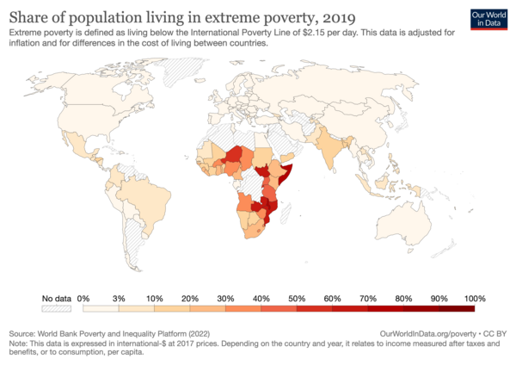

Poverty headcount ratio at $1.90 a day is the percentage of the population living on less than $1.90 a day.

The full text of Target 1.1 is: By 2030, eradicate extreme poverty for all people everywhere, currently defined as living on less than $2.15 per person per day at 2017 purchasing power parity.

Target 1.1 includes one indicator: Indicator 1.1.1 is the "Proportion of population living below the international [poverty line](https://en.m.wikipedia.org/wiki/Poverty_line) aggregated by sex, age, employment status, and [geographical location](https://en.m.wikipedia.org/wiki/Location) ([urban](https://en.m.wikipedia.org/wiki/Urban_area)/[rural](https://en.m.wikipedia.org/wiki/Rural_area))".

It was reported in 2020 that "The share of the world’s workers living in extreme poverty fell by half over the last decade: from 14.3 per cent in 2010 to 7.1 per cent in 2019".

A study published in September 2020 found that extreme poverty had increased by 7 percent in just a few months, after a steady decrease for the last 20 years.

**Target 1.2: Reduce poverty by at least 50%**

The full text of Target 1.2 is: "By 2030, reduce at least by half the proportion of men, women and children of all ages living in poverty in all its dimensions according to national definitions."

Indicators include:

* Indicator 1.2.1: Proportion of population living below the national [poverty line](https://en.m.wikipedia.org/wiki/Poverty_line).
* Indicator 1.2.2: Proportion of men, women and children of all ages living in [poverty](https://en.m.wikipedia.org/wiki/Poverty) in all its dimensions according to national definitions.

**Target 1.3: Implement nationally appropriate social protection systems**

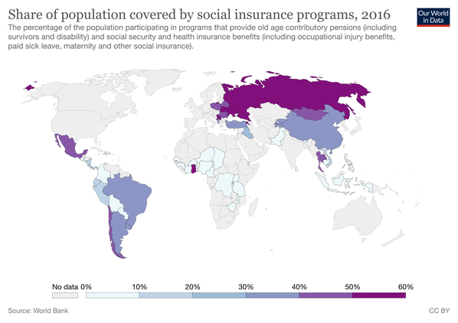

Coverage of social insurance programs shows the percentage of population participating in programs that provide old age contributory pensions

The full text of Target 1.3 is: "Implement nationally appropriate [social protection](https://en.m.wikipedia.org/wiki/Social_protection) systems and measures for all, by 2030 achieve substantial coverage of the poor and the vulnerable."

Indicator 1.3.1 is the "Proportion of population covered by social protection systems, by sex, distinguishing children, [unemployed](https://en.m.wikipedia.org/wiki/Unemployment) persons, older persons, [persons with disabilities](https://en.m.wikipedia.org/wiki/Disability), [pregnant women](https://en.m.wikipedia.org/wiki/Pregnancy), newborns, work-injury victims and the poor and the vulnerable".

**Target 1.4: Equal rights to ownership, basic services, technology, and economic resources**

The full text of Target 1.4 is: "By 2030, ensure that all men and women, in particular the poor and the vulnerable, have equal rights to economic resources, as well as access to basic services, ownership and control over land and other forms of property, inheritance, natural resources, appropriate new technology and financial services, including micro-finance."

Its two indicators are:

* Indicator 1.4.1: Proportion of population living in households with access to basic services.
* Indicator 1.4.2: Proportion of total adult population with secure tenure rights to land, (a) with legally recognized documentation, and (b) who perceive their rights to land as secure, by sex and type of tenure.

**Target 1.5: Build resilience to environmental, economic, and social disasters**

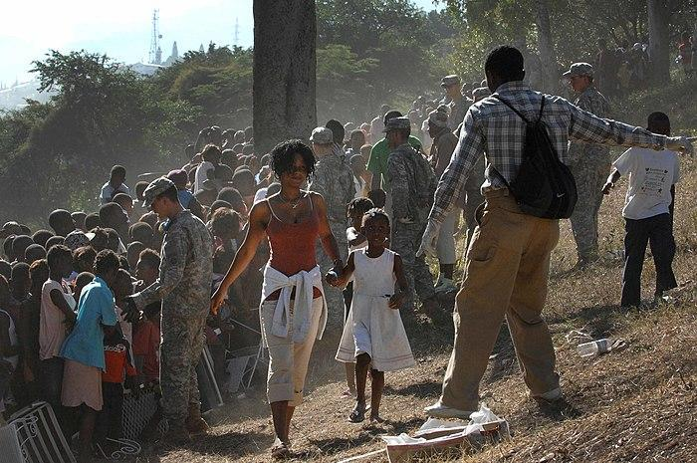

Haitian woman walks with her child toward the distribution line in Port-au-Prince, Haiti, after massive earthquake shook with the whole country in 2010

The full text of Target 1.5 is: "By 2030, build the resilience of the poor and those in vulnerable situations and reduce their exposure and vulnerability to climate-related extreme events and other [economic](https://en.m.wikipedia.org/wiki/Economy), social and environmental shocks and disasters."

It has four indicators:

* Indicator 1.5.1: Number of deaths, missing persons and directly affected persons attributed to disasters.
* Indicator 1.5.2: Direct economic loss attributed to disasters in relation to global [gross domestic product](https://en.m.wikipedia.org/wiki/Gross_domestic_product) (GDP).
* Indicator 1.5.3: Number of countries that adopt and implement national disaster risk reduction strategies in line with the Sendai Framework for [Disaster Risk Reduction](https://en.m.wikipedia.org/wiki/Disaster_risk_reduction)2015–2030.
* Indicator 1.5.4: Proportion of local governments that adopt and implement local disaster risk reduction strategies in line with national disaster risk reduction strategies.

**Target 1.a: Mobilization of resources to end poverty**

The text of Target 1.a is: "Ensure significant mobilization of resources from a variety of sources, including through enhanced development cooperation in order to provide adequate and predictable means for developing countries particularly least developed countries."

It has three indicators:

* Indicator 1.a.1: Proportion of domestically generated resources allocated by the government directly to poverty reduction programmes.
* Indicator 1.a.2: Proportion of total government spending on essential services (education, health and social protection).
* Indicator 1.a.3: Sum of total grants and non-debt-creating inflows directly allocated to poverty reduction programmes as a proportion of GDP.

A proposal has been tabled in 2020 to delete Target 1.a.

**Target 1.b: Establishment of poverty eradication policy frameworks at all levels**

The full text of Target 1.b is: "Create sound policy frameworks at the national, regional and international levels, based on pro-poor and gender-sensitive development strategies, to support accelerated investment in poverty eradication actions."

It has one indicator: Indicator 1.b.1 is the "Pro-poor public social spending".

Custodian agencies

Custodian agencies are in charge of measuring the progress of the indicators:

* For Indicator 1.1.1: [World Bank](https://en.m.wikipedia.org/wiki/World_Bank) (WB) and [International Labor Organization](https://en.m.wikipedia.org/wiki/International_Labour_Organization) (ILO)
* For Indicator 1.2.1: WB
* For Indicator 1.2.2: [National Statistics Offices](https://en.m.wikipedia.org/wiki/List_of_national_and_international_statistical_services), WB, [UNICEF](https://en.m.wikipedia.org/wiki/UNICEF)and [UNDP](https://en.m.wikipedia.org/wiki/United_Nations_Development_Programme)
* For Indicator 1.3.1: ILO and WB
* For Indicator 1.4.1: [United Nations Human Settlements Programme](https://en.m.wikipedia.org/wiki/United_Nations_Human_Settlements_Programme) (UN-HABITAT)
* For Indicator 1.4.2: WB and UN-HABITAT collectively.
* For all four Indicators under Target 1.5: [United Nations International Strategy for Disaster Reduction](https://en.m.wikipedia.org/wiki/United_Nations_Office_for_Disaster_Risk_Reduction) (UNISDR)
* For Indicator 1.a.1: [Organisation for Economic Co-operation and Development](https://en.m.wikipedia.org/wiki/OECD) (OECD)
* For Indicator 1.a.2: UNESCO-UIS
* For Indicator 1.b.1: [UNICEF](https://en.m.wikipedia.org/wiki/UNICEF) and [Save the Children](https://en.m.wikipedia.org/wiki/Save_the_Children)