# Japánkert Fan

## Home

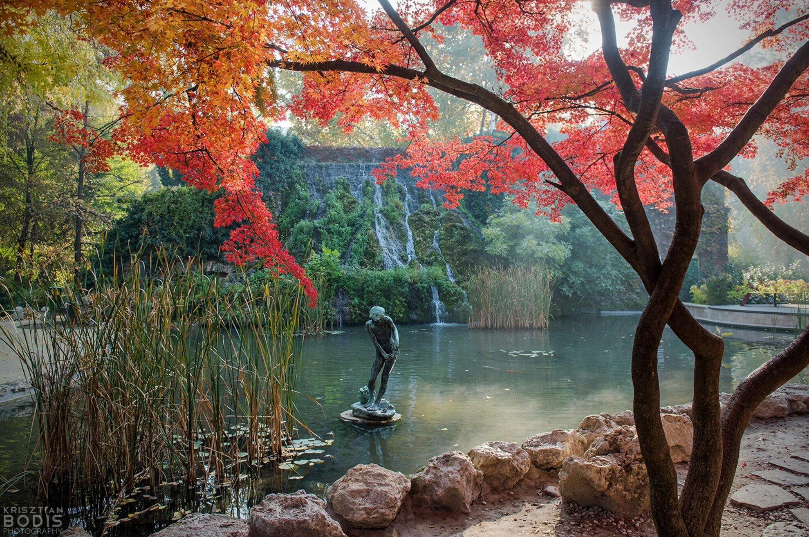

Discover the tranquility of Japanese gardens in Hungary, where traditional aesthetics blend with the local landscape. These serene spaces offer a peaceful escape, inviting you to experience the timeless beauty of Japanese culture in the heart of Europe.

# Japánkert Fan

## About

### Traits of Japanese gardens

Japanese gardens are known for their tranquility, balance, and natural beauty, embodying principles of harmony and simplicity. They often feature stone pathways, koi ponds, wooden bridges, and carefully pruned trees, creating a serene environment that reflects the changing seasons. Water elements, such as small waterfalls or ponds, symbolize purity and life, while rocks and sand represent stability and eternity. Unlike Western-style gardens, which focus on symmetry, Japanese gardens embrace asymmetry and natural flow, making them feel like a miniature representation of nature.

*Let’s learn more of it with this video!*

**“Zen Principles of Japanese Garden Design | 7 Design Tips”**

Video link: <https://youtu.be/Oc0zdboDv0E?si=OzLO0UFnxl1S6R6q>

### Why They Exists in Budapest



In Budapest, Japanese gardens serve as a symbol of the cultural exchange and lasting friendship between Hungary and Japan. These serene spaces reflect the deep connection between the two nations through traditional Japanese landscaping and design elements. Offering a peaceful retreat within the city, the gardens showcase authentic Japanese plants and aesthetic principles. Their presence highlights Hungary’s appreciation for Japanese culture and underscores the ongoing diplomatic and cultural ties between the two countries, inviting visitors to experience the beauty and philosophy of Japan.

# Japánkert Fan

## Find Gardens

*Discover the most popular Japanese garden in Budapest!*

### Japanese Garden on Margaret Island

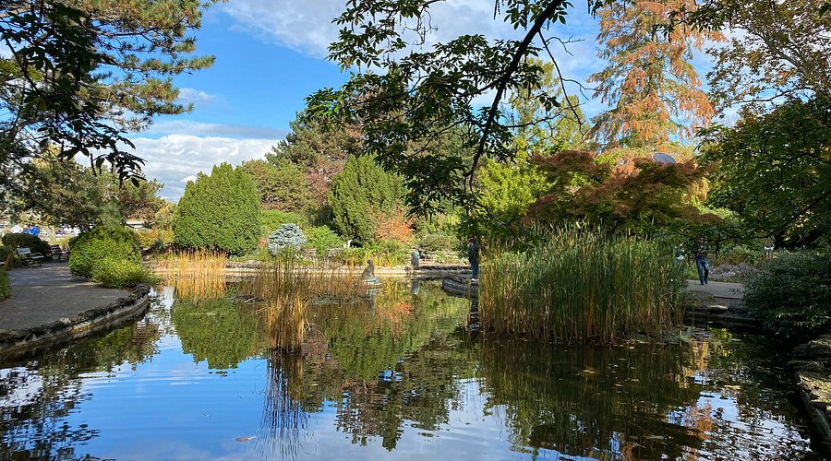

The Japanese Garden on Margaret Island was originally created in the mid-20th century as part of the island's transformation into a recreational park. Over the years, it has been restored and redesigned to enhance its authentic Japanese elements. The garden was influenced by the traditional kaiyū-shiki (strolling garden) style, encouraging visitors to walk through and appreciate the changing scenery.

As part of Margaret Island’s expansive park, this garden remains a favorite retreat for both locals and tourists looking for a quiet escape in the heart of the city.

|  |  |
| --- | --- |
| Information (find access information of the garden here) | |
| address | Margaret Island, 1138 Budapest, Hungary |
| Entrance fee | Free |
| Opening hours | Open daily; accessible at all times |

### Japanese Garden at the Füvészkert Botanical Garden

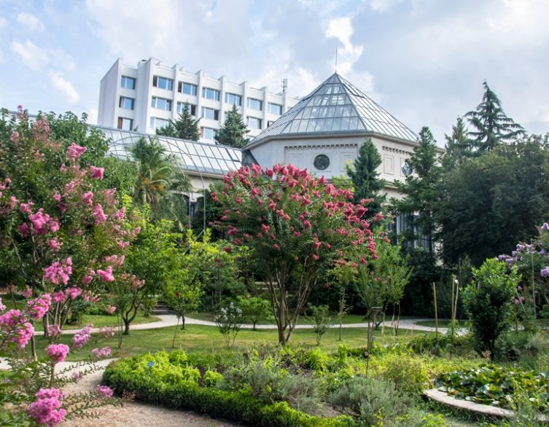

The Füvészkert Botanical Garden, founded in 1771, is Hungary’s oldest botanical garden. The Japanese Garden within it was established in the 20th century, inspired by growing Hungarian interest in Japanese horticulture. The garden was designed to showcase Japan’s landscaping traditions while complementing the diverse plant life of Füvészkert. The Füvészkert Botanical Garden is historically significant, and the Japanese Garden adds a cultural and artistic dimension to this living museum of plants.

|  |  |
| --- | --- |
| Information (find access information of the garden here) | |
| address | Illés utca 25, 1083 Budapest, Hungary |
| Entrance fee | HUF 1,200 for adults; discounts available for students and seniors |
| Opening hours | • Monday to Friday: 9:00 AM – 4:00 PM  • Weekends and holidays: 9:00 AM – 5:00 PM |

### Japanese garden in city park (Városliget)

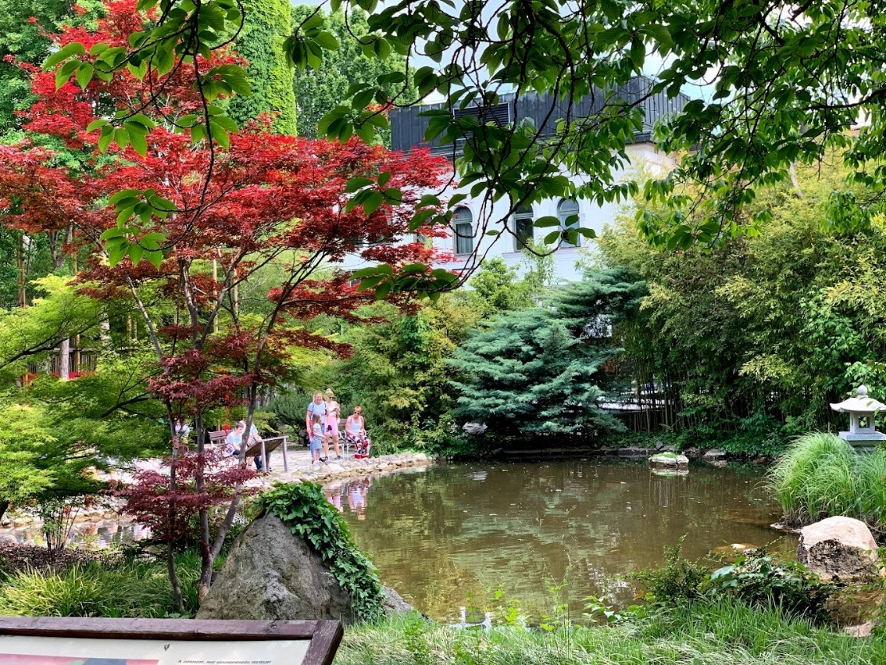

This Japanese Garden was developed as part of City Park (Városliget), one of Budapest’s largest and oldest public parks. The idea of adding a Japanese-inspired section came from 19th-century European enthusiasm for Japanese art and design. Over the years, the garden has been restored multiple times to maintain its tranquil aesthetic.

Located near major attractions like the Széchenyi Thermal Bath and Heroes' Square, this Japanese garden provides a contrast to the city's energetic cultural scene.

|  |  |
| --- | --- |
| Information (find access information of the garden here) | |
| address | City Park, 1146 Budapest, Hungary |
| Entrance fee | Free |
| Opening hours | Open daily; accessible at all times |

### Zugló Japanese Garden

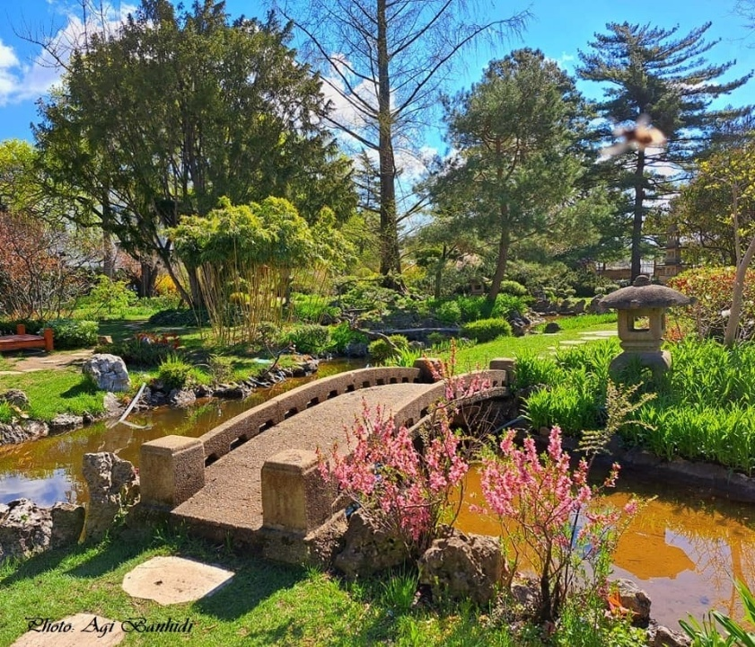

The Zugló Japanese Garden is one of Budapest’s more recent Japanese-style gardens, built to offer a calm, contemplative space in the Zugló district. Its history is tied to community efforts to create more green spaces, drawing inspiration from Japanese aesthetics.

This hidden gem in Zugló offers an intimate, less crowded alternative to Budapest’s larger Japanese gardens.

|  |  |
| --- | --- |
| Information (find access information of the garden here) | |
| address | Mőcsényi Mihály Botanical Garden, 1142 Budapest, Hungary |
| Entrance fee | HUF 500 per adult |
| Opening hours | Typically open during school hours on weekdays; closed on weekends and public holidays |

# Japánkert Fan

## Form

