Villanueva, Ashley Nicole N.
BSIT – 3B
DATA ANALYTICS – DATA PREPROCESSING ACTIVITY 1

- Installing packages
- pip install pandas
- pip install scikit-learn
- pip install seaborn
- pip install pandas statsmodel

- Importing the packages
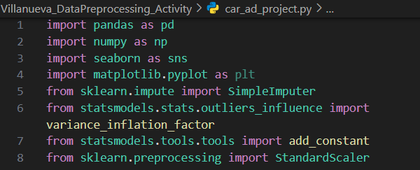

- Loading the Data
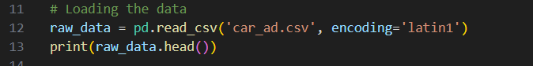

Result in the Vscode Terminal:
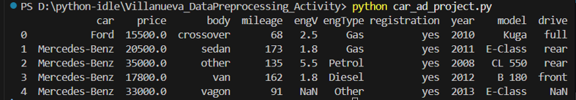

- Discovering the Data
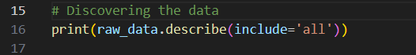

Result in the Vscode Terminal:
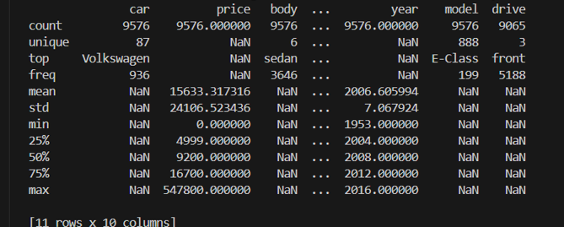

- Handling Missing Values
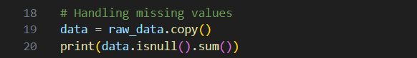

Result in Vscode Terminal:
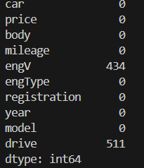

- Eliminating Missing Values in 2 ways:
- Eliminating rows
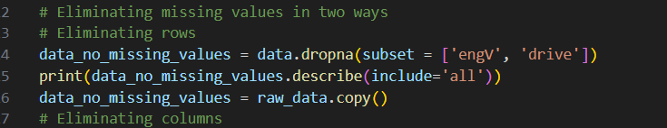
Result in Vscode Terminal:
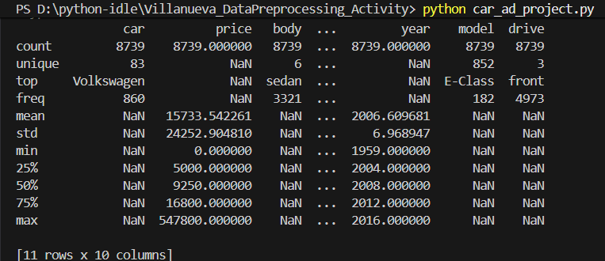

- Eliminating columns
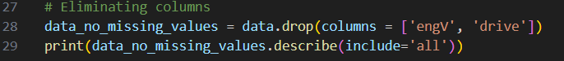
Result in Vscode Terminal:
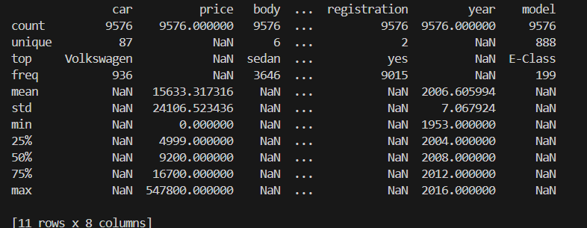

- Imputers
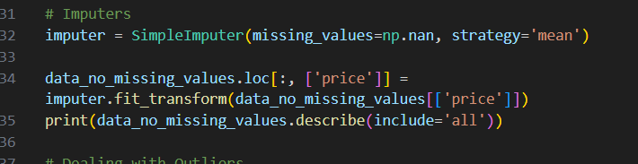
Result in Vscode Terminal:
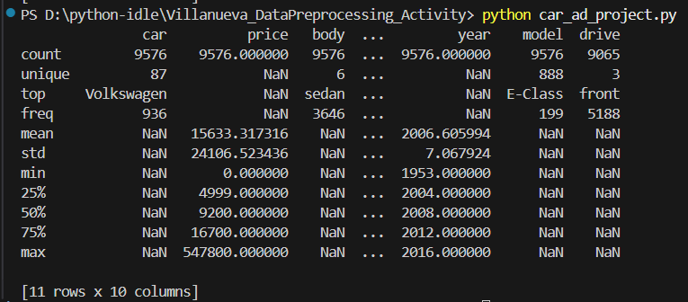
- Dealing with Outliers
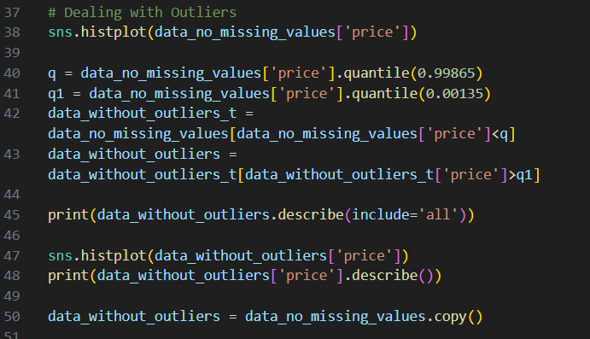

Result in Vscode Terminal:
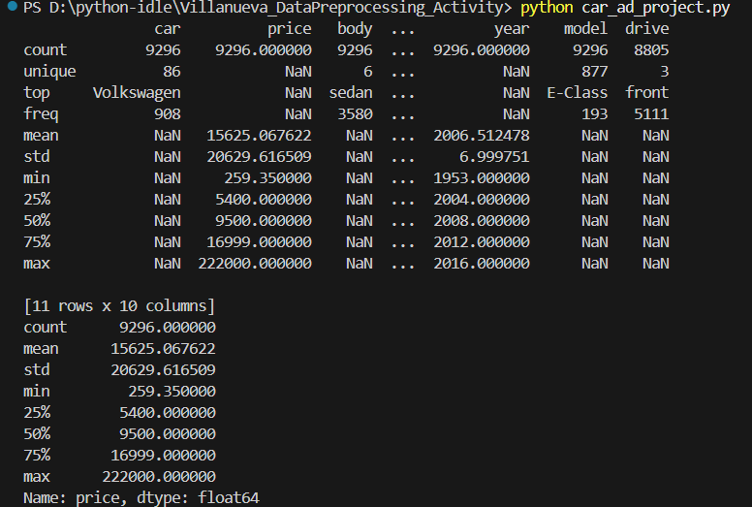

- Multicollinearity
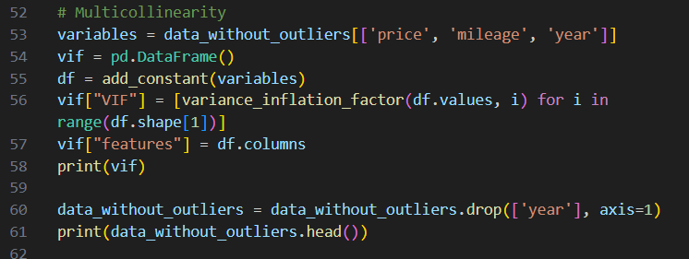

Result in Vscode Terminal:
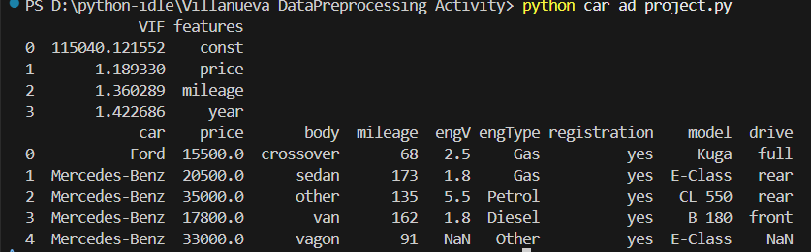

- Dealing with Categorical Values
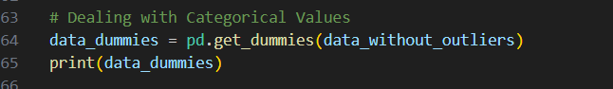

Result in Vscode Terminal:
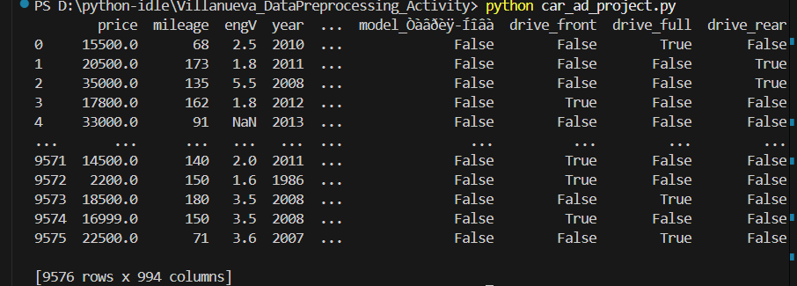

- Standardization
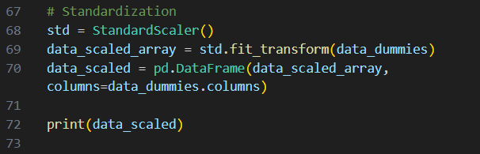
Result in Vscode Terminal:
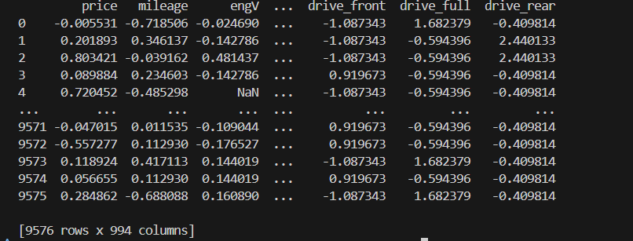

Explanation:
- Since I’m using Vscode as the IDE for this Python Activity and not Jupyter Notebook, I have to put the print() method to show the results in the Vscode Terminal.
- I also installed different pandas and numpy packages, then imported it in the .py file.
- I also added encoding=’latin1’, since Python cannot read the car_ad.csv file as it is in a UTF-8 format, so I searched up on how to fix this issue and found out that it should have encoding=’latin1’.

