How to scrape data from Facebook

1. Install Octoparse
   1. Download link: <http://www.octoparse.com/download/>
   2. Follow the installation steps in ReadMe file
   3. Create an account, and log in
2. Download the tasks
   1. Link:
   2. Double click the files to open it
   3. In “My Task” on the left bar, it shows all your existing tasks.

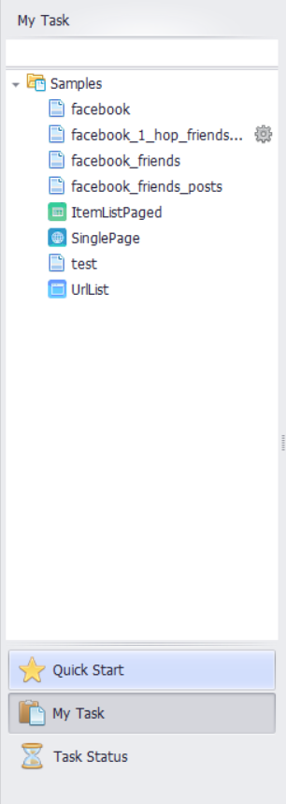

* 1. First, click “facebook_1_hop_friends_posts” task and choose “Edit Task” option in pop-up menu.

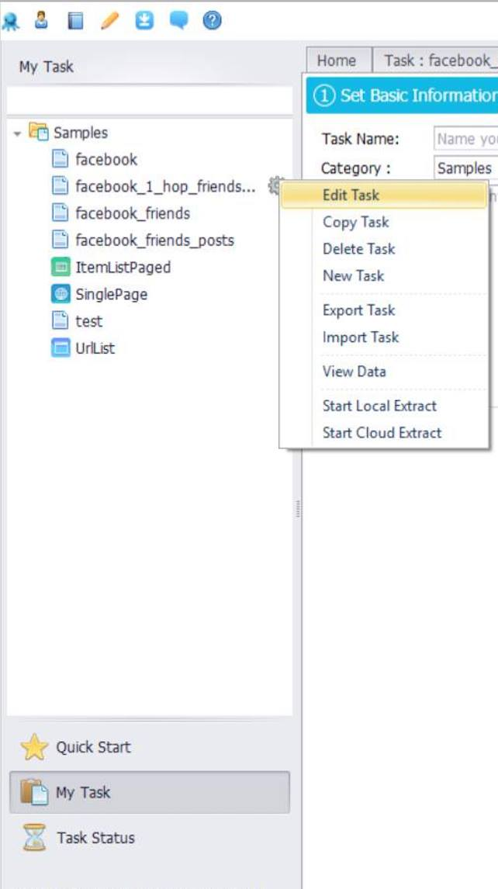

1. Complete the basic information
   1. 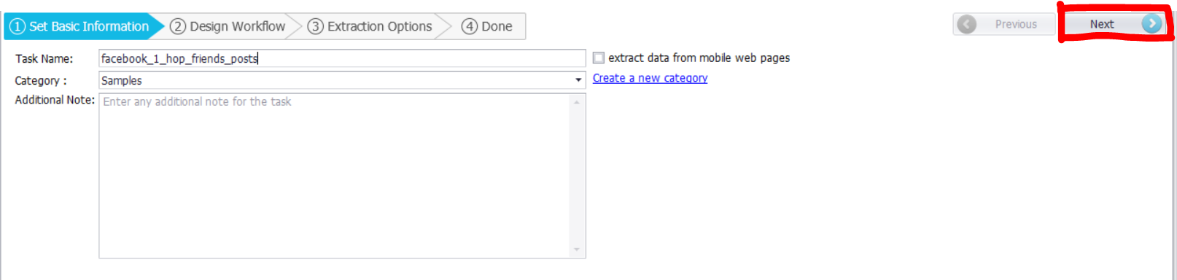On the main screen, click “Next” button to continue.
   2. In the “Workflow Designer”, click the first “Enter Text”, and enter your Facebook account in the input box under Customized Current Action. Click “Save” button, then your account will be shown on the build-in browser.

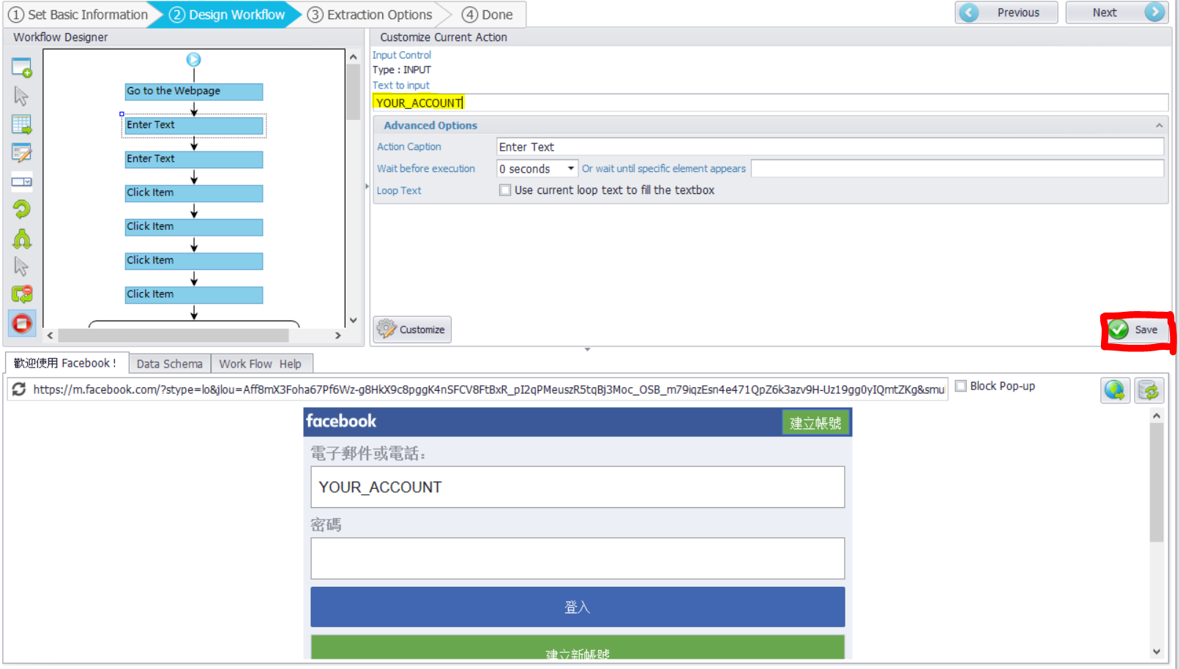

* 1. 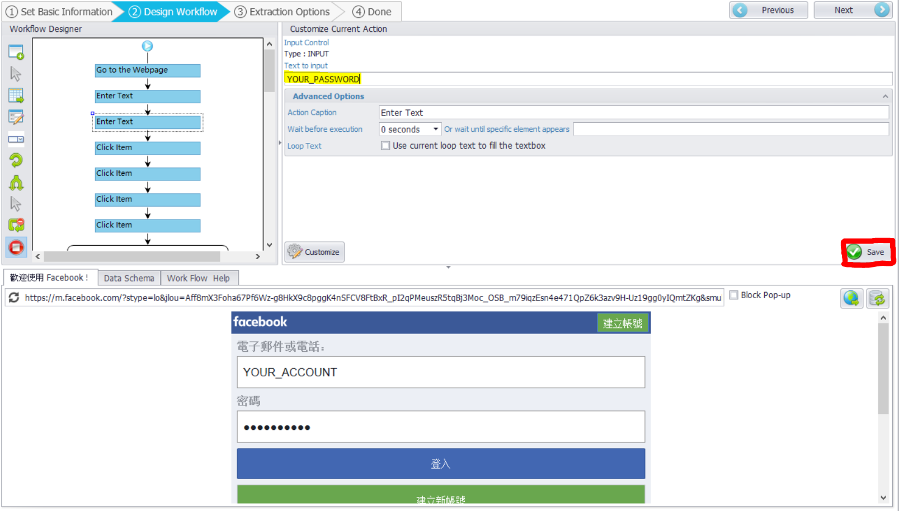Click the second “Enter Text”, and type in your Facebook password in the same place as above. Then click “Save” button.
  2. Click “Click Item” to check if you successfully log in Facebook page in the build-in browser.

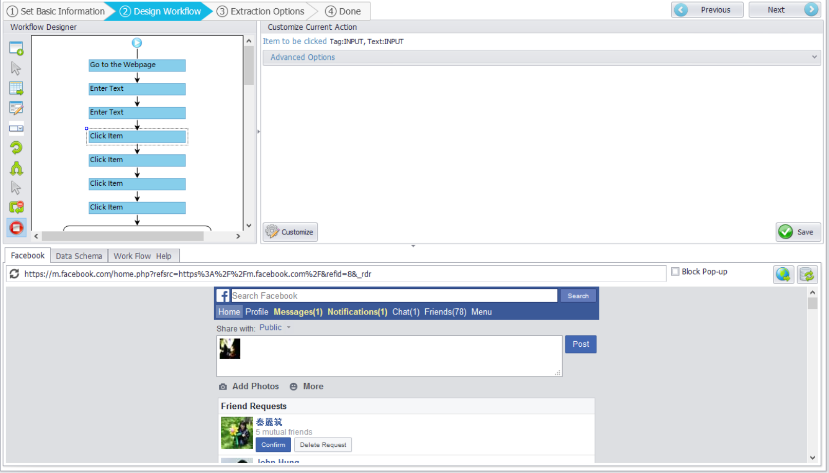

1. Run the task
   1. 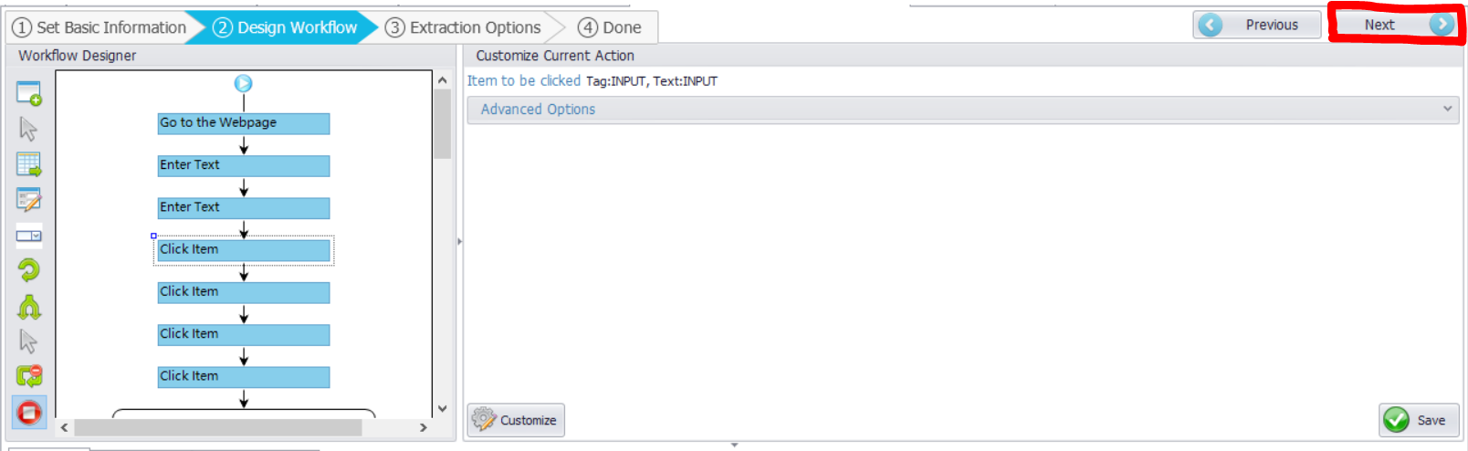Click “Next” once you finish above steps.
   2. 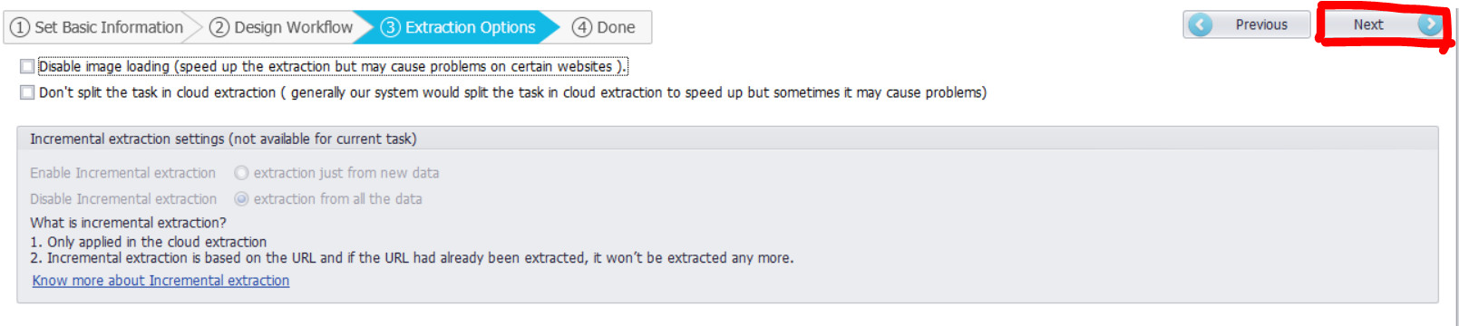Click “Next” again.
   3. 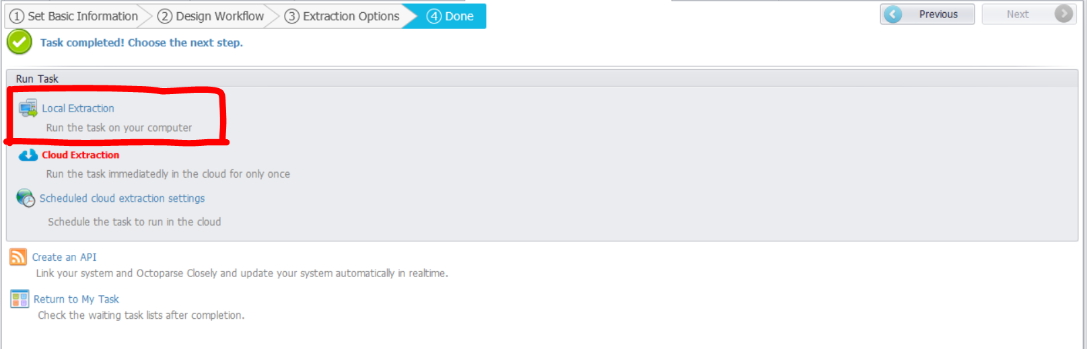Choose “Local Extraction” to run the task
2. Export the data
   1. After the “Extraction Completed” message occurs, please chick the “Export” Button and choose “Excel (2007)”.
   2. Choose “posts” repository the save the data.
3. Run other tasks:
   1. Since you’ve logged in Facebook page. For other tasks, you don’t have to do anything in the 2nd stage. Just simply click “Next” button to straight to the 3rd stage.
   2. After tasks completed, always choose “Excel (2007)” to export the data.