GINHAWA: A Mobile-Integrated IoT Air Quality Monitoring System for High-Foot-Traffic in Barangay Carmen

A Capstone Project Proposal
Presented to the Faculty of the Department of Information Technology
Batoon, Ashley John Z.
Barcubero, Val Samuel C.
Lerasan, Eugene Carl P.
Manzano, Peter P.
Department of Information Technology
College of Information Technology and Computing
University of Science and Technology of Southern Philippines
Cagayan de Oro City, 9000 Philippines
MAY 2026

TABLE OF CONTENTS
CHAPTER I INTRODUCTION 1
1.1 Background of the Study 1
1.2 Statement of the Problem 3
1.2.1 General Problem 3
1.2.2 Specific Problems 3
1.3 Objectives of the Study 4
1.3.1 General Objective 4
1.3.2 Specific Objectives 4
1.4 Scope and Limitations 5
1.5 Significance of the Study 6
CHAPTER II REVIEW OF RELATED LITERATURE 7
2.1 Air Quality, Pollution Concerns, and Government Initiatives 7
2.2 Local Related Literature 8
2.3 Foreign Related Literature 8
2.4 Related Capstone Projects 9
2.5 IoT-Based Air Quality Monitoring Systems 9
2.6 Sensor Technologies Used in Air Quality Monitoring 9
2.7 Wireless Communication in IoT Systems 9
2.8 Cloud Computing and Data Visualization 10
2.9 Real-Time Monitoring Systems 10
2.10 Synthesis and Distinction of the Proposed Study 10
2.11 Comparison of Related Studies 11
CHAPTER III METHODOLOGY 12
3.1 System Methodology 12
3.2 System Design 13
3.2.1 System Overview 13
3.2.2 System Architecture 14
3.2.3 Database Design 15
3.2.4 Use Case Diagram 16
3.2.5 Context Diagram 17
3.2.6 Data Flow Diagram 18
3.2.7 Hardware Block Diagram 19
3.2.8 Circuit Diagram 20
3.2.9 Power Budget and Solar Sizing 21
3.2.10 Enclosure Design, Sensor Placement, and Ventilation 22
3.2.11 GPS Location Tracking and Multi-Station Scalability 23
3.2.12 Flowchart 25
3.2.13 User Interface 26
3.3 System Development 27
3.3.1 Hardware Requirements 27
3.3.2 Software Requirements 28
3.4 Deployment Plan 28
3.4.1 Site Selection and Coordination with the Barangay 28
3.4.2 Installation and Mounting 29
3.4.3 Monitoring Duration and Data Collection Schedule 29
3.5 Testing and Evaluation 30
3.5.1 Sensor Selection, Laboratory Testing, and Validation 30
3.5.2 Outdoor Durability and Reliability Testing 31
3.5.3 Testing Phases 31
3.5.4 Respondents 32
3.5.5 Technical System Evaluation (ISO/IEC 25010) 32
3.5.6 Usability Evaluation (System Usability Scale) 33
3.5.7 Performance Testing 34
3.5.8 Functionality Testing 34
3.6 Costing 35
3.7 Gantt Chart 36
REFERENCES 37

LIST OF FIGURES
Figure 1. Agile Scrum Methodology 12
Figure 2. System Architecture Diagram 14
Figure 3. Entity Relationship Diagram 15
Figure 4. Use Case Diagram 16
Figure 5. Context Diagram 17
Figure 6. Level 1 Data Flow Diagram 18
Figure 7. Monitoring Station Hardware Block Diagram 19
Figure 8. Circuit Diagram 20
Figure 9. System Flowchart 25
Figure 10. Stations Dashboard 26
Figure 11. Station Details 26
Figure 12. Alerts 26
Figure 13. Gantt Chart of Project Activities 36

LIST OF TABLES
Table 1. Comparison of Related Studies and the Proposed System 11
Table 2. Pin Assignments 21
Table 3. Estimated Daily Power Budget of One Station (Worst Case, LTE) 21
Table 4. Physical Dimensions of Station Components 22
Table 5. Hardware Requirements 27
Table 6. Software Requirements 28
Table 7. Testing and Deployment Schedule 30
Table 8. Comparison of Candidate Air Quality Sensors 30
Table 9. Durability and Reliability Tests 31
Table 10. ISO/IEC 25010 Technical Evaluation Instrument 32
Table 11. System Usability Scale (SUS) Questionnaire 33
Table 12. Performance Testing for GINHAWA System Components 34
Table 13. Functionality Testing for the GINHAWA Monitoring Platform 34
Table 14. Estimated Cost of One Monitoring Station 35

CHAPTER I
INTRODUCTION

1.1 Background of the Study
Air quality is an important environmental concern, particularly in urban areas where human activities, transportation, and commercial activities are concentrated. The presence of air pollutants in the environment can vary depending on the location and surrounding activities. In areas with high pedestrian and vehicular activity, monitoring air quality can provide information about the environmental conditions experienced by people who regularly pass through or stay in these locations. Because of this, air quality monitoring plays an important role in collecting environmental information that can be used to understand local air conditions.
Air quality monitoring involves the measurement and observation of pollutants present in the surrounding environment. Common pollutants considered in air quality monitoring include fine particulate matter (PM2.5), coarse particulate matter (PM10), nitrogen oxides (NOx), and volatile organic compounds (VOCs). Fine particles are of particular concern because they can penetrate deep into the lungs; the World Health Organization (2021) updated its global air quality guidelines and lowered the recommended annual mean PM2.5 level to 5 µg/m³ in recognition of these health effects. Monitoring these pollutants allows environmental conditions to be observed over time and provides data that may support environmental assessment and public awareness. However, air quality conditions can differ between locations, making localized monitoring important, especially in areas where traffic and public activities are concentrated.
In the Philippines, environmental monitoring and air pollution control are supported by government policies and programs. Republic Act No. 8749, also known as the Philippine Clean Air Act of 1999, provides a framework for the prevention and control of air pollution, sets emission standards for motor vehicles and industries, and mandates the monitoring of ambient air quality through the Department of Environment and Natural Resources – Environmental Management Bureau (DENR-EMB). Related government initiatives, such as anti-smoke-belching operations and the Public Utility Vehicle Modernization Program of the Department of Transportation (2017), aim to reduce emissions from road transport. These efforts demonstrate the importance of collecting reliable environmental information as part of air pollution management.
Despite these established efforts, government monitoring stations are few and are placed to represent wide areas, so they may not provide the same level of localized information for every community or specific high-traffic area. Conventional monitoring facilities are useful for obtaining reference-grade measurements, but a network of low-cost monitoring stations installed at selected locations can provide additional, more localized observations. This is particularly relevant in areas where traffic, commercial activities, and pedestrian movement are regularly concentrated.
Barangay Carmen in Cagayan de Oro City was selected as the focus of this study for four reasons. First, traffic congestion: the barangay is traversed by busy roads and public utility vehicle routes where vehicles frequently queue and idle, particularly during peak hours. Second, urbanization: Carmen is a densely built-up and populous urban barangay [insert PSA 2020 population and land area of Barangay Carmen], with continuing commercial and residential development. Third, pollution exposure: pedestrians, commuters, vendors, and workers spend extended periods outdoors beside these roads, where they are directly exposed to vehicle emissions and dust. Fourth, public activity concentration: the barangay contains places where many people gather daily, such as markets, schools, transport stops, and commercial establishments [name the specific candidate sites, e.g., the public market vicinity and major intersections, after confirming them with the barangay]. These factors make Barangay Carmen an appropriate setting for examining the feasibility of a localized air quality monitoring system, and focusing on one barangay allows the study to account for the actual environmental and deployment conditions that affect an outdoor IoT device.
The use of Internet of Things (IoT) technology provides an approach for collecting and transmitting environmental data from monitoring devices. An IoT-based system can integrate sensors, a microcontroller, communication technologies, data storage, and a software application to allow collected measurements to be transmitted and presented to users. Compared with manual data collection, an automated monitoring system can continuously collect readings and organize them for viewing and analysis. This makes IoT technology applicable to environmental monitoring systems that require continuous data collection and remote access to measurements.
However, developing an IoT-based air quality monitoring system for outdoor deployment involves several considerations. The sensors must collect measurements under actual environmental conditions, while the hardware must be protected from rain, heat, dust, and other outdoor exposure. Communication reliability and power availability must also be considered because the device is expected to operate unattended in a deployed environment. These factors determine whether a low-cost IoT-based monitoring system can operate reliably outside a controlled laboratory setting.
Existing studies and projects have demonstrated the use of sensors, wireless communication, IoT technologies, and software platforms for environmental monitoring. The proposed GINHAWA system integrates these technologies into a localized network of solar-powered monitoring stations intended for selected high-foot-traffic areas in Barangay Carmen. The study also covers the physical deployment of the stations, data transmission, location tracking, mobile-based visualization, and the evaluation of the system's accuracy, reliability, and durability.
Therefore, this study proposes GINHAWA: A Mobile-Integrated IoT Air Quality Monitoring System for High-Foot-Traffic in Barangay Carmen. The system is designed as a research prototype that collects air quality measurements from selected monitoring locations and transmits the data to a monitoring platform for visualization. The study will deploy the prototype in selected high-foot-traffic areas within Barangay Carmen and evaluate its performance under actual deployment conditions. Through this approach, the researchers aim to examine the feasibility of using a localized IoT-based system as a supplementary tool for collecting and presenting air quality information in a specific urban community.

1.2 Statement of the Problem

1.2.1 General Problem
The general problem of this study is the limited availability of localized and accessible air quality monitoring information in selected high-foot-traffic areas of Barangay Carmen, Cagayan de Oro City. This limitation makes it difficult to obtain location-specific air quality data that can be used for community awareness, monitoring, and environmental assessment.

1.2.2 Specific Problems
Specifically, this study aims to address the following problems:
- The limited availability of localized air quality data in selected high-foot-traffic areas of Barangay Carmen, particularly data that can be monitored according to specific device locations.
- The lack of an accessible digital platform that can collect, transmit, and present air quality measurements from IoT monitoring devices in a clear and understandable manner.
- The need to determine the accuracy and reliability of low-cost IoT-based sensors through laboratory testing, comparison, and actual deployment.
- The need to determine the durability and reliability of the monitoring device when exposed to outdoor conditions, including rain, heat, dust, and prolonged outdoor operation.
- The need to establish a deployment setup that supports the monitoring of selected locations in Barangay Carmen while allowing the system to accommodate additional IoT monitoring stations in the future.
- The need to provide location-based monitoring through GPS and a map feature so that the locations of deployed monitoring devices can be identified and updated within the application.

1.3 Objectives of the Study

1.3.1 General Objective
To design, develop, deploy, and evaluate GINHAWA: A Mobile-Integrated IoT Air Quality Monitoring System for High-Foot-Traffic in Barangay Carmen as a research prototype capable of providing localized, real-time air quality monitoring through IoT technologies and mobile integration.

1.3.2 Specific Objectives
Specifically, the study aims to:
- Design and develop a compact, low-cost, solar-powered IoT monitoring station that uses an ESP32 microcontroller and a Sensirion SEN55 environmental sensor to measure PM1.0, PM2.5, PM4.0, PM10, VOC index, NOx index, temperature, and humidity in selected high-foot-traffic areas of Barangay Carmen.
- Develop a mobile-integrated monitoring platform capable of collecting, transmitting, storing, and displaying air quality data and alerts from the deployed monitoring stations.
- Integrate GPS and map-based monitoring to identify and automatically update the locations of deployed IoT monitoring stations within the application.
- Design the system to support multiple IoT monitoring stations without requiring manual developer configuration or code changes for every additional station.
- Deploy the GINHAWA monitoring stations in selected high-foot-traffic areas of Barangay Carmen, in coordination with the barangay, and conduct actual outdoor monitoring and data collection.
- Evaluate the accuracy, reliability, and durability of the system through sensor validation, laboratory testing, and outdoor deployment under conditions such as heat, rain, dust, and prolonged exposure.
- Evaluate the functionality and usability of the GINHAWA platform using ISO/IEC 25010 and the System Usability Scale (SUS).

1.4 Scope and Limitations
This study focuses on the design, development, deployment, and evaluation of GINHAWA: A Mobile-Integrated IoT Air Quality Monitoring System for High-Foot-Traffic in Barangay Carmen.
Each monitoring station uses a Sensirion SEN55 sensor module, a LilyGO T-SIM7600 board (ESP32 microcontroller with a 4G LTE and GPS modem), an INA219 power monitor, and a compact solar-charged LiFePO4 battery pack, all in a small weatherproof unit. Stations transmit data over Wi-Fi, falling back to 4G LTE when Wi-Fi is unavailable, to a backend built with Node.js and PostgreSQL. Users access the data through a mobile-first web application (Progressive Web App) that shows real-time readings, history, station locations on a map, and alerts.
The study covers the deployment of the prototype in selected high-foot-traffic areas within Barangay Carmen. The physical deployment considers the mounting location, outdoor environment, enclosure design, sensor placement, ventilation, and protection of the device from environmental conditions. The study also includes laboratory testing and outdoor testing to evaluate the accuracy, reliability, and durability of the sensors and monitoring stations, as well as the reliability of data collection and transmission. The study focuses only on the selected deployment locations and the monitoring period established by the researchers.
The study is limited to prototype-level implementation and is intended as a supplementary environmental monitoring tool. It is not intended to replace industrial-grade or government-certified (reference) air quality monitoring stations. The following limitations apply: (a) the SEN55 reports VOC and NOx as relative indices (1–500) rather than concentrations in ppm or µg/m³; (b) optical particle measurements can read higher under very high humidity; (c) the system does not measure carbon monoxide, sulfur dioxide, or ozone; and (d) system performance may be affected by connectivity, sunlight availability, hardware limitations, and other conditions encountered during deployment.

1.5 Significance of the Study
The study will be beneficial to the following:
Commuters and Pedestrians. The GINHAWA system can provide accessible and location-specific air quality information in selected high-foot-traffic areas of Barangay Carmen. The information displayed through the mobile application can help users become more aware of the air quality conditions in the areas they pass through.
Barangay Officials and Local Government Representatives. The collected air quality data can provide additional information that may support local environmental monitoring, planning, and assessment. The system can also demonstrate how IoT-based monitoring can be used within a community setting.
Monitoring Personnel and Environmental Staff. The system provides a centralized platform for viewing monitoring data from deployed IoT stations, checking device status, and exporting data. Location-based monitoring through GPS and the application map helps identify the locations of the monitoring devices.
Future Researchers. This study can serve as a reference for future researchers who plan to develop IoT-based environmental monitoring systems, particularly those involving sensor validation, outdoor deployment, mobile integration, and multiple monitoring stations.
The Researchers. The study allows the researchers to apply their knowledge in IoT, web and mobile application development, networking, sensor integration, and system evaluation while addressing the technical requirements of outdoor air quality monitoring.

CHAPTER II
REVIEW OF RELATED LITERATURE
This review of related literature synthesizes existing research and developments relevant to GINHAWA: A Mobile-Integrated IoT Air Quality Monitoring System for High-Foot-Traffic in Barangay Carmen. It establishes the current state of knowledge in air quality monitoring, identifies the gaps this study addresses, and provides the basis for the design and evaluation of the proposed system.

2.1 Air Quality, Pollution Concerns, and Government Initiatives
Air pollution is one of the largest environmental risks to human health. The World Health Organization (2021) reports that exposure to fine particulate matter (PM2.5) and nitrogen dioxide is associated with respiratory and cardiovascular disease, and its 2021 global air quality guidelines set stricter recommended limits, including an annual mean of 5 µg/m³ and a 24-hour mean of 15 µg/m³ for PM2.5. Air quality is commonly communicated to the public through an Air Quality Index (AQI), which converts pollutant concentrations into categories such as Good, Moderate, and Unhealthy (U.S. Environmental Protection Agency, 2024).
In urban areas of the Philippines, road transport is recognized as a major source of air pollutants, especially in congested corridors where vehicles idle and where pedestrians and commuters are exposed at close range. Pollutant levels can change quickly within short distances and at different times of day, which is why localized monitoring near where people actually spend time is valuable (Magdaong et al., 2026).
The Philippine government addresses air pollution primarily through Republic Act No. 8749, the Philippine Clean Air Act of 1999, which establishes ambient air quality guideline values, emission standards, and an air quality monitoring network managed by the DENR-EMB. Related initiatives include the anti-smoke-belching program for motor vehicles and the Public Utility Vehicle Modernization Program, which aims to replace older, high-emission public utility vehicles (Department of Transportation, 2017). These initiatives rely on monitoring data to measure progress; low-cost community stations such as GINHAWA can supplement the official network by providing denser, location-specific observations. [Optional: add Cagayan de Oro City or DENR-EMB Region 10 air quality initiatives or data, if available.]

2.2 Local Related Literature
Local studies related to air quality monitoring show the use of IoT technologies, environmental sensors, and wireless communication to collect and monitor air quality data. Alarcon et al. (2020) developed an indoor air quality monitoring system using an Arduino Uno and an MQ-135 gas sensor in Cainta, Rizal and Pasay City, demonstrating that low-cost sensors can provide real-time environmental information. Ambat et al. (2026) developed a web-based air quality monitoring and mapping system that uses a fuzzy logic algorithm to interpret sensor data. Teologo et al. (2018) proposed a fuzzy-based approach to AQI classification using CO and NO2, and Magdaong et al. (2026) developed criteria and an algorithm for placing low-cost sensors for near-road monitoring in Quezon City.
These studies provide a foundation for GINHAWA. They show the feasibility of low-cost sensing, data visualization, and careful sensor placement, but they differ from the proposed system in their sensors, deployment environment (mostly indoor or controlled), power source, and user platform. The proposed system will be compared with these studies based on their technologies, features, contributions, and limitations.

2.3 Foreign Related Literature
Researchers from different countries have explored IoT technologies in air quality monitoring systems, examining the integration of environmental sensors, wireless communication, cloud computing, and real-time data visualization. Zhao et al. (2020) reviewed IoT technologies for air pollution prevention and improvement, highlighting interconnected sensor networks, cloud-based decision-making, and online management. Pineda-Tobón et al. (2024) developed AQuality32, a low-cost, open-source air quality monitoring device based on the ESP32. Zaid et al. (2026) investigated an IoT-based low-cost sensor network for real-time, hyper-local air quality monitoring and exposure assessment, and Rahman et al. (2025) presented a portable and cost-effective system for real-time air quality monitoring. Bandara et al. (2021) developed AirSPEC, an IoT air quality monitoring system integrated with a machine-learning framework.
These studies show that low-cost IoT monitoring can provide useful, spatially dense data, but they also stress calibration against reference instruments, power autonomy, and reliable connectivity as the main challenges of real-world deployment. GINHAWA addresses these challenges directly through sensor validation, solar-battery power, and Wi-Fi/LTE fallback.

2.4 Related Capstone Projects
Previous IT and Computer Science capstone projects on air quality monitoring, IoT environmental sensing, and pollution monitoring systems were reviewed to avoid duplication and identify the contribution of the proposed study. [Add 2–3 capstone projects reviewed from the USTP library or other universities: title, authors, year, what they built (sensors, platform), and how GINHAWA differs.] Compared with these projects, GINHAWA emphasizes outdoor deployment in a specific barangay, solar-powered continuous operation, automatic GPS-based station location, cellular fallback, and support for multiple stations managed from one platform.

2.5 IoT-Based Air Quality Monitoring Systems
Magdaong et al. (2026) developed criteria and an algorithm for deploying low-cost IoT-based air quality sensors for near-road air quality monitoring in Quezon City. The study demonstrates the importance of deployment location when establishing a sensor network and shows that low-cost sensors can support broader spatial monitoring when their locations are properly chosen. For GINHAWA, this supports the planned use of multiple monitoring stations and location-based monitoring focused on Barangay Carmen.

2.6 Sensor Technologies Used in Air Quality Monitoring
Low-cost air quality sensors commonly use two sensing principles. Optical particle counters, such as the laser-scattering sensor in the Sensirion SEN55 and the Plantower PMS5003, estimate particulate matter mass concentrations (PM1.0 to PM10). Metal-oxide (MOx) gas sensors, such as the Sensirion SGP41 inside the SEN55, report VOC and NOx indices relative to the typical conditions at the sensor's location (Sensirion AG, 2022). Simpler analog gas sensors such as the MQ-135 respond to many gases at once, have low selectivity, and require careful calibration (Alarcon et al., 2020). Reference-grade monitors remain necessary to validate low-cost sensors, and the U.S. EPA (2021) published performance targets for evaluating PM2.5 sensors against reference instruments.

2.7 Wireless Communication in IoT Systems
Duobiene et al. (2022) developed a wireless sensor network for environmental monitoring, demonstrating that wireless communication allows sensor data to be transferred without physical connections and supports remote, distributed monitoring. Wireless communication improves flexibility and scalability in IoT systems. For outdoor stations where Wi-Fi coverage is not guaranteed, cellular (4G LTE) connectivity provides an alternative uplink to the internet.

2.8 Cloud Computing and Data Visualization
Ambat et al. (2026) developed a web-based air quality monitoring and mapping system in Metro Manila, showing that web platforms enhance data accessibility, storage, and visualization and allow users to monitor environmental conditions and trends remotely. Map-based presentation helps users relate readings to specific places.

2.9 Real-Time Monitoring Systems
Real-time IoT monitoring systems continuously collect and display pollutant measurements, allowing immediate detection of changes in air quality and faster response. Chaidee et al. (2026) and Bakare and Abubaker (2026) demonstrated ESP32-based monitoring systems with real-time data delivery to dashboards, supporting the approach used in the proposed system.

2.10 Synthesis and Distinction of the Proposed Study
The reviewed studies show that IoT-based air quality monitoring systems commonly combine sensors, microcontrollers, wireless communication, and digital platforms. Local studies generally focus on low-cost systems in indoor or near-road settings, while foreign studies emphasize connectivity, cloud data management, scalability, and calibration. However, the reviewed systems differ in sensing technologies, communication methods, deployment environments, and user platforms, and few combine outdoor, unattended operation with community-level deployment and public access.
GINHAWA is distinct in the following ways: (1) it measures particulate matter together with VOC and NOx indices in one outdoor station; (2) each station runs continuously on a solar-charged battery; (3) stations use Wi-Fi with automatic 4G LTE fallback and offline buffering; (4) each station reports its own GPS location, so stations appear on the map automatically; (5) the platform supports any number of stations without code changes; and (6) the system is deployed and evaluated in actual high-foot-traffic areas of Barangay Carmen with sensor validation and outdoor durability testing. Table 1 compares the related studies with the proposed system.

2.11 Comparison of Related Studies
Table 1. Comparison of Related Studies and the Proposed System
Study / System | Type | Unique Features | Contribution | Technologies Used
Zhao et al. (2020) | Existing | IoT-based air pollution monitoring and data collection | Showed how IoT supports continuous environmental monitoring | IoT, smart sensors, wireless networks
Pineda-Tobón et al. (2024) – AQuality32 | Existing | Low-cost, open-source ESP32 monitoring device | Demonstrated affordable ESP32-based air quality sensing with cloud data | ESP32, low-cost sensors, Google platform
Magdaong et al. (2026) | Existing | Near-road monitoring and sensor deployment criteria | Showed the importance of sensor placement for low-cost networks | Low-cost IoT sensors, sensor network, algorithm
Alarcon et al. (2020) | Existing | Low-cost indoor gas sensing | Real-time detection of indoor gases | Arduino Uno, MQ-135
Duobiene et al. (2022) | Existing | Wireless transmission between monitoring devices | Flexible wireless environmental monitoring | Wireless sensor network
Ambat et al. (2026) | Existing | Web-based visualization and mapping of air quality | Digital platform for interpreting air quality data | IoT sensors, web platform, mapping, fuzzy logic
Zaid et al. (2026) | Existing | Hyper-local low-cost sensor network | Real-time exposure assessment at fine spatial scale | IoT sensor network, real-time monitoring
GINHAWA (this study) | Proposed | Solar-powered outdoor stations; Wi-Fi with LTE fallback; automatic GPS station mapping; multi-station; real-time alerts; deployed in Barangay Carmen | Integrated, validated, and field-deployed community monitoring for high-foot-traffic areas | Sensirion SEN55; ESP32 LilyGO T-SIM7600 (LTE + GPS); LiFePO4 + solar; HTTPS REST, WebSocket; Node.js, PostgreSQL; React PWA; Docker

CHAPTER III
METHODOLOGY
This chapter presents the methodology used to design, develop, deploy, and evaluate GINHAWA. It covers the development methodology, system design and diagrams, hardware and power design, the deployment plan for Barangay Carmen, and the testing and evaluation procedures.

3.1 System Methodology
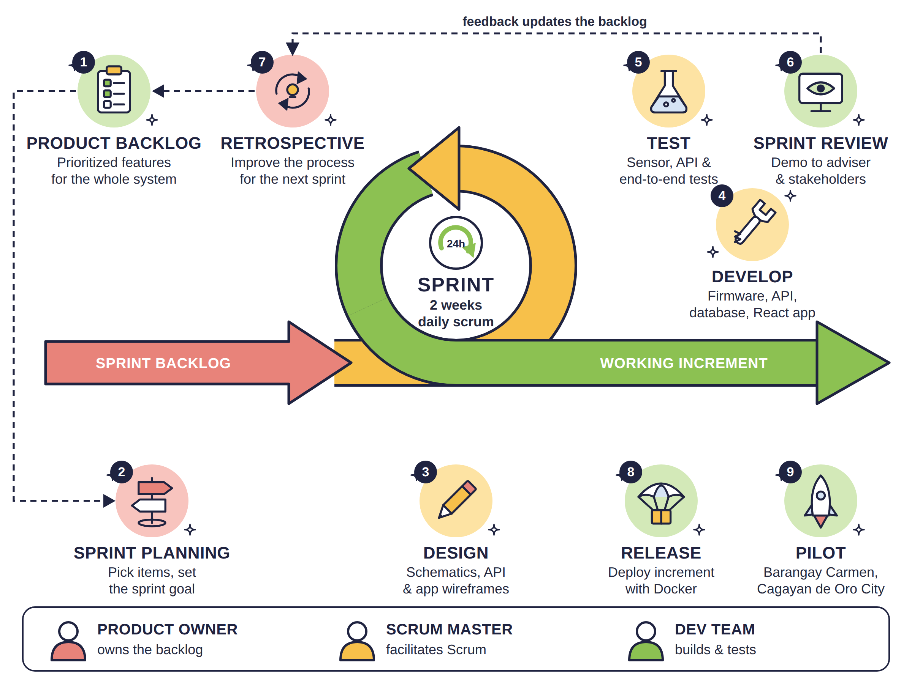
Figure 1. Agile Scrum Methodology
Figure 1 illustrates the Agile Scrum framework adopted for this project. Scrum organizes work into short, fixed-length iterations called sprints (two weeks for this project), which suits an IoT system whose hardware, firmware, backend, and application components must be built and integrated incrementally (Schwaber & Sutherland, 2020).
Development starts from the product backlog (1), a prioritized list of features for the whole system: the sensor station, solar power, data ingestion, database, mobile application, alerts, map, and deployment. In sprint planning (2), the team selects the highest-priority items and sets a sprint goal. During the sprint, the team designs (3), develops (4), and tests (5) the selected items and meets in a short daily scrum to report progress and blockers. At the end of each sprint, a sprint review (6) demonstrates the working increment to the adviser and stakeholders, and a retrospective (7) identifies process improvements; feedback from both updates the product backlog. Each working increment is released (8) using Docker, and the final validated system proceeds to pilot deployment (9) in Barangay Carmen, Cagayan de Oro City.
The Scrum roles are assigned as follows: Product Owner – [member name]; Scrum Master – [member name]; Development Team – [member names] (hardware, backend, application, and testing).

3.2 System Design
During this phase, the requirements gathered from the previous stage were analyzed to develop the overall system design. This included identifying the necessary hardware components and power requirements, defining the system architecture and data model, and designing the enclosure, deployment setup, and user interface. The diagrams in this section follow a consistent notation: UML for the use case diagram, crow's-foot notation for the entity-relationship diagram, Gane–Sarson notation for the context and data flow diagrams, standard electrical symbols for the circuit diagram, and ANSI flowchart symbols for the flowchart.

3.2.1 System Overview
GINHAWA consists of three parts. (1) Monitoring stations are solar-powered devices installed at selected high-foot-traffic locations. Each station measures VOC and NOx indices, temperature, and humidity every second and particulate matter (PM1.0, PM2.5, PM4.0, PM10) for one minute in every five minutes to save power. Every minute it averages the readings, adds its GPS position and battery status, and sends the data to the server over Wi-Fi or 4G LTE. (2) The backend server authenticates each station by its secret key, stores the readings, computes the Air Quality Index, opens and resolves alerts, and pushes live updates to connected users. (3) The GINHAWA application is a mobile-first web application that shows every station on a map and list with its live AQI, history charts, health recommendations, and alerts. Developers (the monitoring personnel) use the same application to register stations, set alert thresholds, and monitor device status.

3.2.2 System Architecture
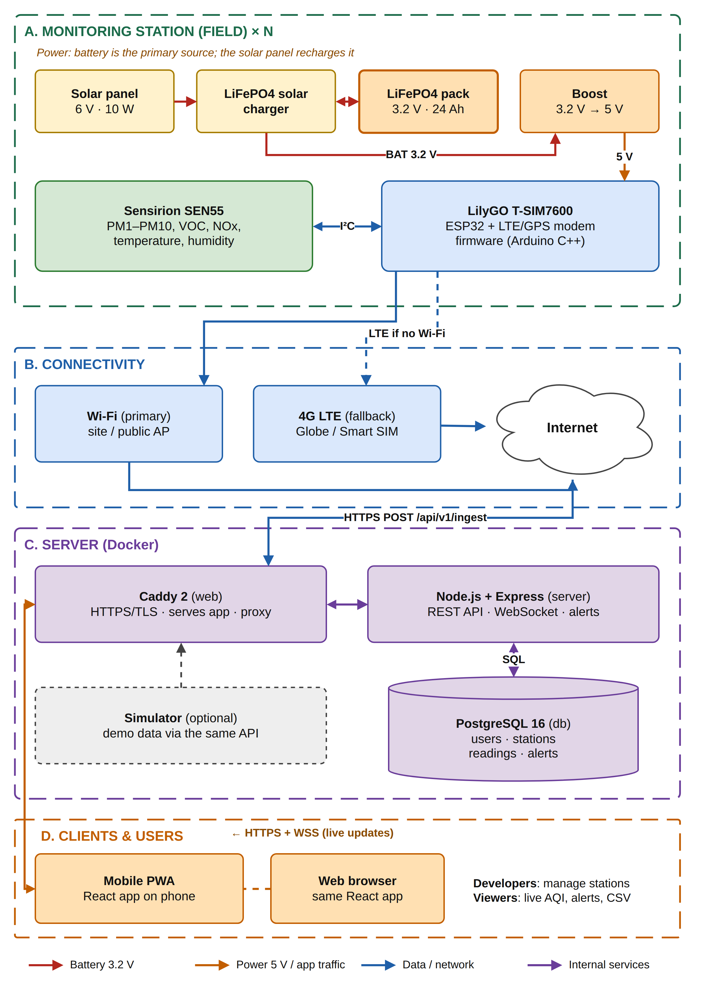
Figure 2. System Architecture Diagram
Figure 2 shows the deployment architecture of GINHAWA in four layers. (A) Monitoring station: a small 6 V, 10 W solar panel charges a compact LiFePO4 battery pack (four 32700 cells, 3.2 V) through a LiFePO4 solar charger; the battery is the primary power source and supplies the station day and night through a 3.2 V-to-5 V boost converter. The Sensirion SEN55 sensor connects to the LilyGO T-SIM7600 board (ESP32 with a SIM7600G-H LTE/GPS modem) over the I²C bus. (B) Connectivity: the station uses Wi-Fi when available and automatically falls back to 4G LTE through a registered SIM; readings are sent as JSON over HTTPS to /api/v1/ingest. (C) Server: the backend runs in Docker containers: Caddy provides HTTPS and serves the application, Node.js with Express provides the REST API and WebSocket hub, and PostgreSQL stores users, stations, readings, and alerts. (D) Clients and users: the React application runs on phones (installable as a Progressive Web App) and web browsers, receiving data over HTTPS and live updates over secure WebSocket (WSS).

3.2.3 Database Design
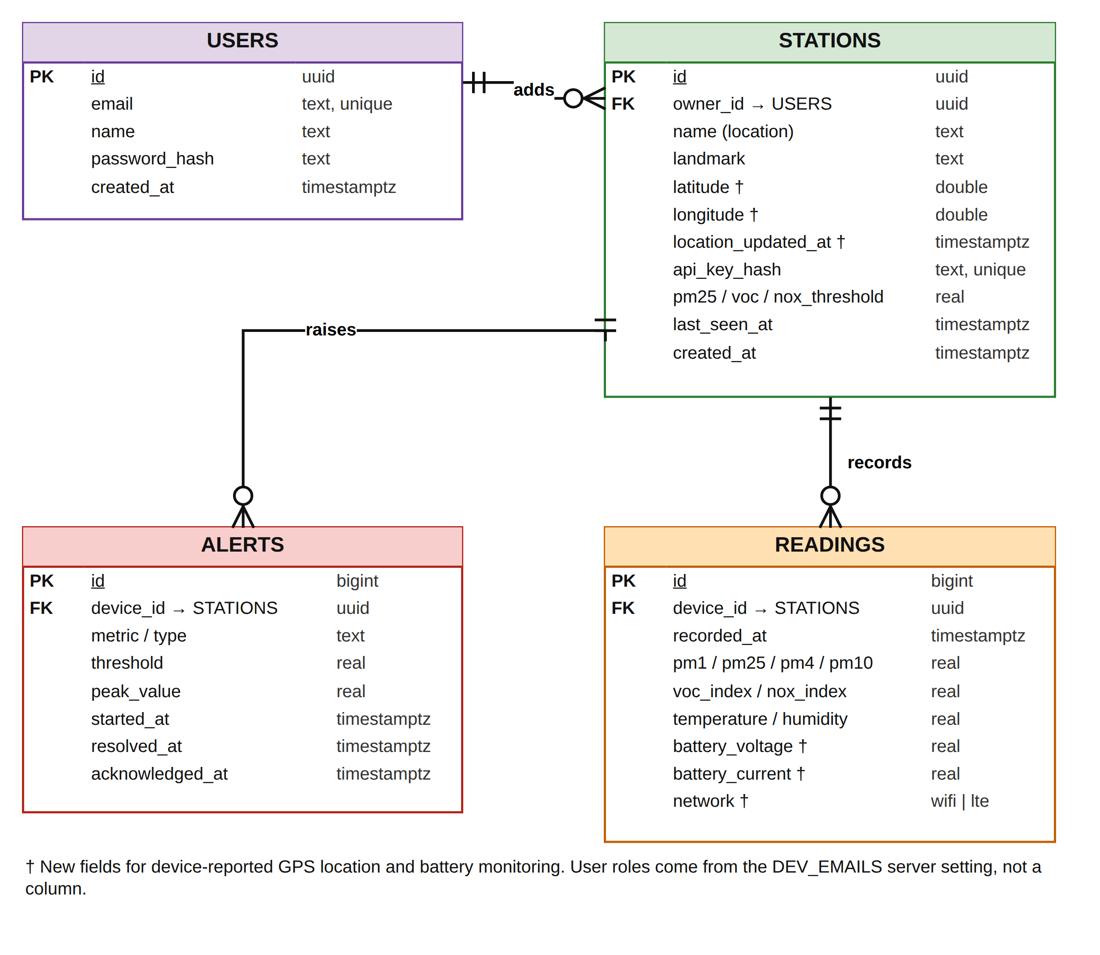
Figure 3. Entity Relationship Diagram
Figure 3 presents the Entity-Relationship Diagram of the GINHAWA database in crow's-foot notation. USERS stores registered accounts (email, name, and hashed password); user roles are assigned by the server from a configured list of developer emails. STATIONS stores each monitoring station: its name (location, e.g., Barangay Carmen), landmark, GPS latitude and longitude with the time the location was last updated, the hashed station key, per-station alert thresholds for PM2.5, VOC, and NOx, and the time the station was last seen. READINGS stores the time-series measurements of each station, including PM1.0–PM10, VOC and NOx indices, temperature, humidity, battery voltage and current, and the network used (Wi-Fi or LTE). ALERTS records threshold exceedances with their peak value, start and resolution times, and acknowledgement. One user can add many stations, and each station records many readings and raises many alerts. Fields marked with † support the GPS location and battery monitoring features.

3.2.4 Use Case Diagram
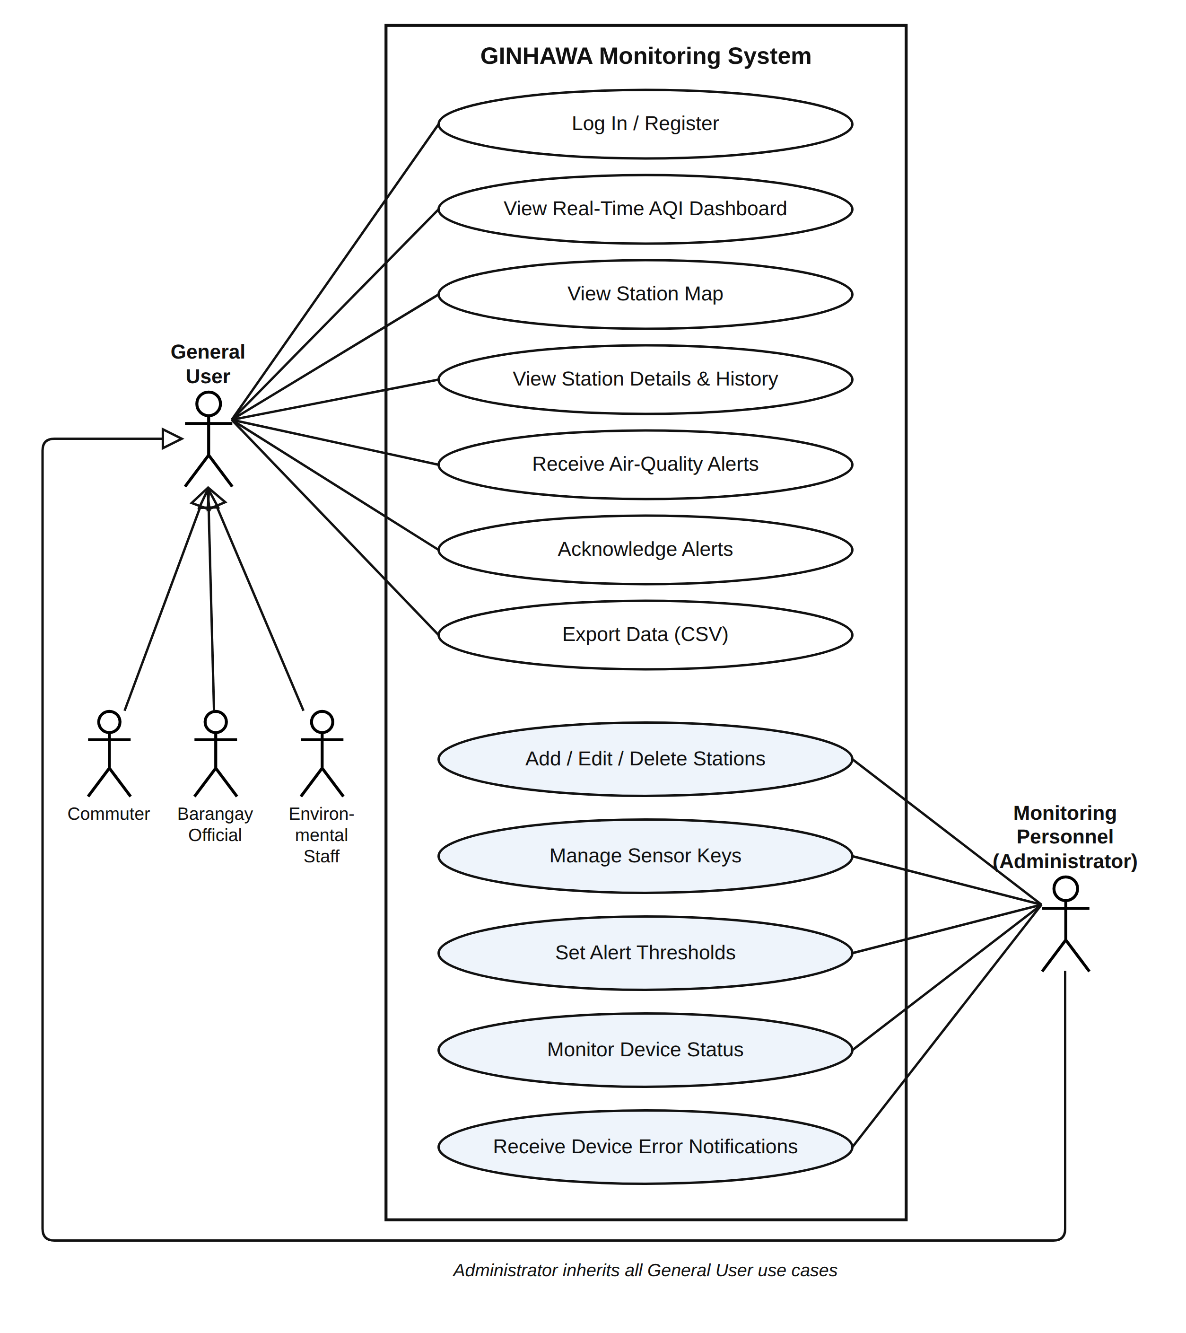
Figure 4. Use Case Diagram
Figure 4 presents the Use Case Diagram of GINHAWA. Only people who directly use the system are shown as actors; hardware and software components such as the monitoring stations, sensors, and backend server are part of the system and are therefore not actors. The General User represents commuters and pedestrians, barangay officials, and environmental staff. General users can log in or register, view the real-time AQI dashboard, view the station map, view station details and history, receive and acknowledge air quality alerts, and export data. The Monitoring Personnel (Administrator) inherits all general-user use cases and additionally performs the administrative functions: adding, editing, and deleting stations; managing sensor keys; setting alert thresholds; monitoring device status (online/offline, battery, and connectivity); and receiving device error notifications.

3.2.5 Context Diagram
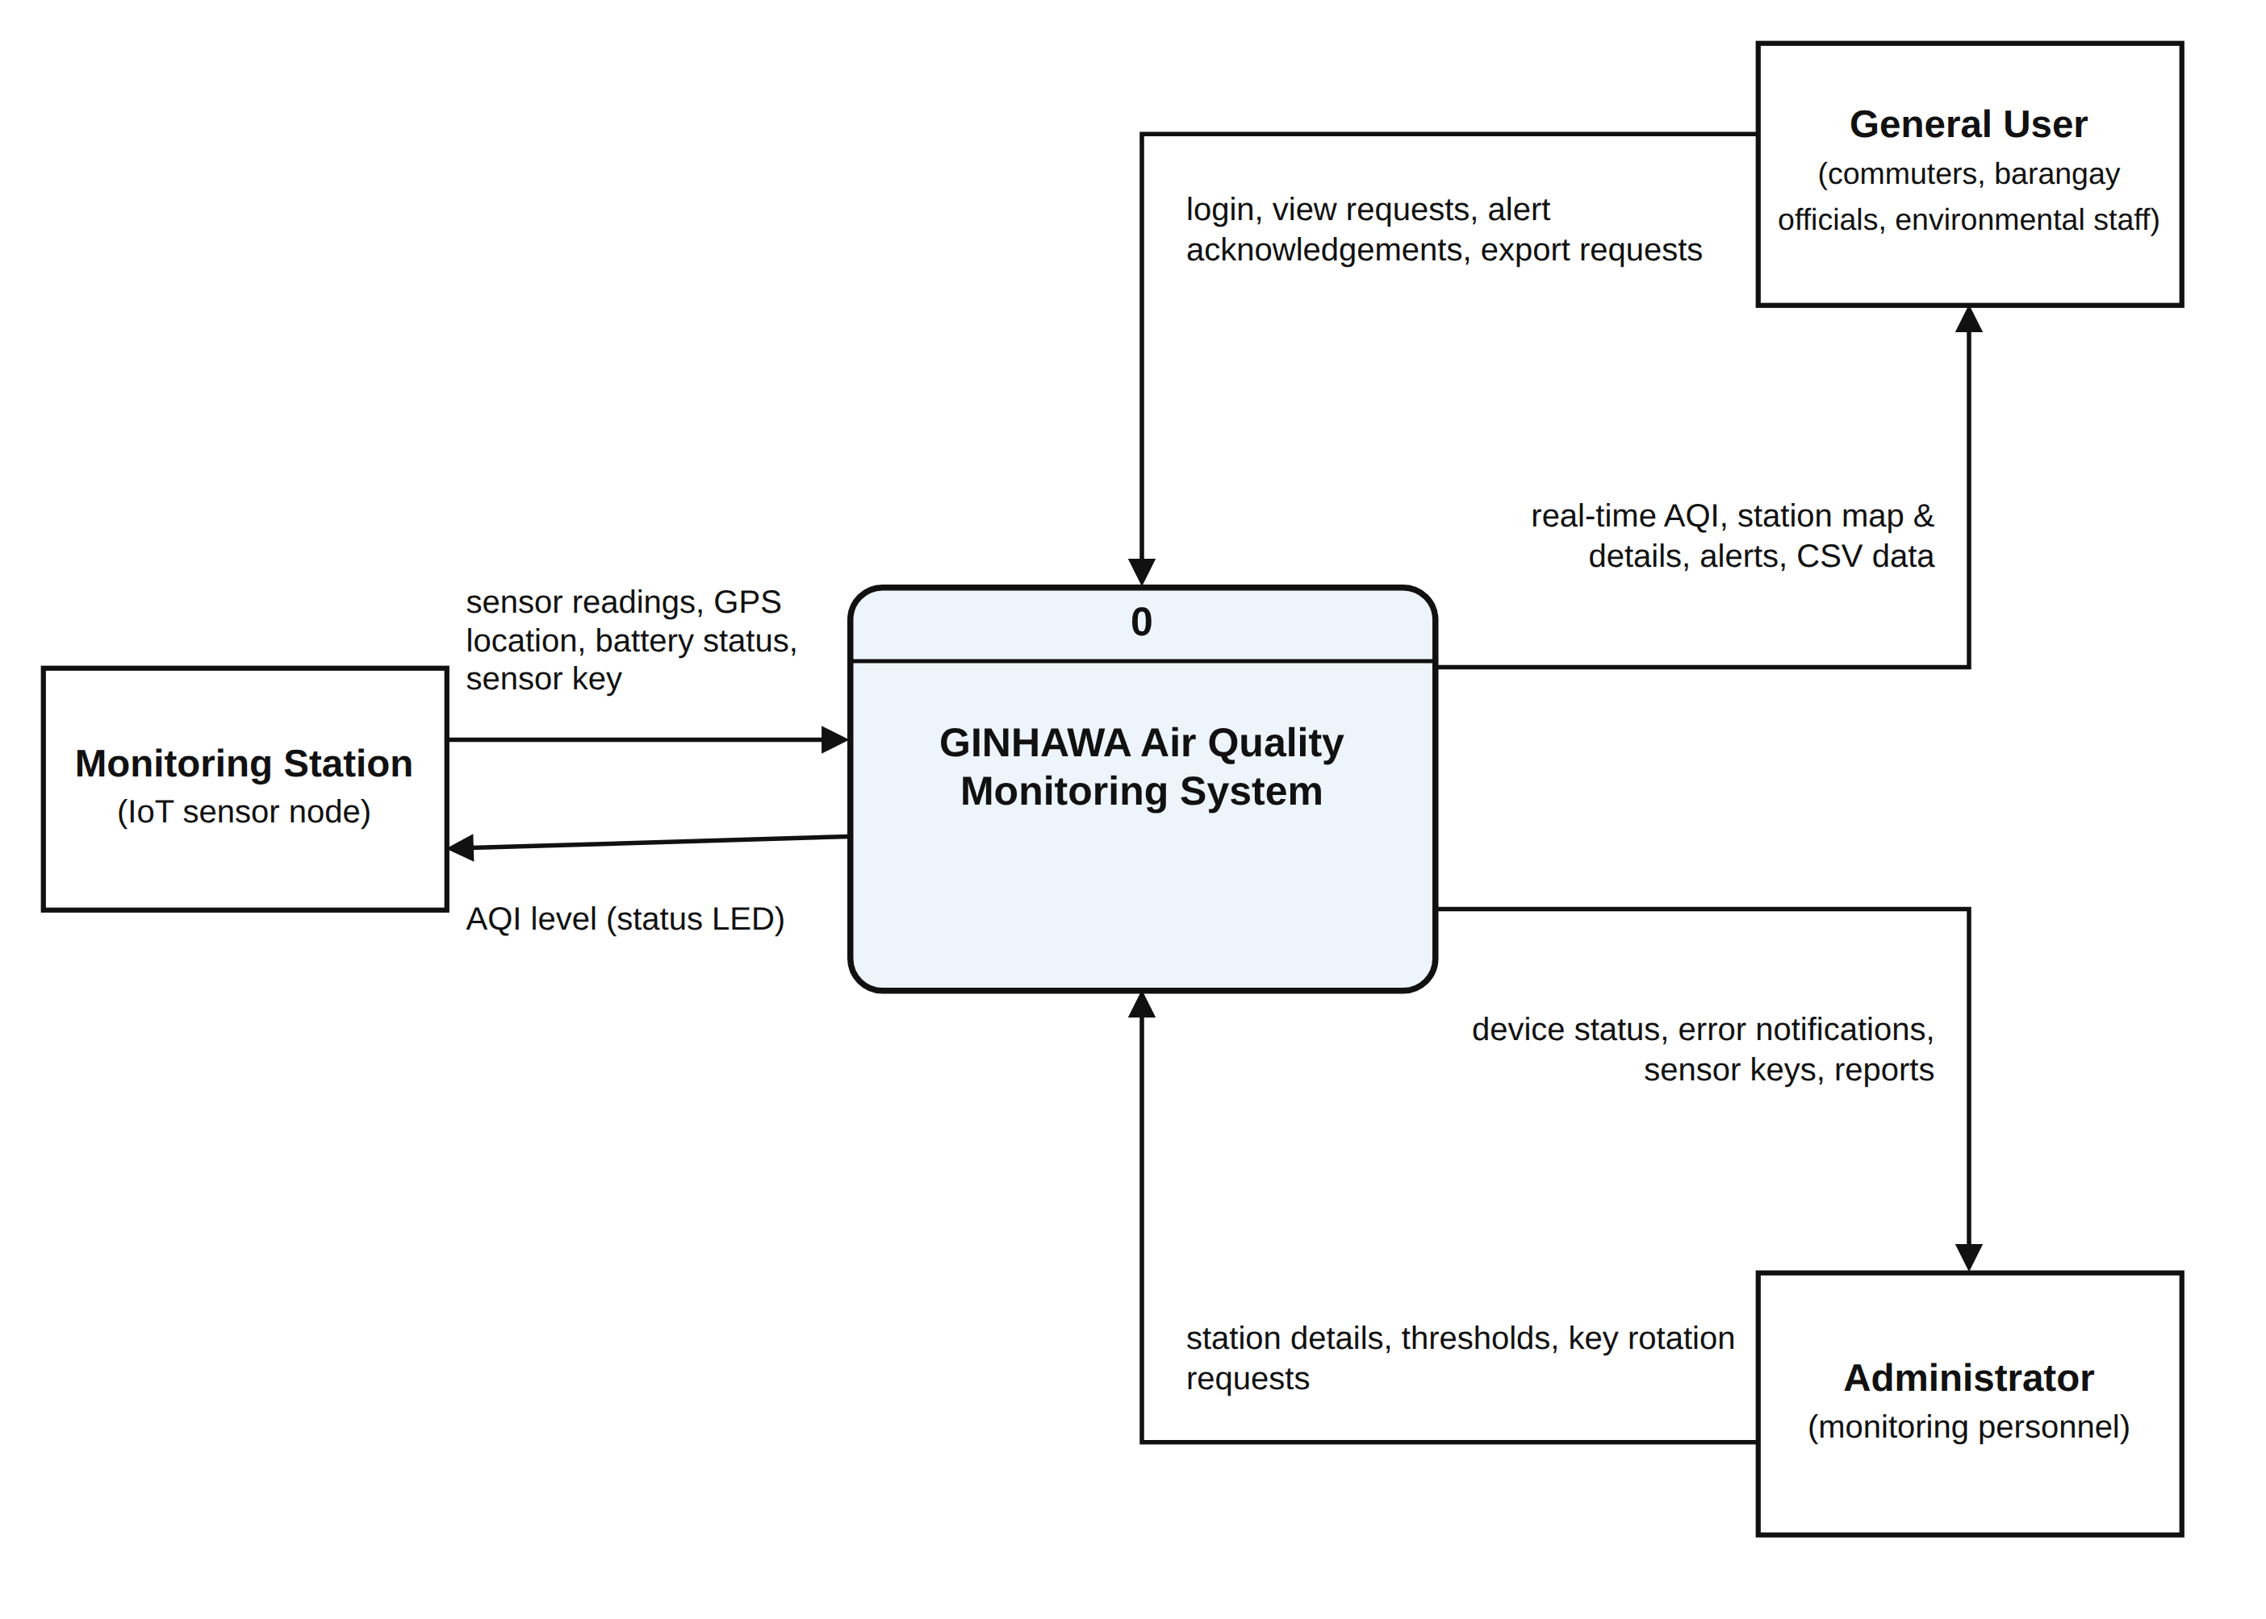
Figure 5. Context Diagram
Figure 5 presents the Context Diagram (Level 0 DFD) of GINHAWA, showing the system as a single process and its data exchanges with three external entities. The Monitoring Station sends sensor readings, GPS location, battery status, and its sensor key, and receives the current AQI level for its status LED. The General User sends login credentials, view requests, alert acknowledgements, and export requests, and receives real-time AQI, station map and details, alerts, and CSV data. The Administrator sends station details, thresholds, and key rotation requests, and receives device status, error notifications, sensor keys, and reports.

3.2.6 Data Flow Diagram
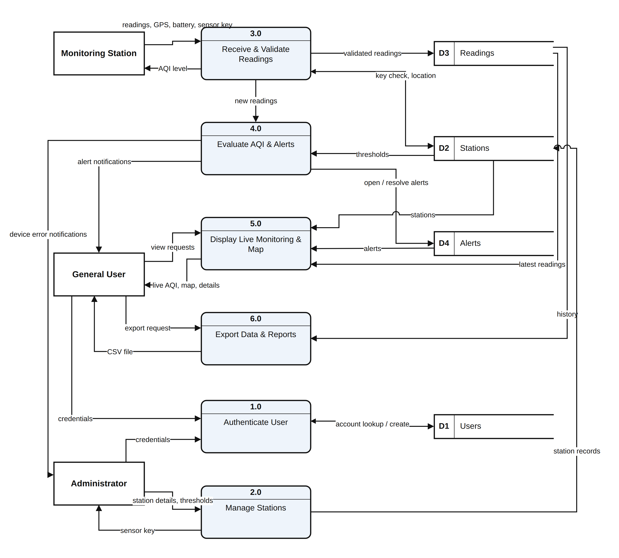
Figure 6. Level 1 Data Flow Diagram
Figure 6 presents the Level 1 Data Flow Diagram, which decomposes the system into six processes and four data stores (D1 Users, D2 Stations, D3 Readings, D4 Alerts). Process 1.0 Authenticate User verifies credentials against D1. Process 2.0 Manage Stations lets the administrator create or update stations and thresholds in D2 and returns the station's sensor key. Process 3.0 Receive and Validate Readings checks the station key against D2, validates the readings, updates the station's location and last-seen time, stores readings in D3, and returns the AQI level to the station. Process 4.0 Evaluate AQI and Alerts compares new readings with the thresholds in D2, opens or resolves alerts in D4, and sends alert and device-error notifications. Process 5.0 Display Live Monitoring and Map combines D2, D3, and D4 to deliver live AQI, the station map, and station details to users. Process 6.0 Export Data and Reports retrieves history from D3 and returns CSV files.

3.2.7 Hardware Block Diagram
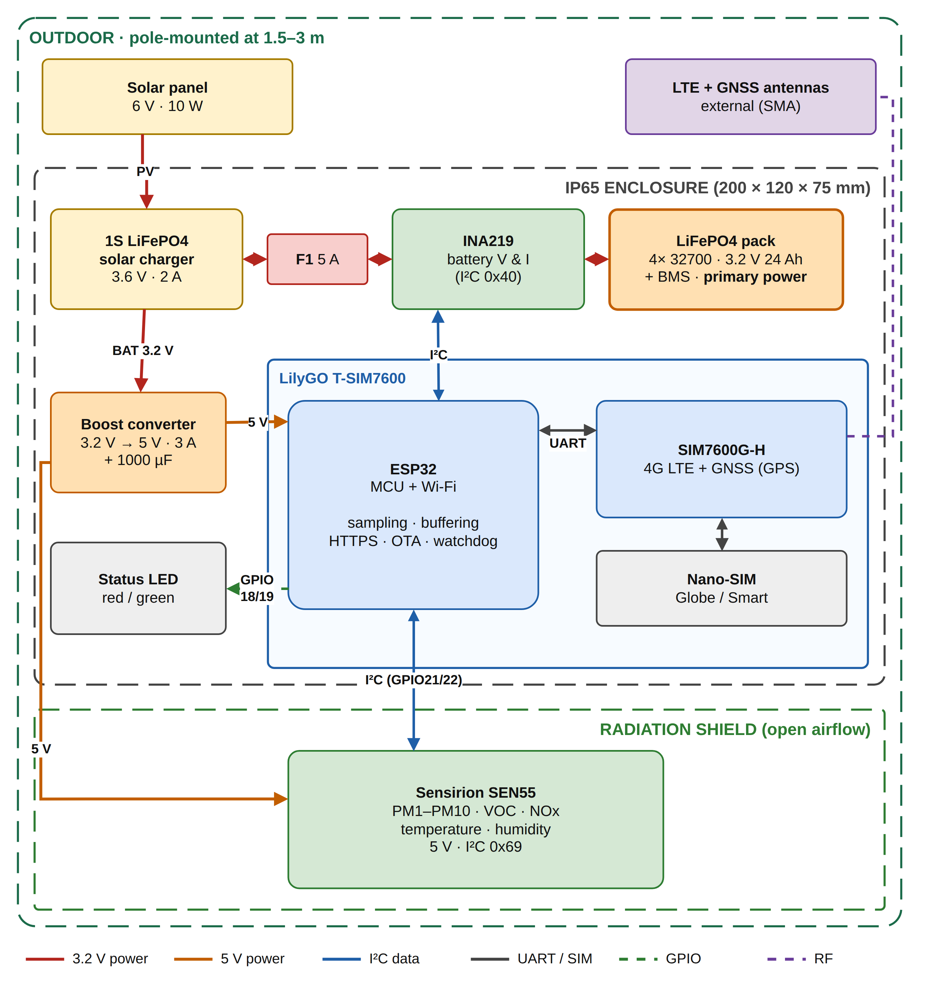
Figure 7. Monitoring Station Hardware Block Diagram
Figure 7 shows the hardware blocks of one monitoring station and how they are grouped physically. The solar panel and LTE/GNSS antennas are mounted outdoors. The IP65 enclosure (200 × 120 × 75 mm) holds the solar charger, 5 A fuse, INA219 power monitor, LiFePO4 battery pack with its protection board (BMS), boost converter, status LEDs, and the LilyGO T-SIM7600 board. The radiation shield holds the SEN55 sensor separately from the enclosure so that heat from the electronics and battery does not affect the readings and air can flow freely around the sensor. Power paths (3.2 V and 5 V), I²C data, UART, GPIO, and RF links are drawn in different line styles, as shown in the legend.

3.2.8 Circuit Diagram
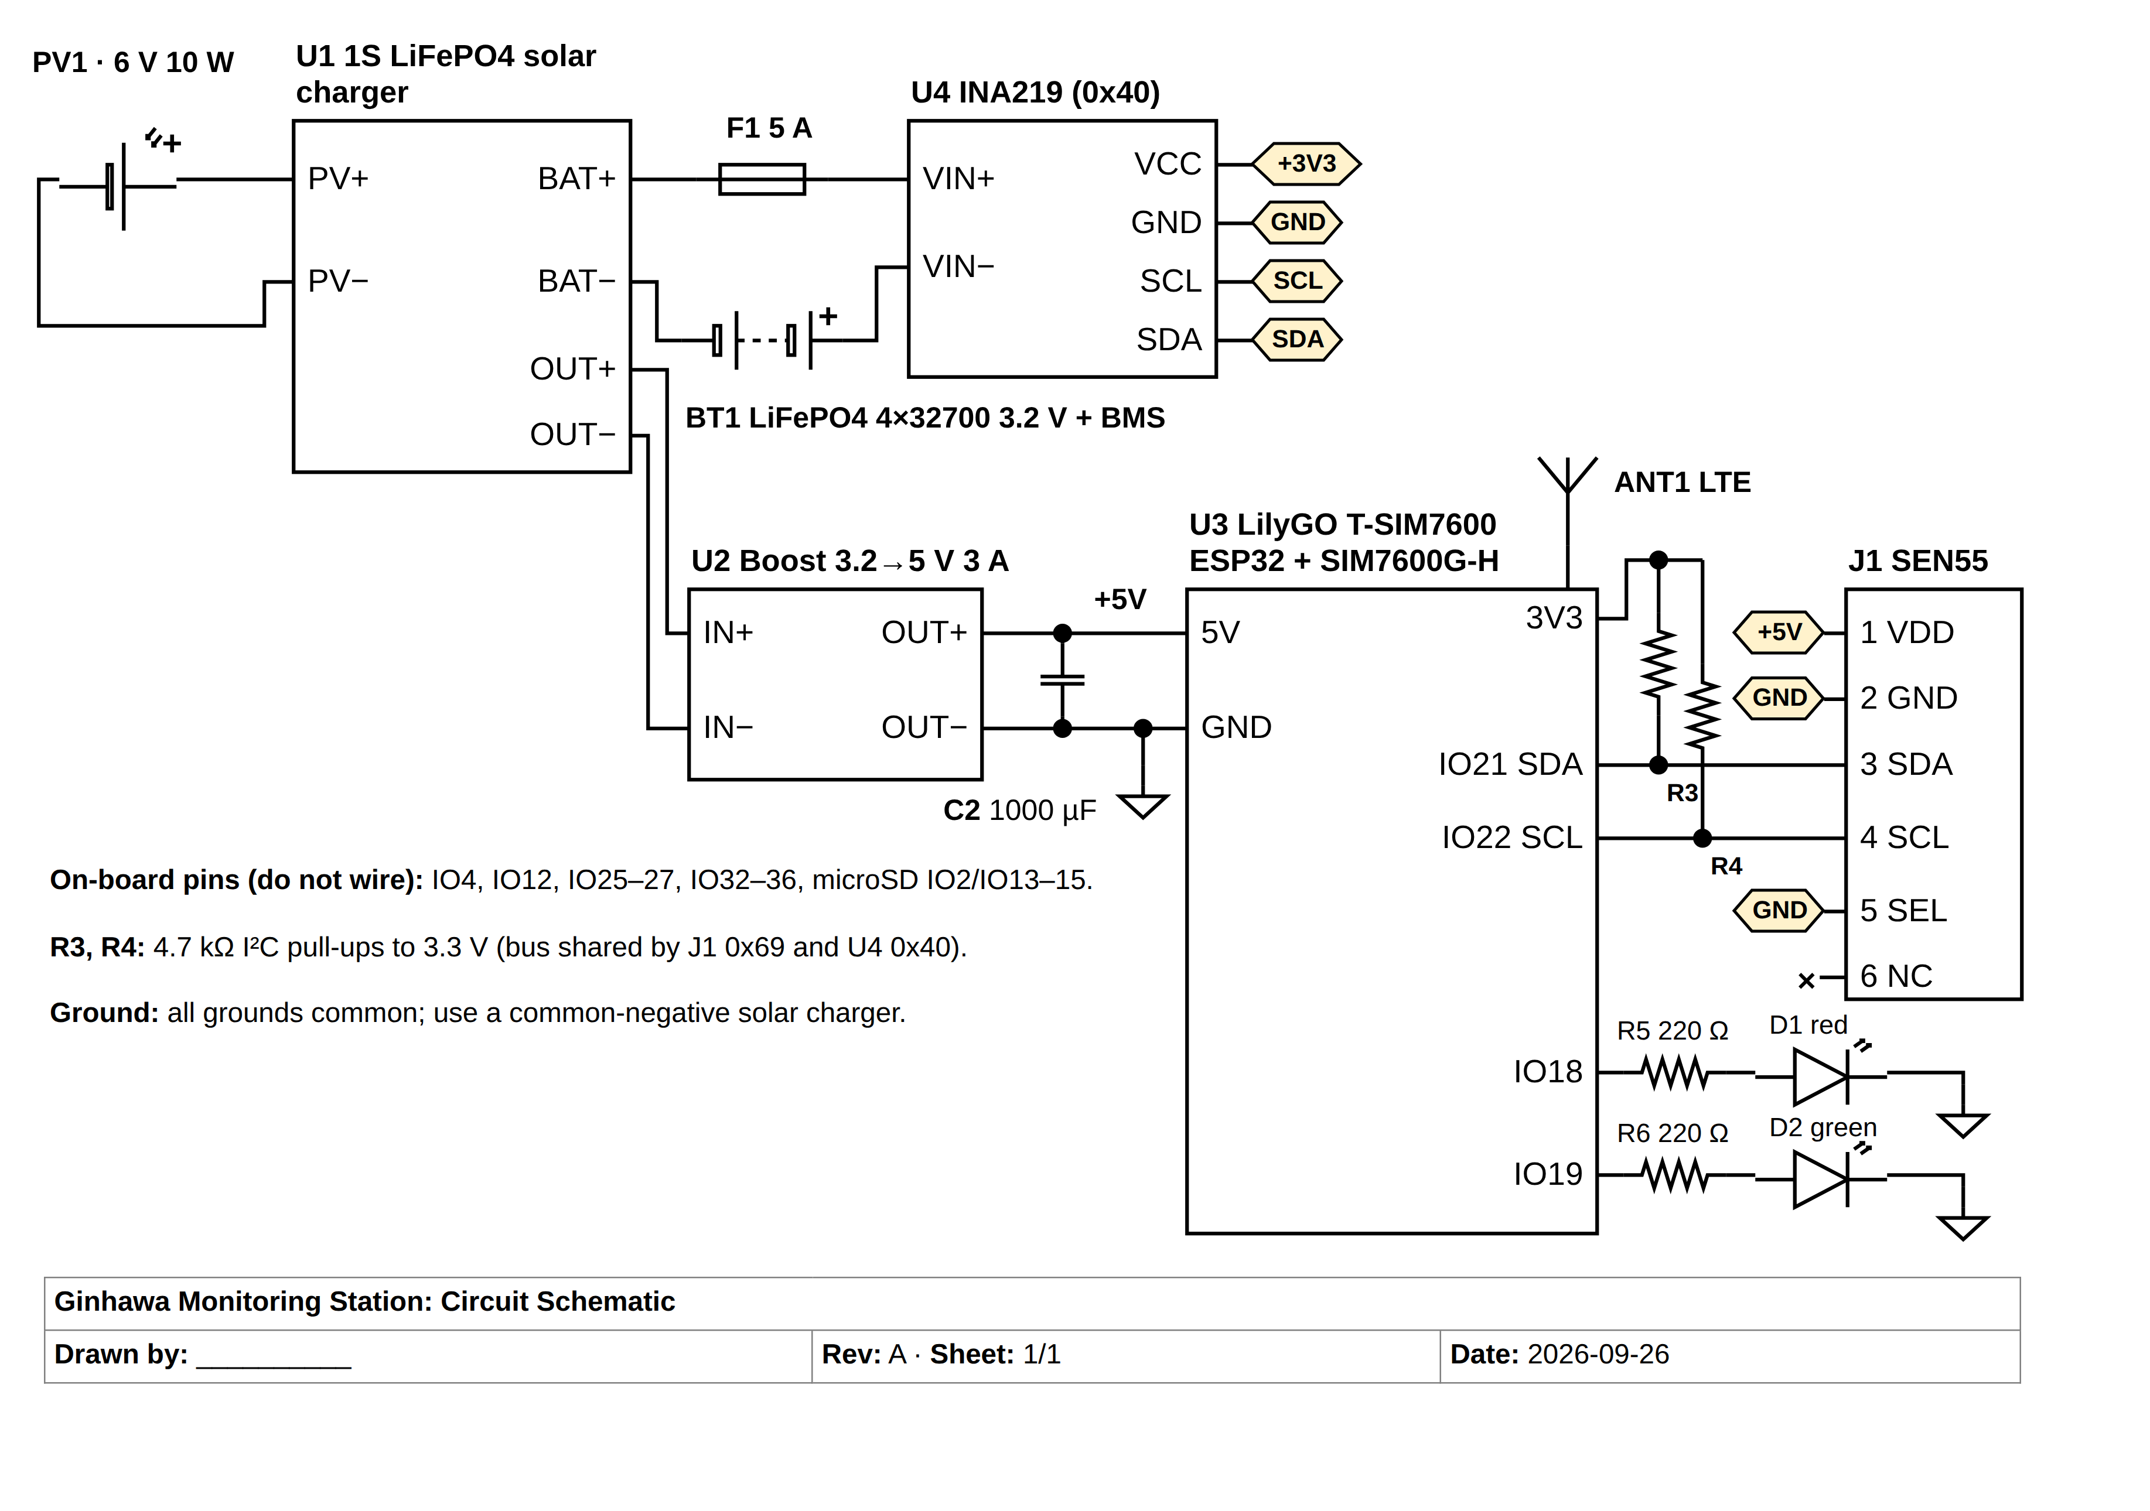
Figure 8. Circuit Diagram
Figure 8 presents the circuit diagram drawn with standard electrical symbols and reference designators. PV1 connects to the solar input of the 1S LiFePO4 charger U1. The battery pack BT1 (four 32700 cells in parallel with a protection board) connects to U1's battery terminals through fuse F1 and the INA219 current-sense input (U4 VIN+ to VIN−), so the INA219 measures battery voltage and charge/discharge current. U1's output feeds the boost converter U2, whose 5 V output (with bulk capacitor C2 to absorb LTE transmit current peaks) powers the LilyGO board U3 and the SEN55 (J1 pin 1). J1 pin 5 (SEL) is tied to ground to select I²C mode. The SEN55 and INA219 share the I²C bus on GPIO21 (SDA) and GPIO22 (SCL) with 4.7 kΩ pull-up resistors R3 and R4. Status LEDs D1 and D2 are driven from GPIO18 and GPIO19 through 220 Ω resistors. Table 2 lists the pin assignments.
Table 2. Pin Assignments
Signal | Component / Pin | ESP32 GPIO | Notes
I²C SDA | SEN55 pin 3, INA219 SDA | GPIO21 | 4.7 kΩ pull-up to 3.3 V (R3)
I²C SCL | SEN55 pin 4, INA219 SCL | GPIO22 | 4.7 kΩ pull-up to 3.3 V (R4)
Interface select | SEN55 pin 5 (SEL) | — | Tied to GND to select I²C
Status LED (red) | D1 via R5 220 Ω | GPIO18 | On when air quality is poor
Status LED (green) | D2 via R6 220 Ω | GPIO19 | On when air quality is good
Modem UART | SIM7600 TX / RX | GPIO27 / GPIO26 | Wired on the board
Modem power key | SIM7600 PWRKEY | GPIO4 | Wired on the board
I²C addresses | SEN55 0x69, INA219 0x40 | — | No address conflict

3.2.9 Power Budget and Solar Sizing
Because each station must operate continuously outdoors while staying compact, the power subsystem was sized from an estimated daily energy budget. To reduce consumption, the SEN55 measures particulate matter for one minute in every five minutes and keeps its VOC, NOx, temperature, and humidity sensing running in its low-power mode the rest of the time; readings are uploaded once per minute, and the ESP32 and modem sleep between uploads. Table 3 lists the estimated consumption under the worst case, in which the station uses 4G LTE all day.
Table 3. Estimated Daily Power Budget of One Station (Worst Case, LTE)
Load | Average Power (W) | Hours / Day | Energy (Wh / day)
Sensirion SEN55 (PM 1 min in 5; gas/RH/T continuous) | 0.10 | 24 | 2.4
ESP32 (active during readings/uploads, light sleep otherwise) | 0.15 | 24 | 3.6
SIM7600 LTE modem and GPS (upload every minute) | 0.25 | 24 | 6.0
INA219, status LEDs | 0.02 | 24 | 0.5
Boost converter losses (≈15%) | — | — | 1.9
Total estimated consumption | ≈0.6 |  | ≈14.4

Battery sizing. Four LiFePO4 32700 cells (6 Ah each) connected in parallel form a 3.2 V, 24 Ah pack that stores about 77 Wh. Using 80% depth of discharge (≈61 Wh usable), the station can run for about 4.3 days without sunlight (61 ÷ 14.4), which covers several consecutive cloudy or rainy days. The whole pack measures only about 130 × 70 × 32 mm and weighs about 0.6 kg, compared with about 1.5 kg for a 12.8 V 12 Ah battery block. LiFePO4 cells were chosen over lithium-ion for their heat tolerance, safety, and long cycle life, and a 1S protection board (BMS) guards against over-charge, over-discharge, and short circuit.
Solar sizing. With about 4.5 peak sun hours per day and a 75% derating for temperature, dust, and charging losses, a 10 W panel produces about 33.8 Wh per day (10 × 4.5 × 0.75), or about 2.3 times the daily consumption, allowing the battery to recover after cloudy days. These values are design estimates; actual consumption and charging will be measured with the INA219 during testing and the sampling schedule or panel size adjusted if necessary.

3.2.10 Enclosure Design, Sensor Placement, and Ventilation
The station is designed for outdoor exposure to rain, heat, and dust. The station is built as one compact unit: a small sealed enclosure for the electronics and battery, with the ventilated sensor shield mounted about 50 mm below it, so the sensor receives unobstructed outside air while the electronics remain sealed. Table 4 lists the physical dimensions used for the 3D model.
Table 4. Physical Dimensions of Station Components
Component | Dimensions (L × W × H) | Notes
Sensirion SEN55 sensor module | 40.6 × 40.6 × 12 mm | From the manufacturer datasheet
Radiation shield (3D-printed) | Ø 110 mm × 140 mm (6 louvered plates) | ASA or PETG, white, UV-resistant; mounted under the enclosure
IP65 electronics enclosure | 200 × 120 × 75 mm | ABS/PC, light gray; vent, cable glands, silica gel
LiFePO4 pack (4 × 32700 cells, 1S4P) | ≈130 × 70 × 32 mm (cells lying flat) | Each cell Ø 32 × 70 mm; ≈0.6 kg total
LilyGO T-SIM7600 board | [measure] mm | Mounted on standoffs
Solar panel 6 V 10 W | ≈[confirm from supplier] mm | Mounted above the unit, tilted ≈15° facing south
Mounting height | 1.5–3.0 m above ground | Breathing height of pedestrians
Complete station (without panel) | ≈200 × 120 × 265 mm | Enclosure + 50 mm gap + shield; ≈1.3 kg (estimate) [verify after assembly]

Sensor placement. The SEN55 is mounted inside the radiation shield with its air inlet facing downward, keeping rain and direct sunlight out while air flows freely between the louvered plates. The 50 mm gap keeps heat from the enclosure away from the sensor, and the unit is positioned away from walls and direct exhaust outlets, with open air on all sides, so that readings are not obstructed or biased by trapped heat. Stainless insect mesh covers the openings. Mounting the sensor at breathing height (1.5–3.0 m) captures the air that pedestrians actually breathe.
Waterproofing and heat protection. The electronics enclosure is IP65-rated, with cable glands for every wire, a pressure-equalizing breathable vent, and silica gel to prevent condensation. Circuit boards receive a conformal coating against humidity. The enclosure is light-colored to reflect heat and the solar panel mounted above it shades the unit from direct midday sun, as LiFePO4 batteries should be charged below about 45 °C. The radiation shield and mounting brackets are 3D-printed in UV-resistant material, which allows the design to be customized and replacement parts to be printed easily. [Update the 3D model figure with these dimensions and insert it here.]

3.2.11 GPS Location Tracking and Multi-Station Scalability
Location tracking. The SIM7600G-H modem on the LilyGO board includes a GNSS (GPS) receiver. Each station obtains a position fix at start-up and at regular intervals (every 15 minutes) and includes its latitude and longitude with its readings. The server updates the station's location and the time it was last updated, and the application places each station on a map (OpenStreetMap) as a marker colored by its current AQI level. If a station cannot obtain a GPS fix, for example when mounted under a roof, its last known location is kept and the administrator can set the location manually. Because the location comes from the device itself, relocating a station automatically updates its position on the map.
Scalability. Adding a station does not require any code or server configuration. The administrator registers the new station in the application, which issues a unique secret key; the same firmware is flashed with that key, and when the station starts reporting it appears automatically on the map and station list for all users, with its location filled in by GPS. The database stores readings per station, the API accepts any number of stations, and live updates are broadcast to all connected users, so the system scales to additional stations in Barangay Carmen or other barangays.

3.2.12 Flowchart
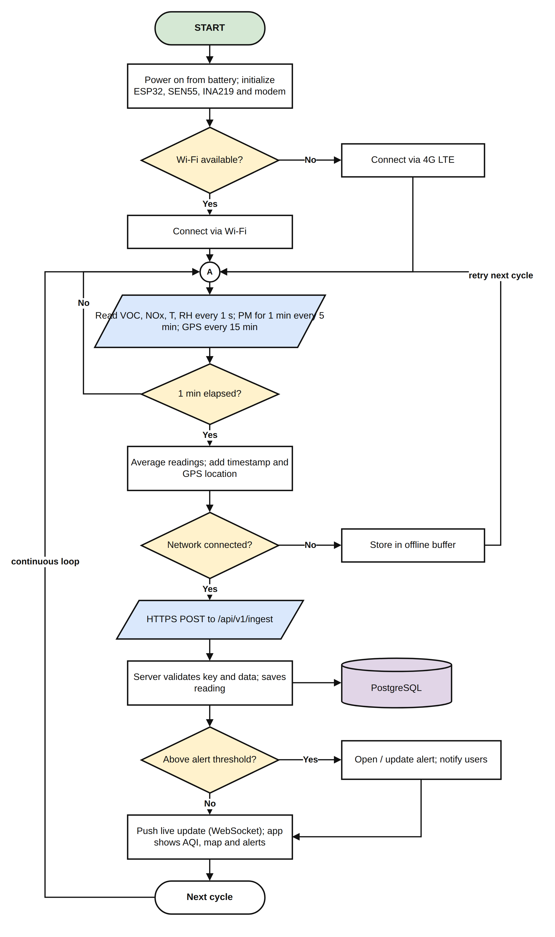
Figure 9. System Flowchart
Figure 9 illustrates the operating cycle of GINHAWA. On power-up, the station initializes its sensor, power monitor, and modem and connects through Wi-Fi, or through 4G LTE when Wi-Fi is unavailable. It reads the VOC, NOx, temperature, and humidity every second, particulate matter for one minute in every five, and GPS every 15 minutes; every minute it averages the readings and adds a timestamp and location. If the network is connected, the data is sent by HTTPS to the server; otherwise it is stored in an offline buffer and sent on the next cycle. The server validates the station key and data, saves the reading to PostgreSQL, checks it against the alert thresholds, opens or updates an alert and notifies users when a threshold is exceeded, and pushes a live update to the application. The cycle then repeats continuously.

3.2.13 User Interface
The GINHAWA application is a mobile-first web application that can be installed on a phone's home screen. Figures 10 to 12 show the main screens, captured from the working prototype with simulated placeholder data.
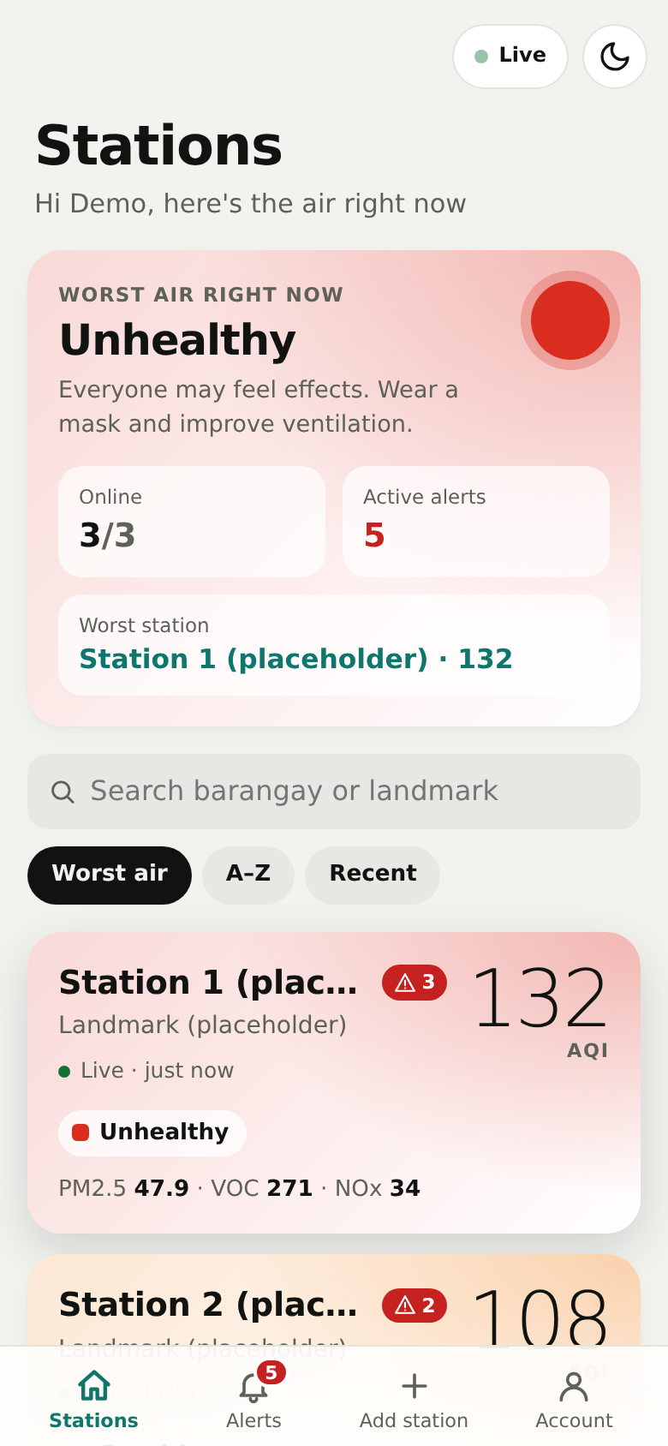  Figure 10. Stations Dashboard | 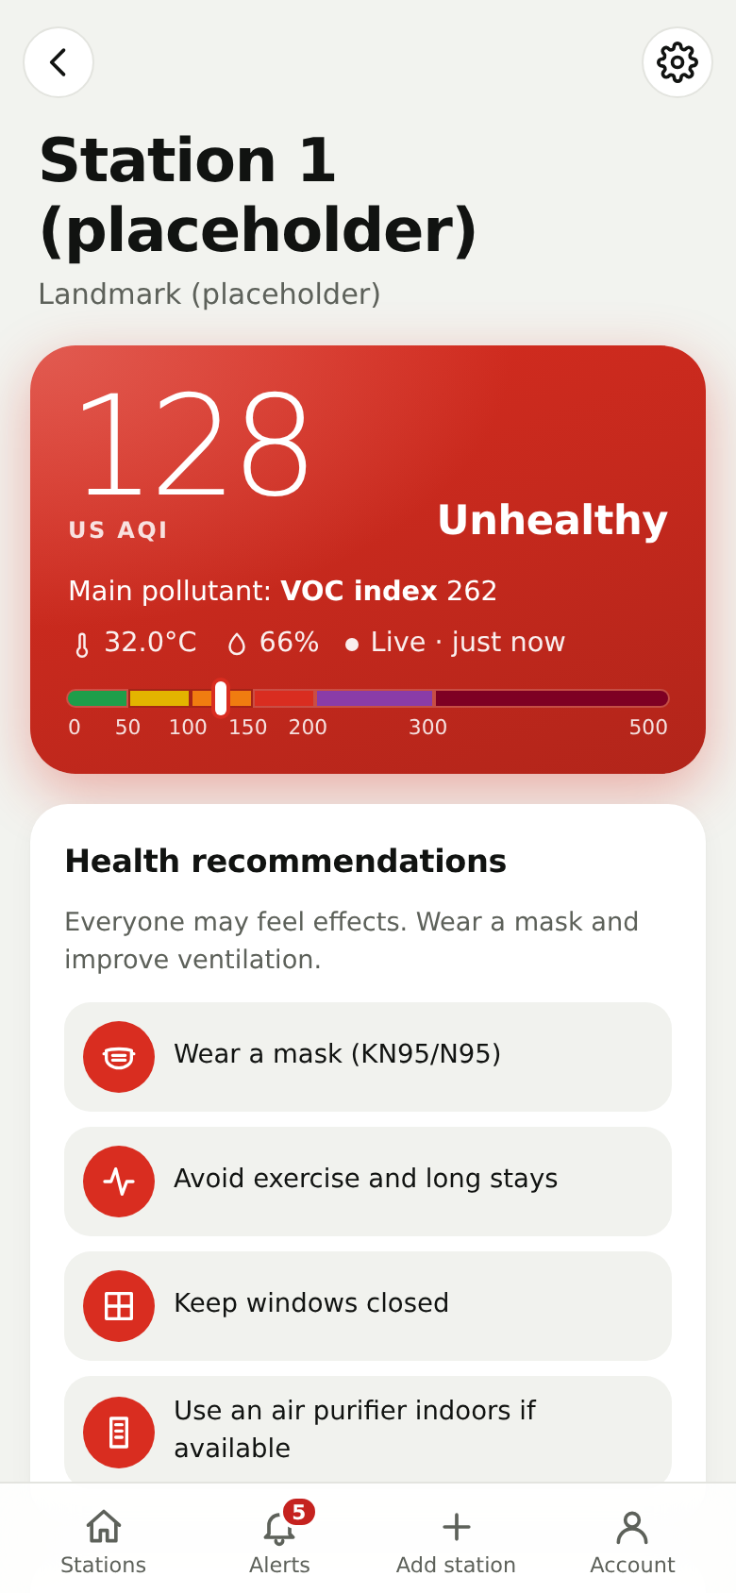  Figure 11. Station Details | 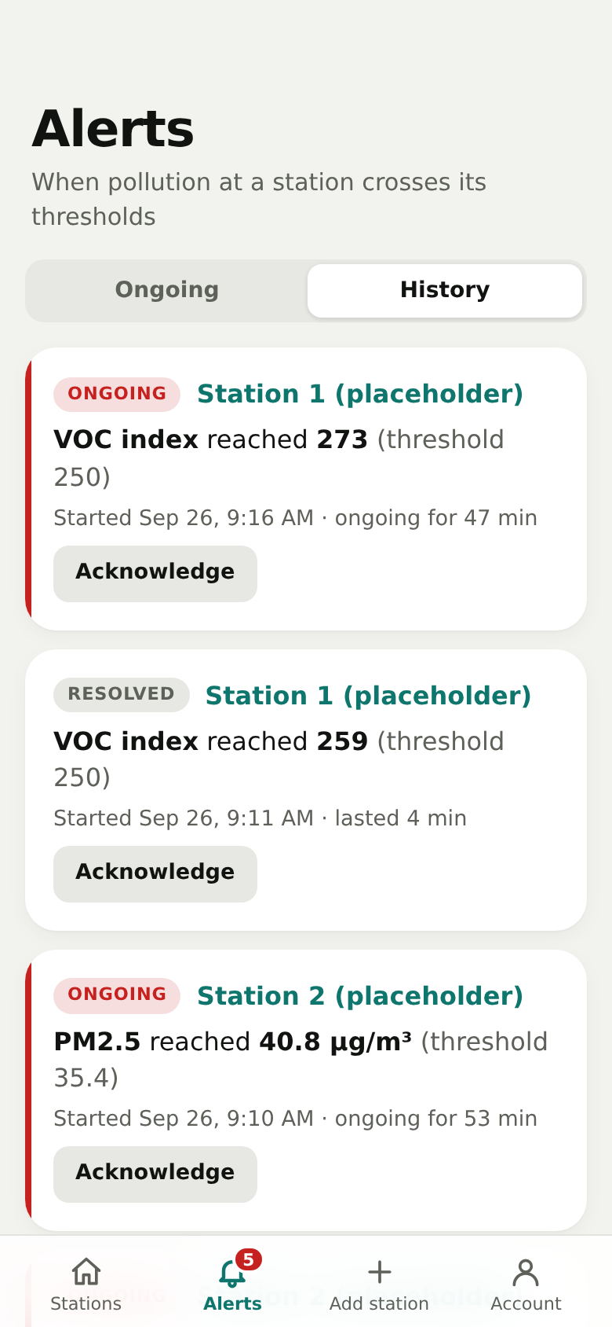  Figure 12. Alerts
The Stations Dashboard (Figure 10) summarizes the worst air quality right now, the number of stations online, and active alerts, followed by a searchable, sortable list of stations tinted by their AQI level. The Station Details screen (Figure 11) shows the station's current AQI, main pollutant, temperature, humidity, the AQI color scale, health recommendations, the last 12 hours of hourly AQI, all readings with plain-language explanations, and history charts. The Alerts screen (Figure 12) lists ongoing and past threshold exceedances, which users can acknowledge. Administrators additionally see the Add Station screen and station settings (thresholds, sensor keys, and deletion). The station map view and device status panel described in Sections 3.2.11 and 3.5 are part of the next development sprint. The application supports light, dark, and system themes.

3.3 System Development

3.3.1 Hardware Requirements
Table 5 lists the hardware components of one monitoring station and the equipment needed to host the backend.
Table 5. Hardware Requirements
Component | Specification | Function
Sensirion SEN55 | PM1.0/2.5/4.0/10, VOC & NOx index, temperature, humidity; I²C; 5 V ±10%; ≈70 mA | Main environmental sensor
LilyGO T-SIM7600G-H | ESP32-WROVER-E + SIMCom SIM7600G-H (4G LTE Cat-4, GNSS) | Microcontroller, Wi-Fi, LTE and GPS
INA219 module | I²C voltage/current monitor (0x40) | Battery voltage and current monitoring
Solar panel | 6 V, 10 W, monocrystalline | Recharges the battery
1S LiFePO4 solar charger module | 3.6 V charge voltage, ≥2 A, solar input | Safe charging from the panel
LiFePO4 cells + protection board | 4 × 32700 (3.2 V, 6 Ah each) in parallel = 24 Ah (≈77 Wh); 1S BMS | Primary power source
DC-DC boost converter | 3.2 V → 5 V, 3 A, with 1000 µF capacitor | Supplies the board and sensor
LTE and GNSS antennas | External, SMA connectors | Cellular and GPS reception
Nano-SIM card | Registered prepaid (Globe or Smart) with data | LTE connectivity
Passive components | LEDs (red/green), 220 Ω and 4.7 kΩ resistors, 5 A fuse and holder | Status indication, I²C pull-ups, protection
IP65 enclosure | 200 × 120 × 75 mm, vent, cable glands | Houses electronics and battery
Radiation shield | 3D-printed ASA/PETG, Ø 110 mm | Protects the sensor while allowing airflow
Mounting hardware | Pole clamps / U-bolts, stainless screws | Installation at 1.5–3.0 m
Server computer or VPS | Any 64-bit machine with Docker, 2 GB RAM or more | Hosts the backend and database

3.3.2 Software Requirements
Table 6 lists the software tools and technologies used to develop the firmware, backend, and application.
Table 6. Software Requirements
Tool / Technology | Purpose
Arduino IDE / PlatformIO (C++) | Firmware development for the ESP32
Sensirion I2C SEN5X, ArduinoJson, TinyGSM libraries | Sensor driver, JSON encoding, LTE and GPS modem control
Node.js 22 with Express 5 | Backend REST API over HTTPS
ws (WebSocket) | Real-time updates to the application
PostgreSQL 16 | Relational database for stations, readings, and alerts
JSON Web Token (JWT) and bcrypt | User authentication and password hashing
Zod, Helmet, express-rate-limit | Input validation and API security
React 19 with Vite | Mobile-first web application (Progressive Web App)
Recharts | History and hourly charts
Leaflet with OpenStreetMap | Station map
Caddy 2 | HTTPS certificates, reverse proxy, and static file server
Docker and Docker Compose | Packaging and deployment of the backend
Git and GitHub | Version control and collaboration
Visual Studio Code, draw.io | Code editing and diagram design

3.4 Deployment Plan

3.4.1 Site Selection and Coordination with the Barangay
Deployment sites within Barangay Carmen will be selected using the following criteria: high pedestrian and vehicle activity; proximity to transport stops, markets, schools, or busy intersections; adequate sun exposure for the solar panel; available Wi-Fi or strong mobile signal; a secure mounting point (existing pole or wall) that deters tampering; and permission from the property owner. Two to three stations will be deployed. [List the proposed sites once confirmed.]
The researchers will coordinate formally with the barangay before deployment. A letter of intent will be submitted to the Punong Barangay, and the study will be presented to the Sangguniang Barangay to secure written permission for installation and access to the sites. The researchers will also request available traffic and environmental information from the barangay and the City Environment and Natural Resources Office, and reference air quality data from DENR-EMB Region 10 for comparison. [State the current status of the permission letter and attach it in the appendices.]

3.4.2 Installation and Mounting
Each station will be installed using the following procedure:
- Register the station in the application to obtain its sensor key, and flash the firmware with the key and Wi-Fi credentials.
- Assemble and test the station in the laboratory for at least 24 hours before installation.
- Mount the station on an existing pole or wall with clamps or U-bolts, placing the sensor shield at 1.5–3.0 m above ground with open air on all sides.
- Mount the solar panel above the enclosure, facing south and tilted about 15°, free of shade between 9:00 AM and 3:00 PM.
- Route antenna and power cables through cable glands, seal all openings, and secure the enclosure with tamper-resistant screws.
- Power on the station and confirm that it appears in the application with the correct GPS location and live readings.

3.4.3 Monitoring Duration and Data Collection Schedule
Table 7 summarizes the testing and deployment schedule. During all phases, stations record readings continuously (24 hours a day) and send an averaged reading every minute; data are aggregated hourly for analysis, with particular attention to peak hours (6:00–9:00 AM, 11:00 AM–1:00 PM, and 4:00–7:00 PM).
Table 7. Testing and Deployment Schedule
Phase | Duration | Location | Data Collected
Laboratory testing and sensor validation | 2 weeks | USTP laboratory | Sensor stability, unit-to-unit and reference comparison
Co-location with reference instrument | 7 days | [DENR-EMB Region 10 station or reference monitor] | Hourly PM2.5 pairs for accuracy metrics
Outdoor exposure and reliability test | 14 days | USTP campus (outdoor, open area) | Uptime, data completeness, battery, enclosure condition
Pilot deployment | 30 days | 2–3 sites in Barangay Carmen | Continuous air quality data, uptime, user evaluation

3.5 Testing and Evaluation

3.5.1 Sensor Selection, Laboratory Testing, and Validation
Candidate sensors were compared to select the most suitable sensor for outdoor air quality monitoring (Table 8).
Table 8. Comparison of Candidate Air Quality Sensors
Sensor | Measures | Interface / Power | Assessment
Sensirion SEN55 | PM1.0–PM10, VOC index, NOx index, temperature, humidity | I²C, 5 V, ≈70 mA | Selected: all required parameters in one factory-calibrated module
Plantower PMS5003 + Sensirion SGP41 | PM1.0/2.5/10 + VOC and NOx indices | UART + I²C, 5 V | Lower cost, but two sensors and more wiring; used as comparison unit
MQ-135 | General gas response (NH₃, NOx, alcohol, benzene, smoke) | Analog, heater ≈150 mA | Not selected: low selectivity, no particulate data, needs calibration

Laboratory testing will verify that the selected sensor is accurate, reliable, and suitable using the following steps: (1) a warm-up and stability test in which the sensor runs for 24 hours in a stable indoor environment to check for drift and missing values; (2) a unit-to-unit comparison in which two or more stations run side by side to check that they report consistent values; (3) a comparison against a PMS5003-based unit; and (4) a co-location test in which a station runs beside a reference instrument (Table 7). Agreement will be measured with the coefficient of determination (R²), mean absolute error (MAE), root mean square error (RMSE), and mean bias. The U.S. EPA (2021) performance targets for PM2.5 sensors (R² ≥ 0.70 and RMSE ≤ 7 µg/m³ for hourly averages) will serve as the acceptance guide, and a correction factor will be applied if a consistent bias is found.

3.5.2 Outdoor Durability and Reliability Testing
Table 9 lists the durability and reliability tests performed before and during deployment.
Table 9. Durability and Reliability Tests
Test | Procedure | Acceptance Criterion
Waterproofing (rain) | Spray water on the enclosure and shield from all sides for 10 minutes; inspect inside | No water inside the enclosure; station keeps operating
Heat | Log enclosure and ambient temperature during midday exposure | Battery below 45 °C while charging; no resets
Dust | Inspect mesh and sensor inlet weekly during outdoor tests | No blockage; PM readings remain consistent
Power autonomy | Run on battery with the panel covered | At least 72 hours of operation
Connectivity | Disable Wi-Fi during operation | Automatic LTE fallback; buffered data uploaded after reconnection
Uptime and data completeness | Compute from server records over each phase | Uptime ≥ 95%; data completeness ≥ 90%

3.5.3 Testing Phases
Alpha testing will be carried out in a controlled laboratory environment before field deployment. The firmware, sensor integration, communication with the server, alert logic, and application will be tested, together with the laboratory sensor tests in Section 3.5.1 and the power and connectivity tests in Section 3.5.2, to identify and fix errors before outdoor use.
Beta testing involves the outdoor exposure test and the 30-day pilot deployment in Barangay Carmen. Stations will be evaluated under real conditions, including heat, rain, dust, vehicle traffic, and changing connectivity. Uptime, data completeness, battery levels, and alerts will be recorded continuously. The field data will serve as the basis for the performance and functionality testing, the ISO/IEC 25010 evaluation, and the SUS usability assessment.

3.5.4 Respondents
The technical evaluation will be performed by three to five IT professionals, embedded systems developers, and software engineers experienced in IoT systems, wireless communication, and web or mobile development. They will examine the monitoring station, power subsystem, Wi-Fi/LTE communication, backend, and application, and then complete the ISO/IEC 25010 instrument (Table 10). The usability evaluation will involve [target number, e.g., 30] respondents from Barangay Carmen, including commuters, barangay officials, and environmental staff, who will complete the SUS questionnaire (Table 11) after performing common tasks in the application.

3.5.5 Technical System Evaluation (ISO/IEC 25010)
The ISO/IEC 25010 software quality model will be used to evaluate the technical quality of GINHAWA in terms of functional suitability, reliability, performance efficiency, and security (International Organization for Standardization, 2023). Respondents will rate each criterion using a five-point Likert scale.
Scale: 1 – Strongly Disagree, 2 – Disagree, 3 – Neutral, 4 – Agree, 5 – Strongly Agree
Table 10. ISO/IEC 25010 Technical Evaluation Instrument
Quality Characteristic | Evaluation Criteria | 1 | 2 | 3 | 4 | 5
Functional Suitability | 1. The system accurately measures and displays PM2.5, VOC, and NOx readings from each station.
 | 2. The system correctly computes the AQI level and generates alerts when thresholds are exceeded.
 | 3. The map correctly shows the location of each deployed station.
Reliability | 4. Stations keep collecting and uploading data during Wi-Fi interruptions (LTE fallback and offline buffering).
 | 5. The solar and battery power subsystem sustains continuous operation.
Performance Efficiency | 6. Readings appear on the dashboard within a few seconds of being measured.
 | 7. The application remains responsive with multiple stations reporting at the same time.
Security | 8. Only authorized administrators can add or change stations, and each station uses its own secret key.

3.5.6 Usability Evaluation (System Usability Scale)
The standard 10-item System Usability Scale (Brooke, 1996) will be used to evaluate the usability of the GINHAWA application. Respondents will perform common tasks, such as viewing real-time AQI, viewing the station map and history, and reviewing alerts, and then answer the questionnaire.
Scale: 1 – Strongly Disagree, 2 – Disagree, 3 – Neutral, 4 – Agree, 5 – Strongly Agree
Table 11. System Usability Scale (SUS) Questionnaire
SUS Statement | 1 | 2 | 3 | 4 | 5
1. I think that I would like to use this system frequently.
2. I found the system unnecessarily complex.
3. I thought the system was easy to use.
4. I think that I would need the support of a technical person to be able to use this system.
5. I found the various functions in this system were well integrated.
6. I thought there was too much inconsistency in this system.
7. I would imagine that most people would learn to use this system very quickly.
8. I found the system very cumbersome to use.
9. I felt very confident using the system.
10. I needed to learn a lot of things before I could get going with this system.

3.5.7 Performance Testing
Performance testing will determine whether the monitoring stations and platform meet their technical requirements under laboratory and field conditions (Table 12).
Table 12. Performance Testing for GINHAWA System Components
System Feature / Objective | Pass | Fail
1. Acquisition of VOC, NOx, temperature, and humidity every second and PM readings on the 5-minute schedule
2. Successful HTTPS upload of readings over Wi-Fi
3. Automatic fallback to 4G LTE when Wi-Fi is unavailable
4. Offline buffering and batch upload after the connection is restored
5. GPS position obtained and station location updated on the map
6. Continuous operation on battery for at least 72 hours without sunlight
7. Live dashboard update within 5 seconds of a reading being uploaded
8. Alert opened when a threshold is exceeded and resolved when air quality recovers
9. No water ingress after the waterproofing test

3.5.8 Functionality Testing
Functionality testing will verify that users and administrators can perform all features of the GINHAWA platform without errors (Table 13).
Table 13. Functionality Testing for the GINHAWA Monitoring Platform
Platform Feature | Pass | Fail
1. Account registration, login, and logout
2. Role-based access for administrators and general users
3. View the real-time AQI dashboard for all stations
4. View the station map with GPS locations
5. View station details, history charts, and busiest hours
6. Receive and acknowledge air quality alerts
7. Add, edit, and delete stations and rotate sensor keys (administrator)
8. Set alert thresholds per station (administrator)
9. Monitor device status: online/offline, battery, and connectivity (administrator)
10. Export station data to CSV

3.6 Costing
Table 14 presents the estimated cost of one monitoring station and the supporting services. Prices are estimates based on local online sellers and will be updated with actual receipts.
Table 14. Estimated Cost of One Monitoring Station
Date | Description | Estimated Amount
Pending | Sensirion SEN55 sensor | ₱2,000.00 – ₱2,800.00
 | LilyGO T-SIM7600G-H board | ₱2,600.00 – ₱3,500.00
 | LTE and GNSS antennas | ₱300.00 – ₱500.00
 | Solar panel, 6 V 10 W | ₱500.00 – ₱900.00
 | 1S LiFePO4 solar charger module | ₱150.00 – ₱400.00
 | LiFePO4 32700 6 Ah cells (×4) | ₱1,000.00 – ₱1,600.00
 | 1S LiFePO4 protection board (BMS), cell holder, nickel strip | ₱150.00 – ₱300.00
 | DC-DC boost converter, 3.2 V → 5 V 3 A | ₱150.00 – ₱300.00
 | INA219 power monitor module | ₱150.00 – ₱250.00
 | Fuse, wires, connectors, cable glands | ₱300.00 – ₱500.00
 | LEDs, resistors, capacitor | ₱50.00 – ₱100.00
 | IP65 enclosure (200 × 120 × 75 mm) | ₱350.00 – ₱700.00
 | 3D-printed radiation shield and brackets | ₱300.00 – ₱800.00
 | Mounting hardware (clamps, U-bolts, screws) | ₱300.00 – ₱600.00
 | Prepaid SIM data (2 months) | ₱600.00 – ₱1,000.00
 | Server hosting / VPS (optional, 2 months) | ₱0.00 – ₱1,200.00
 | Total estimated expenses | ₱8,900.00 – ₱15,450.00

The total estimated cost of one station is ₱8,900.00 to ₱15,450.00, against an initial budget of ₱15,000.00. The compact design keeps one station within budget; additional stations for the pilot deployment will require [budget source for additional stations].

3.7 Gantt Chart
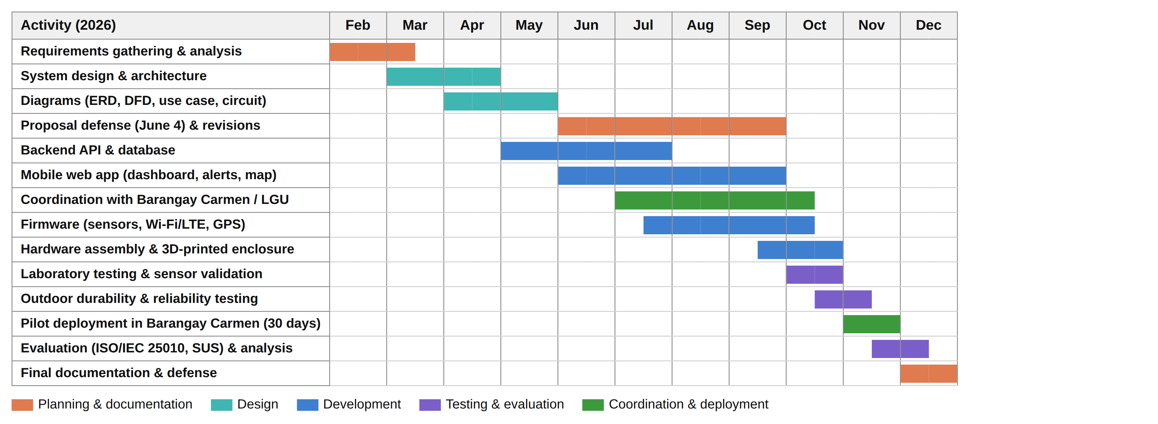
Figure 13. Gantt Chart of Project Activities
Figure 13 shows the schedule of project activities from requirements gathering in February 2026 to the final defense in December 2026, including the barangay coordination, laboratory and outdoor testing, and the 30-day pilot deployment added after the proposal defense. [Adjust the dates to the group's actual schedule.]

REFERENCES
Alarcon, J. A. A., Ocscina, C. J. R., & Castro, E. G. (2020). Indoor air quality monitoring system using Arduino Uno and MQ-135 sensor in Cainta, Rizal and Pasay City, Philippines. Proceedings of the Samahang Pisika ng Pilipinas. https://proceedings.spp-online.org/article/view/SPP-2020-2D-03
Ambat, S. C., Lagman, A. C., Sabonsolin, J. A., & Magnaye, A. D. (2026). Web-based air quality monitoring and mapping system using fuzzy logic algorithm. In Proceedings of the 13th International Conference on Information Technology: IoT and Smart City. https://paraverse.feutech.edu.ph/repository/article/10.1145/3787330.3787355
Bakare, M. S., & Abubaker, K. (2026). IoT-based indoor environmental monitoring system using multi-parameter sensing and ESP32-WROOM integration. https://link.springer.com/article/10.1007/s44291-026-00157-3
Bandara, N., Hettiarachchi, S., & Athukorala, P. (2021). AirSPEC: An IoT-empowered air quality monitoring system integrated with a machine learning framework. https://arxiv.org/abs/2111.14125
Brooke, J. (1996). SUS: A "quick and dirty" usability scale. In P. W. Jordan, B. Thomas, B. A. Weerdmeester, & I. L. McClelland (Eds.), Usability evaluation in industry (pp. 189–194). Taylor & Francis.
Chaidee, K., et al. (2026). Design and implementation of a low-cost IoT-based indoor air quality monitoring system. https://ieeexplore.ieee.org/document/11460041
Department of Transportation. (2017). Department Order No. 2017-011: Omnibus guidelines on the planning and identification of public road transportation services and franchise issuance.
Duobiene, S., Ratautas, K., Trusovas, R., Ragulis, P., Šlekas, G., Simniškis, R., & Račiukaitis, G. (2022). Development of wireless sensor network for environment monitoring and its implementation using SSAIL technology. Sensors, 22(14), 5343. https://www.mdpi.com/1424-8220/22/14/5343
International Organization for Standardization. (2023). ISO/IEC 25010:2023 Systems and software engineering — Systems and software Quality Requirements and Evaluation (SQuaRE) — Product quality model.
Janarthanan, R., Partheeban, P., Somasundaram, K., & Elamparithi, P. N. (2021). A deep learning approach for prediction of air quality index in a metropolitan city. https://www.sciencedirect.com/science/article/abs/pii/S2210670721000159
Magdaong, R. M., Ang, M. R. C. O., Hizon, J. R. E., & Tutanes, J. M. A. (2026). Developing criteria and an algorithm for low-cost IoT-based air quality sensor network for near-road air quality monitoring. https://www.researchgate.net/publication/400653502
Pineda-Tobón, D. M., et al. (2024). AQuality32: A low-cost, open-source air quality monitoring device leveraging the ESP32 and Google platform. https://pmc.ncbi.nlm.nih.gov/articles/PMC11607668/
Rahman, S. M. M., et al. (2025). A portable and cost-effective system for real-time air quality monitoring and environmental impact assessment. https://arxiv.org/abs/2506.22458
Republic Act No. 8749. (1999). Philippine Clean Air Act of 1999.
Schwaber, K., & Sutherland, J. (2020). The Scrum guide. https://scrumguides.org
Sensirion AG. (2022). Datasheet SEN5x: Environmental sensor node for HVAC and air quality applications. https://sensirion.com/media/documents/6791EFA0/62A1F68F/Sensirion_Datasheet_Environmental_Node_SEN5x.pdf
Teologo, A. T., Dadios, E. P., Baldovino, R. G., Neyra, R. Q., & Javel, I. M. (2018). Air quality index (AQI) classification using CO and NO2 pollutants: A fuzzy-based approach. https://animorepository.dlsu.edu.ph/faculty_research/1533/
U.S. Environmental Protection Agency. (2021). Performance testing protocols, metrics, and target values for fine particulate matter air sensors. EPA/600/R-20/280.
U.S. Environmental Protection Agency. (2024). Technical assistance document for the reporting of daily air quality – the Air Quality Index (AQI).
World Health Organization. (2021). WHO global air quality guidelines: Particulate matter (PM2.5 and PM10), ozone, nitrogen dioxide, sulfur dioxide and carbon monoxide. https://www.who.int/publications/i/item/9789240034228
Zaid, M., et al. (2026). Investigating IoT-based low-cost sensor network for real-time hyper-local air quality monitoring and exposure assessment. https://www.sciencedirect.com/science/article/abs/pii/S1309104225003514
Zhao, Y. L., et al. (2020). Development of IoT technologies for air pollution prevention and improvement. Aerosol and Air Quality Research. https://aaqr.org/articles/aaqr-20-05-oa-0255

