CYCLE-2PART-2
1. Create a square matrix with random integer values(use randint()) and
use appropriate functions to find:
i) inverse
ii) rank of matrix
iii) Determinant
iv) transform matrix into 1D array
v) eigen values and vectors

import numpy as np
import numpy as nf
from numpy.linalg import eig
mat = np.random.randint(10, size=(3, 3))
array = nf.random.randint(10, size=(3, 3))
print(mat)

M_inverse = np.linalg.inv(mat)
print("inverse of the array")
print(M_inverse)

rank = np.linalg.matrix_rank(mat)
print("Rank of the given Matrix ")
print(rank)

det= np.linalg.det(mat)
print("determinant of the given Matrix ")
print(det)

arr=mat.flatten()
print("transform matrix to array ")
print(arr)

w,v=eig(array)
print('E-value:', w)
print('E-vector', v)

Output
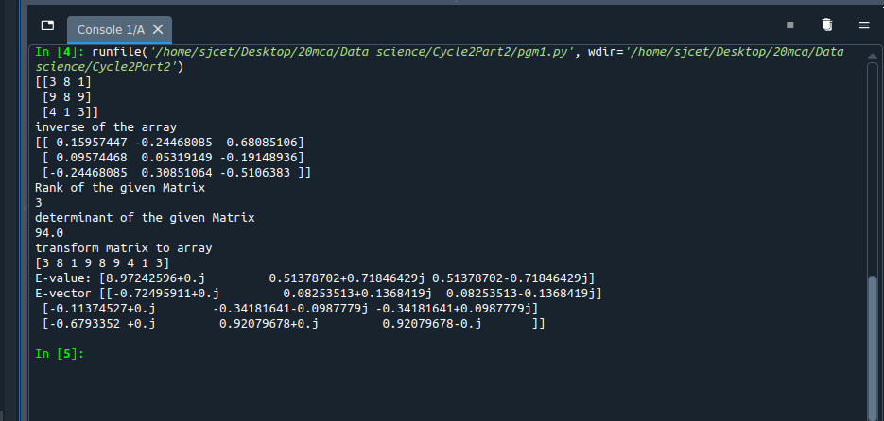

2.Create a
matrix X with suitable rows and columns

i) Display the cube of each element of the matrix using different
methods
(use multiply(), *, power(),**)
ii) Display identity matrix of the given square matrix
iii) Display each element of the matrix to different powers.
iv) Create a matrix Y with same dimension as X and perform the
operation X+2Y.

import numpy as np
x=np.array([[2,3,4],[5,6,7],[8,9,10]])
print(x)

print(np.power(x,3))
print(np.multiply(x,(x*x)))
print(x*x*x)
print(x**3)

b=np.identity(3,dtype=int)
print(b)

out=np.power(x,x)
print(out)

y = np.arange(11,20).reshape(3,3)

print("perform the operation X^2 +2Y: \n",np.add((np.power(x,2)),(np.multiply(y,2))))
Output
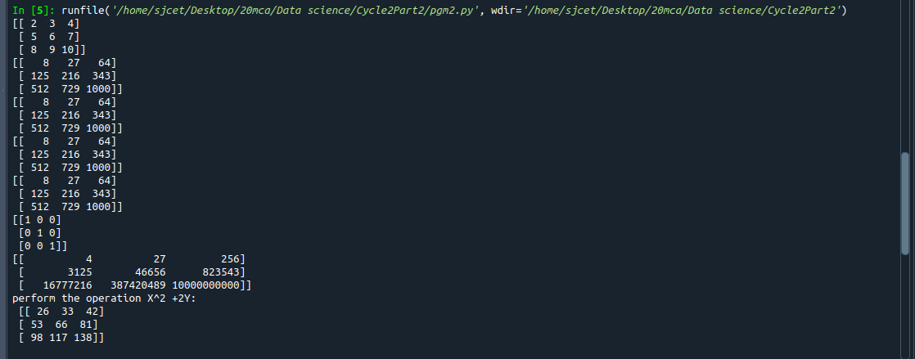

3.Multiply a matrix with a submatrix of another matrix and replace the
same in larger matrix.

import numpy as np

np.random.seed(42)

A = np.random.randint(0, 10, size=(5,6))

B = np.random.randint(0, 10, size=(3,3))

print("Matrix A:\n{}, shape={}\n".format(A, A.shape))

print("Matrix B:\n{}, shape={}\n".format(B, B.shape))

C = A[1:4,2:5] @ B

A[1:4,2:5] = C

print("Matrix A after submatrix multiplication:\n{}, shape={}\n".format(A, A.shape))
Output

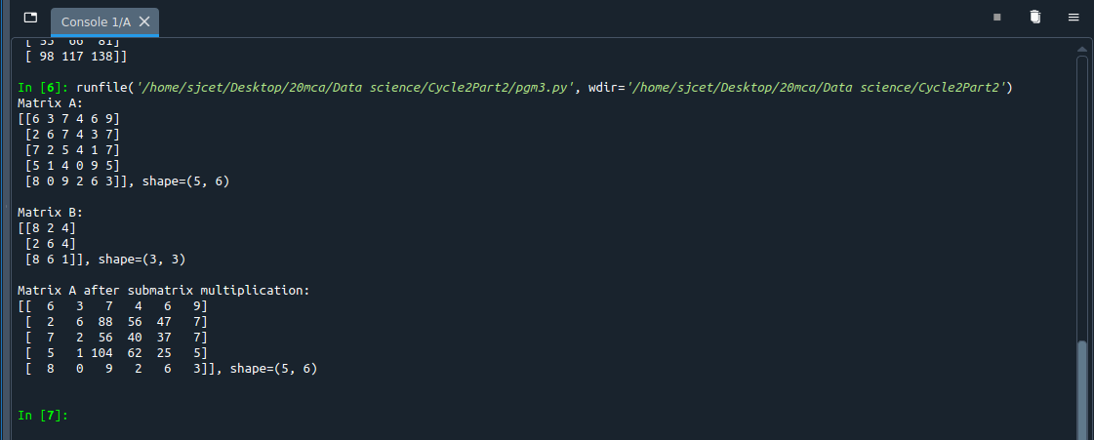

4. Given 3 Matrices A, B and C. Write a program to perform matrix
multiplication of the 3 matrices.

import numpy as np
m1 = np.array([[1,4],[2,5]])
m2 = np.array([[1,4],[2,5]])
m3 = np.dot(m1,m2)
print("multiplication of two matrix")
print(m3)
m4=np.array([[5,6],[1,4]])
m5=np.dot(m3,m4)
print("multiplication of two matrix with third one")
print(m5)

Output
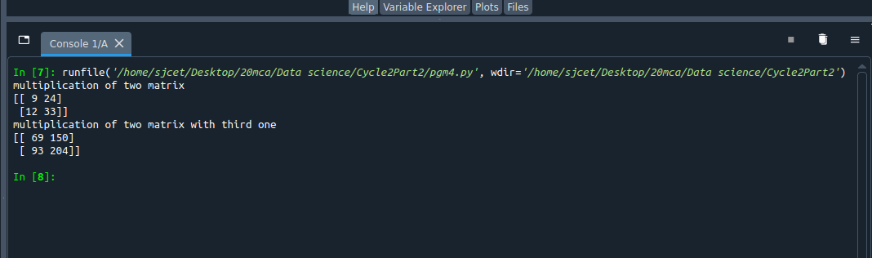

5.Write a program to check whether given matrix is symmetric or Skew Symmetric.

Solving systems of equations with numpy
One of the more common problems in linear algebra is solving a matrix-vector equation.
Here is an example. We seek the vector x that solves the equation
A X = b

Where 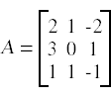 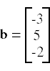And X=A⁻¹ b.
Numpy provides a function called solve for solving such eauations.
import numpy as np
A = np.array([[6, 1, 1],
[1, -2, 5],
[1, 5, 7]])
print("Original Matrix\n",A)
inv=np.transpose(A)
print ("Transpose matrix\n",inv)
neg=np.negative(A)
comparison = A == inv
comparison1 = inv== neg
equal_arrays = comparison.all()
skew=comparison1.all()
if equal_arrays :
print("Symmetric")
else:
print("not Symmetric")

if skew:
print("Skew Symmetric")
else:
print("Not Skew Symmetric")

Output
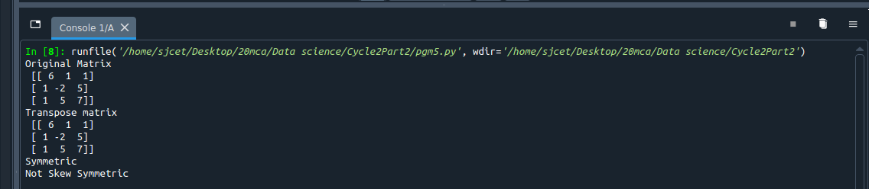

6.Write a program to find out the value of X using solve(), given A and b as above.

import numpy as np
A = np.array([[2, 1, -2],
[3, 0, 1],
[1, 1, -1]])
b=np.array([[3],
[5],
[-2]])
inv=np.linalg.inv(A)
x=np.linalg.solve(inv,b)
print(x)

Output
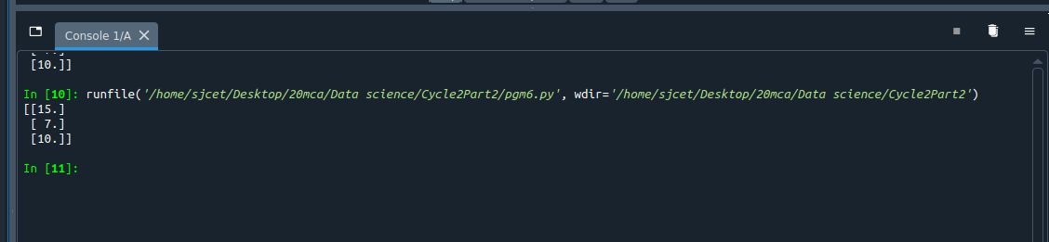

7.Write a program to perform the SVD of a given matrix. Also reconstruct thegiven matrix from the 3 matrices obtained after performing SVD.
from numpy import array
from scipy.linalg import svd
from numpy import dot
from numpy import diag
# define a matrix
A = array([[1, 2,1], [3, 4,2], [5, 6,4]])
print(A)
# SVD
U, s, VT = svd(A)
print(U)
print(s)
print(VT)
Sigma=diag(s)
B=U.dot(Sigma.dot(VT))
print(B)
Output
