Reproducible Reporting

Ashlyn Bray

2024-10-03

## Graph showing IQ levels by location

Figure 1 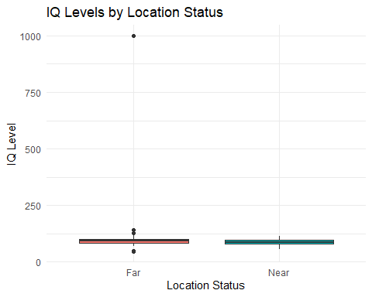

## Formatted Table

Summary of IQ Levels by Location Status

| Location | Mean_IQ | SD_IQ | Median_IQ | Q1_IQ | Q3_IQ |
| --- | --- | --- | --- | --- | --- |
| Far | 106.12 | 111.88 | 93 | 84 | 101 |
| Near | 89.19 | 12.17 | 88 | 80 | 96 |

Note that the echo = FALSE parameter was added to the code chunk to prevent printing of the R code that generated the plot.