This spring task to create an Employee catalog system, is made with 2 controllers.

1. An MVC Controller targeting an application flow in mind
2. A REST Controller having the endpoints as mentioned in the task

Hence, the application can be used to check with a browser at <http://localhost:8081/home> for rendering the webpages or with Swagger at <http://localhost:8081/swagger-ui/index.html> for endpoints, once started.

1. WEB PAGES(Application):

This section contains the webpages starting with the home page.

1. HOME PAGE:

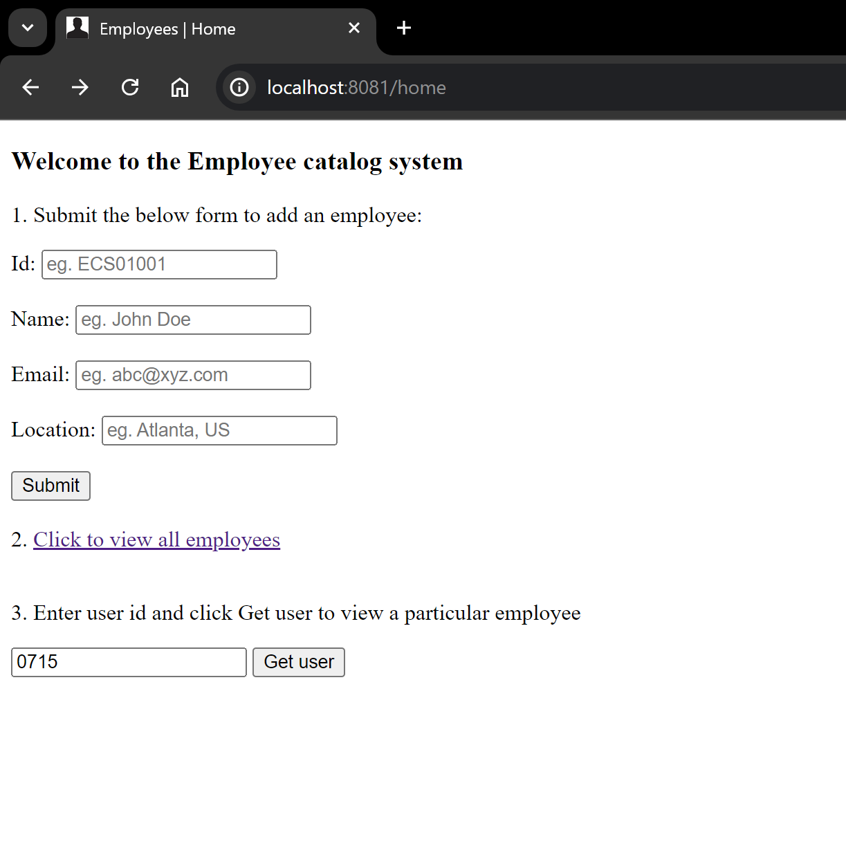

1. ADD EMPLOYEE: (Rendered on filling the form and submitting)

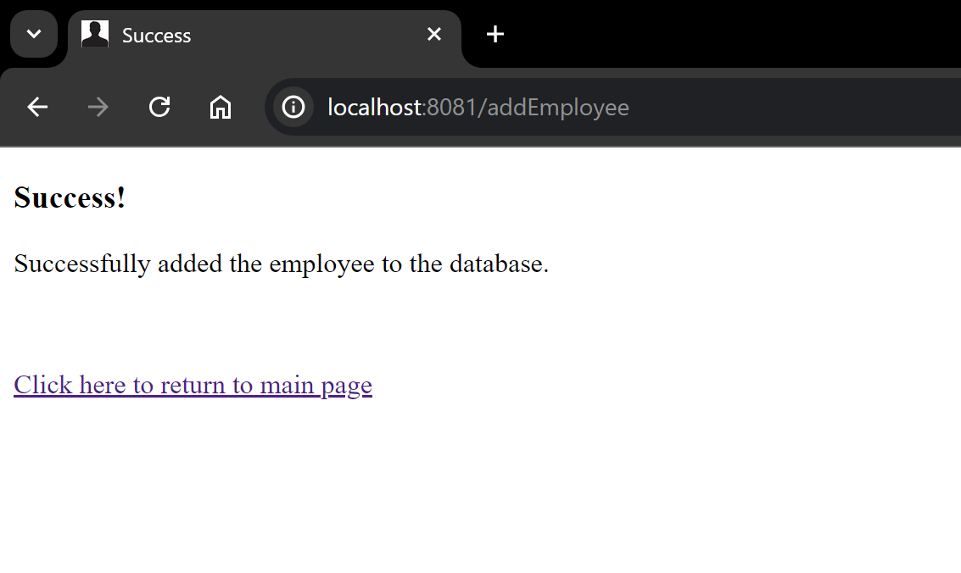

Input validation through spring boot:

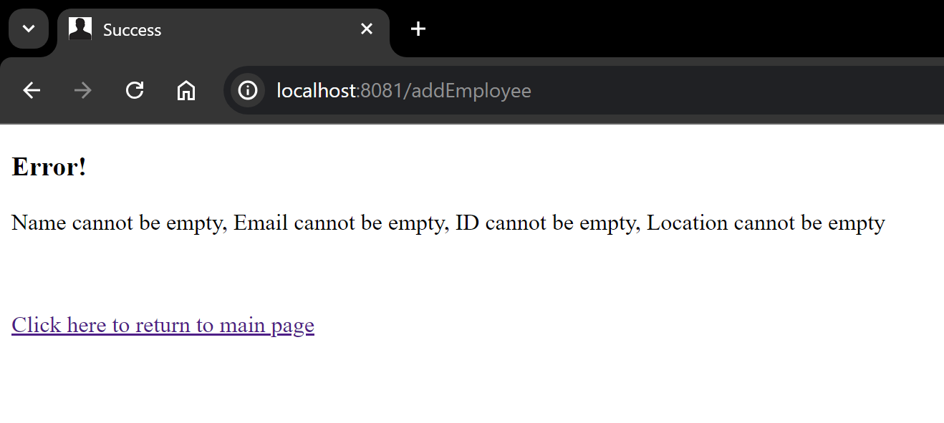

1. DISPLAY EMPLOYEES (Rendered on clicking 2. Click to view all employees)

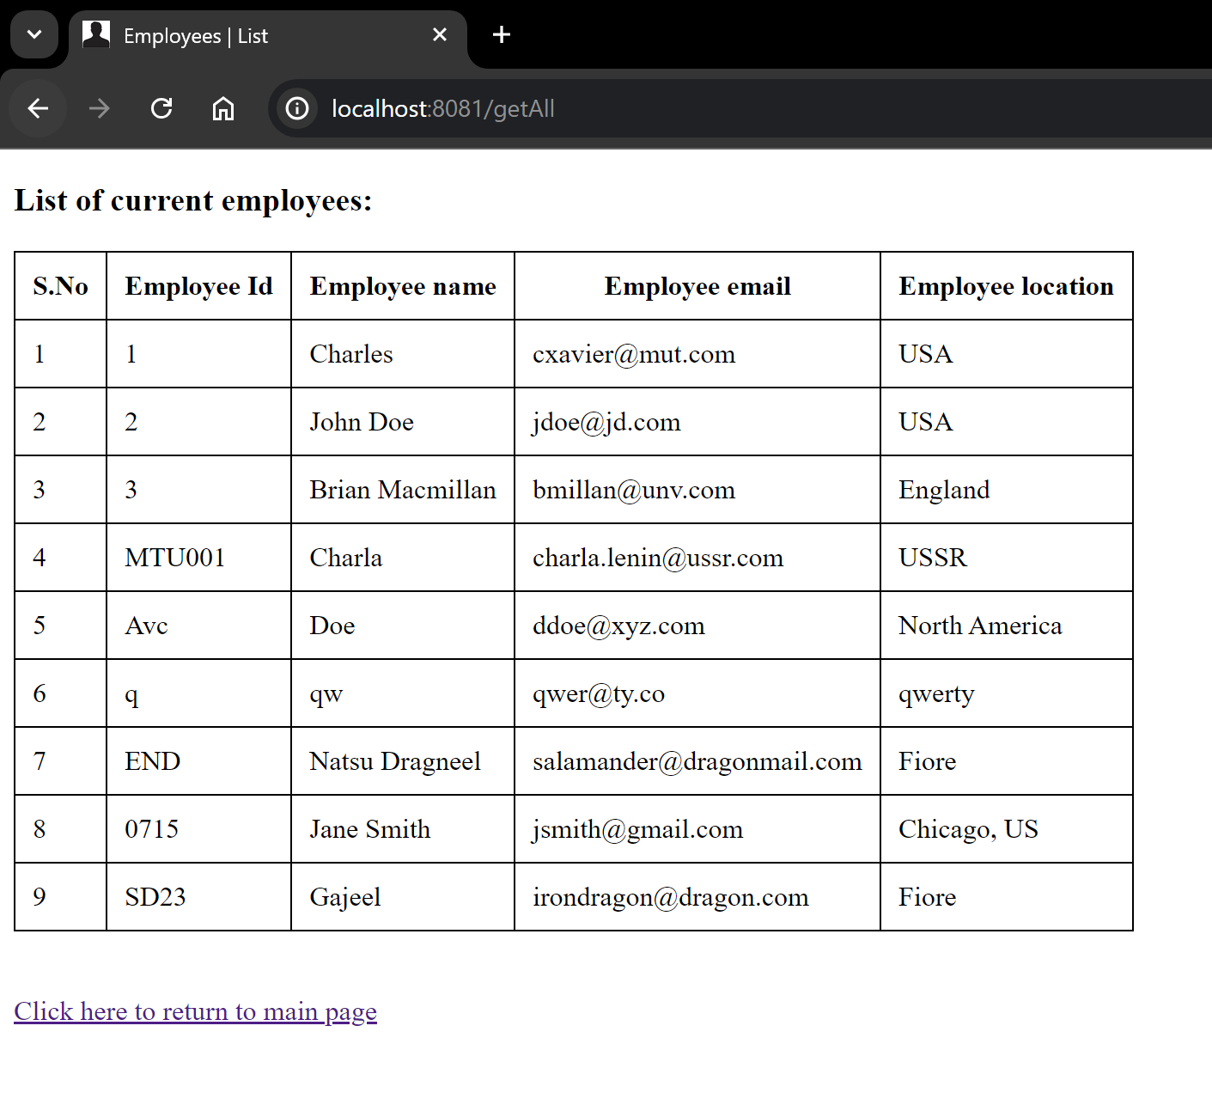

1. Display specific user by id(On providing an id and clicking Get user from home page)

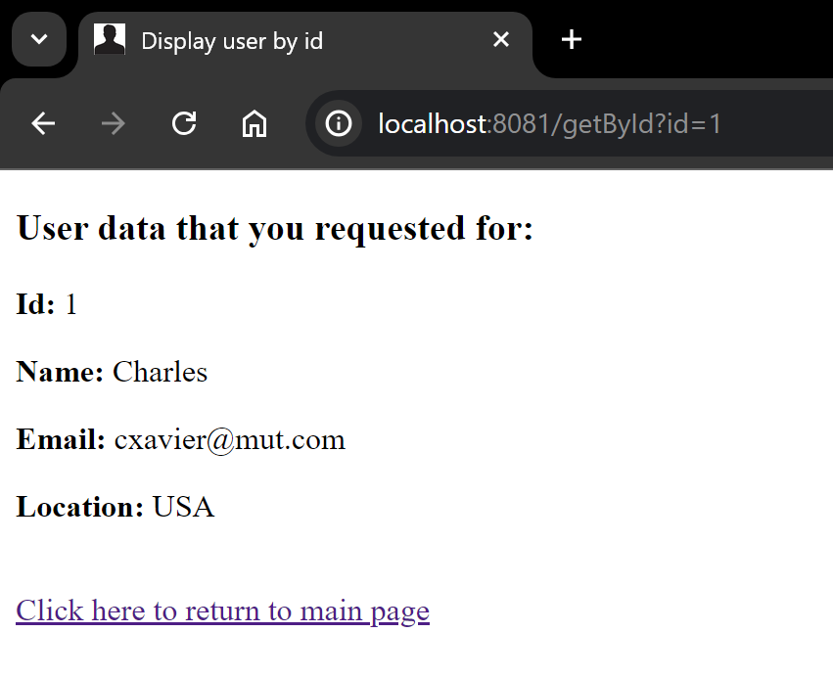

1. SWAGGER ENDPOINTS:

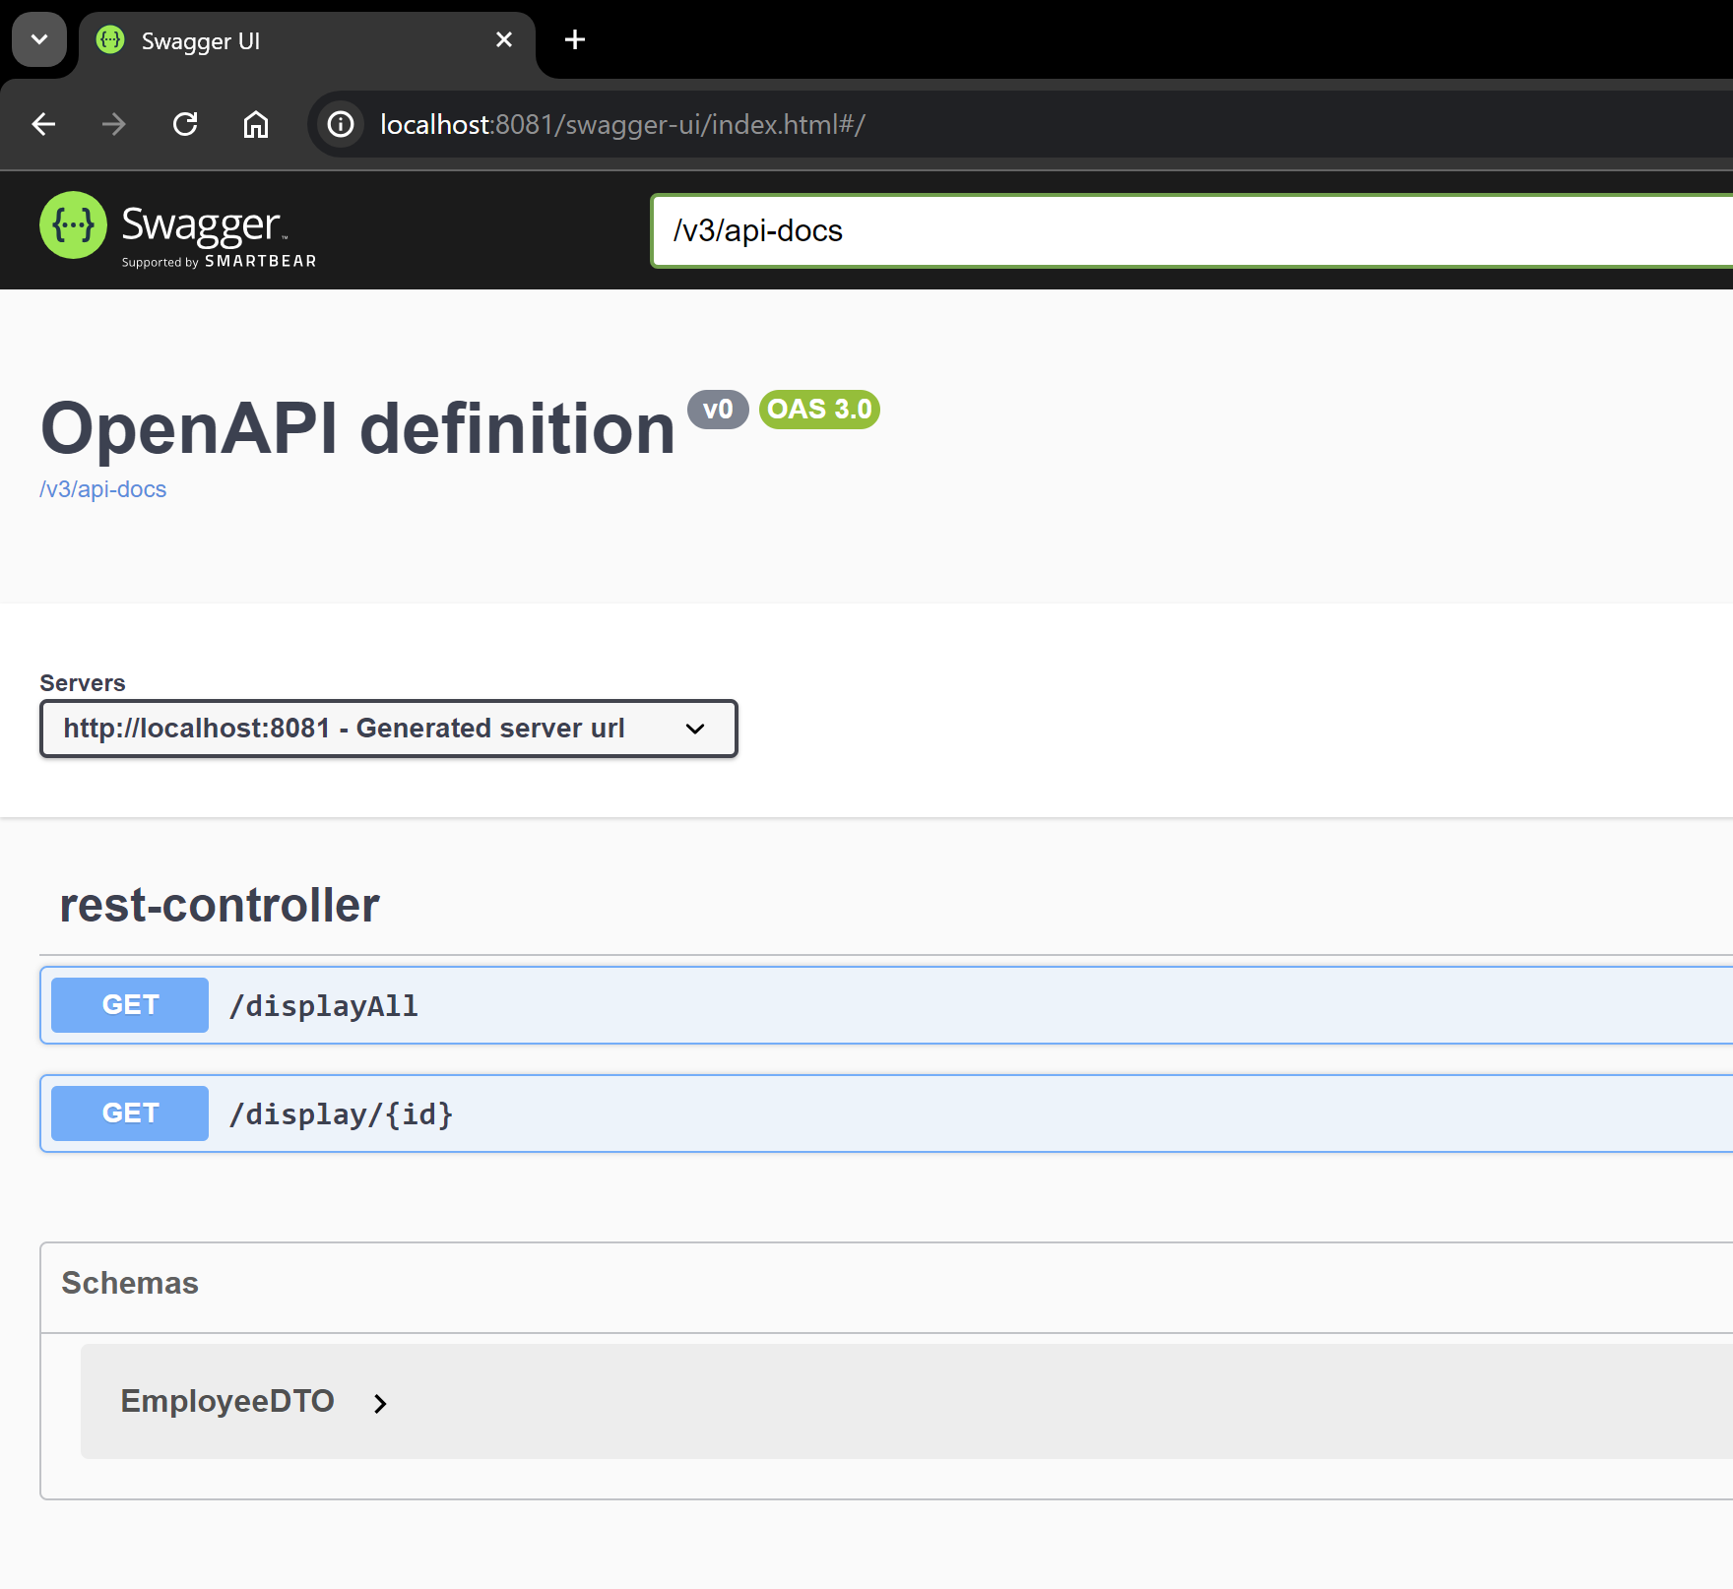

1. /displayAll endpoint

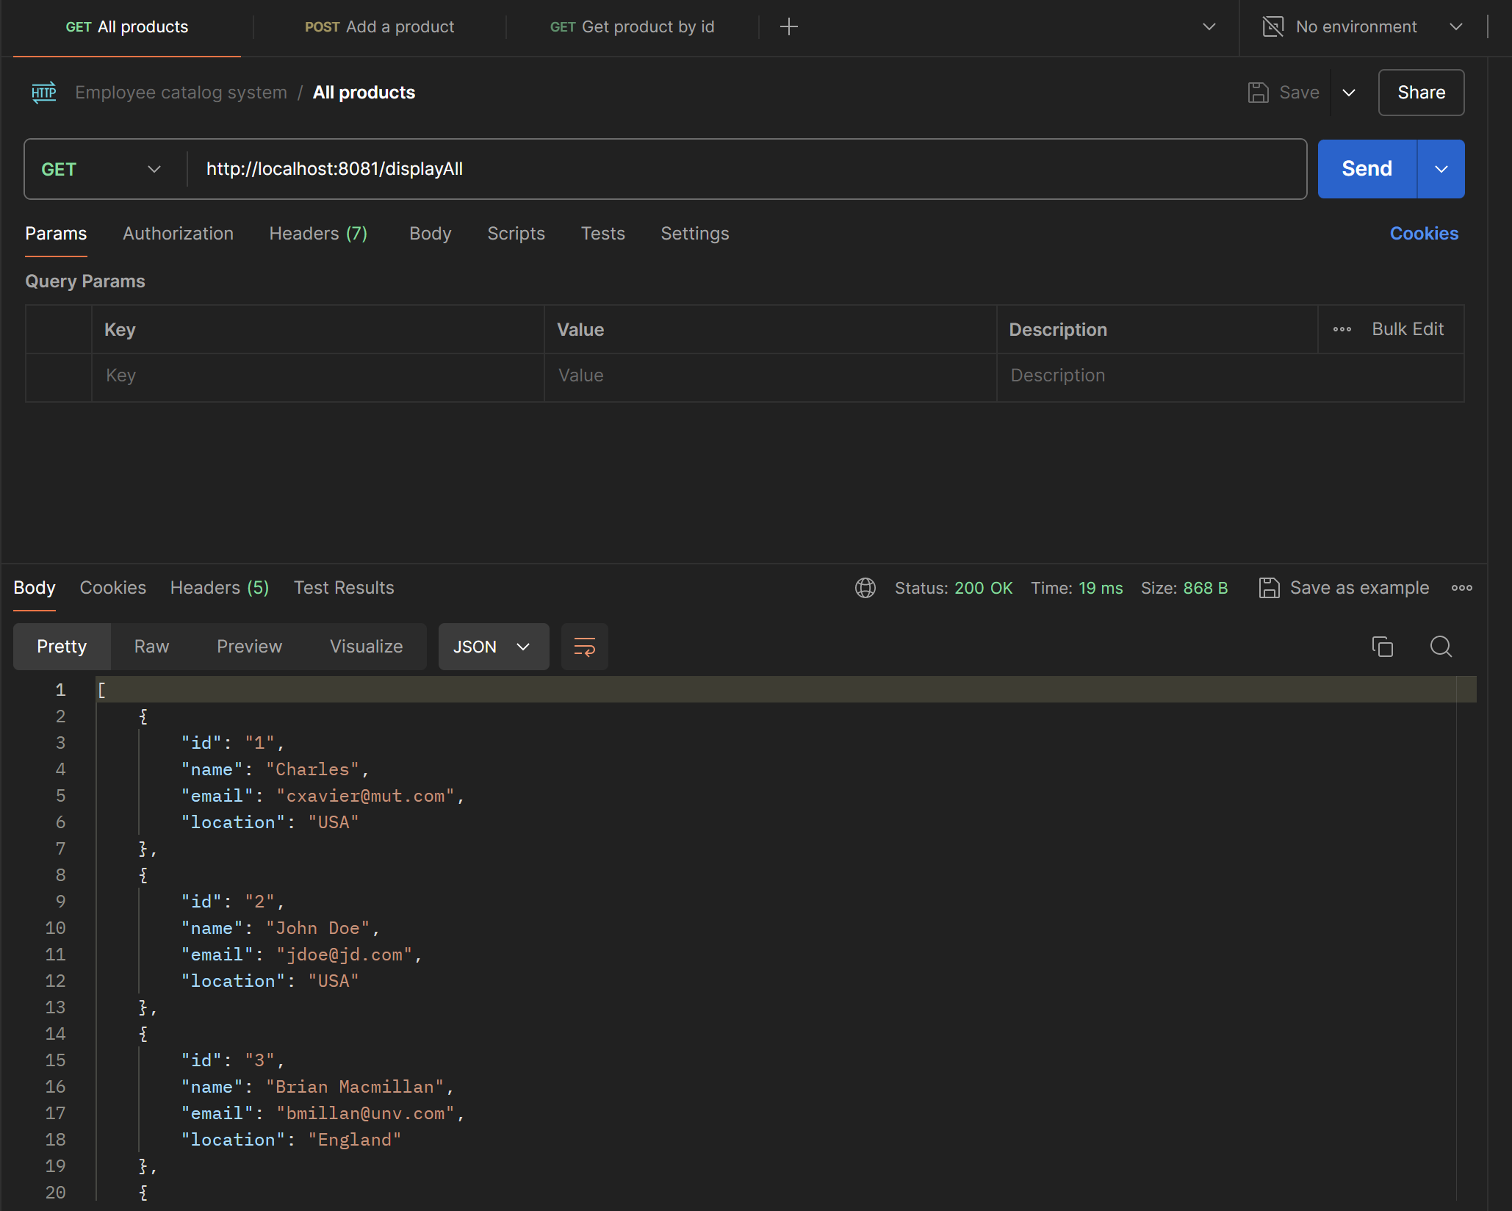

1. /display/{id} endpoint

