1. WEB PAGES:

This section contains the webpages starting with the home page.

1. HOME PAGE:

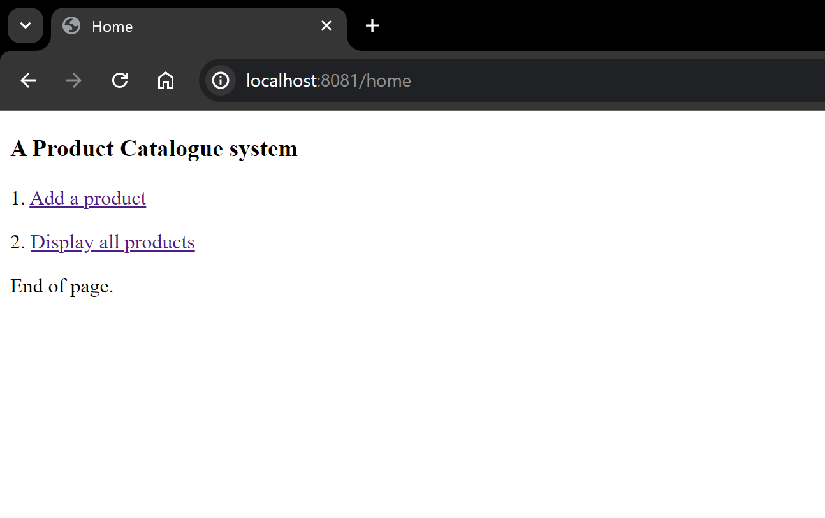

1. ADD PRODUCT: (Rendered on clicking 1. Add a product)

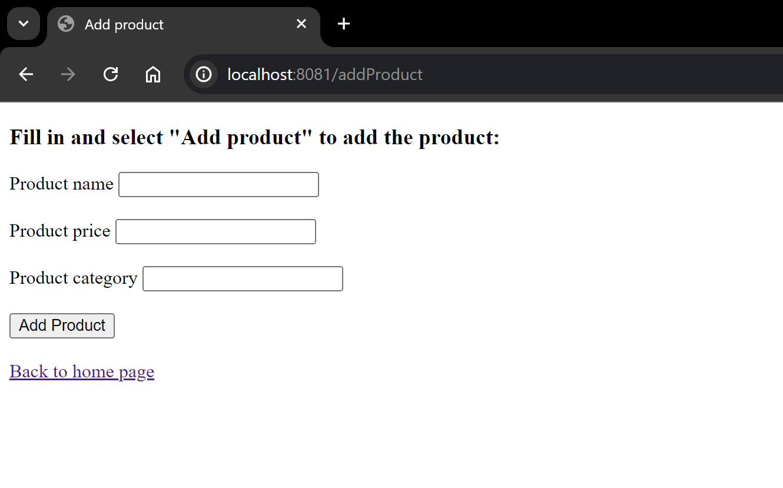

1. ADDED PRODUCTS(Rendered on saving a product):

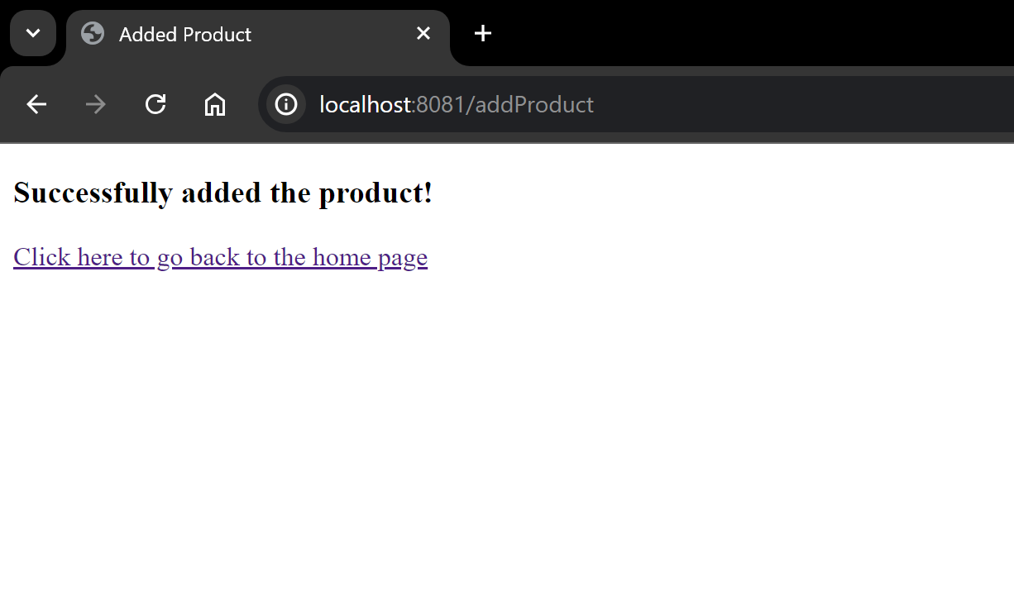

1. DISPLAY PRODUCTS(Rendered on clicking 2. Display all products)

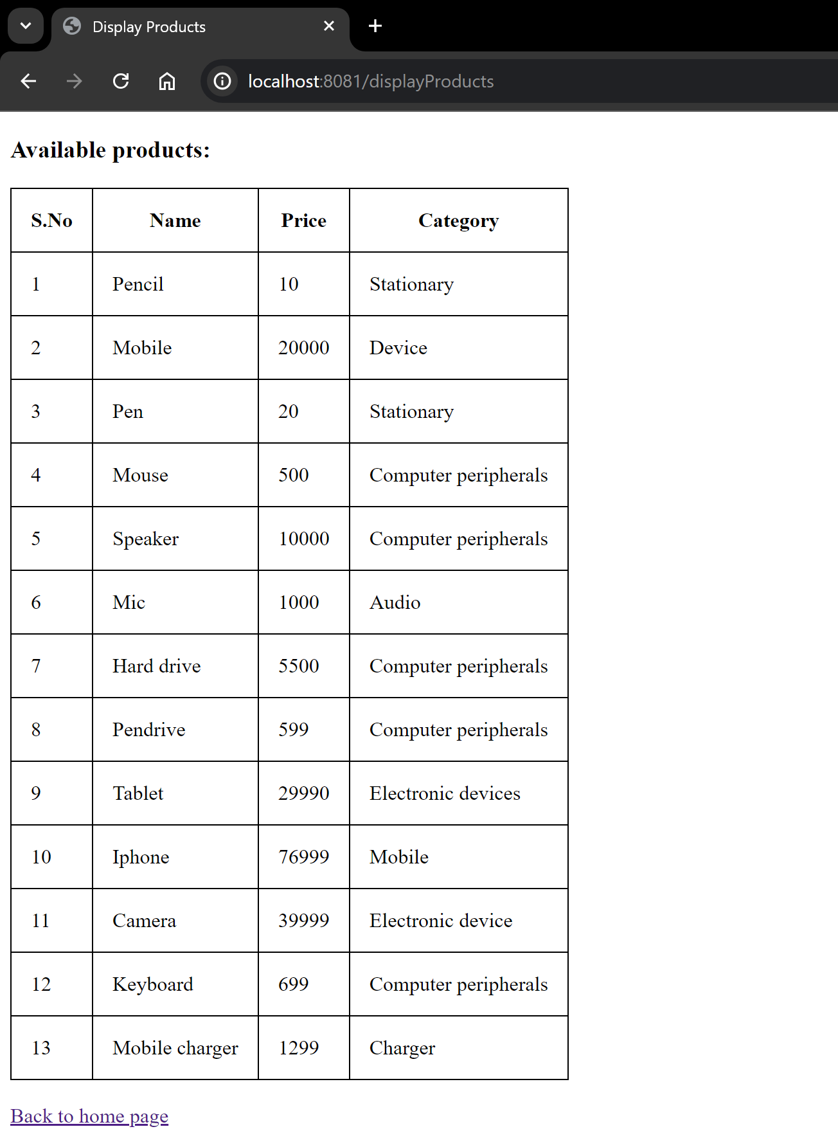

1. CODE:
2. APPLICATION

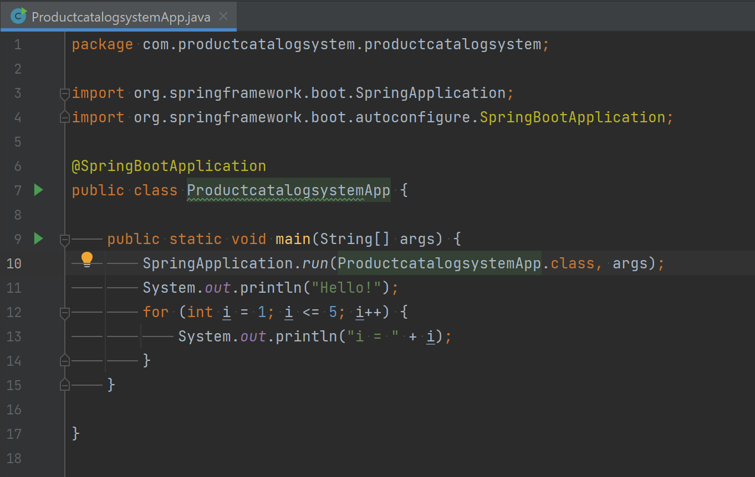

1. CONTROLLER:

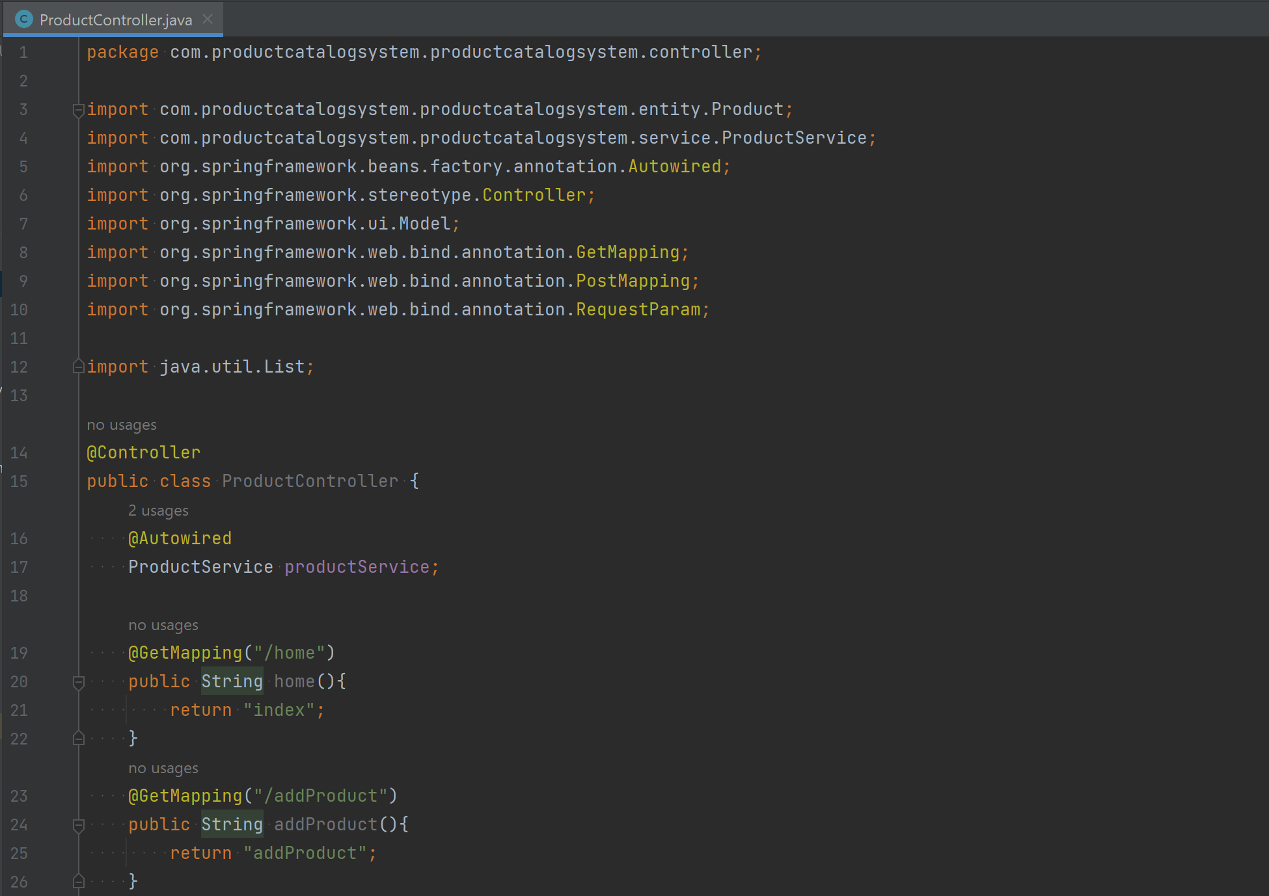

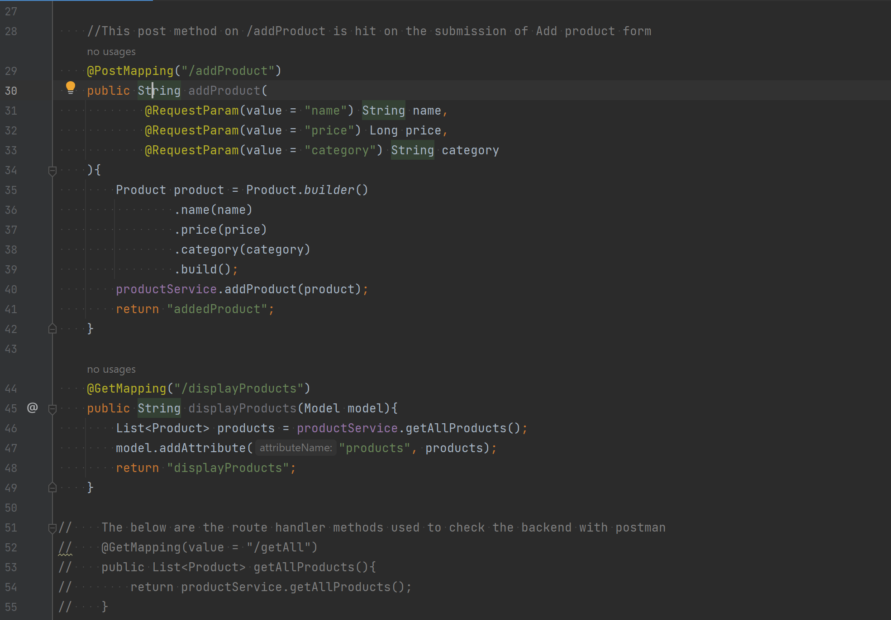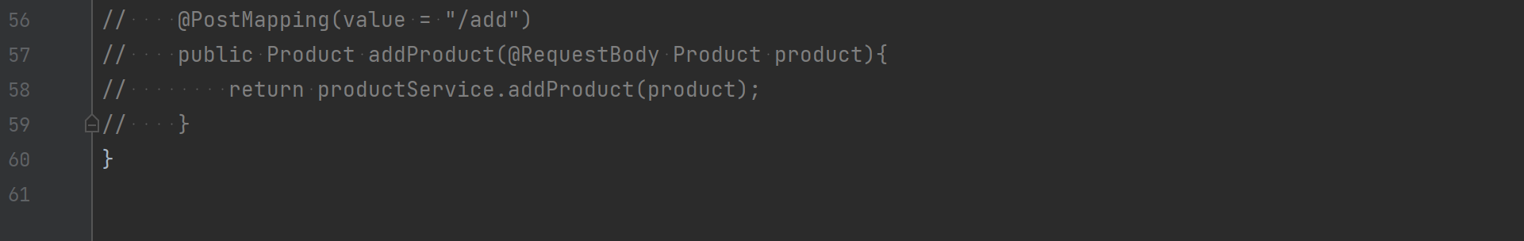

1. SERVICE

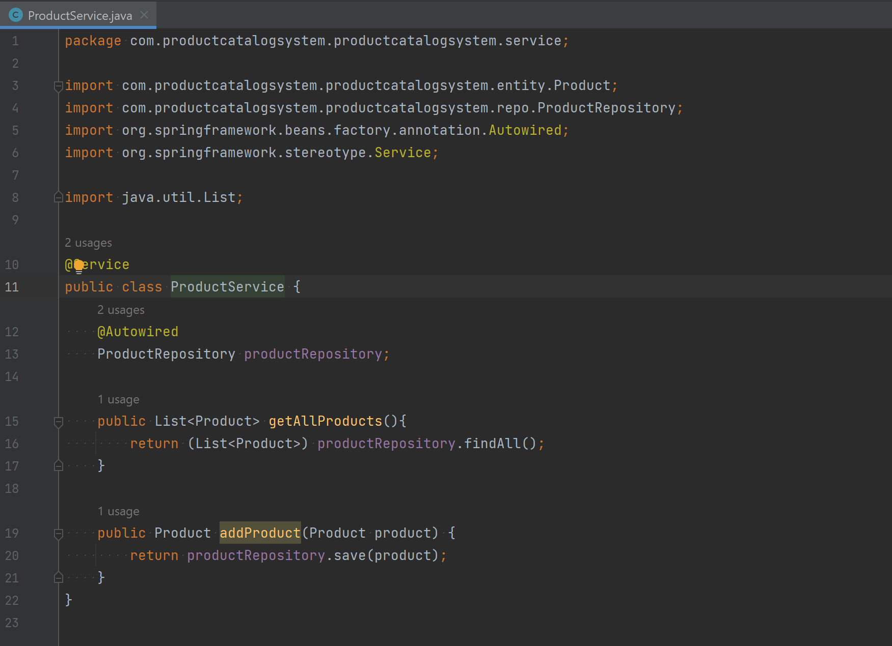

1. REPO

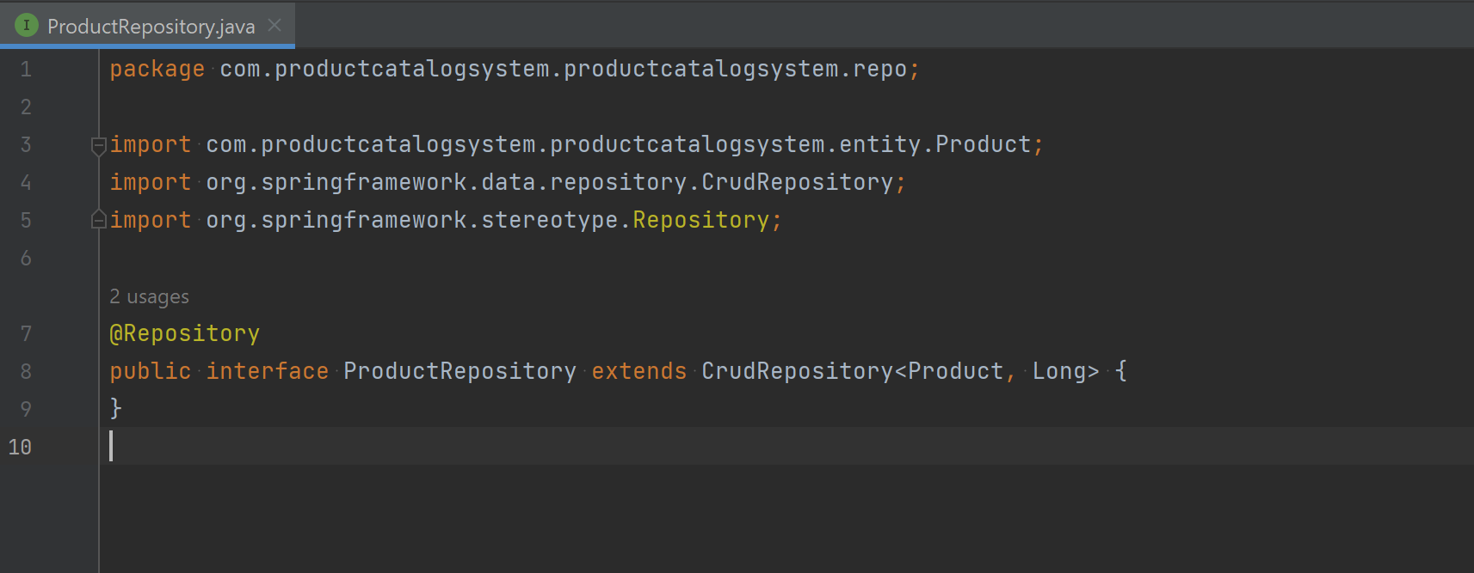

1. ENTITY

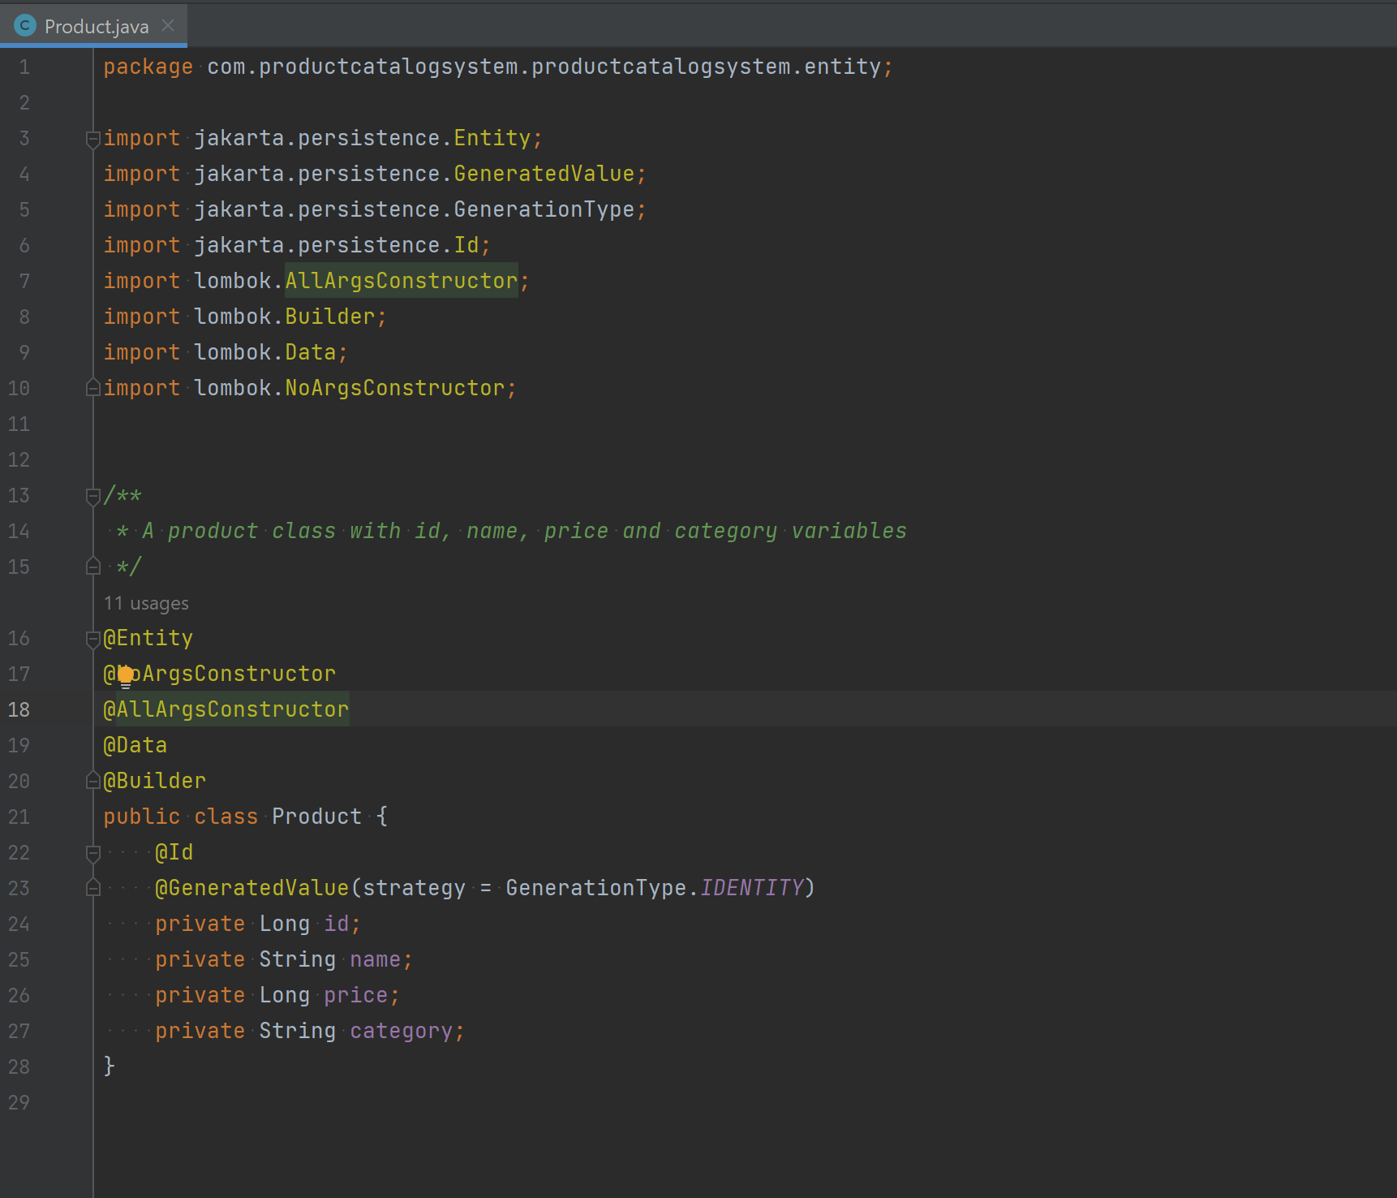

1. WEBSITE URL:

Not deployed. So, checked at <http://localhost:8081/home> .

1. DATABASE(MySQL):

**Database Name**: productcatalogsysd

**Table Name**: product

The table was auto-generated with the help of hibernate.

**TABLE SCHEMA:**

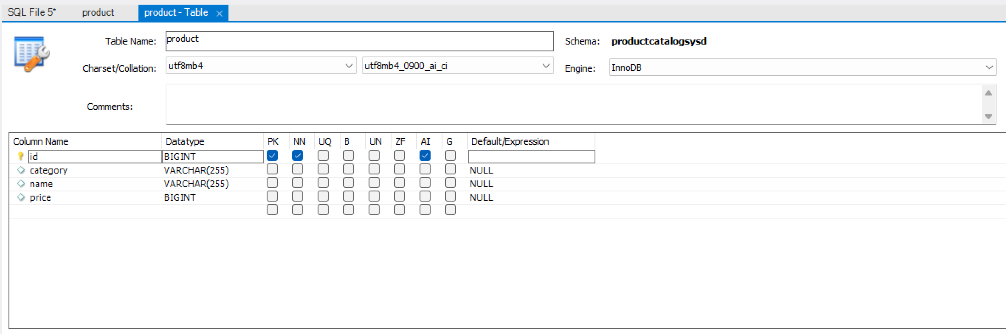

**TABLE DATA:**

Below is the data that I persisted into the table.

