Assignment sheet for IAM

Assignment 1:- Create an IAM user with username of your own wish and grant administrator policy.

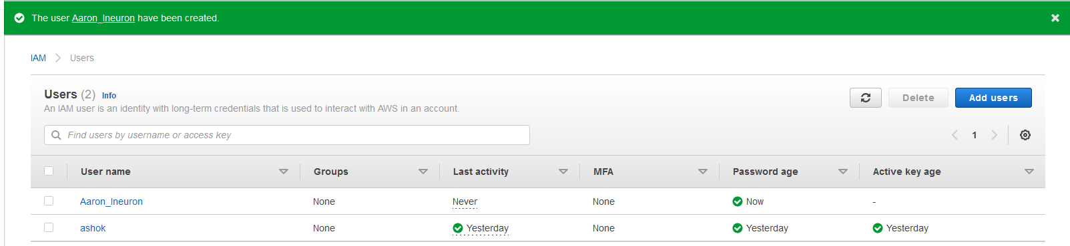

After that I clicked on the user_Name to check the access type

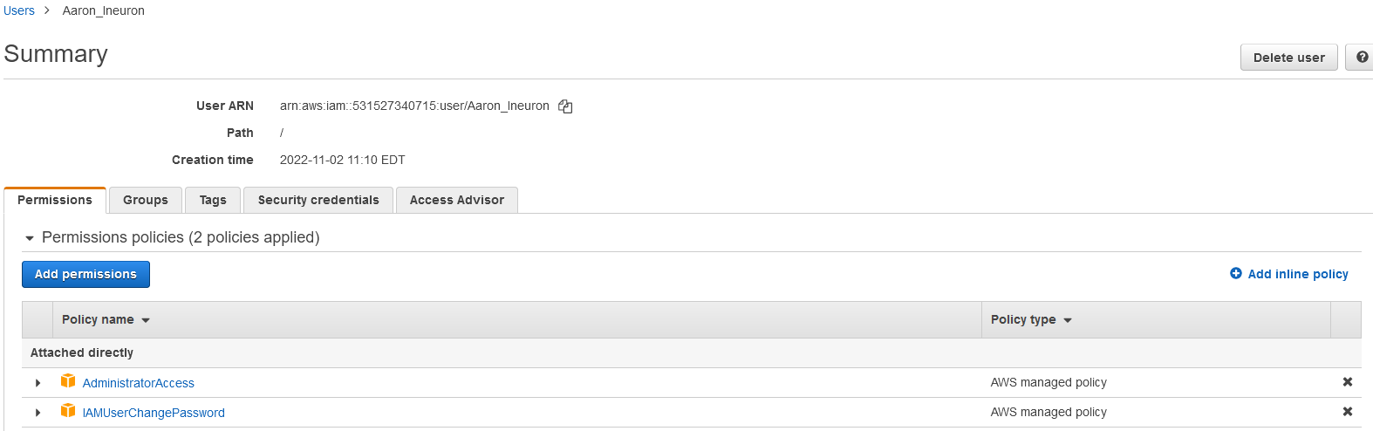

Assignment 2:- Hello students, in this assignment you need to prepare a developers team of avengers.

- Create 3 IAM users of avengers and assign them in developer’s groups with IAM policy.

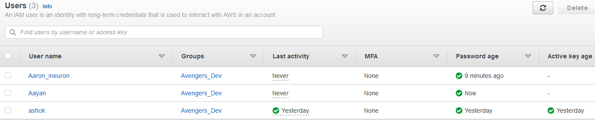

Assignment 3:- Define a condition in policy for expiration like "DateGreaterThan":{"aws:CurrentTime":

"2020-04-01T00:00:00Z"},

"DateLessThan":{"aws:CurrentTime":

"2020-06-30T23:59:59Z"}

Define the span of 4 months as per your wish

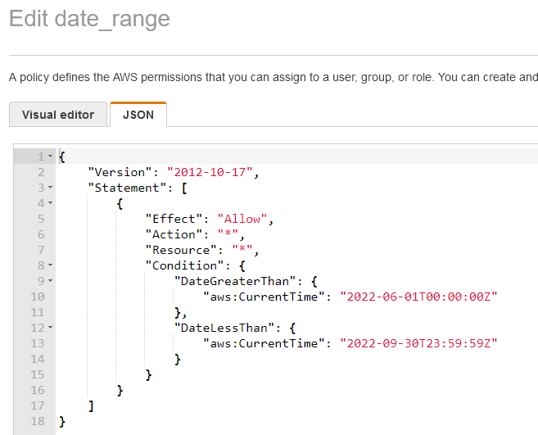

The additional policy is as below:

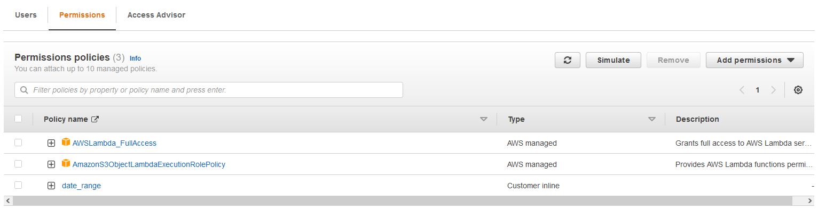

Assignment 3:- Prepare 15 authentic MCQ questions related to IAM.

MCQs for IAM:

1. Which of the following is the most secure way of giving access to AWS services to applications running on EC2 instances?
   1. Creating Service users
   2. Creating service groups
   3. Roles
   4. Attaching policies to applications **(Correct)**
2. Which of the following sections in a policy specifies the entities to whom access to a resource is granted or denied?
   1. Statement ID **(Correct)**
   2. Resources
   3. Principle
   4. Conditions
3. Which of the following is not an IAM best practices?
   1. Delete user accounts not in use
   2. Attach policies to individual users **(Correct)**
   3. Manage permissions by adding users to groups
   4. Enable MFA on user accounts
4. Which of the following set of credentials are used to log in to AWS programmatically?(Choose 2)
   1. Username
   2. Access Key **(Correct)**
   3. Password
   4. Secret Key **(Correct)**
5. Which of these is identity in IAM?
   1. Users
   2. Groups
   3. Roles
   4. All of the above **(Correct)**
6. When you first create an Amazon Web Services (AWS) account, you begin with a single sign-in identity that has complete access to all AWS services and resources in the account. This identity is called:
   1. Root User **(Correct)**
   2. Main User
   3. Super User
   4. None of these
7. An IAM user:
   1. Is an entity that you use create in AWS
   2. Is to give people the ability to sign in to the AWS Management console for interactive tasks and to make programmatic requests to AS services using the API or CLI
   3. Both a and b **(Correct)**
   4. None of these
8. AWS evaluates _______ when an IAM principal makes a request.
   1. Username and Password
   2. MAC Address
   3. Security Policies **(Correct)**
   4. IP Address
9. Temporary credentials:
   1. It expires automatically after a specified time
   2. Have a same set of permissions that your standard IAM user have
   3. We can have control over the duration that the credentials are valid
   4. A and C both **(Correct)**
10. IAM role:
    1. Have credentials (password or access keys) associated with it
    2. Does not have any credentials (password or access keys) associated with it **(Correct)**
    3. May or may not have credentials (password or access keys) associated with it
    4. None of these
11. Which of these is IAM principal?
    1. A user
    2. A role
    3. An application
    4. All of these **(Correct)**
12. IAM group:
    1. Is same as IAM users
    2. Can be used to specify permissions for a collection of users **(Correct)**
    3. Is truly an identity
    4. All of these
13. Choose the below statements are true or false for AWS:

1. When you create an IAM user, you grant it permissions by making it a member of a group that has appropriate permission policies attached (recommended), or by directly attaching policies to the user

2. You can also clone the permissions of an existing IAM user, which automatically makes the new user a member of the same groups and attaches all the same policies.

* 1. a. 1. True, 2. True **(Correct)**

b. 1. True, 2. False

c. 1. False, 2. True

d. 1. False, 2. False

1. Which of these is not an IAM policy type?
   1. Smart policies **(Correct)**
   2. Access control lists (ACLs)
   3. Session policies
   4. Organizations SCPs
2. Names of IAM identities (users, roles, and groups):
   1. Must be unique within the AWS account **(Correct)**
   2. Must be unique within the availability zone
   3. Must be unique within the region
   4. Must be unique within the AWS cloud whole
3. An IAM user cannot be a member of more than __ groups.
   1. 10 **(Correct)**
   2. 20
   3. 50
   4. 100

Assignment 4:- Launch your Linux instance in IAM and update your machine.

