# Ashmin Jayson S6DS Roll No : 14
# Program 3 : Statistical Operation on dataframes
# 15th March 2023

print('Enter the data points and ENTER to stop input')
name <- strsplit(readline('Enter the names : '), ' ')
name <- unlist(name)
age <- strsplit(readline('Enter the ages : '), ' ')
age <- as.numeric(unlist(age))
height <- strsplit(readline('Enter the heights : '), ' ')
height <- as.numeric(unlist(height))
weight <- strsplit(readline('Enter the weights : '), ' ')
weight <- as.numeric(unlist(weight))

df <- data.frame(name = name, age = age, height = height, weight = weight)
num_cols <- unlist(lapply(df, is.numeric))
ndf <- df[, num_cols]

modecalc <-
function(v) {
return(names(sort(-table(v)))[1])
}

ndfcols <- c()
for (col in colnames(ndf)) {

ndfcols <- c(ndfcols, col)

cat('\n\n\nColumn Name :', col, 'Results of statistical operations : ')
cat('\nMEAN:', mean(ndf[[col]]))
cat('\nMEDIAN:', median(ndf[[col]]))
cat('\nMODE:', modecalc(ndf[[col]]))
cat('\nSTANDARD DEVIATION:', sd(ndf[[col]]))
cat('\nFIVE NUMBER SUMMARY:', fivenum(ndf[[col]]))
cat('\nBOX PLOT ON RIGHT')
boxplot(ndf[[col]])

}

print('\n\nCorrelation coefficient of Numeric Attributes is : ')
print(cor(ndf[, ndfcols]))

# Output

> source("~/Ashlab/Experiment 3.r")
[1] "Enter the data points and ENTER to stop input"
Enter the names : Ashmin Anz Joel Anitha
Enter the ages : 20 19 20 21
Enter the heights : 170 168 165 172
Enter the weights : 60 62 70 60

Column Name : age Results of statistical operations :
MEAN: 20
MEDIAN: 20
MODE: 20
STANDARD DEVIATION: 0.8164966
FIVE NUMBER SUMMARY: 19 19.5 20 20.5 21
BOX PLOT ON RIGHT

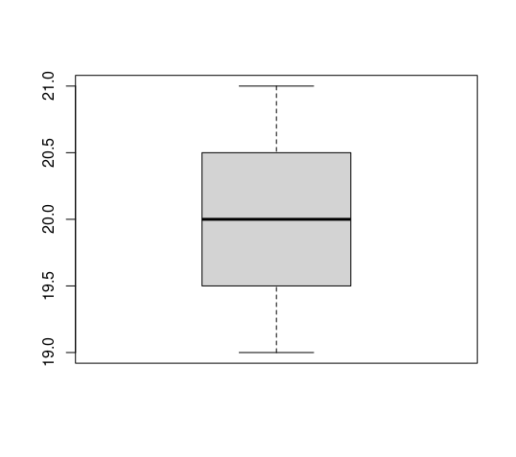

Column Name : height Results of statistical operations :
MEAN: 168.75
MEDIAN: 169
MODE: 165
STANDARD DEVIATION: 2.986079
FIVE NUMBER SUMMARY: 165 166.5 169 171 172
BOX PLOT ON RIGHT

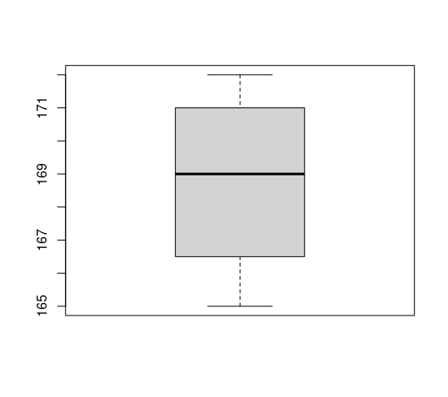

Column Name : weight Results of statistical operations :
MEAN: 63
MEDIAN: 61
MODE: 60
STANDARD DEVIATION: 4.760952
FIVE NUMBER SUMMARY: 60 60 61 66 70
BOX PLOT ON RIGHT
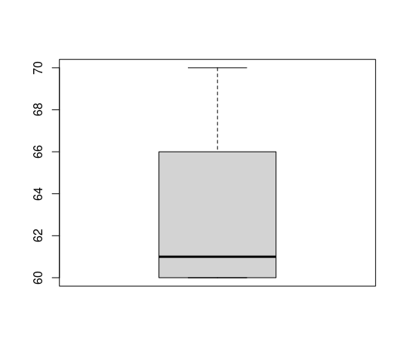

[1] Correlation coefficient of Numeric Attributes is :
age height weight
age 1.0000000 0.5468687 -0.1714986
height 0.5468687 1.0000000 -0.9144254
weight -0.1714986 -0.9144254 1.0000000

