Nike Sales Performance Analysis

Best-Sellers, Discount & Margin Risk, Peak Buying Windows, Regional Demand &
Inventory Risk
Name Ashmit Pradhan
Roll no. | 11
Section | BCA DS-27
Report type | Descriptive Analytics

Note on Data

Live Nike sales data is not publicly accessible, so this report runs on a synthetic dataset built to mirror real sportswear-retail sales patterns: 10 products across 6 categories, 5 store zones, over a 15-day window (Aug 01, 2026 – Aug 15, 2026), for 150 product-day records in total.
Each row represents one product's aggregated activity for one day at its dominant store zone — units sold, revenue, average discount given, customer rating, the time-of-day band with the heaviest buying, and remaining stock level. This is the same granularity a real retail-analytics pipeline would expose at the reporting layer: raw per-transaction events are rolled up before they ever reach a dashboard (see Section 3).
- One product (Nike Air Force 1 '07) generates disproportionate order volume, mirroring the Pareto pattern common on hero SKUs in sportswear retail.
- Weekend and evening demand surges layered on top of small category-level growth trends.

- A slow-building discount-dependency signal at one store zone, where

- the average discount climbs past the 15% margin-safe target over the window — the kind of trend a merchandising dashboard should surface early.

- Uneven zone-level demand concentration, and two products deliberately depleting into Low Stock / Out of Stock states.

Objective

Build a descriptive analytics layer over daily Nike sales data that answers five recurring, operational business questions — the kind a category manager, store operations lead, or merchandising team would otherwise have to ask an analyst for every morning:

Q1. What are the best-selling products, and by how much do they lead the pack?

Q2. | How is discount dependency trending, and which store zone is most at risk of eroding margin past the 15% target?
Q3. | When do customers buy most — by time of day and day of week?
Q4. | Where is sales demand concentrated across store zones, and what does that imply for fulfilment ?
Q5. | Which products are at risk of stocking out at the stores, given current sales velocity?

How This Would Work at Real Scale
processing millions of Nike transactions per day across hundreds of stores and the online store is an engineering problem before it is an analytics one. A realistic architecture behind a report like this one:

Layer | Purpose | Typical Tools
Investigation | Capture each sale event (browsed, added to cart, purchased, returned) in real-time
Stream processing | Roll raw events into per-product, per-zone, per-hour aggregates; flag heavy discounting | Pandas
Storage | Hold raw events + pre-aggregated tables | CSV / Excel files
Batch aggregation | Nightly rollups — daily sales, discount averages, inventory reconciliation | Pandas, NumPy
Serving / BI layer | Dashboards for store ops and category teams | Matplotlib / Seaborn

Best-Selling Products
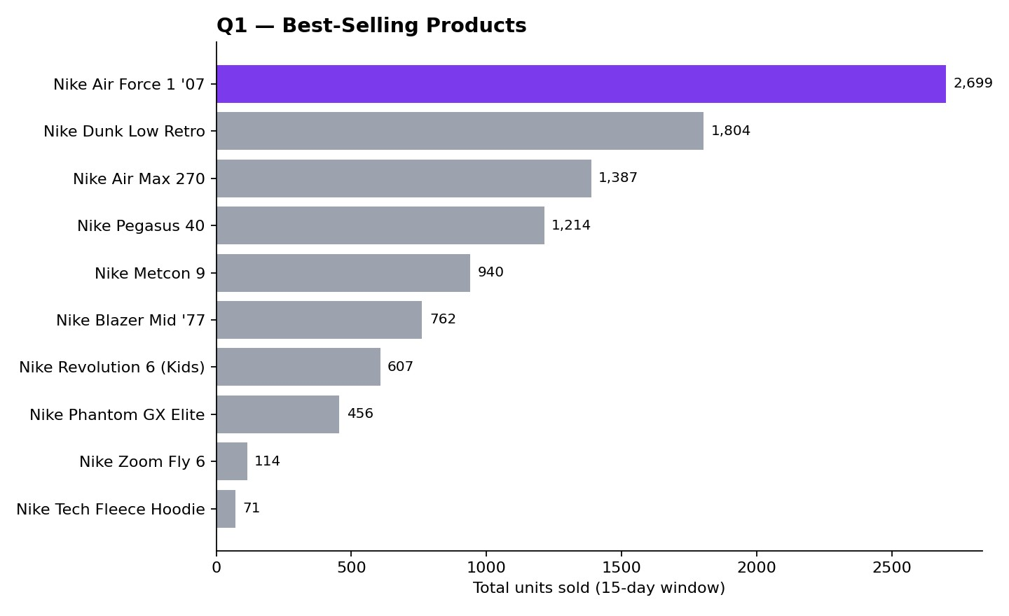
Generated with pandas (aggregation) + matplotlib (visualization) directly from nike_sales_data.csv.
- Nike Air Force 1 '07 led with 2,699 units sold, 49.6% ahead of the second-place product (Nike Dunk Low Retro, 1,804 units).
- The top SKU alone accounts for 26.8% of all units sold across 10 products — a classic hero-SKU pattern where a small number of everyday lifestyle listings drive a disproportionate share of sales volume.

Ranking logic here is units sold, not revenue: an entry-price lifestyle sneaker outselling a premium running or football shoe in unit count matters differently to store slotting (front-of-store shelf space, restock

frequency) than it does to finance (margin contribution per pair) — a real dashboard should expose both cuts as separate views.

The analysis ranks the products based on their total units sold over the 15-day period. Nike Air Force 1 '07 was the best-selling product with 2,699 units, followed by Nike Dunk Low Retro with 1,804 units. Nike Air Force 1 '07 recorded 49.6% more units sold than the second-best-selling product.

The top-selling product accounted for 26.8% of total units sold across all 10 products, showing a Hero-SKU effect, where a single product contributes a disproportionately large share of total demand. This pattern is related to the Pareto Principle (80/20 Rule), where a small number of products can generate a large portion of overall demand. Therefore, high-demand products should receive greater attention in stock management, shelf placement, replenishment, and fulfillment operations.

With Nike Air Force 1 '07 carrying 26.8% of total units sold, it should get priority treatment on three fronts: it should be the first SKU checked in every store's stock audit (a stockout here costs more than on any other SKU), it should sit in the fastest-restocked shelf position, and its sell-through performance (Section 5) should be tracked separately from the store average — a stocked-out hero SKU disproportionately damages the everyday-availability expectation that keeps customers coming back.

KPI definitions used:

Total Units Sold | Sum of units sold across all products during the analysis period.
Top Product Share | Top-selling product units ÷ total units × 100.

Discount Dependency: Distribution & Margin Risk

Left: distribution of average discount percentages across all 150 product-day records against the 15% margin-safe target.
Right: discount-percentage trend at the zone showing the clearest upward drift.

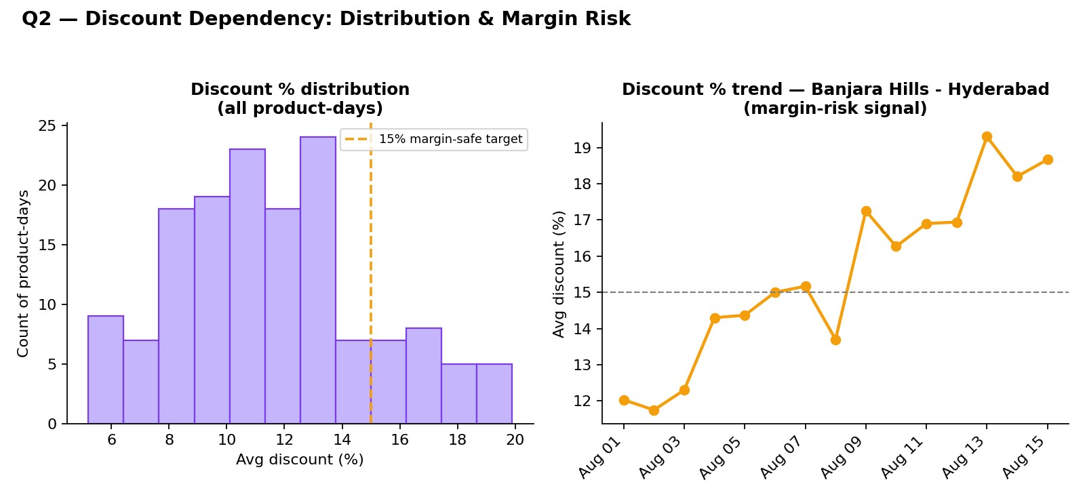

- Average discount across the window is 11.6%, but 16.7% of product-days already exceed the 15% margin-safe target — discounting is running deep enough to matter, not just on rare clearance days.

- Banjara Hills - Hyderabad is the clearest risk: average discount there rose from 12.0% to 18.7% over the window — a steady climb rather than a single promo day, which is the earliest signal of a store leaning on markdowns to hold its sales pace, worth escalating before it shows up in quarterly margin.
- In production this view is most useful segmented, not aggregated: zones trending upward in rolling 3-day discount rate, and zones combining high sales volume with heavy discounting, are the two highest-priority slices — volume amplifies the margin damage of a discount-dependent zone.

The overall average discount given was 11.6%, compared with the 15% margin-safe target used in this analysis. 16.7% of product-days exceeded that target, showing that heavy discounting was occurring frequently enough to be a pattern, not an anomaly.

However, the average alone does not show whether discount dependency is improving or getting worse.
Therefore, trend analysis is also used to observe how the discount rate changes over the period. Banjara
Hills - Hyderabad was identified as the highest margin-risk zone, where the average discount increased from 12.0% to 18.7% during the 15-day period. This upward trend indicates a potential merchandising issue such as weak full-price sell-through or local competitive pressure driving heavier promotions.

Banjara Hills - Hyderabad's discount trend is the single clearest action item in this report: a climb from 12.0% to 18.7% in 15 days, if it continued at the same rate, would push the zone well past the point where markdowns start eating meaningfully into category margin — worth investigating (local pricing pressure, aging inventory at that store, or a promo calendar overcorrecting for a soft sales week) before the next weekly merchandising review rather than after.

Q3 — Order Patterns: Time of Day & Day of Week

Left: total units sold summed by time-of-day band across the window.
Right: total units sold summed by day of week.

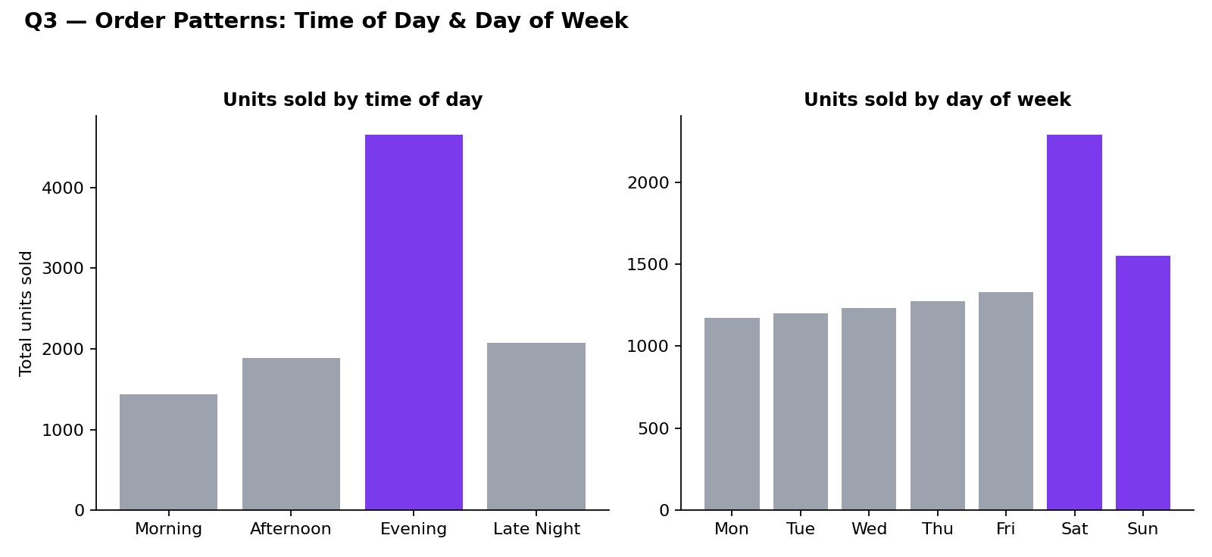

- Evening (5pm–9pm) is the clear peak window, capturing 46.3% of all units sold — consistent with after-work and after-college store visits and app browsing once the day's plans (a workout, a weekend trip, a restock) are actually being acted on.

- Weekend sales volume runs 54.4% higher than the average weekday, reflecting more discretionary, in-store try-on-and-buy behavior on Saturdays and Sundays compared to the lighter, routine online restocking that dominates weekdays.
- Both cuts matter for very different operational decisions: time-of-day drives staff shift-scheduling within a single day, while day-of-week drives store inventory pre-positioning decisions made a day or more in advance.
Demand seasonality refers to recurring patterns in customer demand over different periods of time. In this analysis, sales patterns are studied using two time scales: time of day and day of week.

The analysis shows that evening (5 PM–9 PM) is the peak buying period, accounting for 46.3% of all units sold. This indicates that customer demand is highest during the evening, when customers commonly shop after work or college, or make last-minute purchases ahead of a weekend activity.

The analysis also shows that weekend sales volume is 54.4% higher than the average weekday. This indicates increased demand on Saturdays and Sundays compared with regular weekdays. These patterns represent demand seasonality at multiple time scales. Time-of-day patterns are useful for staff scheduling and floor coverage, while day-of-week patterns help with inventory planning and store staffing.

With 46.3% of units sold landing in the evening window, store staff rosters should be weighted toward that window rather than spread evenly across the day — the margin risk in Section 5 is also most likely to materialize during this same peak, since fitting-room and checkout capacity is stretched thinnest exactly when footfall is highest.

Q4 — Regional (Store-Zone) Demand
Total units sold by store zone, summed across the full 15-day window.

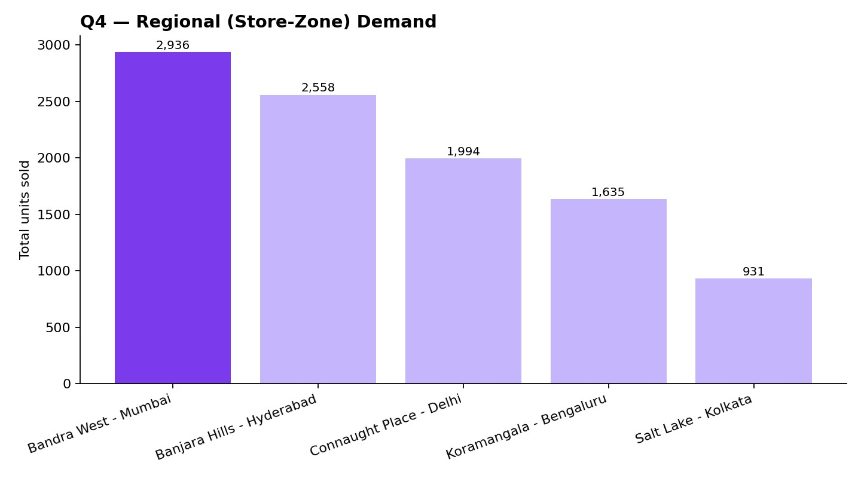

- Bandra West - Mumbai leads with 29.2% of total demand, noticeably ahead of the other 4 zones tracked.

- Demand tapers off fairly smoothly from the top zone down — at real Nike-scale volumes across a full city network, this concentration is typically sharper still, with a handful of dense flagship/mall zones accounting for the large majority of sales and newer or lower-footfall zones long-tailed.

- This view is what drives store replenishment frequency, staff and stock allocation across zones, and new-store siting decisions (a consistently high-demand zone is a candidate for a second, closer store to protect stock availability as footfall grows).

In this analysis, total units sold are compared across the 5 store zones to identify areas with the highest demand.

Bandra West - Mumbai recorded the highest demand with 29.2% of total units sold. It was noticeably ahead of the other zones, showing that demand is concentrated more heavily in this particular zone.

To measure this concentration formally, the analysis uses the Herfindahl-Hirschman Index (HHI). HHI is calculated by squaring the demand-share percentage of each zone and adding the results. A lower HHI indicates that demand is more evenly distributed, while a higher HHI indicates that demand is concentrated in a smaller number of zones. This window's HHI works out to approximately 2244, indicating a moderately concentrated market.

The high demand concentration in Bandra West - Mumbai means that any stock-out, staffing shortage, or store disruption in this zone could have a significant impact on overall sales.

Therefore, stock allocation, staffing, and backup fulfillment capacity should consider the level of demand in each zone. With Bandra West - Mumbai carrying close to a third of demand, a capacity disruption there (a store closure, a staffing shortage, a local event) would affect total sales volume far more than an equivalent disruption in the smallest zone — backup staffing pools and overflow fulfillment plans should be sized to that concentration, not spread evenly across all 5 zones.

Q5 — Inventory & Sell-Through Risk
Left: latest-day stock status across all products.
Right: the five products with the fewest days of supply remaining at their current average daily sales velocity.

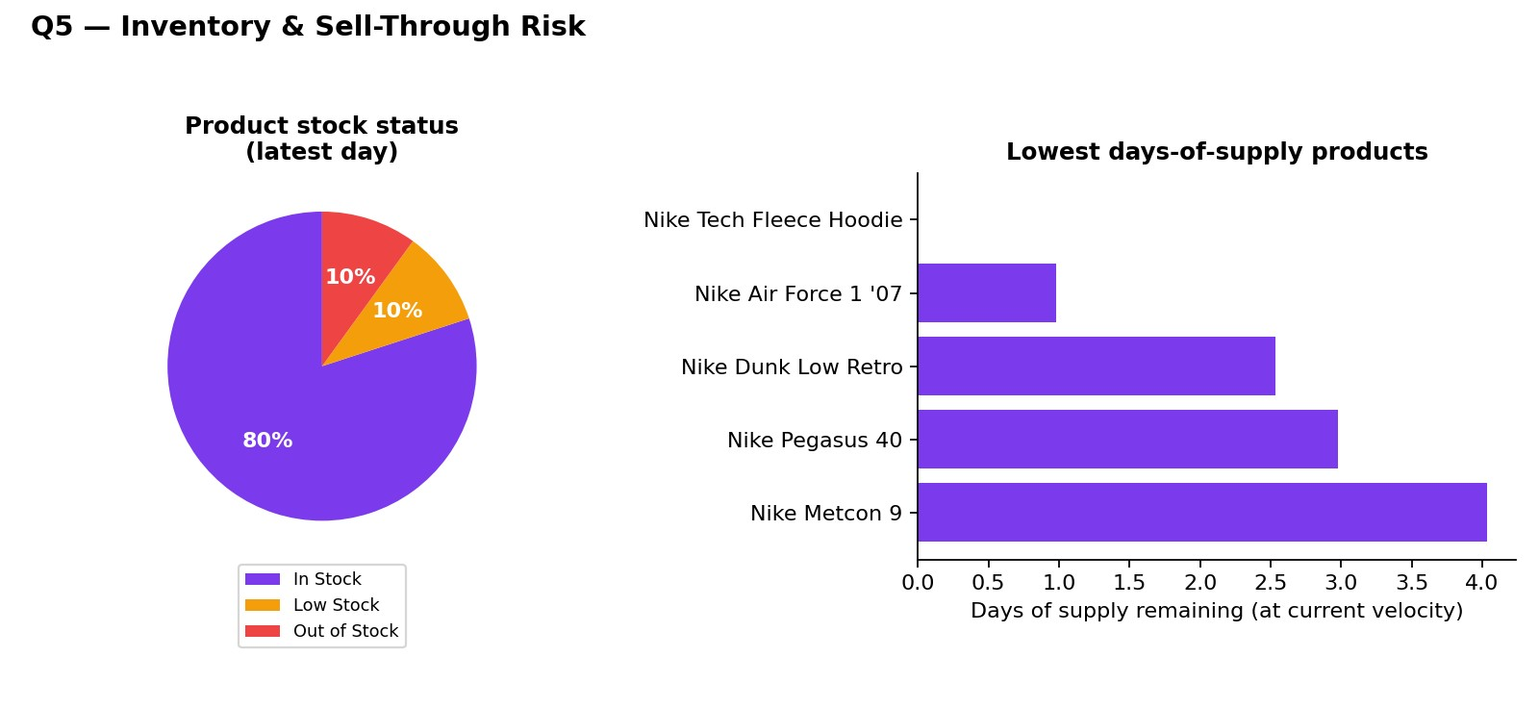

- Of 10 products, 8 are In Stock, 1 is in the Low Stock band, and 1 is fully Out of Stock as of the latest day.

- The Out of Stock product (Nike Tech Fleece Hoodie) is a slower mover, which limits the sales-volume impact — the same event on the #1 best-seller from Section 4 would be a materially bigger problem for both revenue and the everyday-availability use case that keeps customers on the app and in-store.

- "Days of supply" (current stock ÷ average daily units sold) is a more actionable cut than a static stock count: it converts inventory into a time-to-stockout estimate per product, which is what actually triggers a store replenishment run.

The analysis found that out of 10 products, 8 were In Stock, 1 was in Low Stock, and 1 was Out of Stock on the latest day. The Out of Stock product was Nike Tech Fleece Hoodie.

Days of Supply is more useful than looking only at the current stock count because it converts inventory into an estimated time until stockout. This helps identify which products need replenishment sooner. The analysis also uses the concept of a Reorder Point, which is the inventory level at which a new replenishment should be triggered. It is calculated using average daily demand, replenishment lead time, and safety stock.

Overall, 2 out of 10 products were at Low Stock or below in this short window — at real sales volume, the same days-of-supply calculation run continuously per product per store is what would feed an automated replenishment queue, rather than a store associate noticing a stockout after

it has already cost sales and disappointed a customer expecting a popular size to be on the shelf. It is also worth noting that even fast-moving hero SKUs such as Nike Air Force 1 '07 surface on the lowest days-of-supply list — high velocity depletes stock quickly even when raw stock counts still look healthy, which is exactly the kind of risk a static stock report would miss.

Summary of Key Statistics
Metric | Value (this window)
Total units sold | 10,054
Total revenue | Rs. 90,642,405
Average discount given | 11.6% (margin-safe target: 15%)
Product-days exceeding discount target | 16.7%
Top single-window seller | Nike Air Force 1 '07 (2,699 units)
Top seller's share of total units | 26.8%
Peak buying window | Evening (5pm-9pm) (46.3% of units)
Weekend vs. weekday sales lift | +54.4%
Leading store zone | Bandra West - Mumbai (29.2% of demand)
Products at Low Stock or below | 2 of 10
Highest margin-risk zone | Banjara Hills - Hyderabad (12.0% → 18.7%)

Next Steps: Moving From Descriptive → Predictive
Sales forecasting Predicts per-zone sales volume ahead of a week, so staffing and stock positioning can be adjusted before a stockout happens, not after

Demand forecasting | Predicts per-product/per-zone units sold to set store reorder points automatically instead of reacting to a Low Stock alert
Anomaly detection | Flags a sudden discount spike or unexpected demand surge at a specific store automatically, before a human notices the trend

Reference Page

1. The Nike sales dataset

- Synthetic dataset from Claude AI.

2. Pandas documentation
- Data cleaning
- Data manipulation and analysis.

3. Matplotlib documentation

- Creating graphs
- Visualization.

4. reportlab documentation
- PDF report generation.

