Chatbot Builder Application
  - System Architecture Document
Prepared by: Team Byte Squad
- Jordan Spector
- Ashmit Nirwan
- Milton Mupfumira
- Gio Mendoza
Course: Software Engineering
Date: April 2026

1. Introduction
The purpose of this document is to describe the architecture of the Byte Squad Chatbot Builder. The system architecture explains how the major components of the application interact and how data flows from user input to chatbot output.
Unlike a traditional full-stack chatbot application, this project is built as a browser-based educational chatbot system. It does not rely on a backend server, external database, or OpenAI API. Instead, the system runs directly in the browser and demonstrates how user-provided text can be tokenized, trained on, and used for text generation.

2. Architecture Overview
The Byte Squad Chatbot Builder follows a client-side browser architecture.
The main components are:
- Frontend user interface
- Controller layer
- Tokenizer module
- Training engine
- Model engine
- Preset configuration module
- Storage/export-import module
The user interacts with the application through the browser interface. The frontend collects dataset input, training settings, and generation prompts. The controller coordinates these actions and passes data to the tokenizer, training engine, and model. The trained model then generates text output directly in the browser.

3. Logical Architecture

3.1 Description
The logical architecture shows the major software components and how they interact conceptually.
Main Logical Components
- User
- Browser-based UI
- App Controller
- Tokenizer
- Training Engine
- Model Engine
- Presets Module
- Storage Module
- Generated Output
Logical Flow
- User enters or pastes a dataset into the browser interface.
- The UI passes the dataset and settings to the controller.
- The controller sends the dataset to the tokenizer.
- The tokenizer normalizes the text and converts it into token IDs.
- The training engine uses the token IDs to train the model.
- The model updates its internal weights during training.
- User enters a prompt.
- The trained model generates output one token at a time.
- The generated response is displayed in the UI.
- The user may export or import model state as JSON.

3.2 Logical Diagram

4. Physical Architecture

4.1 Description
The physical architecture shows where each part of the system runs in the actual environment.
Physical Components
- Client browser
- Local project files
- JavaScript modules
- Optional local server
- JSON file storage for export/import
Physical Flow
- The user opens the application in a web browser.
- The browser loads the HTML, CSS, and JavaScript files.
- The JavaScript modules run locally in the browser.
- The tokenizer, training engine, model, and generation logic execute client-side.
- No backend server or external AI service is required.
- Model state can be downloaded or uploaded as a JSON file.
4.2 Physical Diagram
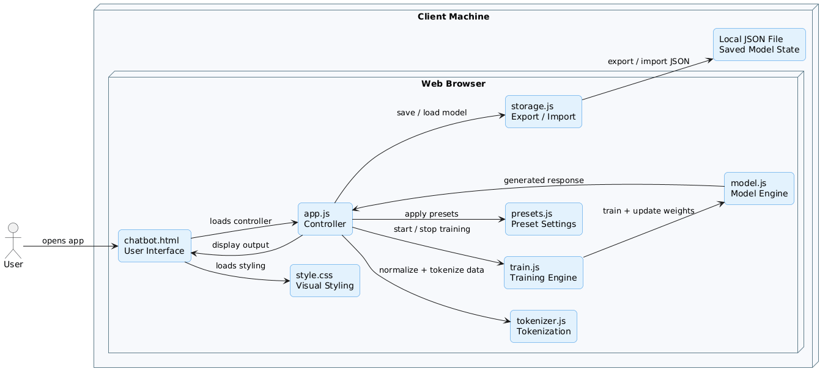

5. Application Component Model

5.1 Description
Since this project does not use a database, the architecture is organized around JavaScript modules rather than database tables. Each module has a specific responsibility in the chatbot-building process.

5.2 Main Components
chatbot.html
Defines the structure of the user interface.
Responsibilities:
- Dataset input area
- Training controls
- Prompt input
- Output display
- Learning dashboard
- Advanced settings
style.css
Controls the visual design of the application.
Responsibilities:
- Layout
- Colors
- Panels
- Buttons
- Dashboard styling
app.js
Acts as the controller between the UI and the system logic.
Responsibilities:
- Connects UI elements to JavaScript logic
- Handles button clicks
- Initializes the application
- Coordinates export/import events
tokenizer.js
Converts raw text into machine-readable tokens.
Responsibilities:
- Normalize text
- Build vocabulary
- Support BPE tokenization
- Encode text into token IDs
- Decode token IDs back into text
train.js
Controls model training and generation workflow.
Responsibilities:
- Apply dataset
- Split data into training and validation sets
- Start and stop training
- Track loss, perplexity, and progress
- Generate chatbot responses
- Update dashboard metrics
model.js
Contains the transformer-style model logic.
Responsibilities:
- Create model weights
- Perform forward pass
- Calculate loss
- Apply gradients
- Support optimizer updates such as Adam and SGD
presets.js
Provides recommended settings based on dataset type.
Responsibilities:
- Detect dataset style
- Suggest training presets
- Suggest generation presets
- Support chat, prose, code, math, and mixed data modes
storage.js
Handles model persistence.
Responsibilities:
- Export model state as JSON
- Import saved model JSON
- Restore tokenizer and model settings

5.3 Component Relationships
- UI interacts with app.js
- app.js coordinates tokenizer.js, train.js, presets.js, and storage.js
- train.js uses tokenizer.js to process data
- train.js uses model.js to train and generate output
- storage.js saves and restores model state
- Generated output is displayed back in the UI

5.4 Component Model Diagram
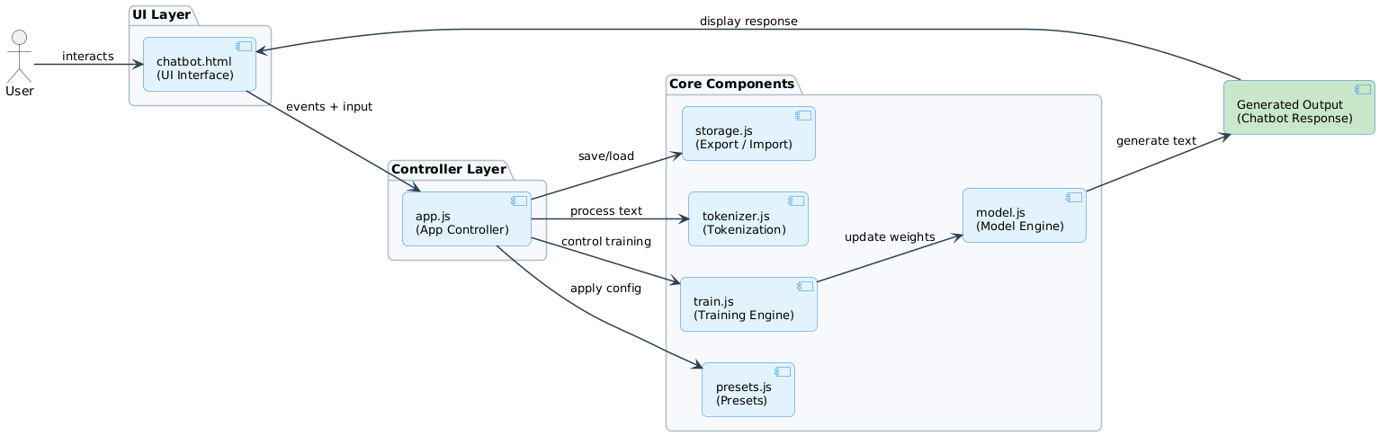

6. Architecture Strengths
The system architecture provides:
- Fully browser-based execution
- No dependency on OpenAI or external AI APIs
- No backend or database setup required
- Clear separation between UI, controller, tokenizer, training, model, and storage logic
- Educational visibility into chatbot creation and training
- Export/import support for model reuse
- Interactive training dashboard with real-time metrics

7. Limitations and Future Improvements
Current Limitations
- Training speed is limited by browser CPU performance
- Model size is smaller than production-scale language models
- Output quality depends heavily on dataset size and quality
- Large datasets may affect browser performance
- The model is educational and not designed to compete with commercial LLMs
Future Improvements
- Add file upload support for datasets
- Improve model performance and training stability
- Add stronger visual explanations of tokenization and training
- Support larger datasets more efficiently
- Add saved training sessions in browser storage
- Improve response quality for question-answer datasets
- Add better preset recommendations for different dataset types

8. Summary
The Byte Squad Chatbot Builder uses a fully client-side browser architecture. The system includes a user interface, controller layer, tokenizer, training engine, model engine, presets module, and storage module. Together, these components allow users to paste their own text, tokenize it, train a small transformer-style model, generate responses, and export or import model state.
This architecture supports the main goal of the project: making chatbot creation and model training understandable, interactive, and accessible without relying on external AI services or backend infrastructure.

