Chatbot Builder Application
  - UML Document
Prepared by: Team Byte Squad
- Jordan Spector
- Ashmit Nirwan
- Milton Mupfumira
- Gio Mendoza
Course: Software Engineering
Date: April 2026

1. Introduction

1.1 Purpose
This document presents the Unified Modeling Language diagrams for the Byte Squad Chatbot Builder. UML is used to visually represent both the structural and behavioral aspects of the system.
The diagrams included in this document are:
- Class Diagram
- Sequence Diagram
- Key Sequence Flows
Unlike the earlier Spring Boot/OpenAI chatbot UML template, this version is aligned with the Byte Squad browser-based chatbot system, which runs client-side and does not use a backend, database, or OpenAI API.

2. Class Diagram

2.1 Purpose
The class diagram represents the structural design of the Byte Squad Chatbot Builder by showing the main JavaScript modules and their relationships. Since this project is browser-based, the diagram focuses on UI, controller, tokenizer, training, model, presets, and storage modules.

2.2 Main Classes / Modules
1. chatbot.html
Responsibilities:
- Provides the main user interface
- Displays dataset input, training controls, prompt box, output area, and dashboard
- Loads JavaScript modules into the browser
2. app.js
Responsibilities:
- Acts as the controller between the UI and core logic
- Connects buttons, inputs, and dashboard fields to application functions
- Initializes the system
- Handles export/import actions
3. tokenizer.js
Responsibilities:
- Normalizes text
- Builds vocabulary from user-provided dataset
- Supports character-level and BPE tokenization
- Encodes text into token IDs
- Decodes token IDs back into readable text
4. train.js
Responsibilities:
- Applies dataset and prepares training data
- Splits data into training and validation sets
- Controls training loop
- Tracks loss, perplexity, learning progress, and dashboard metrics
- Handles response generation
5. model.js
Responsibilities:
- Creates the transformer-style model
- Stores model weights
- Performs forward pass
- Calculates loss
- Applies gradient updates
- Supports Adam and SGD optimizers
6. presets.js
Responsibilities:
- Detects dataset type
- Provides recommended training and generation settings
- Supports presets such as chat, prose, code, math, lyrics, and mixed data
7. storage.js
Responsibilities:
- Exports trained model state as JSON
- Imports saved model JSON
- Restores tokenizer and model state

2.3 Relationships
- chatbot.html loads and displays the UI
- app.js connects UI elements to system logic
- app.js calls train.js to control training and generation
- train.js uses tokenizer.js for text processing
- train.js uses model.js for forward pass, loss, and weight updates
- app.js uses presets.js to apply recommended settings
- app.js uses storage.js to export and import model state
- model.js returns generated output through train.js and app.js back to the UI

2.4 Class Diagram
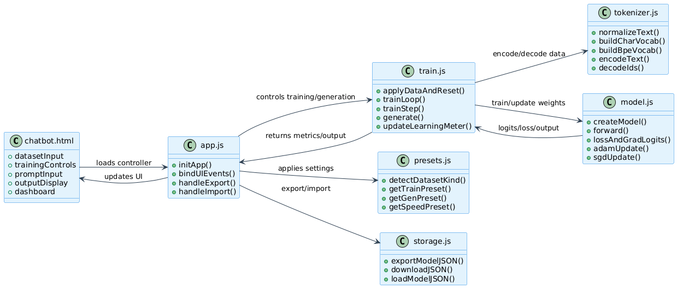

3. Sequence Diagram

3.1 Purpose
The sequence diagram represents how system components interact during the main chatbot workflow.

3.2 Flow Name
Flow: Dataset Training and Chatbot Response Generation

3.3 Participants
- User
- UI (chatbot.html)
- App Controller (app.js)
- Tokenizer (tokenizer.js)
- Training Engine (train.js)
- Model Engine (model.js)
- Output Display

3.4 Flow Description
- User pastes dataset into the UI
- User clicks Apply Data
- UI sends the dataset to app.js
- app.js calls train.js
- train.js sends text to tokenizer.js
- tokenizer.js normalizes and converts text into token IDs
- train.js creates training and validation sets
- model.js initializes model weights
- User clicks Start Training
- train.js repeatedly calls model.js to train the model
- Training metrics are returned to the UI
- User enters a prompt and clicks Generate
- Prompt is tokenized
- Model generates output one token at a time
- Generated response is displayed in the UI

3.5 Sequence Diagram
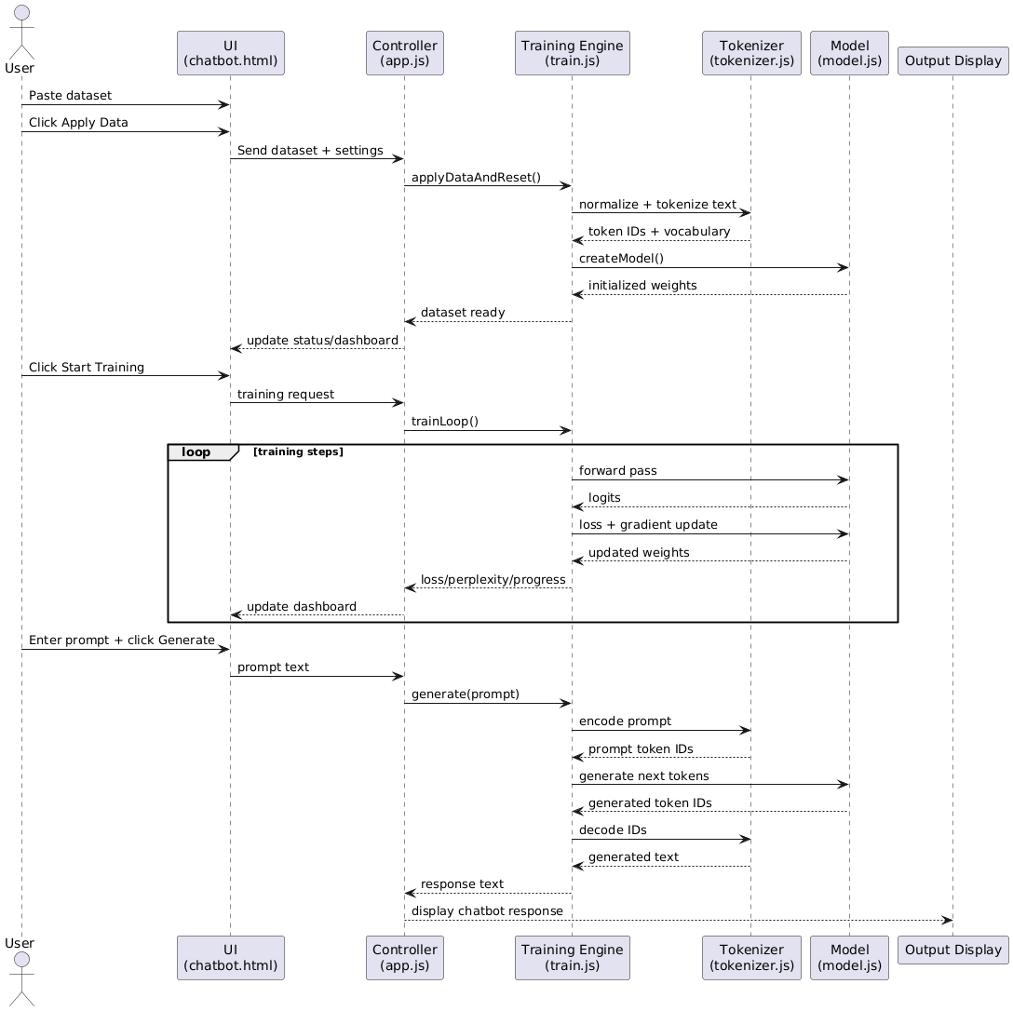

4. Key Sequence Diagrams

4.1 Flow: Dataset Input and Tokenization
This flow shows how raw text is prepared before training.
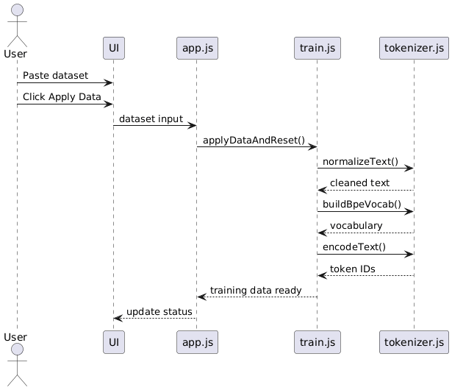

4.2 Flow: Model Training
This flow shows how the model learns from token IDs.
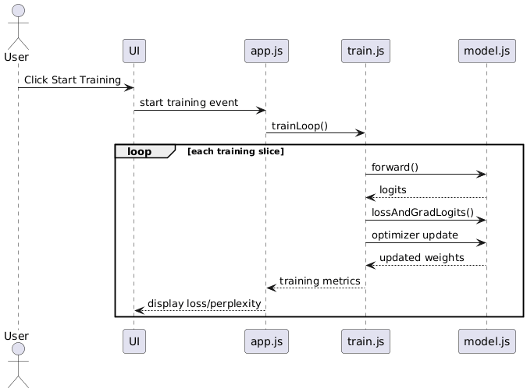

4.3 Flow: Text Generation
This flow shows how the trained model generates chatbot output.
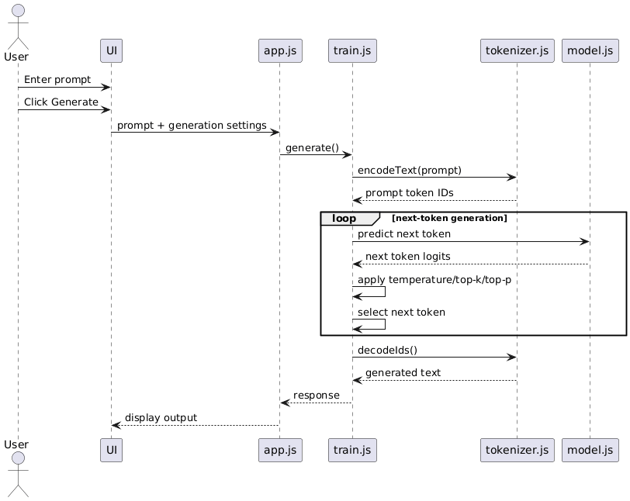

4.4 Flow: Export / Import Model
This flow shows how users save and reload a trained model.
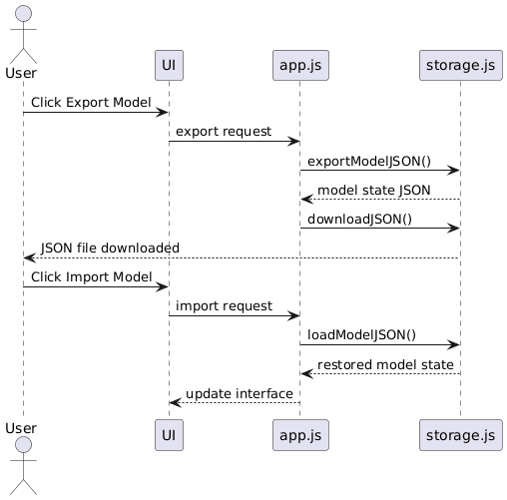

5. Summary
The UML diagrams describe both the structure and dynamic behavior of the Byte Squad Chatbot Builder.
- The Class Diagram shows the core JavaScript modules and their responsibilities
- The Sequence Diagrams show how data is tokenized, how training occurs, how text is generated, and how model state is saved or restored
These diagrams provide a clear representation of the system’s design and implementation as a browser-based educational chatbot training platform.

