Chatbot Builder Application
  - UML Document
Prepared by: Team Byte Squad
- Ashmit Nirwan
- Jordan Spector
- Gio Mendoza
- Milton Mupfumira
Course: Software Engineering
Date: April 2026

1. Introduction

1.1 Purpose
This document presents the Unified Modeling Language (UML) diagrams for the Chatbot Builder Application. UML is used to visually represent both the structural and behavioral aspects of the system.
The diagrams included in this document are:
- Class Diagram
- Sequence Diagram
These diagrams provide a clear understanding of how the system components are organized and how they interact during chatbot operations.

2. Class Diagram

2.1 Purpose

The class diagram represents the structural design of the Chatbot Builder Application by showing the main software classes and their relationships. Unlike the database model shown in the Architecture document, this diagram focuses on the implemented application layers, including controllers, services, models, and repositories.

2.2 Main Classes
- ChatbotBuilderApplication
Responsibilities:
- Serves as the main entry point of the Spring Boot application
- Initializes the backend system and application context
- AuthController
Responsibilities:
- Handles user authentication requests
- Supports login, registration, password reset, and profile-related operations
- BotController
Responsibilities:
- Handles chatbot creation, update, publish, and chat operations
- Connects frontend chatbot actions to backend services
- AnalyticsController
Responsibilities:
- Handles analytics-related API requests
- Provides user-level and admin-level analytics data
- BotService
Responsibilities:
- Contains the core business logic for chatbot creation, ingestion, updating, and response generation
- Manages chunk retrieval, OpenAI interaction, publishing, and conversation tracking
- WebScraperService
Responsibilities:
- Extracts text content from website URLs
- Supports website-based knowledge ingestion
- User
Responsibilities:
- Represents application users and administrators
- Stores account and role-related information
- Bot
Responsibilities:
- Represents a chatbot created by a user
- Stores configuration, deployment, and knowledge source information
- BotChunk
Responsibilities:
- Represents processed chatbot knowledge chunks
- Stores embedding-related information for retrieval
- Conversation
Responsibilities:
- Represents a chatbot conversation session
- Tracks both private and public chat activity
- Message
Responsibilities:
- Represents an individual message in a conversation
- Stores sender, content, and timestamp information
- UserRepository
Responsibilities:
- Provides database access for user records
- BotRepository
Responsibilities:
- Provides database access for chatbot records
- BotChunkRepository
Responsibilities:
- Provides database access for chatbot chunk records
- ConversationRepository
Responsibilities:
- Provides database access for conversation records
- MessageRepository
Responsibilities:
- Provides database access for message records

2.3 Relationships
- ChatbotBuilderApplication initializes the application
- AuthController uses UserRepository
- BotController uses BotService
- AnalyticsController uses repositories to retrieve analytics data
- BotService uses BotRepository, BotChunkRepository, ConversationRepository, and MessageRepository
- BotService also uses WebScraperService
- User owns many Bot
- Bot has many BotChunk
- Bot has many Conversation
- Conversation has many Message

2.4 Class Diagram
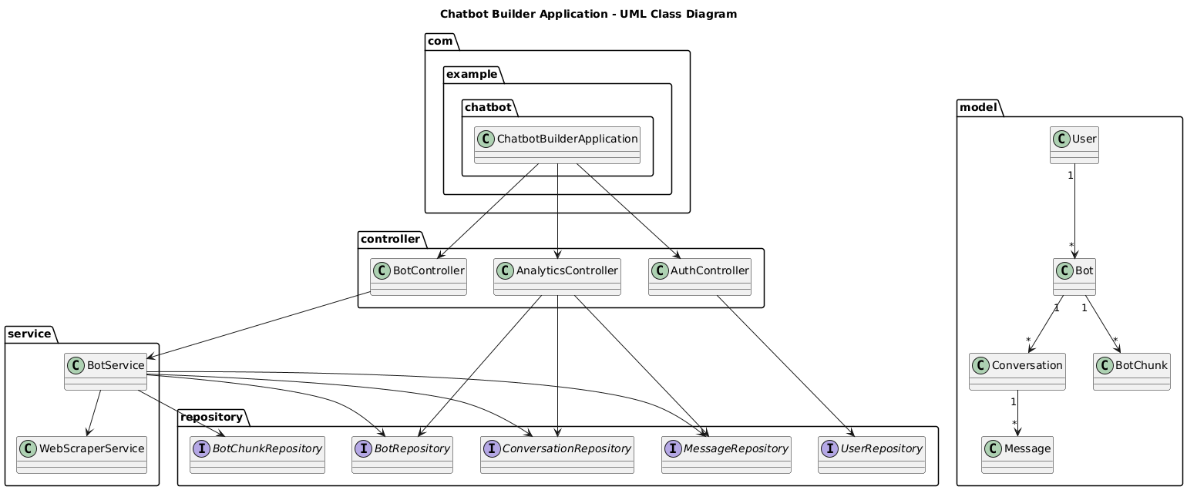

3. Sequence Diagram

3.1 Purpose
The sequence diagram represents the interaction between system components during chatbot response generation.

3.2 Flow Name
The selected scenario is:
Flow: Chatbot Response Generation (User Chat Interaction)

3.3 Participants
- User
- Frontend (UI)
- BotController
- BotService
- BotChunkRepository
- Database (PostgreSQL)
- OpenAI API

3.3 Flow Description
- User enters a message in the chatbot interface
- Frontend sends a request to the backend API
- BotController receives the request
- BotController calls BotService
- BotService retrieves relevant chunks from the database
- BotService sends the context and question to OpenAI
- OpenAI generates a response
- BotService returns the response
- Frontend displays the chatbot response

3.4 Sequence Diagram
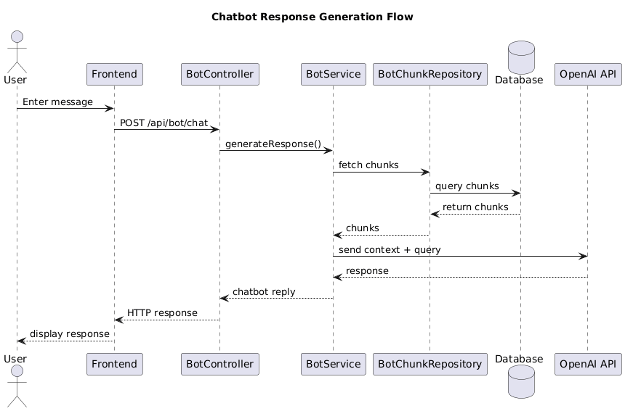

4. Key Sequence Diagrams
The UML diagrams describe both the structure and dynamic behavior of the Chatbot Builder
4.1 Flow: Chatbot Creation and Knowledge Ingestion
This flow shows how a new chatbot is created and saved by the system.
It also shows how knowledge is processed and stored for later use.
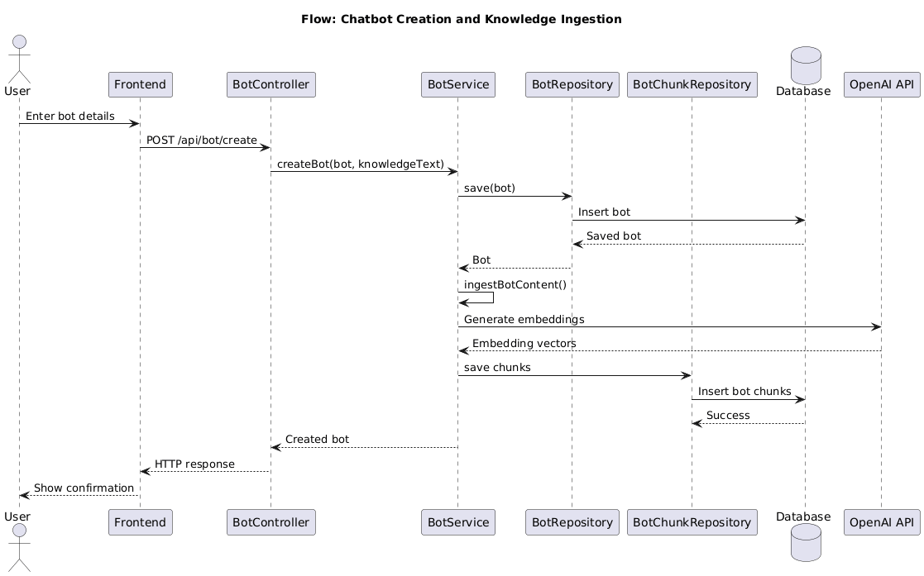

4.2 Flow: Public Chatbot Interaction
This flow shows how a visitor interacts with a published chatbot using a public link.
It includes session tracking and chatbot response generation.
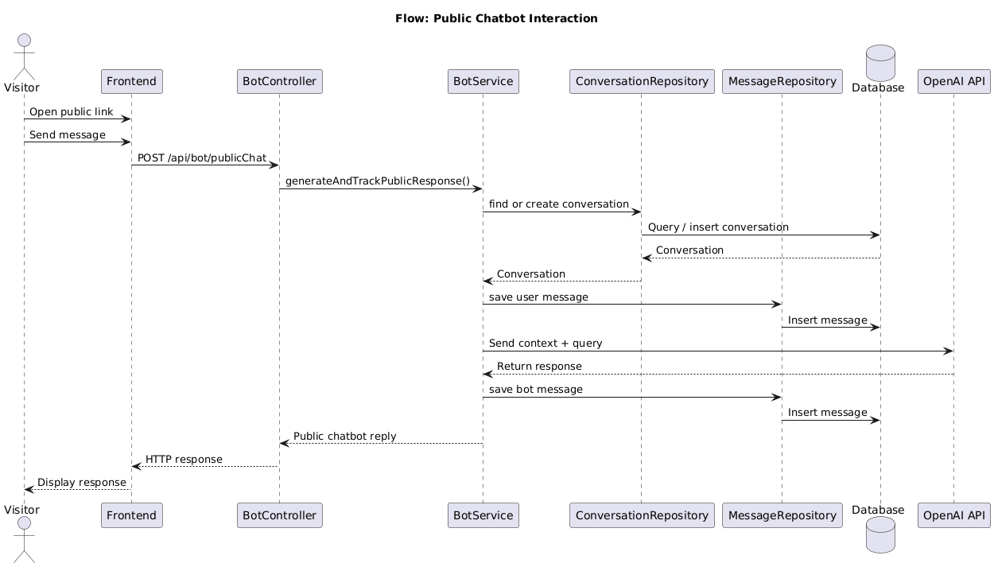
4.3 Flow: Publish Chatbot
This flow shows how a chatbot is published and assigned a public token.
It ends with generation of a public chatbot link.
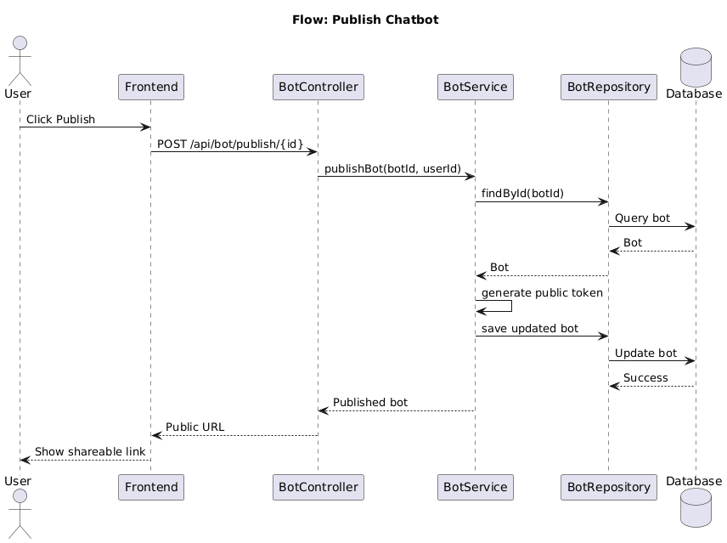

4.4 Flow: View Analytics
This flow shows how analytics data is requested and displayed.
It includes retrieval of conversation and message data from the database.
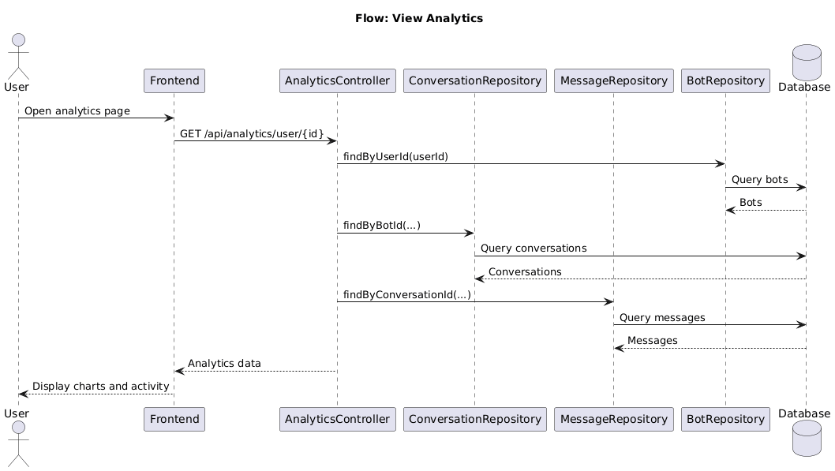

5. Summary
The UML diagrams describe both the structure and dynamic behavior of the Chatbot Builder Application.
- The Class Diagram shows the core entities and relationships
- The Sequence Diagram shows how the system processes chatbot interactions end to end
These diagrams provide a clear representation of the system’s design and implementation.

