Chatbot Builder Application
  - System Architecture Document
Prepared by: Team Byte Squad
- Ashmit Nirwan
- Jordan Spector
- Gio Mendoza
- Milton Mupfumira
Course: Software Engineering
Date: April 2026

1. Introduction
The purpose of this document is to describe the architecture of the Chatbot Builder Application. The system architecture explains how the major components of the application interact and how data flows through the system.
The application is built as a full-stack web system that includes a frontend user interface, a backend application server, a database, and AI integration.

2. Architecture Overview
The Chatbot Builder Application follows a client-server architecture.
The main components are:
- Frontend user interface
- Backend REST API server
- PostgreSQL database
- OpenAI API integration
The frontend allows users to create, customize, test, and deploy chatbots. The backend processes requests, stores data, retrieves chatbot knowledge, and communicates with the AI model. The database stores users, bots, chunks, conversations, and messages

3. Logical Architecture

3.1 Description
The logical architecture shows the major software components and how they interact conceptually.
Main Logical Components
- User / Admin / Public Visitor
- Frontend Interface
- Backend Services
- Database
- OpenAI API
Logical Flow
- User interacts with the frontend
- Frontend sends requests to backend APIs
- Backend processes requests
- Backend stores and retrieves data from PostgreSQL
- Backend communicates with OpenAI for embeddings and response generation
- Backend sends results back to frontend

3.2 Logical Diagram

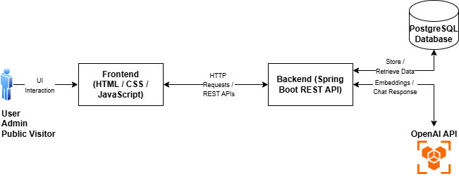

4. Physical Architecture

4.1 Description
The physical architecture shows where each part of the system runs in the real environment.
Physical Components
- Client browser
- Application server
- Database server
- External AI service
Physical Flow
- Users access the application through a web browser
- The browser loads the frontend from the Spring Boot application
- The backend runs on a local or hosted machine
- PostgreSQL runs as the database server
- OpenAI API is accessed through the internet

4.2 Physical Diagram

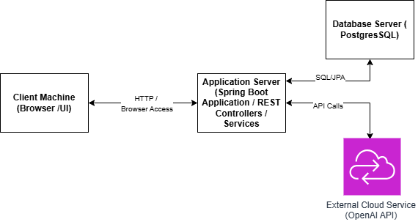

5. Database Model

5.1 Description
The database supports authentication, bot management, chatbot knowledge storage, public and private conversations, and analytics.
The main entities in the system are:
- User
- Bot
- BotChunk
- Conversation
- Message

5.2 Main Tables
- User: Stores account details for users and admins.
Attributes:
- id
- name
- email
- password
- pin
- role
- Bot: Stores chatbot configuration and ownership details.
Attributes:
- id
- name
- url
- description
- language
- personality
- tone
- response_length
- source_type
- knowledge_text
- published
- public_token
- user_id
- BotChunk: Stores processed chatbot knowledge chunks and embeddings.
Attributes:
- id
- chunk_text
- embedding_json
- chunk_index
- bot_id
- Conversation: Stores chatbot conversations.
Attributes:
- id
- bot_id
- session_id
- public_chat
- started_at
- last_message_at
- Message: Stores individual chat messages.
Attributes:
- id
- conversation_id
- sender
- content
- created_at

5.3 Relationships
- One User can own many Bots
- One Bot can have many BotChunks
- One Bot can have many Conversations
- One Conversation can have many Messages

5.4 Database Model

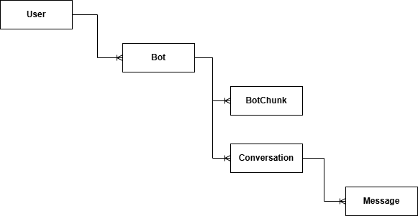

6. Architecture Strengths
The system architecture provides:
- clear separation between frontend and backend
- scalable database-driven design
- reusable chatbot service logic
- support for public and private chatbot interactions
- integration with external AI services

7. Limitations and Future Improvements
Current limitations include:
- reliance on external OpenAI API
- limited fallback behavior when AI is unavailable
- PDF upload not fully implemented
- analytics trend based on recent activity rather than full aggregated history
Future improvements may include:
- stronger authentication and authorization
- advanced analytics processing
- more robust error handling
- broader knowledge source support

8. Summary
The Chatbot Builder Application uses a structured client-server architecture with a web frontend, Spring Boot backend, PostgreSQL database, and OpenAI integration. This architecture supports chatbot creation, knowledge ingestion, deployment, analytics, and public chatbot usage.

