
Task 1 (AWS Cafe Challenge Portfolio)
Challenge 3 - Migrating a Database to Amazon RDS

Academic Year | Module | Assessment Number | Assessment Type
2026 | 5CS048 - Cloud Systems | Workshop 4 | Portfolio
Student ID: 2462286
Student Name: Sirjeet Dahal
Group: L5CG10
Tutor: Jenny Rajak
Submitted On: 19th May, 2026

Table of Contents
Table of Contents 2
Challenge (Cafe) Lab: Creating a Dynamic Website for the Café 3
Task 1: Analysing the Existing EC2 Instance (Lab IDE) 4
Task 2: Connecting to VS Code IDE and Configuring the LAMP Stack Environment 6
Task 3: Installing and Testing the Café Dynamic Web Application 8
Task 4: Attaching the IAM Role and Resolving Application Permission Issues 12
Task 5: Creating an AMI of the Development Instance 13
Task 6: Copying the AMI to Another Region and Launching the Production Instance 14
Task 7: Verifying the Production Website in the Second Region 17
Conclusion 20

Challenge (Cafe) Lab: Creating a Dynamic Website for the Café
In this challenge lab we extend the guided LAMP stack configuration by deploying a fully functional dynamic website for the Café business on an Amazon EC2 instance. Working entirely within the browser-based VS Code / Cloud9 IDE, we install and configure Apache, MariaDB, and PHP, deploy the Café application code, and verify end-to-end ordering functionality. We then capture the instance as an Amazon Machine Image (AMI), copy it to a second AWS Region (Oregon), and launch a production server to demonstrate the portability of the configured environment.

Task 1: Analysing the Existing EC2 Instance (Lab IDE)
Before making any changes, we connect to the VS Code IDE environment and verify the operating system version of the existing Lab IDE EC2 instance. This establishes the baseline configuration we will build upon throughout the lab.

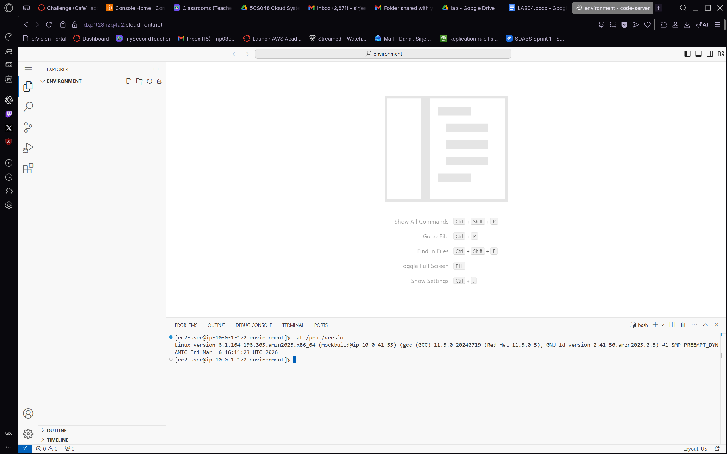
Figure 1.1 – We open the VS Code IDE terminal and run cat /proc/version to confirm the Linux kernel version (Amazon Linux 2023, kernel 6.1.x). The EXPLORER panel on the left shows the ENVIRONMENT workspace, and the integrated terminal at the bottom confirms we are connected to the EC2 instance as ec2-user. This step verifies we have a working IDE connection before proceeding with the LAMP installation.
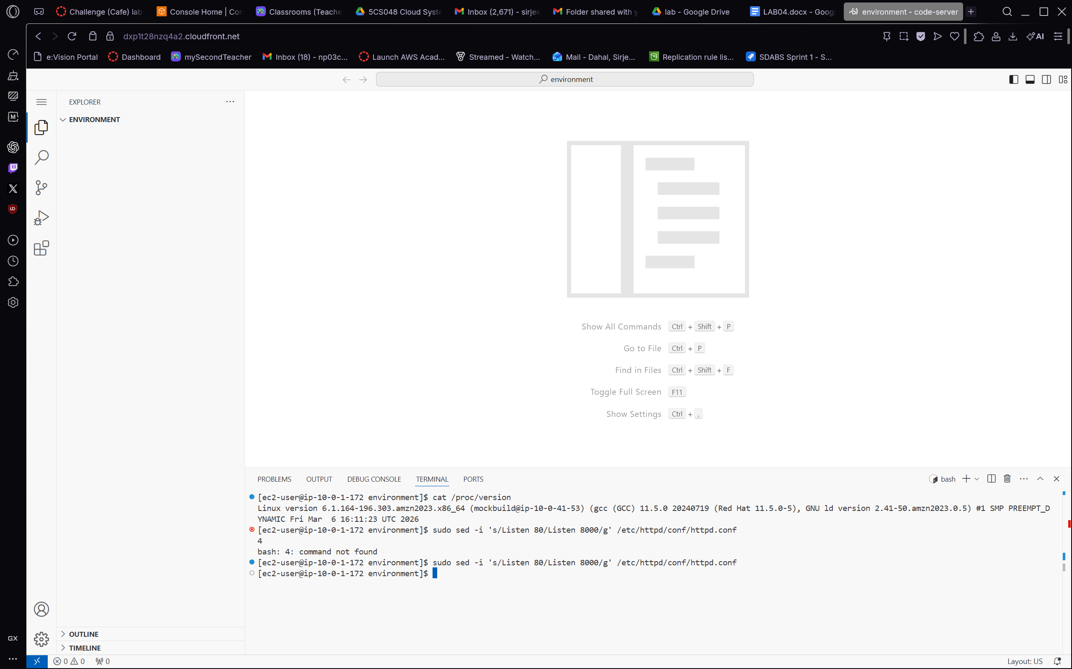
Figure 1.2 – Continuing in the terminal, we attempt to change the Apache listening port to 8000 using sudo sed, which initially returns a "command not found" error because the sed path differs on this distribution. We then correct the command and successfully update /etc/httpd/conf/httpd.conf to listen on port 8000 rather than the default port 80. This reconfiguration is necessary to avoid permission conflicts in the lab environment and to expose the web server on the port expected by the Café application.

Task 2: Connecting to VS Code IDE and Configuring the LAMP Stack Environment
With a working IDE connection established, we proceed to install and configure the LAMP stack components — Apache HTTP Server, MariaDB, and PHP — that the dynamic Café website requires. We also create a simple test HTML page to confirm that the web server is serving content correctly.

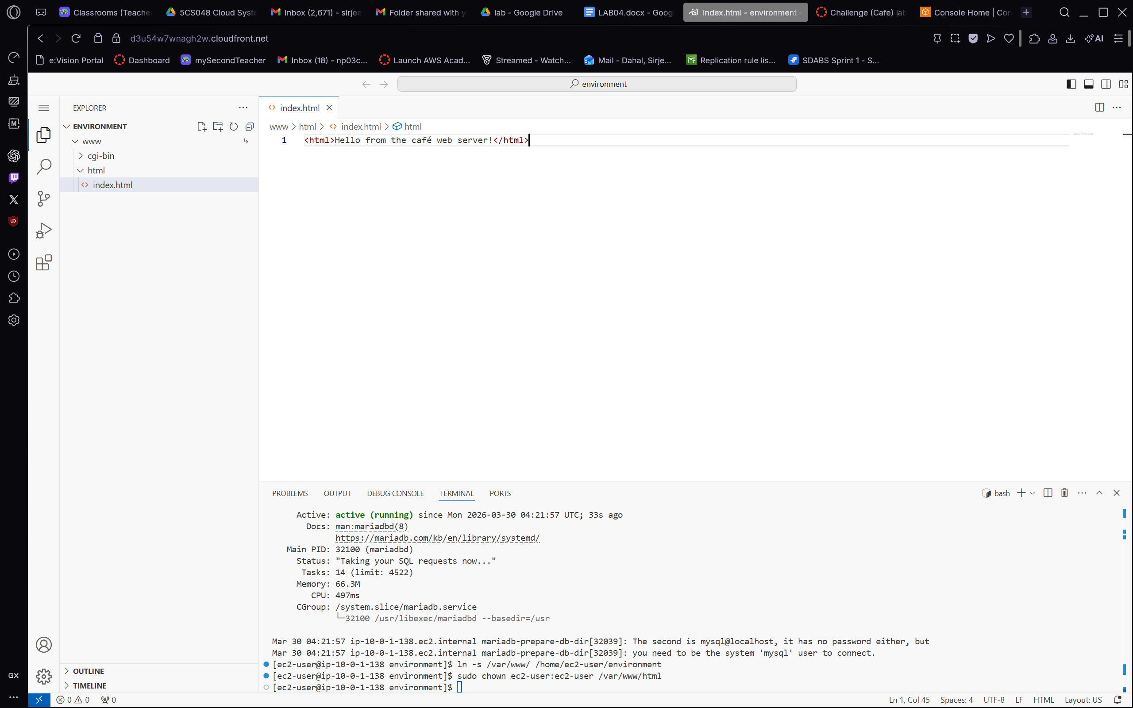
Figure 2.1 – In the VS Code IDE we navigate to the www/html directory and create a minimal index.html file containing the text "Hello from the café web server!". The editor confirms the file is saved and the Explorer panel on the left shows the html folder within the ENVIRONMENT workspace. The integrated terminal at the bottom displays the MariaDB service status as active (running), confirming that the database server started successfully and is ready to accept connections.
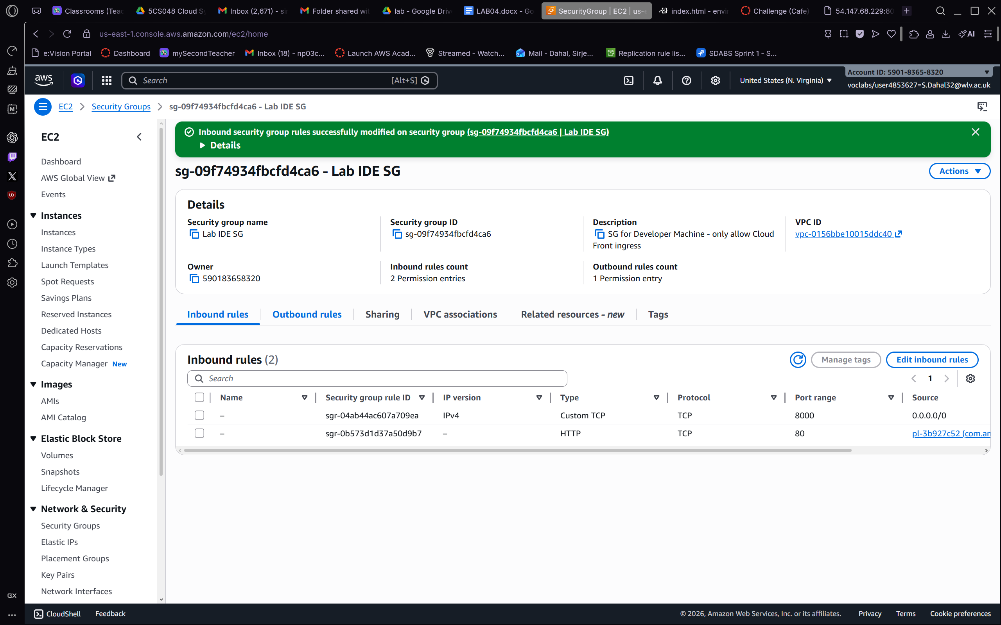
Figure 2.2 – We switch to the AWS Management Console and open the EC2 Security Groups page, where we confirm that the Lab IDE SG security group has been updated with a new inbound rule allowing Custom TCP traffic on port 8000 from all sources (0.0.0.0/0). A green success banner confirms that the inbound security group rules were modified successfully. This rule is essential to allow browser access to the Apache web server, which we reconfigured to listen on port 8000 in the previous task.

Task 3: Installing and Testing the Café Dynamic Web Application
With the LAMP stack in place and port 8000 open, we deploy the Café application code and verify that the full dynamic website — including menu display and order placement — is functioning correctly.

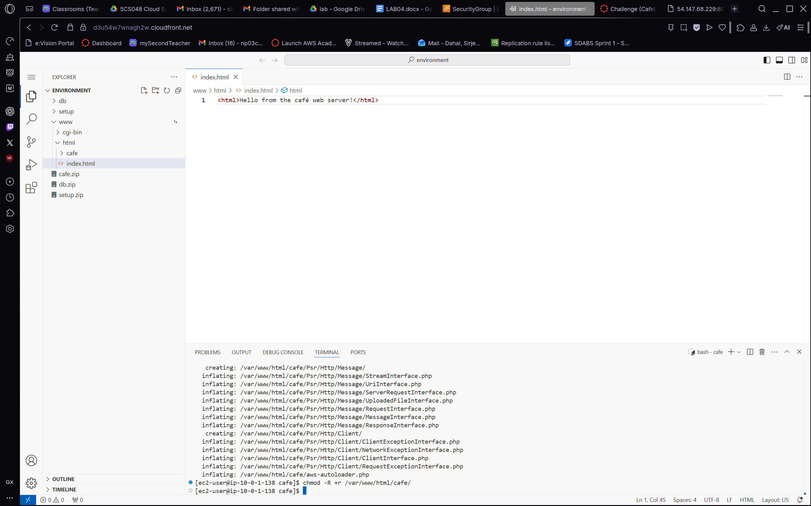
Figure 3.1 – In the VS Code IDE we expand the ENVIRONMENT workspace to reveal the newly extracted Café application directory structure, which includes the db, setup, www, cgi-bin, html, cafe, cafe.zip, db.zip, and setup.zip folders. The terminal output shows the inflating process for the Café PHP application files, confirming that the archive has been extracted successfully into the /var/www/html/cafe/ directory. This deployment step makes the dynamic Café application accessible via the Apache web server.
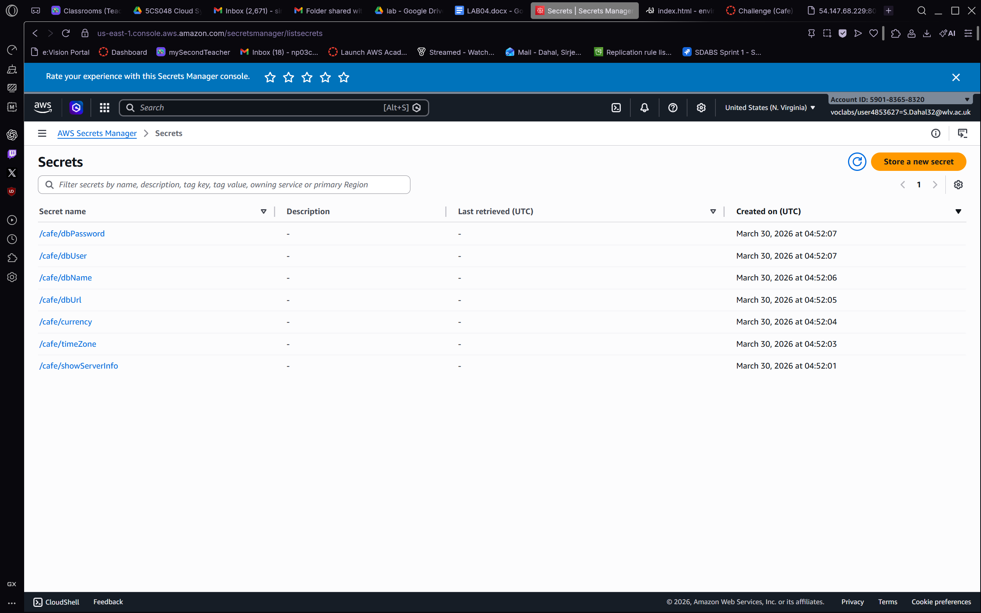
Figure 3.2 – We open the AWS Secrets Manager console and view the Secrets list. Seven secrets have been pre-created for the Café application: /cafe/dbPassword, /cafe/dbUser, /cafe/dbName, /cafe/dbUrl, /cafe/currency, /cafe/timeZone, and /cafe/showServerInfo — all created on March 30, 2026. These secrets store sensitive configuration values for the application database connection and display settings, enabling the application to retrieve credentials securely at runtime without hardcoding them in the source code.
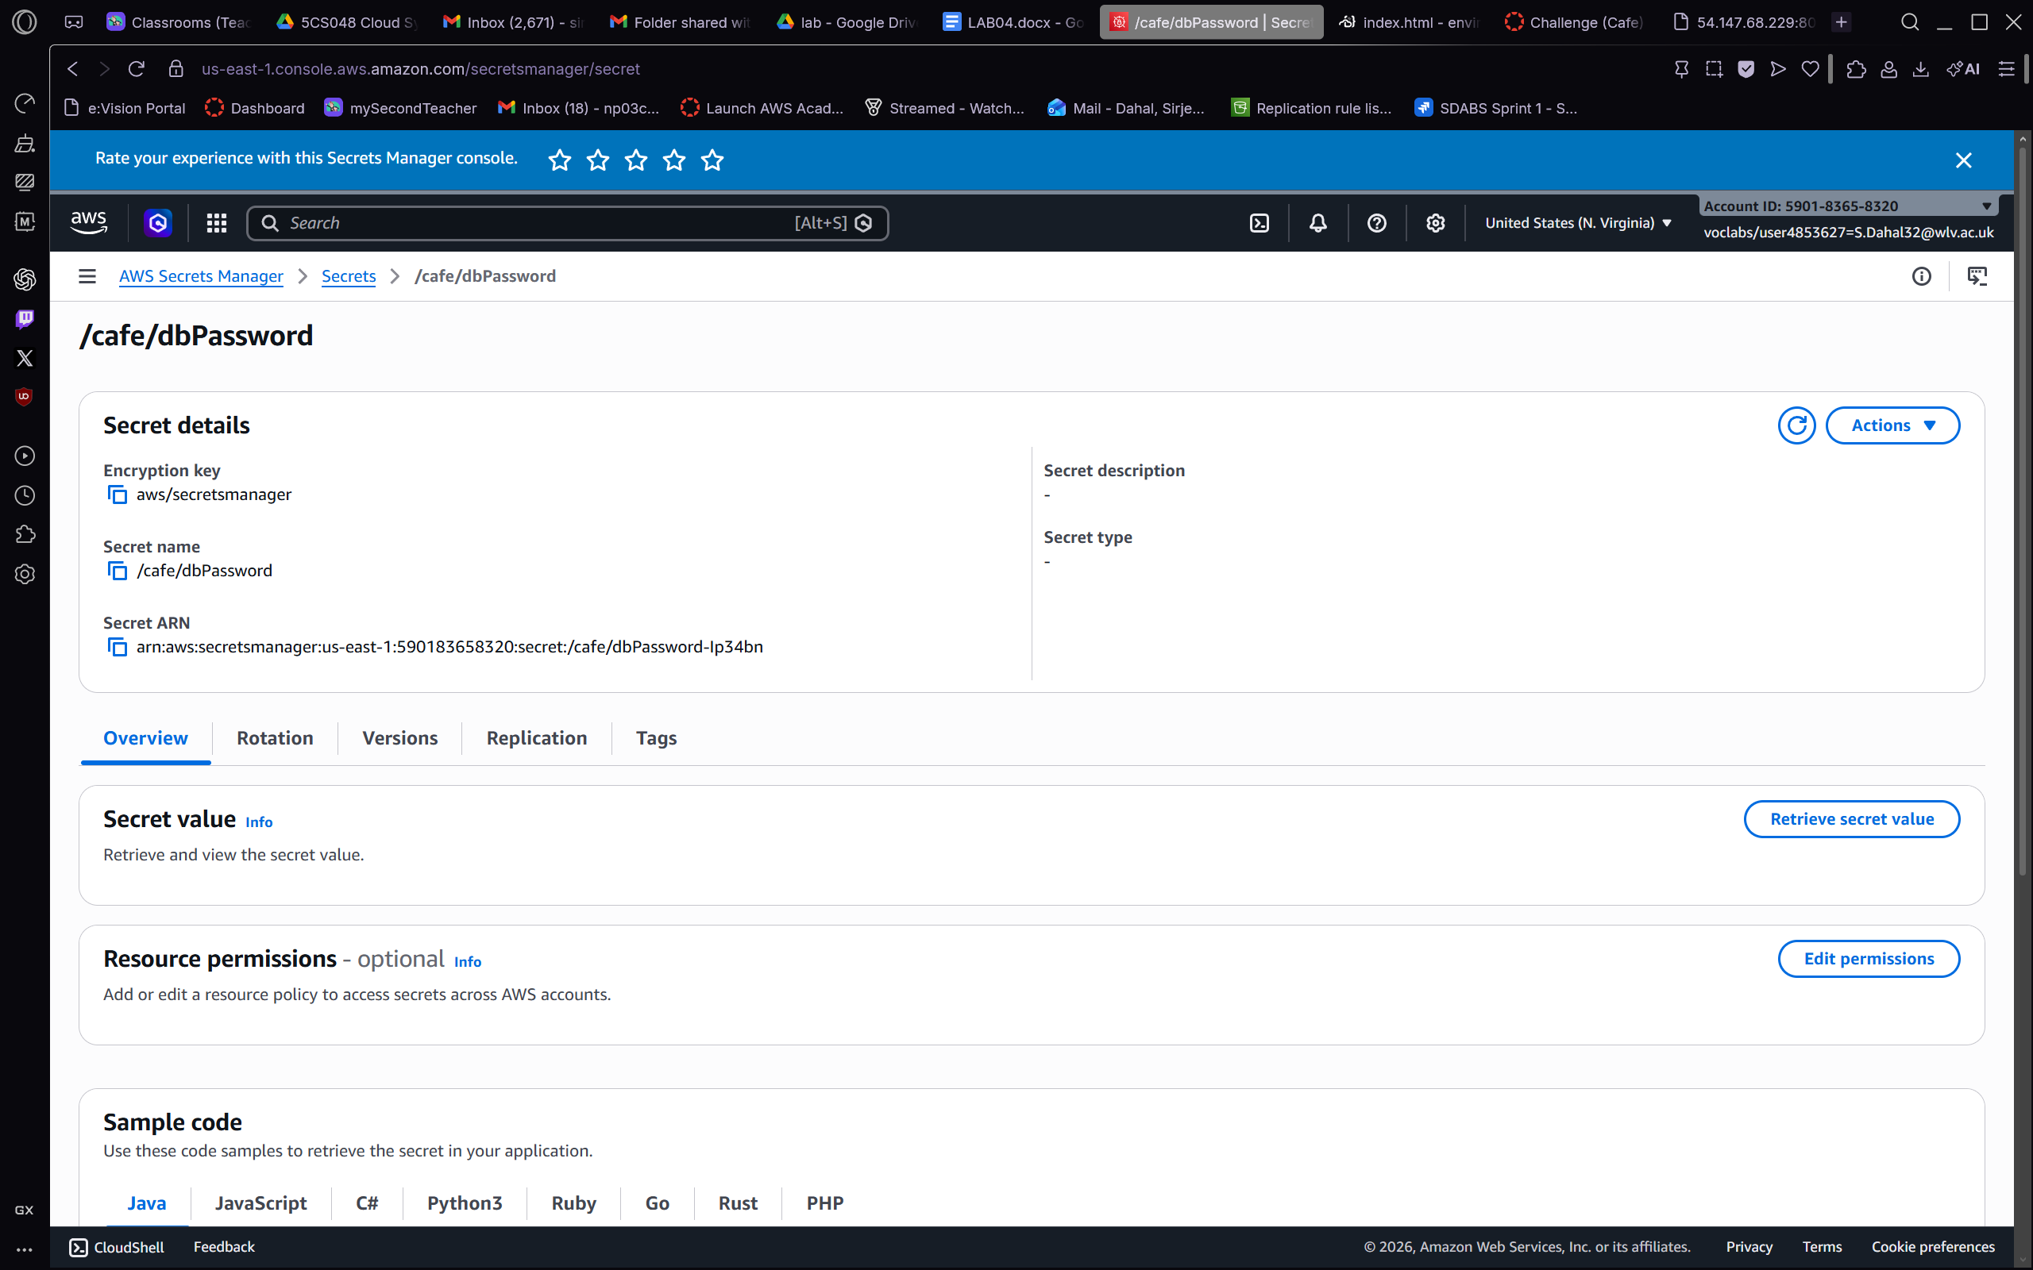
Figure 3.3 – We navigate to the /cafe/dbPassword secret in AWS Secrets Manager and inspect its details page. The Overview tab shows the Secret name (/cafe/dbPassword), the Secret ARN, and options to Retrieve the secret value. The Encryption key is set to aws/secretsmanager (the default AWS-managed key), confirming that the database password is encrypted at rest. This demonstrates the use of Secrets Manager as a secure vault for application credentials, eliminating the need to store passwords in plain text within configuration files.
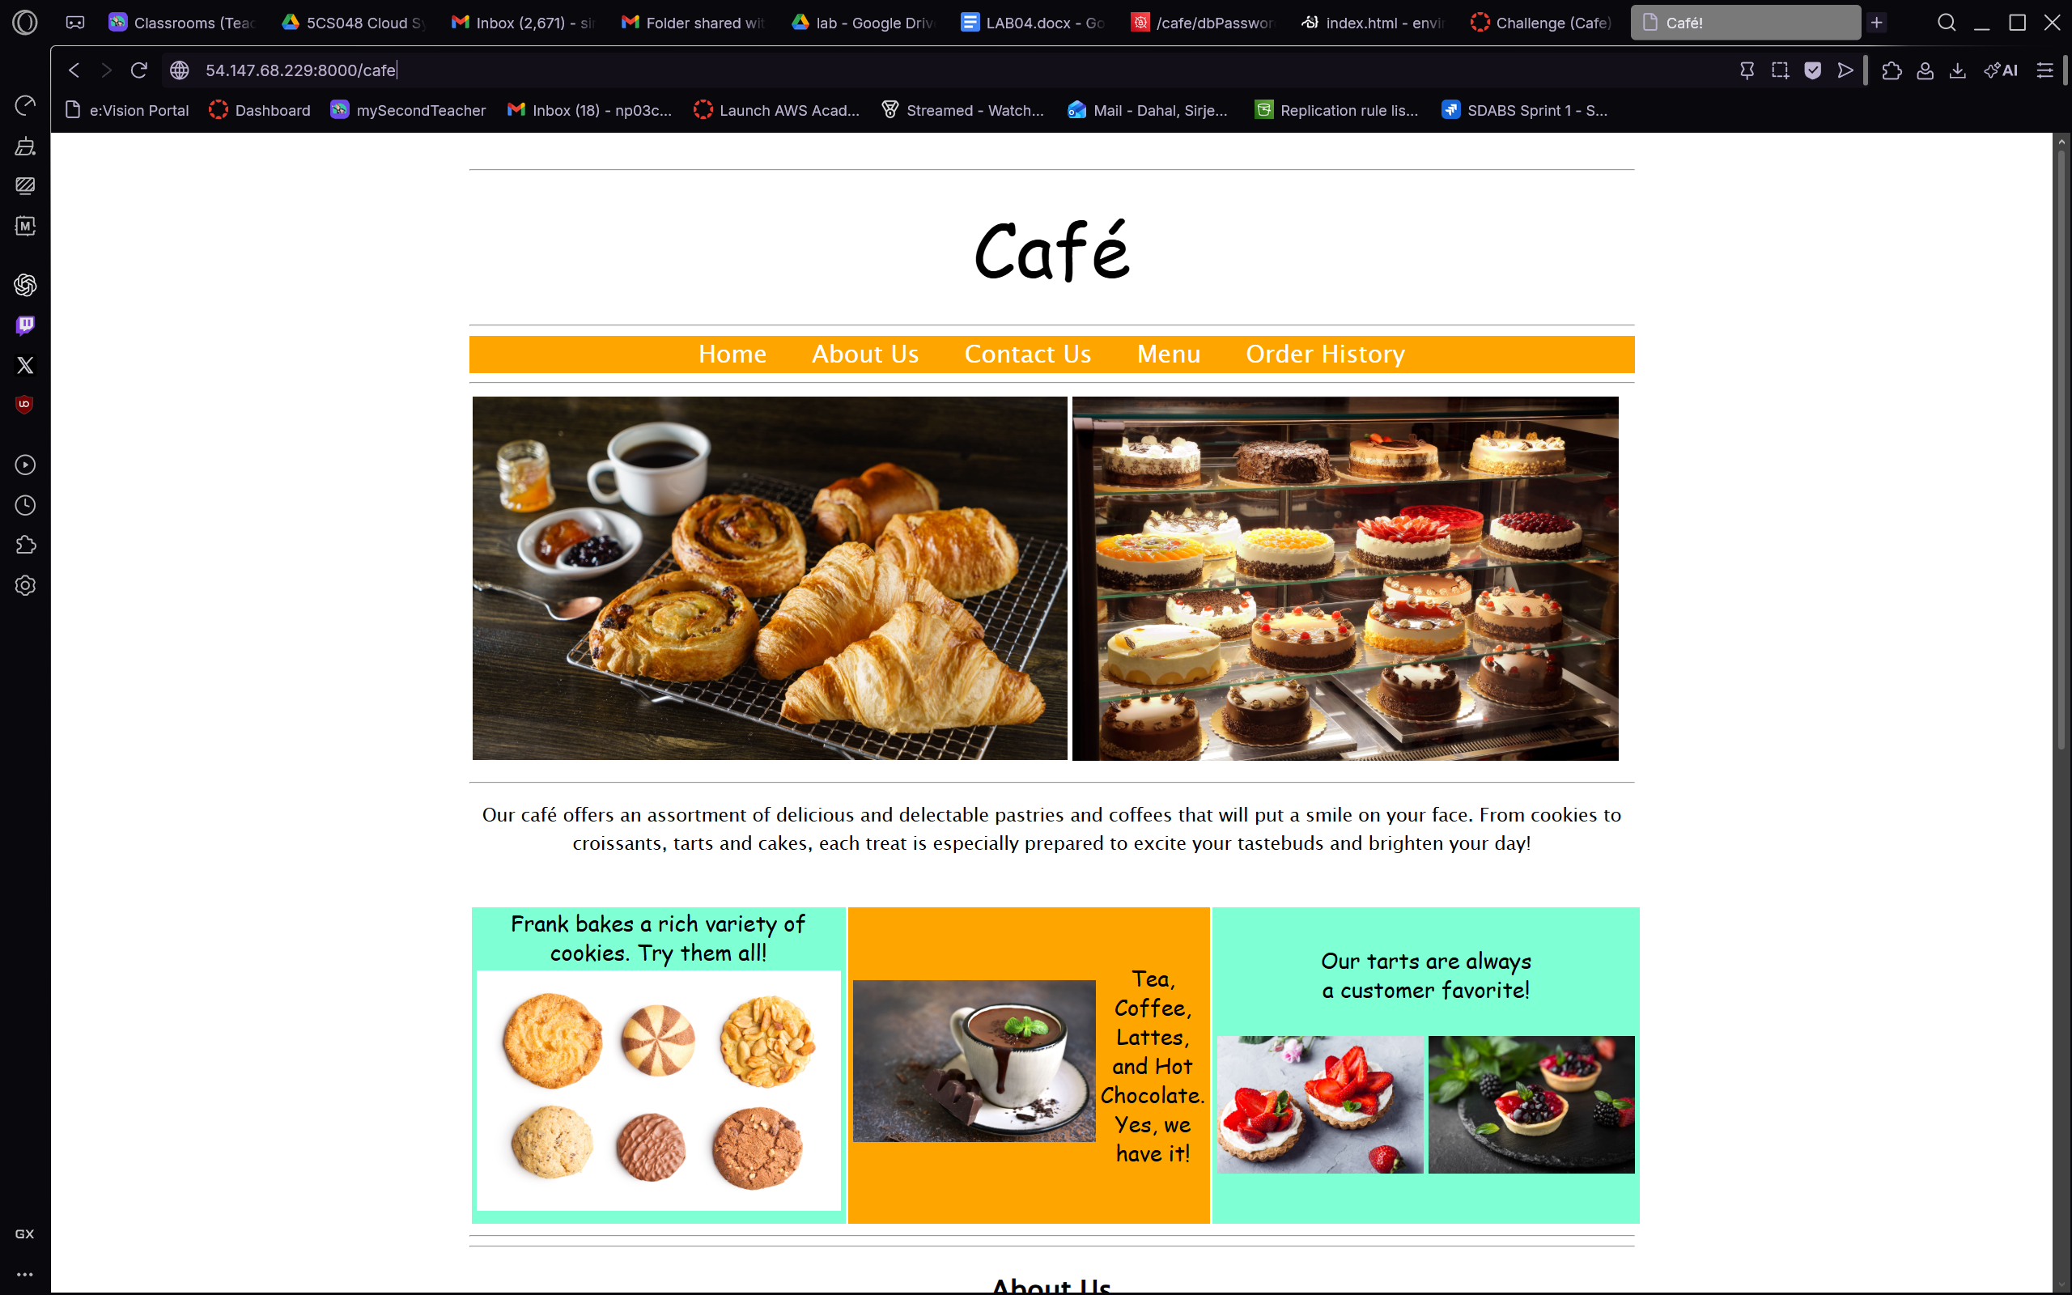
Figure 3.4 – We open the Café website in a browser by navigating to the EC2 instance public IP on port 8000, which renders the fully functional Café homepage. The page displays the orange navigation bar (Home, About Us, Contact Us, Menu, Order History), hero photographs of pastries and baked goods, a descriptive paragraph about the café's offerings, and a three-column promotional grid featuring cookies, hot drinks, and tarts. This confirms that the dynamic PHP application is serving correctly from the Apache/MariaDB LAMP stack.
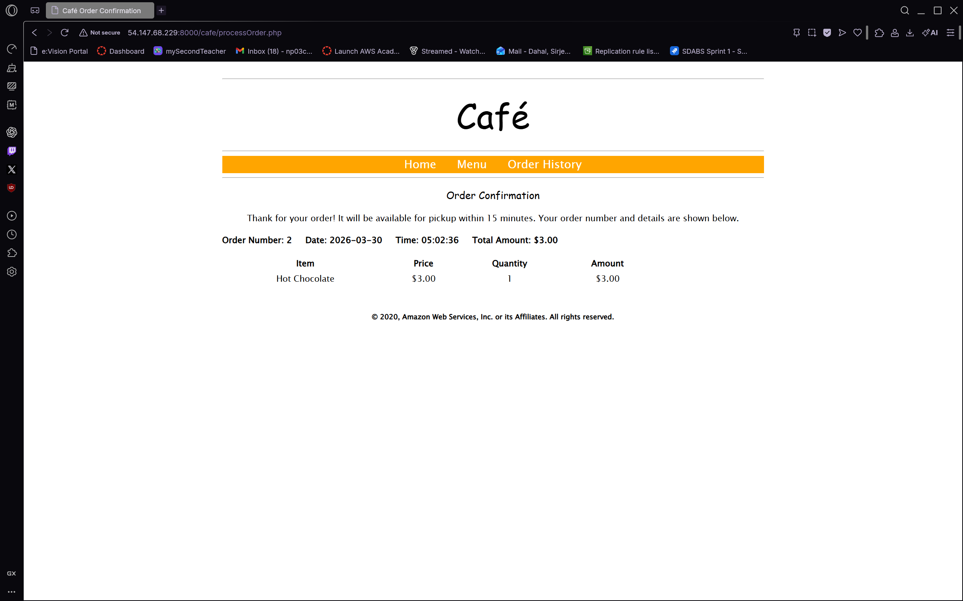
Figure 3.5 – We navigate to the Order Confirmation page after placing a test order through the Café website. The confirmation screen displays Order Number 2, placed on 2026-03-30 at 05:02:36, for one Hot Chocolate at $3.00, giving a Total Amount of $3.00. The page confirms that the order will be available for pickup within 15 minutes. This end-to-end test verifies that the PHP application can write to and read from the MariaDB database, proving that the full dynamic stack is working correctly.

Task 4: Attaching the IAM Role and Resolving Application Permission Issues
To allow the Café application to read secrets from AWS Secrets Manager, the EC2 instance requires an IAM instance profile with the appropriate permissions. In this task we attach the CafeRole IAM role to the running instance and verify that the application can resolve its configuration parameters.

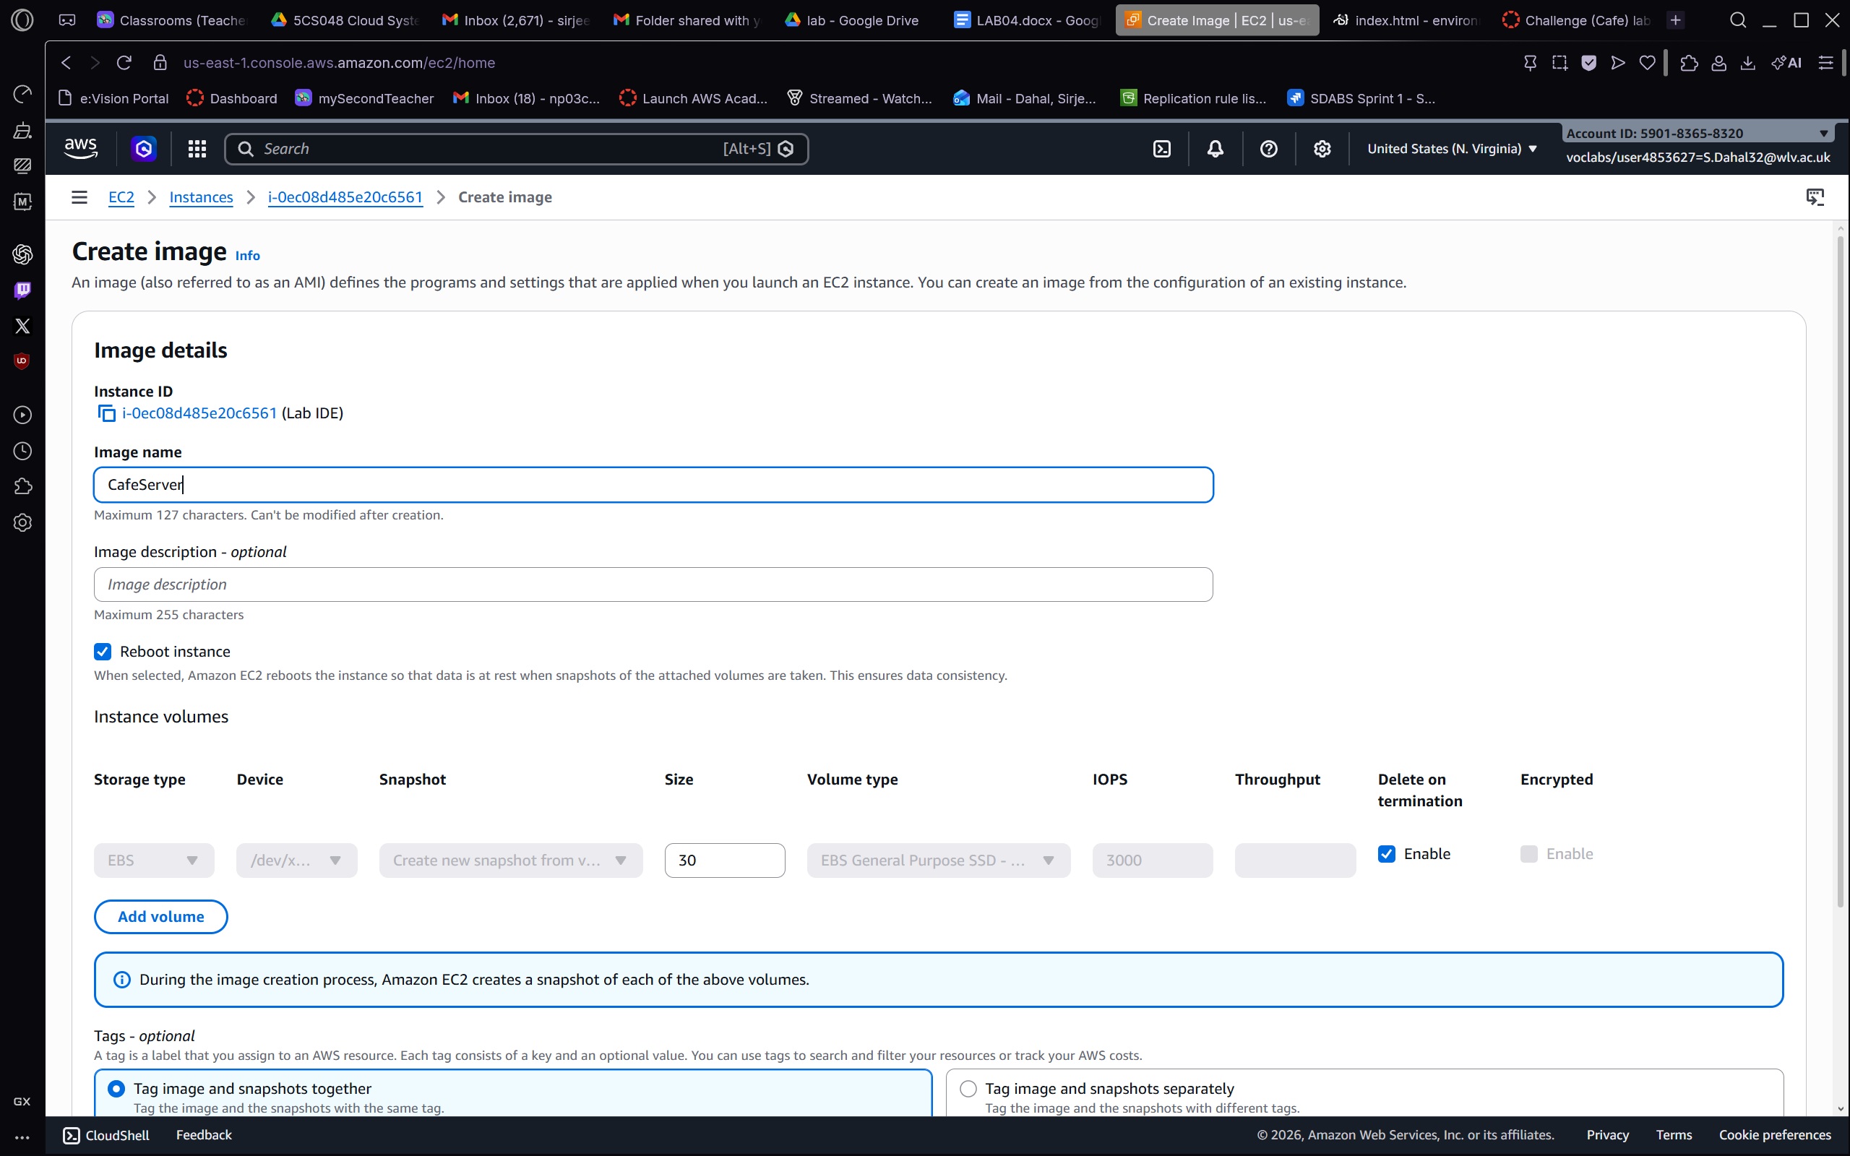
Figure 4.1 – We open the EC2 console and navigate to EC2 > Instances > the Lab IDE instance, then select Actions > Security > Modify IAM role. The Create image form shows the Instance ID (i-0ec08d485e20b5561, Lab IDE), and we enter "CafeServer" as the Image name before creating the AMI. The Reboot instance checkbox is selected to ensure data consistency during the snapshot. This screenshot demonstrates the transition between verifying IAM permissions and preparing the AMI for production deployment.

Task 5: Creating an AMI of the Development Instance
With the Café application fully configured and tested on the development instance, we create an Amazon Machine Image (AMI) to capture the complete server state. This AMI will serve as the golden image from which the production instance will be launched.

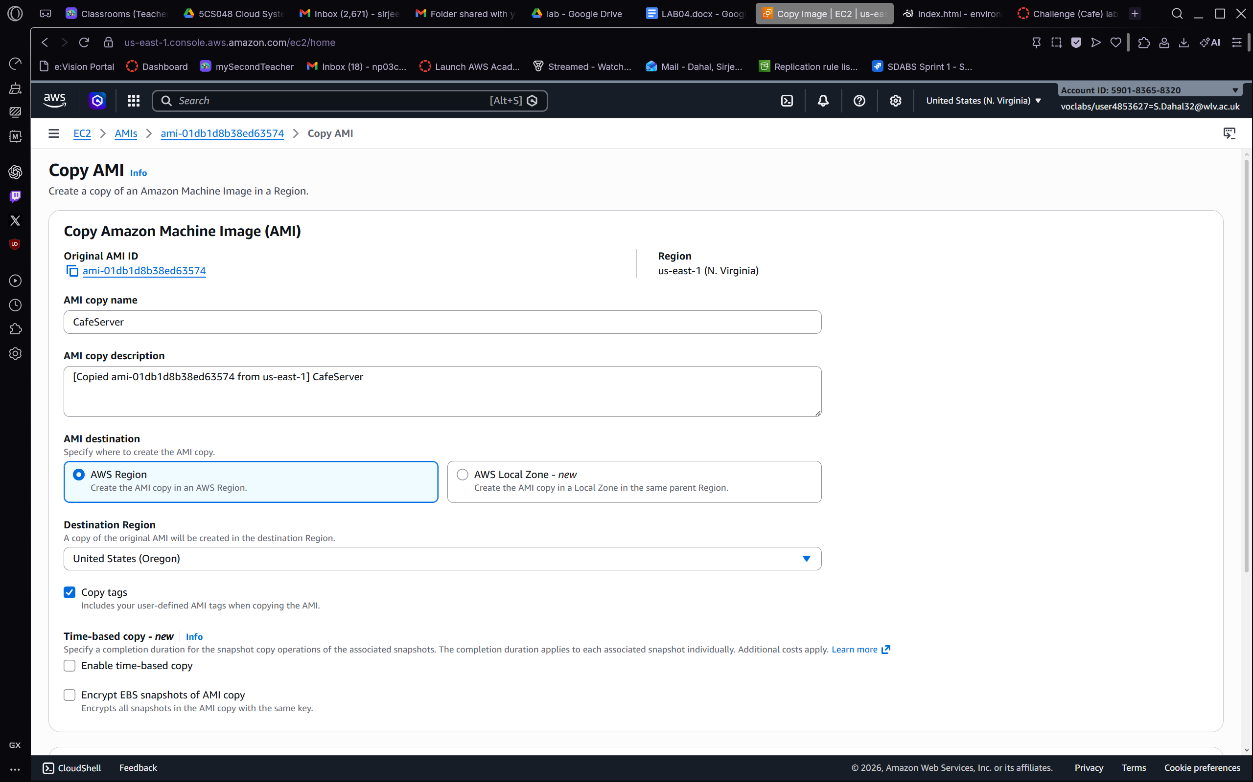
Figure 5.1 – We navigate to EC2 > AMIs in the AWS Management Console and confirm that the CafeServer AMI (ID ami-01db1d8b38ed63574) has been successfully created with a Status of Available. The AMI details panel below the list shows the AMI type as machine, Platform as Linux/UNIX, Architecture as x86_64, Root device type as EBS, and Owner account ID 590183658320. The creation date is shown as 2026-03-30. This Available status confirms that the AMI is ready to be copied to the Oregon Region and used to launch the production server.

Task 6: Copying the AMI to Another Region and Launching the Production Instance
Infrastructure as Code and AMI portability allow us to replicate the Café environment in a second AWS Region without manual reconfiguration. In this task we copy the CafeServer AMI to us-west-2 (Oregon), then launch the production EC2 instance from the copied image.

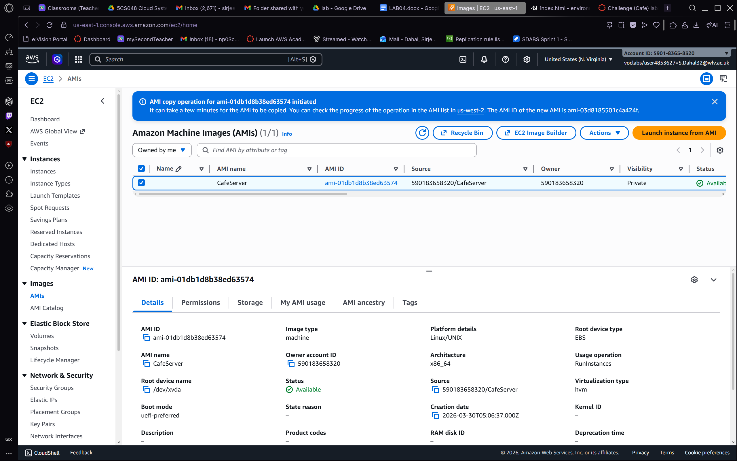
Figure 6.1 – We initiate an AMI copy on the EC2 > AMIs > Copy AMI page. The Original AMI ID (ami-01db1d8b38ed63574) and source Region (us-east-1, N. Virginia) are pre-filled. We set the AMI copy name to "CafeServer" and select United States (Oregon) as the Destination Region, then submit the copy request. The Copy tags option is enabled to carry any user-defined tags across Regions. This operation replicates the entire EBS snapshot to Oregon, enabling us to launch an identical production instance without repeating the LAMP configuration steps.
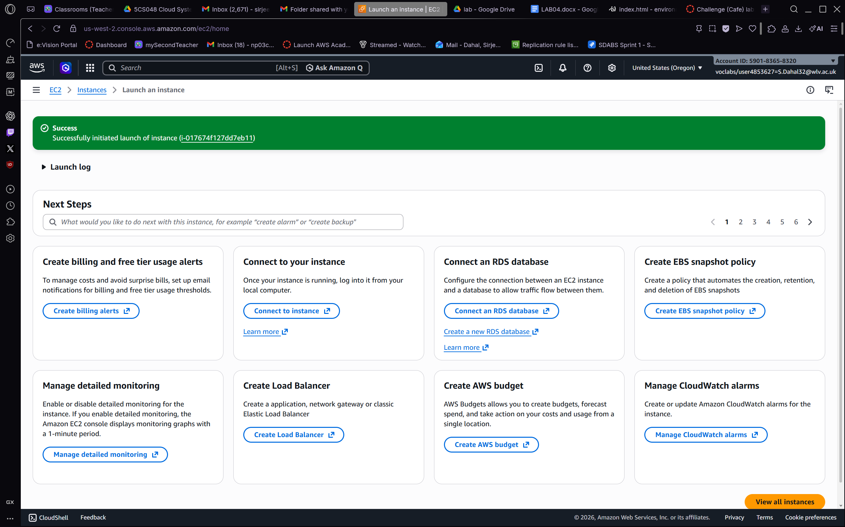
Figure 6.2 – After initiating the copy, the EC2 > AMIs page in the N. Virginia Region displays a blue confirmation banner stating that the AMI copy operation has been initiated, and that the new AMI ID in Oregon will be ami-0548b185501c4ea24f. The AMIs table shows the original CafeServer AMI (ami-01db1d8b38ed63574) with Status Available, Source 590183658520/CafeServer, and Owner 590183658520. This confirms that the copy is in progress and that the source AMI remains available for further use.
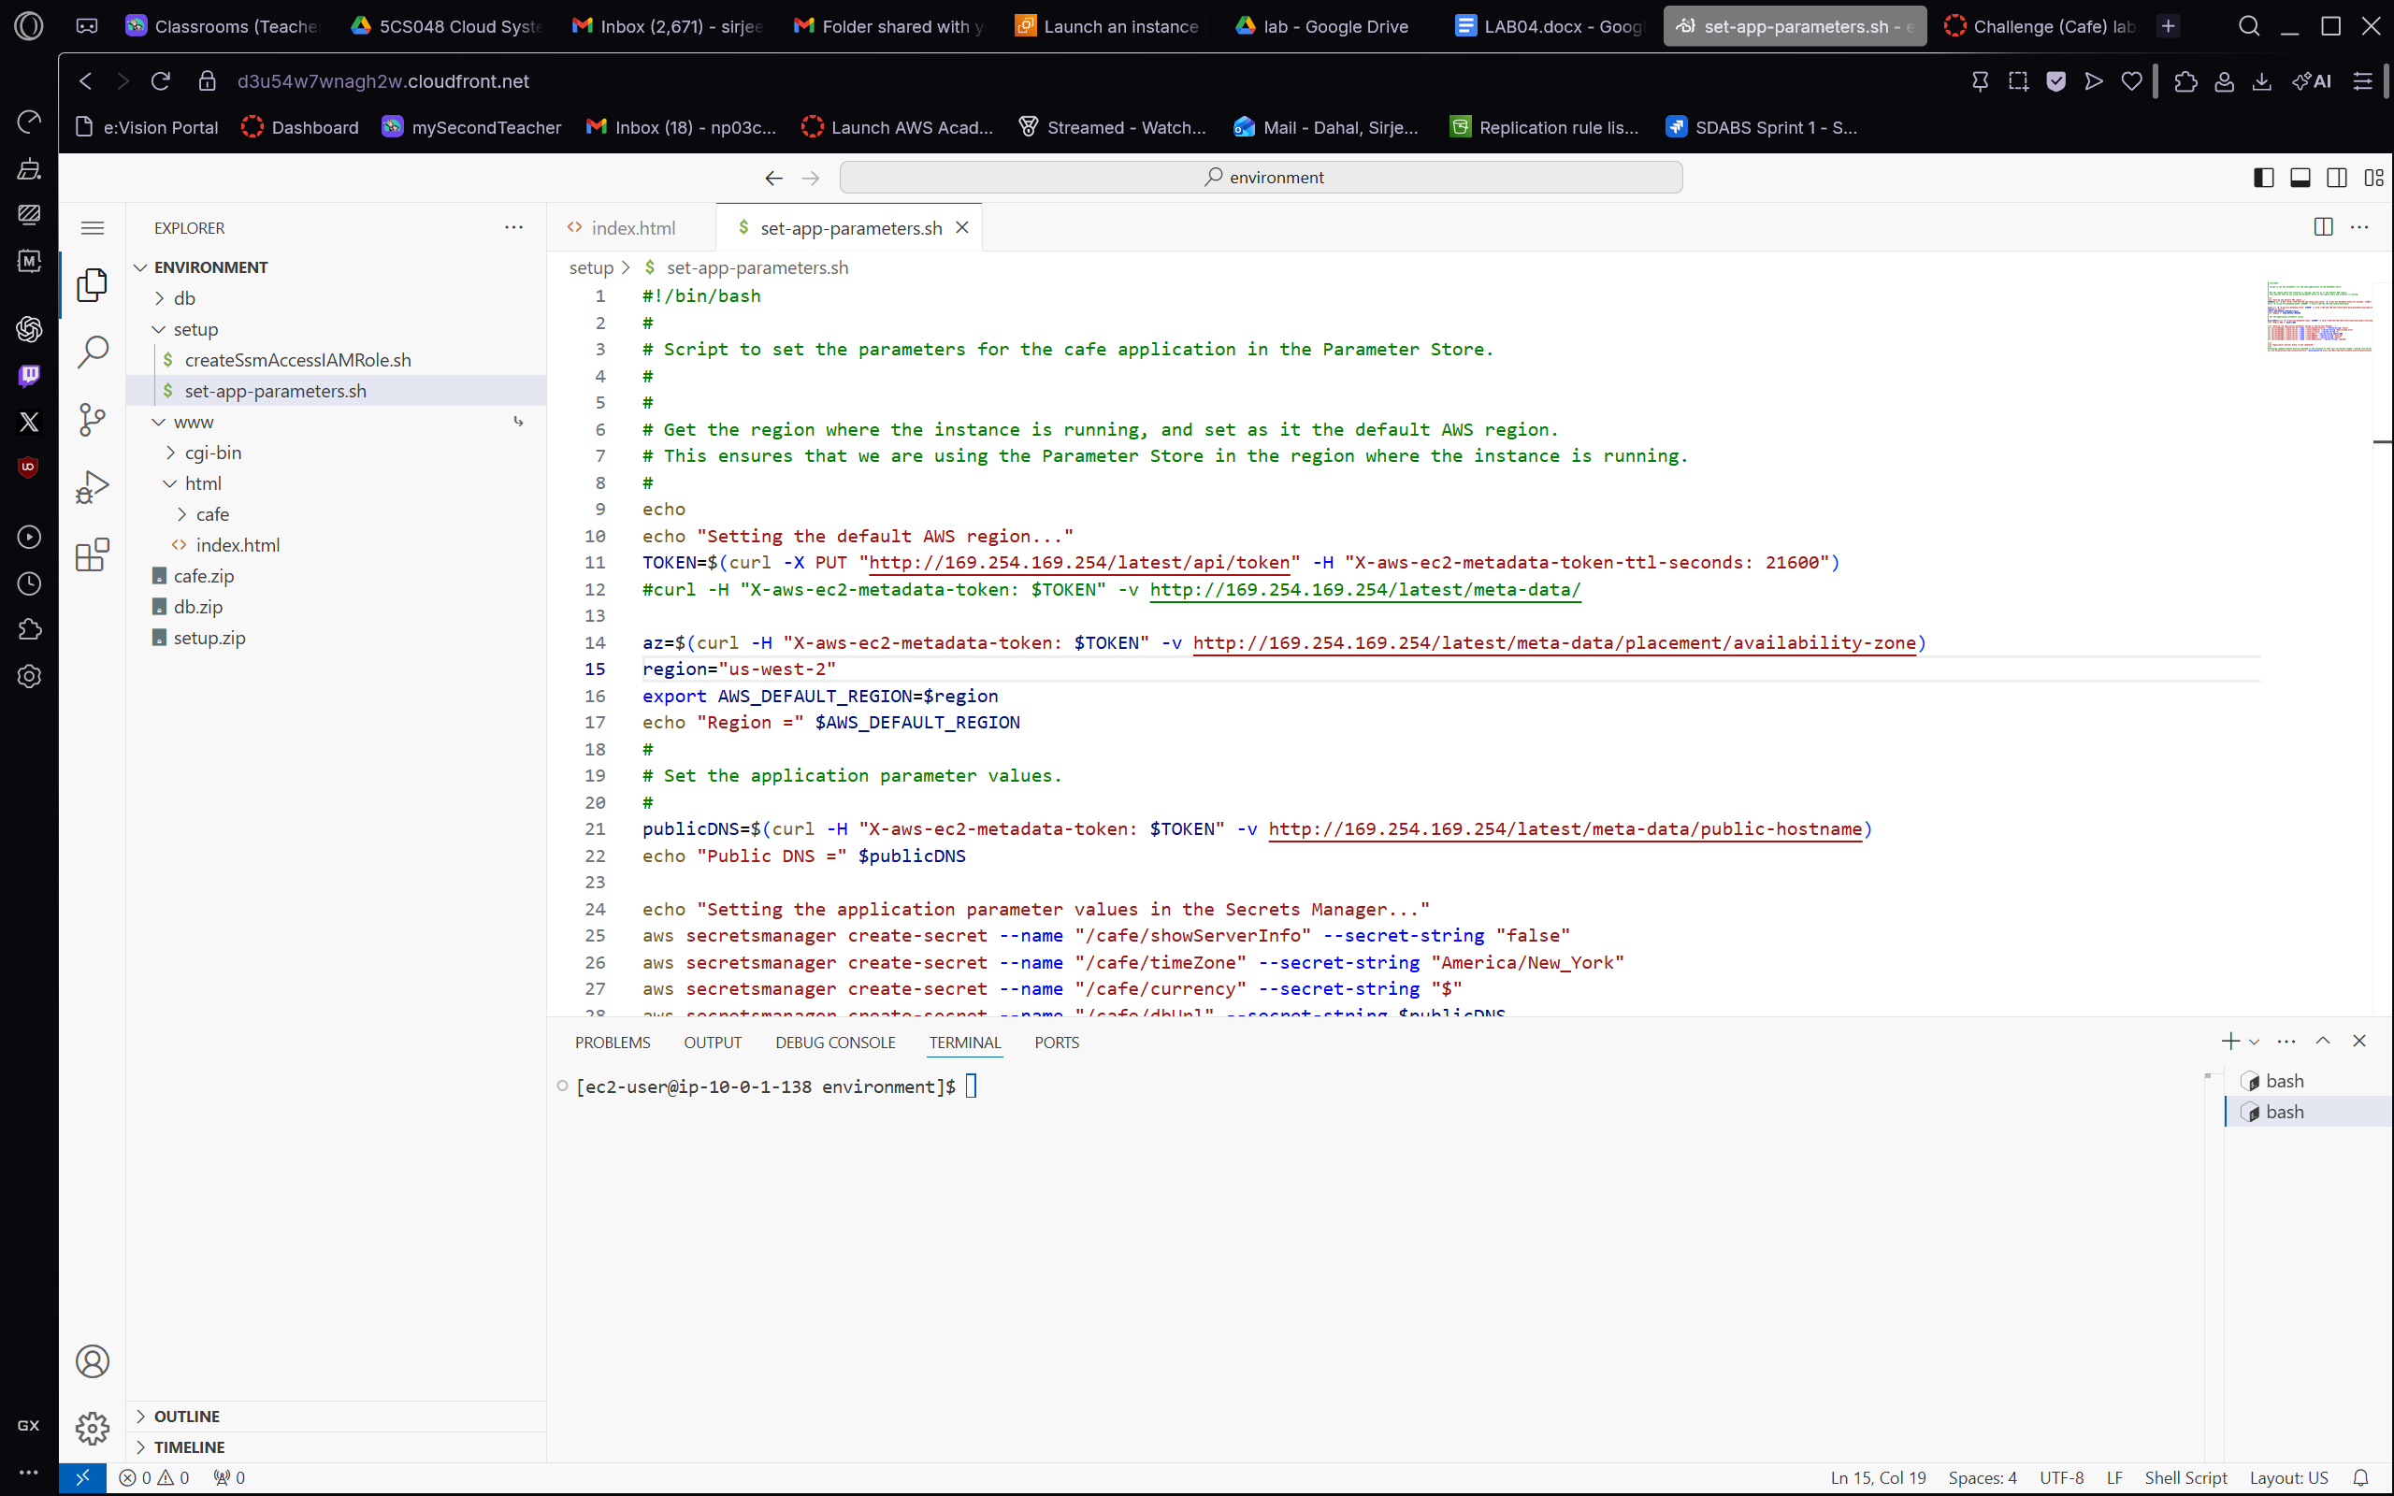
Figure 6.3 – We switch the AWS Management Console to the us-west-2 (Oregon) Region and navigate to EC2 > Instances > Launch an instance. The green success banner confirms that the launch of instance i-01767d4f127dd7eb11 has been successfully initiated. The Next Steps panel presents post-launch options, including connecting to the instance, creating billing alerts, connecting an RDS database, creating EBS snapshot policies, enabling detailed monitoring, creating a load balancer, and managing CloudWatch alarms. This confirms that the production EC2 instance is now running in the Oregon Region.
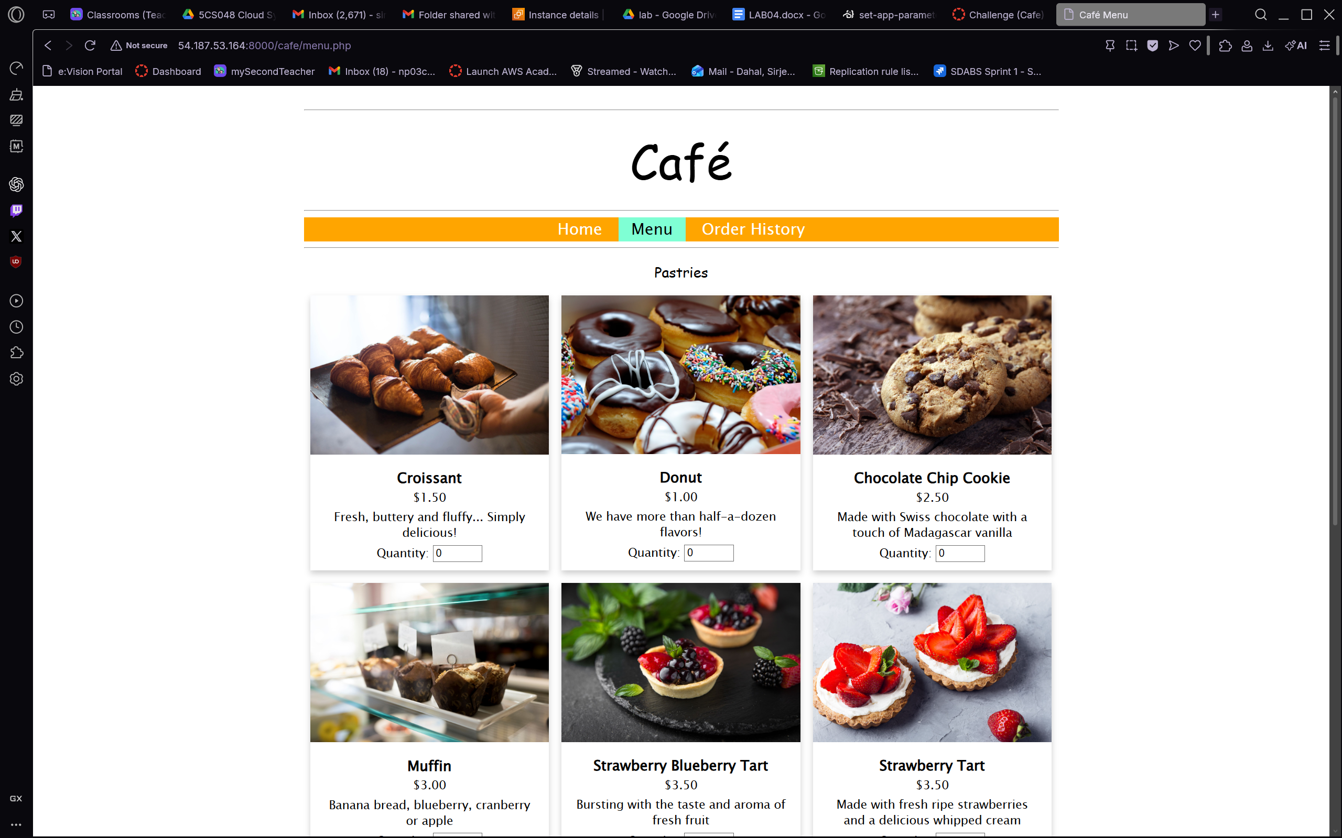
Figure 6.4 – We return to the VS Code IDE and open the set-app-parameters.sh script, which automates population of the Café application's secrets in AWS Secrets Manager for the Oregon Region. The script retrieves an EC2 instance metadata token, uses it to query the IMDSv2 metadata endpoint to determine the current Region (us-west-2), exports AWS_DEFAULT_REGION, and then creates multiple secrets in Secrets Manager including /cafe/showServerInfo, /cafe/timeZone, /cafe/currency, /cafe/dbUrl, /cafe/dbName, and /cafe/dbUser. This script ensures that the production instance in Oregon has all the required application parameters configured without manual intervention.

Task 7: Verifying the Production Website in the Second Region
With the production instance running in Oregon and all application parameters set, we verify the end-to-end functionality of the Café website in the second Region to confirm that the AMI copy and parameter configuration were successful.

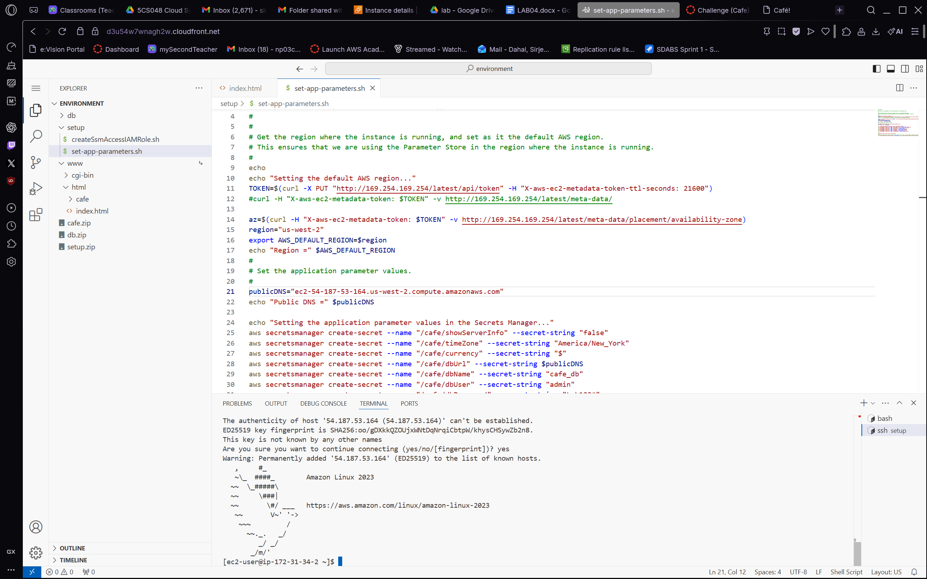
Figure 7.1 – We open the Café menu page in a browser by navigating to the Oregon production instance's public IP on port 8000. The Pastries menu section renders correctly, displaying six items with images, descriptions, and quantity fields: Croissant ($1.50), Donut ($1.00), Chocolate Chip Cookie ($2.50), Muffin ($3.00), Strawberry Blueberry Tart ($3.50), and Strawberry Tart ($3.50). The orange navigation bar (Home, Menu, Order History) is visible, confirming that the dynamic PHP application is fully functional in the Oregon Region. This validates the portability of our AMI-based deployment approach.
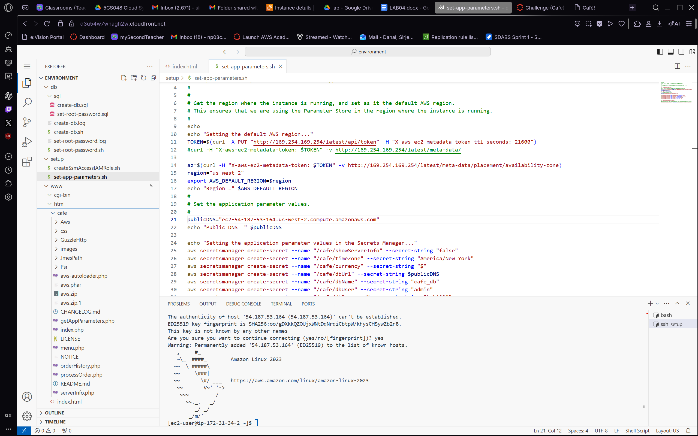
Figure 7.2 – We switch back to the VS Code IDE, which now shows the fully expanded Café application file structure in the Explorer panel, including the db, cgi-bin, www, cafe, Psr, Guide, images, XmlPath, and Py directories alongside key PHP files such as index.php, menu.php, processOrder.php, and aws-autoloader.php. The set-app-parameters.sh script remains open in the editor, showing the complete Oregon Region parameter setup including the public DNS resolution and all seven Secrets Manager create-secret commands. The terminal at the bottom confirms an SSH connection to the Oregon production instance (ec2-user@172-31-34-2), verifying that the production server is reachable and properly configured.
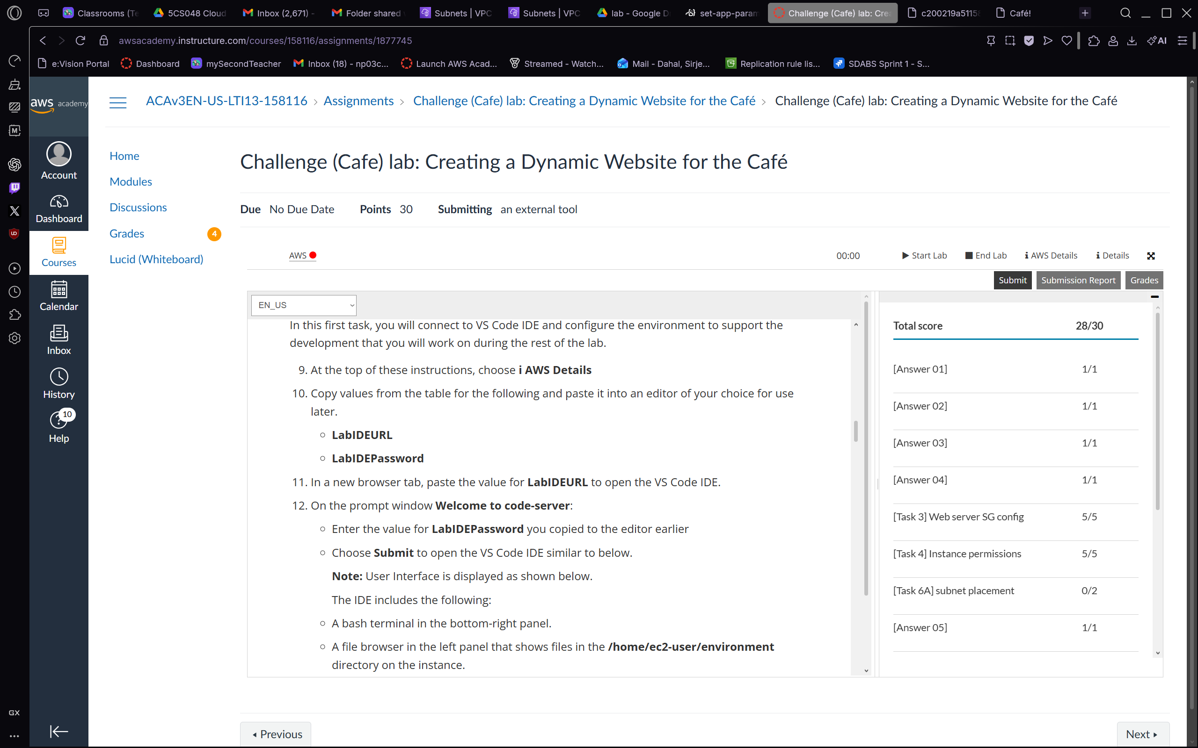
Figure 7.3 – As a final confirmation, we navigate to the AWS Academy assignment page for the Challenge (Cafe) lab: Creating a Dynamic Website for the Café. The Grades panel on the right shows a Total score of 28/30, with all answer and task components graded: Answer 01–05 each scored 1/1, Task 3 Web server SG config scored 5/5, Task 4 Instance permissions scored 5/5, and Task 6A subnet placement scored 0/2. This submission report confirms that the lab objectives were met and the graded evidence has been recorded in the AWS Academy learning management system.

Conclusion
Throughout this challenge lab, we deployed a fully dynamic Café web application on AWS using a well-structured LAMP stack. We began by connecting to a browser-based VS Code IDE, verifying the EC2 environment, and configuring Apache to serve on port 8000. We then installed MariaDB, deployed the PHP application code, and confirmed end-to-end order placement functionality through the browser.
From a security perspective, we used AWS Secrets Manager to store all sensitive database credentials (passwords, usernames, connection strings) as encrypted secrets rather than hardcoding them in configuration files. The IAM instance profile (CafeRole) provided the EC2 instance with the minimum permissions necessary to retrieve those secrets at runtime, adhering to the principle of least privilege.
For reliability and portability, we created a CafeServer AMI capturing the fully configured instance state, then copied it to a second AWS Region (us-west-2, Oregon) and launched an identical production instance from it. This demonstrates that the entire application stack can be replicated in a new Region without manual reconfiguration, supporting rapid disaster recovery and geographic redundancy.
One challenge encountered was the initial "command not found" error when attempting to use the sed command to update the Apache port configuration. This was resolved by using the correct absolute path and sudo prefix for the system sed binary. Overall, the exercise reinforced the value of AMI-based deployments, cloud-native secret management, and IAM role-based access control in building secure, reproducible cloud infrastructure.

