FINDTHATSHIT
MVP Senior Technical Documentation
Architecture • Requirements • APIs • Data Model • Security • HLD • LLD

Document Attribute | Value
Document type | Senior Technical Design / MVP Engineering Brief
Product | FindThatShit — AI-Powered Social Resource Library
Target load | 100 concurrent users; 500 daily active users minimum
Architecture | Modular monolith + asynchronous workers
Backend | Python / Django / Django REST Framework
Frontend | React / TypeScript / Vite / Tailwind CSS
Data | PostgreSQL + pgvector
Object storage | Amazon S3
Queue | Redis + Celery
Version | 1.0
Source basis: Product Brief & SOW. The SOW defines the MVP around saving a resource, understanding it with AI, organizing it, and finding it later; it also requires asynchronous processing, PostgreSQL, S3, semantic-search readiness, and a voice-search foundation. fileciteturn0file0L26-L29 fileciteturn0file0L194-L205
Design position: the MVP should remain a modular monolith. Go is intentionally not required for the first production release; a future Go service can be introduced behind a stable service boundary if high-volume ingestion, webhook processing, or other concurrency-heavy workloads justify it.

1. Introduction

1.1 Purpose
- Define the production-ready MVP architecture, implementation boundaries, database schema, API surface, security controls, processing model, and deployment approach.
- Provide a concrete engineering baseline that supports at least 100 concurrent users and 500 daily users without introducing premature microservice complexity.
- Preserve architectural seams for future semantic retrieval, voice interaction, mobile share flows, and official platform integrations.

1.2 Scope
- In scope: authentication, private resource library, source/resource capture, document upload, S3 storage, AI enrichment, asynchronous processing, keyword search, semantic-search foundation, resource detail, secure retrieval, operational status, and observability.
- Out of scope: automatic Instagram/X login, follows, likes, comments, DMs, inbox reading, unofficial browser automation, temporary/proxy accounts, and fully automated social-media claiming.
- The source SOW explicitly places these social automation capabilities outside MVP scope. fileciteturn0file0L275-L290

1.3 Audience
- Senior engineers and developers implementing the platform.
- Technical leads reviewing architecture and tradeoffs.
- QA/automation engineers defining functional and non-functional tests.
- DevOps engineers deploying and operating the MVP.
- Product stakeholders validating scope against the SOW.

2. System Overview

2.1 Architecture
The MVP uses a modular-monolith application API with asynchronous Python workers. User-facing requests remain short and transactional; expensive extraction, transcription, LLM, embedding, and indexing work is executed through the queue.
- Web client: React/TypeScript SPA communicates with the API over HTTPS.
- API: Django/DRF owns authentication, authorization, CRUD, search orchestration, upload authorization, and resource lifecycle.
- PostgreSQL is the system of record for users, resources, source content, tags, jobs, files, and embeddings.
- S3 stores uploaded binaries; PostgreSQL stores object keys and metadata.
- Redis/Celery provides durable-enough asynchronous execution for the MVP; jobs are idempotent and retryable.
- AI provider calls are isolated behind application interfaces so providers can be replaced without changing resource-domain code.

2.2 Technologies Used
Layer | Technology | MVP rationale
Frontend | React + TypeScript + Vite | Fast, typed SPA development
UI | Tailwind CSS | Consistent responsive UI with low styling overhead
API | Django + DRF | Auth, ORM, admin, validation and REST APIs
Database | PostgreSQL | Transactional relational system of record
Vector | pgvector | Semantic-search foundation without a second database
Async | Celery + Redis | Background processing and retries
Storage | Amazon S3 | Scalable object storage
AI | LLM + embeddings | Summaries, metadata, tags and semantic retrieval
Speech | Gnani STT | Reel transcription / future voice query path
Deployment | Docker + AWS | Repeatable deployment and managed infrastructure

2.3 Dependencies
- External: LLM provider, embedding provider, Gnani STT, Amazon S3.
- Runtime: PostgreSQL 15+ recommended, Redis 7+ recommended, Python 3.12+ recommended, Node.js 20+ recommended.
- Operational: DNS/TLS, secrets manager or encrypted environment configuration, centralized error logging, database backups.

3. Installation Guide

3.1 Prerequisites
- Docker and Docker Compose for local development.
- Python 3.12+ and Node.js 20+ if running services directly.
- PostgreSQL client tools for migrations/diagnostics.
- AWS account with S3 bucket and least-privilege credentials or workload identity.
- Credentials for the selected LLM/embedding provider and Gnani STT.

3.2 System Requirements
Component | MVP baseline | Notes
API | 2 vCPU / 2–4 GB RAM | Stateless; horizontal replicas supported
Worker | 2 vCPU / 4 GB RAM | Scale independently for AI/document load
PostgreSQL | 2 vCPU / 4–8 GB RAM | Managed service preferred
Redis | 1 vCPU / 1–2 GB RAM | Managed Redis preferred
S3 | Managed | No local persistence
Browser | Modern Chromium/Firefox/Safari | HTTPS required in production

3.3 Installation Steps
- Clone the repository and copy the environment template to the local configuration file.
- Start PostgreSQL, Redis and the API dependencies with Docker Compose.
- Create the Django database schema with migrations.
- Create the initial administrative user.
- Create the S3 bucket and configure CORS for the web origin.
- Start the Django API and Celery worker.
- Start the React/Vite frontend.
- Run unit, integration and smoke tests before using the local environment.
The exact command names should be captured in the repository README and CI workflow; this document defines the deployment contract rather than prescribing one shell-script implementation.

4. Configuration Guide

4.1 Configuration Parameters
Parameter group | Examples | Rule
Application | APP_ENV, DEBUG, ALLOWED_HOSTS | DEBUG false outside local development
Database | DATABASE_URL | TLS/encrypted connection in production
Auth | JWT/secure cookie settings, token TTL | Short-lived access; revocable refresh/session strategy
S3 | bucket, region, prefix | Private bucket; signed access only
Queue | REDIS_URL, worker concurrency | No user data in queue payloads; use IDs
AI | LLM key, model, embedding model | Secrets never committed
STT | Gnani endpoint/key | Timeout + retry + provider error mapping
Security | CORS, CSRF, rate limits | Explicit allow-list; no wildcard production CORS

4.2 Environment Setup
- Separate local, test, staging and production configuration.
- Store secrets in AWS Secrets Manager/Parameter Store or an equivalent secret manager.
- Use separate S3 buckets or prefixes and separate databases for staging/production.
- Disable debug tooling and verbose SQL logging in production.
- Use UTC for persistence and convert to user locale only at presentation.

4.3 External Services Integration
- S3: generate presigned upload/download URLs; never expose bucket credentials to browsers.
- LLM: submit normalized source/resource text with structured output requirements; validate returned JSON before persistence.
- Embeddings: generate only after normalized content exists; persist model/version metadata.
- Gnani STT: invoke only when source audio is technically available; failures must not invalidate an otherwise valid resource.
- All external calls require bounded timeouts, retry policy, error classification, and observability.

5. Usage Guide

5.1 User Interface Overview
- Dashboard: searchable list/grid of private resources with status, source, creator, tags and date.
- Add Entry: source type, source URL, optional creator, external resource URL or upload, optional title/tags.
- Resource Detail: source metadata, source content/transcript, resource metadata, AI output, processing status and actions.
- Search: keyword/metadata search in MVP; semantic retrieval foundation is stored with the resource.

5.2 User Authentication
- User registers and signs in over HTTPS.
- Every resource query is scoped to the authenticated user.
- Authorization is enforced server-side; UI hiding is not a security boundary.
- Logout/revocation invalidates active sessions according to the selected token/session strategy.

5.3 Core Functionality
- User discovers a resource on Instagram, X/Twitter or another platform.
- User independently completes any required follow/comment/like/DM action.
- User opens Add Entry and records source and resource information.
- The API creates the resource and returns immediately with processing status.
- Uploaded files are stored in S3; URLs are stored as references.
- A background worker extracts content, performs STT where applicable, calls the LLM, creates metadata and embeddings, then marks the resource processed.
- The resource becomes searchable and retrievable.

5.4 Advanced Features
- Semantic retrieval can be enabled once embeddings and hybrid ranking are populated.
- Voice UI should feed transcription into the same query service rather than creating a second search path.
- Future mobile share-sheet and official platform integrations should create the same normalized Resource model.

5.5 Troubleshooting
- Processing stuck: inspect processing_jobs, worker health and queue depth.
- Upload unavailable: verify S3 presigned URL, bucket policy, CORS and object existence.
- AI failure: inspect provider error class and retryable flag; do not duplicate the resource.
- Search missing result: verify resource status, extracted content, embedding status and user ownership filter.
- Concurrent update conflict: API returns 409 and client refreshes the latest resource version.

6. API Documentation

6.1 Endpoints
Method | Endpoint | Purpose | Auth
POST | /api/v1/auth/register | Create account | Public
POST | /api/v1/auth/login | Create session/token | Public
POST | /api/v1/auth/logout | Revoke session | User
GET | /api/v1/me | Current user | User
GET | /api/v1/resources | List/search resources | User
POST | /api/v1/resources | Create resource entry | User
GET | /api/v1/resources/{id} | Get detail | Owner
PATCH | /api/v1/resources/{id} | Update metadata | Owner
DELETE | /api/v1/resources/{id} | Delete resource | Owner
POST | /api/v1/resources/{id}/upload-url | Create S3 upload URL | Owner
POST | /api/v1/resources/{id}/process | Queue/requeue processing | Owner
GET | /api/v1/resources/{id}/status | Processing status | Owner
GET | /api/v1/search | Keyword/semantic search | User
GET | /api/v1/tags | List user/available tags | User
POST | /api/v1/resources/{id}/tags | Attach tag | Owner
DELETE | /api/v1/resources/{id}/tags/{tag_id} | Remove tag | Owner
GET | /api/v1/resources/{id}/download-url | Secure file URL | Owner

6.2 Request and Response Formats
JSON is used for application requests/responses. File bytes are uploaded directly to S3 using a presigned URL. API responses include a stable resource id, status, timestamps and a version field for optimistic concurrency.
Operation | Key request fields | Response contract
Create resource | source_type, source_url, creator, resource_url/file metadata, title/tags | 201 + resource + processing_status
Update resource | title, creator, tags, version | 200 + updated resource/version
Search | q, filters, page, limit, mode=keyword|semantic|hybrid | 200 + ranked results
Upload URL | filename, mime_type, size | 200 + signed URL + object key
Process | optional force flag | 202 + job/status

6.3 Authentication and Authorization
- Use HTTPS-only transport.
- Authenticate every private endpoint.
- Authorize resource access by user_id ownership at query level and object level.
- Use request IDs for tracing and idempotency keys for create/queue operations.
- Return 401 for missing/invalid authentication, 403 for authenticated but unauthorized actions, 404 where resource existence should not be disclosed, and 409 for version/idempotency conflicts.

7. Database Schema

7.1 Entity-Relationship Diagram
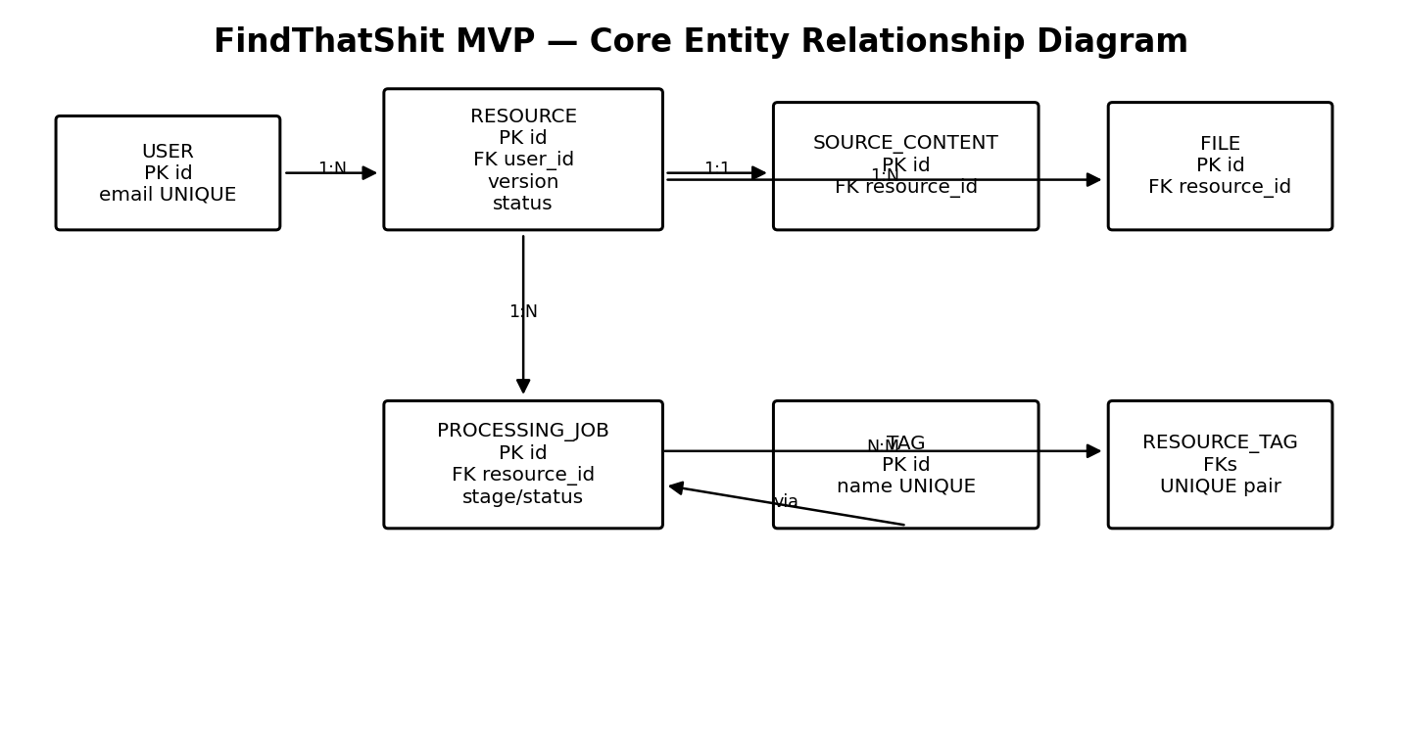
Figure 7-1. Core MVP ERD

7.2 Table Definitions
Table | Core fields | Indexes / constraints
users | id UUID, email, name, password_hash/auth fields, created_at, updated_at | PK; email UNIQUE
resources | id UUID, user_id, title, creator, platform, source_url, resource_url, resource_type, description, date_added, processing_status, version, created_at, updated_at | PK; FK user; index(user_id, created_at); version check
source_contents | id UUID, resource_id, source_type, transcript, post_text, extracted_metadata, created_at, updated_at | PK; UNIQUE resource_id
files | id UUID, resource_id, s3_object_key, filename, mime_type, file_size, checksum, created_at | PK; UNIQUE s3_object_key; FK resource
tags | id UUID, user_id nullable, name, normalized_name, created_at | PK; unique(user_id, normalized_name)
resource_tags | resource_id, tag_id, created_at | PK(resource_id,tag_id); FKs
embeddings | id UUID, resource_id, vector, model, content_hash, created_at | PK; index/vector index as scale requires
processing_jobs | id UUID, resource_id, stage, status, attempt, idempotency_key, error_code, error_message, started_at, completed_at, created_at, updated_at | PK; unique(idempotency_key); index(status, created_at)
audit_events | id UUID, user_id, resource_id nullable, action, request_id, metadata, created_at | PK; index(user_id, created_at)

7.3 Relationships and Constraints
- One user owns many resources; resource ownership is never inferred from client input.
- One resource has one logical source_content record and zero or more files, tags, embeddings and processing jobs.
- Foreign keys use RESTRICT/CASCADE intentionally: deleting a resource may cascade only to resource-owned metadata/jobs/files; user deletion should be a controlled account lifecycle operation.
- Use CHECK constraints for enum-like statuses where practical and validate business rules in the service layer.
- Use UTC timestamps, UUID primary keys, NOT NULL where the domain requires values, and explicit maximum lengths.
- Use database uniqueness for idempotency and conflict prevention; application checks alone are insufficient under concurrency.

7.4 Concurrent Read/Write and Conflict Avoidance
- Optimistic locking: resources include integer version; UPDATE requires the expected version. If zero rows update, return HTTP 409.
- Atomic transactions: resource creation, tag changes and job state transitions use transaction.atomic() boundaries.
- Pessimistic locking only for short critical sections such as claiming a processing job; use SELECT ... FOR UPDATE SKIP LOCKED to prevent two workers claiming the same pending job.
- Idempotency: POST resource/process operations accept an Idempotency-Key; the server persists the key and resulting object/job reference.
- Queue payloads contain IDs, not full mutable objects, so workers reload the latest committed state.
- Unique constraints prevent duplicate tags, duplicate resource-tag pairs, duplicate S3 object keys and duplicate job idempotency keys.
- User-scoped indexes and queries keep concurrent reads efficient and prevent accidental cross-user scans.
- Use database transactions rather than distributed locks for normal resource CRUD.
- Never use a shared mutable in-memory cache as the source of truth.

7.5 Performance Baseline
- 100 concurrent users is a modest load for a stateless Django API when AI/file work is removed from request paths.
- 500 daily users should be comfortably supported with a small API replica set and independently scalable workers.
- Target API p95 below 500 ms for ordinary CRUD/search requests excluding external AI/file operations; measure rather than treat this as a hard SLO.
- Paginate all list/search endpoints; default page size 20–50 and enforce a maximum.
- Use connection pooling and indexed ownership/status/date fields.
- Load-test at 100 concurrent sessions with mixed reads/writes before production release.

8. Testing

8.1 Test Plan
- Unit: domain services, validators, ranking, state transitions and provider adapters.
- Integration: PostgreSQL transactions, S3 presigned flow, Redis/Celery, authentication and API permissions.
- Contract: stable JSON schemas and error responses.
- End-to-end: register → add resource → upload → process → search → retrieve.
- Security: authorization bypass, object access, rate limits, malicious uploads, injection payloads, token/session abuse.
- Concurrency: simultaneous edits, duplicate submissions, duplicate job claims, repeated webhooks/requests.
- Performance: 100 concurrent users and representative 500-user/day traffic.

8.2 Test Cases
ID | Scenario | Expected result
TC-01 | Two users create resources concurrently | Both commit; no cross-user data
TC-02 | Two updates use same resource version | One succeeds; other receives 409
TC-03 | Same idempotency key submitted twice | One resource; second returns original result
TC-04 | Two workers claim same job | Only one worker processes the claim
TC-05 | User requests another user's resource | 404/403 per security policy; no data leak
TC-06 | Invalid file type/oversize | Rejected before processing
TC-07 | STT timeout | Job retries or fails recoverably; resource remains usable
TC-08 | LLM malformed response | Validation fails; retry/error recorded
TC-09 | Search during processing | Resource can appear with status; processed fields absent until committed
TC-10 | S3 object missing | Secure retrieval reports recoverable storage error

8.3 Test Results
Baseline result is to be recorded by CI and release testing. This document defines acceptance gates, not fabricated execution results. Production readiness requires passing functional tests plus the 100-concurrent-user load scenario.

9. Deployment

9.1 Deployment Process
- Merge reviewed code to the protected main branch.
- CI runs lint, type checks, unit tests, integration tests and build validation.
- Build immutable frontend/API/worker Docker images.
- Run database migrations in a controlled deployment step.
- Deploy API and workers independently but from the same release version.
- Run smoke tests against health endpoints and a synthetic resource flow.
- Monitor error rate, queue depth, worker failures, database connections and latency.
- Rollback application images if required; database migrations must be backward-compatible where rollback is possible.

9.2 Release Notes
- v1.0 — MVP architecture and implementation baseline.
- Initial release includes the SOW-defined resource library workflow, asynchronous AI processing, S3 storage, search foundation and secure private access.
- Voice interaction is architecture-ready but not a dependency for the core MVP workflow.

9.3 Known Issues and Limitations
- External social-platform content may be unavailable or incomplete; the user remains responsible for providing the source/resource.
- Reel transcription depends on technically available audio/source content.
- AI output quality varies by provider/model and source quality; generated metadata is not treated as authoritative facts.
- Semantic ranking quality must be tuned with real user retrieval data.
- The MVP intentionally avoids unofficial social automation and platform account control.

10. Support and Maintenance

10.1 Troubleshooting Guide
Symptom | Primary checks | Resolution
API 5xx | application logs, request_id, DB connectivity | Rollback/fix provider or database fault
Queue backlog | Redis health, worker count, provider latency | Scale workers or inspect retry storm
Repeated job failures | processing_jobs.error_code/error_message | Fix provider/input and requeue
Slow search | query plan, indexes, result size | Add/adjust indexes; paginate; optimize ranking
Unauthorized resource | user_id filter, permission tests | Fix object-level authorization
File inaccessible | S3 key, bucket policy, signed URL expiry | Regenerate URL; verify object

10.2 Frequently Asked Questions (FAQs)
- Why not Go in MVP? The dominant workload is AI/content processing and product iteration, where Python provides the stronger ecosystem and development velocity.
- Can Go be added later? Yes. Introduce it only behind a clear boundary such as high-volume ingestion or webhook processing.
- Why PostgreSQL for vectors? It keeps relational metadata and semantic representations together and avoids premature operational complexity.
- Why async processing? Extraction, STT and LLM calls are slow and failure-prone compared with normal API CRUD.
- What is the product success criterion? The ability to retrieve a saved resource from what the user remembers, not merely the number of saved resources. fileciteturn0file0L365-L379

10.3 Contact Information
- Engineering owner: project engineering team.
- Production incidents: use the project's incident channel/on-call process.
- Architecture changes: require technical review and an update to this document/change log.

11. Change Log

11.1 Version History
Version | Date | Owner | Summary
1.0 | 2026-11-06 | Engineering | Initial senior technical MVP brief based on the Product Brief & SOW

11.2 Change Summary
- Confirmed modular-monolith MVP.
- Confirmed React/TypeScript/Django/PostgreSQL/S3/Redis/Celery stack.
- Defined concurrency controls: optimistic locking, idempotency, unique constraints and short pessimistic locks for job claiming.
- Defined MVP API surface, schema, security model, processing states and deployment/testing requirements.
- Added HLD and LLD diagrams for implementation alignment.

12. Glossary

12.1 Terms and Definitions
Term | Definition
Resource | The saved external URL or uploaded document plus its contextual metadata.
Source | The Instagram/X/other post or reel from which the resource was discovered.
Source Content | Transcript, post text and extracted source metadata.
Semantic Retrieval | Finding resources by meaning rather than exact keyword matches.
Embedding | Vector representation of normalized content used for semantic similarity.
Hybrid Search | Combination of conventional keyword/metadata search and vector similarity.
Processing Job | A retryable background task that enriches a resource.
Idempotency Key | Client-provided key ensuring repeated requests do not create duplicate effects.
Optimistic Locking | Version-based conflict detection for concurrent updates.
Presigned URL | Time-limited S3 URL allowing controlled browser access without exposing AWS credentials.
HLD | High-Level Design: system components and major data/control flows.
LLD | Low-Level Design: implementation-level modules, operations, transactions and sequences.

13. High-Level and Low-Level Design

13.1 HLD — System Context
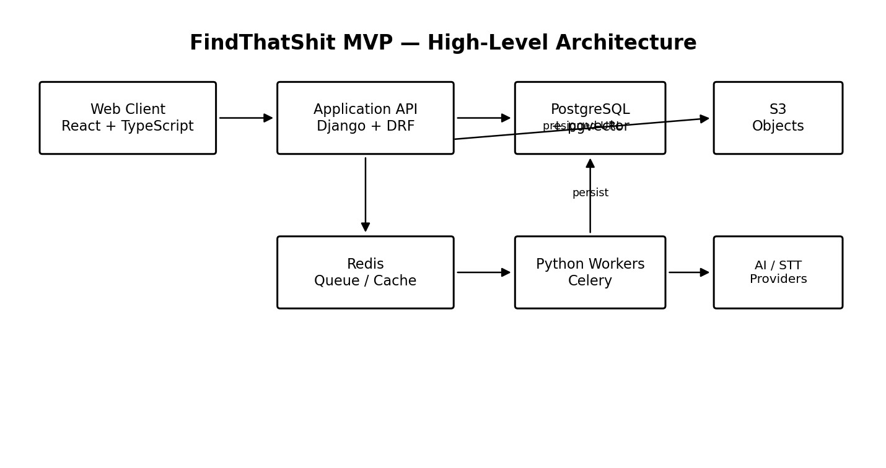
Figure 13-1. MVP high-level architecture

13.2 HLD — Component Responsibilities
Component | Responsibility | Scaling boundary
React Web | UI, form validation, search, upload initiation, status display | CDN/static hosting
Django API | Auth, CRUD, authorization, search orchestration, signed URL creation | Horizontal replicas
PostgreSQL | Transactional state, search metadata, vectors | Vertical first; read replicas later if required
S3 | Binary resource storage | Managed
Redis | Queue/cache coordination | Managed scaling
Celery workers | Extraction, STT, LLM, embeddings, retries | Horizontal worker scaling
AI/STT providers | External inference/transcription | Provider limits and retries

13.3 HLD — Security Boundaries
- Internet → TLS → API/WAF/load balancer boundary.
- API → private PostgreSQL/Redis/S3 service boundary.
- Browser → S3 only through scoped, short-lived presigned URLs.
- Worker → external AI providers through outbound HTTPS with secret-managed credentials.
- Every resource operation is constrained by authenticated user ownership.

13.4 LLD — Resource Creation and Processing
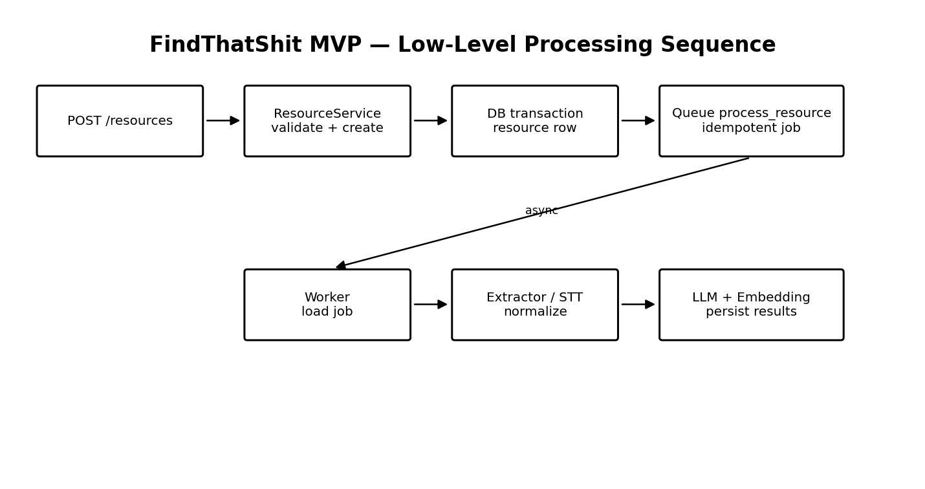
Figure 13-2. Low-level asynchronous processing sequence

13.5 LLD — Transaction and Concurrency Rules
- Create resource: validate input → begin transaction → insert resource → insert idempotency record if applicable → commit → enqueue job after commit.
- Update resource: require current version → UPDATE ... WHERE id AND version → increment version atomically → if row count is zero, return 409.
- Job claim: transaction + SELECT FOR UPDATE SKIP LOCKED → mark job RUNNING → commit → perform external work outside transaction.
- Job completion: transaction → persist extracted/AI fields and embedding → mark stage/status → increment resource version if the resource representation changed → commit.
- Retry: only retry explicitly retryable errors; exponential backoff with bounded attempts; dead-letter/failed status after exhaustion.
- Delete: authorize owner → transactionally mark/delete resource metadata → remove S3 object asynchronously after database commit.
- Search: always apply user ownership predicate before ranking; paginate results and cap query size.

13.6 LLD — API Layering
- View/controller: authentication, request parsing, serializer validation, response mapping.
- Application service: resource use cases and transaction boundaries.
- Repository/query layer: optimized ORM queries and ownership predicates.
- Provider adapters: S3, LLM, embeddings and STT interfaces.
- Worker task: orchestration only; domain logic remains reusable/testable outside Celery.
- Domain model: resource lifecycle, processing state transitions, concurrency rules and validation.

13.7 LLD — MVP Design Decisions
- No direct AI provider calls from HTTP controllers.
- No binary file storage in PostgreSQL.
- No cross-user shared resource records in MVP.
- No distributed locking service for ordinary CRUD.
- No dedicated search/vector database until measurements demonstrate PostgreSQL is insufficient.
- No Go service until a measured workload or integration boundary justifies it.
- All future ingestion paths normalize into the same Resource/SourceContent/File/ProcessingJob model.
End of technical documentation. The implementation should treat the Product Brief & SOW as the scope authority and this document as the MVP engineering baseline. The SOW's acceptance criteria require private libraries, supported source/resource capture, secure S3 retrieval, asynchronous processing, AI metadata generation, searchable content and an architecture that can evolve toward semantic and voice retrieval. fileciteturn0file0L338-L361

