//When the user chooses option 1 and add a product in Clothing section
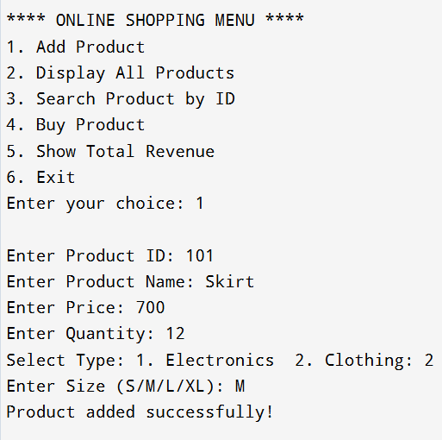

//When the user chooses option 1 and add a product in Electronics section
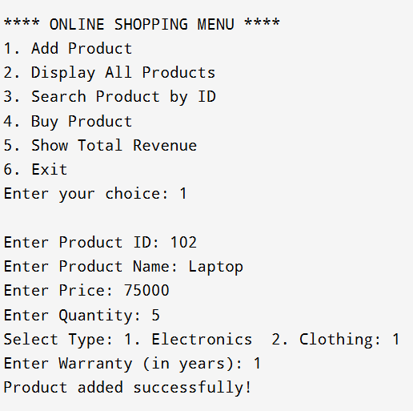
//When the user chooses option 2 and the products are displayed on the screen
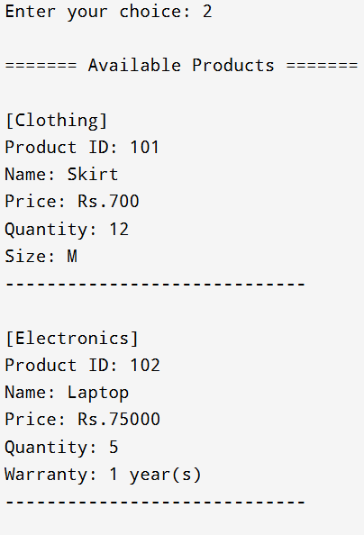
//When the user chooses option 3 and search for a product using product ID
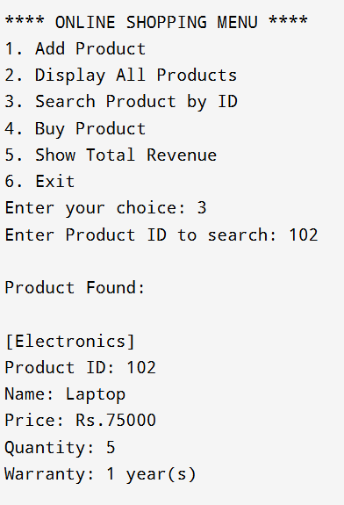

//When the user chooses option 4 to buy a product
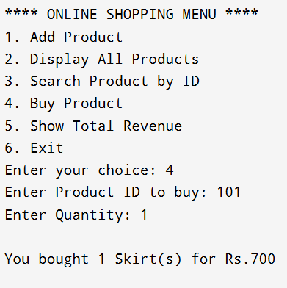
//When the user chooses option 5 to show total revenue
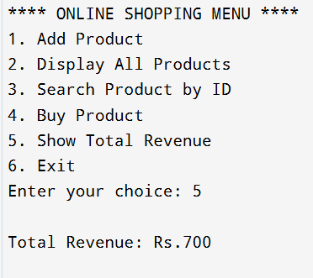

//When user wants to exit they can use option 6
