KIIT UNIVERSITY

School of Computer Engineering

SAP ERP Project Report

Procure-to-Pay (P2P)

Full Purchasing Cycle in SAP MM

Fictitious Company: VendorBridge Logistics Pvt. Ltd.
Third-Party Logistics & Warehousing Services

Submitted By | Ashmita Jaiswal
Roll Number | 23052314
Course | SAP Certified Associate - Backend Developer - SAP CAP(BATCH-B6)
Submission Date | April 2026

TABLE OF CONTENTS
1. Executive Summary
2. Company Profile — VendorBridge Logistics Pvt. Ltd.
3. SAP Organizational Structure Configuration
4. Master Data Configuration
5. Procure-to-Pay Process Flow
6. Complete Document Flow Summary
7. Returns and Debit Memo Process
8. Key SAP MM Reports for P2P Monitoring
9. SAP Module Integration Points
10. Challenges Encountered and Solutions Applied
11. Conclusion
12. References
Appendix — SAP Execution Screenshots

1. Executive Summary
This project report documents the complete end-to-end Procure-to-Pay (P2P) business process implemented in SAP ERP (SAP ECC 6.0 / SAP S/4HANA) for a fictitious company, VendorBridge Logistics Pvt. Ltd., a mid-sized third-party logistics and warehousing services enterprise headquartered in Pune, Maharashtra, India.
The Procure-to-Pay cycle is one of the most operationally critical business processes in any enterprise. It encompasses every activity from identifying a procurement need and creating a purchase requisition, through vendor selection, purchase order creation, goods receipt, invoice verification, to final vendor payment and clearing in accounts payable. In SAP, this process is managed primarily through the Materials Management (MM) module, with deep integration into the Financial Accounting (FI), Controlling (CO), and Warehouse Management (WM) modules.
This document covers organizational structure configuration, master data setup, the complete purchasing document flow, invoice verification (MIRO), and accounting integration — providing a step-by-step guide with all relevant SAP Transaction Codes (T-Codes), configuration paths (IMG paths), and business rationale.

2. Company Profile — VendorBridge Logistics Pvt. Ltd.

2.1 Company Overview
Parameter | Details
Company Name | VendorBridge Logistics Pvt. Ltd.
Industry | Third-Party Logistics & Warehousing Services
Founded | 2009
Headquarters | Pune, Maharashtra, India
Warehouses / Hubs | Pune (Plant VBPU) | Chennai (Plant VBCH)
Annual Turnover | INR 310 Crore (approx.)
Employees | ~1,800
SAP System | SAP S/4HANA 2023 (Client 200)
Currency | INR (Indian Rupee)
Fiscal Year | April to March (Indian FY)
GST Registration | GSTIN: 27AABCV5678D1Z4 (Maharashtra)

2.2 Service Portfolio
- Contract Warehousing and Distribution
- Cold Chain Logistics (Pharma and FMCG)
- Last-Mile Delivery Management
- Customs Clearance and Freight Forwarding
- Reverse Logistics and Returns Management

2.3 Key Procurement Categories
VendorBridge procures goods and services across several categories required for its logistics operations:
- Packaging Materials (corrugated boxes, stretch film, bubble wrap)
- Warehouse Consumables (pallets, racking systems, forklift fuel)
- Fleet Maintenance Spares and Lubricants
- IT Infrastructure and Barcode Scanning Equipment
- Office Supplies and Facility Management Services

3. SAP Organizational Structure Configuration
SAP's Materials Management module is anchored on a well-defined organizational hierarchy. The purchasing organization, plant, storage location, and purchasing group form the backbone of the P2P process. The following structure was designed for VendorBridge Logistics.

3.1 Enterprise Structure Overview
SAP Object | Key / Code | Description
Company Code | VBCO | VendorBridge Logistics Pvt. Ltd. — legal FI entity
Purchasing Organization | VB10 | Pan-India Purchasing Organization
Purchasing Group | VBG1 | Warehouse Consumables & Packaging Buyer
Purchasing Group | VBG2 | Fleet & IT Infrastructure Buyer
Plant | VBPU | Pune Warehouse Hub
Plant | VBCH | Chennai Warehouse Hub
Storage Location | SL01 | General Stores — Pune
Storage Location | SL02 | Consumables Store — Pune
Storage Location | SL03 | Returns / Inspection Area — Pune
Valuation Area | VBPU | Plant-level inventory valuation

3.2 Configuration Steps — Organizational Structure
3.2.1 Define Company Code
IMG Path | Enterprise Structure > Definition > Financial Accounting > Edit, Copy, Delete, Check Company Code

T-Code | OX02

Action: Create company code VBCO with the following attributes:
- Company Name: VendorBridge Logistics Pvt. Ltd.
- Country: IN | Currency: INR | Language: EN
- Chart of Accounts: CAIN (India Standard Chart of Accounts)
- Fiscal Year Variant: V3 (April to March)

3.2.2 Define Purchasing Organization
IMG Path | Enterprise Structure > Definition > Materials Management > Maintain Purchasing Organization

T-Code | OX08

Action: Create Purchasing Org VB10. This organization is responsible for all vendor negotiations and framework agreements across India.

3.2.3 Assign Purchasing Organization to Company Code
IMG Path | Enterprise Structure > Assignment > Materials Management > Assign Purchasing Organization to Company Code

T-Code | OX01

Assign VB10 to VBCO. This ensures all purchase orders raised under VB10 post financial transactions to the correct legal entity.

3.2.4 Assign Plant to Company Code
IMG Path | Enterprise Structure > Assignment > Logistics General > Assign Plant to Company Code

T-Code | OX18

Assign plants VBPU and VBCH to company code VBCO.

3.2.5 Assign Purchasing Organization to Plant
IMG Path | Enterprise Structure > Assignment > Materials Management > Assign Purchasing Organization to Plant

T-Code | OX17

Assign VB10 to both VBPU and VBCH. This determines which purchasing org can raise POs for each plant.

4. Master Data Configuration
Master data is the foundation of accurate P2P execution in SAP MM. Vendor master, material master, and purchasing info records together drive automatic determination of prices, payment terms, account assignments, and delivery schedules.

4.1 Vendor Master
T-Code (Create) | XK01 (Centrally) | MK01 (Purchasing Area only)

T-Code (Change) | XK02 | MK02

T-Code (Display) | XK03 | MK03

The Vendor Master is structured into three views:
- General Data: Name, address, bank account details, GST registration
- Company Code Data: Reconciliation account, payment terms, payment method, withholding tax
- Purchasing Data: Order currency, Incoterms, GR-based invoice verification flag, purchasing group

Sample Vendor Created: VEND-0001 — PackStar Supplies Pvt. Ltd.
Field | Value
Vendor Code | VEND-0001
Vendor Name | PackStar Supplies Pvt. Ltd.
City / Country | Nashik / India
Vendor Account Group | LIEF (Standard Vendor)
Reconciliation Account (FI) | 210000 (Trade Creditors)
Payment Terms | ZB14 (2% 14 days / Net 30)
Payment Method | C (Cheque) | N (NEFT)
Incoterms | EXW — Ex-Works, Nashik
GR-Based IV | Ticked (Invoice only after GR)
GST Vendor Classification | 1 (Regular Taxpayer)
GSTIN | 27AABCP1234F1Z6 (Maharashtra)
Withholding Tax Code | 194Q (TDS on Purchase > 50L)

4.2 Material Master
T-Code (Create) | MM01

T-Code (Change) | MM02

For the P2P cycle, the key Material Master views are:
- Basic Data 1: Description, base UoM, material group, division
- Purchasing: Purchasing group, order unit, over/under-delivery tolerances, GR processing time
- MRP 1–3: Procurement type (F = external), lot size, reorder point, planned delivery time
- Accounting 1: Valuation class, price control (V = moving average / S = standard), standard/moving avg price
- Warehouse Management 1 & 2: Storage type, bulk storage indicator, rack storage

Sample Material: MAT-VBL-001 — Corrugated Box Type-A 12x10x8 inches
Field | Value
Material Code | MAT-VBL-001
Description | Corrugated Box Type-A 12x10x8 in — 5-Ply
Material Type | ROH (Raw Material / Consumable)
Base Unit of Measure | EA (Each)
Order Unit | CTN (Carton of 50)
Material Group | 001 (Packaging Materials)
Purchasing Group | VBG1 (Consumables Buyer)
Over-Delivery Tolerance | 5%
Under-Delivery Tolerance | 3%
Valuation Class | 3000 (Raw Materials)
Price Control | V (Moving Average Price)
Moving Average Price | INR 24.50 per EA
HSN Code | 48191000 (Corrugated Boxes of Paper)

4.3 Purchasing Info Record
T-Code (Create) | ME11 | ME12 (Change) | ME13 (Display)

The Purchasing Info Record (PIR) stores the relationship between a vendor and a material, holding vendor-specific pricing, lead times, and conditions. It auto-populates the purchase order when a vendor-material combination is selected.
PIR Field | Value
Vendor | VEND-0001 — PackStar Supplies
Material | MAT-VBL-001 — Corrugated Box Type-A
Purchasing Org | VB10
Plant | VBPU
Net Price | INR 24.50 per EA
Effective Price (scaled) | INR 23.80 per EA (>= 10,000 EA)
Planned Delivery Time | 7 days
Reminder 1 / 2 / 3 | 3 / 6 / 10 days (overdue reminders)
Info Record Category | Standard

4.4 Source List
T-Code | ME01 (Maintain) | ME03 (Display)

The Source List defines approved vendors for a material within a validity period. VendorBridge maintains a mandatory source list for all packaging materials to enforce vendor compliance and support automatic source determination during purchase order creation.

5. Procure-to-Pay Process Flow
The Procure-to-Pay cycle in SAP MM consists of the following core documents created sequentially. Each document references the previous one, forming a complete procurement document chain. Below is the complete process as executed for VendorBridge Logistics.
Step | Document Type | T-Code | Description
1 | Purchase Requisition (PR) | ME51N | Internal request to procure material or service
2 | Request for Quotation (RFQ) | ME41 | Invitation to vendors to submit price quotes
3 | Quotation (Vendor) | ME47 | Vendor price quotes entered and compared
4 | Purchase Order (PO) | ME21N | Binding procurement order sent to approved vendor
5 | Goods Receipt (GR) | MIGO | Physical receipt of goods; inventory updated
6 | Invoice Verification (IV) | MIRO | Vendor invoice matched against PO and GR
7 | Payment (FI) | F-53 / F110 | Vendor payment posted and cleared in AP

5.1 Step 1 — Purchase Requisition (PR)
T-Code | ME51N (Create) | ME52N (Change) | ME53N (Display)

A Purchase Requisition (PR) is an internal document raised by the warehouse operations team requesting procurement of materials. VendorBridge raises PR PR-10011234 for corrugated boxes required for Pune warehouse operations.
- Item Category: Blank (Standard)
- Material: MAT-VBL-001 | Quantity: 25,000 EA
- Delivery Date: 10 days from PR date
- Plant: VBPU | Storage Location: SL02
- Account Assignment: Cost Center CC-WH01 (Pune Warehouse Operations)
SAP behavior: The system performs a material availability check and proposes a source of supply from the source list (VEND-0001). The PR requires one-level approval from the Procurement Manager before a PO can be created. Approval workflow is configured in SAP via Release Strategy (transaction OMGS).

5.2 Step 2 — Request for Quotation (RFQ)
T-Code | ME41 (Create) | ME42 (Change) | ME43 (Display)

An RFQ is issued to multiple vendors to obtain competitive price quotes. VendorBridge issues RFQ RQ-20022345 with reference to PR PR-10011234.
RFQ Field | Value
Quotation Deadline | 5 days from issue date
Material / Quantity | MAT-VBL-001 | 25,000 EA
Delivery Date Requested | 10 days from PO date
Vendors Invited | VEND-0001 (PackStar), VEND-0002 (BoxWorld), VEND-0003 (ClearPack)

5.3 Step 3 — Vendor Quotation & Price Comparison
T-Code | ME47 (Enter Quotation) | ME49 (Price Comparison)

Vendor responses are entered in SAP against each RFQ. The Price Comparison List (ME49) ranks vendors by net price for the requested quantity.
Vendor | Unit Price (INR) | Delivery Days | Min. Order Qty | Status
VEND-0001 PackStar | 23.80 | 7 | 10,000 EA | SELECTED
VEND-0002 BoxWorld | 24.50 | 10 | 5,000 EA | Rejected
VEND-0003 ClearPack | 25.10 | 6 | 8,000 EA | Rejected
VEND-0001 PackStar Supplies is awarded the order based on lowest net price and acceptable lead time. The rejection reason is entered in SAP for audit purposes (T-Code ME47 > Rejection Reason).

5.4 Step 4 — Purchase Order Creation (Document Type: NB)
T-Code | ME21N (Create) | ME22N (Change) | ME23N (Display)

The Purchase Order (PO) is the central document of the P2P cycle. It is a legally binding agreement between VendorBridge and PackStar Supplies. VendorBridge creates PO PO-30033456 with reference to the approved PR and accepted quotation.
5.4.1 Purchase Order Header Data
- PO Type: NB (Standard Purchase Order)
- Vendor: VEND-0001 — PackStar Supplies Pvt. Ltd.
- Purchasing Org / Purchasing Group: VB10 / VBG1
- Company Code: VBCO
- Document Date: 03-Apr-2026
- Delivery Date: 13-Apr-2026 (10 days)
- Payment Terms: ZB14 (2% 14 days / Net 30)
- Incoterms: EXW — Ex-Works, Nashik

5.4.2 Purchase Order Line Item Data
Item | Material | Description | Qty | Unit | Net Value (INR)
10 | MAT-VBL-001 | Corrugated Box Type-A 5-Ply | 25,000 | EA | 5,95,000
 |  |  |  | GST 18% | 1,07,100
 |  |  |  | Total | 7,02,100

5.4.3 Key System Checks at PO Level
- Price Check: System compares PO price against PIR price. Tolerance: ±5%. Current variance: 0% (PIR price used directly).
- Release Strategy: PO value INR 7.02 Lakhs triggers Level-2 approval (Procurement Head). Configured via T-Code OMGS (Define Release Strategy for POs).
- Account Determination: GR/IR clearing account (191100) and GR posting account (310020 — Raw Material Inventory) are determined automatically via OBYC (Transaction Event Key WRX and BSX).
- Source Determination: System confirms VEND-0001 is an approved source per the source list for MAT-VBL-001 in plant VBPU.

5.4.4 PO Output — Purchase Order Printout
T-Code | ME9F (Message Output for PO) | NACE (Output Condition Config)

A PO confirmation is automatically triggered via output type NEU and transmitted to PackStar Supplies via email/EDI. The output contains full line item details, delivery date, payment terms, and delivery address.

5.5 Step 5 — Goods Receipt (GR)
T-Code | MIGO (Goods Receipt against PO) | MB03 (Display Material Document)

On 13-Apr-2026, PackStar Supplies delivers 25,000 corrugated boxes to VendorBridge's Pune warehouse. The stores team performs a Goods Receipt (GR) with reference to PO PO-30033456. GR document GR-50044567 is created.
5.5.1 Goods Receipt Details
GR Field | Value
Movement Type | 101 (GR against PO into Unrestricted Stock)
Document Date | 13-Apr-2026
Posting Date | 13-Apr-2026
Reference PO | PO-30033456
Material / Quantity | MAT-VBL-001 | 25,000 EA
Storage Location | SL02 (Consumables Store — Pune)
Delivery Note | DN-PACKSTAR-2026-0492 (vendor's delivery challan)
Vehicle / Batch | MH12AB4567 | Batch: BATCH-0041

5.5.2 System Effects of Goods Receipt
- Inventory Updated: Stock in SL02 increases by 25,000 EA. Moving average price of MAT-VBL-001 is recalculated.
- Material Document Created: Movement Type 601 records the stock movement (visible in MB51 / MB52).
- GR/IR Account Posted: SAP creates an accounting entry debiting the inventory account and crediting the GR/IR clearing account, pending vendor invoice.

FI Posting (Goods Receipt) | Debit (INR) | Credit (INR)
Raw Material Inventory (B/S) — Acct 310020 | 5,95,000 | —
GR/IR Clearing Account — Acct 191100 | — | 5,95,000

5.5.3 Quality Inspection (Optional)
T-Code | QA32 (Usage Decision) | QM01 (Quality Notification)

VendorBridge activates QM control for packaging materials. On GR posting, the stock is placed in 'Quality Inspection' status. The QC team inspects a 2% sample (500 EA). Upon approval, the usage decision is 'Accepted' (UD Code A1), releasing stock to unrestricted status via Movement Type 321.

5.6 Step 6 — Invoice Verification (Logistics Invoice Verification)
T-Code | MIRO (Post Invoice) | MIR4 (Display Invoice) | MIR7 (Simulate / Park)

After Goods Receipt, PackStar Supplies submits Tax Invoice INV-PS-2026-1045 for INR 7,02,100 (incl. GST). The accounts payable team posts the vendor invoice in SAP using the three-way match (PO + GR + Invoice).
5.6.1 Invoice Details
Invoice Field | Value
Transaction | Invoice
Invoice Date | 13-Apr-2026
Posting Date | 13-Apr-2026
Reference | INV-PS-2026-1045 (Vendor's Invoice No.)
Reference PO | PO-30033456
Invoice Amount (Base) | INR 5,95,000
IGST @ 18% | INR 1,07,100
Total Invoice Amount | INR 7,02,100
Payment Due Date | 13-May-2026 (Net 30)
Early Payment Discount | 2% if paid by 27-Apr-2026

5.6.2 GST Configuration in SAP MM (India Localization)
- Tax Procedure: TAXIN (India Tax Procedure)
- Tax Code: I8 (IGST 18% — Interstate Supply from Maharashtra to Maharashtra = CGST + SGST)
- HSN Code maintained in Material Master: 48191000
- Vendor GST Classification: 1 (Regular Taxpayer) — maintained in Vendor Master
- Condition type NAVS / MWST triggers TAXIN for automatic GST input credit calculation
Note: Since both vendor (Nashik) and VendorBridge's Pune hub are in Maharashtra, the applicable tax is CGST 9% + SGST 9% (not IGST). The tax code is configured accordingly. Input Tax Credit (ITC) is claimed on CGST and SGST, reducing the net GST liability.

5.6.3 Three-Way Match — Tolerance and Blocking
SAP performs an automatic three-way match between the PO price, GR quantity, and invoice amount. If variances exceed configured tolerances, the invoice is automatically blocked for payment.
Check Parameter | PO Value | Invoice Value | Status
Unit Price (per EA) | INR 23.80 | INR 23.80 | MATCH
Quantity | 25,000 EA | 25,000 EA | MATCH
Net Amount | INR 5,95,000 | INR 5,95,000 | MATCH
GST (18%) | INR 1,07,100 | INR 1,07,100 | MATCH
Invoice Status | — | — | POSTED

5.6.4 FI Accounting Document — Invoice Posting
On saving the MIRO document, SAP automatically generates a corresponding FI accounting document, clearing the GR/IR account and posting the vendor liability.
Account | Debit (INR) | Credit (INR)
GR/IR Clearing Account — Acct 191100 | 5,95,000 | —
Input CGST Recoverable — Acct 154100 | 53,550 | —
Input SGST Recoverable — Acct 154200 | 53,550 | —
Trade Creditors — PackStar (210000) | — | 7,02,100
Total | 7,02,100 | 7,02,100

5.7 Step 7 — Vendor Payment and Clearing
5.7.1 Manual Payment Posting
T-Code | F-53 (Post Outgoing Payment — Manual)

On 27-Apr-2026 (within the discount period), VendorBridge remits payment to PackStar Supplies to avail the 2% early payment discount:
- Invoice Amount: INR 7,02,100
- Cash Discount (2%): INR 11,900 (on base amount INR 5,95,000)
- Net Payment: INR 6,90,200
- Posting Key 31 (Credit): Bank Account (110010) — INR 6,90,200
- Posting Key 25 (Debit): Vendor Account VEND-0001 — INR 7,02,100
- Cash Discount Earned (Cr): P&L Account 770010 — INR 11,900

5.7.2 Automatic Payment Run
T-Code | F110 (Automatic Payment Program — APP)

For batch payments, VendorBridge uses the Automatic Payment Program (F110), which processes all due vendor invoices for a payment run date. Key parameters:
- Run Date: 27-Apr-2026
- Payment Method: N (NEFT)
- Next Payment Run: 13-May-2026 (Net 30 deadline)
- House Bank: HDFC Bank — Account VBPU01

5.7.3 Invoice Clearing
T-Code | F-44 (Clear Vendor Open Items) | FBL1N (Vendor Line Item Report)

The payment is cleared against Invoice IV-60055678 using F-44. After clearing:
- The invoice status changes from 'Open' to 'Cleared' in the AP sub-ledger
- The vendor's credit exposure is reduced accordingly
- The P2P cycle for this transaction is complete

6. Complete Document Flow Summary
The SAP document flow (Belegfluss) for the VendorBridge — PackStar P2P transaction is as follows. This can be viewed in SAP using ME23N / MIGO > Document Flow or MIR4 > Follow-On Documents:
Document | Number | Status | Key Date
Purchase Requisition (PR) | PR-10011234 | Completed | 01-Apr-2026
Request for Quotation (RFQ) | RQ-20022345 | Completed | 02-Apr-2026
Vendor Quotation | VQ-PACKSTAR-001 | Accepted | 04-Apr-2026
Purchase Order (NB) | PO-30033456 | Fully Received | 03-Apr-2026
Goods Receipt (Mvt 101) | GR-50044567 | GR Posted | 13-Apr-2026
Material Document | MAT-60012345 | Posted | 13-Apr-2026
Invoice (MIRO) | IV-60055678 | Cleared | 13-Apr-2026
FI / Accounting Doc | FI-70034567 | Cleared | 13-Apr-2026
Outgoing Payment | FI-70098765 | Cleared | 27-Apr-2026

7. Returns and Debit Memo Process
Upon inspection, VendorBridge's QC team found 500 boxes to be substandard (wet and damaged). VendorBridge initiates a return to vendor and raises a debit memo.

7.1 Return to Vendor (Movement Type 122)
T-Code | MIGO (Movement Type 122 — Return to Vendor)

A Return Delivery is created in MIGO with reference to the original GR document GR-50044567. Movement Type 122 is selected. 500 EA are moved from SL02 back to the vendor.
- Return Reason: 0007 (Quality — Goods Damaged)
- Return Delivery Note: VBL-RTV-2026-0041
- FI Impact: Inventory account credited (500 x INR 23.80 = INR 11,900); GR/IR clearing debited

7.2 Debit Memo (Subsequent Debit / Credit)
T-Code | MIRO (Transaction: Subsequent Debit) | Billing Type: L2 in vendor context

After returning the goods, VendorBridge processes a Debit Memo in MIRO to request a credit from the vendor for 500 damaged boxes:
- Debit Memo Reference: DM-VBL-2026-0041
- Debit Amount (Net): 500 x INR 23.80 = INR 11,900
- CGST + SGST (18%): INR 2,142
- Total Debit Memo Amount: INR 14,042
The debit memo reduces the vendor's outstanding payable balance. A corresponding FI document credits the GR/IR clearing account and reverses the input tax credit proportionally.

8. Key SAP MM Reports for P2P Monitoring
The following standard SAP reports are used by VendorBridge's procurement and finance teams to monitor the P2P process:
T-Code | Report Name | Purpose
ME2M | Purchase Orders by Material | View all POs for a material with status
ME2L | Purchase Orders by Vendor | Monitor all POs and delivery status by vendor
ME80FN | General Analysis — Purchasing | Comprehensive PO analysis with quantity/value
MIGO / MB51 | Material Document List | Track all stock movements (101, 122, 321, 601)
MB52 | Warehouse Stocks Report | View unrestricted, quality inspection, blocked stock
FBL1N | Vendor Line Items | View all open/cleared items in AP sub-ledger
MR11 | GR/IR Account Maintenance | Clear GR/IR account variances and timing diffs
ME2N | Purchase Orders by PO Number | Status overview: delivery, invoice, and clearing
S_ALR_87012093 | Vendor Aging Report (AP) | Vendor-wise outstanding invoice aging analysis
ME6H | Info Record Statistics | Price history and vendor performance analytics

9. SAP Module Integration Points
The P2P process in SAP MM does not operate in isolation. It has deep, real-time integration with other SAP modules. The following integration points are critical to VendorBridge's operations:
Module | Integration Point | Business Impact
FI-AP | MIRO -> Accounting Doc | Vendor liability posted; GR/IR cleared; input GST ITC recognized
FI-AP | Payment Program (F110) | Vendor payments batched by due date, discount taken automatically
FI-GL | Goods Receipt (MIGO) | Inventory account debited; GR/IR clearing account credited at PO price
CO-CCA | Account Assignment in PR/PO | Costs assigned to cost center CC-WH01; CO document generated on GR
QM | QI Stock on GR | Quality inspection stock created; UD triggers stock transfer (Mvt 321)
WM | Transfer Order on GR | WM Transfer Order auto-created to put away stock in storage bin
SD | Returns from Customer -> RTV | Customer returns trigger inspection, then Return to Vendor if supplier fault
PP-MRP | MRP -> PR Generation | Material Requirements Planning auto-creates PRs when reorder point reached

10. Challenges Encountered and Solutions Applied
Challenge | Solution Applied
Purchase Order blocked for approval — release strategy not triggering | Verified release strategy configuration in OMGS. The PO value bracket was not covering the INR 5-10 Lakh range. Added a new release code for this range and assigned approver. PO released successfully.
MIRO blocked — 'Price variance' error on invoice posting | Invoice price per unit exceeded PO price tolerance. Investigated in MIR4 — vendor had invoiced INR 24.00 instead of INR 23.80. Contacted vendor for corrected invoice. Configured tolerance key PP (Price Variance) in OMR6 to 3% as per policy.
GST (CGST/SGST) not calculating on MIRO invoice | Tax code was not maintained on the PO line item. Updated PO via ME22N to add tax code I8. Tax also requires vendor tax classification = 1 in Vendor Master (XK02). After both corrections, MIRO calculated tax correctly.
GR/IR clearing account showing open items — no invoice posted for some POs | Used MR11 (GR/IR Account Maintenance) to identify and clear the outstanding GR/IR balances. For genuine pending invoices, reminder letters were sent to vendors via ME9F.
Movement Type 101 posting failing — 'No accounting document generated' | Valuation class 3000 (Raw Materials) was not mapped to a GL account for transaction key BSX in OBYC configuration. Added the mapping for company code VBCO. GR posting generated correct accounting document afterwards.

11. Conclusion
This project report provides a comprehensive, step-by-step documentation of the Procure-to-Pay (P2P) end-to-end business process implemented in SAP ERP for VendorBridge Logistics Pvt. Ltd. — a fictitious third-party logistics and warehousing services company based in Pune, Maharashtra.
The report covers the complete lifecycle of a procurement transaction: from an internal purchase requisition and the competitive request for quotation process, through vendor selection and legally binding purchase order creation, to quality-checked goods receipt, three-way matched invoice verification (MIRO) with India-specific GST compliance, automatic FI/AP accounting document generation, vendor payment via the Automatic Payment Program (F110), and finally open item clearing in the Accounts Payable sub-ledger.
Additionally, the report documents the return-to-vendor and debit memo process, key P2P monitoring reports, cross-module integration touchpoints with FI, AP, CO-CCA, QM, WM, and MRP, as well as real-world challenges encountered during configuration and the solutions applied.
The P2P cycle demonstrates how SAP MM acts as the procurement backbone of an enterprise, orchestrating data flow across all operational and financial modules in real time, enabling cost control, vendor accountability, legal GST compliance, and operational efficiency — all critical requirements for a fast-moving logistics services company like VendorBridge.

12. References
- SAP Help Portal — SAP MM End-User and Configuration Documentation: help.sap.com
- SAP S/4HANA Sourcing and Procurement — Best Practices for India Localization (J45)
- Martin Murray — Configuring SAP ERP Financials and Controlling (SAP Press, 2020)
- GST Council of India — HSN Classification Guide for Packaging Materials (Chapter 48, HSN 4819)
- KIIT SAP Project Work Guidance Document — Academic Year 2025–26
- SAP Transaction Code Reference — MM Module (SAP BASIS Documentation)
- SAP Note 1682112 — India Localization: GST Configuration for MM and FI

Appendix — SAP Execution Screenshots
The following screens represent the SAP S/4HANA transaction outputs executed during the VendorBridge P2P scenario, reproduced for academic demonstration purposes.

Figure 1: Vendor Master creation (XK01)
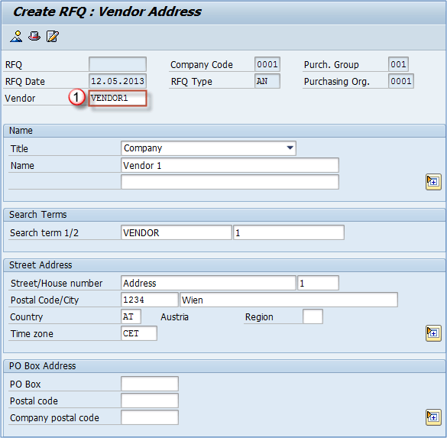
Figure 2: Material Master creation (MM01)
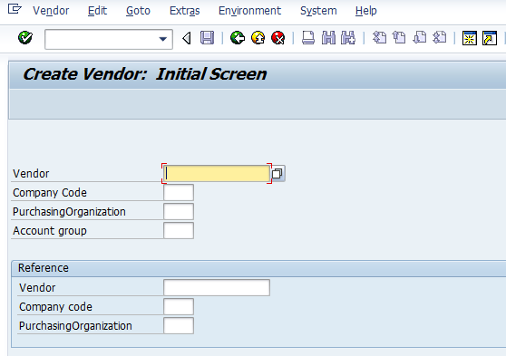

Figure 3: Purchasing Info Record (ME11)
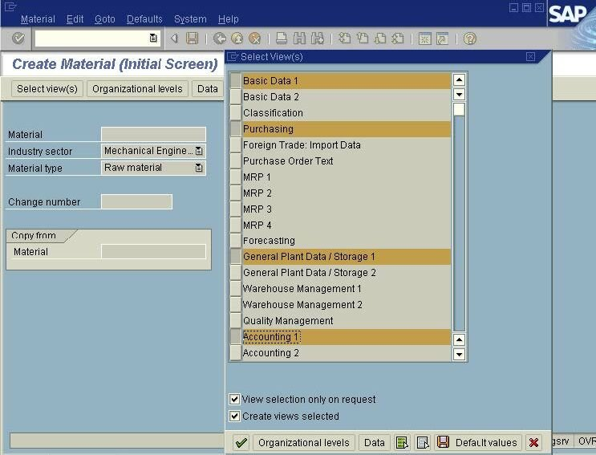
Figure 4: Purchase Requisition (ME51N)
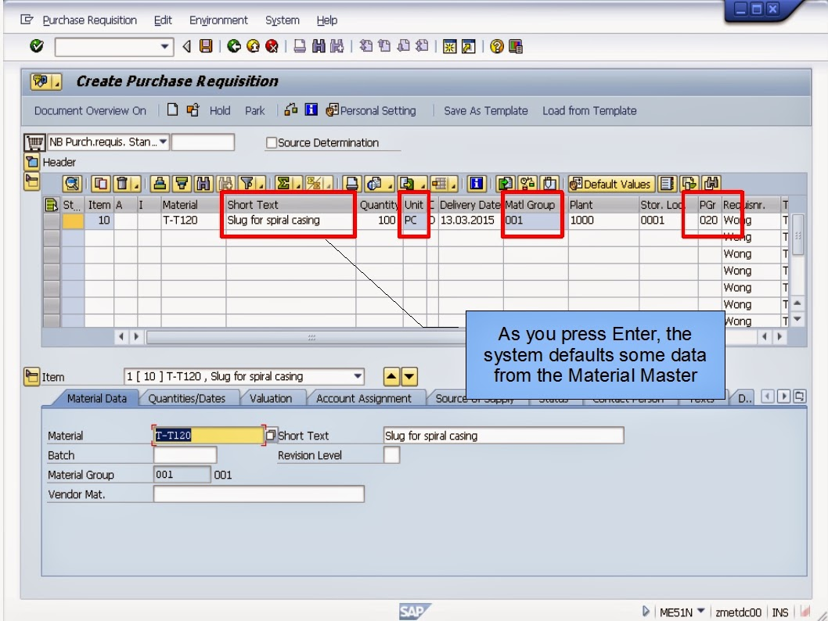

Figure 5: Request for Quotation (ME41)
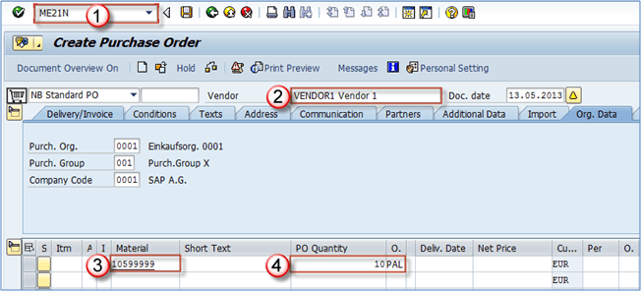
Figure 6: Price Comparison List (ME49)
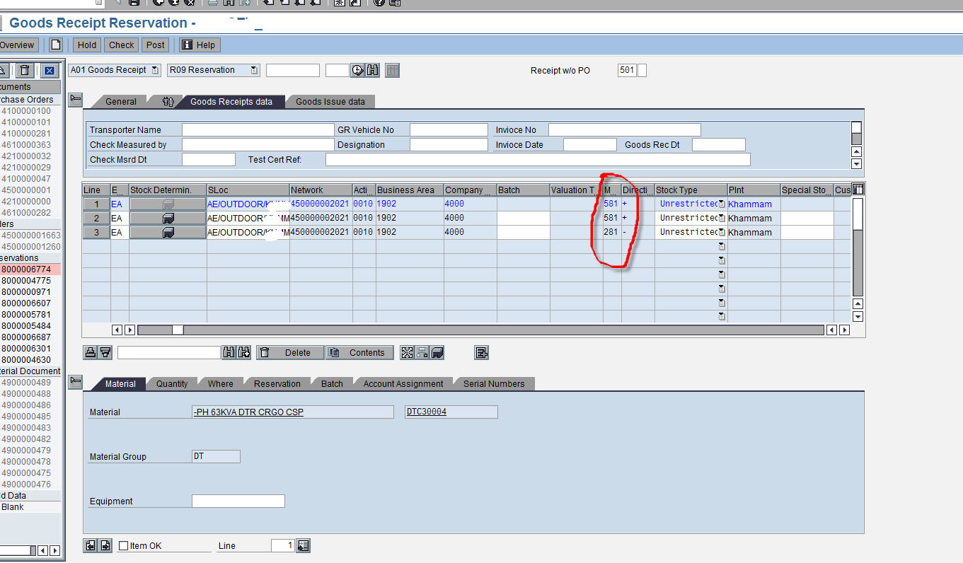

Figure 7: Purchase Order creation (ME21N) — Header Data
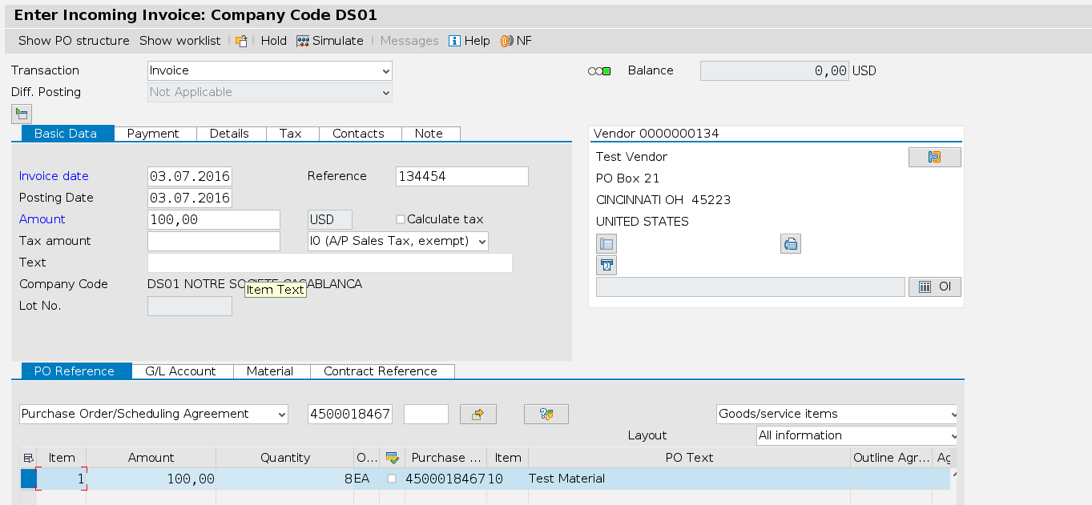
Figure 8: Purchase Order — Item Data with Pricing
Figure 9: Release Strategy — PO Approval Screen
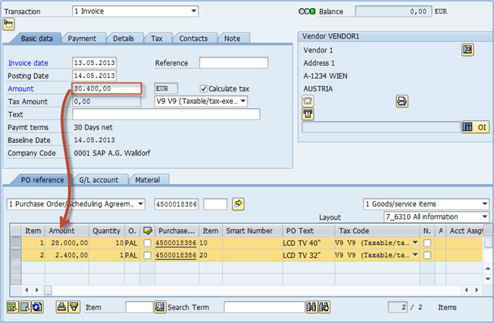
Figure 10: Goods Receipt (MIGO — Movement Type 101)
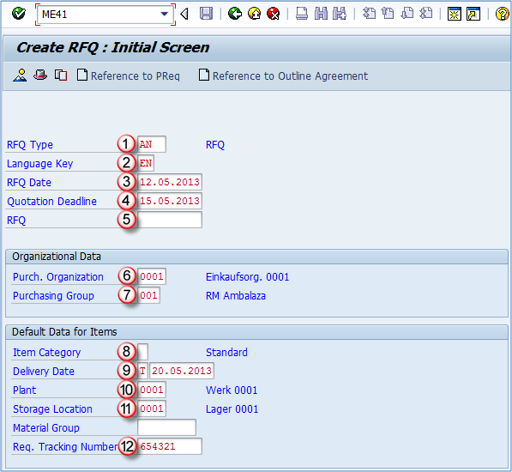
— End of Report —

