Lab 6 Managing Windows Server 2016
Network Services - Answers
Task 2 – Activity

Activity 7-1 Installing and Configuring DHCP

Objective: Learn how to install and configure the DHCP role.

Description: DHCP is installed as a server role in Windows Server 2016 using Server Manager. In this activity, you install DHCP. Also, you practice configuring a scope on a DHCP server. Before you start, obtain the address or computer name of a DNS server from Activity 3-1 (or use the address of this computer). You will also need to know the subnet mask and authorization of DHCP server. In later steps, you verify that the DHCP server you have configured is set up to automatically register with a DNS server the IP addresses that it leases and that it is configured for the types of clients on your network.

Requirements: Take Screenshots on Steps 1.0, 1.10, 1.14, 1.17, 1.18, and 1.35, and answer questions on Steps 1.19, 1.21, 1.25 and 1.28.
1.0 Open Command/PowerShell prompt, type: date; ipconfig /all (two commands in one line) as below. Press Enter.
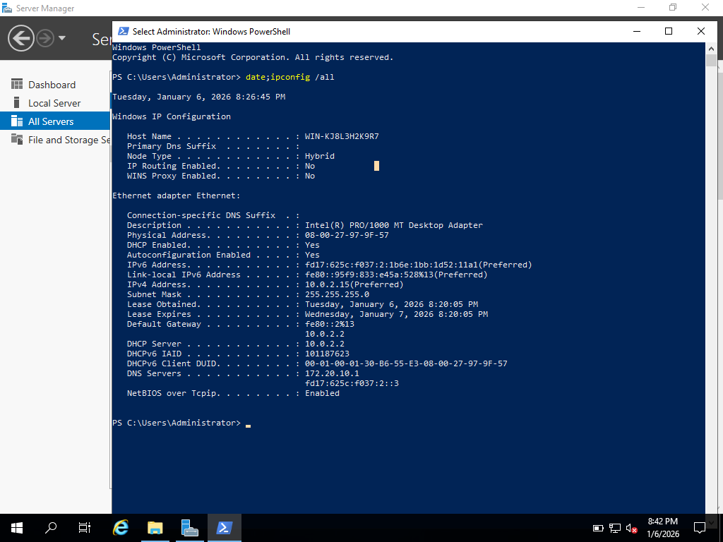
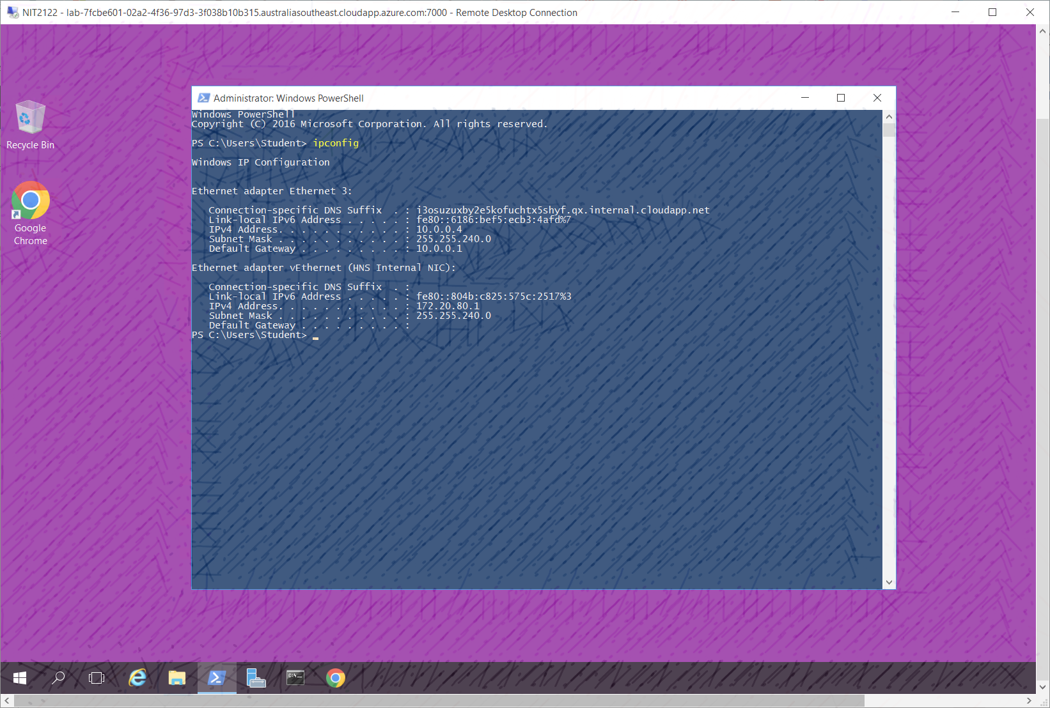
Figure 1.0 Windows Server 2016 Info 1
Capture your screen with date and time from Azure VM task bar, replace above and save to your file.
1.1 Open Server Manager, if necessary.
1.2 Click Manage and click Add Roles and Features.
1.3 If you see the Before you begin window, click Next.
1.4 Make sure that Role-based or feature-based installation is selected in the Select installation type window. Click Next.
1.5 In the Select destination server window, ensure your server is selected and click Next.
1.6 Click the box for DHCP Server in the Select server roles window.
1.7 Click Add Features in the Add Roles and Features Wizard box (to install the DHCP management tool).
1.8 Click Next in the Select server roles window.
1.9 Click Next in the Select features window.
1.10 In the DHCP Server window, read the information. Click Next.
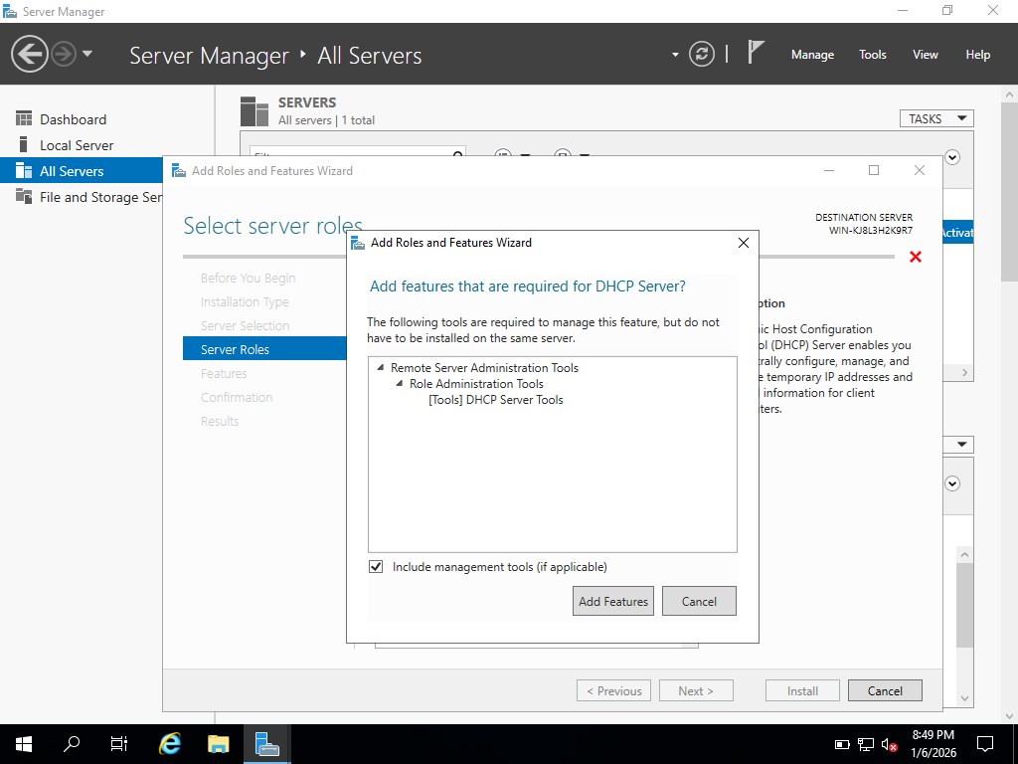
1.11 Click Install in the Confirm installation selections window.
1.12 Click Close.
1.13 Click Tools and click DHCP.
1.14 In the tree in the left pane of the DHCP window, double-click the name of the server under DHCP, such as accounting (or click the right-pointing arrow in front of the server name), to view IPv4 and IPv6 listed under the server name.
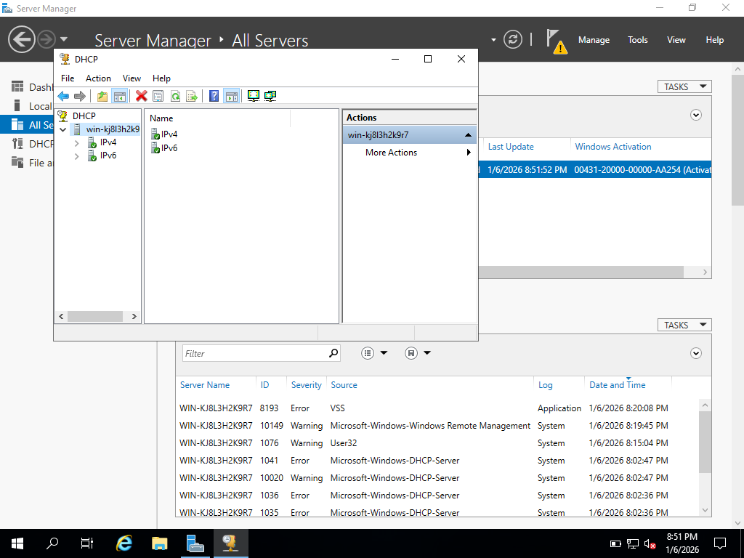
1.15 In the left pane, click IPv4 to view the configuration information in the middle pane. Right-click IPv4 and click New Scope.
1.16 Click Next after the New Scope Wizard starts.
1.17 Enter YourLastName for the scope so it is easy for you to identify as you maintain it, i.e. Admin plus Your Last Name (AdminYourLastName), and enter a description for the scope, such as Admin area subnet. Click Next.
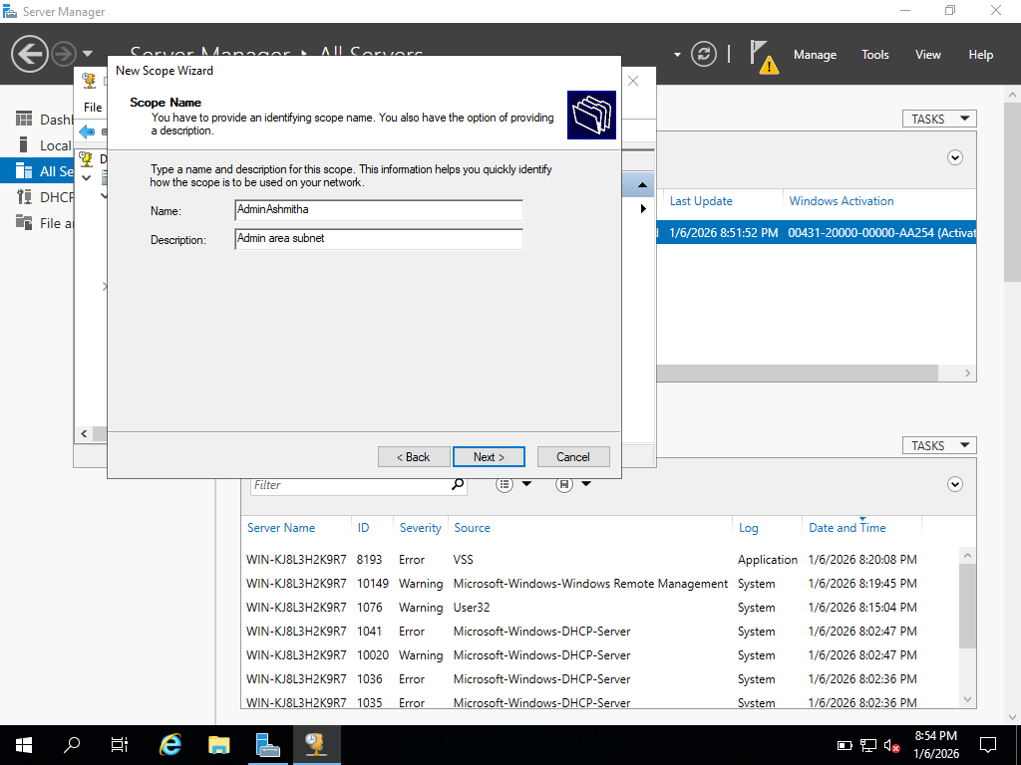
1.18 Enter the start and end IP addresses, such as 198.4.100.51 and 198.4.100.99. To go from field to field, press the period key (when you enter fewer than three numbers) If necessary, enter the subnet mask, such as 255.255.255.0. Click Next.
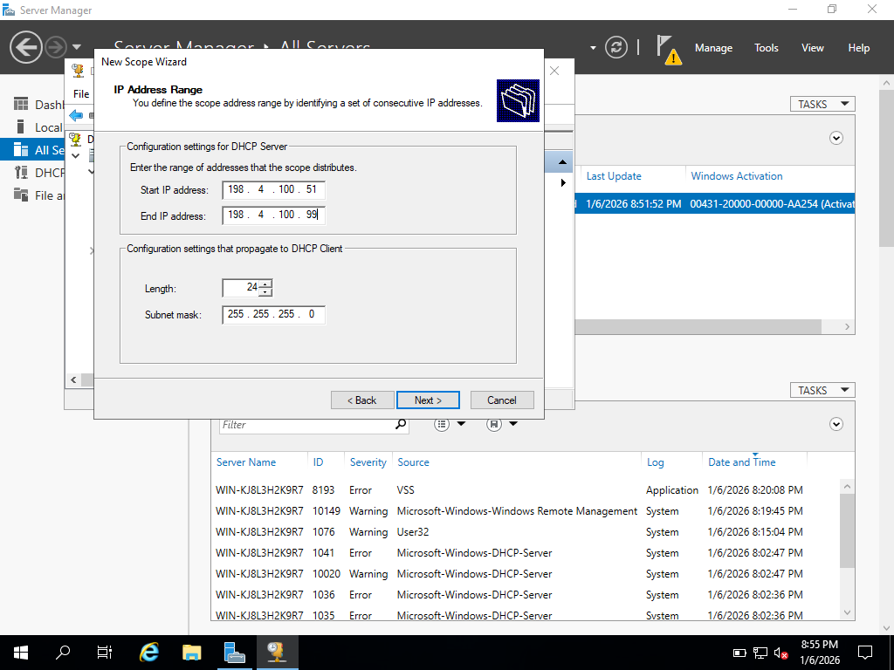
1.19 In the Add Exclusions and Delay window, enter an address to exclude, such as 198.4.100.70, in the Start IP address box and click Add.
• What happens after you click Add? Do you need to enter an ending address?
the specified IP address is added to the exclusion list. No ending address is required
1.20 Click Next.
1.21 You can now configure the lease duration.
• What is the default lease time? For what types of situations would this default be appropriate?
Days: 8
Hours: 0
Minutes: 0
- for stable networks where devices remain connected for long period such as office desktops and servers
1.22 Change the default lease time to 14 days. Click Next.
1.23 Ensure that “Yes, I want to configure these options now” is selected and click Next.
1.24 The next dialog box offers the ability to enter an IP address for a router (default gateway). You would configure this information if access to the addresses in this scope is through a router (default gateway). Click Next.
1.25 Enter the parent domain in which DNS name resolution will occur, such as s1234567.com (your domain will be entered by default, but you can change it). Select IP address shown in the bottom right box. Click Next.
• How would you enter more than one DNS server?
typing the IP address of the additional DNS server in the IP address field and click Add
1.26 In the next dialog box, you can enter the names and IP addresses of WINS servers. This would be used on networks that have old Windows Server computers in which NetBIOS naming is used and so that these names can be mapped to IP addresses. (Entering the name of your WINS server is optional. If you do, click Resolve and then click Add.) Click Next. (If you see the WINS Servers dialog box, click Next.)
1.27 Ensure that “Yes, I want to activate this scope now” is selected and then click Next (or click Cancel if you do not have permission to finish creating the scope).
1.28 Click Finish.
• What now appears in the middle pane of the DHCP window? (You may need to select Address Pool in the left pane under Scope to view this.)
The IP address range of the newly created scope now appears in the middle pane, showing available, leased, and excluded addresses under the Address Pool
1.29 Your server may be authorized by default, but you will likely have to authorize it. You can verify this by right-clicking the server name in the tree. If you see the menu option Unauthorize, this means your server is already authorized and you should click an open space to close the menu. If instead you see Authorize in the menu, click this option to authorize the server.
1.30 Ensure the server in the left pane of DHCP tool is expanded to show the elements under it.
1.31 Double-click IPv4 to select it.
1.32 Right-click IPv4 and then click Properties.
1.33 Click the DNS tab and make sure that the box for Enable DNS dynamic updates according to the settings below is checked. Clients running the Windows 7, 8/8.1, 10, Server 2012/R2, and Server 2016 operating systems can request to update a DNS server.
1.34 Ensure Dynamically update DNS records only if requested by the DHCP clients is selected. If older operating systems are connecting to the network, such as Windows 98 or Windows 95, which do not request to update a DNS server, click instead Always dynamically update DNS records—which means that the DHCP server takes the responsibility to update the DNS server’s records every time a client obtains the IP address.
1.35 Make sure that Discard A and PTR records when lease is deleted is checked, so that the DHCP server alerts the DNS server to delete a record each time a lease is up. If some older clients are running Windows 95, 98, and NT (unlikely but possible), also check Dynamically update DNS records for DHCP clients that do not request updates (for example, clients running Windows NT 4.0).
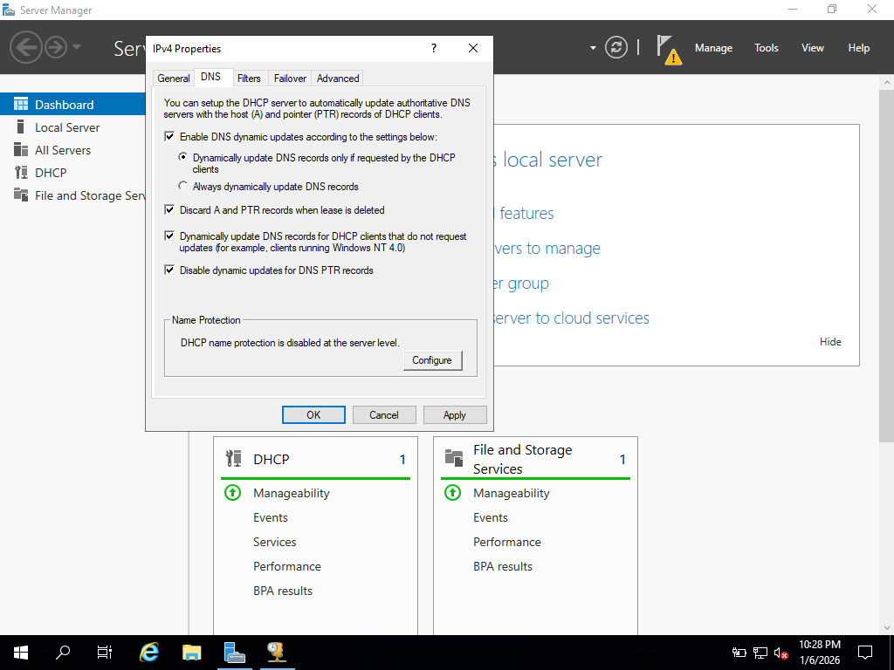
1.36 Click OK.
1.37 Close the DHCP window.

Activity 7-2 Installing and Configuring IIS

Objective: Learn how to install and configure IIS.

Description: The Web Server (IIS) role is used to turn your Windows Server 2016 server into a website hosting server. In this activity, you use Server Manager to install the Web Server (IIS) role.

Requirements: Take screenshots on Steps 2.0, 2.6, 2.12, 2.18, 2.27, 2.33, 2.38, and answer questions on Steps 2.11, 2.21, and 2.25.
2.0 Open Command/PowerShell prompt, type: date; ipconfig /all (two commands in one line) as below. Press Enter.
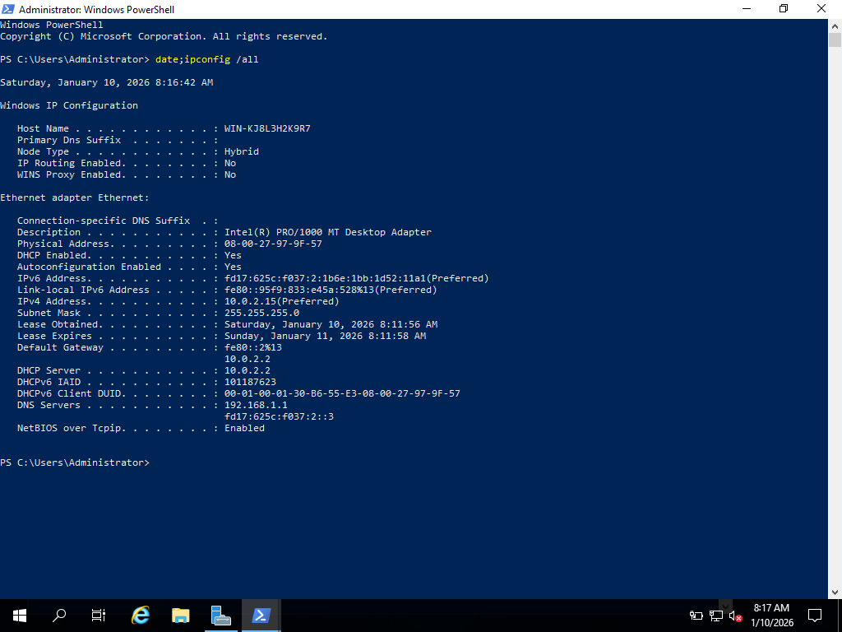

Figure 2.0 Windows Server 2016 Info 2
Capture your screen with date and time from Azure VM task bar, replace the above and save to your file.
2.1 Open Server Manager, if it is not open.
2.2 Click Manage and click Add Roles and Features.
2.3 If you see the Before you begin window, click Next.
2.4 Make certain Role-based and feature-based installation is selected in the Select installation type window and click Next.
2.5 Your server should be selected in the Select destination server window. Click Next.
2.6 Click the box for Web Server (IIS) in the Select server roles window.
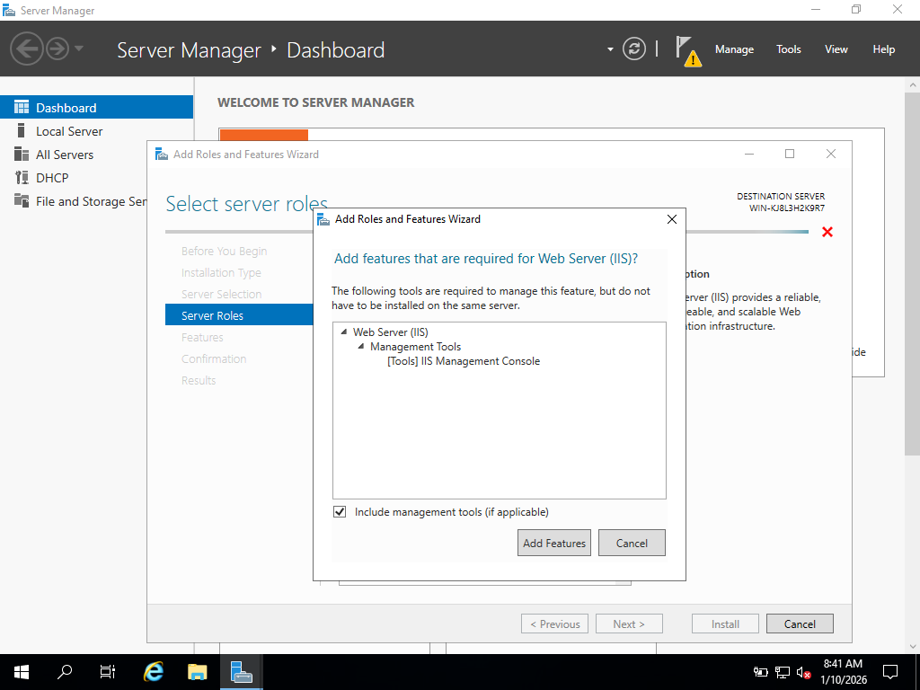
2.7 So that you install the module for IIS Management Console, click Add Features in the Add Roles and Features Wizard.
2.8 Click Next in the Select server roles window.
2.9 Click Next in the Select features window.
2.10 Review the information window about Web Server Role (IIS) and then click Next.
2.11 Review the modules that are installed by default in the Select role services window.
• Record the modules checked by default
- Common HTTP Features
- Static Content
- Default Document
- Directory Browsing
- HTTP Errors
- Health and Diagnostics
- HTTP Logging
- Performance
- Static Content Compression
- Security
- Request Filtering
- Management Tools
- IIS Management Console
2.12 Under Security, click the box for IIS Client Certificate Mapping Authentication and read its description on the right side of the window. This selection enables you to use digital IDs for security.
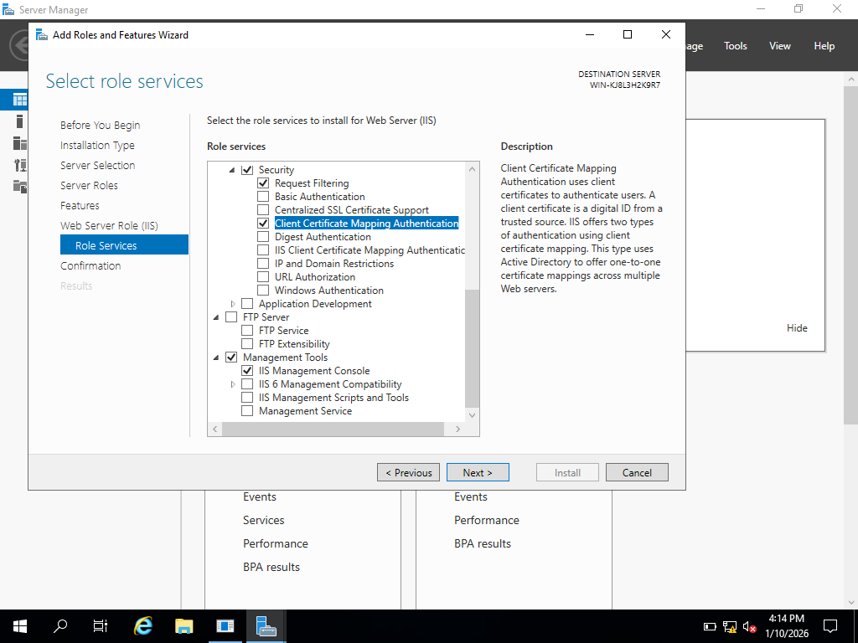

2.13 Click Next in the Select role services window.
2.14 Review your selections and click Install.
2.15 Click Close.
2.16 Click Tools and click Internet Information Services (IIS) Manager.
2.17 Expand the tree in the left pane to view Default Web Site under the Sites folder. Right-click Default Web Site in the tree and click Add Virtual Directory.
2.18 Enter an alias for the virtual directory, which users will employ to access it, i.e. www plus your first name at the end, such as wwwFirstName. Also, enter the path to the physical folder i.e. C:\Users\Student\wwwYourFirstName which you can choose to “Make New Folder” by browsing … folder option. Click OK.
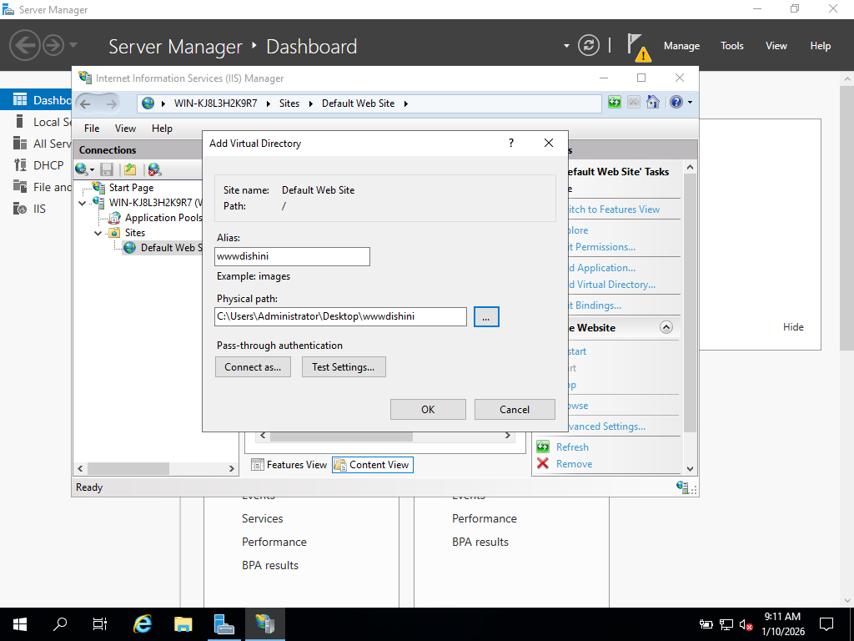
2.19 In the tree under Default Web Site (if necessary, click the right pointing arrow to expand it), right-click the virtual directory you created and click Edit Permissions.
2.20 Click the Security tab to view the current permissions.
2.21 Click the Sharing tab.
• How can you set up this folder for sharing?
The folder can be set up for sharing by clicking the Sharing tab, selecting Advanced Sharing, enabling Share this folder, and then configuring the appropriate permissions for users or groups.
2.22 Click Cancel in the Properties dialog box.
2.23 Open IIS Manager, if you have closed it.
2.24 If necessary, expand the tree under the Sites folder to see Default Web Site.
2.25 Right-click Default Web Site to see the menu and review its contents Point to Manage Website.
• How can you rename the website? Also, how can you restart the website if it is stopped?
The website can be renamed by right-clicking Default Web Site, selecting Rename, and entering a new name.
If the website is stopped, it can be restarted by right-clicking the website, selecting Manage Website, and then clicking Start or Restart.
2.26 Click the pointer in a blank area to close the open menu.
2.27 Double-click Default Document in the middle pane. Notice that Default.htm is set up to display first when the client connects to the website without specifying a file to access. Right-click iisstart.htm and notice there is an option to move it up the list.
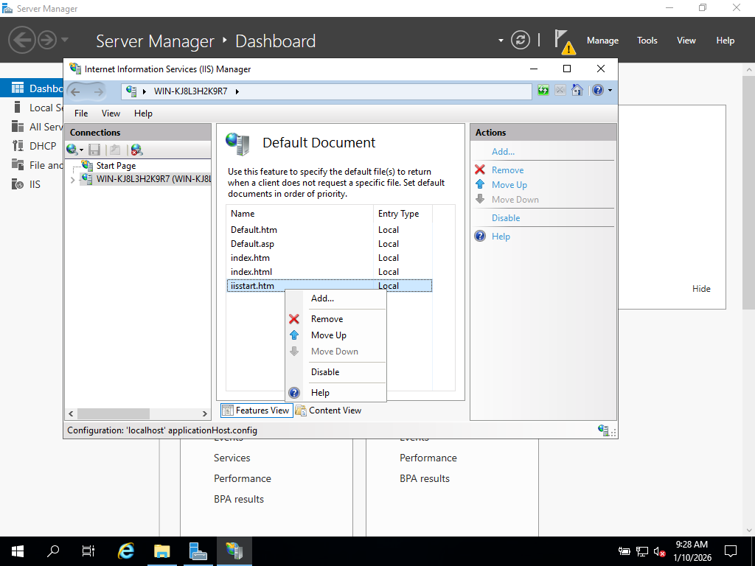
2.28 Click the back arrow in the upper-left side of the Internet Information Services (IIS) Manager window.
2.29 Double-click Directory Browsing in the middle pane.
2.30 In the right pane, click Enable to enable directory browsing.
2.31 Click the back arrow in the upper-left side of the Internet Information Services (IIS) Manager window.
2.32 Right-click Default Web Site in the tree, click Edit Permissions, and click the Security tab.
2.33 Click Users (s1234567\IIS_IUSERS) under Group or usernames: to view the security given to web users in the domain.
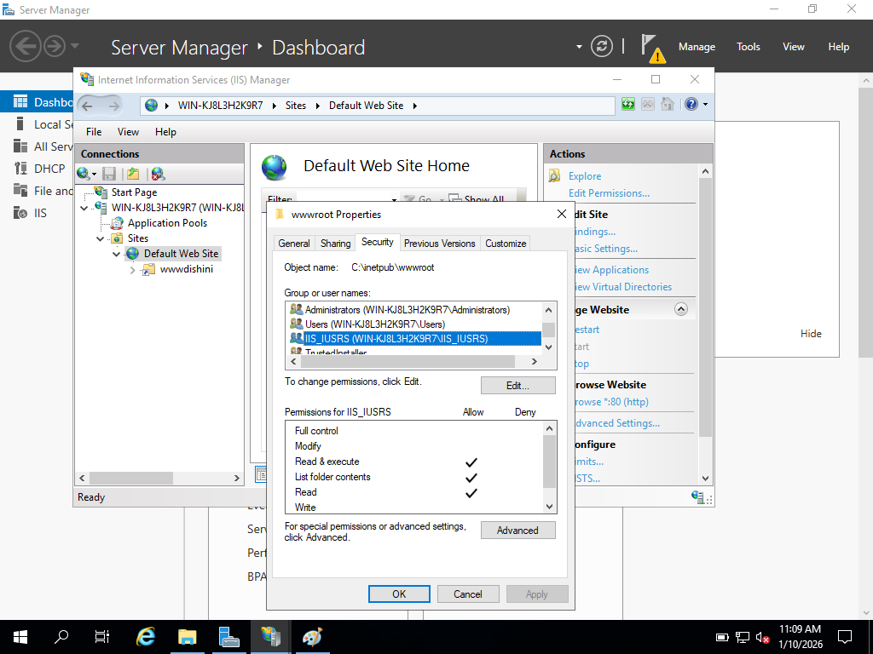
2.34 Click Cancel in the Properties dialog box.
2.35 In the left pane, click Default Web Site in the tree, so that it is highlighted.
2.36 In the right pane, find the Configure section and click Limits.
2.37 Enter 240 in the Connection time-out (in seconds): box to increase the amount of time a user can be connected without taking action.
2.38 Click the box for Limit number of connections. Enter 500 as the number for simultaneous connections so you can control the load on the server. This is a number you should monitor in the future. If the server is frequently overloaded with users and performing slowly, you can reduce this number, for example, by 50 at a time, as needed. Click OK.
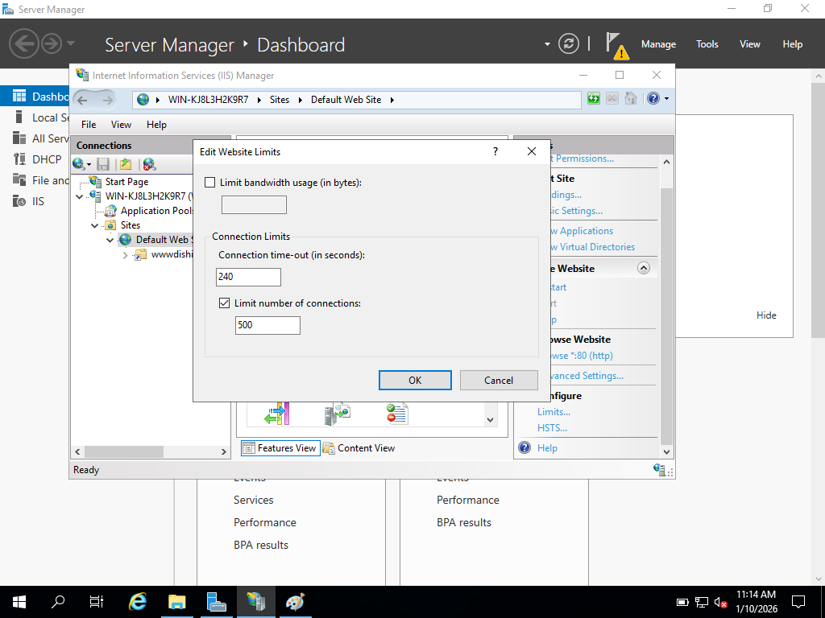
2.39 Close the Internet Information Services (IIS) Manager window.

Congratulations! You reach the end of Lab Assessment 2.

