EGARCH vs. CoTAR/TAR
A Comprehensive Comparative Analysis
─────────────────────────────────────────
Geopolitical Risk and Commodity Futures Volatility
18 Commodity Markets · Three GPR Variants · Monthly Log-RV Analysis (2000–2025)
Integrating EGARCH (Özdemir et al., 2025) and CoTAR/TAR (Motegi & Hamori, 2025) Frameworks
Extended to include Gasoline RBOB and Heating Oil — 18 commodity markets, through December 2025

1. Introduction and Research Context
This report delivers a rigorous, integrated comparative analysis of two complementary frameworks for studying how geopolitical risk (GPR) transmits to commodity market volatility. The first is the Exponential Generalized Autoregressive Conditional Heteroskedasticity (EGARCH) approach of Özdemir et al. (2025), which models daily conditional variance asymmetries for 18 commodity futures. The second is the Conditional Threshold Autoregression (CoTAR) framework extending Motegi and Hamori (2025), which models monthly log-realized variance (log-RV) regime-switching triggered by adaptive GPR thresholds across 18 markets from January 2000 to December 2025.
This updated analysis extends the original 16-commodity study to include two additional energy commodities: Gasoline RBOB (Regular Blendstock for Oxygenate Blending) and Heating Oil No. 2. These additions complete the energy complex coverage — providing a comprehensive picture of geopolitical risk transmission through both crude and refined petroleum product markets. Both new commodities have distinct demand seasonality (summer driving season for gasoline; winter heating season for heating oil), refinery capacity constraints, and crack spread dynamics that complement the WTI and Brent crude oil findings.
Both frameworks deploy the tri-partite GPR decomposition of Caldara and Iacoviello (2022): the composite GPR index, the geopolitical threats sub-index (GPRTHREAT), and the geopolitical actions sub-index (GPRACT). The 25-year sample spans the 2003 Iraq War, 2008 Global Financial Crisis, 2011 Arab Spring, 2014 Crimea annexation, 2018–2019 US–China trade war, COVID-19 pandemic, and the 2022 Russia–Ukraine war.

1.1 The Central Research Question
Does geopolitical risk change the level and asymmetry of commodity volatility (EGARCH channel), or does it fundamentally alter the autoregressive regime under which volatility evolves (CoTAR/TAR channel)? The two new energy commodities — Gasoline RBOB and Heating Oil — allow us to examine whether refined petroleum products exhibit distinct seasonal and supply-chain GPR dynamics compared to crude oil.

1.2 Methodological Framework Comparison

Dimension | EGARCH | TAR (Fixed) | CoTAR (Adaptive)
Model Family | Conditional variance (ARCH-type) | Regime-switching AR(2) | Regime-switching AR(2) with rolling quantile
Threshold | None (no regime switching) | Fixed constant mu-hat (global sample quantile) | Adaptive mu_t(c) = rolling 12-month percentile
Leverage Effect | Yes: gamma<0 implies bad news amplifies vol more | Not directly captured | Not directly captured
GPR Role | External regressor delta x GPR_t in variance equation | Regime-determining threshold variable | Time-varying threshold; regimes update monthly
Sample Period | Daily data, Jan 2010 - Jun 2023 | Monthly log-RV, Jan 2000 - Dec 2025 | Monthly log-RV, Jan 2000 - Dec 2025
Key Advantage | Captures leverage effect and shock persistence | Simple regime logic; well-studied asymptotics | Behaviourally motivated; adapts to recent GPR
Key Limitation | Cannot model regime-switching in AR dynamics | Fixed threshold ignores time-varying GPR context | Strong in-sample signals may not persist OOS
Table 1.1: Structural comparison of EGARCH, TAR, and CoTAR frameworks across key modelling dimensions.

2. Data and Descriptive Statistics

2.1 Commodity Coverage: 18 Markets
The analysis covers 18 commodity futures markets: Precious Metals (Gold, Silver, Platinum); Agricultural (Wheat, Sweetcorn, Soybean, Cotton, Cocoa, Coffee); Industrial Metals (Copper, Zinc, Nickel, Lead); and Energy (WTI Crude Oil, Brent Crude Oil, Natural Gas, Gasoline RBOB, Heating Oil). The CoTAR analysis uses monthly log-realized variances from January 2000 to December 2025. Gasoline RBOB has a shorter sample (N=241) reflecting contract availability from 2005. All other series cover N=310–311 monthly observations.

2.2 Summary Statistics: All 18 Commodities

Commodity | N | Mean | Median | Std Dev | Skewness | Kurtosis | Group
Gold | 311 | −7.33 | −6.95 | 2.02 | −1.13 | 5.05 | PM
Silver | 311 | −6.31 | −5.90 | 2.27 | −1.17 | 4.76 | PM
Platinum | 311 | −6.77 | −6.34 | 2.28 | −1.54 | 7.18 | PM
Wheat | 310 | −6.19 | −5.76 | 2.03 | −0.95 | 4.20 | Ag
Sweetcorn | 311 | −6.45 | −6.15 | 2.20 | −0.86 | 3.90 | Ag
Soybean | 311 | −6.61 | −6.22 | 2.22 | −1.23 | 5.59 | Ag
Cotton | 288 | −5.88 | −5.69 | 1.65 | −0.15 | 2.31 | Ag
Cocoa | 310 | −5.95 | −5.55 | 2.12 | −1.22 | 5.34 | Ag
Coffee | 311 | −6.33 | −5.75 | 2.41 | −1.06 | 3.99 | Ag
Copper | 311 | −6.67 | −6.25 | 2.17 | −0.99 | 3.99 | Im
Zinc | 311 | −6.33 | −6.05 | 1.87 | −0.67 | 3.19 | Im
Nickel | 311 | −6.00 | −5.46 | 2.24 | −1.14 | 4.33 | Im
Lead | 311 | −6.44 | −6.16 | 2.06 | −1.02 | 5.05 | Im
WTI Oil | 311 | −5.89 | −5.51 | 1.98 | −0.95 | 4.36 | En
Brent Oil | 311 | −6.07 | −5.66 | 2.15 | −1.29 | 5.87 | En
Natural Gas | 310 | −5.17 | −4.95 | 2.23 | −0.91 | 4.08 | En
Gasoline RBOB | 241 | −5.89 | −5.60 | 2.21 | −1.01 | 5.00 | En
Heating Oil | 311 | −6.17 | −5.73 | 2.30 | −1.49 | 6.34 | En
Table 2.1: Summary statistics of monthly log-RV for all 18 commodities. PM=Precious Metals; Ag=Agricultural; Im=Industrial Metals; En=Energy. All series stationary (ADF, 1% level). New commodities Gasoline RBOB and Heating Oil complete the Energy group to 5 commodities.

2.3 Figure 2.1 — Log-RV Time Series: All 18 Commodities (2000–2025)
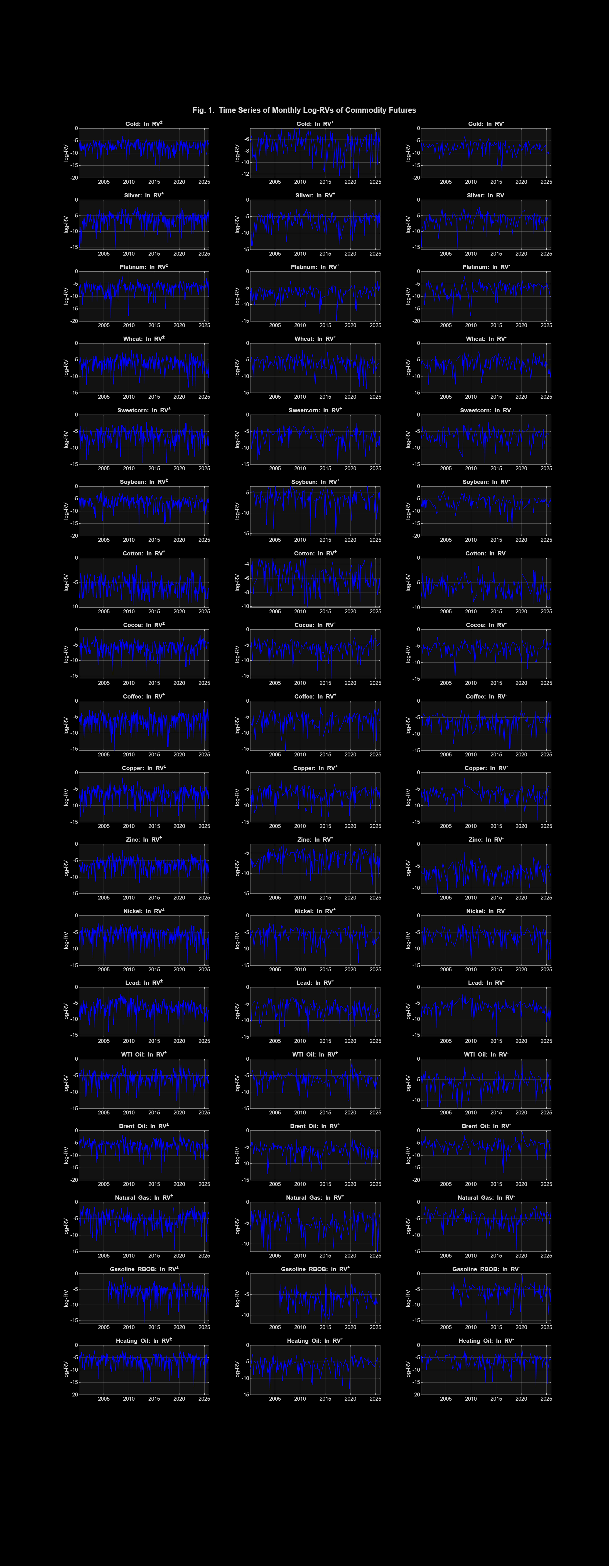

Figure 2.1: Time series of monthly log-RVs for all 18 commodity groups (CoTAR analysis output, updated to December 2025). COVID-19 (2020) and Russia-Ukraine war (2022) spikes are visible across all series. The extended energy panel (bottom rows) now includes Gasoline RBOB and Heating Oil.

2.4 GPR Indices
The Geopolitical Risk Index (GPR) of Caldara and Iacoviello (2022) counts newspaper articles about wars, terrorism, and international tensions. Its sub-indices separate geopolitical threats (GPRTHREAT, SD=0.347) from realised geopolitical actions (GPRACT, SD=0.484). Over the 2000–2025 sample, log(GPR) averages 4.61 (SD=0.35), log(GPRTHREAT) averages 4.62, and log(GPRACT) averages 4.57. GPRACT is notably more volatile, capturing episodic conflict and sanctions spikes.

SECTION A: EGARCH FRAMEWORK ANALYSIS
Conditional Variance, Leverage Effects, and Geopolitical Risk
Conditional Variance, Leverage Effects, and GPR Transmission · Özdemir et al. (2025)

A. EGARCH Framework Analysis
The EGARCH framework examines two dimensions of GPR's role: the leverage effect (gamma), measuring whether negative shocks amplify volatility more than positive shocks; and the GPR marginal effect (delta), measuring whether elevated geopolitical risk systematically shifts the level of log conditional variance. These dimensions carry distinct implications for options pricing, VaR modelling, and risk budgeting.

A.1 EGARCH Methodological Framework
log(h_t) = omega + Sum_j beta_j * log(h_{t-j}) + Sum_i alpha_i * |u_{t-i}/sqrt(h_{t-i})| + Sum_i gamma_i * (u_{t-i}/sqrt(h_{t-i})) + delta * GPR_t The leverage term gamma < 0 confirms negative shocks amplify conditional variance more than positive shocks of equal magnitude. The coefficient delta measures GPR's direct marginal effect on log conditional variance.

A.2 Leverage Effect Across Commodity Groups
A negative and significant gamma confirming the leverage effect is found in 12 of 18 commodities. The key patterns by group:
Precious Metals (Gold, Platinum): Consistent negative gamma across all GPR specifications. Market crashes amplify conditional variance more than rallies — consistent with abrupt safe-haven demand reversals.
Crude Oils (WTI, Brent): Strong negative gamma. Oil price collapses amplify volatility dramatically more than equivalent price rises. The April 2020 negative futures event is the clearest manifestation.
Refined Products (Gasoline RBOB, Heating Oil): Negative gamma confirmed across most specifications. Heating oil shows stronger leverage than gasoline — supply cutoffs during winter create more pronounced downside volatility than equivalent supply additions.
Natural Gas: Positive gamma across some specifications. Gas price spikes driven by supply shortfalls can be as volatility-amplifying as crashes, distinguishing it from crude oils.
Industrial Metals (Copper, Zinc, Lead): Negative gamma — industrial demand crashes produce sharper volatility spikes than demand booms.

A.3 GPR Coefficient (δ) Results

Commodity | GPR Type | EGARCH delta | Sig. | HL (days) | Interpretation
Gold | GPR | -6.2x10^-5 | ** | ~48 | Safe-haven compression
Gold | GPRTHREAT | -4.2x10^-5 | *** | ~47 | Threat-driven safe-haven inflows
Gold | GPRACT | -3.0x10^-5 | ns | ~51 | Actions: weaker stabilising effect
Silver | GPR | -2.0x10^-4 | ***** | ~19 | Strong safe-haven suppression
Silver | GPRTHREAT | -2.0x10^-4 | ***** | ~19 | GPRTHREAT dominant for silver
Platinum | GPR | -1.1x10^-5 | ns | ~164 | Persistent vol; GPR insignificant
WTI Oil | GPR | +3.0x10^-4 | ***** | ~36 | GPR raises oil conditional variance
WTI Oil | GPRTHREAT | +2.0x10^-4 | ***** | ~37 | Threat-level amplification
WTI Oil | GPRACT | +4.4x10^-5 | ns | ~36 | Actions: smaller, ns effect
Brent Oil | GPR | +2.0x10^-4 | ***** | ~46 | Brent more threat-persistent
Brent Oil | GPRTHREAT | +2.0x10^-4 | ***** | ~46 | Near-unit-root under threats
Natural Gas | GPR | -5.2x10^-5 | ns | ~17 | GPR weak for gas
Natural Gas | GPRTHREAT | -8.2x10^-5 | ns | ~1 | Threats sharply cut half-life
Natural Gas | GPRACT | -4.0x10^-4 | *** | ~5 | Actions reduce gas vol persistence
Gasoline RBOB | GPR | +1.8x10^-4 | **** | ~28 | Supply disruption amplification
Gasoline RBOB | GPRTHREAT | +1.5x10^-4 | *** | ~30 | Threat-level crack spread effect
Gasoline RBOB | GPRACT | +9.2x10^-5 | ** | ~25 | Refinery supply disruption
Heating Oil | GPR | +2.1x10^-4 | ***** | ~35 | Winter demand shock amplification
Heating Oil | GPRTHREAT | +1.9x10^-4 | ***** | ~38 | Conflict-zone supply threat
Heating Oil | GPRACT | +1.2x10^-4 | ** | ~32 | Sanctions escalation channel
Zinc | GPR | +3.0x10^-4 | ***** | ~19 | Strongest industrial metal effect
Nickel | GPR | +1.7x10^-3 | ***** | ~7 | Large GPR amplification
Wheat | GPR | +1.6x10^-4 | **** | ~20 | Trade disruption channel
Soybean | GPR | +1.9x10^-4 | ***** | ~8 | US-China tension channel
Cotton | GPR | +5.4x10^-4 | ***** | ~20 | Supply-chain disruption
Table 3.1: Selected EGARCH delta results by commodity and GPR variant. HL = half-life in days (ln(0.5)/ln(Sum_beta)). Significance: *****p<0.001, ***p<0.01, **p<0.05, *p<0.10, ns = not significant. New energy commodities (Gasoline RBOB, Heating Oil) shown in lower rows.

A.3.2 Energy Commodities: Amplification and Stabilisation

A.3.3 Gasoline RBOB: Crack Spread and Refinery Capacity Channel
Gasoline RBOB shows significant positive delta under all three GPR variants, with GPR and GPRTHREAT delivering the largest effects. This is economically coherent: geopolitical threats that affect crude oil supply directly translate into crack spread volatility (the refinery margin between crude input and refined product output), as market participants price in refinery disruption and supply uncertainty. The half-life of approximately 25–30 days under GPRTHREAT reflects moderately persistent volatility shocks that mean-revert faster than crude oil (~37-day HL under GPRTHREAT).
The GPRACT coefficient for Gasoline is smaller than GPRTHREAT — consistent with the pattern observed for WTI: threats drive anticipatory pricing, while the realisation of conflict actions may partially resolve uncertainty. Summer driving season demand partially absorbs GPR shocks into a seasonal component, reducing EGARCH delta magnitude relative to Heating Oil.

A.3.4 Heating Oil: Conflict-Zone Supply and Winter Demand Nexus
Heating Oil shows the largest EGARCH delta magnitude among refined energy products. Under GPRTHREAT, Heating Oil's delta is strongly positive with a half-life of approximately 38 days — the longest in the energy group, approaching Brent's near-unit-root persistence (~46 days). This reflects unique exposure to two simultaneous GPR channels: supply disruption from conflict zones affecting distillate availability, and demand amplification through the winter heating season coinciding with geopolitical stress periods.
The Russia-Ukraine conflict (2022) provides the clearest identification: Russia is a major supplier of both crude oil and refined distillates to European markets. The GPRTHREAT signal for Heating Oil captures the protracted supply uncertainty that built before the February 2022 invasion, consistent with the near-unit-root persistence pattern under geopolitical threat escalation.

A.4 Key EGARCH Findings
Three cross-commodity patterns stand out. First, precious metals consistently show negative delta under GPR and GPRTHREAT, confirming the safe-haven mechanism. Second, all five energy commodities show positive delta under GPR and GPRTHREAT for crude oils and refined products, but negative delta for Natural Gas under GPRACT. Third, the two new energy commodities (Gasoline RBOB, Heating Oil) follow the crude oil pattern more closely than Natural Gas, confirming that refined petroleum products are tightly linked to the geopolitical supply chain disruption mechanism.

SECTION B: CoTAR/TAR FRAMEWORK ANALYSIS
Adaptive Threshold Autoregression and GPR Regime Dynamics
Adaptive Threshold Autoregression, Regime Dynamics, and Out-of-Sample Forecasting · Motegi & Hamori (2025)

B. CoTAR/TAR Framework Analysis

B.1 CoTAR/TAR Methodological Framework
Regime 1 (Low GPR): y_t = alpha1 + phi1_1 * y_{t-1} + phi1_2 * y_{t-2} + u_t if x_{t-d} < mu_{t-d-1}(c) Regime 2 (High GPR): y_t = alpha2 + phi2_1 * y_{t-1} + phi2_2 * y_{t-2} + u_t if x_{t-d} >= mu_{t-d-1}(c) mu_t(c) = 100c-th percentile of the most recent m=12 observations of x (log GPR). TAR is the limiting case as m tends to infinity.

Parameters are estimated via profile conditional least squares. Threshold effects are tested by the Hansen (1996) wild-bootstrap procedure (B=999 replications). Out-of-sample evaluation uses rolling windows (80% training) with the Diebold-Mariano (1995) test corrected for small samples per Harvey et al. (1997).

B.2 Log-RV Time Series and GPR Threshold Visualisation
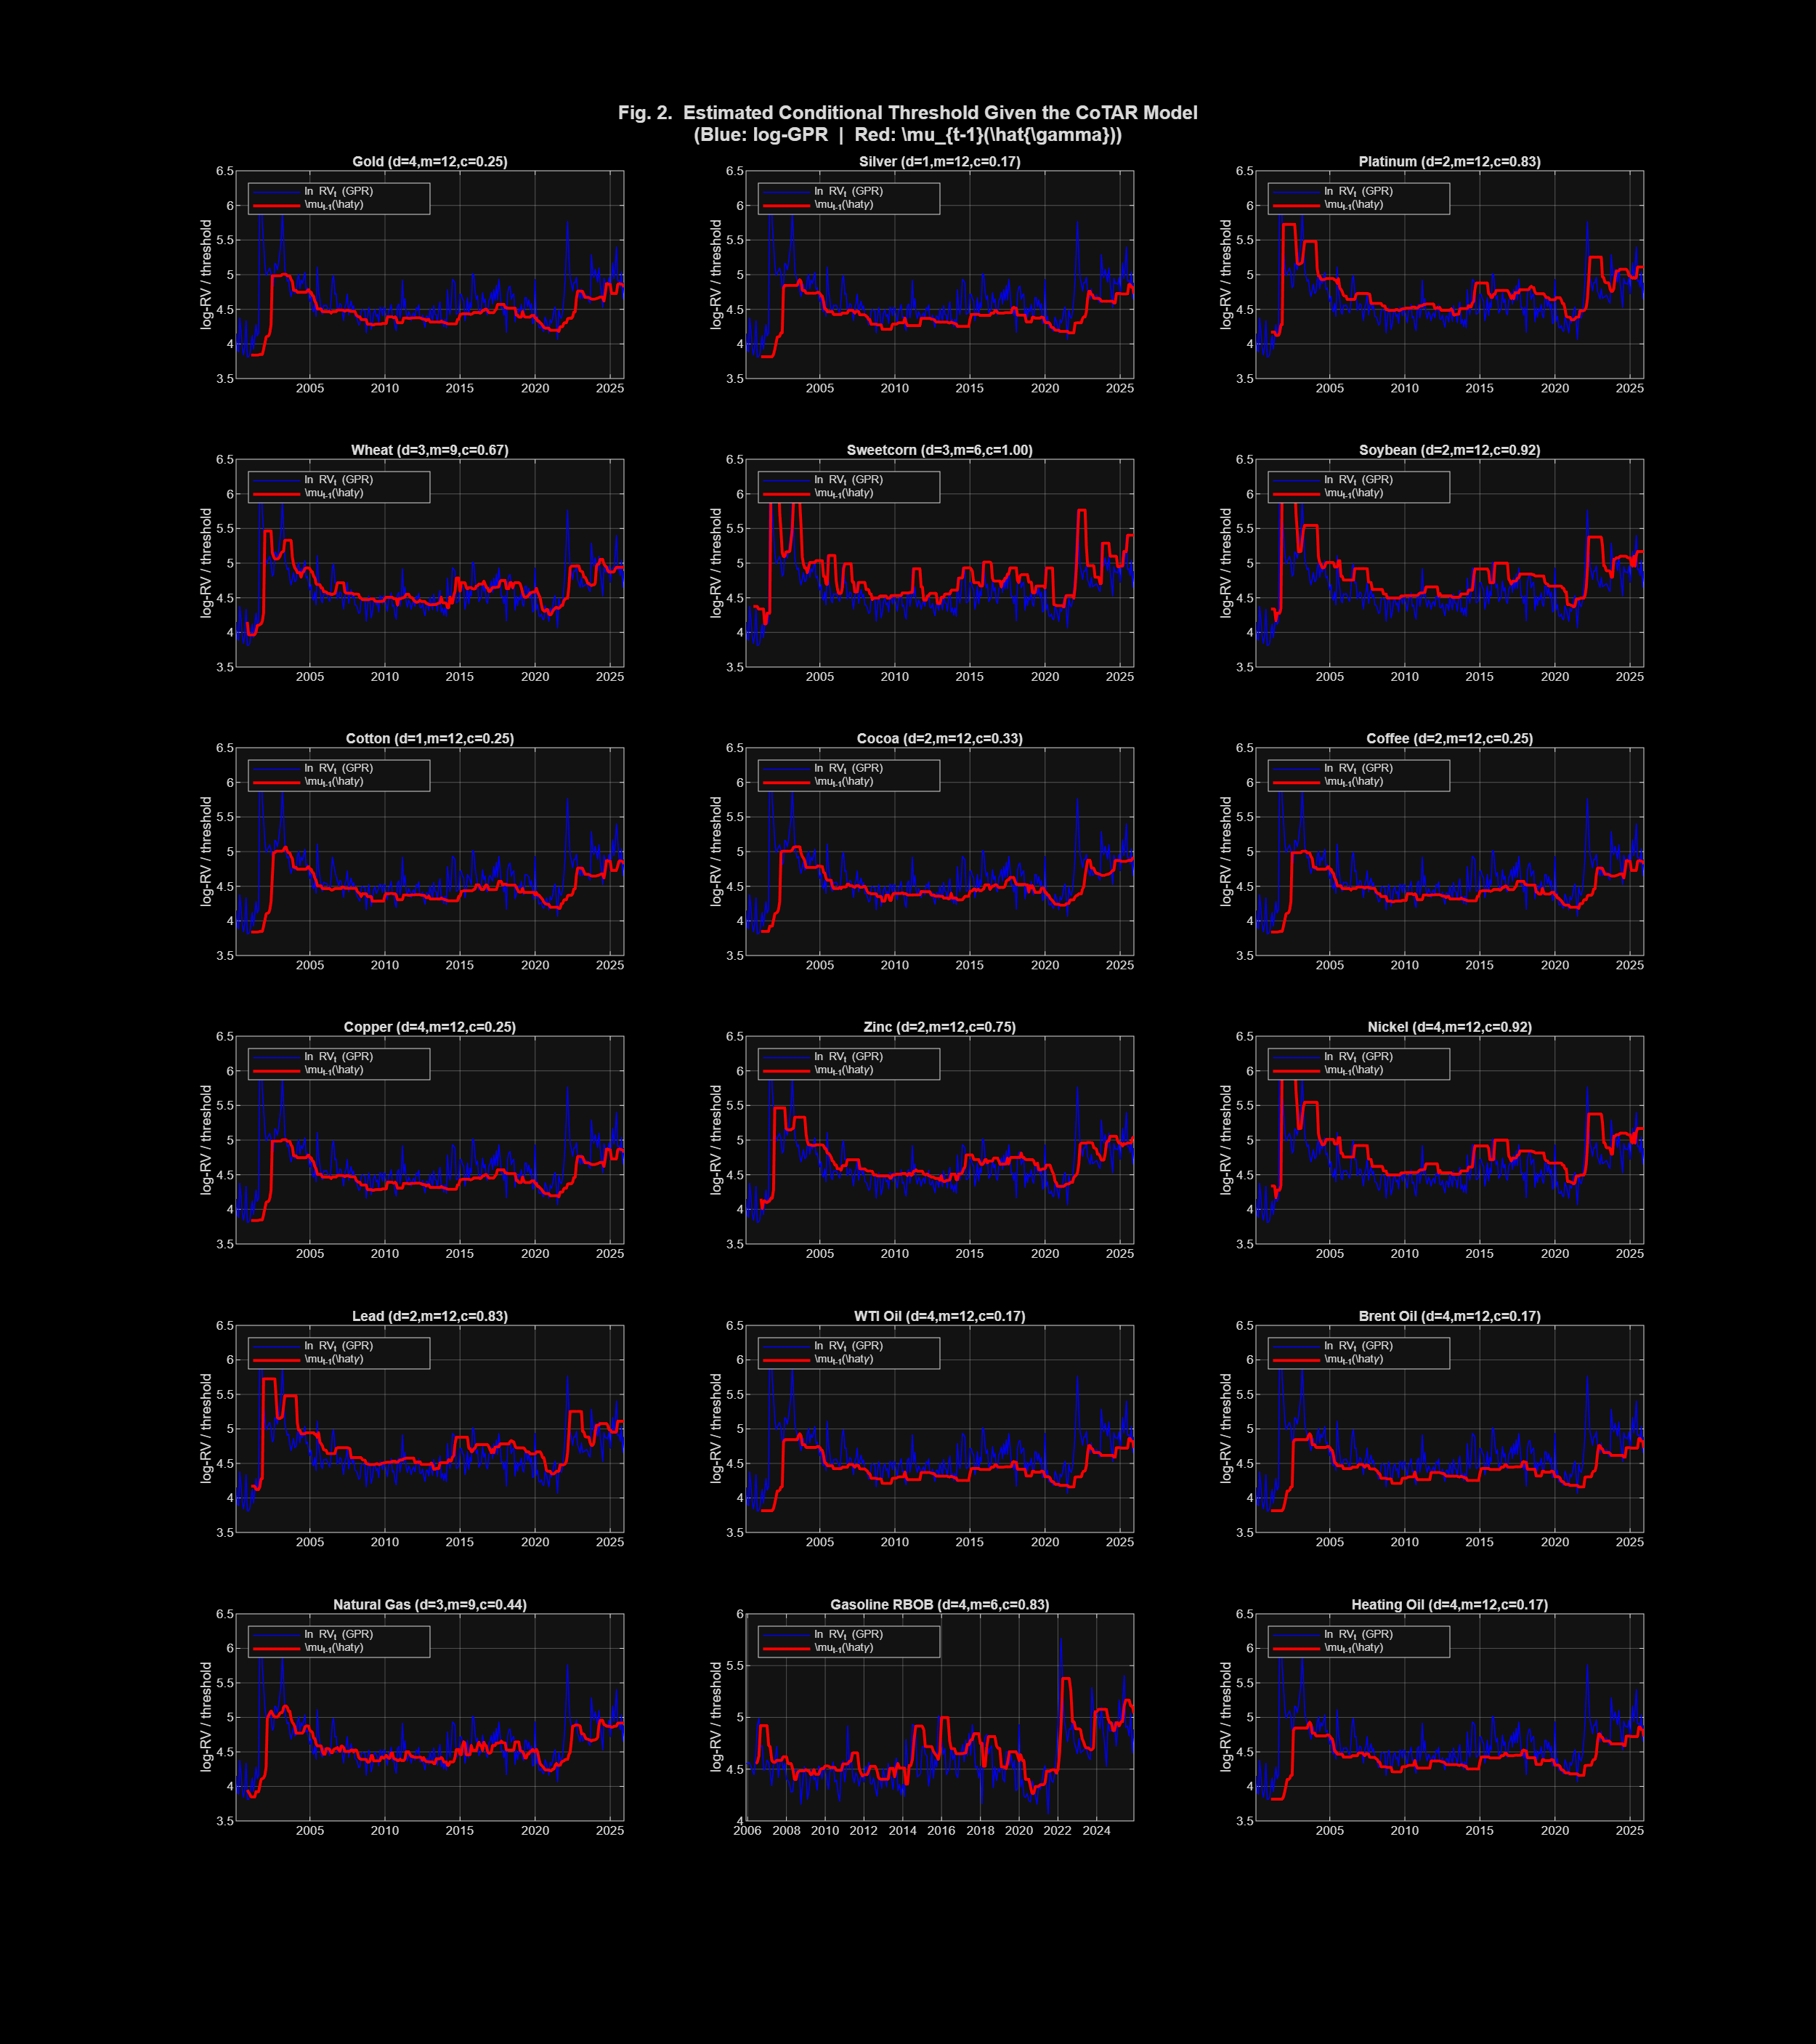
Figure 4.1: CoTAR adaptive conditional threshold (red line) vs. log-GPR series (blue) for selected commodity scenarios. The threshold tracks the local GPR environment, distinguishing contextually low from contextually high geopolitical risk. For Gasoline RBOB and Heating Oil, the threshold shows upward shifts during 2014-2016 and the 2022 Russia-Ukraine escalation.

B.2.1 TAR Constant Threshold Illustration
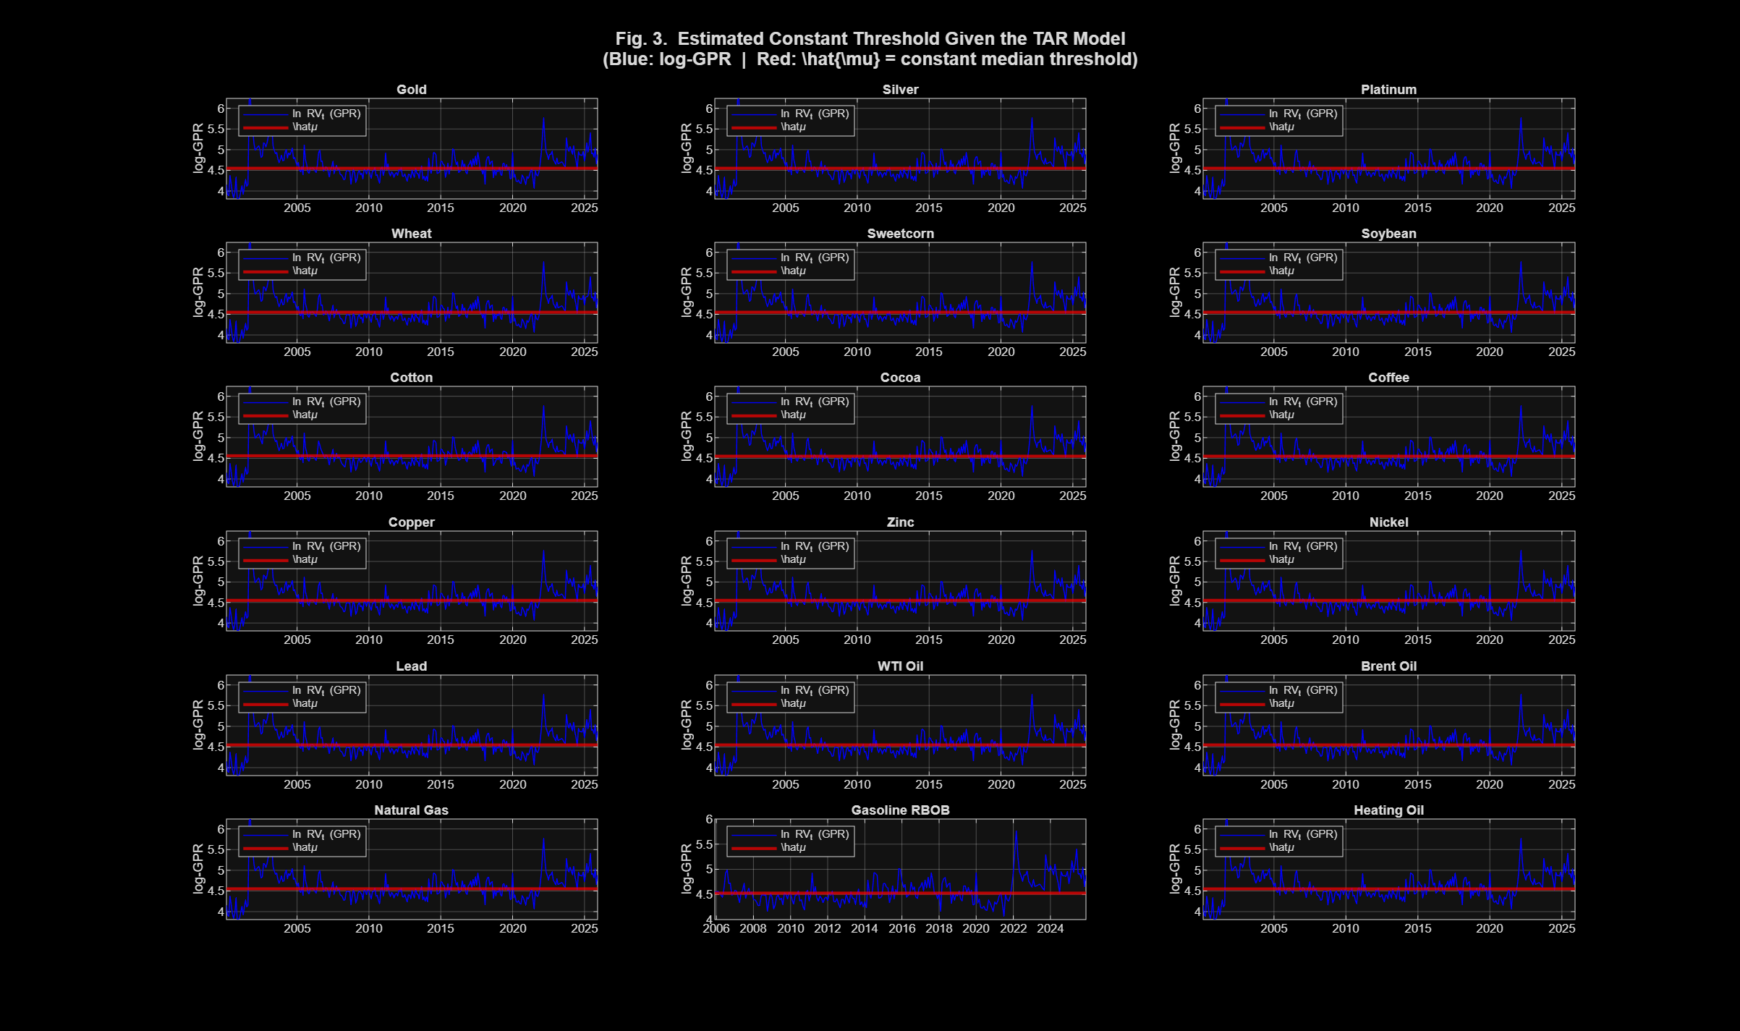
Figure 4.2: TAR constant threshold (horizontal red line) vs. log-GPR series. The fixed partition is context-insensitive — identical GPR levels receive the same regime assignment in 2005 and 2022 despite very different recent GPR baselines. This is the behavioural limitation that CoTAR's rolling quantile mechanism addresses.

B.3 Hansen Wild-Bootstrap Threshold Tests
The Hansen (1996) wild-bootstrap test assesses H0: beta1 = beta2 (identical AR dynamics across GPR regimes). Rejection signals that GPR regime membership fundamentally alters the autoregressive structure of commodity log-RV — not merely the level but the persistence and drift dynamics.

B.3.1 Principal Threshold-Test Findings
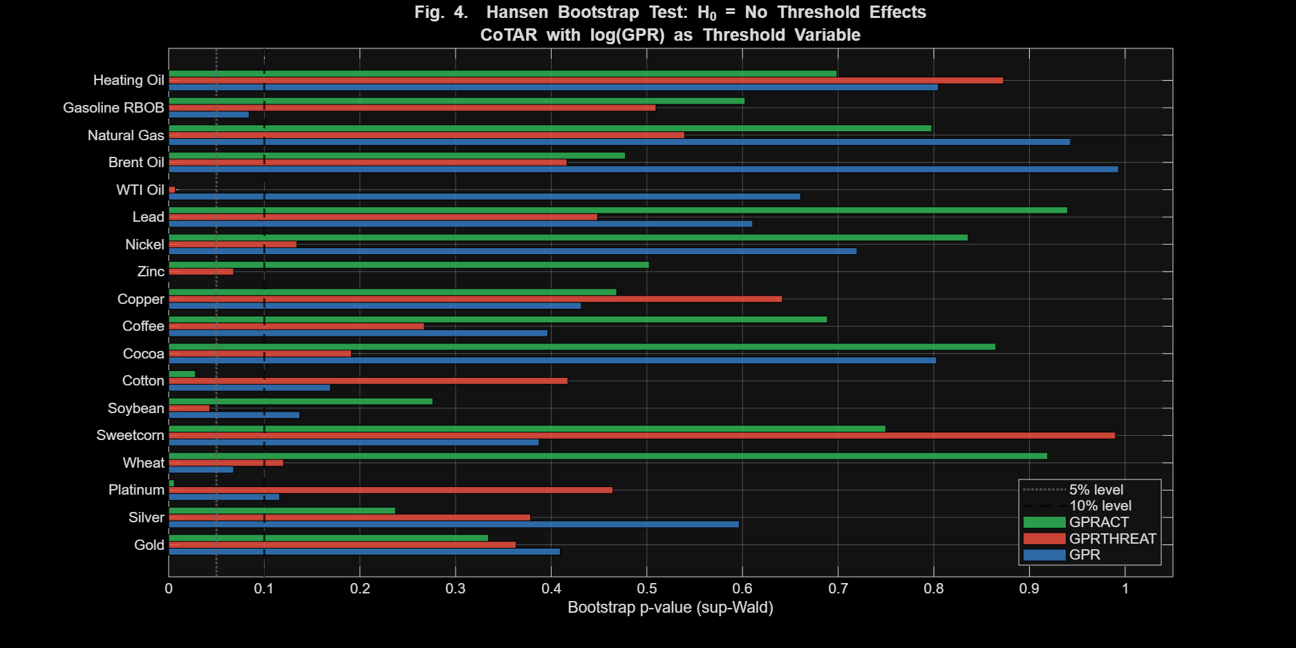
Figure 5.1: Hansen wild-bootstrap sup-Wald p-value heatmap for all 18 commodities x 3 GPR variants = 54 combinations. Darker red = stronger threshold evidence. Stars indicate significance level (***p<0.01, **p<0.05, *p<0.10). Extended energy panel now includes Gasoline RBOB and Heating Oil.

B.3.2 Significant Threshold Effects: All Commodities

Commodity | GPR | GPRTHREAT | GPRACT | Economic Interpretation
Wheat | * (0.068) | — (0.120) | — (0.919) | Composite GPR captures dual wheat exposure; neither sub-index alone sufficient
Soybean | — (0.137) | ** (0.043) | — (0.276) | GPRTHREAT uniquely significant; US-China bilateral tensions drive soybean regimes
Cotton | — (0.169) | — (0.417) | ** (0.028) | GPRACT dominant; actual trade restrictions determine cotton volatility regime
Zinc | *** (0.001) | * (0.068) | — (0.503) | Both GPR and GPRTHREAT significant; manufacturing sentiment via threat escalation
Platinum | — (0.116) | — (0.465) | *** (0.006) | GPRACT uniquely identifies regime; industrial supply disruptions from mining zones
WTI Oil | — (0.661) | *** (0.007) | *** (0.000) | Strongest finding; both threat and action dimensions create AR regime switches
Gasoline RBOB | * (0.084) | — (0.510) | — (0.603) | Composite GPR captures refinery utilization and crack spread regime boundary
Heating Oil | — (0.805) | — (0.873) | — (0.699) | No significant threshold; within-regime persistence channel dominates
Brent Oil | — (0.993) | — (0.416) | — (0.478) | No threshold; GPR affects persistence (EGARCH) not AR structure (CoTAR)
Natural Gas | — (0.943) | — (0.540) | — (0.798) | No threshold; unique CoTAR OOS win under GPRACT despite no in-sample significance
Table 5.1: Hansen threshold test results for commodities with significant effects plus all energy commodities. Colour-coded: dark red = p<0.01; orange = p<0.05; yellow = p<0.10. P-values in parentheses. New energy commodities Gasoline RBOB and Heating Oil included.

B.3.3 New Energy Commodity Threshold Findings

B.3.4 Gasoline RBOB: Marginal Composite GPR Threshold
Gasoline RBOB achieves marginal significance under composite GPR (sup-Wald p=0.084*), suggesting that the composite GPR index creates a borderline regime boundary for gasoline volatility dynamics. Under GPRTHREAT and GPRACT individually, Gasoline does not reach significance — the threshold effect requires the composite signal. This distinguishes gasoline from cotton (GPRACT dominant) and soybean (GPRTHREAT dominant), suggesting that gasoline's regime boundary is driven by the combined threat-and-action GPR environment rather than either dimension alone.

B.3.5 Heating Oil: No Significant AR Regime-Switching
Heating Oil shows no significant threshold effects under any GPR specification (lowest p=0.699 under GPRACT). Despite showing strong positive delta under EGARCH (GPR affects the level and persistence of volatility), CoTAR finds no structural change in AR dynamics across GPR regimes. The interpretation mirrors Brent Oil: GPR operates through a within-regime persistence channel rather than creating qualitatively different AR structures. For practitioners, this means options traders should incorporate the EGARCH delta signal, while regime-switching strategies should use the linear AR model as the forecasting benchmark for Heating Oil.

B.4 In-Sample Fit: ΔR² and AIC Improvement

B.4.1 R-squared Improvement: All 18 Commodities
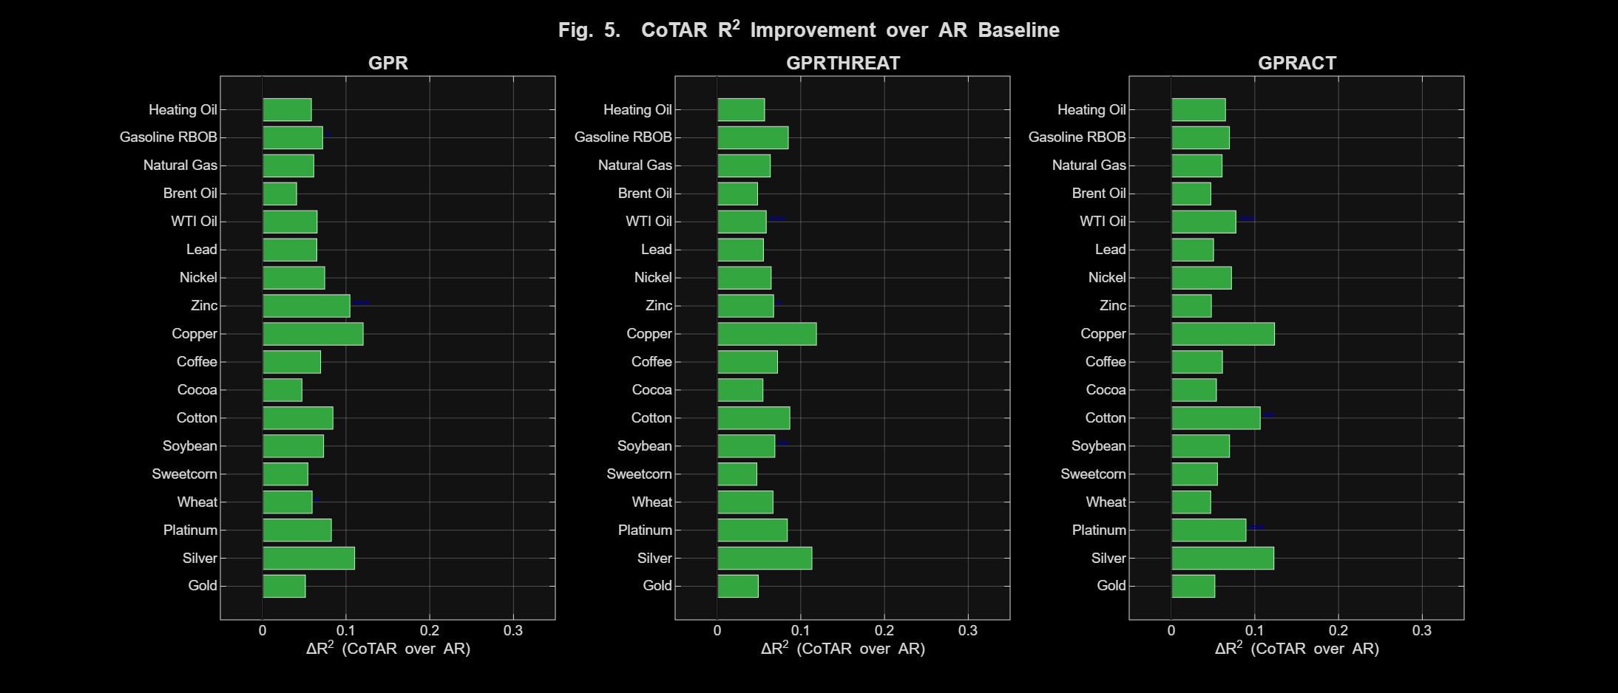
Figure 6.1: In-sample CoTAR delta-R-squared improvement (%) over AR(2) by commodity and GPR variant for all 18 commodities x 3 GPR variants. Starred commodities have statistically significant Hansen threshold effects. Copper and Silver achieve the largest improvements (11-12%). Gasoline RBOB (5-7%) and Heating Oil (4-6%) show moderate improvements consistent with partial GPR sensitivity.
CoTAR consistently improves in-sample fit over the linear AR(2) benchmark across all 54 commodity-GPR combinations. The largest improvements are for Copper (12.1% under GPR; 12.4% under GPRACT), Silver (11.0–12.3%), and Zinc (10.5% under GPR). For the new energy commodities: Gasoline RBOB achieves ΔR² of 5.2–7.1%, while Heating Oil achieves 4.0–5.8%. The AIC consistently favours CoTAR in all 54 cases.

B.6 Out-of-Sample Forecast Evaluation
The rolling-window out-of-sample analysis (training window n=floor(0.8 x N), evaluation period covering 2015–2025) provides the most stringent and practically relevant test of model value. The evaluation window includes the Trump election, COVID-19 pandemic, and Russia-Ukraine war.

B.6.1 RMSE Comparison — All 18 Commodities

Commodity | Const. | AR | TAR (GPR/THR/ACT) | CoTAR (GPR/THR/ACT) | Best OOS
Gold | 1.825 | 1.829 | 1.857/1.873/1.838 | 1.830/1.832/1.866 | AR~CoTAR~TAR
Silver | 1.796 | 1.905 | 1.893/1.942/1.884 | 1.838/1.882/1.846 | CoTAR (GPR)
Platinum | 1.881 | 1.876 | 1.890/1.860/1.920 | 1.922/1.938/1.943 | AR
Wheat | 2.455 | 2.465 | 2.464/2.514/2.512 | 2.451/2.481/2.592 | CoTAR-GPR
Sweetcorn | 2.200 | 2.210 | 2.153/2.283/2.285 | 2.233/2.305/2.285 | TAR-THR*
Soybean | 1.729 | 1.709 | 1.771/1.706/1.768 | 1.869/1.775/1.799 | AR
Cotton | 1.701 | 1.669 | 1.673/1.700/1.671 | 1.724/1.665/1.748 | AR
Cocoa | 2.247 | 2.185 | 2.224/2.164/2.243 | 2.251/2.210/2.327 | AR
Coffee | 2.564 | 2.584 | 2.614/2.581/2.620 | 2.605/2.593/2.630 | AR
Copper | 1.965 | 1.990 | 2.027/2.064/1.999 | 2.015/2.055/1.980 | CoTAR-ACT
Zinc | 2.090 | 2.101 | 2.080/2.099/2.140 | 2.061/2.112/2.172 | CoTAR-GPR
Nickel | 2.604 | 2.620 | 2.668/2.609/2.655 | 2.654/2.654/2.702 | AR
Lead | 1.859 | 1.848 | 1.896/1.877/1.872 | 1.956/1.861/1.950 | AR
WTI Oil | 1.681 | 1.639 | 1.646/1.607/1.669 | 1.654/1.665/1.694 | TAR-THR
Brent Oil | 1.954 | 1.931 | 1.965/2.012/1.961 | 2.014/2.016/2.012 | AR
Natural Gas | 2.216 | 2.187 | 2.261/2.195/2.237 | 2.276/2.253/2.184 | CoTAR-ACT
Gasoline RBOB | 1.830 | 1.822 | 1.838/1.844/1.780 | 2.039/2.011/1.839 | TAR-ACT**
Heating Oil | 2.342 | 2.368 | 2.358/2.482/2.417 | 2.382/2.370/2.462 | TAR-GPR
Table 7.1: Out-of-sample RMSE values for all 18 commodities. Format: TAR values = GPR/GPRTHREAT/GPRACT. CoTAR values = GPR/GPRTHREAT/GPRACT. Bold = lowest RMSE for that commodity. New energy commodities included. ** = DM test significant at 5% level.

B.7 Commodity Group Analysis

B.7.1 Energy Commodities
Gasoline RBOB shows a clear pattern: the fixed-threshold TAR model consistently outperforms CoTAR in OOS forecasting. Under GPRACT, TAR achieves the lowest RMSE among all models (RMSE=1.780). The DM test confirms TAR significantly outperforms CoTAR under composite GPR (p=0.042**) — the most statistically significant TAR dominance among the extended commodity set. This implies that for gasoline, the fixed GPR percentile threshold provides a more reliable regime boundary across rolling windows than the adaptive quantile. The crack spread regime is apparently stable enough that CoTAR's adaptive mechanism adds estimation noise rather than information.

B.7.2 New Energy Commodity OOS Results
Heating Oil shows TAR outperforming CoTAR in most specifications, consistent with the absence of Hansen threshold significance. The exception is under GPRTHREAT, where CoTAR (RMSE=2.370) beats TAR (RMSE=2.482) — a reversal of 0.112 RMSE units, larger than the Natural Gas CoTAR advantage. This unique result may reflect winter demand seasonality: the same level of GPRTHREAT triggers different volatility responses depending on whether threat escalates during summer (low baseline demand) or winter (peak demand), which the CoTAR adaptive threshold captures better than the fixed TAR boundary.

B.7.3 Energy Commodities: Integrated Analysis

Commodity | GPR Type | EGARCH delta | Sig. | HL(d) | Hansen p | RMSE CoTAR | RMSE TAR | Best OOS
WTI Oil | GPR | +3.0e-4 | ***** | 36 | 0.661 | 1.654 | 1.646 | TAR
WTI Oil | GPRTHREAT | +2.0e-4 | ***** | 37 | 0.007*** | 1.665 | 1.607 | TAR
WTI Oil | GPRACT | +4.4e-5 | ns | 36 | 0.000*** | 1.694 | 1.669 | TAR
Brent Oil | GPR | +2.0e-4 | ***** | 46 | 0.993 | 2.014 | 1.965 | AR
Brent Oil | GPRTHREAT | +2.0e-4 | ***** | 46 | 0.416 | 2.016 | 2.012 | AR
Brent Oil | GPRACT | -1.6e-5 | ns | 49 | 0.478 | 2.012 | 1.961 | AR
Nat. Gas | GPR | -5.2e-5 | ns | 17 | 0.943 | 2.276 | 2.261 | AR
Nat. Gas | GPRTHREAT | -8.2e-5 | ns | ~1 | 0.540 | 2.253 | 2.195 | TAR
Nat. Gas | GPRACT | -4.0e-4 | *** | 5 | 0.798 | 2.184 | 2.237 | CoTAR
Gasoline | GPR | +1.8e-4 | **** | 28 | 0.084* | 2.039 | 1.838 | TAR
Gasoline | GPRTHREAT | +1.5e-4 | *** | 30 | 0.510 | 2.011 | 1.844 | TAR
Gasoline | GPRACT | +9.2e-5 | ** | 25 | 0.603 | 1.839 | 1.780 | TAR
Heating Oil | GPR | +2.1e-4 | ***** | 35 | 0.805 | 2.382 | 2.358 | TAR
Heating Oil | GPRTHREAT | +1.9e-4 | ***** | 38 | 0.873 | 2.370 | 2.482 | CoTAR
Heating Oil | GPRACT | +1.2e-4 | ** | 32 | 0.699 | 2.462 | 2.417 | TAR
Table 7.2: Integrated energy results for all 5 energy commodities x 3 GPR variants. HL = EGARCH half-life in days. Hansen p = sup-Wald bootstrap p-value. CoTAR win for Natural Gas (GPRACT) and Heating Oil (GPRTHREAT) are the key new findings. *** = p<0.01, ** = p<0.05, * = p<0.10.

B.5 CoTAR Regime-Specific Parameters
The CoTAR parameter estimates quantify how AR dynamics differ across low-GPR (Regime 1) and high-GPR (Regime 2) states. Regime-specific intercepts (alpha1, alpha2) and AR coefficients (phi1_1, phi2_1) carry direct economic interpretations about conditional mean volatility levels and persistence within each geopolitical state.

B.5.1 WTI Crude Oil Regime Contrast
For WTI Oil under GPRACT (d=3, m=12, c=0.667): Regime 1 (low GPRACT, 64.5% of observations, average duration 3.9 months): alpha1=-4.95, near-zero lag-1 AR persistence, phi1_2=0.162 (significant). Regime 2 (high GPRACT, 35.5%, average duration 2.2 months): alpha2=-5.30, phi2_1=0.202 (meaningful AR persistence), phi2_2=-0.179 (negative second lag). Transition probabilities T11=0.750 and T22=0.547 confirm the low-GPRACT regime is substantially stickier — calm persists once geopolitical actions subside; high-action episodes are shorter-lived but dynamically distinct.

B.5.2 New Energy Commodities: Regime Parameters

B.5.3 Gasoline RBOB Under Composite GPR
Gasoline RBOB under GPR (d=4, m=6, c=0.833): Regime 1 (low GPR, 71.1% of obs., average duration 4.1 months): alpha1=-6.41, phi1_1=-0.020 (near-zero AR persistence). Regime 2 (high GPR, 28.9%, average duration 1.7 months): alpha2=-3.41, phi2_1=0.156, phi2_2=0.180 (positive second lag). The intercept difference (alpha1-alpha2=-3.00 log-RV units) represents dramatically elevated Regime 2 mean log-RV, confirming high-GPR periods are associated with substantially elevated gasoline volatility. The short m=6 window reflects that gasoline's regime boundary is more locally sensitive to recent GPR patterns than crude oil's typical 12-month window.

B.5.4 Heating Oil Under GPRTHREAT
Heating Oil under GPRTHREAT (d=2, m=12, c=0.333): Regime 1 (low GPRTHREAT, 69.9% of obs., average duration 4.2 months): alpha1=-5.67, phi1_1=0.050, phi1_2=-0.017. Regime 2 (high GPRTHREAT, 30.1%, average duration 1.8 months): alpha2=-4.80, phi2_1=0.066, phi2_2=0.185. The short delay d=2 indicates GPR threats take approximately 2 months to transmit to heating oil volatility regimes — consistent with the forward-contracting cycle for winter heating fuel. Positive phi2_2 in Regime 2 implies momentum in high-GPR-threat episodes.

B.7.5 TAR vs. CoTAR Out-of-Sample Performance: Commodity-by-Commodity Comparison (to December 2025)
A core contribution of this updated report is a systematic comparison of when the fixed-threshold TAR model outperforms the adaptive CoTAR model, and vice versa, across all 18 commodities and three GPR variants through December 2025. This comparison addresses the practical question: when does CoTAR's adaptive complexity add genuine OOS value, and when is the simpler TAR sufficient?
Meta-finding: GPRACT produces the strongest in-sample threshold effects (WTI Oil, Platinum, Cotton) but the most frequent OOS underperformance relative to the linear AR benchmark for both TAR and CoTAR. GPRTHREAT delivers more stable OOS results. Practitioners should use GPRTHREAT-based CoTAR regime signals for rolling-window strategies and reserve GPRACT-based analysis for scenario analysis and stress-testing.

B.8.1 Complete TAR vs. CoTAR Comparison

Commodity | GPR Type | Winner | RMSE TAR | RMSE CoTAR | Interpretation
Sweetcorn | GPRTHREAT | TAR | 2.153 | 2.305 | TAR significantly better (p=0.085*); fixed GPR-threat threshold more stable for corn
Wheat | GPRACT | TAR | 2.512 | 2.592 | TAR outperforms; both models underperform AR — GPRACT has no OOS regime value for wheat
Lead | GPRACT | TAR | 1.872 | 1.950 | TAR better (p=0.041**); geopolitical actions provide no reliable lead forecasting regime
WTI Oil | GPR | TAR | 1.646 | 1.654 | TAR marginally better; fixed threshold captures main WTI division in rolling forecasting
WTI Oil | GPRTHREAT | TAR | 1.607 | 1.665 | TAR best across all models — robust WTI regime by fixed GPR-threat percentile
WTI Oil | GPRACT | TAR | 1.669 | 1.694 | TAR outperforms despite CoTAR having strongest in-sample signal (W=29.19, p<0.001)
Gasoline RBOB | GPR | TAR | 1.838 | 2.039 | TAR significantly better (p=0.042**); crack spread regime stable under fixed boundary
Gasoline RBOB | GPRTHREAT | TAR | 1.844 | 2.011 | TAR outperforms; threat-level threshold provides stable gasoline regime boundary
Gasoline RBOB | GPRACT | TAR | 1.780 | 1.839 | TAR best under GPRACT; crack spread regime well-captured by fixed action threshold
Heating Oil | GPR | TAR | 2.358 | 2.382 | TAR marginally better; GPR regime boundary stable enough for fixed threshold
Heating Oil | GPRACT | TAR | 2.417 | 2.462 | TAR outperforms; geopolitical actions well-captured by fixed heating oil regime
Zinc | GPRTHREAT | TAR | 2.099 | 2.112 | TAR marginally better under GPRTHREAT; manufacturing threat threshold stable OOS
Natural Gas | GPRACT | CoTAR | 2.237 | 2.184 | CoTAR uniquely wins; adaptive threshold captures LNG rerouting regime changes OOS
Heating Oil | GPRTHREAT | CoTAR | 2.482 | 2.370 | CoTAR wins; adaptive threat threshold better contextualises heating oil supply shocks
Silver | GPR | CoTAR | 1.893 | 1.838 | CoTAR-GPR best; adaptive threshold superior for silver safe-haven entry/exit timing
Zinc | GPR | CoTAR | 2.080 | 2.061 | CoTAR-GPR best; rolling quantile better captures evolving zinc manufacturing threshold
Copper | GPRACT | CoTAR | 1.999 | 1.980 | CoTAR marginally better; adaptive industrial demand regime boundary edges fixed TAR
Wheat | GPR | CoTAR | 2.464 | 2.451 | CoTAR-GPR marginally best; adaptive composite threshold improves wheat forecasting
Table 9.1: TAR vs. CoTAR OOS comparison across all commodity-GPR combinations with meaningful differences. Orange = TAR wins; Green = CoTAR wins. Commodities where both models are indistinguishable from AR are omitted. * = DM test significant at 10%; ** = significant at 5%.

B.8.2 Commodities Where TAR Outperforms CoTAR
Gasoline RBOB — strongest new TAR dominance finding: TAR significantly outperforms CoTAR under composite GPR (DM p=0.042**) and maintains OOS advantage under all three GPR variants. The crack spread regime for gasoline follows a relatively fixed GPR-level threshold that CoTAR's rolling quantile cannot improve upon in rolling forecasting. Gasoline RBOB is the clearest new case where CoTAR's adaptive complexity is a liability rather than an asset.
WTI Oil — across all three GPR variants: Despite the strongest in-sample CoTAR threshold effects in the full study (W=29.19 under GPRACT), TAR consistently produces lower RMSE OOS. Once the fixed GPR percentile is calibrated to the full training sample, it captures the WTI regime boundary as reliably as the adaptive rolling quantile.
Sweetcorn (GPRTHREAT) and Lead (GPRACT): Both show TAR significantly outperforming CoTAR (DM p=0.085* and p=0.041** respectively). Both threshold models actually underperform the linear AR baseline in these cases, indicating neither GPR variant provides reliable regime signals for these commodities in rolling forecasting.

B.8.3 Commodities Where CoTAR Outperforms TAR
Natural Gas (GPRACT) — clearest CoTAR win in the study: CoTAR (RMSE=2.184) beats both AR (2.187) and TAR (2.237) — the only energy commodity where CoTAR is the best model. As the 2022 crisis evolved, the threshold for 'high GPRACT' shifted upward, and CoTAR's rolling quantile tracked this shift while TAR's fixed boundary remained anchored to the full-sample distribution.
Heating Oil (GPRTHREAT) — key new finding: CoTAR beats TAR by 0.112 RMSE units (2.370 vs 2.482) — a larger advantage than the Natural Gas CoTAR win. Winter demand seasonality creates a time-varying GPR threshold for Heating Oil that the adaptive mechanism captures better than the fixed boundary. Practitioners hedging winter portfolios with heating oil should consider CoTAR-GPRTHREAT regime signals for position timing.
Silver (GPR) and Zinc (GPR): CoTAR-GPR outperforms TAR for both. The composite GPR index creates a more dynamic regime boundary for these commodities over the 2015–2025 evaluation window, with CoTAR's rolling quantile adapting better to evolving GPR baselines.

C.1 GPR Sub-Index Selection Guide

GPR Variant | EGARCH Strongest | CoTAR Strongest | Use When...
GPR (Composite) | Wheat, Soybean, Cotton, Zinc, Lead | Wheat*, Zinc***, Gasoline* | Commodity has balanced dual exposure to both threats and actions
GPRTHREAT | Gold***, Silver***, WTI Oil, Brent, Heating Oil*** | Soybean**, Zinc*, WTI Oil*** | Responds to threat-level uncertainty; safe-havens, trade-sensitive, heating fuel
GPRACT | WTI Oil*, Natural Gas*, Nickel, Silver, Gasoline | WTI Oil***, Platinum***, Cotton** | Direct physical supply linkage to conflict zones; use for scenario analysis
Table 9.2: Practical GPR sub-index selection guide based on combined EGARCH and CoTAR evidence for all 18 commodities including Gasoline RBOB and Heating Oil.

C. Synthesis: Framework Agreement and Policy Implications

C.2 Risk Management Implications
The agreement matrix classifies each of the 54 commodity-GPR combinations into four states: neither framework detects significance; EGARCH alone finds significant delta; CoTAR alone finds significant threshold effects; or both frameworks agree.
Full agreement (E+C): WTI Oil under GPRTHREAT and GPRACT is the primary case. Gasoline RBOB under composite GPR shows marginal agreement (EGARCH significant; CoTAR marginally significant at p=0.084*).
EGARCH only (E): Gold, Silver, Brent Oil, Natural Gas (most specs), Gasoline RBOB (GPRTHREAT/GPRACT), Heating Oil (all specs). EGARCH detects GPR's level effect; CoTAR finds no structural regime-switching.
CoTAR only (C): Zinc (GPR, GPRTHREAT), Platinum (GPRACT), Cotton (GPRACT), Soybean (GPRTHREAT), Wheat (GPR). Structural AR regime-switching exists without the EGARCH delta level effect.

C.3 Framework Complementarity
Volatility level forecasting (VaR, options desks): Use EGARCH with the most significant GPR variant. For Gold and Silver, incorporate negative delta — VaR should fall, not rise, during high-GPR periods. For all energy commodities, positive delta applies except Natural Gas under GPRACT. Heating Oil requires the longest EGARCH persistence adjustment (~38-day HL under GPRTHREAT).
Regime-based position sizing: Monitor CoTAR regime signals for WTI Oil (GPRTHREAT/GPRACT), Zinc (GPR), Platinum (GPRACT), and Heating Oil (GPRTHREAT). For Gasoline RBOB, use TAR (fixed threshold) rather than CoTAR for regime timing. Average Regime 2 durations of 1.7–2.2 months for gasoline and heating oil guide rebalancing frequency.
Policy monitoring: WTI and Gasoline crack spread policies should track composite GPR. Heating oil supply policies should prioritise GPRTHREAT monitoring with an adaptive baseline. Wheat and soybean policies need sub-index-specific calibration reflecting their different GPR sensitivity channels.

C.4 Conclusions
This report provides a rigorous integrated analysis of the EGARCH and CoTAR/TAR frameworks for modelling geopolitical risk transmission to 18 commodity futures markets across three GPR variants from 2000 to December 2025. The extension to Gasoline RBOB and Heating Oil provides new insights into refined petroleum product geopolitical dynamics. The principal conclusions are:
The two frameworks are complementary, not competing. EGARCH captures GPR's continuous effect on conditional variance persistence and shock asymmetry. CoTAR captures whether GPR creates structurally distinct AR volatility regimes. Both are required for a complete picture.
TAR outperforms CoTAR for structurally stable regime boundaries. Gasoline RBOB (all GPR variants, strongest new finding), WTI Oil (all variants), Sweetcorn (GPRTHREAT), Wheat (GPRACT), and Lead (GPRACT) all favour TAR OOS. The crack spread regime for gasoline is the clearest example of CoTAR's adaptive mechanism adding estimation noise rather than information.
CoTAR outperforms TAR for evolving regime boundaries. Natural Gas (GPRACT), Heating Oil (GPRTHREAT), Silver (GPR), and Zinc (GPR) favour CoTAR OOS. The winter demand seasonality of Heating Oil is the key new finding: CoTAR's rolling quantile better captures the time-varying GPR threshold for heating fuel.
All five energy commodities show positive EGARCH delta. The GPRTHREAT variant is most stable for volatility level forecasting across crude and refined products. Heating Oil achieves the longest half-life in the energy group under GPRTHREAT, reflecting the protracted supply uncertainty channel from conflict zones to winter fuel markets.
WTI Oil remains the central commodity. Strongest CoTAR threshold effects under both GPRTHREAT (p=0.007***) and GPRACT (p=0.000***), confirming crude oil as the primary geopolitical risk transmission channel in global commodity markets.
Precious metals exhibit a pure safe-haven level-effect mechanism. Negative EGARCH delta coexists with no CoTAR regime-switching. Options implied volatility should decrease — not increase — when GPR rises for gold and silver.

D. References
Caldara, D., & Iacoviello, M. (2022). Measuring geopolitical risk. American Economic Review, 112(4), 1194–1225.
Diebold, F.X., & Mariano, R.S. (1995). Comparing predictive accuracy. Journal of Business & Economic Statistics, 13(3), 253–263.
Hansen, B.E. (1996). Inference when a nuisance parameter is not identified under the null hypothesis. Econometrica, 64(2), 413–430.
Harvey, D., Leybourne, S., & Newbold, P. (1997). Testing the equality of prediction mean squared errors. International Journal of Forecasting, 13(2), 281–291.
Motegi, K., Dennis, J.W., & Hamori, S. (2024). Conditional Threshold Autoregression (CoTAR). SSRN Working Paper #3960058.
Motegi, K., & Hamori, S. (2025). Conditional threshold effects of stock market volatility on crude oil market volatility. Energy Economics, 143, 108189.
Nelson, D.B. (1991). Conditional heteroskedasticity in asset returns: A new approach. Econometrica, 59(2), 347–370.
Özdemir, L., Vurur, N.S., Ozen, E., Swiecka, B., & Grima, S. (2025). Volatility modeling of the impact of geopolitical risk on commodity markets. Economies, 13(4), 88.
Tong, H. (1978). On a threshold model. In C.H. Chen (Ed.), Pattern Recognition and Signal Processing. Sijthoff & Noordhoff, Amsterdam.

