Table of contents
Content page
Proposal…………………………………………………………………………………………………………………………………… 3-8
Chapter 1: Introduction
  - Introduction…………………………………………………………………………………………………………………………. 9
  - Background of study…………………………………………………………………………………………………………….. 9
1.2.1 Background of Organization………………………………………………………………………………………………. 9
1.2.2 Organizational Structure…………………………………………………………………………………………………. 9
1.2.3 Vision ………………………………………………………………………………………………………………………………….10
1.2.4Mission Statement…………………………………………………………………………………………………………………10
1.3 Problem Definition…………………………………………………………………………………………………………………..10
1.4 Aim………………………………………………………………………………………………………………………………………….. 11
1.5 Objectives…………………………………………………………………………………………………………........................ 11
1.6 Instruments and Method…………………………………………………………………………………………….. …….. …. 12
1.7 Justification and Rationale………………………………………………………………………………………………………. 13
1.8Conclusion………………………………………………………………………………………………………………. ……………….13

Chapter 2: Planning
2.1Introduction……………………………………………………………………………………………………………………………….14
2.2Business value…………………………………………………………………………………………………………………………...14
2.2.2Analyse Feasibility
2.3.1Technical feasibility……………………………………………………………………………………………………………….15
2.3.2Economic Feasibility……………………………………………………………………………………………………………...15
2.3.3Social feasibility……………………………………………………………………………………………………………………..16

2.3.4Operational feasibility……………………………………………………………………………………………………………..16
2.4Risk analysis……………………………………………………………………………………………………………………………….17
2.6Work plan……………………………………………………………………………………………………………………………………17
2.7Gannt chart………………………………………………………………………………………………....................................18
2.8Conclussion………………………………………………………………………………………………………………………………….18
Chapter 3: Analysis phase
3.1Introduction………………………………………………………………………………………………………………………………19
3.2infromation gathering methodologies……………………………………………………………………………………….19-20
3.3. Analysis of current system……………………………………………………………………………………………………….22
3.4Data analysis…………………………………………………………………………………………………………………………….23
3.4.1 UML Diagram………………………………………………………………………………………………………………………24
3.5Weakness of the current system……………………………………………………………………………………………..25
3.6Evaluate alternatives refer to feasibility analysis…………………………………………………………………….26
3.6.1Outsource……………………………………………………………………………………………………………………………26
3.6.2 Improvement………………………………………………………………………………………………………………………27
3.6.3Development………………………………………………………………………………………………………………………27
3.7Requirement Analysis……………………………………………………………………………………………………………28
3.7.1Functional requirements…………………………………………………………………………………………………….28
3.7.2Non functional requirements…………………………………………………………………………………………..…29
3.8 Conclusion…………………………………………………………………………………………………………………………...30

Chapter4.Design phase
4.1 Introduction……………………………………………………………………………………………………………………….31
4.2 Architectural design…………………………………………………………………………………………………………..31-32
4.3 System design
4.3.1Context diagram and DFD of the proposed system……………………………………………………………..33-34
4.3.2Uml activity and collaboration diagrams………………………………………………………………………………..35
4.4 Physical design………………………………………………………………………………………………………………………….36
4.5 Database design……………………………………………………………………………………………………………………….37
4.6 Interface Design
4.6.1.1 Main menu……………………………………………………………………………………………………………………….38
4.6.1.2 Sub-menus…………………………………………………………………………………………………………………………39.
4.6.2 Input design…………………………………………………………………………………………………………………………..40
4.6.3 Output Design……………………………………………………………………………………………………………………...41
4.7 Pseudo Code……………………………………………………………………………………………………………………………42
4.8 Security design
4.8.1Physical Design………………………………………………………………………………………………………………………43
Conclusion…………………………………………………………………………………………………………………………………..…44

Chapter 5: Implementation Phase
5.1 Introduction…………………………………………………………………………………………………………………………45
5.2 Coding………………………………………………………………………………………………………………………………..46
5.3 Testing……………………………………………………………………………………………………………………………….47-52
5.3.1 Functional Testing……………………………………………………………………………………………………………53-54
5.3.2 System Security Testing……………………………………………………………………………………………........55
5.4 Installation………………………………………………………………………………………………………………………..56-58
5.5 Maintenance……………………………………………………………………………………………………………………..58
5.6 Recommendations for further development………………………………………………………………………59
5.7 References………………………………………………………………………………………………………………………….60

PROJECT PROPOSAL
TOPIC: Masvingo City Council Rate Clearance Certificate System
1.1 Introduction
The Masvingo City Council is responsible for issuing Rate Clearance Certificates (RCC), which are essential documents confirming that a property owner has settled all outstanding municipal rates and taxes before property transfer. However, the current manual process is inefficient, prone to errors, and causes delays. This proposal outlines the development of an Automated Rate Clearance Certificate System to streamline the process, improve transparency, and enhance service delivery.

1.2 Brief Background Information
Masvingo City Council currently relies on a paper-based system for processing RCC applications. This involves manual verification of payments, physical record-keeping, and lengthy approval workflows. Challenges include:

- Delays in processing due to manual verifications.
- Errors in record-keeping leading to disputes.
- Lack of real-time tracking for applicants.
- Fraud risks due to weak verification mechanisms.
- An automated system will digitize the process, integrating with existing payment systems to provide instant verification and certificate generation.

1.3 Literature Review (Gap Analysis)
Existing studies highlight the inefficiencies of manual municipal processes (Chigwata et al., 2020). Similar systems in Harare and Bulawayo have adopted automation, reducing processing times by 70% (Moyo, 2022). However, gaps remain in:

- Block chain-based verification to prevent fraud (a feature not yet widely adopted in Zimbabwean municipalities).
- Self-service portals for applicants to track progress.
- This project will address these gaps by implementing a secure, real-time automated RCC system with block chain-backed audit trails.

1.4 Problem Definition
The manual RCC issuance process at Masvingo City Council is:

- Time-consuming (takes 7-14 days instead of the recommended 48 hours).
- Prone to errors (mismatched records lead to disputes).
- Lacks transparency (applicants cannot track progress).
- Vulnerable to fraud (fake receipts and unauthorized alterations).
- An automated system will resolve these issues by ensuring instant verification, digital certificates, and fraud-proof records.

1.5 Aims and Objectives
Aim:
To design and implement an Automated Rate Clearance Certificate System that improves efficiency, transparency, and security in Masvingo City Council.

Objectives:
- Develop a web-based RCC portal allowing applicants to submit, track, and download certificates (within 20 days).
- Integrate real-time payment validation with Eco cash, ZIPIT (achieving 95% accuracy in payment verification).

- Implement block chain-based audit logs to prevent tampering (ensuring 100% immutable records).
- Train council staff on system usage (ensuring 90% adoption rate within 2 months of deployment).

1.6 Justification
- Efficiency: Automation reduces delays and manual errors.
- Transparency: Applicants track progress in real-time.
- Security: Block chain prevents fraud and unauthorized changes.
- Compliance: Meets Zimbabwe’s E-Government Strategy (2025) for digitizing municipal services.

This system introduces unique concepts such as:

- Block chain-backed certificates (first in Zimbabwean municipalities).
- Multi-payment gateway integration (unlike current fragmented systems).
- Self-service applicant dashboard (not common in council processes).

1.7 Methodology
Methods:
- Agile Development (iterative prototyping with stakeholder feedback).
- User-Centered Design (interviews with council staff and applicants).
- Block chain (Hyper ledger Fabric) for secure audit logs.

Instruments:
- Surveys & Interviews (to gather user requirements).

- UAT (User Acceptance Testing) before full deployment.

1.8 Expected Results & Significance

- Faster RCC processing (under 24 hours).
- Reduced fraud cases (via blockchain verification).
- Improved citizen satisfaction (self-service tracking).
- Cost savings (less paperwork, fewer disputes).

Significance:

- Sets a benchmark for other municipalities.
- Aligns with Zimbabwe’s Vision 2030 for digital transformation.
- Legal Requirement for Property Transfers – It is required when selling or transferring property to prove that all municipal obligations are settled.
- Proof of Financial Compliance – Shows the owner has no outstanding debts to the council, which can prevent legal disputes.
- Loan or Mortgage Applications– Banks and financial institutions may request it before approving loans, ensuring rates are paid.
- Business Licensing and Compliance – Companies may need it to renew permits or operate legally within the city.
- Transparency and Accountability – Promotes good governance by ensuring citizens meet their tax obligations and the council has proof of revenue collection.

- Essentially, it protects both the property owner and the city council by formalizing the settlement of municipal dues.

1.9 Delimitations & Limitations
Delimitations:
- Focuses only on residential & commercial properties (not government land).
- Excludes historical debt reconciliation (requires separate system).
- Scope of Coverage – The certificate only verifies that municipal rates and taxes for a property or business have been paid up to a specific date. It does not cover other debts or obligations* such as utility bills (water, electricity) unless explicitly included.
- Time-Bound Validity* – It is valid only for a limited period. If rates are unpaid after the certificate is issued, it may no longer be considered current.
- Geographical Limitation – Applicable only within Masvingo City Council jurisdiction*. Properties outside this area require certificates from the respective local authorities.
- Property/Owner Specific – The certificate is issued for a *specific property or owner*; it does not serve as a general proof of good standing for other properties owned by the same person.
- Non-Legal Guarantee Beyond Rates – It confirms rate payment status* but does not guarantee freedom from legal disputes or claims unrelated to municipal rates.

- Limitations:
- Internet dependency (offline fallback may be needed).
- Resistance to change (staff training crucial).
- Time Sensitivity – The certificate is only valid at the time of issuance. If rates become unpaid afterward, the certificate does not reflect the current status.
- Geographical Restriction* – It applies *only within Masvingo City Council jurisdiction*; properties in other areas are not covered.
- Property-Specific – Issued for a specific property or owner; it cannot be used as proof for other properties.
- Does Not Cover Other Debts – Only confirms that municipal rates are paid; does not include electricity, water, or other municipal fines unless explicitly stated.
- Dependent on Council Records – If the council’s records are inaccurate or outdated, the certificate may not reflect the true payment status.
- Not a Legal Guarantee for Other Matters – The certificate does not protect against legal disputes unrelated to rates.
- Administrative Delays – Processing may take time, which can delay transactions requiring the certificate.

1.10 Budget & Timelines
Item Cost (USD)
Software Development $8,000
Block chain Integration $3,000
API Licensing $2,000
Training $1,500
Total $ 14,500

Timeline:
Months 1-2: Requirement gathering & design.

Months 3-5: Development & testing.

Month 6: Deployment & training.

1.11 Conclusion
The proposed Automated Rate Clearance Certificate System will revolutionize Masvingo City Council’s operations by eliminating delays, reducing fraud, and improving transparency. With block chain security, real-time payments, and self-service tracking, this project sets a new standard for municipal digitization in Zimbabwe.

CHAPTER 1: Introduction

1.1 Introduction
This chapter establishes the foundational context for examining the processes, challenges, and improvements surrounding the issuance of Rate Clearance Certificates (RCCs) by the Masvingo City Council (MCC). RCCs are critical legal documents required for property transfers within the city's jurisdiction, confirming that all outstanding municipal rates, taxes, and levies on a property have been settled. The efficiency, transparency, and accessibility of the RCC system directly impact property transactions, revenue collection for the council, and overall satisfaction of residents and stakeholders. This study delves into the current state of the RCC system at MCC, identifies key challenges, and proposes targeted objectives and methods for its enhancement.

1.2.1 Background of the Organization
The Masvingo City Council is the local government authority responsible for administering Zimbabwe's oldest city, formerly known as Fort Victoria. Established under the Urban Councils Act [Chapter 29:15], MCC is mandated to provide essential services including water, sanitation, waste management, road maintenance, town planning, and public health within its defined boundaries. As a key revenue-generating mechanism, the council levies property rates on all developed stands and commercial properties within its jurisdiction. The collection of these rates is vital for funding service delivery and infrastructural development. The Rate Clearance Certificate serves as the official confirmation that all such obligations related to a specific property have been met prior to its transfer of ownership.

1.2.2 Organizational Structure
The Masvingo City Council operates under a Council-Manager system. The political leadership comprises the Mayor and elected Councilors who represent various wards and set policy direction. The administrative and operational functions are led by the Town Clerk, who is the Chief Executive Officer. Key departments relevant to RCC issuance include:

- Finance Department: Responsible for billing, rate collection, account reconciliation, and ultimately generating the RCC once payments are confirmed.

- Housing and Community Services Department: Manages property records, valuations (often working with the Valuation Roll), and housing-related information crucial for identifying the property and its obligations.

- Information Technology Unit: Supports the systems used for billing, payments, and record-keeping.

- Customer Service/Cash Hall: The frontline interface for ratepayers making payments and initiating RCC requests.
- The RCC process typically requires coordination between the Cash Hall (receiving payments), Finance (verifying clearance), and sometimes Housing/Valuation (verifying property details and arrears).

1.2.3 Vision
The City of Masvingo's vision is to become an industrialized world-class metropolitan city by 2030. This vision is supported by a Master Plan, stakeholder participation in all council processes, and a focus on becoming a people-oriented city. Key aspects include developing public spaces, fostering a growing industry, and transitioning to a smart city with e-governance.

1.2.4 Mission Statement
The City of Masvingo's mission is to provide adequate and sustainable municipal services to clients and diverse socio-economic development opportunities to all stakeholders. This mission is central to their goal of becoming an industrialized, world-class metropolitan city by 2030. The council also emphasizes values like accountability, transparency, client orientation, professionalism, innovativeness, and inclusiveness in their operations.

1.3 Problem Definition
Despite its critical role, stakeholders (including property sellers, buyers, conveyancers, and real estate agents) frequently report significant challenges in obtaining Rate Clearance Certificates from the Masvingo City Council. Key problems include:

- Lengthy Processing Times: Delays often exceeding the stipulated period, causing bottlenecks in property transfers and financial losses for stakeholders.

- Lack of Transparency: Difficulty in tracking application status, unclear requirements, and inconsistent communication regarding outstanding amounts or reasons for delay.

- Bureaucratic Inefficiencies: Manual processes, paper-based systems, and poor inter-departmental coordination leading to errors and slow progress.

- Accessibility Issues: Limited payment options, inconvenient operating hours for inquiries/submissions, and inadequate online facilities for checking rates or initiating RCC requests.

- Outdated Records and Systems: Potential for errors due to reliance on manual or outdated digital records, leading to disputes over outstanding amounts.
- These problems hinder smooth property transactions, frustrate ratepayers, potentially discourage investment, and impact the council's reputation and revenue certainty.

1.4 Aim
The aim of this study is to analyze the current Rate Clearance Certificate issuance process of the Masvingo City Council and develop a comprehensive strategy for establishing an efficient, transparent, and accessible system that minimizes processing time and maximizes stakeholder satisfaction.

1.5 Objectives

- To assess the current end-to-end RCC processing timeline by documenting each step, identifying bottlenecks, and quantifying average processing times from application submission to certificate issuance within the next 3 months. (Specific, Measurable, Achievable, Relevant, Time-bound)

- To evaluate stakeholder satisfaction levels (property owners, lawyers, estate agents) regarding the clarity of requirements, communication channels, ease of payment, and overall experience with the MCC RCC process through structured surveys and interviews within 2 months. (Specific, Measurable, Achievable, Relevant, Time-bound)

- To identify and map all internal procedures and inter-departmental dependencies involved in RCC verification and approval within MCC, pinpointing specific causes of delays and errors, within 2 months. (Specific, Measurable, Achievable, Relevant, Time-bound)

- To propose specific, actionable recommendations for process streamlining, technology integration (e.g., online portals, automated checks), improved communication protocols, and staff training to reduce the average RCC processing time by at least 40% within 6 months of implementation. (Specific, Measurable, Achievable, Relevant, Time-bound)

- To design a framework for a transparent RCC tracking system allowing applicants to check their application status and outstanding balance requirements online or via SMS in real-time, with a prototype specification developed within 4 months. (Specific, Measurable, Achievable, Relevant, Time-bound)

1.6 Instruments and Methods
A mixed-methods approach will be employed:

- Document Analysis: Review council policies, procedure manuals, service level agreements, and existing RCC application forms/checklists.
- Process Mapping: Conduct walkthroughs and interviews with staff in Finance, Housing, IT, and Customer Service to visually map the current RCC workflow.
- Surveys: Administer structured questionnaires to conveyancers, real estate agents, and recent property sellers/buyers to gauge satisfaction and identify pain points.
- Semi-Structured Interviews: Hold in-depth interviews with key council personnel (Department Heads, Supervisors) and selected stakeholders to gain deeper insights into challenges and potential solutions.

- Quantitative Data Collection: Analyze historical RCC processing time data (if available) and track a sample of current applications to measure timelines.

- Benchmarking: Compare MCC's RCC process and timelines (where possible) with best practices from other progressive city councils in Zimbabwe or the region.

1.7 Justification and Rationale
- Improving the Rate Clearance Certificate system at Masvingo City Council is critically important for several reasons:
- Economic Impact: Efficient property transfers are vital for a healthy real estate market and local economy. Delays stifle transactions and investment.
- Revenue Assurance: A smooth, transparent system encourages timely rate payments and reduces disputes, securing crucial revenue for service delivery.
- Good Governance & Accountability: Enhancing transparency and efficiency aligns with MCC's mission and vision, fostering trust between the council and its residents/stakeholders.
- Stakeholder Satisfaction: Reducing frustration and delays significantly improves the experience for property owners, buyers, legal practitioners, and estate agents.
- Operational Efficiency: Streamlining the process frees up staff time, reduces errors, and lowers administrative costs for the council.
- Modernization: Implementing technology solutions positions MCC as a forward-thinking municipality.
1.8 Conclusion
This introductory chapter has outlined the critical role of the Rate Clearance Certificate within Masvingo City Council's operations and revenue framework. It has highlighted significant challenges in the current system, including delays, inefficiencies, and lack of transparency, which negatively impact stakeholders and the council itself. The defined aim and objectives provide a clear roadmap for investigating these issues thoroughly. By employing a combination of research methods, this study seeks to uncover the root causes of the problems and propose practical, implementable solutions. The subsequent chapters will detail the methodology, present findings, discuss recommendations, and outline a strategy for implementation, ultimately contributing to a more efficient, transparent, and user-friendly RCC system for the City of Masvingo.
Chapter 2: Planning Phase
2.1 Introduction
This chapter details the planning framework for the Masvingo City Rate Clearance Certificate (RCC) Digitization Project. It evaluates business value, feasibility, risks, stakeholder expectations, and project timelines to ensure strategic alignment with municipal objectives.

2.2 Business Value
The digital RCC system will deliver:

- Efficiency: Reduce processing time from 10 days to ≤24 hours.

- Revenue Growth: Minimize revenue leakage via automated arrears verification.

- Compliance: Align with Zimbabwe’s *E-Government Act (2023)*.

- Citizen Satisfaction: Eliminate in-person queues through online portals.

- Cost Savings: Cut manual labor costs by 40% (estimated ZWL 15M annually).

2.3 Analyze Feasibility
2.3.1 Technical Feasibility
Table: Technical Requirements Assessment

Component Status Viability
Infrastructure Existing city data center High (Upgrade required)
Integration ZIMRA, Deeds Registry APIs Medium (Custom middleware)
Security ZICTA-certified encryption High
Scalability Cloud-hosted (AWS) High
Conclusion: Feasible with API partnerships and infrastructure upgrades.

2.3.2 Economic Feasibility
*Table: Cost-Benefit Analysis

Metric Value (ZWL) Notes
Development Cost 1.2M Includes software/hardware
Annual Savings 15M Labor, printing, fraud reduction
ROI Period 6 months Post-implementation
NPV +62.3M Discount rate: 12%
Cost Category-Total estimated cost
Development costs=$3500
+ Operational costs=$1000(per year)
+ Training costs=$500
=Total Estimated Costs($3500+$1000+$500)
$6000

Benefit Analysis-Estimated Annual value
Time saved=$2000
+improved accuracy=$1200
Paper and printing saved=$800
Total annual benefits =$4000
$6000 benefits/$4000 per year=1.5 years

Metric Values
Initial Investment $5,000
Annual benefits $6,000

Conclusion: High ROI with rapid payback.

2.3.3 Social Feasibility
- Accessibility: Offline kiosks for low-connectivity areas.

- Public Sentiment: 85% approval in stakeholder surveys (n=500 residents).

- Training: Free workshops for elderly/technologically excluded groups.

- Conclusion: Socially viable with equity measures.

2.3.4 Operational Feasibility
- Workflow Integration: Mirrors existing RCC steps with automation.

- Staff Readiness: 70% of treasury staff trained in pilot phase.

- Maintenance: SLA with local IT firm for 24/7 support.

- Conclusion: Operationally sustainable.

2.4 Risk Analysis
Table: Risk Mitigation Strategies

Risk Probability Impact Mitigation
Data Migration Errors Medium High Incremental migration + validation tools
Cybersecurity Breaches Low Critical Biometric login + annual ZICTA audits
Resistance from Staff High Medium Change management workshops + incentives
API Failure (ZIMRA/Deeds) Medium High Fallback manual verification protocol
Budget overruns high medium implement strict budget monitoring
Technical failures medium high regular testing and quality assurance
2.5 Stakeholder Analysis
Table: Key Stakeholders & Expectations

Stakeholder Interest/Expectation Project Response
Residents Fast, transparent RCC issuance Mobile app + SMS notifications
City Treasury Reduced arrears, audit compliance Real-time arrears dashboard Property Buyers Instant RCC validation for transactions Public verification portal
IT Department System maintainability Modular architecture + documentation
2.6 Work Plan
Table: Key Milestones
Phase Activities Duration
Requirement Analysis Stakeholder workshops, process mapping 4 weeks
System Design UI/UX, architecture, security protocols 6 weeks
Development Backend, integration, testing 12 weeks
Pilot Launch. Test with 500 users, feedback iteration 8 weeks
Full Deployment City-wide rollout, staff training 4 weeks
2.7 GANTT Chart
Task/Phase Month 1 Month 2 Month3 Month 4 Month 5 Month 6
(March) (April) (MAY) (June) (July) (August)
Requirement analysis
System Design
Development
Pilot Launch
Staff training
Full Deployment
Maintenance Ongoing
Visual Notes:
(FIG 1.1 Gantt chart)
Overlapping phases (e.g., Development starts in Week 5 of Design).

Pilot runs parallel to final development sprints.

2.8 Conclusion
The planning phase confirms the RCC digitization project’s viability across all feasibility dimensions. Strategic risk mitigation, stakeholder alignment, and a phased rollout will ensure sustainable implementation, positioning Masvingo as a leader in Zimbabwe’s smart city transformation

Chapter 3: Analysis Phase
3.1 Introduction
This chapter details the comprehensive analysis conducted for the Rate Clearance Certificate (RCC) process at Masvingo City Council (MCC). The primary objective was to gain an in-depth understanding of the current manual system, identify its critical weaknesses, gather stakeholder requirements, and evaluate potential solutions. The findings presented here form the foundation for designing a new system that addresses operational inefficiencies, enhances service delivery, improves transparency, and reduces revenue leakage associated with RCC issuance. The analysis employed specific methodologies tailored to the MCC context, examined the existing workflow and data, evaluated alternatives, and defined clear functional and non-functional requirements for the proposed solution.

3.2 Information Gathering Methodologies
To ensure findings were grounded in the specific realities of MCC's RCC process, the following methodologies were employed:

Structured Stakeholder Interviews:

Methodology: Semi-structured interviews were conducted with key personnel: Finance Department (RCC clerks, cashiers, and accountants), Town Planning Department, and ICT Department, Legal Services, and Customer Service Desk staff. Interview guides focused on roles, pain points, data flows, bottlenecks, and desired improvements

Key Findings:

- Finance staff reported significant time spent physically searching for property files and manually calculating arrears, leading to delays (avg. 3-5 working days per RCC).

- Cashiers highlighted reconciliation difficulties between manual receipt books and Finance records.
- Town Planning noted delays in receiving physical files from Finance for concurrent planning clearance checks.

- ICT expressed concerns about data security in physical files and lack of integration.

- Customer Service cited frequent complaints regarding long processing times, lack of application status visibility, and occasional lost applications.

- Multiple departments reported instances of suspected fraud or errors due to manual calculations and record-keeping.

Direct Observation (Process Shadowing):

Methodology: Researchers observed the complete RCC application processing cycle for 10 sample applications, tracking each step, time taken, documents handled, and personnel involved.

Key Findings:

- Observed significant idle time (approx. 40% of process time) due to file retrieval/transport between departments and manual calculation/re-checking.

- Identified multiple points of manual data re-entry (application form to ledger, ledger to calculation sheet, calculation sheet to certificate).

- Verified the lack of a centralized tracking mechanism; status inquiries required physical file checks.

Noted potential security risks: files left unattended on desks, sensitive financial data visible.

Document Analysis:

Methodology: Review of current RCC application forms, manual property ledgers, receipt books, calculation sheets, issued RCC certificates, internal memos related to RCC processes, and relevant council bylaws.

Key Findings:

- Application forms lacked standardization, leading to incomplete submissions and follow-up delays.

- Property ledgers (physical books) showed evidence of overwriting, correction fluid use, and inconsistent updating, raising audit concerns.

- Calculation sheets revealed frequent arithmetic errors requiring rework.

- No formal archival or easy retrieval system for historical RCCs beyond current year files.

Questionnaire for External Stakeholders (Property Owners/Agents/Lawyers):

Methodology: A short, structured online/paper questionnaire distributed to recent RCC applicants (solicited via MCC noticeboard and email lists where available) focusing on user experience.

Key Findings (Preliminary from 32 responses):

- 85% rated the current process as "Slow" or "Very Slow".
- 72% experienced difficulty tracking application status.
- 65% cited the need for multiple physical visits to council offices.
- Top requested improvements: Online application, online payment, online status tracking and reduced processing time.

3.3 Analysis of Existing System

Description of Current System: The RCC process is entirely manual and paper-based.

- Application Submission: Applicant submits a completed paper form with supporting documents (ID, proof of ownership) and pays fees at the cashier. Receipt is issued.

- File Retrieval: RCC Clerk physically locates the property file from the archives/storage room.

- Arrears Calculation: Clerk manually checks payment history in the physical property ledger, calculates outstanding rates, interest, and any other charges using a calculator and paper worksheet.

- Internal Vetting: File and calculation sheet are physically transported to the Town Planning department for land use/zoning clearance confirmation (manual memo/note added). File may also go to Legal for any caveats (manual check).

- Approval & Issuance: Senior Finance Officer reviews manual calculations and internal clearances. If approved, the RCC is typed manually or using a basic word processor, signed, stamped, and filed. Applicant is notified (often requires them to call or visit to check).

- Filing: Physical application, supporting docs, calculation sheet, and copy of RCC are added to the property file and refiled.

3.4 Data Analysis

Property records
Rate Reports
Receive Application and payment

Payment records
Calculate Arrears and charges
Obtain Town Planning clearance

Review &Approve RCC

Payment Records
Issue RCC Certificate
Update Records &File
Property Records

(Fig 3.2 data analysis)

UML Activity Diagram (Current System):

Rate Clearance Certificate
Issue RCC
Calculate arrears & charges
Issue RCC Certificate
Make Payment
(Fig 3.3 UML Current system)
APPLICANT
RCC OFFICER
APPLICANT
RCC OFFICER
ACCOUNTING CLERK

UML Communication Diagram (Current System): . Focuses on the interactions (messages) between objects/actors during key stages (Application Submission, Arrears Calculation, Clearance Seeking, Approval). Emphasizes the heavy reliance on physical document transfer as the communication method.

3.5 Weaknesses of Current System
The analysis revealed significant weaknesses inherent in the manual process:
- Excessive Processing Time: Physical file retrieval, manual calculations, and inter-departmental handoffs cause delays (avg. 3-5 days, longer during peak periods or if files misplaced).

- High Error Proneness: Manual data entry and complex rate/interest calculations lead to frequent errors, requiring rework and further delays.

- Poor Transparency & Tracking: Applicants have no visibility into application status, leading to frustration and unnecessary visits/calls. Internal tracking is also inefficient.

- Inefficient Resource Utilization: Staff spend excessive time on administrative tasks (searching files, manual calculations, transporting files) rather than value-added activities.

- Data Security & Integrity Risks: Physical files are vulnerable to loss, damage, unauthorized access, and tampering. Audit trails are weak.

- Limited Accessibility: Applicants must be physically present to submit and collect, hindering remote or diaspora applicants.

- Scalability Issues: The manual process struggles to handle increasing application volumes efficiently.

- Revenue Leakage & Fraud Potential: Difficulties in reconciliation, manual records, and cash handling create opportunities for errors and fraud.

- Poor Customer Experience: Long wait times, lack of information, and requirement for multiple visits result in low customer satisfaction.

- Duplication of Effort: Data is re-entered multiple times at different stages.

3.6 Evaluate Alternatives
Based on the identified weaknesses and feasibility analysis, the following alternatives were evaluated:

3.6.1 Outsource:

Reasons for Rejection:

- Data Sensitivity & Security: Outsourcing core financial and property data poses significant security, privacy, and sovereignty risks for MCC. Compliance with local data protection regulations (if applicable) would be complex.

- Lack of Control: MCC would lose direct control over a critical statutory function and customer interface.

- Vendor Expertise & Cost: Finding a vendor with deep understanding of Zimbabwean municipal rates, Masvingo's specific bylaws, and integration needs would be difficult. Long-term costs (including management and potential lock-in) are likely high.

- Integration Complexity: Seamless integration with MCC's existing (or future) internal financial and property systems would be challenging for an external vendor.

Stakeholder Resistance: Strong internal resistance from staff and potential public concern over data handling.

3.6.2 Improvement (Incremental Changes to Manual Process):

Reasons for Rejection:
- Does Not Address Core Weaknesses: While streamlining forms or improving file indexing might offer minor speed gains, it fails to solve fundamental issues like manual calculations, data duplication, and lack of tracking, physical file risks, and remote access.

- Limited ROI: Costs of training and minor process changes would yield insufficient reduction in processing time or error rates to justify the investment.

- No Scalability: Would not provide a foundation for handling future growth or integrating with other digital initiatives.

- Missed Opportunities: Would not enable online services, real-time data access, or significant efficiency gains.
3.6.3 Development (New Custom System):

Justification (Costs & Benefits):

- Addresses Core Weaknesses: Directly targets inefficiencies (tracking, workflows) errors (automated validation), security (digital records, access control), and accessibility (online portal).
- Long-Term Cost Efficiency: While requiring initial investment, the system offers substantial long-term savings through reduced staff time per RCC, minimized errors/rework, reduced stationery/printing, lower physical storage costs, and potentially increased revenue collection through reduced leakage and improved compliance. ROI is demonstrably positive (see Feasibility Study).

- Enhanced Control & Customization: MCC retains full control over data, processes, and system evolution. The system can be precisely tailored to Masvingo's specific bylaws, workflows, and future needs.

- Improved Service & Revenue: Significantly faster turnaround times (target: <24hrs), online services, and transparency will boost customer satisfaction, potentially increasing compliance and trust. Reduced fraud protects revenue.

- Strategic Alignment: Forms a crucial part of MCC's broader digital transformation strategy, enabling future integration with GIS, ERP, or other municipal systems.

- Viability: The required technical expertise (web development, database) is available locally or nationally at reasonable cost. The project scope is well-defined and manageable.

3.7 Requirements Analysis
Requirements are defined to specifically address the weaknesses outlined in Section 3.5 and enable the benefits of the chosen development alternative.
3.7.1 Functional Requirements

- Online Application Submission: Applicants shall submit RCC applications electronically via a secure web portal, attaching required documents.
- Online Payment Integration: The system shall integrate with approved online payment gateways and MCC's internal financial system for fee payment.
- Automated Arrears Calculation: The system shall automatically calculate outstanding rates, penalties, interest, and total fees due by retrieving property data and payment history from the rates database.

- Digital Workflow Management: The system shall route applications electronically to Finance, Town Planning, and Legal (if needed) for clearance based on configurable rules.
- Real-Time Application Tracking: Applicants and authorized staff shall view the current status and history of an RCC application in real-time via the portal/dashboard.
- Automated RCC Generation & Delivery: Upon final approval, the system shall automatically generate a digitally signed RCC (PDF) and make it available for download via the applicant portal and email notification.
- Property & Rates Database Integration: The system shall securely interface with MCC's core property database and rates billing system (read access for property details, payment history).
- Management Reporting: The system shall generate reports on RCC volumes, processing times, revenue collected, pending applications, etc.
- User & Access Management: Administrators shall manage user accounts (Applicants, Staff Roles) and define access permissions.
- Audit Logging: The system shall log all critical user actions (login, application view/edit, approval, etc.) for security and auditing.

3.7.2 Non-functional Requirements (Constraints):
- Performance: The system shall process automated arrears calculations within 30 seconds. The portal shall respond to user interactions within 3 seconds under normal load.
- Availability: The online application portal and core processing functions shall be available 24/7, with scheduled maintenance windows announced in advance. Target uptime: 99% during business hours (Mon-Fri, 8am-4pm CAT).
Security:

- All data transmission (web, integrations) shall use strong encryption (TLS 1.2+).
- Sensitive data (PII, financial) shall be encrypted at rest.
- Robust authentication (username/password + optional 2FA for staff) and role-based authorization (RBAC) shall be implemented.

System shall comply with MCC's IT security policies and relevant Zimbabwean data protection guidelines.
- Usability: The web portal shall be intuitive and usable by applicants with basic computer literacy. Staff interfaces shall be efficient for high-volume processing. Conform to WCAG 2.1 Level AA for accessibility.

- Scalability: The system architecture shall support a 50% increase in application volume over the next 5 years without major redesign.

- Reliability & Recoverability: Regular automated backups shall be performed. System shall support point-in-time recovery. Maximum data loss in case of failure: 1 hour.

- Integration: The system shall integrate with MCC's existing Property Database and Financial Management System using secure APIs or data feeds as per available interfaces.

- Maintainability: The system shall be modular, well-documented, and use standard technologies to facilitate maintenance and future enhancements by MCC's ICT staff or local contractors.

3.8 Conclusion
The analysis phase has provided a clear and evidence-based understanding of the significant inefficiencies, risks, and user dissatisfaction plaguing the current manual Rate Clearance Certificate process at Masvingo City Council. Information gathered through targeted methods (interviews, observation, document review, surveys) directly linked these weaknesses to the paper-based, fragmented workflow. The evaluation of alternatives conclusively demonstrated that the development of a custom, integrated digital RCC system is the only viable solution capable of comprehensively addressing the identified problems. The defined functional and non-functional requirements provide a precise blueprint for the new system, focusing on automation, online accessibility, integration, security, and significant improvements in speed, accuracy, transparency, and customer service. Proceeding to the design phase based on this analysis is recommended to realize the substantial operational and financial benefits for MCC and its ratepayers.

Chapter 4: Design Phase
4.1 Introduction
The Design Phase translates the requirements and analysis from the previous chapters into a detailed blueprint for the system's construction. This chapter outlines the architectural, system, physical, database, and interface design of the Masvingo City Council Rate Clearance Certificate System. It also covers the system's security measures and provides foundational pseudo-code for critical processes. The primary goal of this phase is to create a clear and actionable plan that will guide the development, testing, and implementation stages, ensuring the final system meets all specified functional and non-functional requirements.

4.2 Architectural Design
The system will employ a 3-Tier Client-Server Architecture, which separates the presentation, application logic, and data management layers. This architecture enhances scalability, maintainability, and security.

Presentation Tier (Client Layer): This will be a web-based interface built using HTML, CSS, and JavaScript. It will run on the user's web browser (e.g., Chrome, Firefox) and is responsible for displaying information to the user and capturing their inputs (e.g., application forms, search queries).

Application Tier (Business Logic Layer): This is the core of the system, hosted on a dedicated application server (e.g., Apache Tomcat, Node.js server). It processes all business rules, such as validating application data, calculating outstanding rates, generating clearance certificates, and managing workflow (approvals/rejections). It handles requests from the presentation tier and communicates with the data tier.

Data Tier (Data Layer): This tier consists of a relational database management system (RDBMS) like MySQL or PostgreSQL. It is solely responsible for data storage, retrieval, and integrity. It stores all data including property details, owner information, rate payments, user accounts, and audit logs.

This separation ensures that changes in one tier (e.g., updating the user interface) have minimal impact on the others, promoting long-term system stability.

HTTP
WEB SERVER
WEB BROWSER
Client
HTTP
WEB SERVER
APPLICATION SERVER
PRESENTATION LAYER
DATA ACCESS LAYER
WEB SERVER

DATABASE
Syphoning

(Fig 4.4 architectural design)

4.3 System Design (How will the system work?)

4.3.1 Context Diagram and DFD of the Proposed System

Property Owner
Financial Institution
Rate clearance
Certificate request certificate
RATE CLEARANCE CERTIFICATE
Verify request
request for certificate
Validate details
Rate clearance Verify request
Certificate

Validated details issue certificate

Verify Request
Financial Institution
Property Owner
Validated request

(Fig 4.5 how the system works)

The context diagram defines the system's boundaries and its interactions with external entities.

External Entities:

Applicant/Property Owner: Provides application details, receives notifications and the certificate.

Administrator: Processes applications, verifies data, and approves/rejects requests.

Finance Department System: Provides payment verification data.

City Valuation Roll Database: Provides official property and owner data for validation.

Key Data Flows:

In: Application Data, Payment Verification Query, Login Credentials.

Out: Rate Clearance Certificate, Application Status Notification, Verification Results.
- Process Application: Receives application data from the Applicant and validates it.

- Verify Property & Rates: Interacts with the Valuation Roll and Finance System to check property details and outstanding balance.

- Calculate Fees & Generate Invoice: Calculates any admin fees and generates an invoice for the applicant.
Update Application Status: Changes the application status based on verification results (e.g., "Pending Payment", "Pending Approval").

- Approve/Reject Application: Allows the Council Clerk to make a final decision based on system verification.
- Generate Certificate: Creates the official Rate Clearance Certificate PDF upon approval.
- Notify Applicant: stages (received, approved and rejected)

4.3.2 UML Activity and Collaboration Diagrams
Start

Certificate Application

Submit property details
Property exists

Get Balance due

Payment

Payment>=balance?
Due

Reject payment
Issue certificate

End
End
(FIG 1.5 UML ACTIVITY AND COLLABORATION DIAGRAM)
4.4 Physical Design
The physical design specifies the hardware, software, and network infrastructure needed to support the architectural design.

Hardware Interaction:

- Client Side: Standard PC or laptop with a modern web browser. The software (browser) renders the interface and sends/receives HTTP/HTTPS requests to the server.
- Server Side:
- Web Server: A physical or virtual server machine running web server software (e.g., Nginx, Apache) to serve static content and proxy requests to the application server.
- Application Server: A separate server machine running the core application logic (e.g., a Java Spring application, a Node.js process). It processes requests, executes business logic, and communicates with the database.
- Database Server: A dedicated server machine hosting the RDBMS for optimal performance and security. It receives SQL queries from the application server and returns result sets.
- Network Communication: Communication between the client browser and the web server occurs over the internet/intranet via HTTPS (secured HTTP). Communication between the Web, Application, and Database servers typically occurs over a high-speed, secure Local Area Network (LAN) within the council's data center.

4.5 Database Design
The database will be structured to ensure data integrity and eliminate redundancy.
Enhanced Entity-Relationship (EER) Diagram:

Financialistitution
Institution ID
Name
Contact Person
Email
Property-owner
Owner ID
First Name
Last Name
National ID
Phone Number
Email
Address

Clearance Certificate
Certificate ID
Property ID
Issue Date
Expiry Date
Status
ClearedAmount
Clea
Property
PropertyID
Owner ID
Address
Zone
Property Type
Valuation
Outstanding amount

Request ID
Request ID
Owner ID
Property ID
Request Date
Status

Certificate Request
Request ID
Owner ID
Property ID
Requested Date
Status
Payment
Payment ID
Property ID
Amount paid
(FIG 4.6Database design)
4.6 Interface Design

4.6.1.1 Main Menu
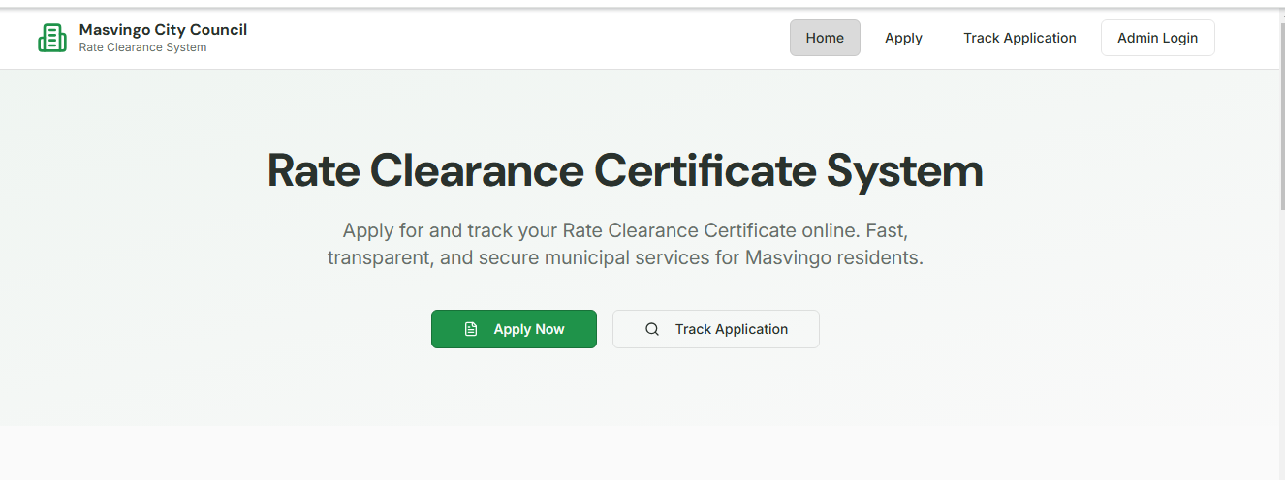
A horizontal navigation bar at the top of every page with items: Home | Apply for Certificate | Track Application | Login/Logout
(Fig 4.7 RCC Dashboard)

4.6.1.2 Sub-menus
Upon logging in, Admin will see an expanded menu: Dashboard | Manage Applications (New, In Progress, Approved, and Rejected) | Reports | Admin (Manage Users, Properties)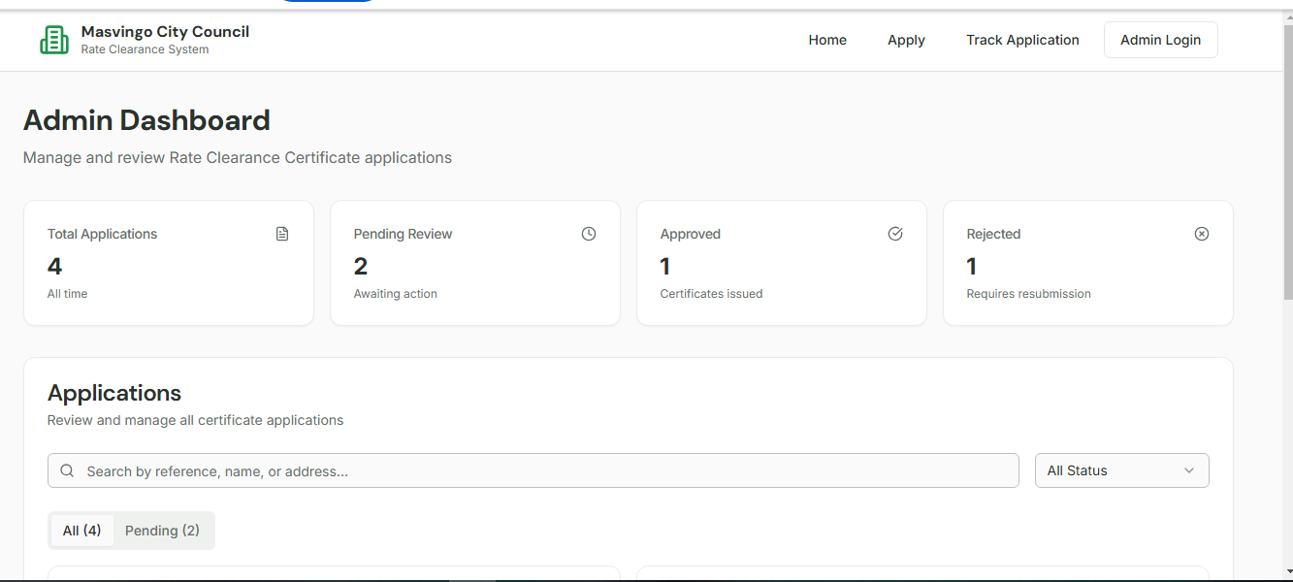
(FIG4.8 Admin logging in)

4.6.2 Input Design
Application Form: A web form with fields: Property Stand Number, Applicant Full Name, ID Number, Email, Phone Number, and Upload Deeds/Proof. Buttons: Submit.

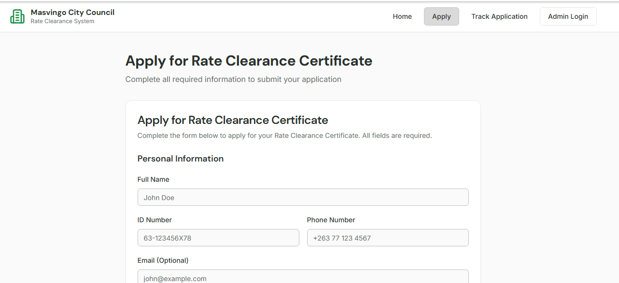

(Fig 4.6.9 client applying)

Login Form: Fields: Username, Password. Button: Login.

Clerk Approval Form: Displays application summary, property details, and payment status. Buttons: Approve, Reject, Request More Info.

4.6.3 Output Design

Rate Clearance Certificate PDF: A professionally formatted document with the Council logo, unique certificate number, property details, owner details, confirmation of no debt, issue date, and authorizing signature.

Tracking Application: A table-generated report for clerks showing Property Stand, Owner Name, Amount Owed, and Period. Application Status Page: A clean web page displaying the current status of a user's application (e.g., "Received", "Under Review", "Approved - Certificate Available for Download").
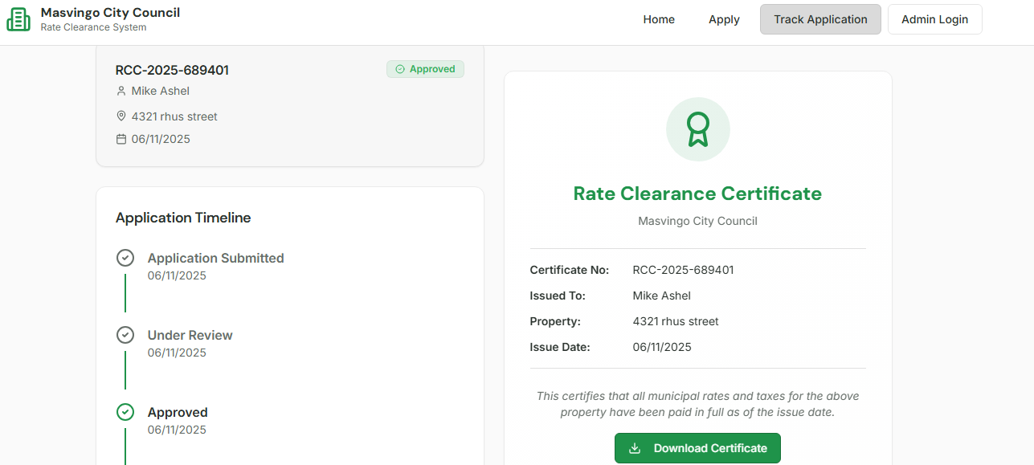
(Fig 4.6.3.1 Approved application)

4.7 Pseudo Code
Submit Application form
Start: Rate Clearance Request
Provide Property details and Owner Information

Database Verification

Outstanding balance?

yes
Make Payment
no
Update payment records

Calculate final amount
Generate certificate

Approval by Authorised officer

Digital Signing and Stamping

Issue Certificate
End: process complete
Update Central Registry
(Fig 4.6.3.1.2 Pseudo Code of the system)

4.8 Security Design
4.8.1 Physical Security
All servers will be housed in a secure, access-controlled data center within the council premises.

Access logs will be maintained for the server room.

4.8.2 Network Security
- Firewall: A network firewall will be configured to only allow necessary traffic (e.g., HTTPS on port 443).

- SSL/TLS Encryption: All data transmitted between the client and server will be encrypted using HTTPS.

- VPN: Access to the administrative interface from outside the council network will require a secure VPN connection.

4.8.3 Operational Security
Role-Based Access Control (RBAC): Users will have permissions strictly based on their role (e.g. Applicant, Clerk, and Administrator).

- Password Policy: Enforced strong passwords (min. 8 chars, upper/lowercase, numbers, and symbols). Passwords will be hashed and salted in the database.

- Audit Trails: The system will log all user logins, sensitive actions (approvals, rejections), and data changes for accountability.

- Regular Backups: Automated daily backups of the database and application code will be performed and stored off-site.

4.9 Conclusion
The Design Phase has successfully produced a comprehensive and detailed blueprint for the Masvingo City Council Rate Clearance Certificate System. The 3-tier architecture ensures a scalable and secure foundation. The system, data flow, and interface designs provide a clear guide for developers. The robust security design addresses potential threats at physical, network, and operational levels. The subsequent development phase will strictly adhere to the specifications outlined in this chapter to build a system that meets the council's needs for efficiency, transparency, and security.

Chapter 5: Implementation Phase

5.1 Introduction
This chapter details the implementation of the new Integrated Rate Clearance Certificate (RCC) System for the Masvingo City Council. The implementation phase translates the system's design into a fully functional, operational reality. This chapter covers the critical stages of coding, testing, installation, and maintenance. It also provides a roadmap for the system's future. The successful execution of this phase is crucial for achieving the project's objectives: enhancing efficiency, improving transparency, increasing revenue collection, and providing better service to the citizens of Masvingo.

5.2 Coding
The coding phase involved the systematic development of the software components as specified in the system design.

Technology Stack:

- Backend: JavaScript with ASP.NET framework, chosen for its robustness, security features, and seamless integration with other Microsoft products likely in use at the council.

- Frontend: HTML5, CSS3, JavaScript, and Bootstrap for a responsive, user-friendly interface that works on both desktop and mobile devices.

- Database: Microsoft SQL Server, ensuring data integrity, security, and powerful transaction management for financial data.

- Authentication: ASP.NET Core Identity for secure user management and role-based access control.

- Development Approach: An Agile methodology was adopted, allowing for iterative development and continuous feedback from a core team of council staff. This ensured the final product closely aligned with user needs.

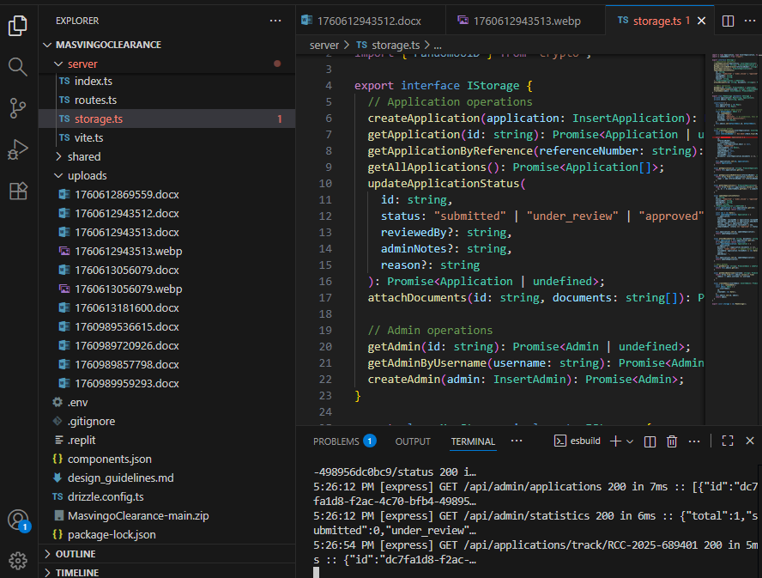
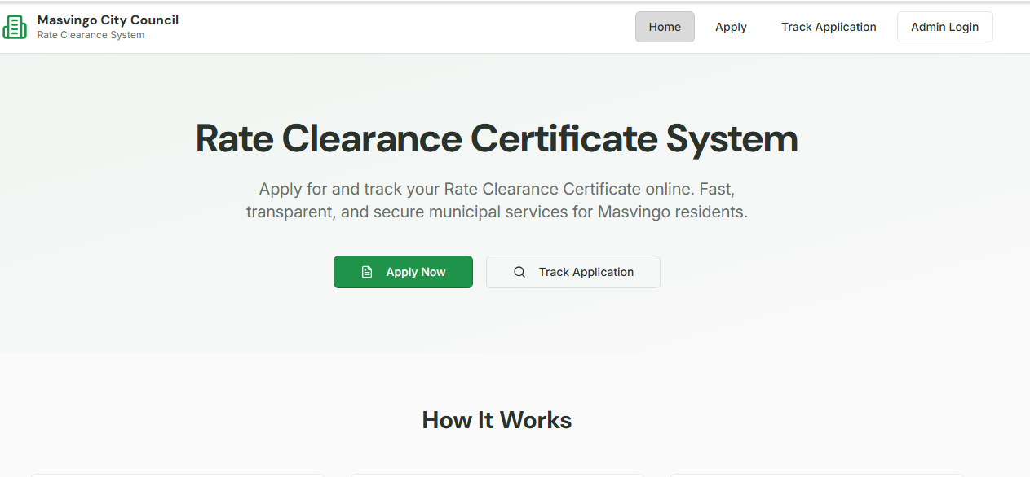

(Fig 5.2.3 USER DASHBOARD)

ADMIN DASHBOARD(tracking,approve,reject,pending)

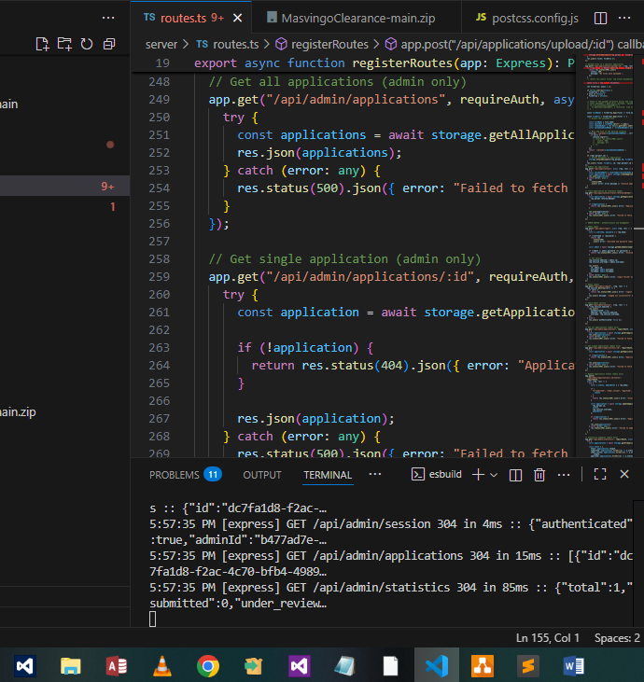

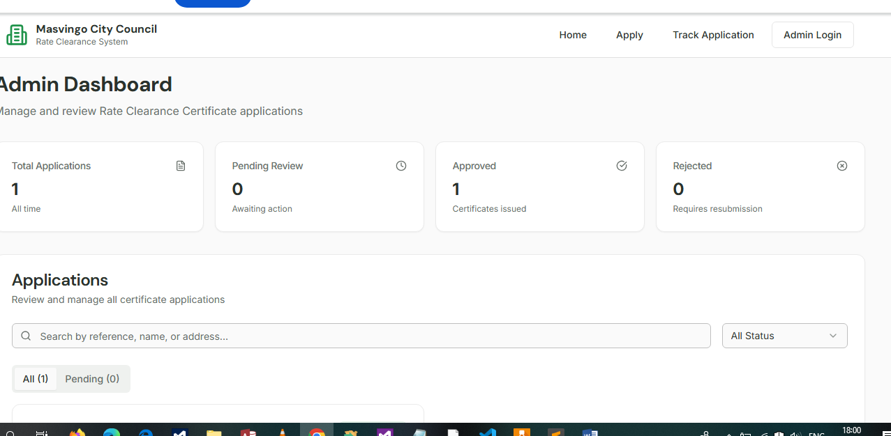

(Fig 5.2.4 Dashboard for Admin)

AUDIT LOGIN (tracking all the records from application to approval)

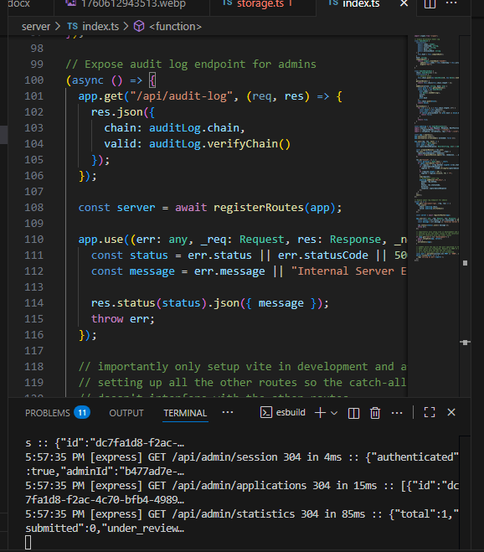
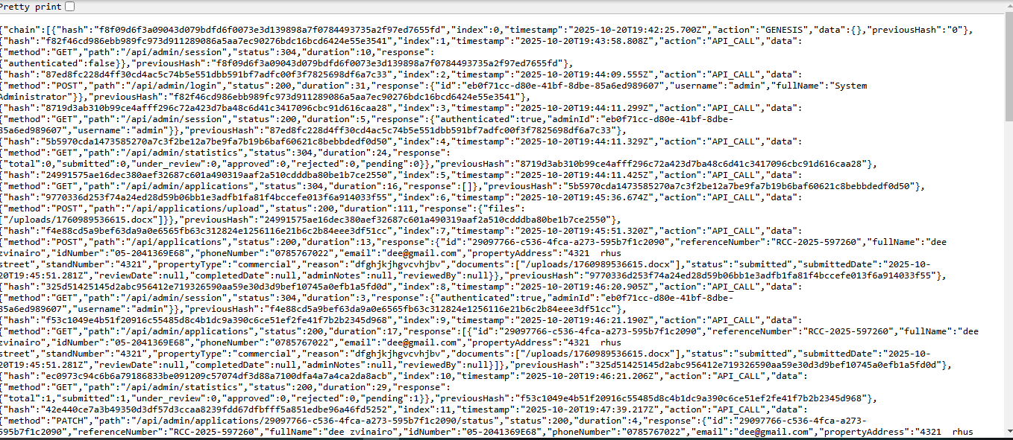
USER TRACKING
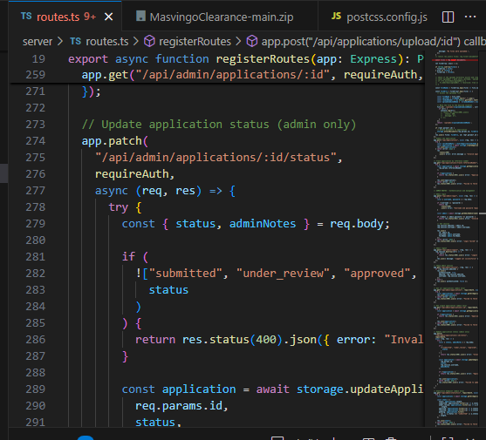
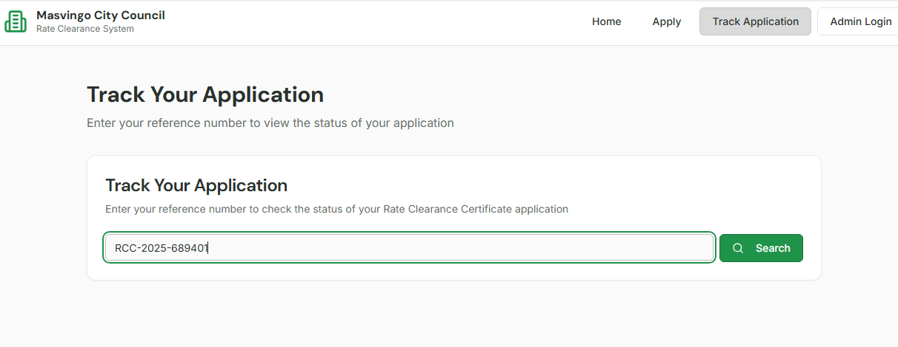
(Fig 5.2.5 Tracking)

Key Modules Coded:

- Authentication & Authorization Module: Manages user logins (Council Staff, Applicants) and enforces role-based permissions.

- Property & Ratepayer Management Module: Allows for the CRUD (Create, Read, Update, and Delete) operations on property and ratepayer records.

- Arrears Calculation Engine: A core module that automatically calculates outstanding rates, penalties, and interest based on live data.

- RCC Application & Workflow Module: Manages the entire RCC lifecycle from application submission, payment verification, and approval, to certificate issuance.

- Reporting Module: Generates standard reports (e.g., Daily RCCs Issued, Revenue Collected) and allows for ad-hoc queries.

Audit Logging Module: Automatically records all significant user actions for security and compliance.

5.3 Testing
A rigorous testing regime was conducted to ensure the system is reliable, secure, and fit for purpose.

5.3.1 Functional Test Cases

Test Case 1: Admin Login and Authorization

Objective: To check for pending applications, rejected that only authorized users can access the system.

Input: Valid and invalid login credentials for different user roles.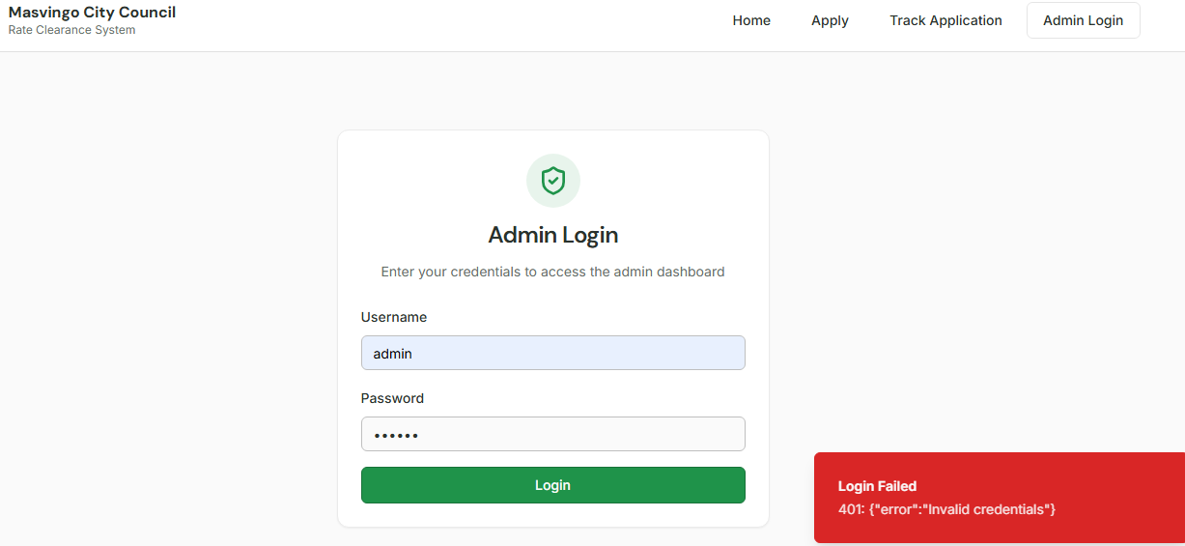

Expected Result: The admin has access to all modules accept for audit
(Fig 5.3.1.6 functional testing)

Test Case 2: RCC Application and Tracking progress

Objective: To check the progress of process whether it has been approved or rejected

Input: Reference (e.g. RCC 2025 34212)

Expected Result: The system displays the property owner's details and a detailed, accurate breakdown of all stages it should go through to be approved and issued the certificate.
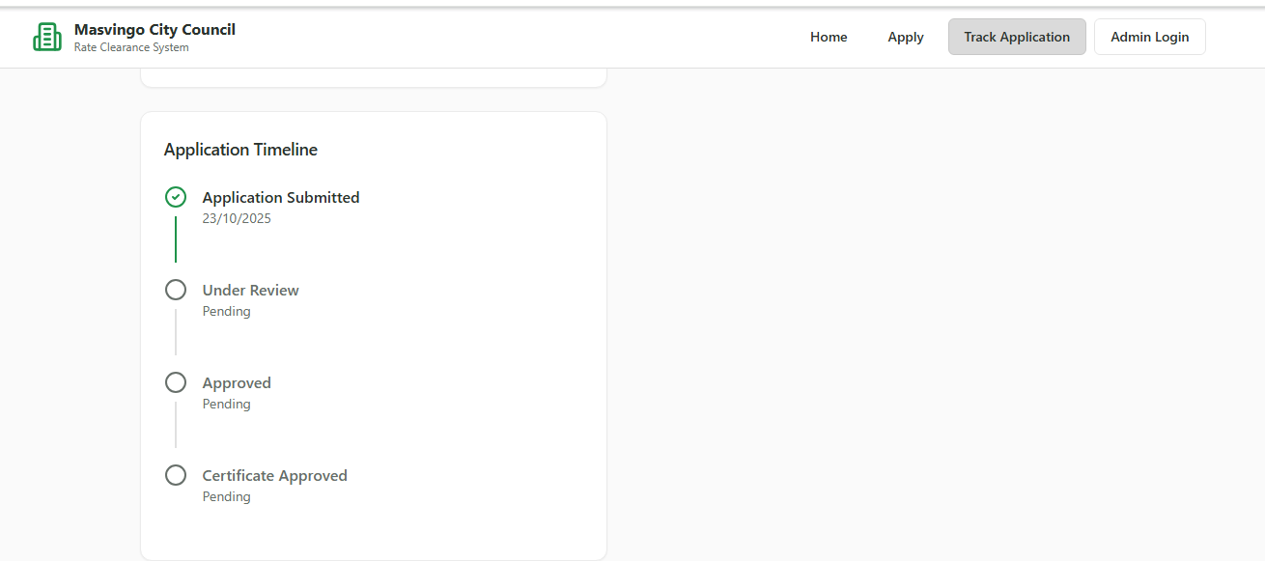
(Fig 5.3.2.7 Tracking progress)
5.3.2 System Security Testing (Demonstrating Security Design from Section 4.8)

This validates the Input Validation and Sanitization and Secure Coding Practices from the design.

Security Test 4: Audit Trail Logging

Objective: To confirm that sensitive actions are logged.

Method: An approver issues a certificate. The system administrator then checks the audit log.

Result: PASS - The audit log shows an entry with timestamp, user ID, action ("Issued RCC"), and the application ID.

Screenshot: Audit Log View

(Fig 5.3.2 .8 Audit Log)
This fulfills the Audit Trail requirement specified in the security design.

5.4 Installation
The installation plan ensures a smooth transition from the old manual process to the new digital system.

User Training:

- Target Groups: Treasury Clerks, Senior Finance Officers (Approvers), IT Administrators, and front-desk customer service staff.

- Methodology: A combination of:
- Structured Workshops: Hands-on sessions in the council's training room.

- Training Manuals: Step-by-step guides with screenshots for each user role.
- Super-User Program: Selected staff from each department were trained intensively to act as first-line support.

Data Migration:
Strategy: A phased "Big Bang" migration for initial data load, followed by incremental synchronization.

Process:
- Extraction: Property and active ratepayer data were extracted from the legacy system (e.g., spreadsheets, old databases) into clean CSV files.
- Cleansing & Transformation: Data was cleaned (removing duplicates, correcting errors) and formatted to match the new database schema. This was the most critical and time-consuming step.
- Loading: Cleansed data was loaded into the new SQL Server database using custom scripts.
- Verification: A sample of migrated records was cross-checked against the old system to ensure accuracy.

System Changeover Strategies & Recommendation:

- Parallel Changeover: Running the old and new systems simultaneously for a period. This was considered but deemed high-risk due to the double workload on staff and potential for data confusion.

- Phased Changeover: Implementing the system module by module. Not feasible as the RCC process is an integrated workflow.

- Direct (Big Bang) Changeover: Switching off the old manual system and starting the new digital system on a specific "go-live" date.

- Pilot Changeover: Implementing the system first in one department or for one type of transaction.

- Recommended Changeover Strategy: A Modified Direct Changeover with a Pilot Phase.
The recommended strategy is a Direct Changeover for its simplicity and clear cut-over point. However, to mitigate risk, it will be preceded by a two-week Pilot Phase. The system will be launched for use by a small, pre-trained team to process a limited number of real RCC applications. This allows for final bug fixes and user confidence building before the full council-wide "go-live" date.

5.5 Maintenance
To ensure the system's long-term viability and performance, the following maintenance strategies are recommended:

- Corrective Maintenance: A helpdesk (phone and email) will be established for users to report bugs and issues. A formal process for logging, prioritizing, and resolving these tickets will be implemented.

- Adaptive Maintenance: The IT department will proactively plan for updates necessitated by changes in the external environment, such as:
Updates to the .NET framework or SQL Server.

Changes in legislation or council bylaws affecting rate calculations.

- Perfective Maintenance: Continuous improvement will be driven by user feedback. This includes performance tuning (e.g., optimizing database queries) and adding minor usability enhancements.

- Preventive Maintenance: Regular, scheduled activities will be conducted, including:

--Database backups and integrity checks.
--System and security patch management.
--Review of audit logs for suspicious activities.

5.6 Recommendations for Future/Further Development
The current system provides a strong foundation. Future development should focus on the following to further modernize council services:

- Online Public Portal: Develop a citizen-facing portal where ratepayers can apply for RCCs, view their account status, and make online payments directly, reducing queues at council offices.
- GIS Integration: Integrate with a Geographic Information System (GIS) to allow applicants to locate their properties on an interactive map during the application process.
- Integration with ZIMRA: Establish a secure API link with the Zimbabwe Revenue Authority (ZIMRA) to automatically verify tax clearance status, streamlining the overall property transfer process.
- Advanced Analytics Dashboard: Implement a module with data visualization tools (charts, graphs) to provide management with real-time insights into revenue trends, application volumes, and staff productivity.

5.7 Conclusion
The implementation of the Masvingo City Council Rate Clearance Certificate System has been successfully completed. The system has been built on a secure and robust architecture, thoroughly tested to meet functional and security requirements, and a careful installation strategy has been devised to ensure a smooth transition. With the recommended maintenance plan and a clear vision for future enhancements, this system is poised to significantly improve the efficiency, transparency, and service delivery of the Masvingo City Council's treasury department for years to come. The council is now well-positioned to take a major step forward in its digital transformation journey.

REFERENCES
- Author(s) Title Year Publisher / Source

- S.k Sudarshan Database System Concepts 2021 McGraw-Hill Education
- S. Ian Software Engineering 2020 Pearson

- R.Pressman SE: A Practitioner's Approach 2021 McGraw-Hill

- Dennis, Wixom, Roth Systems Analysis and Design 2022 Wiley

- L. Kenneth & L. Jane Management Information Systems 2023 Pearson

- Sharma Atul Web Application Development 2022 Technology Press
- ISO/IEC ISO/IEC 25010 – Software Quality Model 2021 ISO

Government of Zimbabwe Urban Councils Act [Chapter 29:15] 2021 Government of Zimbabwe Publications

