Gravity Clinic - Initial Review Report

Section 1: Introduction
This report provides an initial preview of the newly redesigned Gravity Clinic website. The project focuses on creating a premium, professional, and user-friendly digital presence that reflects the clinic's high standards of medical care to ensure high performance and smooth interactions.

Section 2: Screenshots Preview

1. Homepage (Hero & Main Section)
The homepage features a striking hero section with high-quality imagery and clear calls to action. It sets a professional tone and immediately communicates the clinic's core value proposition.
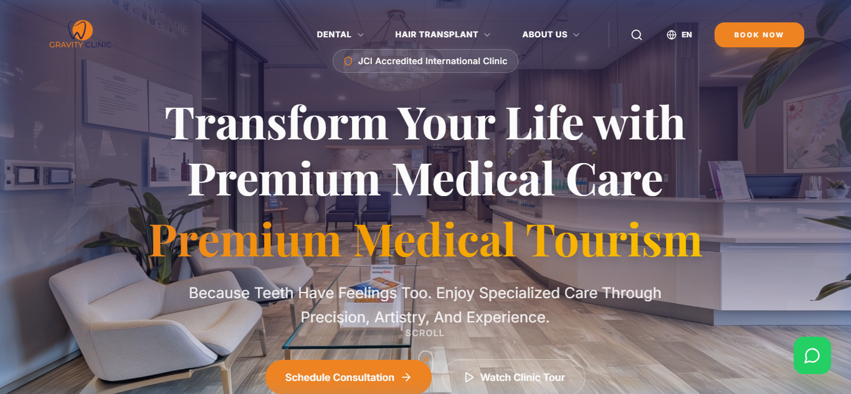

2. Dental Services Page
A dedicated page for dental treatments, showcasing services with clean layouts and easy-to-read information.
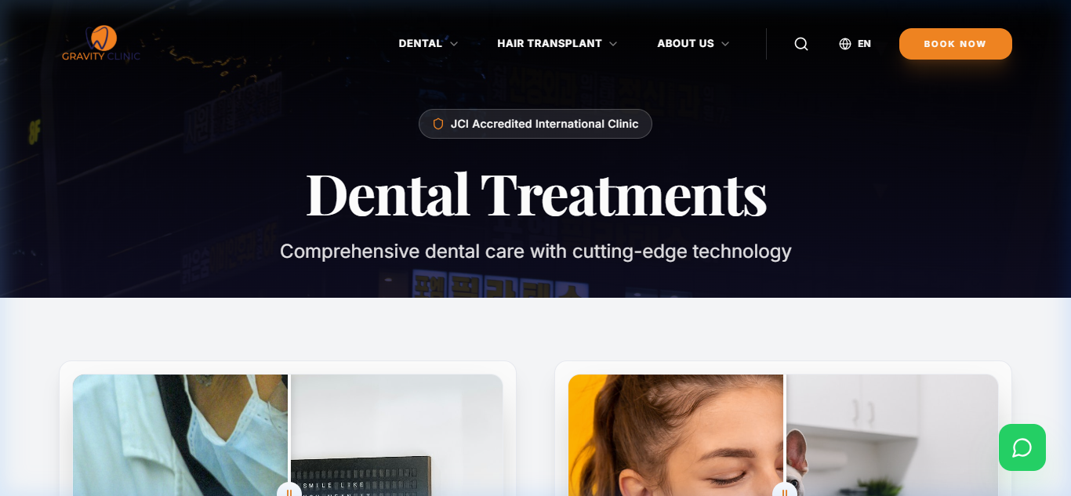
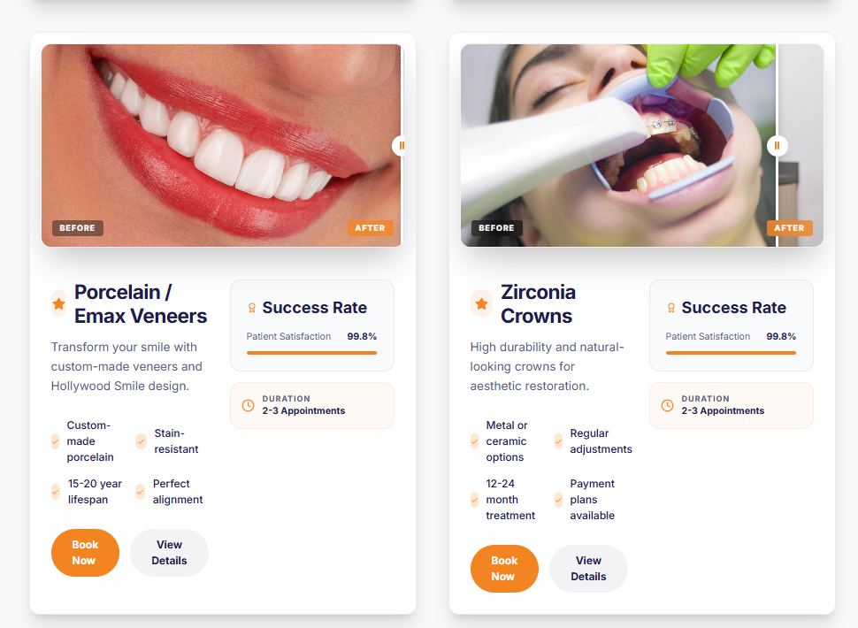

3. Hair Transplant Page
The hair restoration page focuses on advanced techniques and natural results, designed to build trust with potential patients.
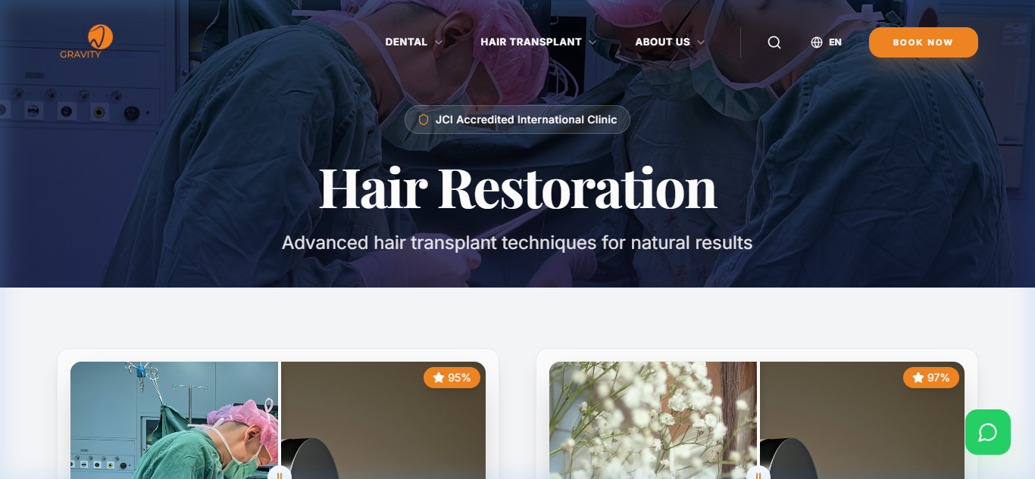

4. Online Booking System
A streamlined, step-by-step booking process that makes it easy for patients to schedule their consultations.
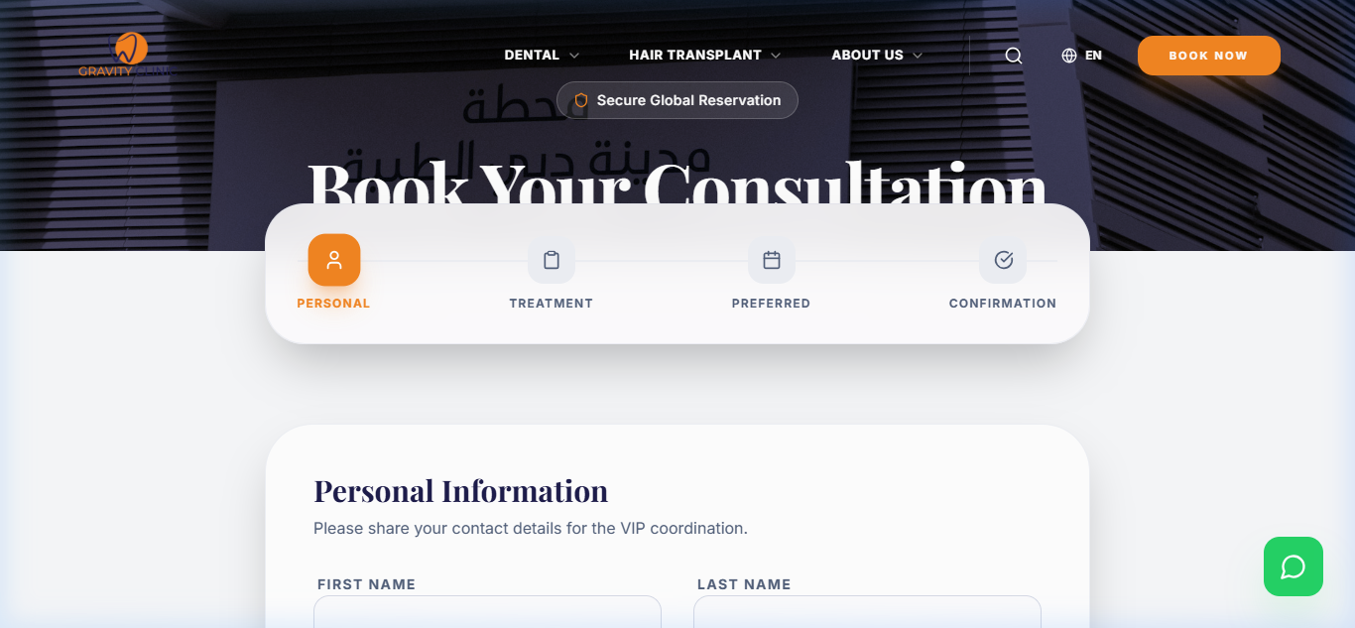

5. Contact & Support
A clear and accessible contact page with multiple ways to reach out, ensuring a smooth communication channel for clients.
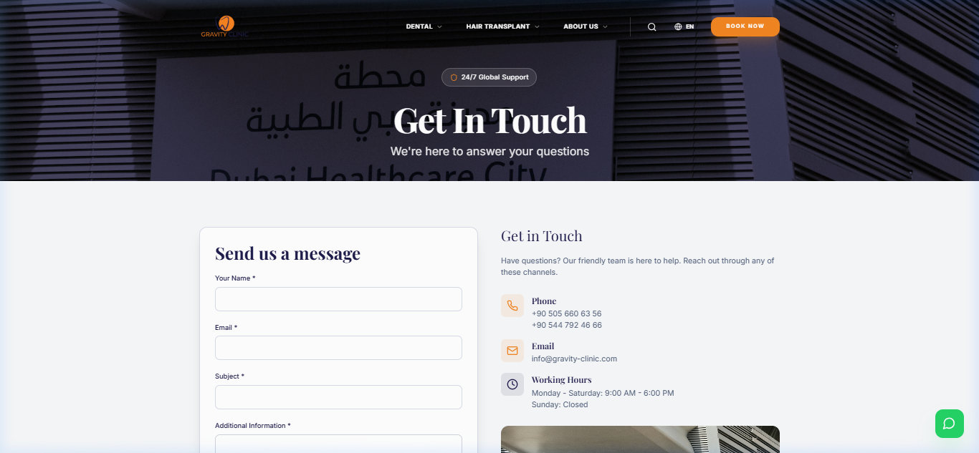

Section 3: Key Features
- Modern Design: A clean, premium aesthetic that aligns with global healthcare standards.
- Multi-language Support: Fully localized for English, Arabic, French, and Russian.
- Responsive Layout: Perfect viewing experience on desktops, tablets, and smartphones.
- Smooth Animations: Subtle micro-interactions and transitions for a premium feel.
- Improved UI/UX: Simplified navigation and intuitive user flows.

Section 4: Improvements Made
- Better Layout and Spacing: Optimized use of white space to improve content hierarchy and focus.
- Improved Colors and Readability: A curated color palette that enhances brand identity and ensures accessibility.
- Enhanced Navigation: A more logical and accessible menu structure.
- Added Animations and Interactivity: Engaging elements that make the website feel alive and responsive.

Section 5: Notes for Client
- This is an initial version designed for your early feedback.
- We are open to adjustments regarding colors, imagery, or specific wording.
- The final version will include further performance optimizations and secondary page refinements.

Section 6: Blog / Articles Preview

Showcases latest articles or news related to treatments.
- Includes images, titles, and excerpts.
- Demonstrates educational content and engagement.
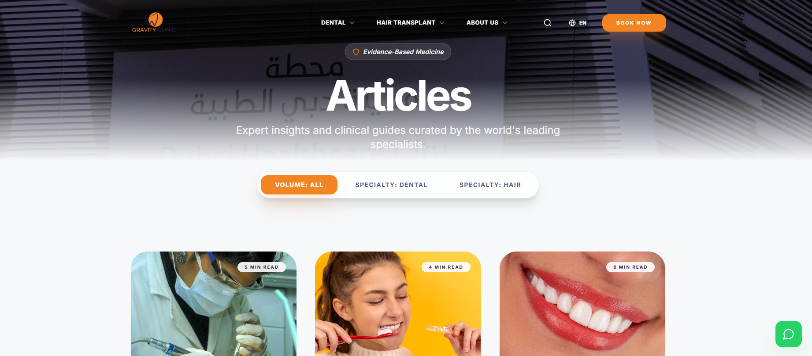
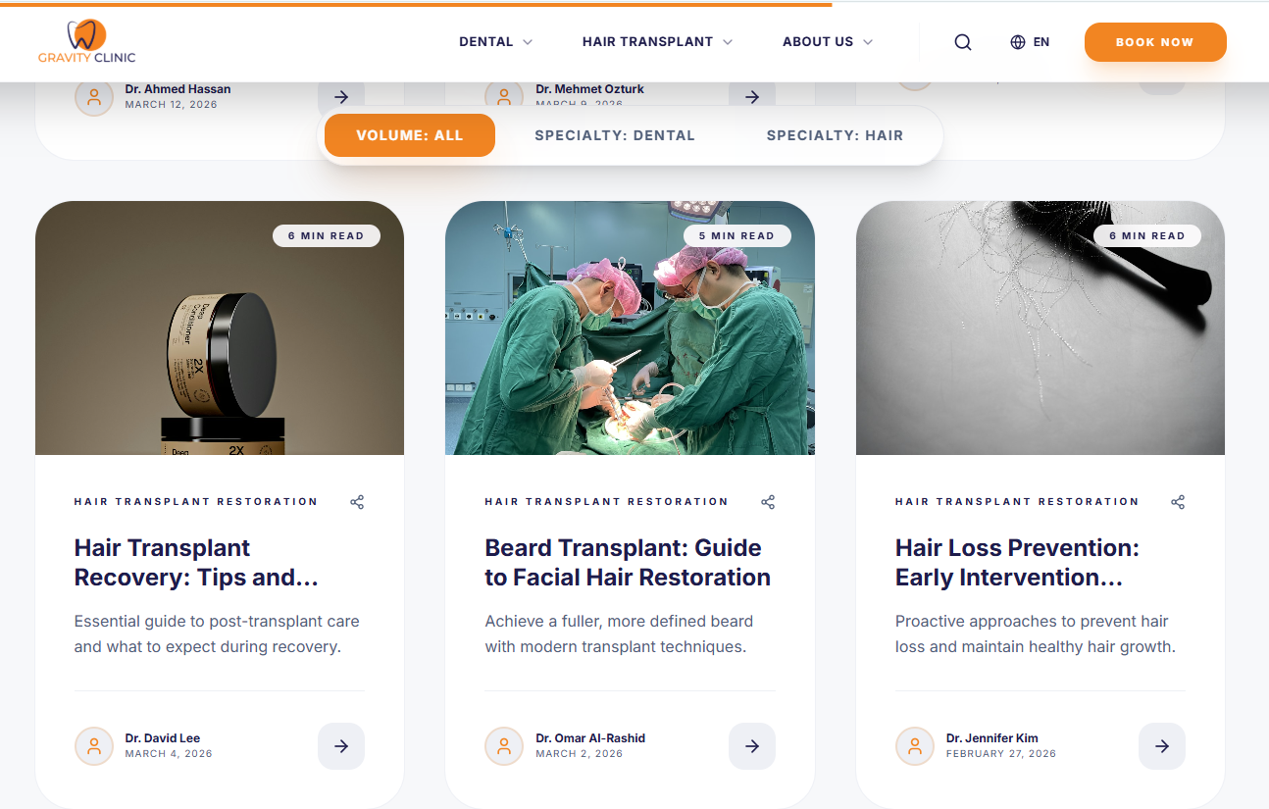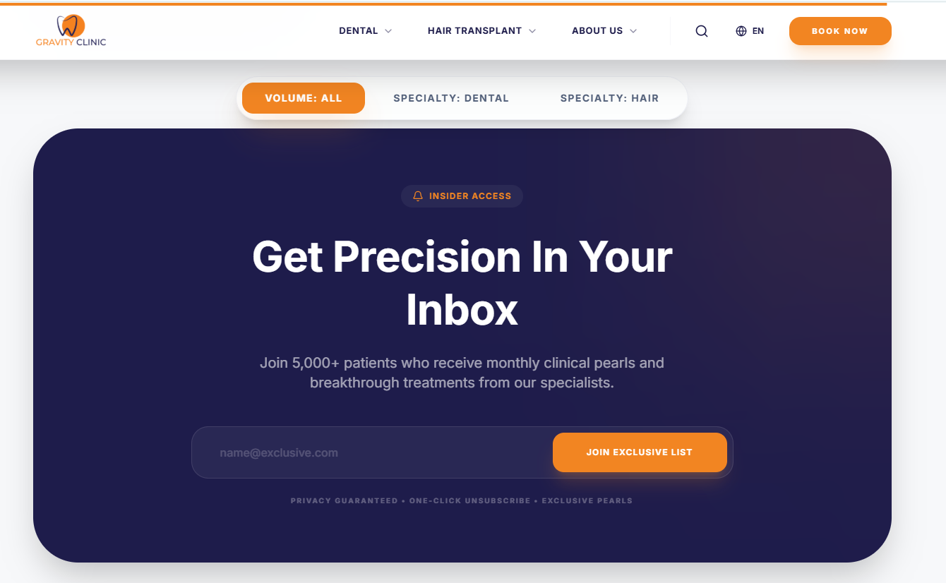

Section 7: FAQ Section

Frequently Asked Questions for patient guidance.

Clear Q&A display, possibly expandable/collapsible sections.

Improves user experience by answering common concerns.

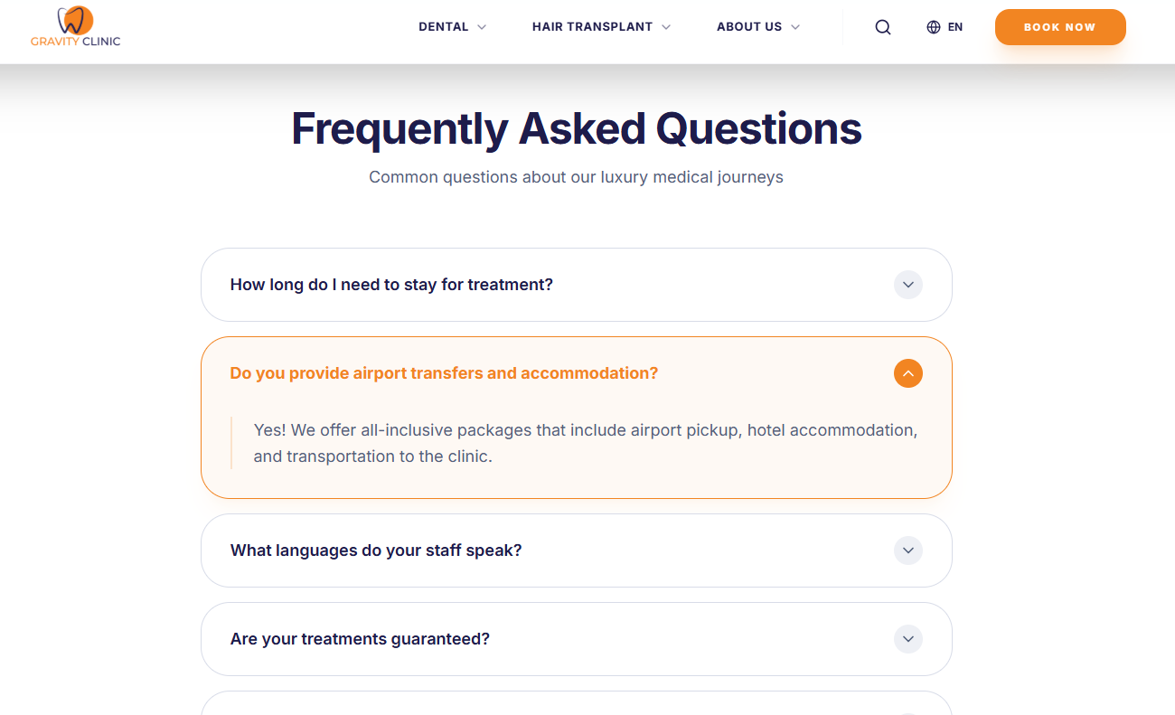

Section 8: Testimonials & Reviews

Displays patient feedback in a visually appealing format.

Includes avatars, patient names, roles, and comments.

Highlights real experiences for trust-building.
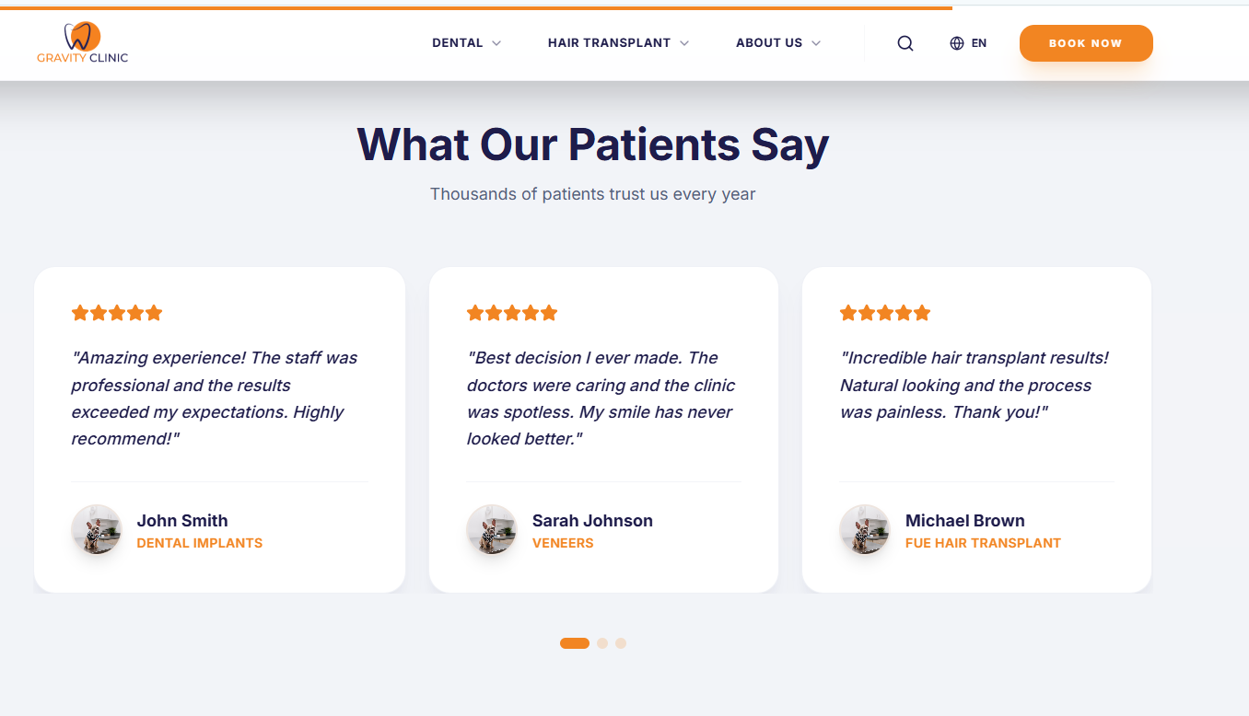

Section 9: Footer & Contact Info

Organized layout of footer content:

Links, clinic address, contact info, social media, opening hours.

Consistency across pages ensures professionalism.

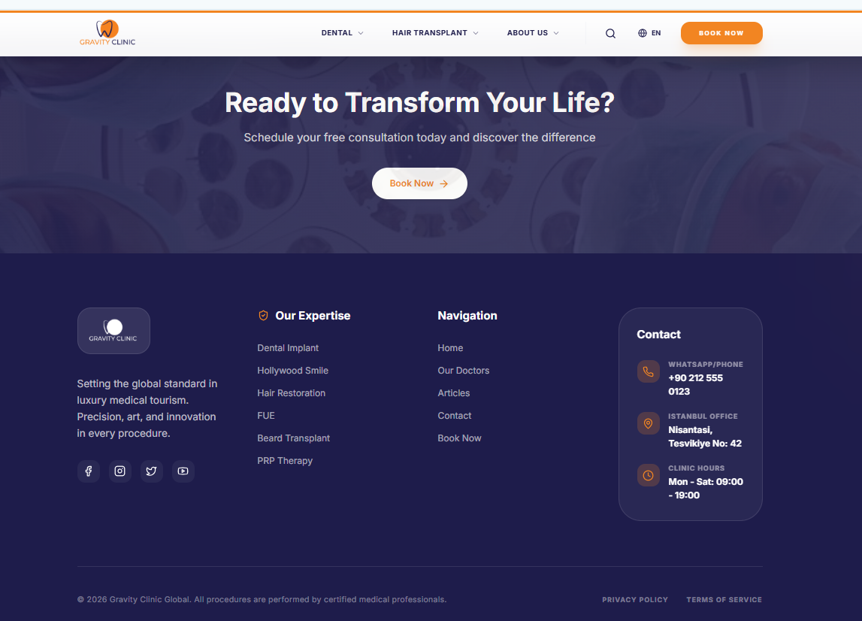

Section 10: Mobile & Tablet Views
Screenshots demonstrating fully responsive design.
- Confirms usability across desktop, tablet, and smartphone.
- Highlights how layout adapts and maintains clarity.
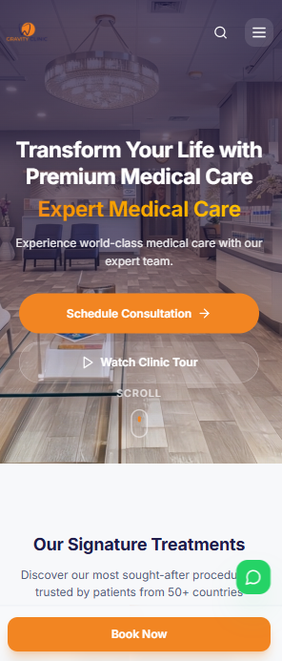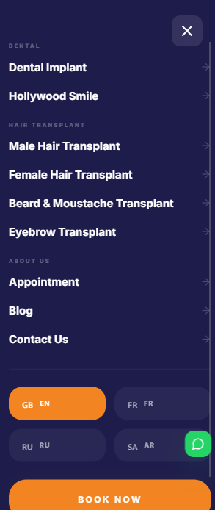

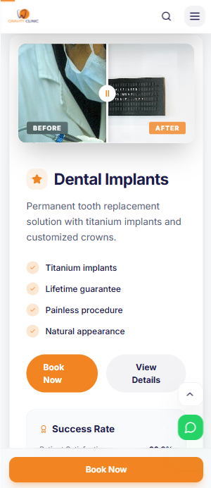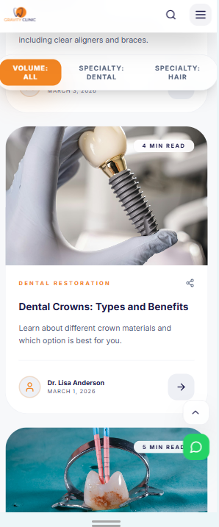
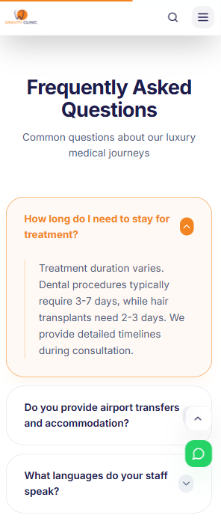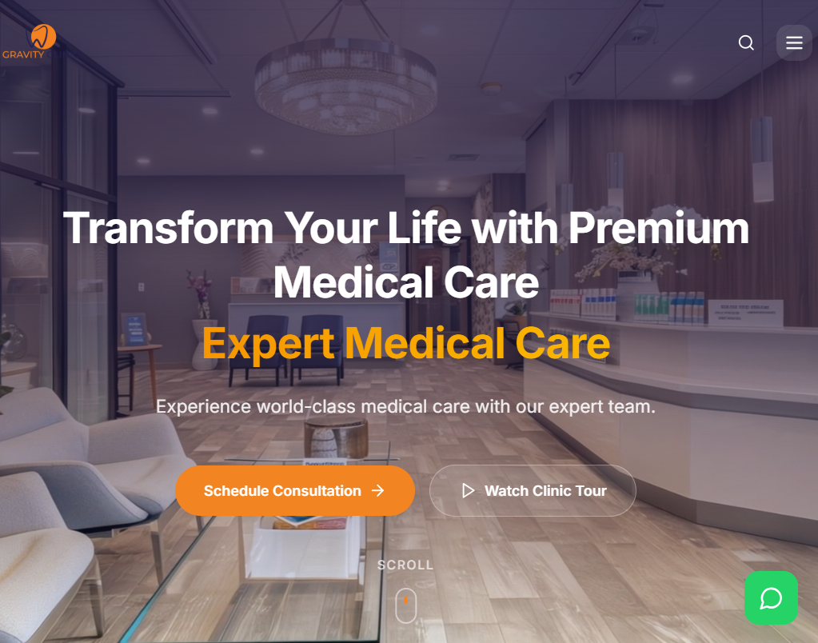
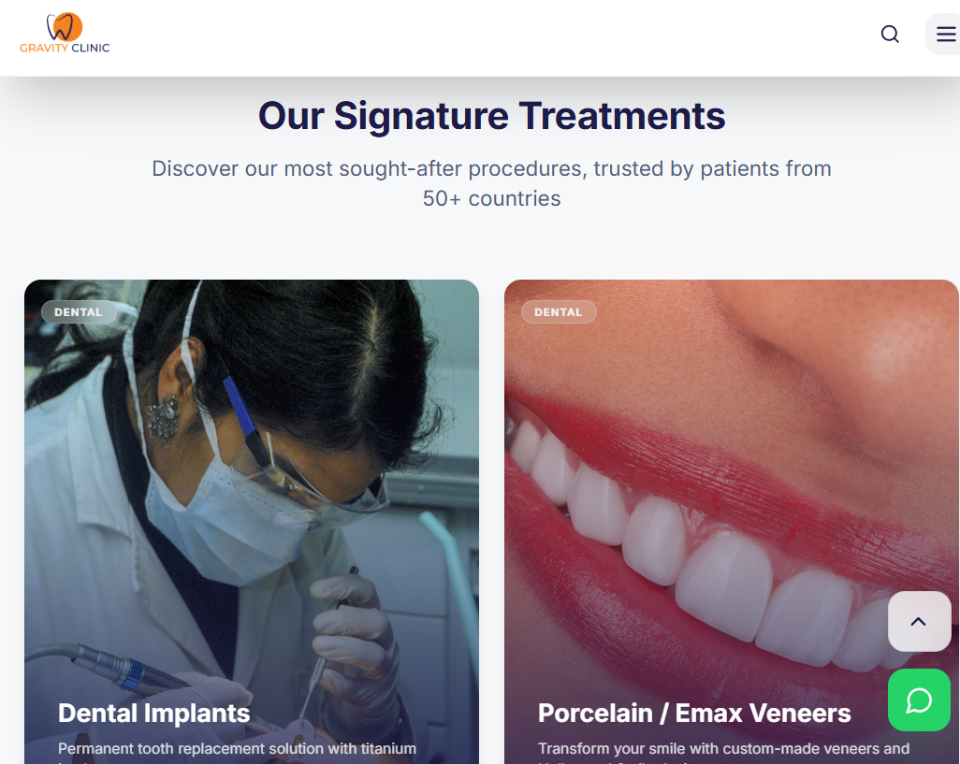
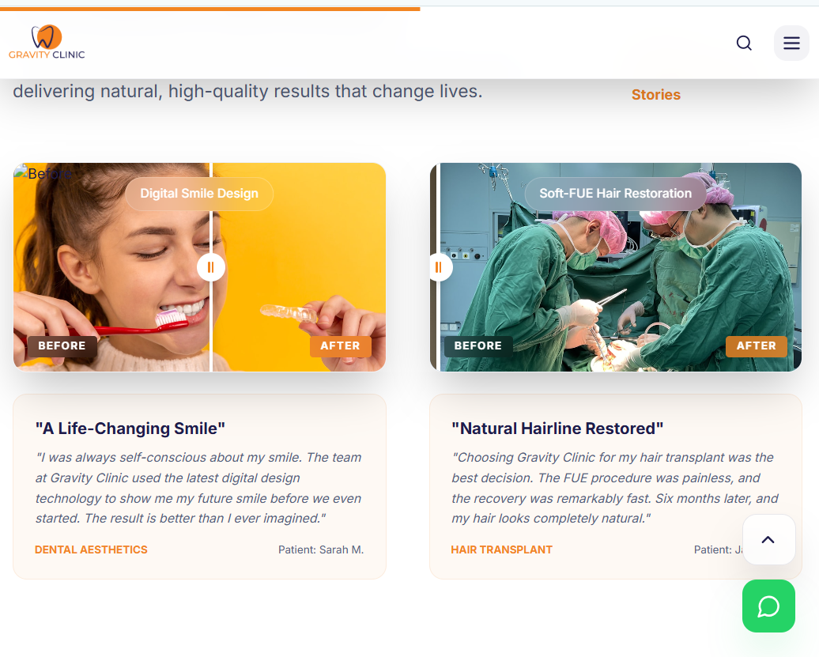
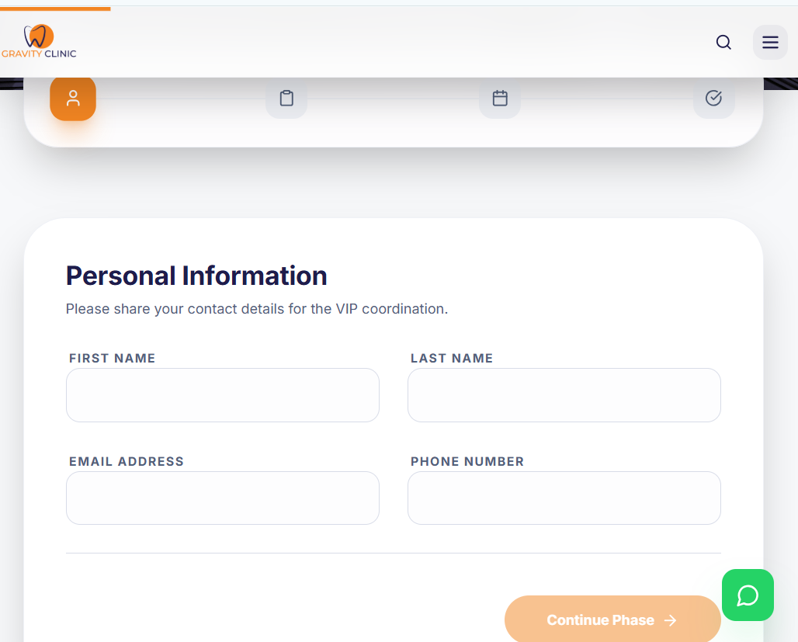

We look forward to your feedback!

