Graphs Part 1

Joshua F. Wiley

2019-05-21

Download the raw R markdown code here <https://jwiley.github.io/MonashHonoursStatistics/Graphs_Pt1.rmd>.

options(digits = 2)  
  
## two new packages are: (1) cowplot and (2) ggthemes  
## You can try installing  
## by uncommenting the install.packages() code below  
  
#install.packages("cowplot", type = "binary")  
#install.packages("ggthemes", type = "binary")  
  
  
## some people also report type="binary" does not work  
## if that happens to you, try:  
# install.packages("cowplot")  
# install.packages("ggthemes")  
  
## once installed, open the packages using the   
## library() calls below  
  
library(data.table)  
library(ggplot2)  
library(cowplot)  
library(ggthemes)  
  
## read in the dataset  
d <- readRDS("aces_daily_sim_processed.RDS")  
  
## small sample dataset  
dt <- data.table(  
 Age = c(20, 30, 40, 50, 60),  
 Memory = c(7, 5, 6, 4.5, 4))  
  
## convert a few variables in mtcars dataset  
## into discrete factor variables  
mtcars$cyl <- factor(mtcars$cyl)  
mtcars$vs <- factor(mtcars$vs)  
mtcars$am <- factor(mtcars$am)

# Grammar of Graphics

ggplot2 is based on the **g**rammar of **g**raphics, a framework for creating graphs.

The idea is that graphics or data visualization generally can be broken down into basic low level pieces and then combined, like language, into a final product.

Under this system, line plots and scatter plots are essentially the same. Both have data mapped to the x and y axes. The difference is the plotting symbol (**ge**ometries labelled geoms in R) in is a point or line. The data, axes, labels, titles, etc. may be identical in both cases.

ggplot2 also uses aesthetics, which control how geometries are displayed. For example, the size, shape, colour, transparency level all are **aes**thetics.

# Univariate Graphs

To begin with, we will make some simple graphs using ggplot2. The first step is specifying the dataset and mapping variables to axes. For basic, univariate plots such as a histograms, we only need to specify the dataset and what variable is mapped to the x axis. We can re-use this basic setup with different **geom**etries to make different graphs.

pb <- ggplot(  
 data = mtcars,  
 aes(x = mpg))

Using our basic mapping, we can “add” a histogram geometry to view a histogram.

pb + geom_histogram()

## `stat_bin()` using `bins = 30`. Pick better value with `binwidth`.

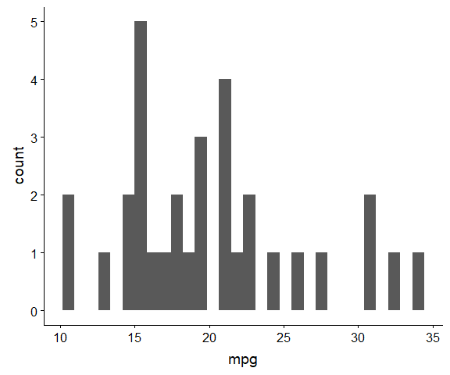

A histogram in ggplot2 for mpg

We also can make a density plot, which also attempts to show the distribution, but using a smooth density function rather than binning the data and plotting the frequencies. Like histograms, the height indicates the relative frequency of observations at a particular value. Density plots are designed so that they sum to one.

pb + geom_density()

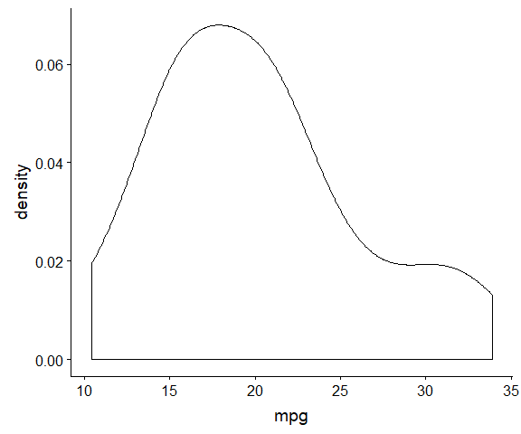

A density plot for mpg

Another type of plot are (stacked) dotplots. These are very effective at showing raw data for small datasets. Each dot represents one person. If two dots would overlap, they are stacked on top of each other. While these often are difficult to view with large datasets, for small datasets, they provide greater precision than histograms.

pb + geom_dotplot()

## `stat_bindot()` using `bins = 30`. Pick better value with `binwidth`.

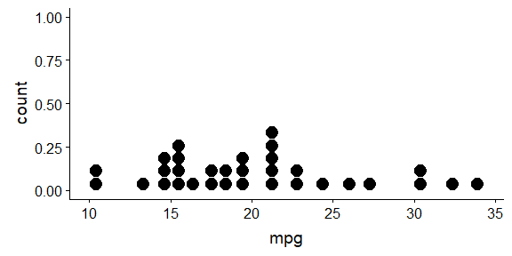

A dot plot for mpg

Finally, we can make Q-Q plots, although these require sample values instead of values on just the x-axis. We use the scale() function to z-score the data on the fly. Finally, we add a line with an intercept (a) and slope (b) using geom_abline() which is the line all the points would fall on if they were perfectly normally distributed.

ggplot(mtcars, aes(sample = scale(mpg))) +  
 geom_qq() +  
 geom_abline(intercept = 0, slope = 1)

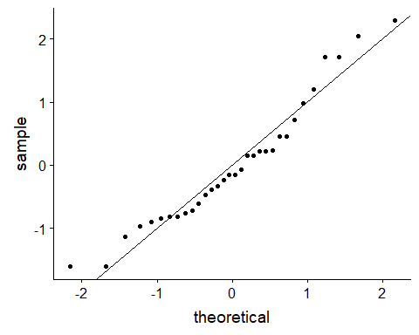

## Mapping Additional Variables

We can map additional variables to aesthetics such as the colour to include more information. To break the dataset down further, it is helpful to have a bit larger dataset than the 32 cars in mtcars. The iris dataset has measurements on 150 flowers from three species of iris. For density plots, separating by colour is easy, by adding the Species variable as an additional aesthetic.

ggplot(iris, aes(Sepal.Length, colour = Species)) +  
 geom_density()

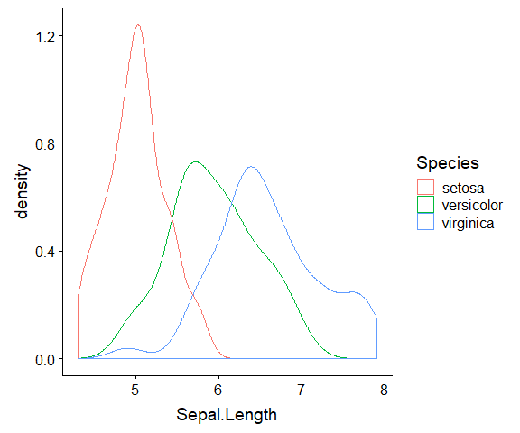

Density plot coloured by Species for Sepal Length

For histograms, rather than control the colour of the lines, it is more helpful to control the fill colour. By default, overlapping bars are stacked on top of each other.

ggplot(iris, aes(Sepal.Length, fill = Species)) +  
 geom_histogram()

## `stat_bin()` using `bins = 30`. Pick better value with `binwidth`.

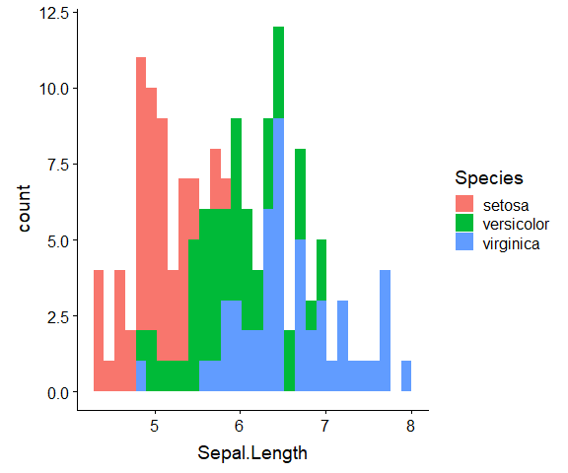

Histogram coloured by Species for Sepal Length

Overlapping bars also can be dodged instead of stacked.

ggplot(iris, aes(Sepal.Length, fill = Species)) +  
 geom_histogram(position = "dodge")

## `stat_bin()` using `bins = 30`. Pick better value with `binwidth`.

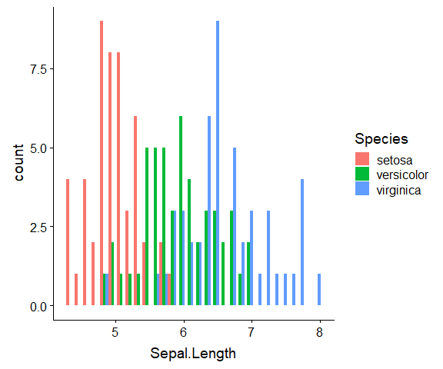

Dodged histogram coloured by Species for Sepal Length

Multiple geometric objects can be combined. The following figure combines dot and density plots into one.

ggplot(iris, aes(Sepal.Length, colour = Species)) +  
 geom_dotplot() + geom_density()

## `stat_bindot()` using `bins = 30`. Pick better value with `binwidth`.

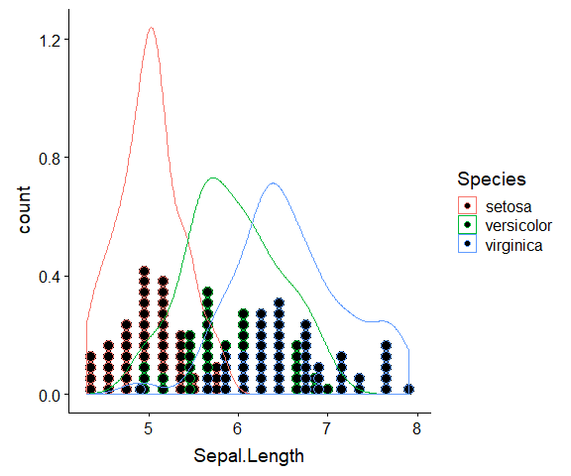

Density and dot plot plot coloured by Species for Sepal Length

While the colour works well for the density plots, filling would work better for the dotplot. We can map separate aesthetics to each geometric object.

ggplot(iris, aes(Sepal.Length)) +  
 geom_dotplot(aes(fill = Species)) +  
 geom_density(aes(colour = Species))

## `stat_bindot()` using `bins = 30`. Pick better value with `binwidth`.

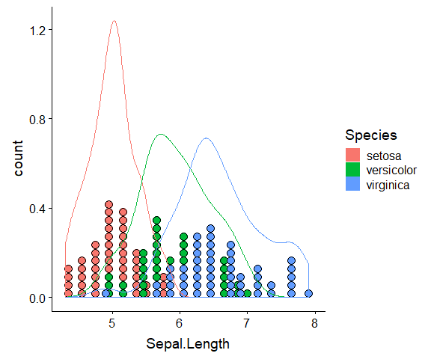

Density and dot plot plot coloured by Species for Sepal Length

## Try It - Univariate

Using the mtcars dataset:

1. make a histogram for the variable: qsec.
2. make a QQ plot for qsec
3. Make a dotplot and density plot for: disp *separated* by am

## histogram code here (qsec)  
  
## QQ plot code here (qsec)  
  
## dotplot and density plot code here (disp by am)

# Bivariate Graphs

We can make bivariate plots by mapping variables to both the x and y-axis. For a scatter plot, we use point geometric objects.

ggplot(mtcars,  
 aes(  
 x = mpg,  
 y = hp)) +  
 geom_point()

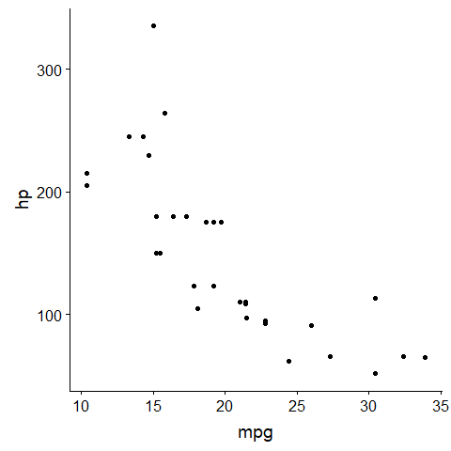

Scatter plot of mpg and hp

We also can use lines for bivariate data. For this example, we will use a small made up dataset. Compared to a scatter plot, we only change point to line geometric objects.

ggplot(dt, aes(Age, Memory)) +  
 geom_line()

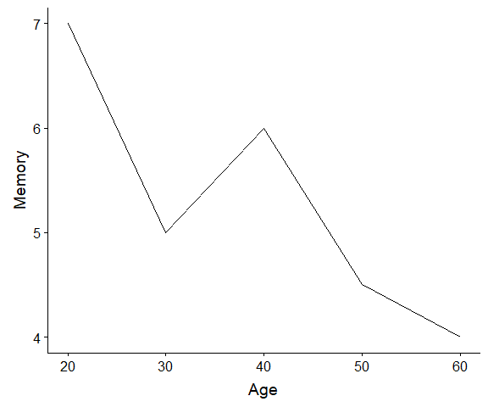

Line plot of age and memory

With relatively discrete x axis, we can use a barplot for bivariate data. By default, geom_bar() calculates the count of observations that occur at each x value, so if we want our values to be the actual bar height, we set set = "identity".

ggplot(dt, aes(Age, Memory)) +  
 geom_bar(stat = "identity")

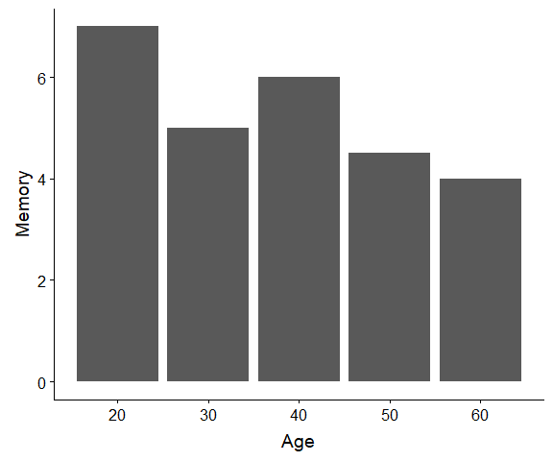

Bar plot of age and memory

The grammar of graphics is designed to be like sentences, where you can add or modify easily. For example, “There is a ball.” or “There is a big, red, striped ball.” are both valid sentences. So to with graphics, we often can chain pieces together to make it more nuanced. In R we just “add” more by separating each component with +. Note that most argument names (i.e., data =, mapping =) are not strictly required. R will match input to the correct argument by position, often. The two sets of code below yield the same plot. In the first, we explicitly label all arguments, in the second we rely on position matching. Positional matching does not always work, for example we still must specify size = because we don’t always provide input for every argument, instead relying on defaults and only changing the specific arguments we want changed from defaults.

ggplot(  
 data = dt,  
 mapping = aes(  
 x = Age,  
 y = Memory)) +  
 geom_bar(  
 mapping = aes(fill = Age),  
 stat = "identity") +  
 geom_line(size = 2) +   
 geom_point(size = 6)

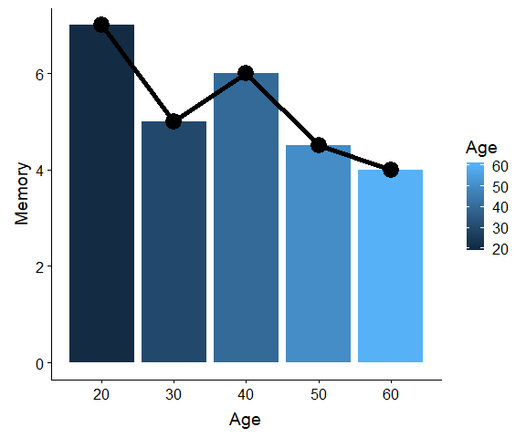

Bar plot of age and memory

ggplot(dt, aes(Age, Memory)) +  
 geom_bar(aes(fill = Age), stat = "identity") +  
 geom_line(size = 2) +   
 geom_point(size = 6)



Bar plot of age and memory

# Improving Data Visualization

Before we continue examining graphs, it is helpful to think a bit more about what makes a good graph or good data visualization.

Edward Tufte and William Cleveland are two authors who have written extensively on data visualization and how to make good graphs. There work is well worth reading to improving understanding on how to efficiently convey data graphically.

* Tufte: <https://www.edwardtufte.com/tufte/>
* Cleveland: <http://www.stat.purdue.edu/~wsc/>

A few additional pages with good discussions on making good graphs: [Graphic Design Stack Exchange 1](https://graphicdesign.stackexchange.com/questions/35052/how-to-visualise-two-dimensional-scientific-data-points-in-a-chart-in-graysca/35062#35062) and [Graphic Design Stack Exchange 2](https://graphicdesign.stackexchange.com/questions/36908/best-plotting-symbols-for-scientific-plots-with-multiple-datasets/57122)

One key principle that Tufte emphasises is the data to ink ratio. This ratio is how much data is conveyed versus ink used, and Tufte argues to try to maximize this (i.e., more data, less ink). To see this, consider the following graph, which is a fairly standard way stats programs (Excel, etc.) tend to make barplots.

ggplot(dt, aes(Age, Memory)) +  
 geom_bar(stat = "identity") +  
 theme_bw()

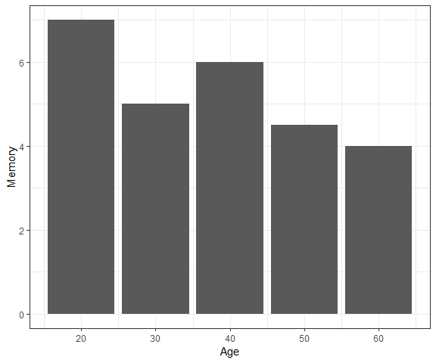

Bar plot of age and memory - Step 1

For starters, the borders tell us nothing. They edge the space but convey no information. This can be cleaned up using a different theme. Once we loaded the cowplot package, it automatically set its own theme as the default, so if we leave off the theme_bw() we get a cleaner graph.

ggplot(dt, aes(Age, Memory)) +  
 geom_bar(stat = "identity")



Bar plot of age and memory - Step 2

However, there are still some borders, which we can strip away with no loss of data, but reducing the ink.

ggplot(dt, aes(Age, Memory)) +  
 geom_bar(stat = "identity") +  
 theme(axis.line = element_blank())

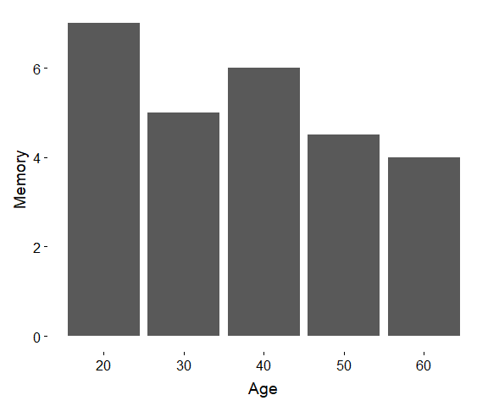

Bar plot of age and memory - Step 2

Next, think about what data are conveyed in this graph. The bars capture two pieces of information: (1) the age and (2) the memory at that age. The only pieces of the bars we really need are the top. The rest of the bars take up a lot of ink, but convey no data. Points can do this more efficiently. The chart that follows has a much higher data-to-ink ratio as it is stripped back nearly to just the data.

ggplot(dt, aes(Age, Memory)) +  
 geom_point(size = 4) +  
 theme(axis.line = element_blank())

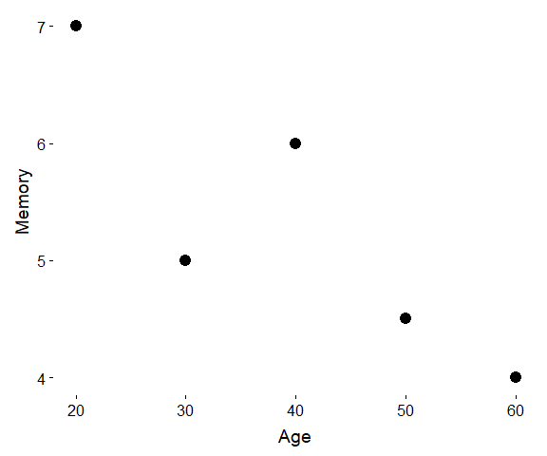

Dot plot of age and memory - Step 3

Depending on the number of data points, one may push a bit further. Many people in practice find they are unfamiliar with these sort of graphs and at first it can take a bit longer to read. We are trained and used to seeing plots with “chartjunk” and low data to ink ratios. However, a chart like this is a far more condensed display of data and removes distractions to really highlight the raw data or results.

ggplot(dt, aes(Age, Memory)) +  
 geom_point(size = 4) +  
 geom_text(aes(y = Memory + .5, label = Memory)) +   
 theme(axis.line = element_blank(),  
 axis.ticks.x = element_blank(),  
 axis.ticks.y = element_blank(),  
 axis.text.y = element_blank(),  
 axis.title.y = element_blank()) +  
 ggtitle("Working memory levels across the lifespan")

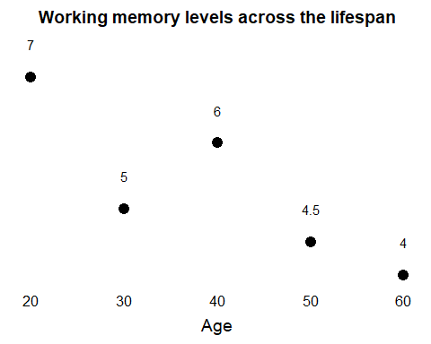

Dot plot of age and memory - Step 4

Another example is the popular scatter plot. By default scatter plots already have relatively high data to ink ratios.

ggplot(mtcars, aes(mpg, hp)) +  
 geom_point()



Scatter plot - Step 1

However, “normal” axes don’t convey data, so they can be removed.

ggplot(mtcars, aes(mpg, hp)) +  
 geom_point() +  
 theme(axis.line = element_blank())

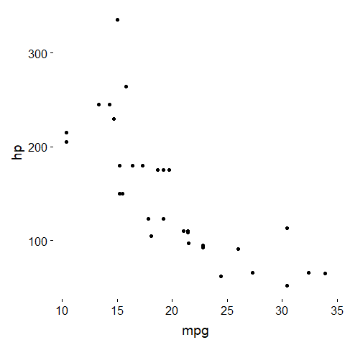

Scatter plot - Step 2

If we want something *like* axes but to be more useful, we can use the function geom_rangeframe() from the ggthemes package to put more informative data in. Range frames add “axes” but only that go the range of the observed data. Thus, these new axes show the minimum and maximum of each variable.

ggplot(mtcars, aes(mpg, hp)) +  
 geom_point() +  
 theme(axis.line = element_blank()) +  
 geom_rangeframe()

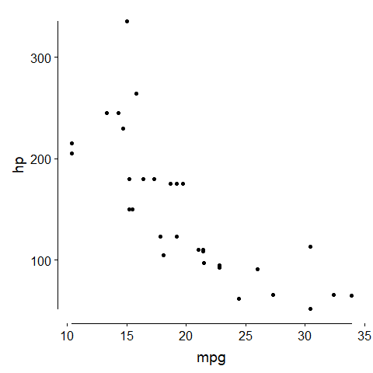

Scatter plot - Step 3

Finally, we can make the axis labels more informative. Instead of presenting “pretty” numbers but that convey no data, we can pick axis labels and breaks at meaningful points of the data. One option is quantiles / percentiles: 0th, 25th, 50th (median), 75th and 100th percentiles are given by default from the quantile() function. Now almost every piece of ink in this figure conveys some useful information. We can visually see the range of the mpg and hp variables from the axes. We can see the median and interquartile range as well.

ggplot(mtcars, aes(mpg, hp)) +  
 geom_point() +  
 scale_x_continuous(breaks = as.numeric(quantile(mtcars$mpg))) +   
 scale_y_continuous(breaks = as.numeric(quantile(mtcars$hp))) +   
 theme(axis.line = element_blank()) +  
 geom_rangeframe()

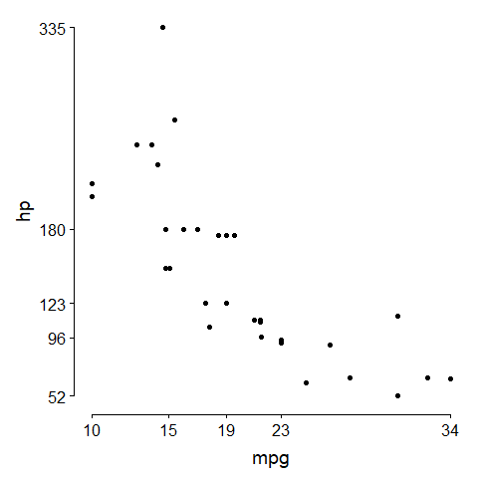

Scatter plot - Step 4

In the rest of the graphs we examine, we will try to implement this data to ink ratio principle. It does require some additional R code versus simply plotting with the defaults and often at first, you may need to spend a bit more time explaining your graph to people in text or in the figure legend. However, ultimately, such plots convey more data. For example, it makes it clear that cars in the top 25% of mpg (i.e., 23 to 34) all fall below the median hp (i.e., below 123). Conversely, cares in the bottom 25% of mpg(i.e., 10 to 15) all fall above the median hp (i.e., 123) with nearly all in the top 25% of hp.

# Advanced Bivariate Graphs

As with univariate graphs, we can map additional variables to additional aesthetics. This allows us to integrate more into standard bivariate plots. The following graph shows a simple example of this.

ggplot(mtcars, aes(mpg, hp, shape = cyl)) +  
 geom_point() +  
 scale_x_continuous(breaks = as.numeric(quantile(mtcars$mpg))) +   
 scale_y_continuous(breaks = as.numeric(quantile(mtcars$hp))) +   
 theme(axis.line = element_blank()) +  
 geom_rangeframe()

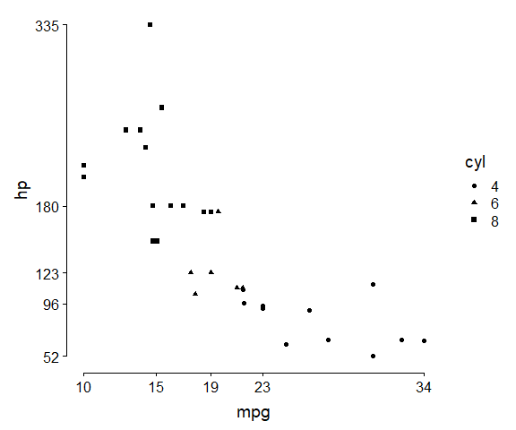

Scatter plot with shapes

However, although the shapes are distinguishable, they are visually difficult. Cleveland did some studies around shape perception, particularly when points may be partially overlapping and on this basis suggested other shaped. We can manually specify the number for which shape we want applied to which value of cyl using the scale_shape_manual() function[1]. We also use the name = argument so that instead of getting the legend labelled cyl it is labelled Number Cylinders. In R the \n means add a line break so in the legend there will be a line break between “number” and “cylinders”.

ggplot(mtcars, aes(mpg, hp, shape = cyl)) +  
 geom_point(size = 3) +  
 scale_shape_manual(  
 name = "Number\nCylinders",  
 values = c("4" = 1, "6" = 3, "8" = 83)) +   
 scale_x_continuous(breaks = as.numeric(quantile(mtcars$mpg))) +   
 scale_y_continuous(breaks = as.numeric(quantile(mtcars$hp))) +   
 theme(axis.line = element_blank()) +  
 geom_rangeframe()

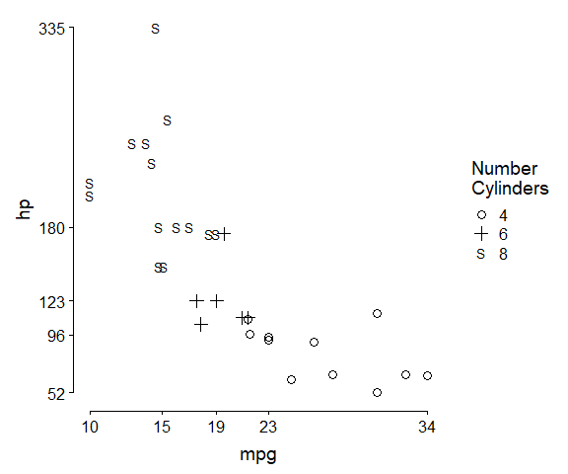

Scatter plot with shapes

Scatter plots are a helpful way to represent the raw data and association between two variables. In some cases, however, it can be harder to see the results. The following graph is a scatter plot of stress and positive affect in the daily diary data we have used. First we remove any missing data on those variables, then we plot.

d2 <- d[!is.na(STRESS) & !is.na(PosAff)]  
  
ggplot(d2, aes(STRESS, PosAff)) +  
 geom_point(alpha = .2) +  
 scale_x_continuous(breaks = as.numeric(quantile(d2$STRESS))) +   
 scale_y_continuous(breaks = as.numeric(quantile(d2$PosAff))) +   
 theme(axis.line = element_blank()) +  
 geom_rangeframe()

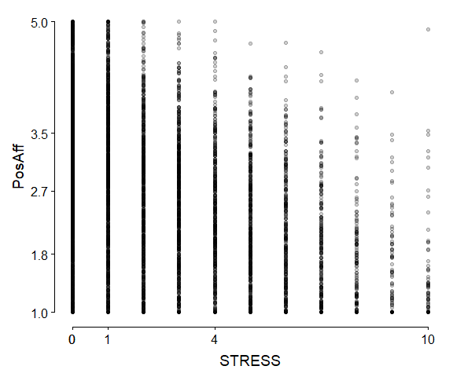

Scatter plot with a lot of data

There are so many assessments and each overlap with each other so much that it is very difficult to see any pattern or trend. STRESS is skewed so both the minimum value and the 25th percentile are 0, which is why we only see four labels on the x axis instead of five. We can try to better see the data by shrinking the raw points, making them transparent and adding some noise (a.k.a., jittering) on stress. This works relatively well for these data and helps us see the pattern more clearly.

ggplot(d2, aes(jitter(STRESS), PosAff)) +  
 geom_point(size = 0.6, alpha = .2) +  
 scale_x_continuous(breaks = as.numeric(quantile(d2$STRESS))) +   
 scale_y_continuous(breaks = as.numeric(quantile(d2$PosAff))) +   
 theme(axis.line = element_blank()) +  
 geom_rangeframe()

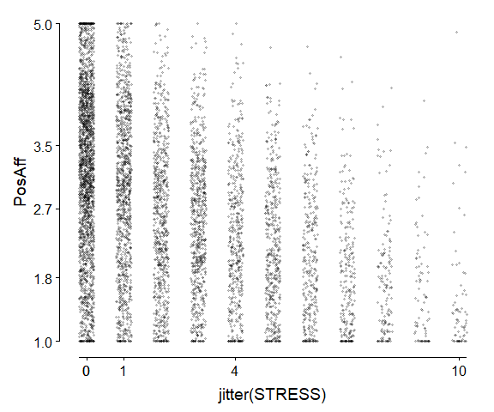

Scatter plot with a lot of data reducing overplotting

The breaks for positive affect are useful but probably printed in too much precision. We can use the round() function to reduce this precision and clean up the numbers.

ggplot(d2, aes(jitter(STRESS), PosAff)) +  
 geom_point(size = 0.6, alpha = .2) +  
 scale_x_continuous(breaks = as.numeric(quantile(d2$STRESS))) +   
 scale_y_continuous(breaks = round(as.numeric(quantile(d2$PosAff)), digits = 2)) +   
 theme(axis.line = element_blank()) +  
 geom_rangeframe()

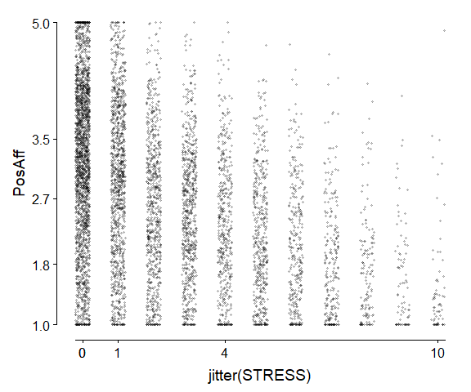

Scatter plot with a lot of data reducing overplotting with rounding for positive affect

To more clearly see the trend in scatter plot data, we can add smooth lines. R can add these easily using some flexible regression-based models but that allow flexibility in the association. With repeated measures data, the standard errors will be wrong, so we turn them off using the argument se = FALSE.

ggplot(d2, aes(jitter(STRESS), PosAff)) +  
 geom_point(size = 0.6, alpha = .2) +  
 scale_x_continuous(breaks = as.numeric(quantile(d2$STRESS))) +   
 scale_y_continuous(breaks = round(as.numeric(quantile(d2$PosAff)), digits = 2)) +   
 theme(axis.line = element_blank()) +  
 geom_rangeframe() +  
 stat_smooth(se = FALSE)

## `geom_smooth()` using method = 'gam' and formula 'y ~ s(x, bs = "cs")'

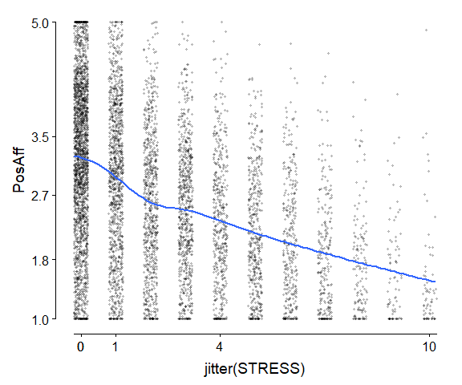

Scatter plot with a lot of data reducing overplotting with rounding for positive affect and a smooth trend line added

Another option for large amounts of data where plotting the raw points may be too much is to use summaries. For example, to examine univariate distributions, we used histograms and density plots. Similar options exist for bivariate data. Before we look at some of these, we start with a 3D graph of the density of data by stress and positive affect.

You must enable Javascript to view this page properly.

Once you are familiar with this 3D representation, now we can look at the 2D versions. One common approach is a contour plot. Each line in a contour plot represents the same value on the third dimension, here density. They are equally spaced, so if contours are near together, it means that the level of the third variable changes rapidly with a change in x or y. If they are far apart, it means the value of the third variable changes slowly with x or y.

ggplot(d2, aes(STRESS, PosAff)) +  
 geom_density2d(size = 1, colour = "black") +  
 scale_x_continuous(breaks = as.numeric(quantile(d2$STRESS))) +   
 scale_y_continuous(breaks = round(as.numeric(quantile(d2$PosAff)), 2)) +   
 theme(axis.line = element_blank()) +  
 geom_rangeframe()

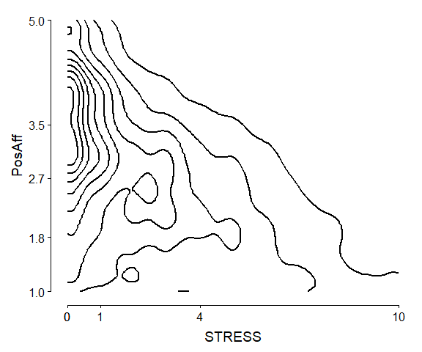

2D contour plot of densities

We can use the fill argument to add colour to help. Higher numbers indicate higher density (i.e., more observations).

ggplot(d2, aes(STRESS, PosAff)) +  
 stat_density_2d(aes(fill = ..level..), geom = "polygon", colour = "black") +   
 scale_x_continuous(breaks = as.numeric(quantile(d2$STRESS))) +   
 scale_y_continuous(breaks = round(as.numeric(quantile(d2$PosAff)), 2)) +   
 theme(axis.line = element_blank()) +  
 geom_rangeframe()

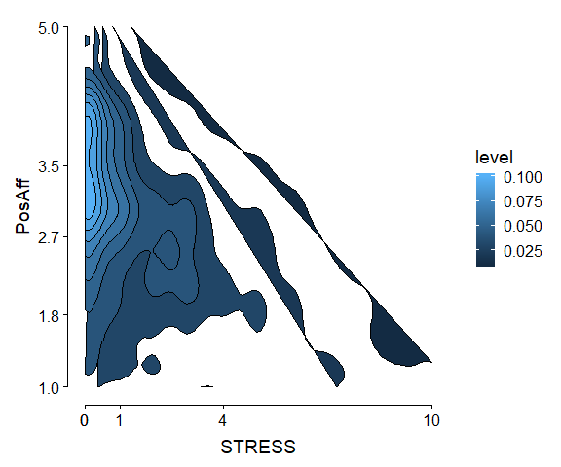

2D filled contour plot of densities

One last option we will look at for large amounts of two-dimensional data is kind of like a histogram. The data are binned, and counted. Instead of binning on one dimension, data are binned on two dimensions.

ggplot(d2, aes(STRESS, PosAff)) +  
 geom_hex(bins = 20) +   
 scale_x_continuous(breaks = as.numeric(quantile(d2$STRESS))) +   
 scale_y_continuous(breaks = round(as.numeric(quantile(d2$PosAff)), 2)) +   
 theme(axis.line = element_blank()) +  
 geom_rangeframe()

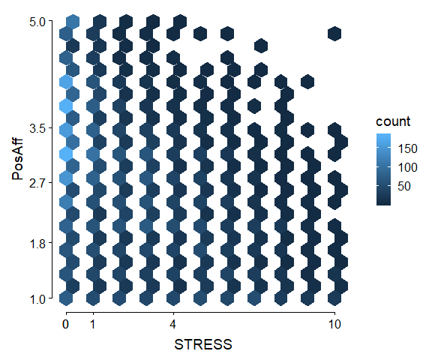

2D histogram by hexagonal binning

A challenge with these plots can be figuring out the ideal number of bins to use, especially withvery skewed or “clumpy” data. Too many people in one bin means that the colour scale must go up so high that you do not get much granularity to compare different frequencies on the lower end (e.g., below with bins = 10 the colour scale is in 100s of observations).

ggplot(d2, aes(STRESS, PosAff)) +  
 geom_hex(bins = 10) +   
 scale_x_continuous(breaks = as.numeric(quantile(d2$STRESS))) +   
 scale_y_continuous(breaks = round(as.numeric(quantile(d2$PosAff)), 2)) +   
 theme(axis.line = element_blank()) +  
 geom_rangeframe()

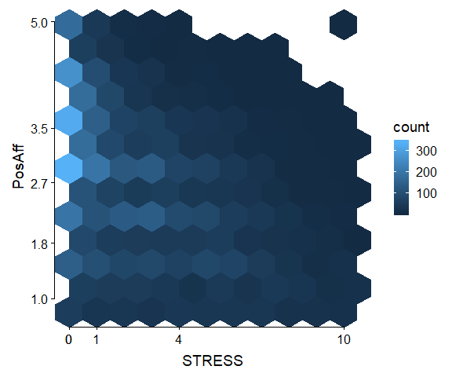

2D histogram by hexagonal binning

## Try It - Bivariate

Using the daily diary dataset we have worked with all semester, d dataset:

1. Make a scatter plot (points) for SUPPORT and COPEPrb. Use the good visualization principles we have learned. Make your own decisions about jittering, size, and alpha transparency to make the scatter plot most useful to read.
2. Extend your final plot from number 1 to include an overall trend line.
3. Create a plot of the distribution/density of SUPPORT and COPEPrb. This can be a contour plot, hexgonal bin, or if you are very keen, a 3D plot.

## scatter plot code here  
  
  
## scatter plot + trend line code here  
  
  
## 2d distribution plot code here

# Longitudinal Plots

For longitudinal data or time series data, line plots often make sense. We have seen simple line plots before, but when there are multiple people, using an overall line plot is not effective.

The following code subset the data to just 4 randomly sampled people with non missing support values and creates a line plot.

set.seed(123)  
d3 <- d[!is.na(SUPPORT) & UserID %in% sample(unique(d$UserID), 4)]  
  
ggplot(d3,aes(SurveyDay, SUPPORT)) +  
 geom_line()

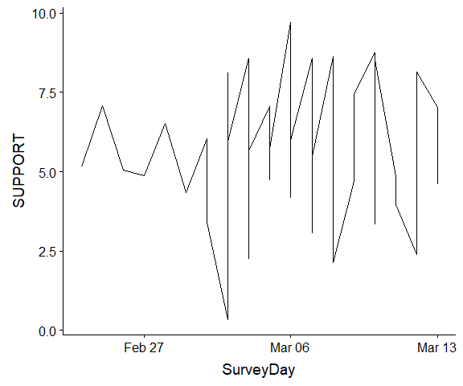 The vertical jumps in the lines are because there are multiple assessments on the same day. To address this, we need to separate the lines by person. We can do this by using another aesthetic, such as colour, and/or by specifying a grouping variable. We do both below.

ggplot(d3,aes(SurveyDay, SUPPORT,  
 colour = UserID, group = UserID)) +  
 geom_line()

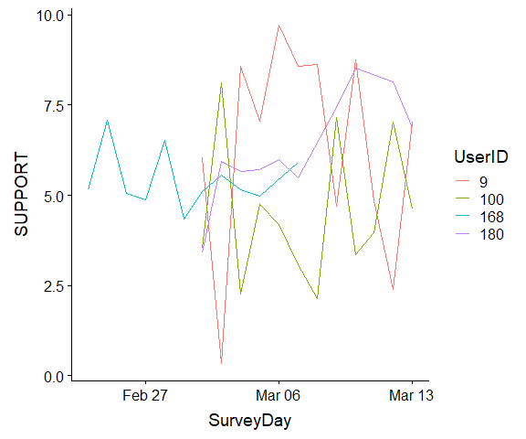

Longitudinal plots by person

Just as we looked at plotting some smooth lines for scatter plots, we can do that for each person. All we need to do is add another line with the stat_smooth() function.

ggplot(d3,aes(SurveyDay, SUPPORT,  
 colour = UserID, group = UserID)) +  
 geom_line() +  
 stat_smooth(se=FALSE)

## `geom_smooth()` using method = 'loess' and formula 'y ~ x'

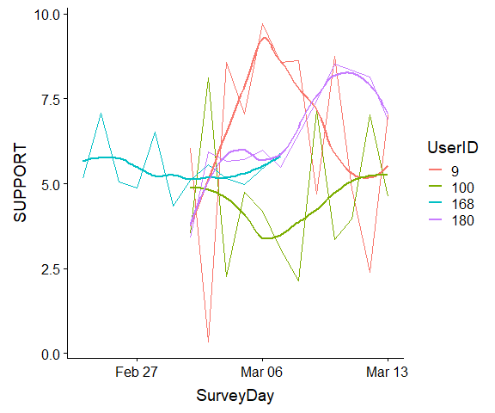

Longitudinal plots by person with smooths

If we think that the smooth lines are relatively good approximations, a cleaner image may be made by just showing these, which smooths out some of the “noise” in the raw data.

ggplot(d3,aes(SurveyDay, SUPPORT,  
 colour = UserID, group = UserID)) +  
 stat_smooth(se=FALSE)

## `geom_smooth()` using method = 'loess' and formula 'y ~ x'

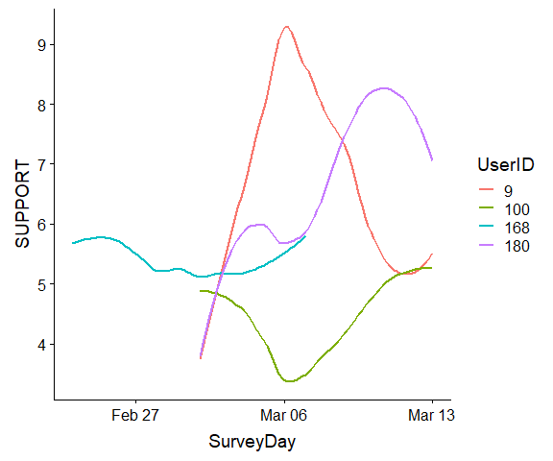

Longitudinal smooth plots by person

Finally, by default R uses flexible smooths. However, by specifying method = "lm" we can force a linear smooth function (linear regression), although this might be a (very) poor fit to some data, such as ID 9.

ggplot(d3,aes(SurveyDay, SUPPORT,  
 colour = UserID, group = UserID)) +  
 geom_line() +   
 stat_smooth(method = "lm", se = FALSE)

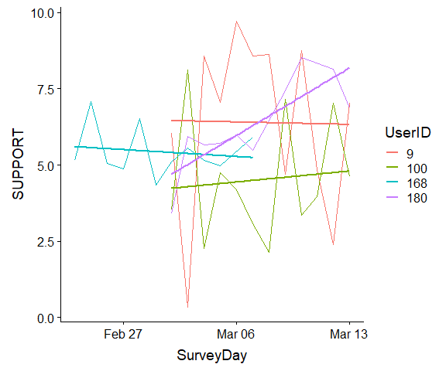

Longitudinal linear smooth plots by person

## Try It - Longitudinal

Using the daily diary dataset we have worked with all semester, d dataset:

1. Change the random seed and subset the dataset to just a few participants’ IDs.
2. Plot problem focused coping over time for those few people.

## subset the data  
  
  
## longitudinal plot

1. There are many other shapes available. To see a list, go to: <http://sape.inf.usi.ch/quick-reference/ggplot2/shape>.