**Capstones project -8**

Received mail from Keshav: Wed 30-10-2024 13:03

**Problem Statement:**

**Scenario**: Local businesses are the backbone of many communities, offering unique products and services that large chains and online retailers often can't provide. However, these small businesses frequently struggle to compete due to limited resources, lower visibility, and challenges in managing day-to-day operations. For example, a local bakery may find it difficult to reach new customers or manage its inventory effectively, while a neighborhood bookstore might struggle with promoting events or special offers. Moreover, local consumers may be unaware of the variety and quality of products available right in their neighborhoods, leading them to shop at larger, more well known stores instead. The ongoing challenges posed by economic downturns and changing consumer habits have made it even more critical for local businesses to find innovative ways to attract and retain customers.

|  |  |  |  |
| --- | --- | --- | --- |
| Group | Learner 1 | Learner 2 | Capstone Project Number |
| 8 | Ashna P K | Prajwal Gowda M M | 8 |

Nov 1st ,2024

**Abstract**

Local businesses play a vital role in enriching communities by offering diverse products and personalized services that larger chains often cannot match. However, these small businesses face challenges such as limited visibility, competition from well-known brands, and resource constraints, which hinder their ability to attract new customers and manage operations effectively. This project aims to develop a web application using Angular 18 and .NET 8 to support local businesses by providing a robust platform that enhances their reach, streamlines their operations, and builds stronger connections with local consumers. By using different kinds of API, the application offers a comprehensive platform that boosts the visibility of local businesses, streamlines daily operations, and engages consumers by making local products and services more accessible. This project leverages modern technologies to empower local businesses to compete more effectively and foster vibrant, thriving communities.

### 1. ****Customer****

* **Authentication and User Management**
  + Register and log in securely with JWT-based authentication.
  + Option for multi-factor authentication (MFA) if enabled.
* **Nearby Business Search**
  + Search for nearby businesses within a specific radius based on their location.
  + Filter businesses by type (e.g., bakery, bookstore) or proximity.
  + Sort results by distance to show businesses closest to the user's location.
* **Product and Inventory Viewing**
  + View product listings with detailed descriptions, photos, categories, and prices.
  + See real-time inventory levels, with indicators if products are low in stock.
* **Deals and Promotions**
  + Browse highlighted deals, special offers, and member-only discounts.
  + Filter deals by type (e.g., seasonal offers).
* **Review and Rating**
  + Submit reviews and star ratings for businesses they have interacted with.
  + Sort reviews by most recent, highest-rated, or lowest-rated.
  + Flag inappropriate reviews for moderation.

### 2. ****Business Owner****

* **Authentication and User Management**
  + Register, log in, and manage their business profile securely.
  + Role-based access control ensures access to business management tools.
  + Option for multi-factor authentication (MFA) if enabled.
* **Product and Inventory Management**
  + Add, update, and delete product listings, including descriptions, images, categories, and pricing.
  + Track inventory in real-time, with low-stock notifications.
* **Deals and Promotions**
  + Create, update, and manage special offers, discounts, and events for their business.
  + Set expiration dates on deals with automated expiration tracking.
  + Highlight certain deals for prominent placement in the app.
* **Review and Rating Management**
  + View customer reviews and ratings for their business.
  + Use moderation tools to flag and address inappropriate or inaccurate reviews.
* **Business Profile and Visibility**
  + Ensure their business appears in the Nearby Business Search results.
  + Add business details and update business type for better search filtering.

### 3. ****Administrator****

* **Authentication and User Management**
  + Access to all administrative and management tools.
  + Manage users, roles, and permissions across the platform.
* **Business and User Oversight**
  + View and manage all business profiles on the platform, including editing or removing businesses if necessary.
  + Oversee user accounts, including blocking or suspending accounts as needed.
* **Deals and Promotions Moderation**
  + Monitor deals and promotions created by business owners to ensure they adhere to platform standards.
* **Review and Rating Moderation**
  + Access to moderation tools to manage flagged reviews, ensuring reviews remain appropriate and constructive.
* **Platform Management and Analytics**
  + Access analytics and usage data to assess platform performance.
  + Generate reports on user engagement, popular businesses, top-rated products, and overall platform activity.

**Microservices providing**

### 1.Authentication and User Management API

* **Purpose**: Manages user authentication, registration, and roles. Supports customers, business owners, and admin roles with distinct access and permissions.

**Features**:

* Secure JWT-based authentication.
* Role-based access control (RBAC) to define and restrict access based on user roles.
* Support for multi-factor authentication (MFA) if required.

**3. Product and Inventory Management API**

* **Purpose**: Enables businesses to manage their product listings and inventory levels, including stock and pricing details.
* **Features**:
  + Real-time inventory tracking with notifications for low-stock products.
  + Basic product categorization (e.g., seasonal items, trending products).
  + Support for product photos and descriptions to enhance customer experience.

**5.Deals and Promotions API**

* **Purpose**: Allows businesses to create, update, and promote special offers, discounts, and events.

**Features**:

* Expiration tracking to automatically archive expired deals.
* Highlighted deals section for prominent promotion.
* Filtering by deal type (e.g., seasonal offers, member-only discounts).

**6.Review and Rating API**

* **Purpose**: Enables customers to review and rate businesses, providing valuable feedback for other users.

**Features**:

* Star rating aggregation for each business (e.g., average rating).
* Moderation tools for business owners or admins to flag inappropriate content.

Sorting by most recent, highest-rated, or lowest-rated reviews

**Existing Api**

#### **Nearby Business Search**

* **Purpose**: Helps users find businesses within a specific radius of their current location.
* The **Nearby Business Search API** can be configured to show **only businesses within a specified radius** (e.g., 0.5 miles) or it can show **all businesses, sorted by proximity** with those closest to the user appearing first. The approach depends on the implementation needs of the application and the user’s preferences.

**Key Features**:

* **Filtered Searches**: Users can filter businesses by type (e.g., bakery, bookstore) or proximity.
* **Sorting by Distance**: Sort results to show businesses closest to the user’s location

Nov 2nd ,2024

Database Schema discussion

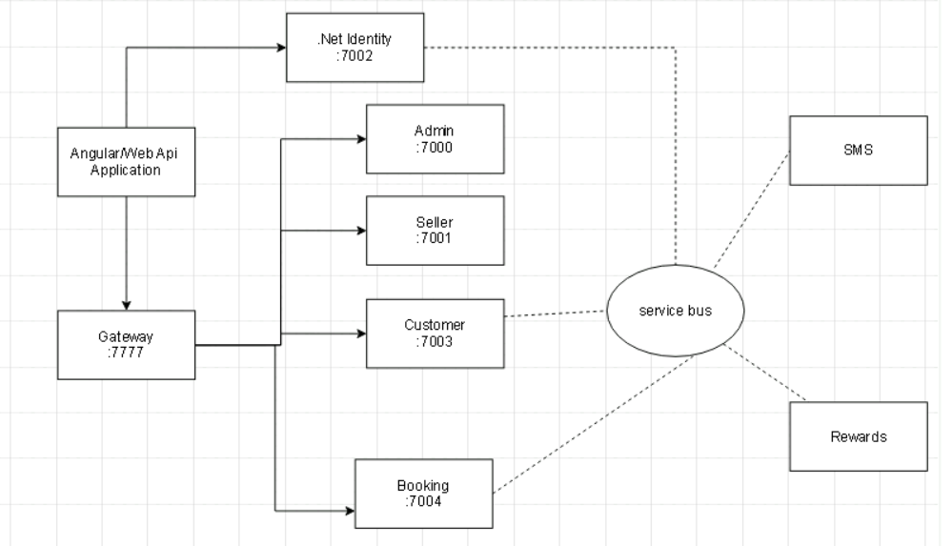

**Nov 5th 2024**

**Class diagram**

**Microservice 1**

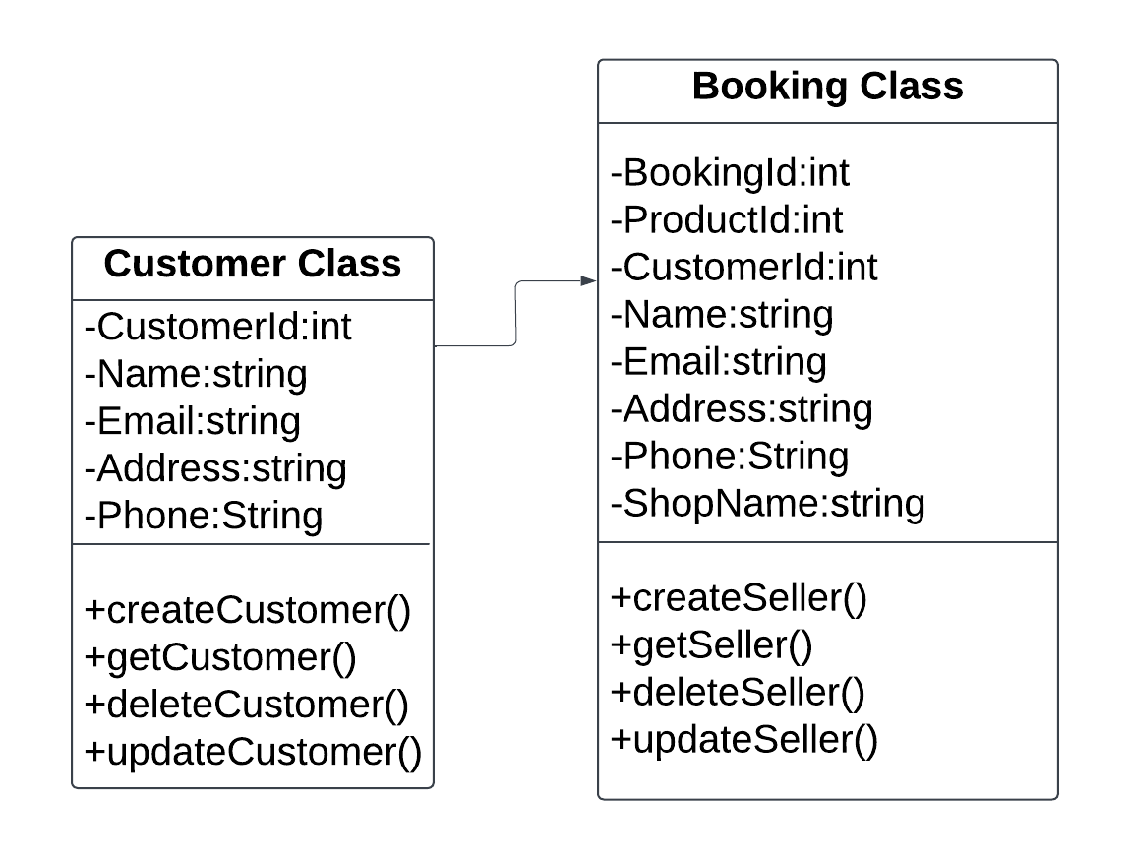

**Microservice 2**

