MVC

1. What is mvc?
2. What are the advantages of mvc?
3. Difference between mvc and asp?
4. How to handle session in mvc?
5. View bag,view data,tent data,

**1.ASP.NET WITH MVC DATA FIRST METHOD WITH STORED PROCEDURE**

**Example 1**

**STEP1**

* Create Database
* Create Table
* Create Stored Procedure

**STEP2**

* Create an application
  + Open vscode, new project, select mvc instead of empty, remove tick of http configure
* Create edmx(Entity Data Model XML.)
  + In solution explorer—add new item—select data on left side— ado.net entity data model---add—Ef designer---next—new connection—ms sql Server—continue—set server name(from sql)—select db name—ok—next—tick on the db and sp that we use—finish.
* Save and Build

**STEP3(To connect with database)**

* To add class inside model
  + Solution explorer—Models (right click)—add—class.
* Create automatic property for all fields in the table and etc one for display message
* To set validation
  + Validation set on above the property. Type[Required] then right click on it and select quick and add the namespace
* Save and Build

**STEP4**

* Add Controller
  + Add namespace( using application name.Models)
  + Create object of entities
  + Add action
  + Add viewpage
  + In viewpage on top write @model application name.Moodels.class name
  + Create form
  + In routeconfig set controller and action

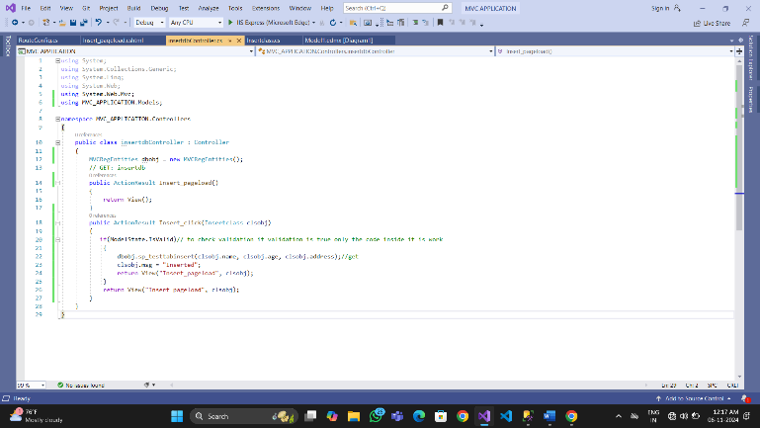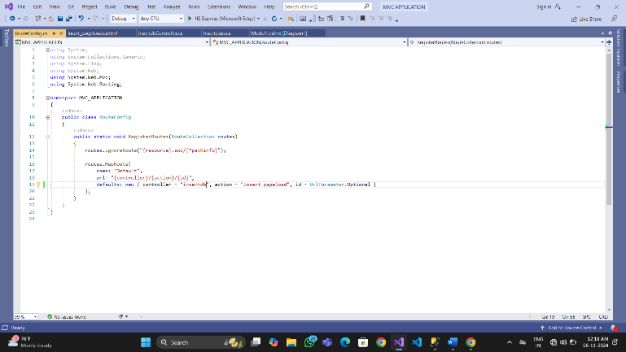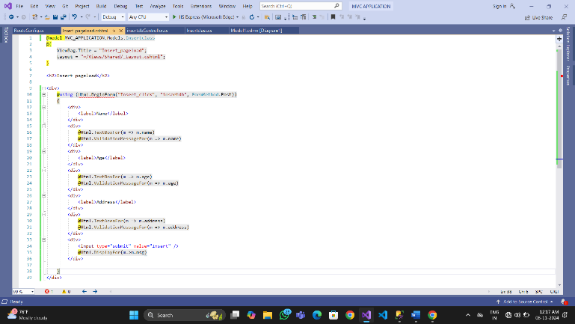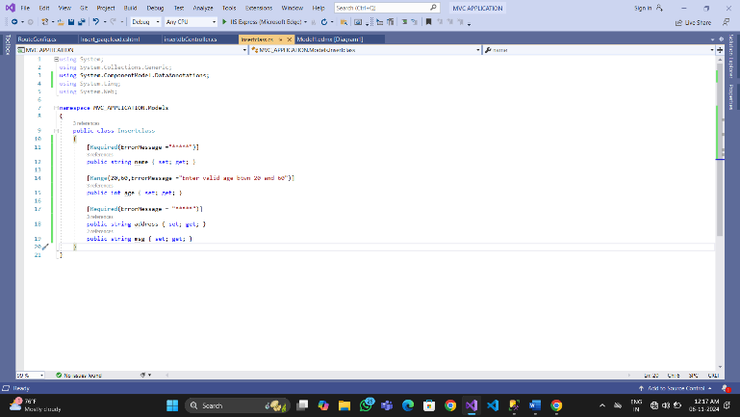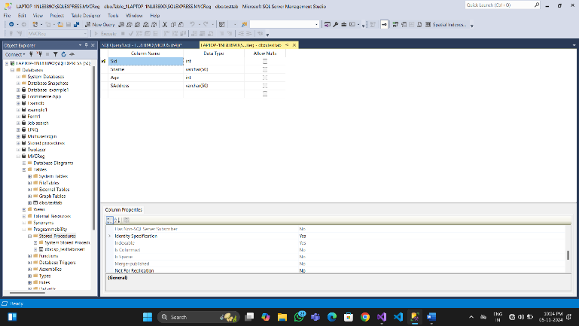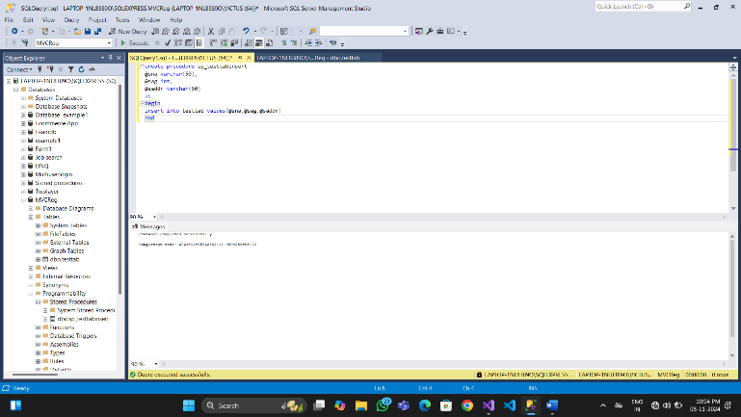

**1.ASP.NET WITH MVC with entity framework**

1. Create an application
2. Add edmx file (chosse table only) save and build
3. No need to create new model class. We use model class of edmx that automatically generated.
4. After add edmx next add controller
5. Add controller------select option mvc5 controller with views, using entity framework----select model class as table name and data context class as entity name
6. If we want layout we can add and if need change the controller’s name----add----save and build