

**Name:** Ashna Wasif

**Roll Number:** 2791

**Class:** BSCS 7B (Morning)

**Subject:** Computer Graphics

**Assignment No.:** 01

**Submitted To:** Mam Sabina Irum

**Date:** 28th March, 2025

**Question:**

Apply various concepts & related to 2d and 3d Computer Graphics.

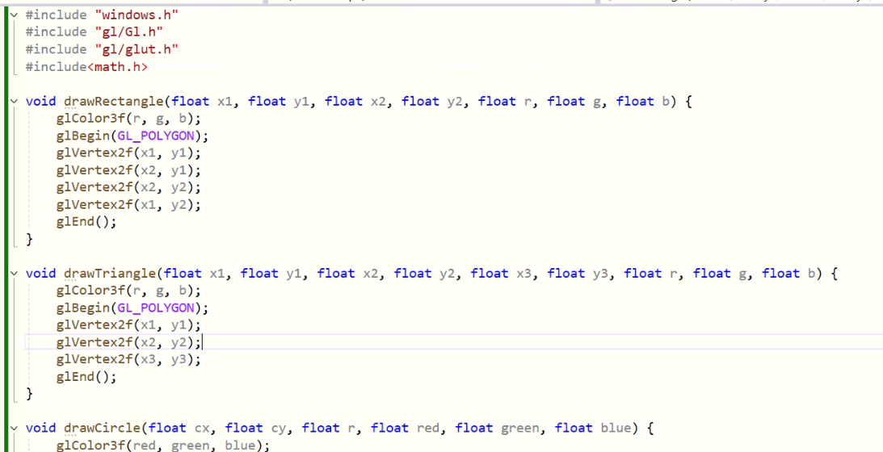**Program:**

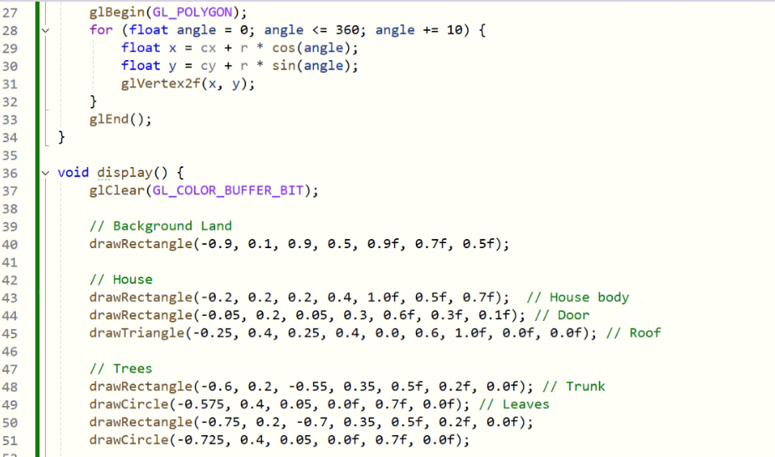

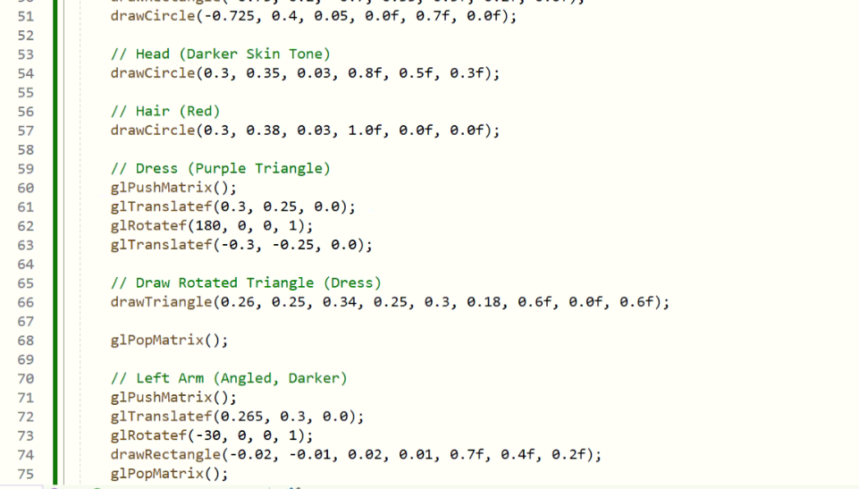

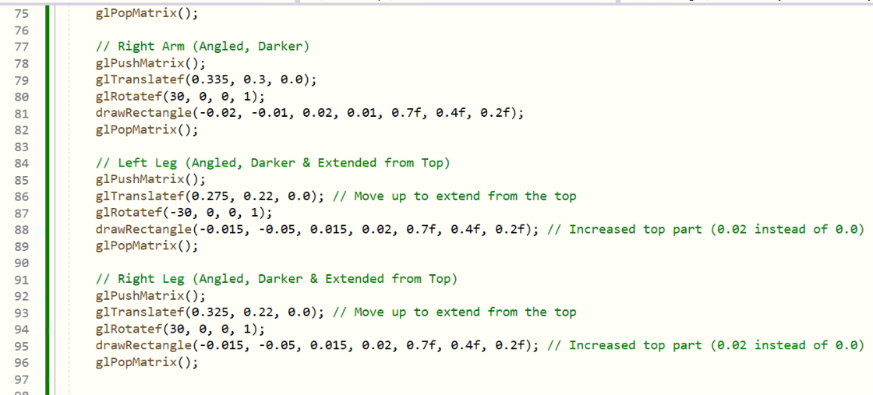

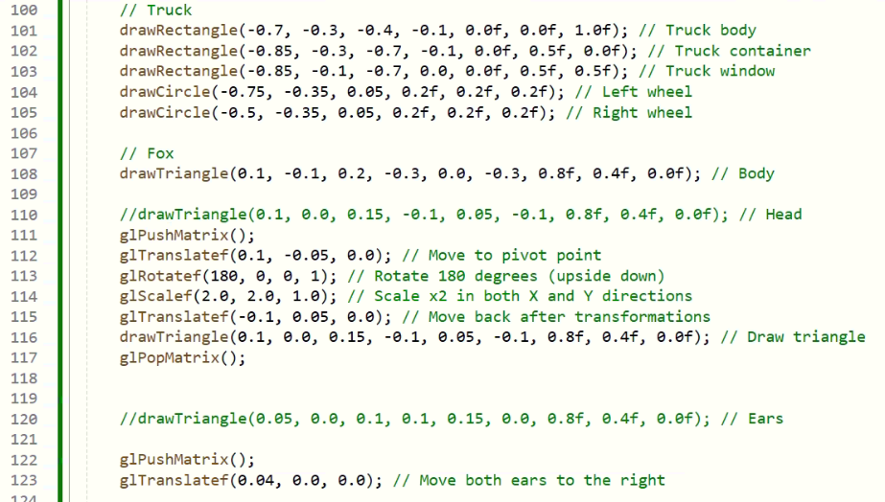

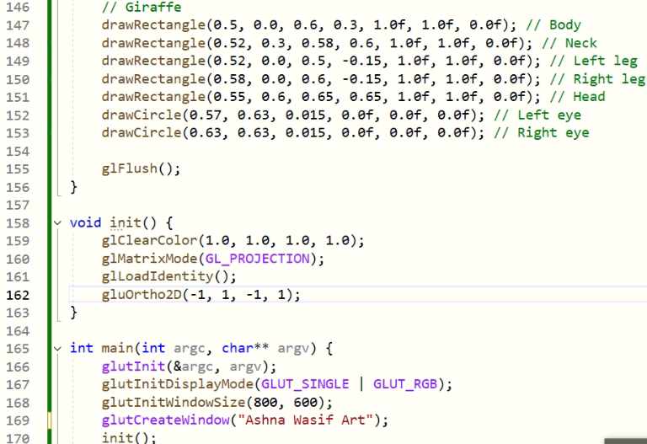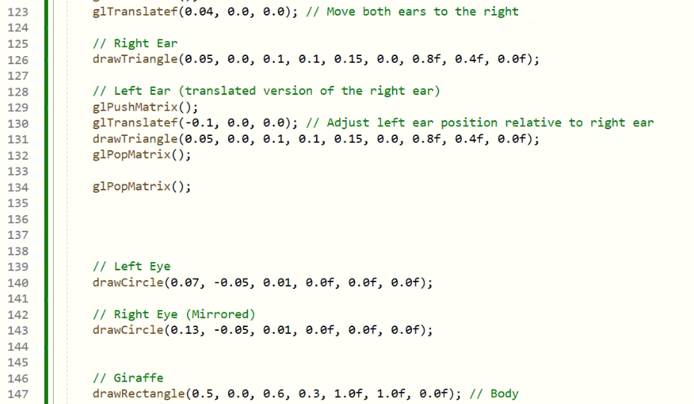

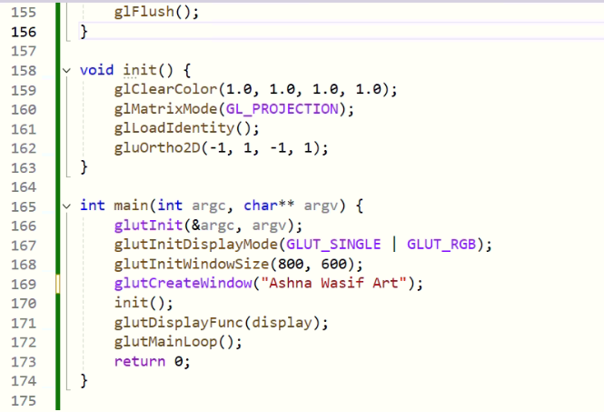

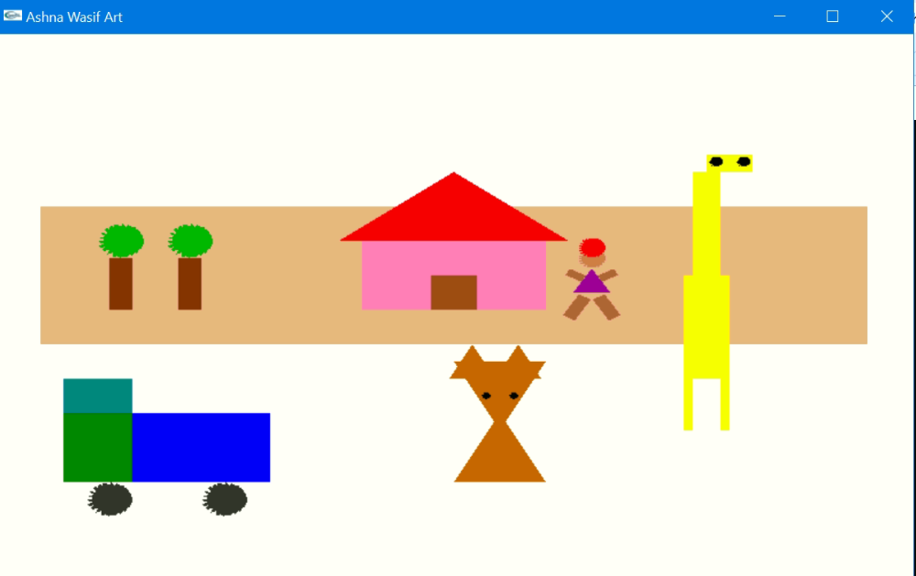**Output:**