

**Submitted By:**Ashna Wasif (2791)  
**Class**: BSCS 7B (Morning)

**Subject**: Computer Graphics

**Submitted To:** Mam Sabina Irum

**Date:** 2nd June, 2025

**Objective:**   
To further develop the basic 3D scene in Unity by integrating additional objects, effects, and interactivity for educational exploration.

* **Setting Up the Project:**
* 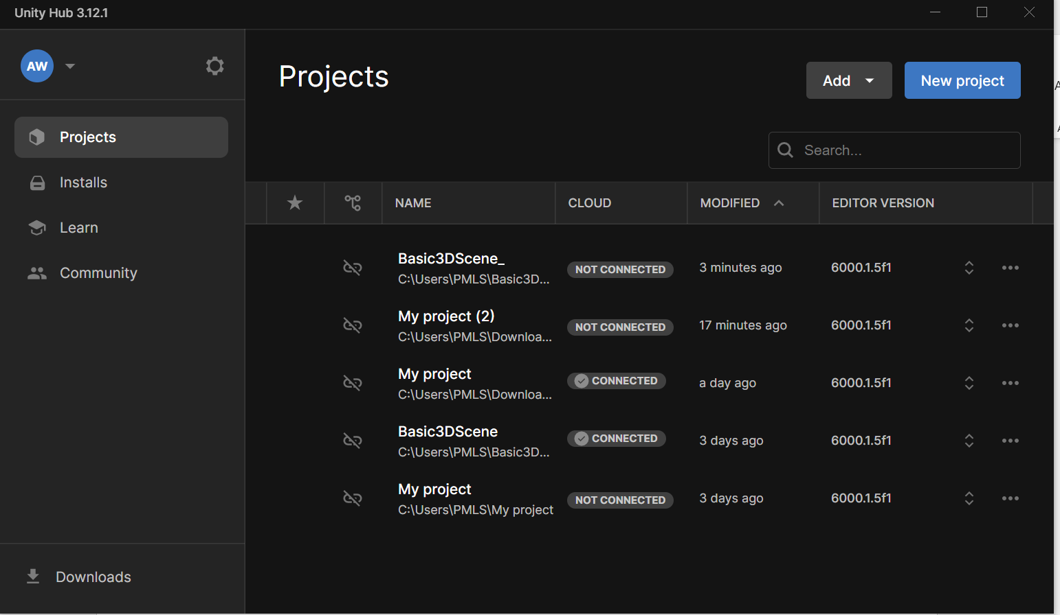Open Unity Hub and load the "Basic3DScene" project.

2**. Adding More Objects:**

* Introduce additional 3D objects like cylinders, cones, or capsules to the scene.

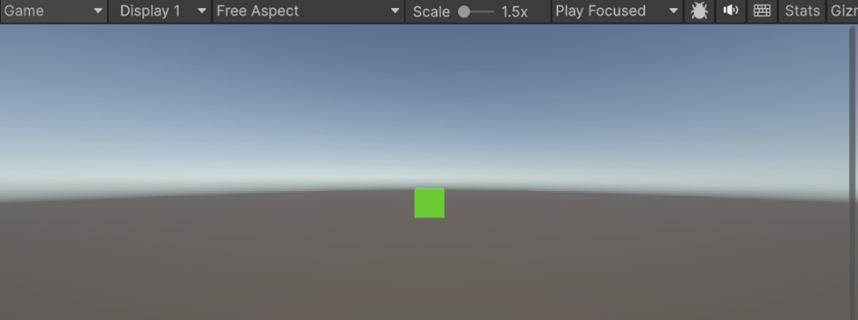Our previous project has just one green cube. Let’s add more things:

* Name them appropriately and position them around the existing objects to create an interesting composition.

For learning purpose, I added 3D shapes to observe their look. Here it is:  
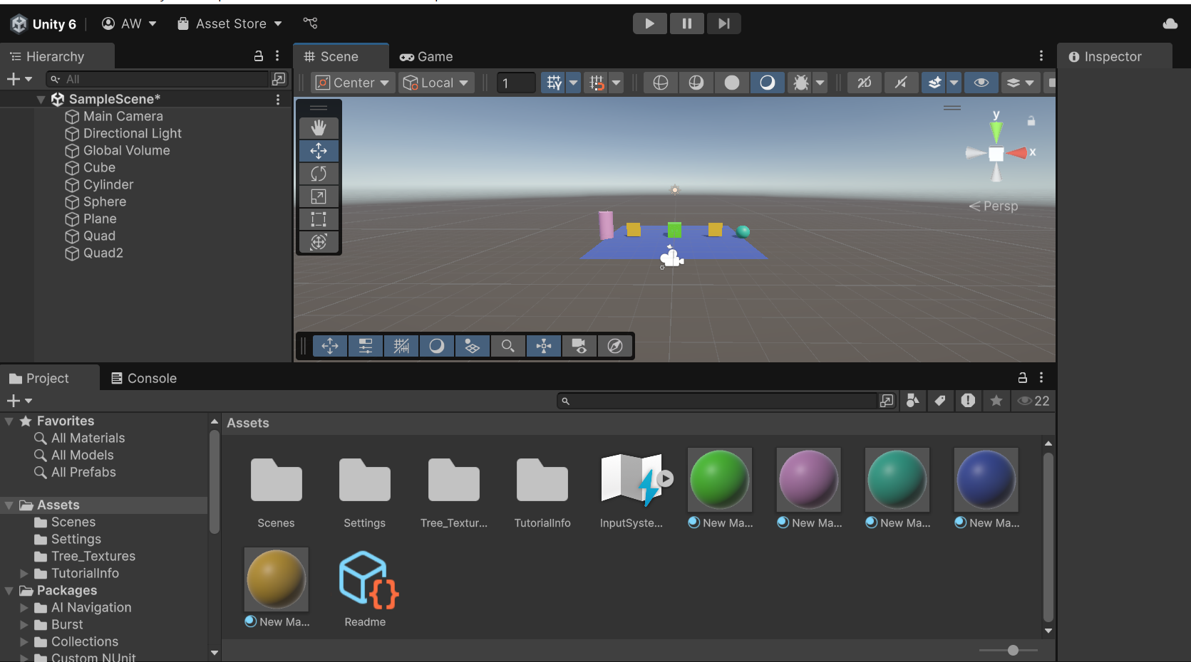

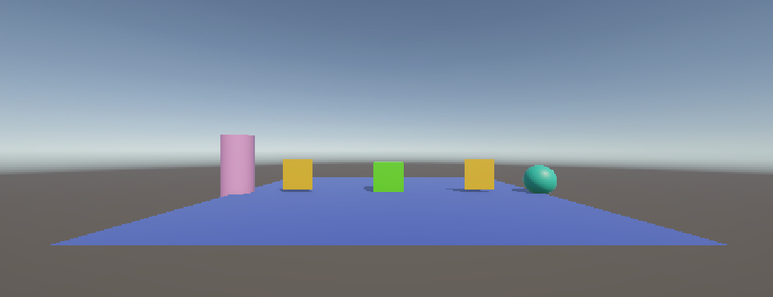And in game view:

1. **Applying Textures and Materials:**

* Create or import textures to apply to the objects in the scene.
* Experiment with different materials, shaders, and lighting settings to achieve desired visual effects.

Here, I’ve imported Water texture that I’ll be applying on a plane:

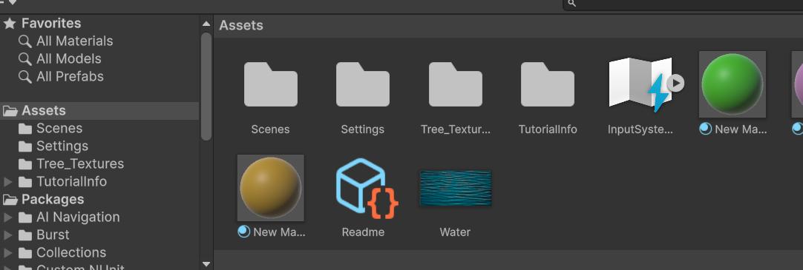

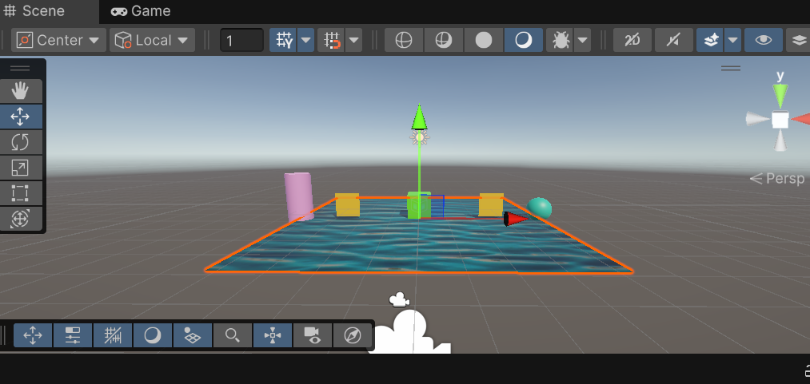On dragging and dropping it on plane, we got water texture:

1. **Implementing Animation:**

* Create animations for some of the objects to demonstrate movement or transformation.
* Use Unity's Animation window or write scripts to animate object properties such as position, rotation, or scale.

For this, we’ll be opening Animation window:

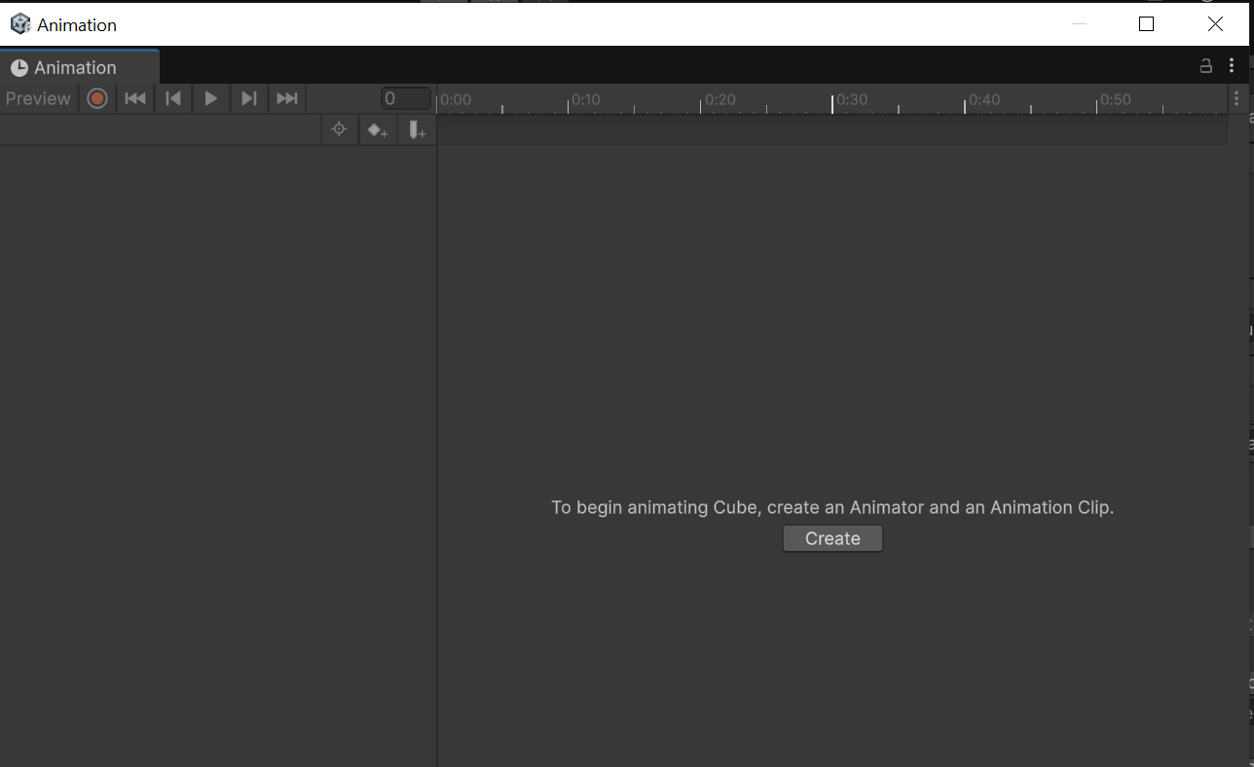

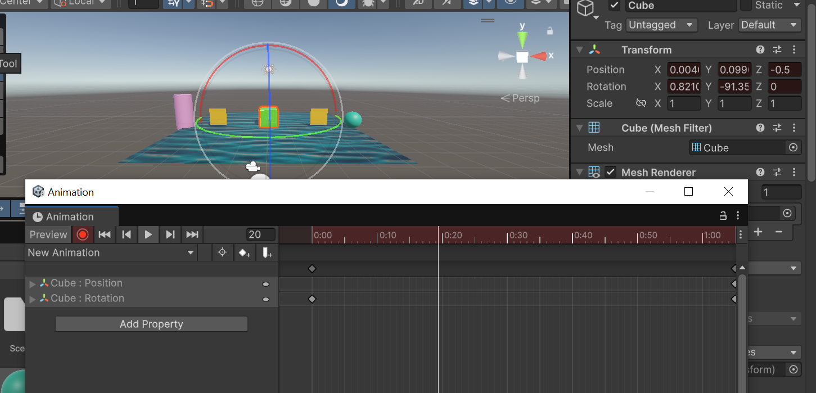Start recording and animate object:

We’ll now record and set the time to 1 seconds. Then you can test it as well by clicking on play button:

1. 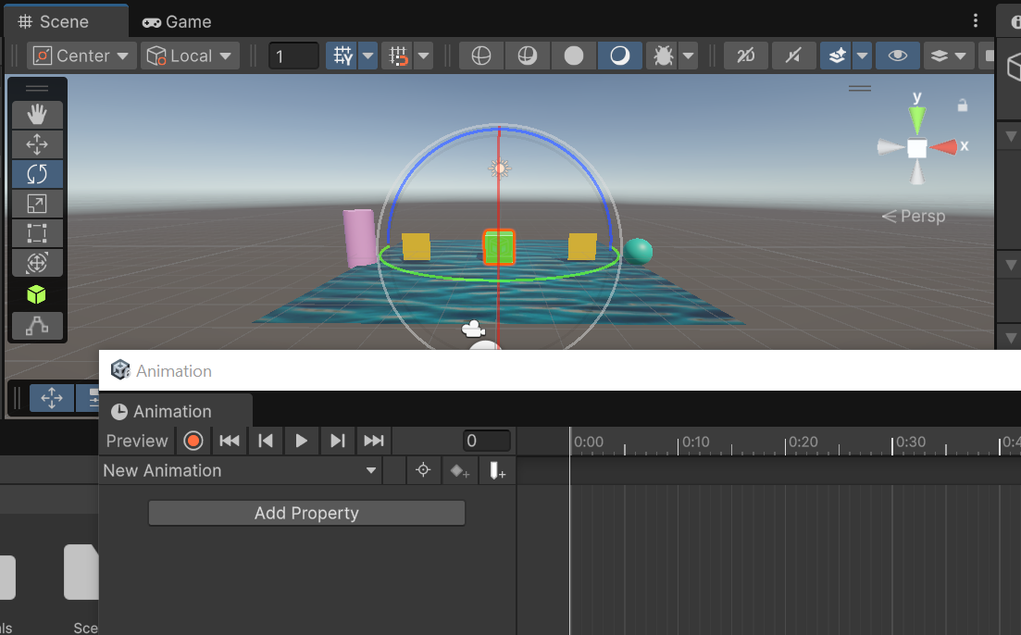**Adding Particle Systems:**
   * Integrate particle systems to simulate effects like fire, smoke, or sparks.
   * Adjust parameters such as emission rate, size, and color to customize the particle effects.

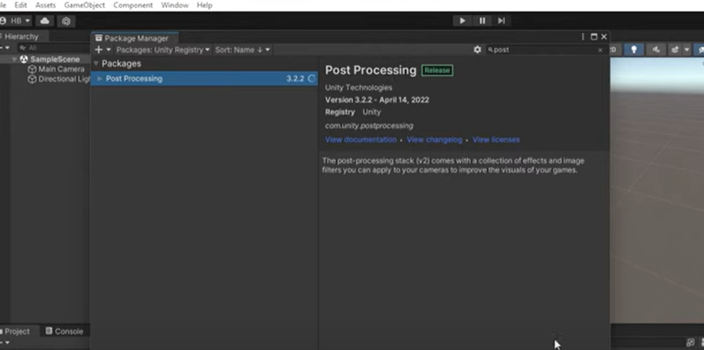For this, click windows >> Package management >> Pacakge Manager. You’ll see this window. Search Post processing:

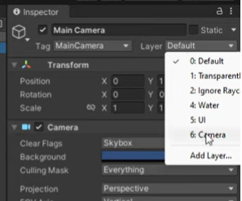Install this package. Once installed, Add layer in main camera:

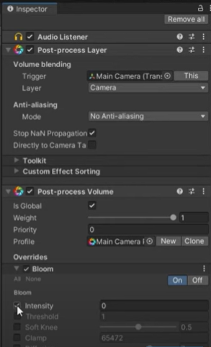

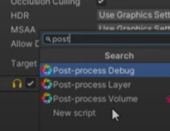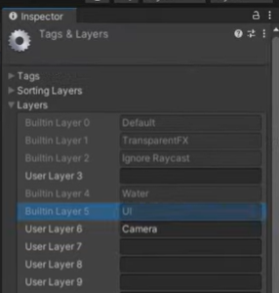Then, adding audio and setting intensity:

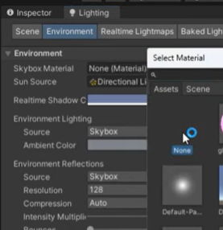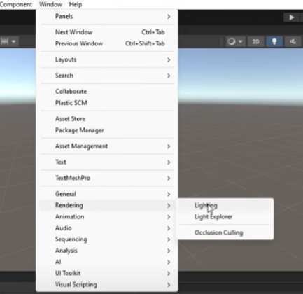Now adding Lightning in our cube:

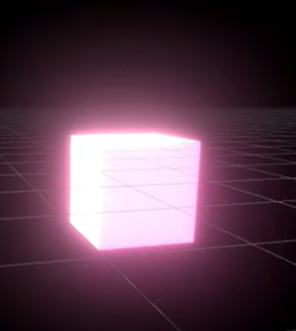It will make our cube to glow, I’ve added another cube of pink color and it glows as:

1. **Implementing Audio:**

Already Done in heading 5.

1. **Creating Interactive Elements:**

* Develop interactive elements such as buttons, switches, or levers using Unity's UI system.
* 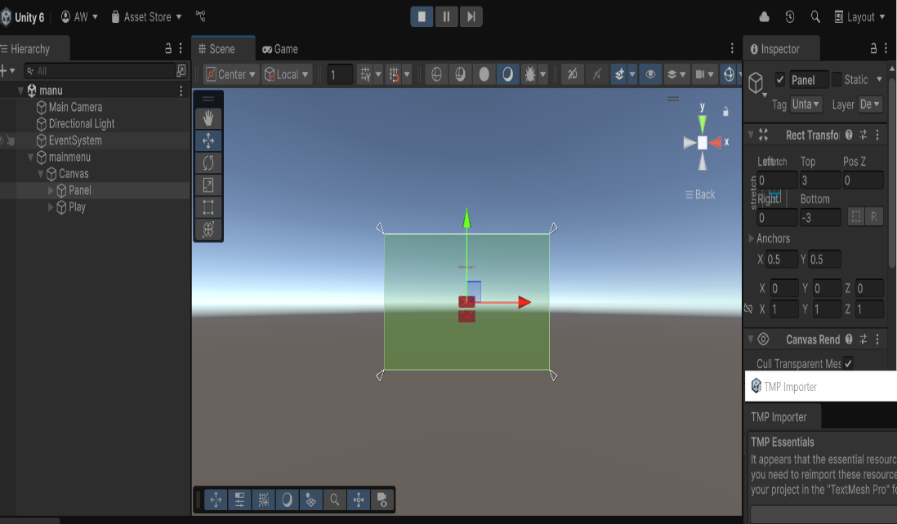Write scripts to handle user inputs and control the behavior of interactive elements.

For writing script, go to File > Build Settings. In the Scenes in Build list, make sure your Level 1 scene is added. Note the name or index (e.g., "Level1" or index 1). Then write the following code:

using UnityEngine;

using UnityEngine.SceneManagement;

public class StartGame : MonoBehaviour

{

// This function will be called when the Start button is clicked

public void LoadLevelOne()

{

SceneManager.LoadScene("Level1");

}

}

* **Testing, Debugging, and Optimization:**
* Test the scene thoroughly to ensure all elements function as intended.
* Debug any issues that arise during testing and optimize performance by adjusting settings like draw calls, poly count, or texture resolution.