

**Name:** Ashna Wasif

**Roll Number:** 2791

**Class:** BSCS 7B (Morning)

**Subject:** Computer Graphics

**Submitted To:** Mam Sabina Irum

**Date:** 25th April, 2025

**Question:**

Create a 2D representation of a car using basic shapes (rectangles, circles, etc.).

* Simulate the movement of the car along a horizontal road.
* Implement basic animation where the car continuously moves from left to right across the screen.

**Tasks:**

**Car Representation:**

* Draw the car using basic geometric shapes:
* Use a rectangle for the body of the car.
* Use circles for the wheels of the car.
* Color the body of the car in one color (e.g., blue) and the wheels in black.

**Road Representation:**

* Draw a simple road as a wide rectangle spanning the width of the screen.
* Color the road in gray or any other suitable color.

**Car Movement:**

* Animate the car so that it moves from the left side of the screen to the right along the road.
* When the car reaches the right side, make it reappear at the left side (looping effect).
* The movement should be smooth and continuous, updating the car's position over time.

**Animation:**

* Use OpenGL transformations (translation) to move the car along the x-axis.
* Update the position of the car on each frame, ensuring smooth animation.

**Do not copy the code from AI**

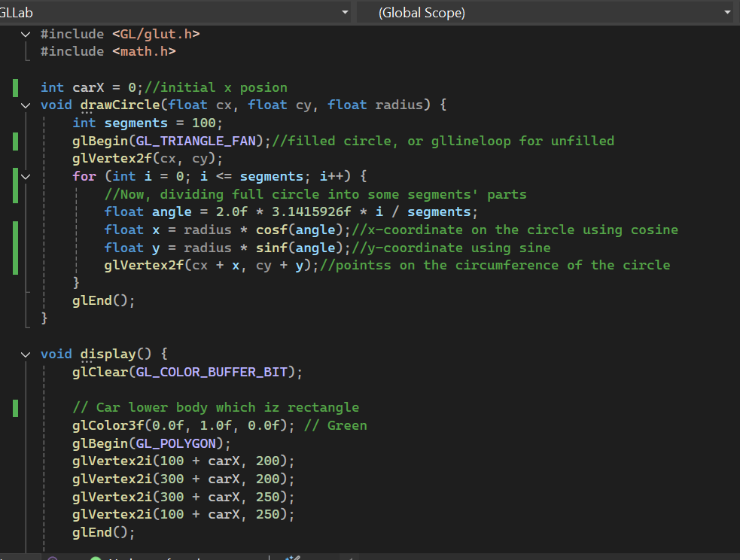**Code:**

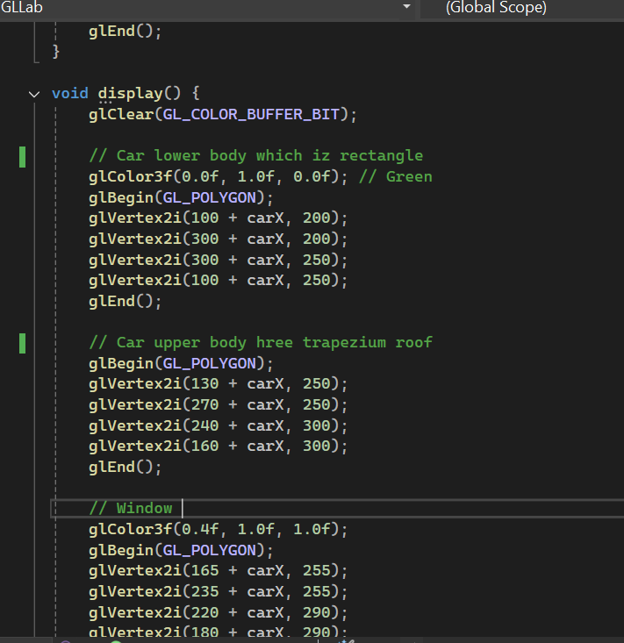

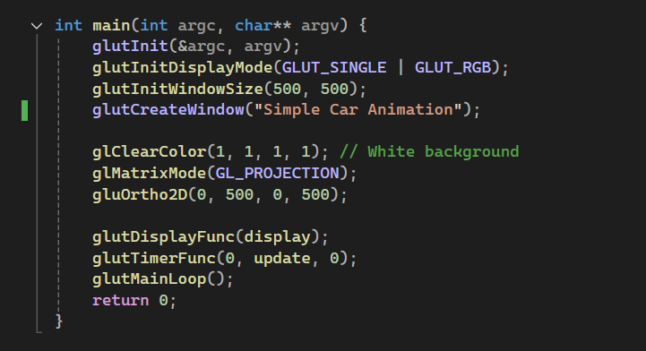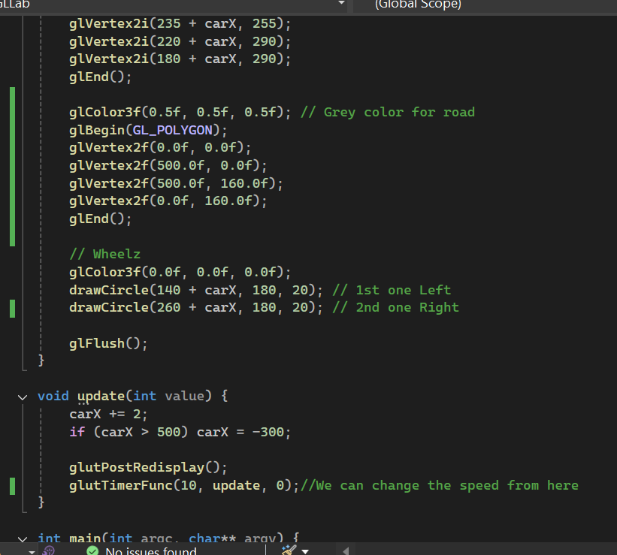

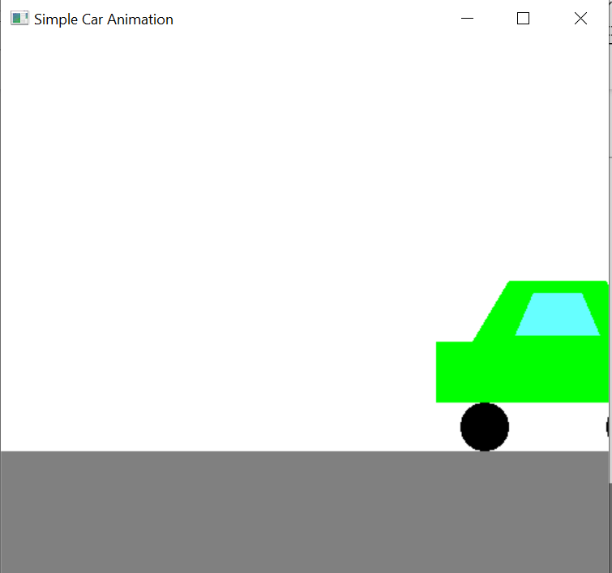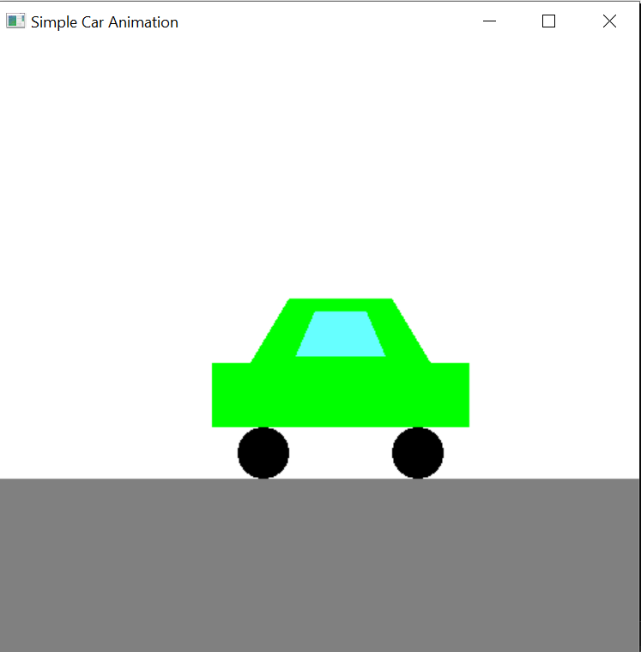**Output:**

