

**Submitted By:**Ashna Wasif (2791)  
**Class**: BSCS 7B (Morning)

**Subject**: Computer Graphics

**Submitted To:** Mam Sabina Irum

**Date:** 2nd June, 2025

**Objective:** To create a simple 3D scene in Unity using basic shapes and materials.

1. **Setting Up the Project:**

* 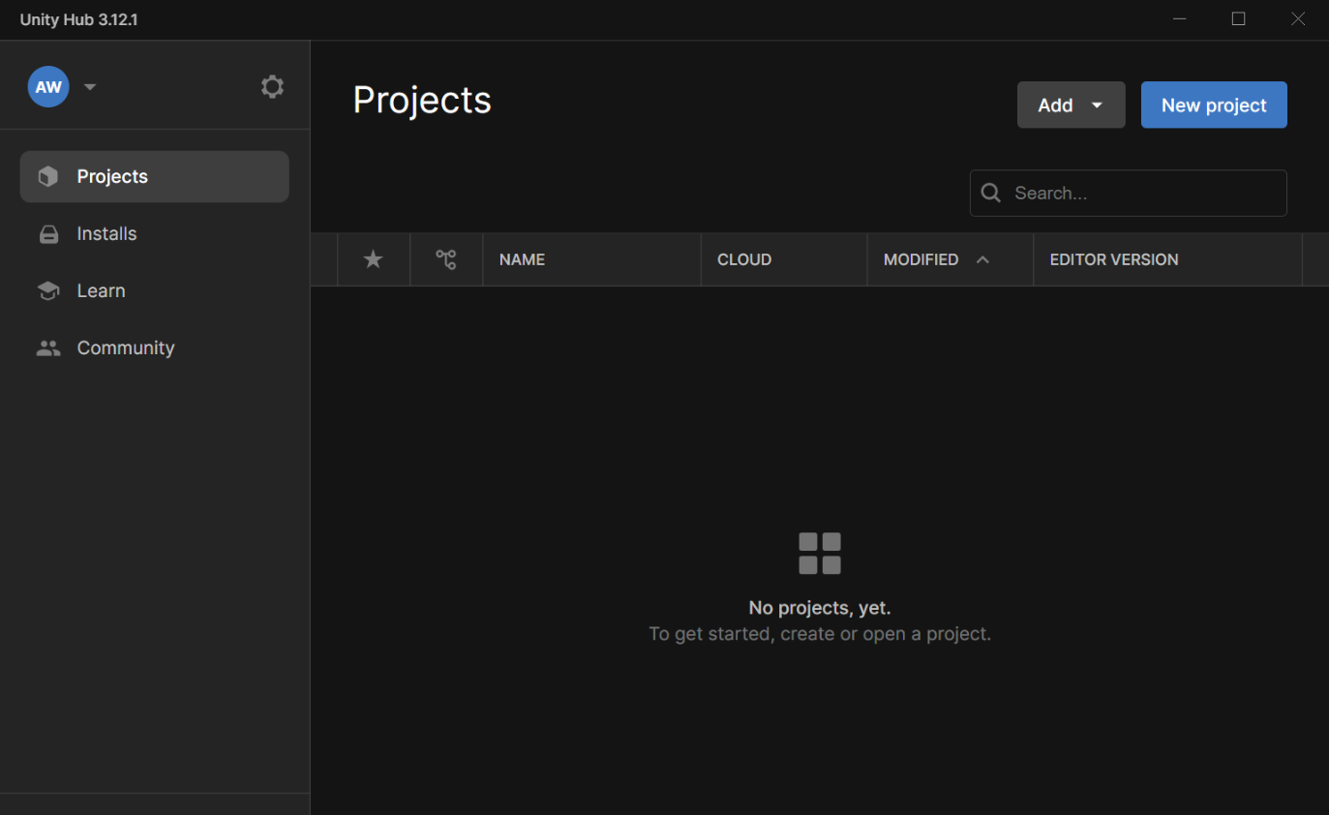Open Unity Hub and create a new 3D project:
* 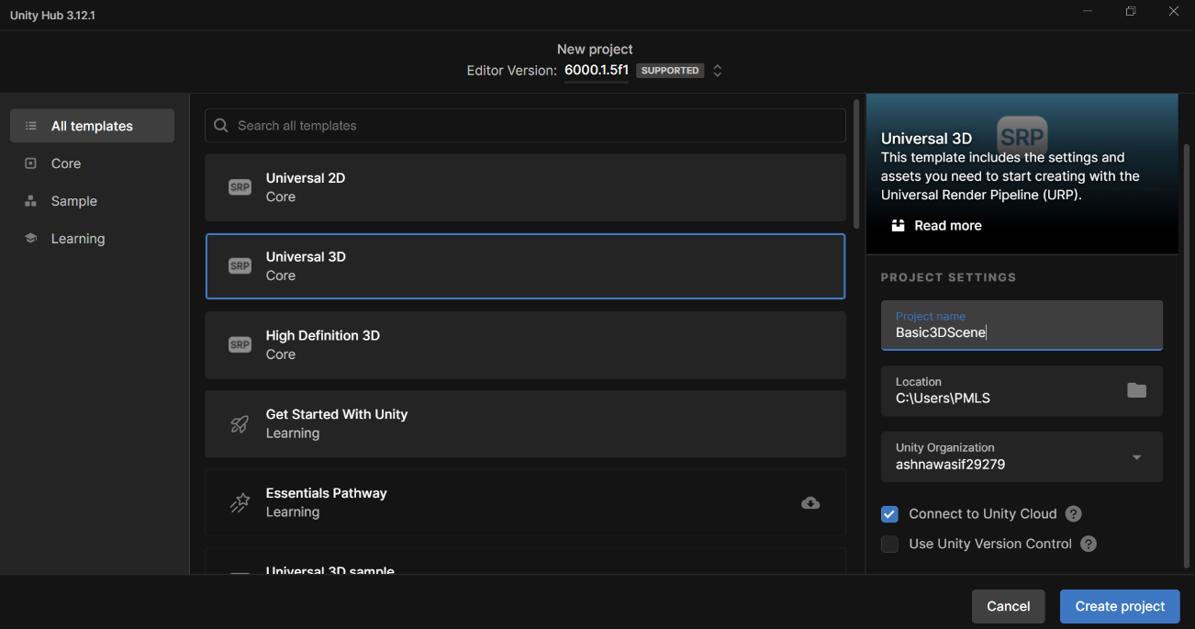Name the project "Basic3DScene" and set the location where you want to save it.

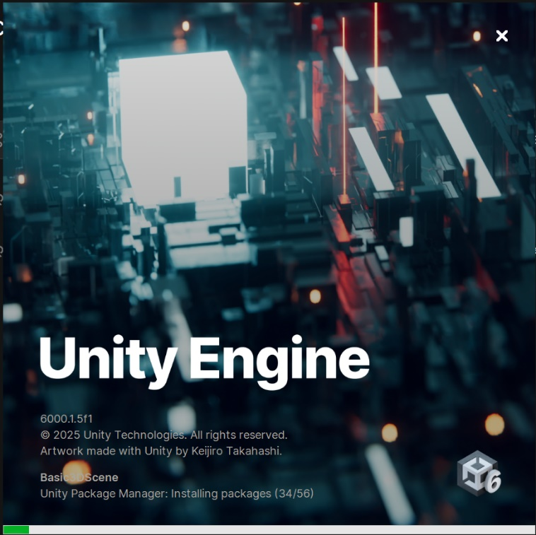 • Click on the "Create" button to create the project.,   
The following window will appear. Let it download:

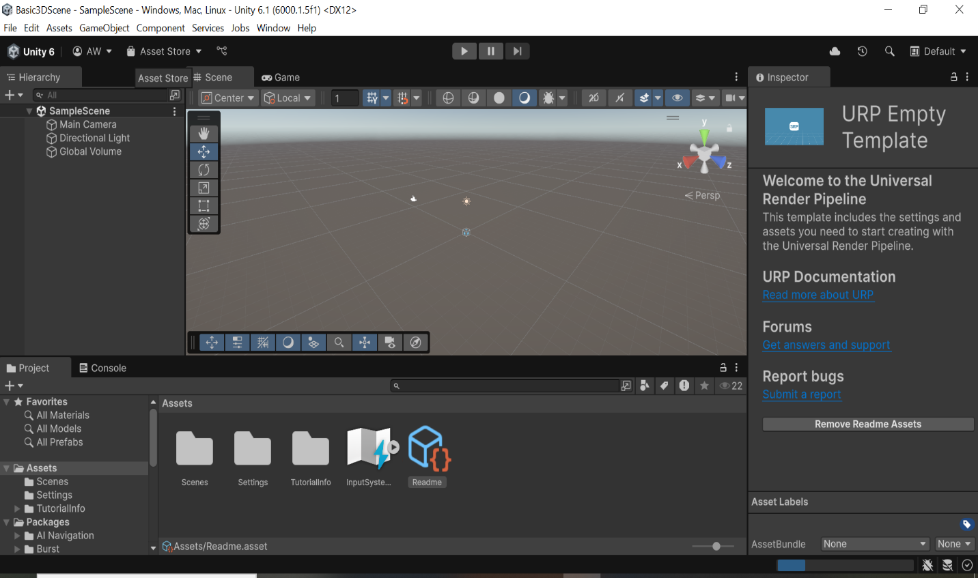You’ll be redirected to this window:

1. **Setting Up the Scene:**

* In the Hierarchy window, right-click and create an empty GameObject called "Scene".

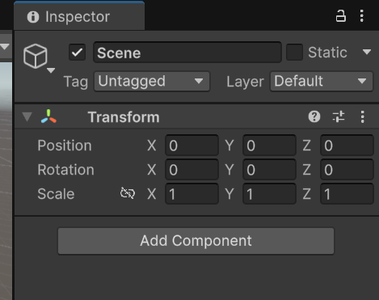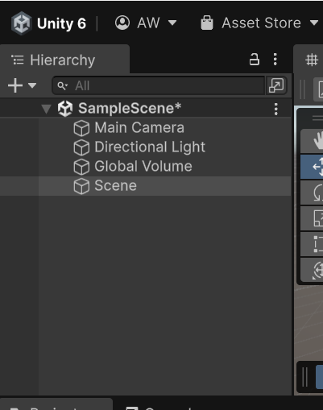The Hierarchy window is left panel by default. Right-click anywhere inside it. Click on Create Empty. A new GameObject named "GameObject" will appear. Select it, then go to the Inspector which is the right panel. At the top of the Inspector, we’ll change the name to "Scene".

* 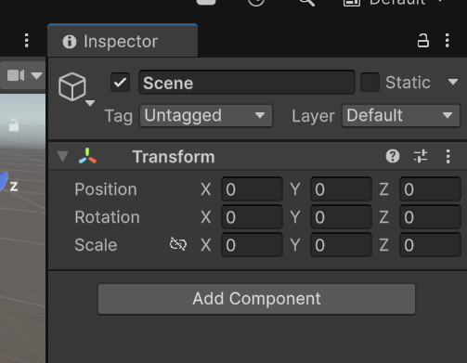Reset its transform (position, rotation, and scale) to (0, 0, 0).
* This GameObject will act as the parent for all other objects in the scene.

1. **Adding a Ground Plane:**

* Right-click on the "Scene" GameObject in the Hierarchy window.
* 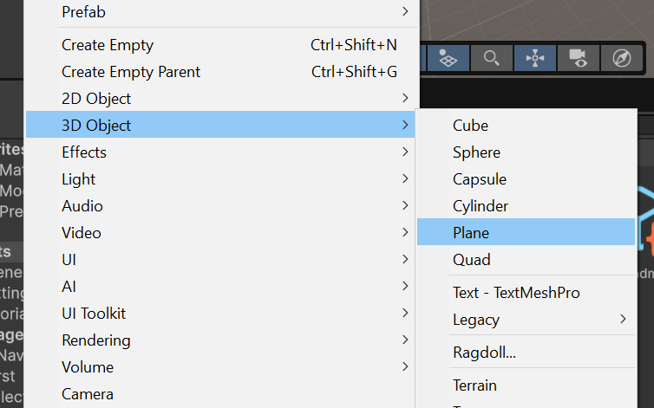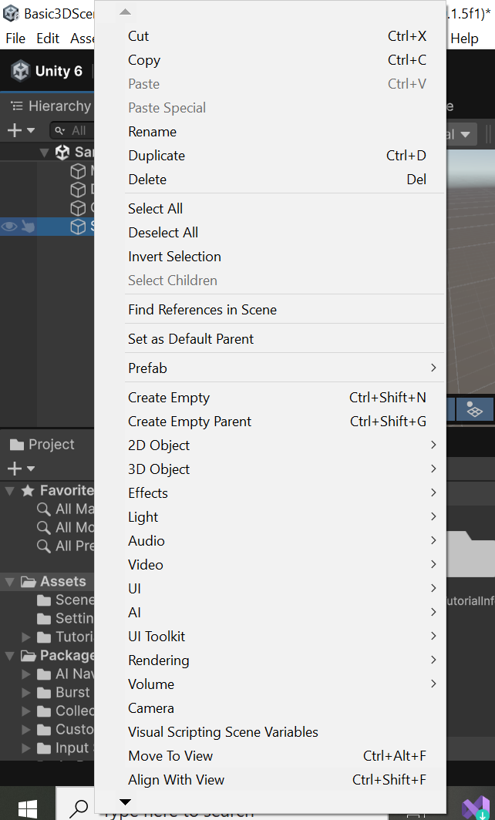Select 3D Object > Plane to create a ground plane.
* 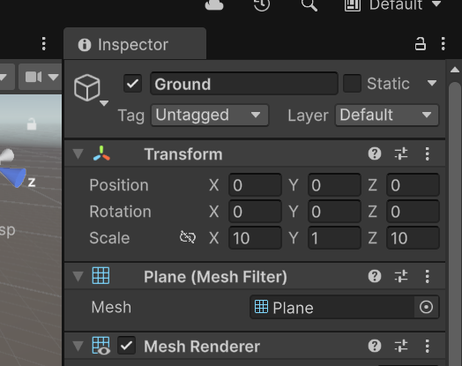Rename the plane to "Ground" and scale it up to (10, 1, 10) to make it larger.

1. **Creating 3D Objects:**

* Right-click on the "Scene" GameObject.
* 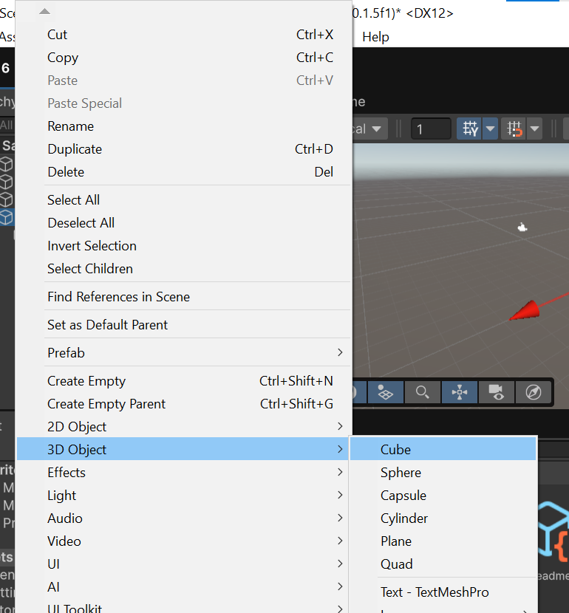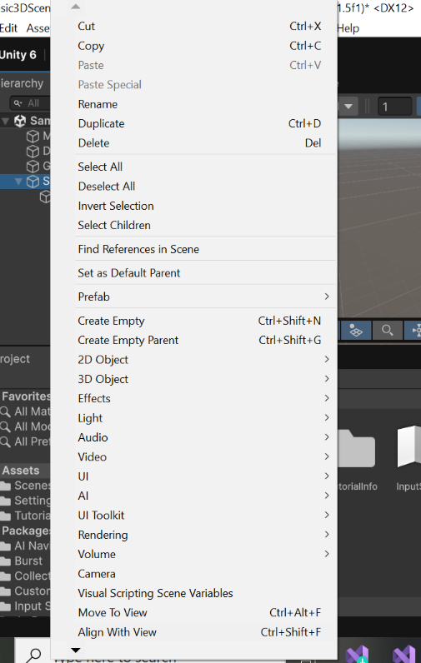Select 3D Object > Cube to create a cube.
* Rename the cube to "Cube1" and position it above the ground plane.

Now, in order to position it above the Ground, set its Position Y value. In order to do so, with Cube1 selected, go to Transform > Position. Set the Position to something like (0, 0.5, 0) so it sits above the plane.

1. **Adding Materials:**

* 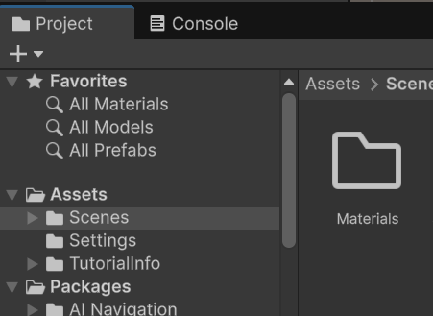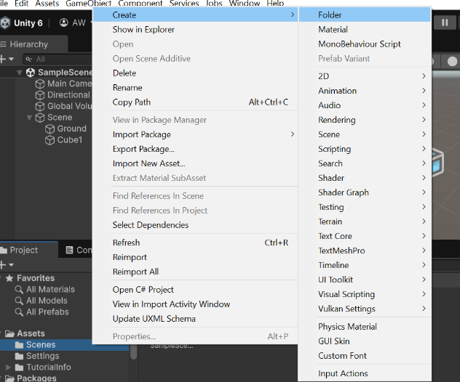In the Project window, create a new folder called "Materials".
* 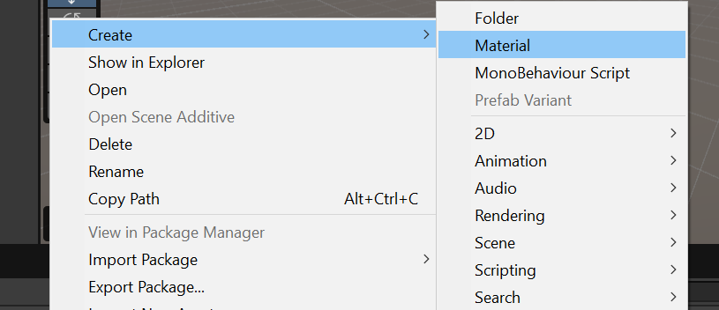Right-click on the "Materials" folder and select Create > Material.
* 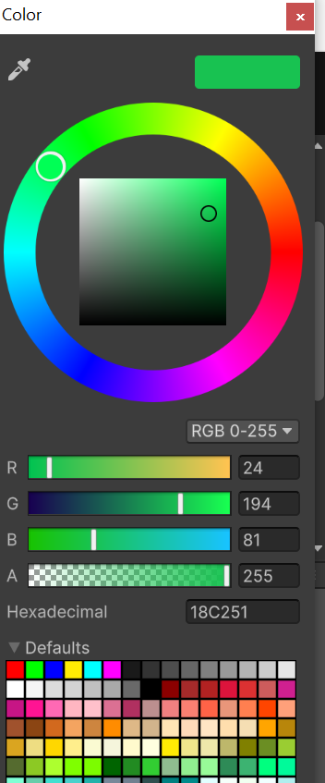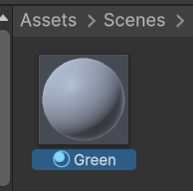Name the material "Green" and change its color to green.
* 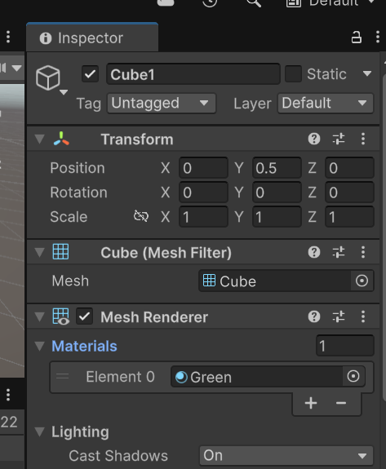Drag and drop the "Green" material onto the "Cube1" in the Hierarchy window to apply it.

1. **Adding Lights:**

* 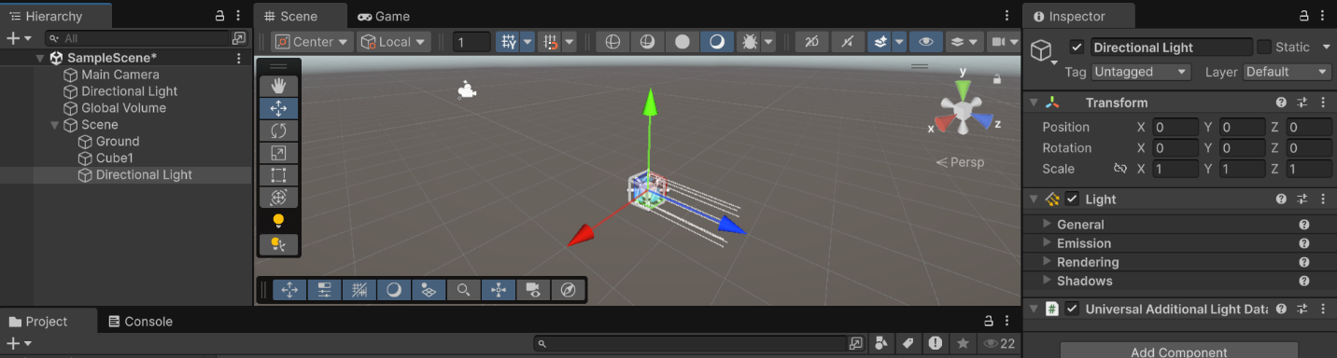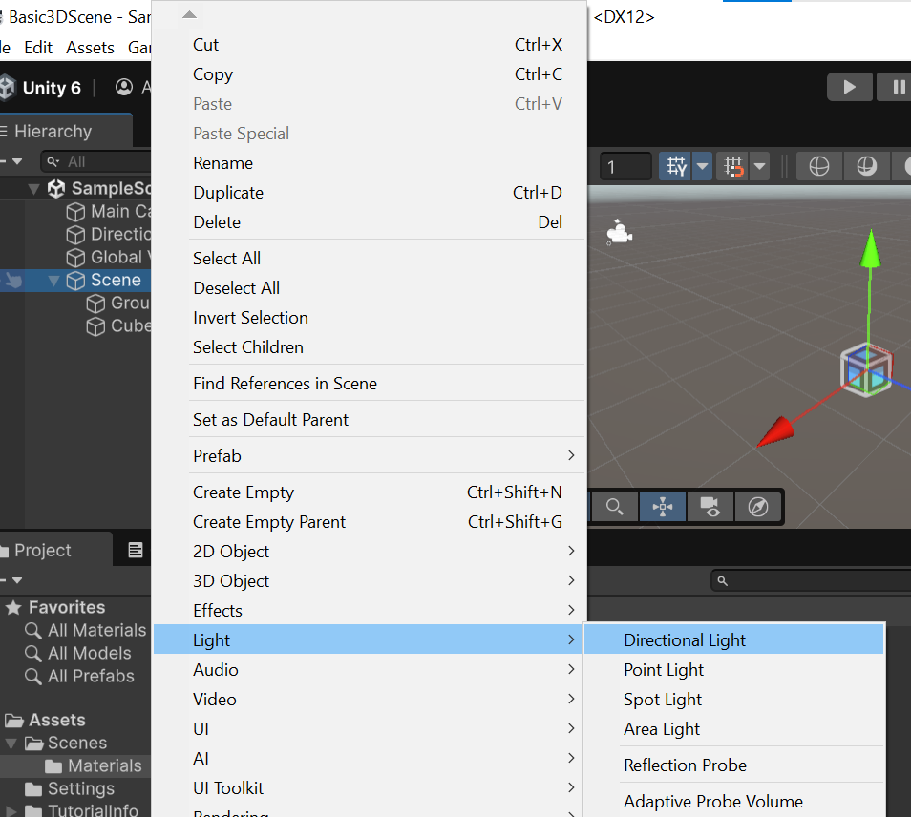Go to GameObject > Light > Directional Light to create a directional light in the scene.
* 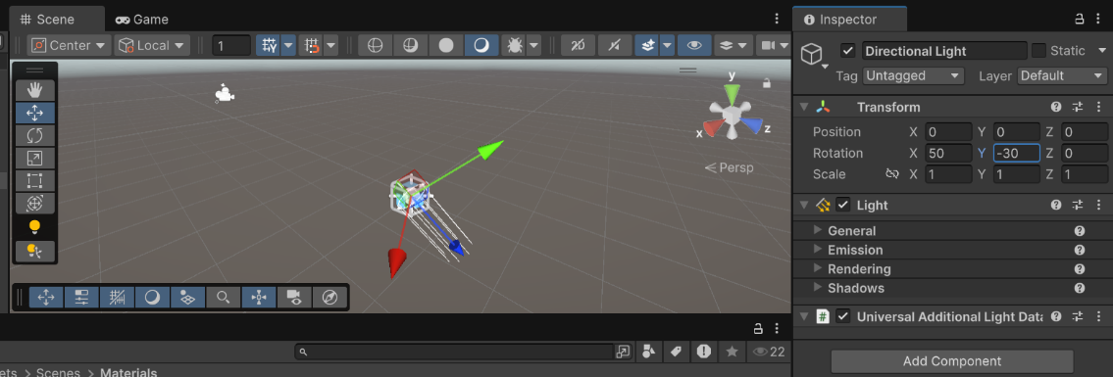Position the light to shine on the objects in the scene.

1. **Adjusting the Camera:**

* 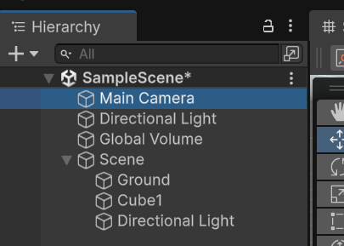Select the Main Camera in the Hierarchy window.
* Position the camera above the scene and rotate it to look down at the objects.

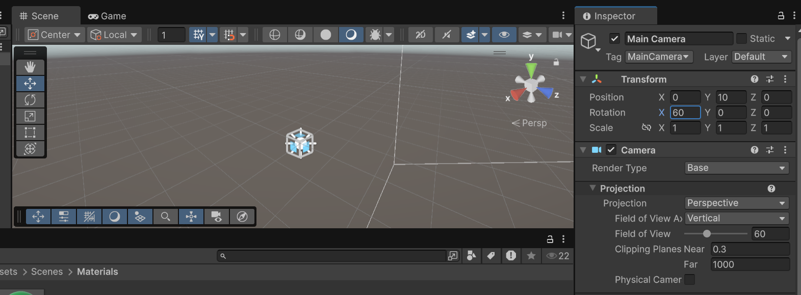

* Adjust the camera's field of view to get a better view of the scene.

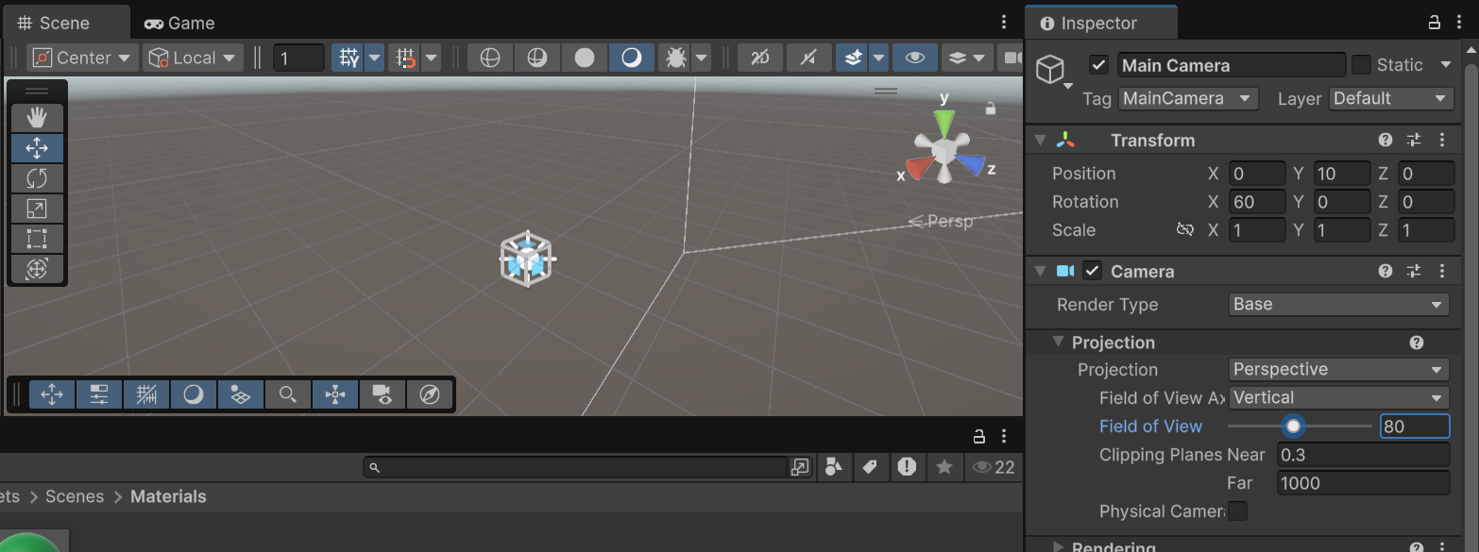

1. **Testing the Scene:**

* Click on the "Play" button at the top of the Unity editor to enter Play mode.

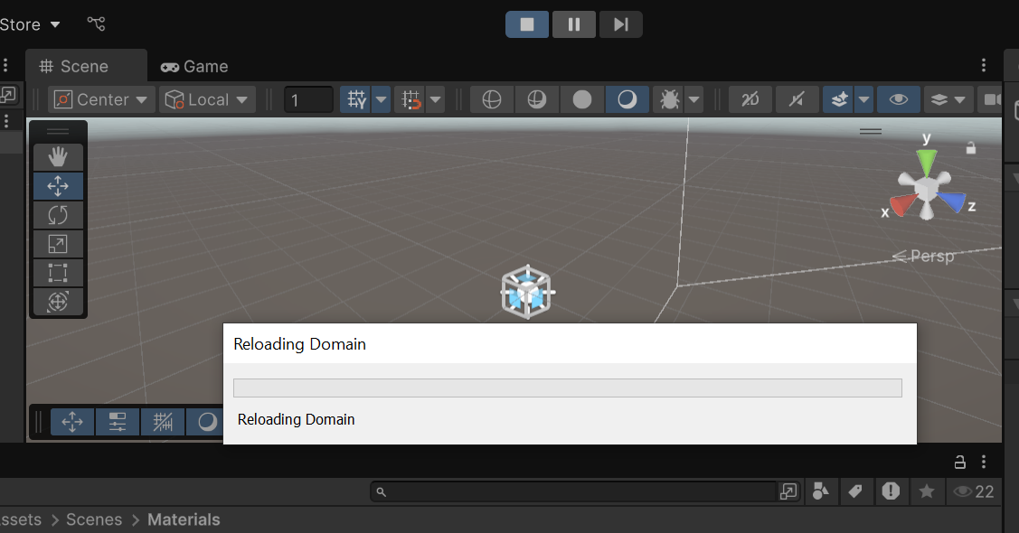

* 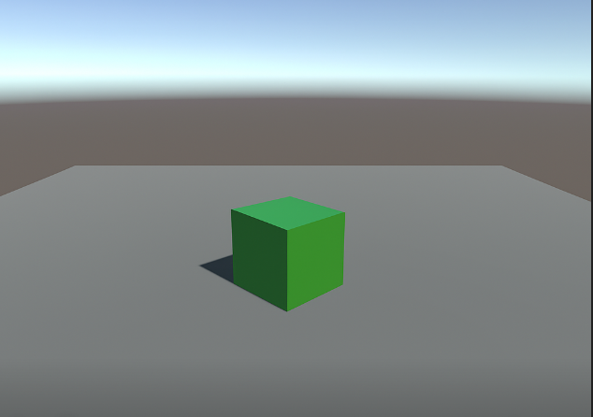Exit Play mode when you're done testing.

1. **Saving the Scene:**

* Go to File > Save Scene As and save the scene as "Basic3DScene" in the Scenes folder of your project.

Or you can save by simply pressing Ctrl+s.

1. **Building the Project:**

* Go to File > Build Settings.
* Click on "Add Open Scenes" to add the current scene to the build.
* Click on "Build" to build the project for your chosen platform.