

**Name:** Ashna Wasif

**Roll Number:** 2791

**Class:** BSCS 7B (Morning)

**Subject:** Computer Graphics

**Lab No.:** 01

**Submitted To:** Mam Sabina Irum

**Date:** 21st February, 2025

**Lab Task 1:**

Write a program that shows a Hut made up of Points/ Lines/ Line Loop.

* Shape of the Hut should be proper and it should have a proper color.

**Solution:**

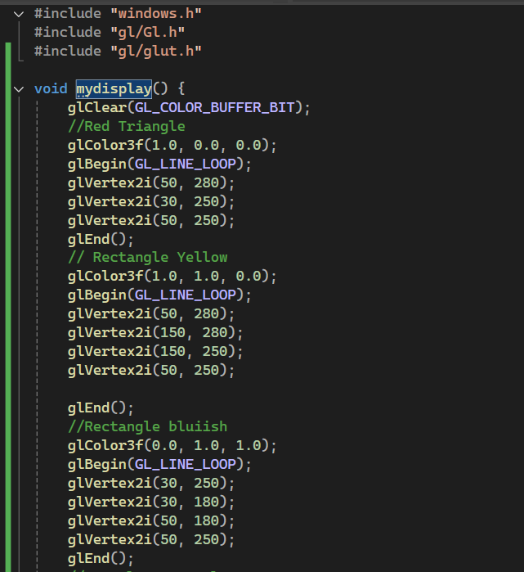Before performing this task, it is essential to download and include libraries in your project. This task is done on Visual Studio 2022 IDE. The code with the output is given Below:

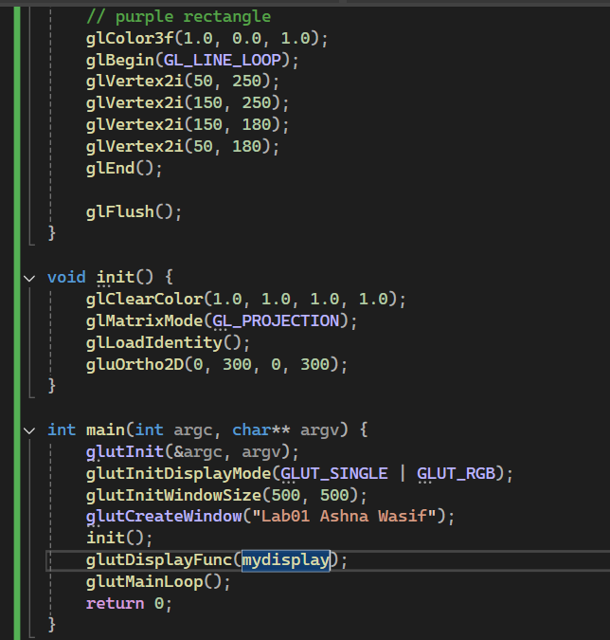

**Output:**

