

**Name:** Ashna Wasif

**Roll Number:** 2791

**Class:** BSCS 7B (Morning)

**Subject:** Computer Graphics

**Lab No.:** 02

**Submitted To:** Mam Sabina Irum

**Date:** 28th February, 2025

**Lab Task:**

Draw tic-tac-toe board of 2 different widths separately. OpenGL provides tools for setting the attributes of lines. A line’s color is set using glColor3f().width is set using glLineWidth(4.0) ,default thickness is 1.0. Now, use these lines as the tic tac toe board.

**Solution:**

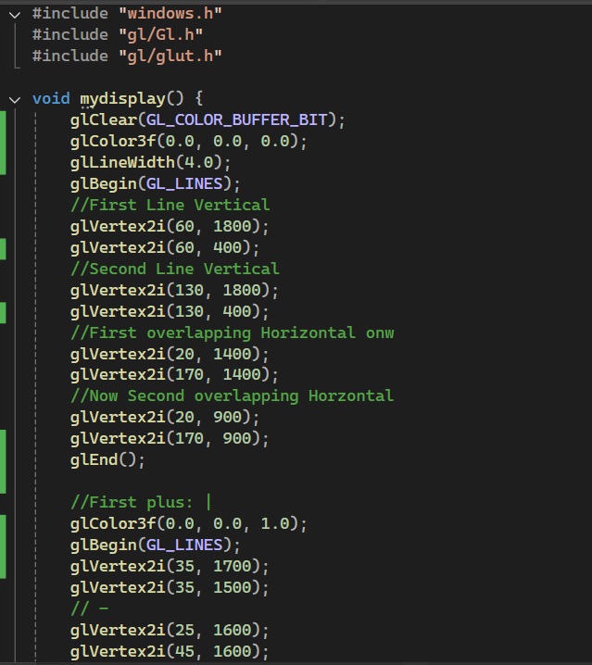IDE: Visual Studio 2022.

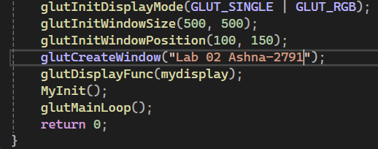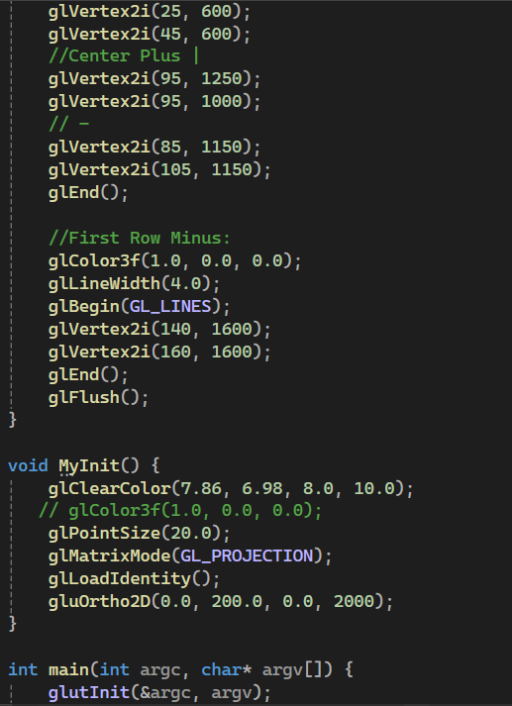

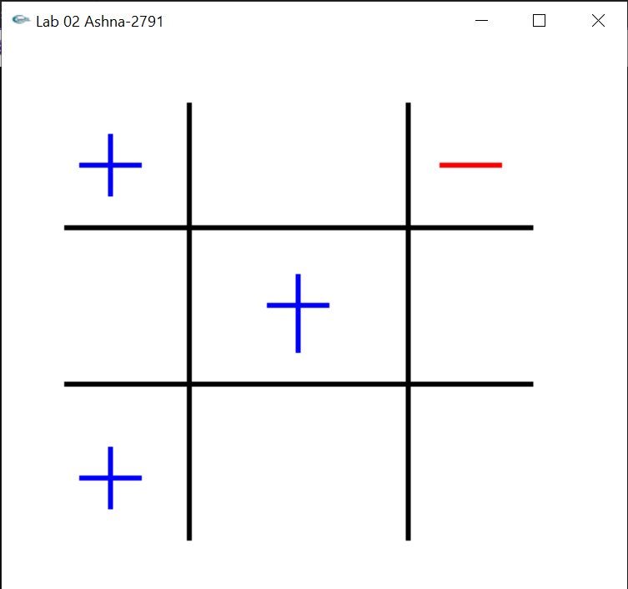**Output:**

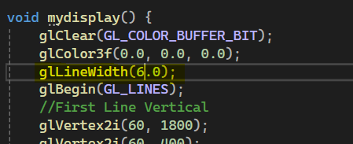Now, On changing Width:

**Output:**

